University of Wales Trinity Saint David
Student name: Berendei Nicoleta-Suzana
Student Id: 2230195
Module: Learning in the digital era
Module code: BMPS4009 & BMPL4007
Assignment Title: Evidence of Learning (E-Portfolio)

TASK 1

Preparing for the higher education

It is never to late to continue to learn new things…
In the modern days is easier to become a student due to the unlimited resources that can be easily found on internet, libraries, or online libraries.
However deciding to go ahead and start a new career is not as simple as a thought, it involves attention, dedication, time and patience.
Before starting any new studies, it is very important to analyse everything in your life, such as a study space, or time off for lectures, a suitable place, quiet where you can focus
There are many debates on the subject and many have said that studying can be challenging and not as easy as it seems.(Zhan. 2023)

Not only the student goes through this journey, but also the teachers and the members of the institution that they attend, the authenticity that the course offers and the knowledge that can be accumulated.
Exams and assignments can be difficult, mostly if they are left in the last minute as the stress of achieving the results can Couse over stress and by doing so the risks of failing is greater than the chance of passing them.(Adams, R. 2023)

That’s why a peace of mind, a clear, quiet place and the proper motivation is very important during the studies, as it can improve the quality and a better understanding of what actual is presented within the lectures.

Once that is established then the only thing left to do is to enjoy every step of the way the subject and to give the best tries to finalise the studies.

TASK 2

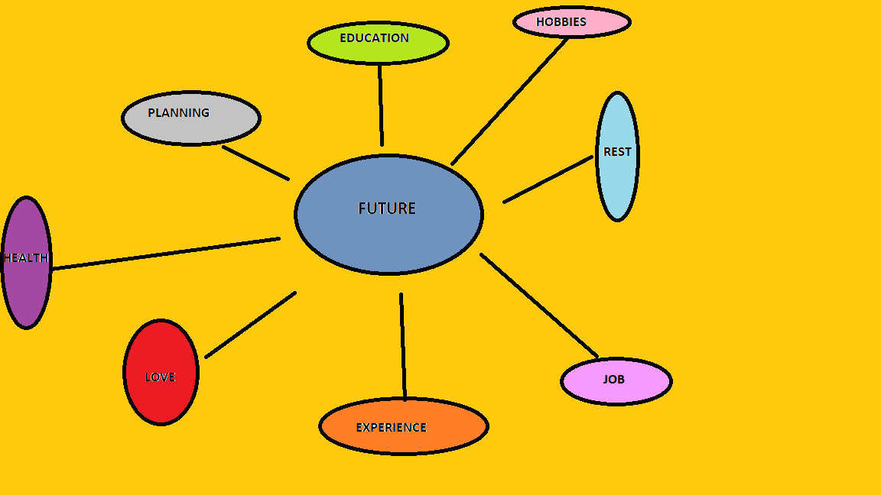

Having a proper plan is essential to achieve your dream career, and even when the thought that there is still time, by leaving it be the only result could be failure.
The modern technologies give the opportunity for every individual to access almost everything at any time.
Successful online learners are often self-motivated, by setting the goals no matter how small or big they are, the success is more near than anticipated.
There are many advantages for studying in the digital era, as the online is more advantageous then the classrooms. There are videos which could be accessed, materials, archives and many more at the end of a click. (Houx, L. 2017)
There are benefits in studying in the digital era such as access anywhere any time, not wearing a uniform and being comfortable, track of lectures, personalise learning.
However sometimes is time consuming because the need of self-educating on how to safe navigate or identify the right source.
Regardless of the content the organisation needs to explain how the technology meet the needs of the digital learner, by providing support, guidance and information. (CIPD)
The education system is responsible for ensuring that students have the skills and competences required to live, learn, work, and play within this global setting. Not only can digital technology impact many parts of life, but they also play a crucial role in reforming education institutions to fulfil these demands.
Societal factors that have an effect on education, but also because they provide us more options to help students. (Resnick, 2014).
The relationship between a culture's tools and the way its thinking evolves is crucial when selecting how digital technologies, which are today's social tools, should be used. So, if we think that each person actively creates their own meanings and that each learner produces knowledge, we must give students the capacity to utilise these "convivial instruments" to alter the world rather than to be moulded by it. (Illich, 1974)

TASK 3

https://youtu.be/ZqQDZwTOu6s

TASK 4.
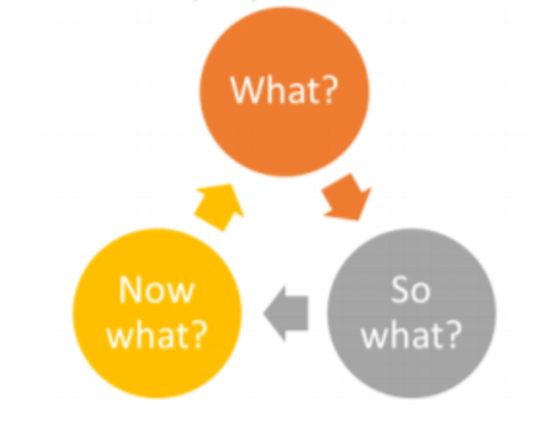

Last year, I have thought that I couldn’t study anymore as I have passed the “school age” and my memory, time and ability on getting on a new course will be impossible.
However I have taken the leap and registered to the course hoping that I can still adapt to the “new era” and keep up to date with the modern students

Is more difficult than I have anticipated due to the nature of the course, due to the challenges and the way that the academic years has evolved. During my years in school it used to be classrooms and teachers using physical books and writing down on the actual paper.
But by making this steps I have taken the commitment to understand, to adapt and to succeed by making mistakes and by learning from them as the mistakes make the human perfect.(Macmillan. S. 2015)
Having to write my first assignments has been more challenging then I have anticipated as the pressure was there to manage to get the most accurate information, to assess correct article, website, to be able to select from fake news and credible sources by identifying the key points of the correct information.
I am now half way through and it seems more doable then it was at the beginning because I have wanted , I have entered and now I have to finish want I have started.
I have left my assignments until the last moments as I have believed that there is enough time, but I understand now how important is to be able to take time to select, understand and create an successful assignment.
Having this in mind, I now know, that for next assignment I need to give myself at least a month to be able to write a good one.

Reference list:

. Zhan, Maya. Weblog post. The Student Life: Claremont Colleges News [Blog]Newstex. Mar 10, 2023.
Adams, R.(2023) Students should be told of university course job prospects, says commission.Available at: https://www.theguardian.com/education/2023/feb/09/students-university-course-job-prospects-social-mobility-commission (Accessed: 10 March 2023)
CIPD. Available at: https://www.cipd.co.uk/knowledge/fundamentals/people/development/digital-learning-factsheet#gref (Accessed: 10 March 2023)
Illich, I. (1974). Tools for conviviality. Marion Boyars
Houx L. (2017).Digital learning: how to keep your students switched on. Available at: https://www.theguardian.com/higher-education-network/2017/may/11/digital-learning-how-to-keep-your-students-switched-on (Accessed: 10 march 2023)

Macmillan S.(2015) Glorious failure: the joy of learning from your mistakes. Available at: https://www.theguardian.com/global-development-professionals-network/2015/mar/30/glorious-failure-joy-learning-from-your-mistakes (Accessed: 10 march 2023)

Resnick, M. (2014). Give P’s a chance: Projects, peers, passion, play. In Constructionism and creativity: In Constructionism and creativity: Proceedings of the third international constructionism conference. Austrian computer society, Vienna (pp. 13-20).

