

UNIVERSITY OF WALES TRINITY SAINT DAVID

Trial balance and final accounts of a sole trader

Accounting fundamentals
LCBB 4001

Student name: Sorina-Iulia Cosa
Student number: 2211474
Lecturer’s name: Dr David Jenkins

Task 1

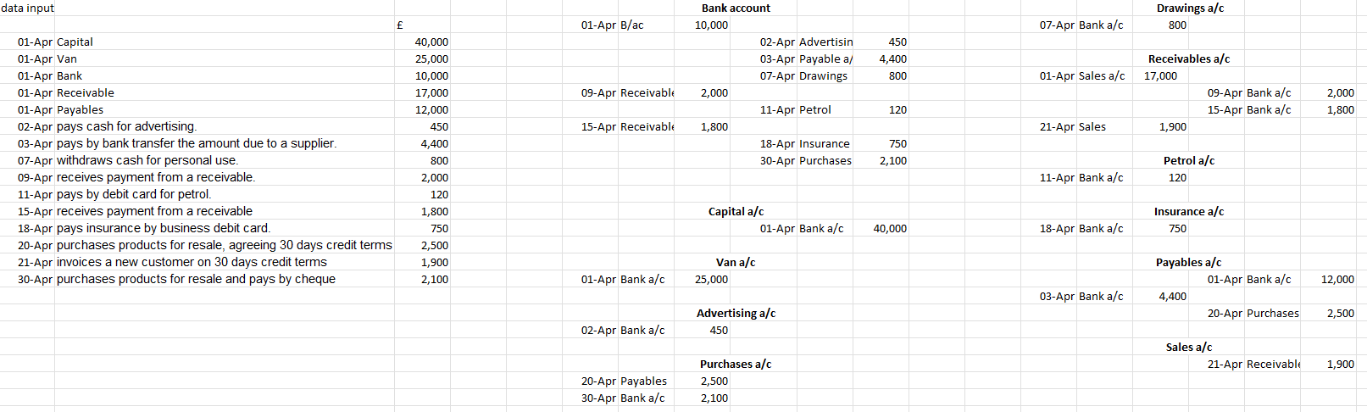

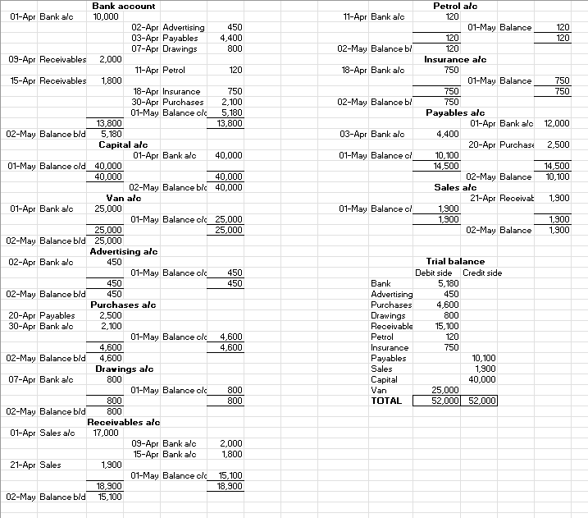

Task 2

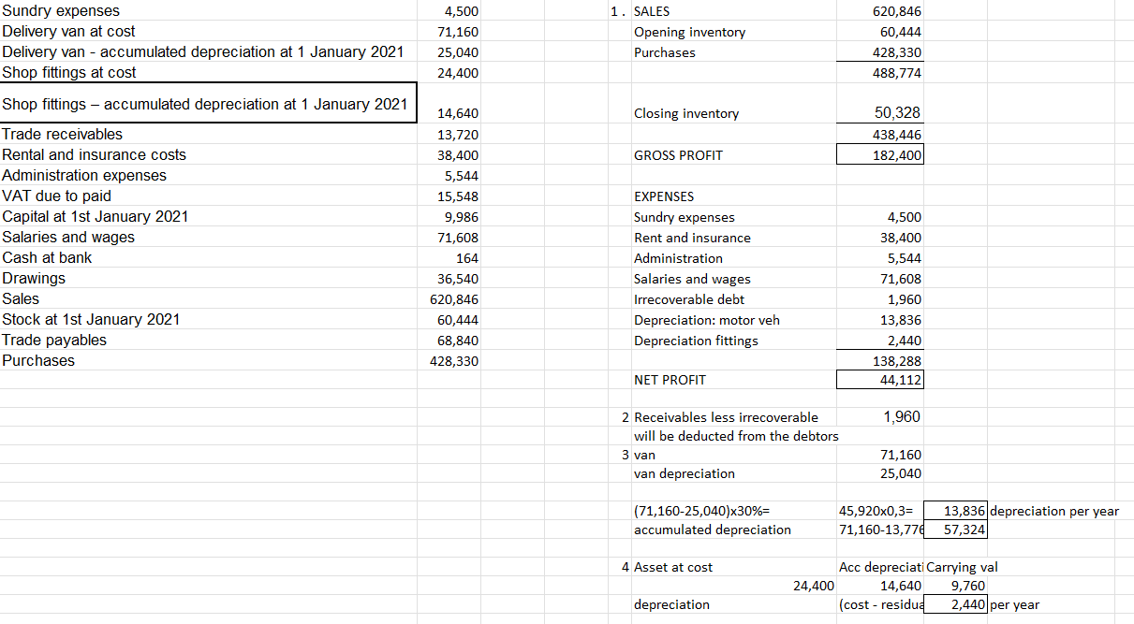

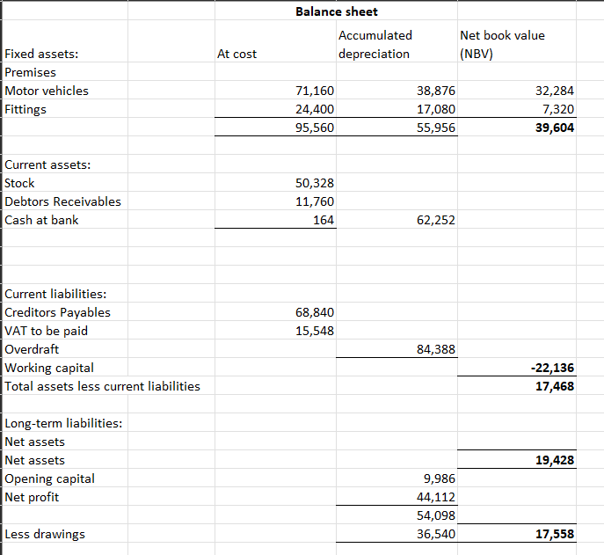

Task 3

The tools a company needs to operate and expand are referred to as assets in financial accounting. Current and noncurrent assets are the two types of assets that are listed on a company's balance sheet and add up to the total assets of the firm, from which noncurrent assets are long-term, since they have a usable life of longer than a year. (Nickolas, 2015)
Noncurrent assets are listed at their purchase price, which has been depreciated, on the balance sheet. The depreciation is a widely used component in financial accounting and financial administration. (Istrate, 2018). Depreciation is the methodical distribution of an asset's depreciable value over the course of its useful existence. Depreciation, in other words, matches the capitalised cost of a non-current asset to the time to which it pertains by applying the accruals concept to this cost. The most common methods of depreciation non-current assets are straight-line and reducing balance method. The accelerated technique is no longer widely used, with the straight-line method being the most common. (ACCA Global, 2016). In application, because the value of the company pf a sole trader is directly correlated to the value of the assets, the business may also experience asset value decline. Depreciation requires that a fixed asset register, which is where your assets are noted on your balance sheet, be updated on a regular basis. In accounting, when calculating profit or the annual calculation of how much value was lost from company assets, gives a value that must be subtracted from revenue, depreciation play a very important role in knowing exactly how many expenses the company suffered. When depreciation is disregarded, the company will overestimate its expenses and compute its annual profit incorrectly. (Depreciation and its practical applications for your business, 2020)
It's crucial to remember that depreciation doesn't entail a cash transaction. Instead, a portion of the cost of non-current assets is transferred to generate a charge against profit in a book entry. Since the value of non-current assets is decreased by the same quantity as the profit charge, the accounting equation is maintained. The depreciation fee results in a debit entry in an expense account. (ACCA Global, 2008)

References:

‘ACCA Global’ (2016) in Wiley 2016: Interpretation and Application of International Financial Reporting Standards. Hoboken. (Accessed: 24 February 2023).
ACCA Global, (2008) Accounting for non-current/fixed assets, Accaglobal.com. Available at: https://www.accaglobal.com/content/dam/acca/global/PDF-students/2012t/sa_may08_patton1.pdf (Accessed: 24 February 2023).
Depreciation and its practical applications for your business (2020) Xeinadin Group. Available at: https://xeinadin.com/blog/depreciation-and-its-practical-applications-for-your-business/ (Accessed: 24 February 2023).
Istrate, C. 2018. Non-current assets depreciation and impairment between legal, accounting at tax rules: Evidence from Romania. Eufire, 2018. (Accessed: 24 February 2023).
Nickolas, S. (2015) Current assets vs. Noncurrent assets: What’s the difference?, Investopedia. Available at: https://www.investopedia.com/ask/answers/042915/what-difference-between-current-and-noncurrent-assets.asp (Accessed: 24 February 2023).

