Alexandru Mardare (1701698)

Alexandru Mardare 1701698
Application development

Contents

Table of Contents
Contents 1
Introduction 2
Report contents 2
Introduction to the web-based application website 2
Web app requirements 3
Design stages of the web-based application 3
Design screenshots 4
Website navigation 4
Further navigation and website exploring 5
Contacting the seller for spare parts 5
Conclusion 6

Introduction

The purpose of this assignment is to give students a better understanding of the various types of web application technologies that can be currently used to create a web application-based website. There are various steps which students need to cover in order to achieve and complete this assignment report. The students must show a representation of their web application website and also show that knowledge and understanding of the specific application has been properly understood.

Report contents

This report will outline different characteristics ranging from the very beginning of the report outlining the introduction, to report contents then to the last section of the introduction part which will explain the introduction to web-based application website which is the website style that was created. The report will then explain application software that was used to create the website and how the website functions. Later in the report there will be a section on the designing and showing how the website functions and its features and function. This is one of the most important sections of this report as you are telling the reader what the website is capable of doing and what its really all about.

To finish off the report will then transfer to the conclusion section where the reader will be given an end result conclusion of what the report and web-application was about. This section is also important since you could be talking about some of the other possible features and also simplifying the user the features and the website contents to give the user a better understanding of what has been mentioned.

Introduction to the web-based application website

The web application designed is based on a website similar to a shopping website but instead of buying products you research for information about the product then you can contact a product supplier if you intend to buy the product. The website is called LegacyiPhoneParts and was designed to give the user a very simple way of getting to know about their device and knowing what is needed to purchase for their older iPhone in case something was to go wrong such as a bad battery or cracked screen. This method of online shopping might be a great idea for new start-up businesses who find trusting customers a difficult matter such as on eBay where sometimes people can get scammed.

This way of shopping puts you directly with the seller to make sure that you are certain to purchase the item and that you are for certain that it will be the right item. This will also reduce the probability of ordering items by mistake or scamming the seller which does occasionally happen on large websites such as eBay. Payments will also be made possible through PayPal only where you know that payments are secured and only released if the customer is satisfied with their purchase.

Web app requirements

One of the main requirements for creating a website app is to have a decent code text editor such as NotePad++ which has been chosen to create this specific website. This code editing software has been chosen because it doesn’t use all of the system resources and is relatively easy to understand and create code on. The way that NotePad++ works is if you know the code syntax you can type it in and then save the code to whatever language or style the code is which then can be accessed and tested trough the appropriate software.

Another main requirement is to have a fairly up to date computer to use all the needed up to date software and operating system needed to run the program once its been completed. A smooth user experience is always essential both for the end user and also for the programmer who will spend hours creating the web-based application.

Depending on the nature of the program code and what code language has been used to create the web application you will then need up to date versions of the running software to be installed to make sure everything runs bug free and without any stability issues.

Design stages of the web-based application

The design stage of this application will be represented with screenshots and text to represent to the end user what the application is about. This will be done to ensure the end user fully understands the concept. Various screenshots of various functions of the website will be shown below along with descriptive information on what each screenshot represents.

Design screenshots

When the website is first launched the user will be greeted with the title page and a few options for the user to interact with in order to access the correct device and to see if the device they have matches on the website. The user has built in navigation so its almost impossible to get lost on the website since it has been designed to be user friendly. The website is also very professional looking without too much extra features and functions that are not needed.

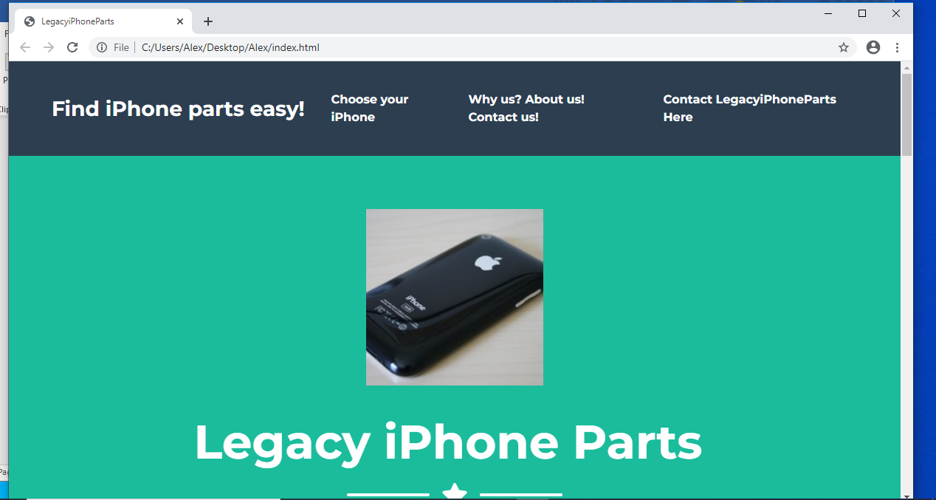

Website navigation

The user can navigate through the website by using the buttons on the banner next to where it says Find iPhone parts easy! Each tag will take the user to the appropriate part of the website. For example, as the screenshots suggest the user has selected one of the buttons which has brought the page to the correct place on the website. This will allow the user to select the right device that they are looking at.
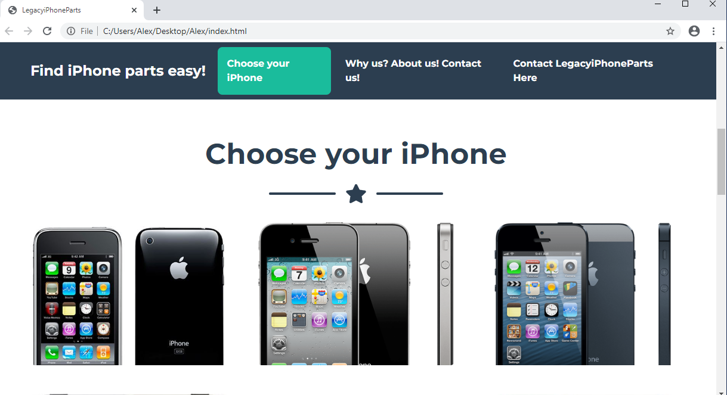

Further navigation and website exploring

The user has navigated now to the chosen device which they can see that it matches their very own device. The user can now see that the description matches the device.

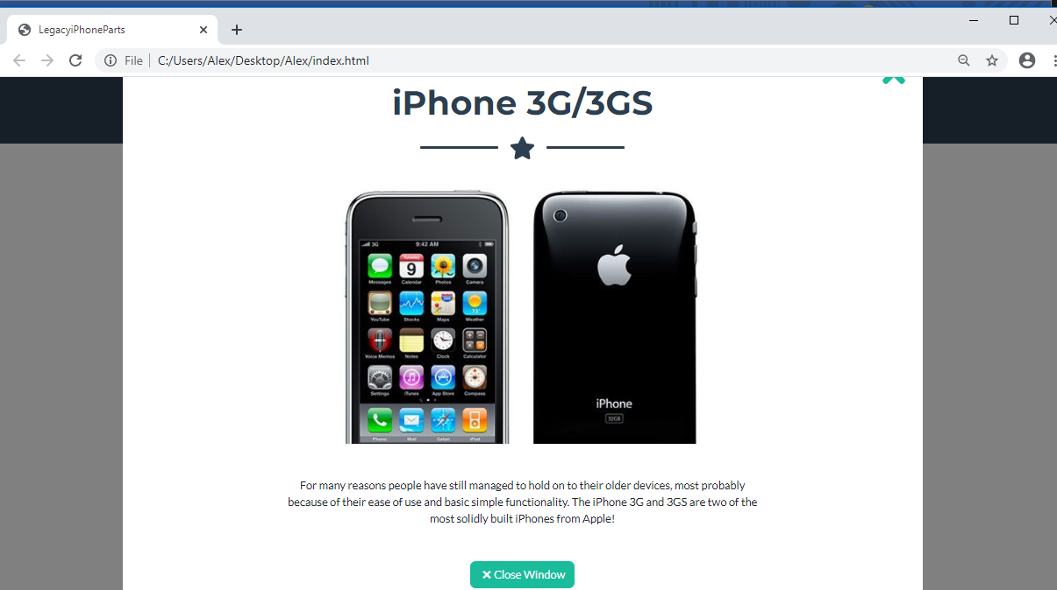

Contacting the seller for spare parts

After the user understands that the device matches with what they need they can get into contact with the seller which will check stock to see if the specific parts are available to purchase. In order to contact the user will get to the appropriate part of the website with all the contact details in order to make a purchase.
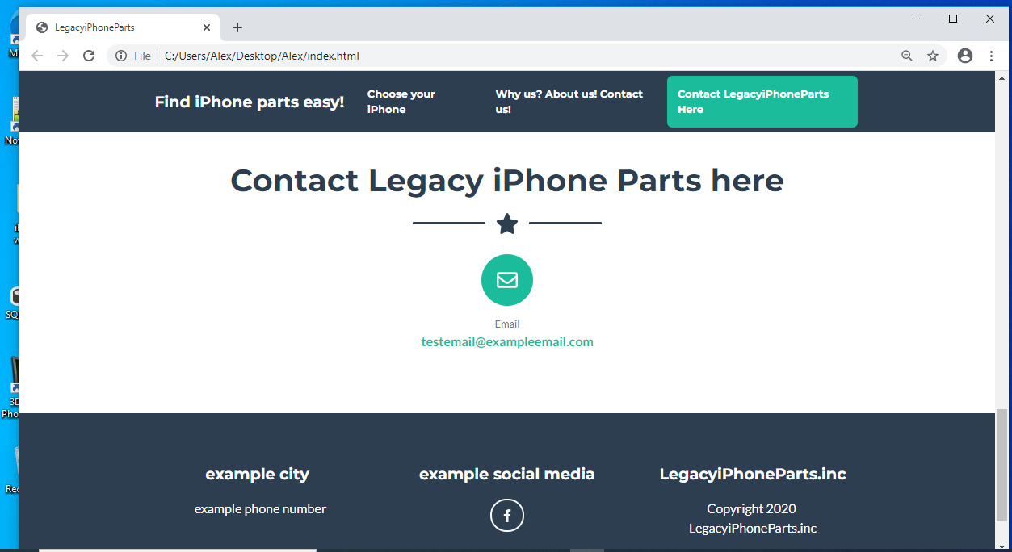

Conclusion

To finish off this evaluation the user now can see how to use the website and all its features. This evaluation can be compared to a step by step guide which allows the user to understand anything that they are not sure of. The website and connect is relatively easy so anyone can understand how the concept functions. This website can also be viewed on mobile too.

marking criteria and Student FEEDBACK

This section details the extent to which the assessment criteria are demonstrated by you, which in turn determines your mark. The marks available for each category of skill are shown. Lecturers will use the space provided to comment on the achievement of the task(s), including those areas in which you have performed well and areas that would benefit from development/improvement.

Common Assessment Criteria Applied (Assignment 2) | Marks available | Marks  awarded
1. Engagement with Literature Skills

2. Knowledge and Understanding Skills

3. Cognitive and Intellectual Skills

Unfortunately the submission does not really include the required work for this section. Please read the assignment brief carefully. (Grade mark: 3.33%) | 30 | 1
4. Practical Application Skills

The submitted work is not what has been asked for in the assignment brief and does not demonstrate your understanding of the required learning outcomes. (Grade mark: 10.00%) | 60 | 6
5. Transferable Skills for Life and Professional Practice

The report is of a good standard, but it is missing some of the required elements. (Grade mark: 50.00%) | 10 | 5

Assignment Mark (Assessment marks are subject to ratification at the Exam Board. These comments and marks are to give feedback on module work and are for guidance only until they are confirmed. ) | Late Submission Penalties (tick if appropriate) |  | 12%
 | Up to 1 week late (40% Max) |  | 12%
 | Over 1 week late (0%) |  | 12%

