E-Portfolio Evidence of Learning.
Keeley Marie Williams, 2004801

Contents Page:

Page 2: Contents
Page 3: Mindmap
Page 4: Pitch and Flyer
Page 5: Poster
Page 6- 7: Bibliography

Task One: Mind Map
Available at: https://lucid.app/lucidspark/0cf2c884-9d3b-46a8-9df9-53d505b86abe/edit?viewport_loc=-399%2C-392%2C3927%2C1947%2C0_0&invitationId=inv_cb006eaf-2c18-4818-914b-177b4e23c6d8
Enter Join ID
MEH GJZ

Task Two: Summary
Knife crime affects more than just those that carry sharp weapons, when a crime involving a knife occurs it brings devastation to families of all parties as well as having an impact on the community. The main perpetrators of knife crime are between the ages of 13-24, but the House of Commons (2023) has recently reported that 18% of the offenders of knife crime in 2022 were aged between 10 and 17. Youths between these ages sometimes are unaware or do not fully understand the impacts or consequences of carrying knifes or sharp objects. To carry a knife or sharp object is a crime in itself, and four years is the maximum jail time for this, as well as a 20 year sentence for the worst case, the murder as a result of stabbing.
The government has issued a change in the way that the law enforcement should be dealing with these sorts of crimes, however they have backed officers fully in the increase of stop and search policy, (Home Office, 2022). There is little evidence to suggest that stop and search does actually decrease the amount of knifes carried publicly, officers claimed that more drugs than weapons were found, (Brown, 2020). However, since the increase of stop and search, more than 50,000 knifes/ offensive weapons have been taken off the streets and it is now easier than ever for officers to target and search known knife carriers, (Home Office, 2022).
These sort of crimes are better known for being in much more deprived areas of the UK. There is an alarming number of knife crimes in larger cities like London and Cardiff. From figures set out by the mayors office (London) it is known that minority ethnic boys ranging in ages from 12-27 were disproportionately affected. They are more likely to be perpetrators or victims. Many sharing the attitude of rapper Headie One who wrote a line that says, “I’d rather be dead than poor”, (Perera, 2020). From this it is clear that some of these youths are desperate and carry knifes as way of threat so that they are more likely to gain something out of a robbery.
Speaking of desperation, Perera (2020), went on to suggest that this type of violence is ‘born out of deprivation’, essentially saying that those who are in poverty may be more likely to participate in knife or gang crime. Children who are in toxic environments are less likely to engage in school and find other ways of occupying themselves, Casey (2019) states that children who find themselves excluded from school are 200 times more likely to be caught up in gang culture and knife crimes than those who attend regularly.
Since the COVID-19 Pandemic and the increase in the costs of living, the statistics of knife crime have only increased, as people are only getting more desperate and the rewards of violent crime increasing, (Robson, 2022). Sadiq Khan stated that “rising costs will deepen deprivation and poverty” which he believes to be the key drivers of violent crime.

Task Three: Pitch and Flyer
Knife Crime Prevention Pitch by Keeley Williams available at: https://clipchamp.com/watch/6kNGxfqDBDI

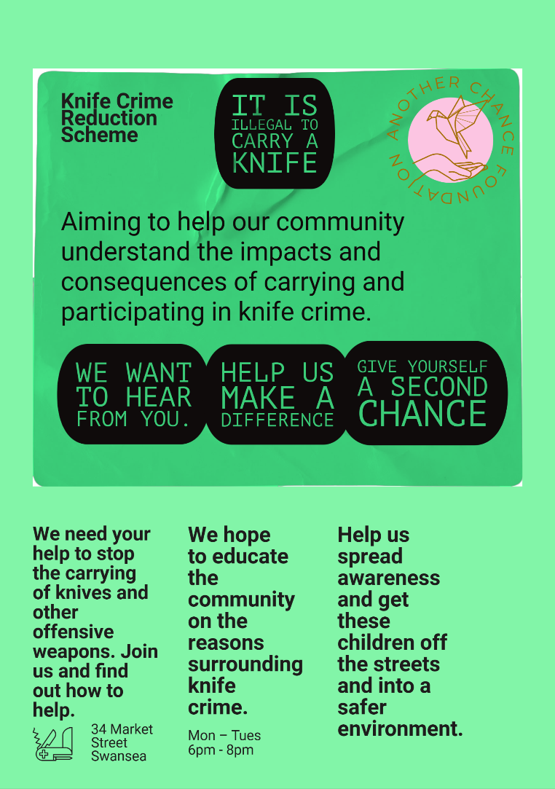
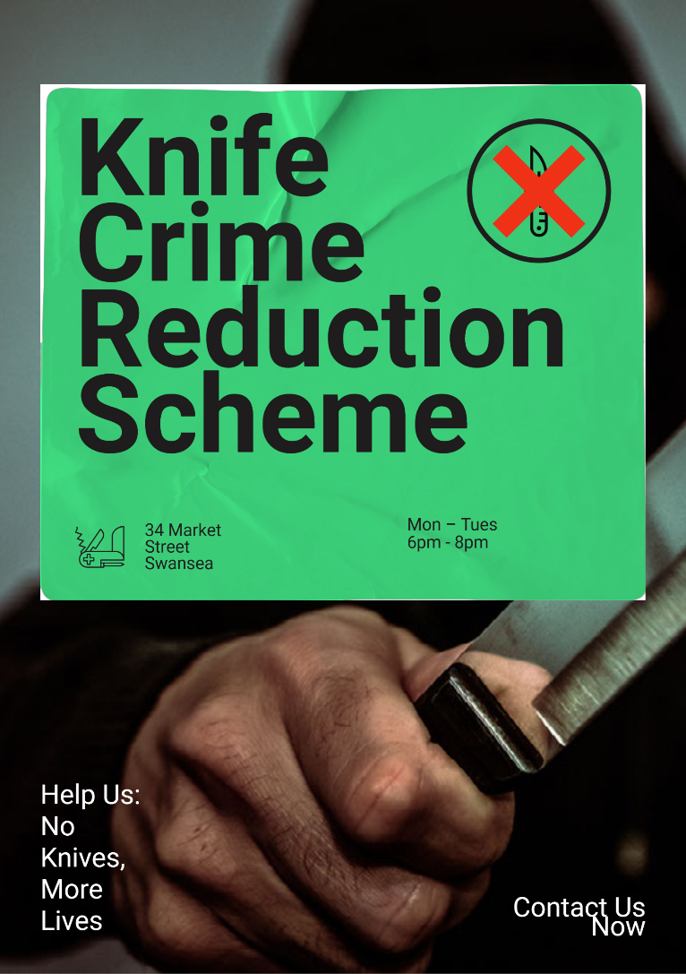
Flyer:

Task Four: Poster

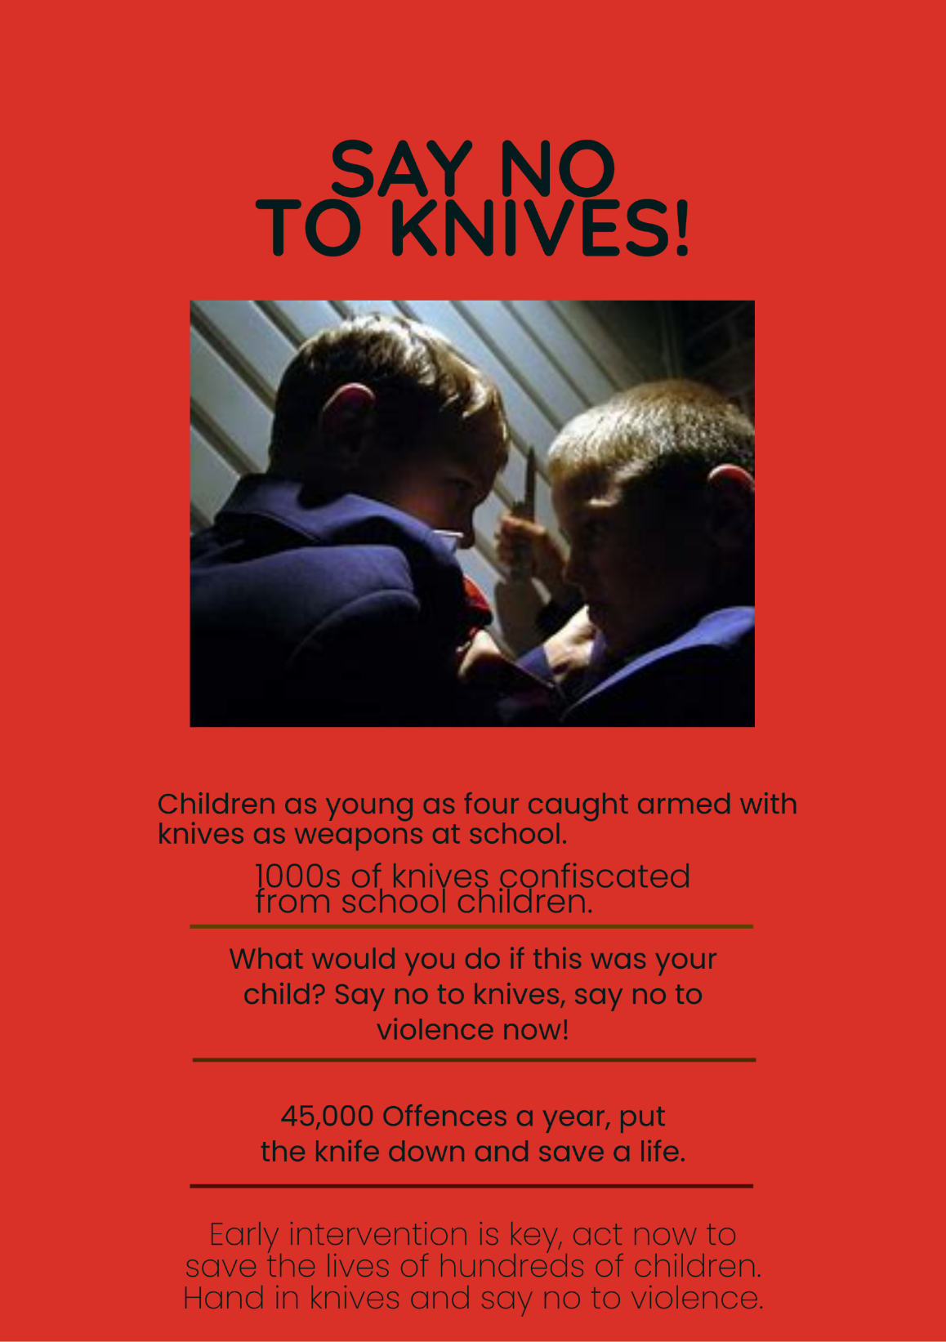

Bibliography:
Casey, L. 2019. We Can Tackle Knife Crime by Tackling Poverty. Available at: https://www.kcl.ac.uk/newa/we-can-tackle-knife-crime-by-tackling-poverty
Epidemiol, N.J. 2022. Exploring UK Knife Crime and Its Associated Factors: A Content Analysis of Online Newspapers. Available at: https://www.ncbi.nlm.nih.gov/pmc/articles/PMC9886559/
Her Majesty’s Inspectorate of Probation. 2022. Promising Approaches to Knife Crime: An Exploratory Study. Available at: https://www.justiceinspectorates.gov.uk/hmiprovation/wp-content/uploads/sites/5/2022/05/RAB-2022-03-Promising-approaches-to-knife-crime-v1.1.pdf
Home Office. 2022. Home Secretary Backs Police to Increase Stop and Search. Available at: https://www.gov.uk/government/news/home-secretary-backs-police-to-increase-stop-and-search
Kirby, D; Milmo, C; Day, A et al. 2018. Revealed: Children As Young As Four Caught In School Armed With Knives and Other Lethal Weapons. Available at: https://inews.co.uk/news/revealed-children-young-four-caught-school-armed-knives-lethal-weapons-121167
Osley, R. 2018. WATCH: Poverty is Fuelling Knife Crime, Camden’s Youth MP Tells Commons. Available at: https://www.camdennewjournal.co.uk/article/watch-poverty-is-fuelling-knife-crime-camdens-youth-mp-tells-commons
Ng, E. 2023. Knife Crime on Rise Due to ‘Teenagers Made Vulnerable by Pandemic’. Available at: https://www.independant.co.uk/news/uk/london-office-for-national-statistics-england-wales-gangs-b2279272.htnl?amp
Perera, J. 2020. ‘I’d Rather Be Dead Than Poor’: Knife Crime in London. Available at: https://irr.org.uk/article/id-rather-be-dead-than-poor-knife-crime-in-london/
Seddon, S. 2022. Gun and Knife Crime in London ‘Could Rise Because of Cost of Living Crisis’. Available at: https://metro.co.uk/2022/06/09/sadiq-khan-warns-london-violent-crime-could-rise-because-of-poverty-16797478/amp/
The Children’s Society. 2023. The Unseen Effects of Knife Crime on Children. https://www.childrenssociety.org.uk/what-we-do/blogs/the-unseen-effects-of-knife-crime-on-children
Robson, S. 2022. As The Cost of Living Soars, So Do The Rewards From Organised Crime- and The Violence. Available at: https://inenews.co.uk/news/crime/as-the-cost-of-living-soars-so-do-the-rewards-from-organised-crime-and-the-violence-1875984

Images:
https://th.bing.com/th/id/OIP.TcHzA_q7Liai3NVwp3h3-AHaE2?w=281&h=184&c=7&r=0&o=5&pid=1.7
https://th.bing.com/th/id/OIP.Xk0x152Xt0IFu4GoxmgPVAHaEJ?w=332&h=185&c=7&r=0&o=5&pid=1.7
https://th.bing.com/th/id/OIP.6vP_qZFF-eHQHWL2Vt_c9QHaEc?w=250&h=180&c=7&r=0&o=5&pid=1.7
https://th.bing.com/th/id/OIP.-KlwSe8Mb91jMeuPPPpSNAHaE5?w=232&h=180&c=7&r=0&o=5&pid=1.7
https://th.bing.com/th/id/OIP.RdUANzoSvJqh8wKHoisWdQHaE9?w=252&h=180&c=7&r=0&o=5&pid=1.7

