
Programme: BA Leadership and Management Skills in the Workplace.
Module: Design Thinking and Innovation.
Module code: LCLM 6002
ID: 2334056
Student Name: Chaudhry Badar Munir Mehar.
Lecture: Charles Obinwa.

Table of Contents
Introduction: 3
Task 1: Identifying Key Opportunity Areas Using a Design Thinking Lens 4
The Role of Design Thinking in Identifying Market Opportunities: 4
Opportunity Area 1: E-commerce Platforms 5
Opportunity Area 2: Digital Marketing Services 6
Opportunity Area 4: Integrated Digital Payment Systems 9
Opportunity Area 5: Supply Chain and Last-Mile Delivery Solutions 10
Task 2: Applying the Five Stages of Design Thinking to Develop a New Venture Concept 12
Empathise: 12
Define: 13
Ideate: 14
Prototype (Minimum Viable Product - MVP): 16
Testing and Refinement: 16
Lean Startup and Double Diamond Frameworks: 16
Evaluation, Critical Reflection and Conclusion: 17
References: 19

Introduction:
In the United Kingdom, business-to-business and/or business-to-consumer interactions were impacted by the coronavirus pandemic (COVID-19). Due to the pandemic, businesses had to adjust to the requirements of their customers who started reducing their number of in-person interactions and shopping. These motivated a lot of businesses to get onboard the digital globe and offer ecommerce stores, online payment, cloud collaboration software and digital marketing. Many small and medium businesses, mostly in storefronts, began to invest in online business, and began opening online booking systems and home delivery. Such changes have not only continued since the outbreak of the pandemic but have also fundamentally impacted consumer behavior in future (OECD, 2021). SME businesses are one of the drivers of economic growth and more than 99% of businesses in the UK are SME businesses, they are important in terms of employment opportunities (Department for Business and Trade, 2023). However, SMES still face several challenges when it comes to the adoption of digital technologies such as budgets, technical expertise and the competition from larger organizations (Brynjolfsson and McAfee, 2022). Thus, it is with innovation that competitiveness can be achieved and maintained. The ideal approach is design thinking that can be executed to identify customers' needs and that could be merged to create ingenious solutions to businesses. Design thinking is user centered, Brown (2019) explains these following steps are taken: Understand users, identify problems, generate creator idea, develop prototypes, Test and refine continuously. The DT process has 5 steps – Empathies, Define, Ideate, Prototype and Test. The Design thinking is all about experimentation, customer involvement and continuous learning, which is a different way of business planning to the traditional approach (Dam and Siang, 2023). This assignment adopts the Design Thinking approach in the context of the opportunity that the UK businesses have encountered as they embarked on a fast-paced digital transformation. Task 1 will carry out an analysis of the market, including user need, a market gaps, technology enablers and scalability and sustainability opportunities. Task 2 asks the student to use Design Thinking (5 stages) to develop an innovative new venture idea to solve a problem that exists relating to the UK consumers and/or SMEs.

Task 1: Identifying Key Opportunity Areas Using a Design Thinking Lens

The Role of Design Thinking in Identifying Market Opportunities:
Human centered design and innovation (Design Thinking) is a process or a way of learning about the people before a product/service is developed (Dam and Siang, 2023). All the businesses don't begin with today's technology but rather go directly into the problem and what the customer is accustomed to doing and what they desire which has technologically interesting value. It leads to less risk, less uncertainty on business, less business endangers and more innovation occurrence – product/service created meets the market requirements. The UK economy is undergoing digital transformation and has a significant number of entrepreneurship/business opportunities. There is a demand for a solution that is affordable, has a high ROI and helps organizations make processes easier, customer service extraordinary and gives them an edge – and this is digital. So, companies can use Design Thinking to know what their customers need but haven't received yet, before investing in product development by using empathy processes, observation and testing. The customer-oriented approach which helps to develop commercially viable and sustainable businesses. Opportunity areas are identified that have high potential and can be realized using the Design Thinking framework - there is more than one (Liedtka, 2021). E-Commerce sites connect enterprises with greater people online and make them convenient. Services enable companies to target their audience with customized marketing materials in the digital marketing world. Retail Management Software improves retail stocks management and working, at the same time Digital Repayment Systems provide safe transactions easily. Further, the user centered innovation of the last mile delivery solutions addresses the rising consumers' demand for speed and efficient delivery services, and demonstrates how user centered innovation can unlock opportunities in the current digital UK economy.

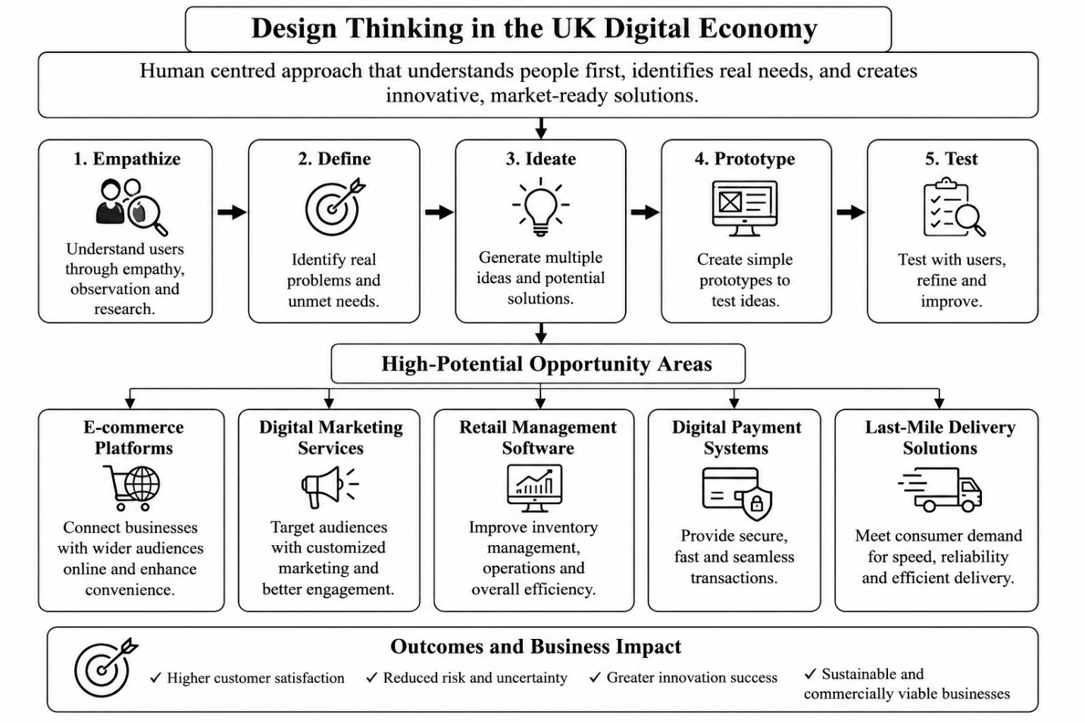
Source: (Liedtka, 2021)

Opportunity Area 1: E-commerce Platforms
One of the biggest opportunities in the UK's digital economy is the development of e-commerce platforms. In the last few years, many small and medium enterprises (SMEs) have established a very primitive online shopping store or got into the ‘trendy’ movement of selling their share of products through various social media post-COVID-19. However, the difference in financial resources and lack of technical knowledge and utilization of advanced tools is still an obstacle for many independent retailers attempting to compete with online retailers like Amazon. Businesses can understand the users' experience and create solutions that meet their needs by using DT (Chaffey 2019).
User Pain Points:
There are many problems in small businesses as far as introducing e-commerce technologies are concerned. These range from costly website development to a lack of digital skills, low visibility of your website, inventory management and integration with secure online payments. Another cause for customers to have inconsistent shopping experiences is that some websites are not designed properly, are not mobile friendly, that they take too long to display, and that payments are not secure. Such problems deteriorate customer satisfaction and have a negative impact on business growth.
Market Gaps:
While there are many different platforms available for creating websites, many of the sites may be geared towards larger organizations or too much information for many SMEs. There is therefore a strong market need for easy to use state-of-the-art, all in one' e-commerce platforms that would be accessible to and affordable for UK SMEs, especially small retailers and rural businesses, and could be easily expanded to meet the growing business demands of these areas (OECD, 2021).
Technological Enablers:
Some of the new technologies which enable this business opportunity include cloud computing, Artificial Intelligence (AI), Software-as-a-Service (SaaS), mobile applications and digital payment gateways and customer analytics (Brynjolfsson and McAfee, 2022). For instance, cloud analytics helps in reducing the infrastructure costs, automated customer support services with AI powered customer support recommendation systems and chatbots help in customer engagement and streamline the support process, and AI will ensure that customers get the most accurate information.
Scalability and Sustainability:
Cloud ecommerce is extremely scalable, allowing users and services to add more users and services without having to spend a lot on operation. Moreover, the subscription pricing model can have the added advantage for SMEs when accessing digital services, to generate recurring revenues. This business model has long-term sustainability and, in general, has long term value creation for their customers, constant innovation and cost efficiency.

Opportunity Area 2: Digital Marketing Services
With the always evolving digital landscape along with digital communication and new social media emerging on the scene, digital marketing companies that serve the small and medium business market (SMEs) have been offered up with great opportunities. Well, many small business owners know they need to have a powerful Internet marketing plan, but may lack the know-how, time and resources to create and maintain a successful campaign. Using Design Thinking allows for a better understanding of the unique needs and problems of SMEs and to develop marketing solutions to satisfy customer needs to boost their performance and competitiveness.
User Pain Points:
Some of the problems that business owners face as they do their online marketing. This encompasses producing fascinating and suitable content, handling more than one social media stack, tracking campaign success, comprehending users' actions, and transforming web interactions into sales. Lack of marketing knowledge and the fact that SME have limited budgets do not achieve consistent outcomes on their marketing efforts. This means that there are still businesses out there that rely on old-fashioned marketing techniques that may not be as effective with today's tech-savvy population to develop their business over a period.
Market Gaps:
While there are many digital marketing agencies around in the UK, many concentrate on big corporate organizations that have significant marketing budgets. This makes there a tremendous opportunity for low-cost, flexible and tailored digital marketing solutions for SMEs. Solutions should be accessible to small businesses with limited financial and technical resources, affordable, and provide measurable results, which are essential for the small business (Kotler, Kartajaya and Setiawan, 2021).
Technological Enablers:
As the new technologies that have emerged to the forefront become more present, this becomes increasingly possible. An AI chatbot could be employed for content creation automation, personalization of customer interactions, and the marketing automation system can manage repetitive tasks. Google Analytics may also give precious insights into user interactions on a web site, but Meta advertising and Search Engine Optimization (SEO) can help businesses segment customers more successfully and boost the chances of an advertiser that may convert at a more cost-effective rate.
Scalability and Sustainability:
Digital marketing services offer many scaling opportunities, with the ability to work remotely across the UK with various collaboration tools in the cloud. The idea of recurring revenue, for example, via subscription-based service contracts, aligns with the automation that AI can provide, relieving from manual processes, boosting efficiency and ensuring sustainability.
Opportunity Area 3: Retail Management Software
In this contemporary digital transformation of the retail sector in the UK, a growing need for the retailers to implement unified retail software which encompasses retail management, inventory management, customer relationship management (CRM) and online retail has surfaced. Many small and medium-sized business enterprises are seeking low cost and an Internet based system that will facilitate and improve their business. Through Design Thinking, the small retailers can gain a better understanding of their daily problems, and the software developers can develop easy-to-use software that meets the small retailers' requirements.
User Pain Points:
Many Small and Medium sized Enterprise (SME) are using various software or applications, that are distinct and can't communicate effectively. This can cause several issues such as duplicate data, incorrect inventory, late decision making, and a lack of customer service. Manual processes also incur cost, lose employee time and have a detrimental effect on business productivity. Business owners need integrated solutions that help them run their daily business, but with access to accurate real-time business information to help with strategic decision making.
Market Gaps:
There are several enterprise resource planning (ERP) systems available, however most are geared towards medium-sized or larger enterprises and tend to be too costly or technically complicated for SMEs. For this reason, there's an opportunity to introduce readily available and simple retail management software that requires a short implementation time, little employee training, and, naturally, an affordable price tag. This would help small businesses to handle the positive effects of digital transformation without the financial and technical burden (Ries, 2020).
Technological Enablers:
Several new technologies are used to support the integrated Retail Management systems, such as Cloud databanks, Artificial Intelligence (AI) forecasting, CRM software, Business Intelligence (BI) dashboards and Mobile applications. Cloud-based systems provide secure and flexible data storage and AI forecasting can improve demand forecasting and inventory planning. Personalized conversations with the CRM software enhance customer relationship management (CRM) efforts and business intelligence (BI) dashboards give real-time insights to support intelligent decision making in business management.
Scalability and Sustainability:
Retail management software offers outstanding scalability as digital products can be sold to other market segments in addition to involving the smallest amount of marginal cost. Cloud infrastructure means that software can be continually updated, technical support and feature enhancements can be done without disrupting the smoothness of the process. Another attribute that dictates the feasibility and competitiveness of its subscription enterprise business would be the fact that it has predictable recurring revenues and new customer retention.

Opportunity Area 4: Integrated Digital Payment Systems
Since the start of the Covid-19 pandemic, mobile and online payment has become more and more popular as an alternative to low and no touch payment. With e-commerce becoming mainstream, businesses need a payment service that can process online and offline payments and one that can process payments on the mobile platform – and do it securely. Through Design Thinking Solution Providers can gain deeper insight into their client's pain points to make a seamless-payment experience for their client and their business.
User Pain Points:
Multiple challenges are faced by many SMEs in dealing with digital payment systems. They involve high transaction fees, relying on several payment suppliers, complex recon and issues with payment safety as well as fraud. The same can also be said for customers when it comes to payment experiences, they expect these to be fast, secure, reliable and convenient through a variety of channels. Without effective and secure payment solutions, there will be a loss of customer confidence, and its effect will be reflected in sales and customer loyalty.
Market Gaps:
However, there are several different payment platforms available which support the UK market and there is a clear need for simple platforms which meet the requirements of SMEs. Businesses, especially those with small business needs, are looking for all-in-one solutions for a more streamlined payments experience, seamless integration with accounting software, ease of creating bills and financial reporting, and integration with customer rewards and loyalty programs. This type of integration can save administration time, optimize customer interactions and financial management (World Bank, 2022).
Technological Enablers:
There are different advanced technologies to create integrated digital payment systems. QR code payments are simple and effortless contactless payment solution and Open Banking is a safer alternative to share financial data across financial institutions (Trott, 2021). Artificial Intelligence (AI) fraud detection, digital wallets for hassle-free transactions, and blockchain for secure and transparent transactions. These are complementary technologies and when used together will speed and solidify transactions, minimize operation risk and enhance customer trust levels.
Scalability and Sustainability:
Digital payment systems have great “network effects” – the more businesses and consumers purchase through it, the more valuable the system is. Cloud-based infrastructure is more likely to enable quick growth at relatively low operating costs and the ongoing move towards cashless payments in the UK will help ensure the long-term viability of the business. As a result, the platform continues to continuously innovate and comply with laws, making it even a lot more competitive in the financial technology field.

Opportunity Area 5: Supply Chain and Last-Mile Delivery Solutions
As a result of this growth of ecommerce, more effective and efficient supply chain and last-mile delivery solutions are in demand. Despite the significant strides in the evolution of the courier industry, even today, the options available for courier services and the speed of deliveries are less in the rural areas as compared to urban areas. Logistics enterprises can understand the specific problem of the enterprise or consumers/customer expectations with DT, and design logistics system and solutions that can help improve logistics access, efficiency and customer satisfaction.
User Pain Points:
When the delivery service is concerned, there are various problems both business and consumers are facing with delivery: Delivery delay, transportation cost, lack of parcel tracking, no delivery options in rural areas are some. Local producers/farmers and independent retailers have troubles with access to logistics services as well, that are not only cost-efficient but can also reach larger markets amongst their customers. These restrictions lead to loss of customer satisfaction, increases running costs and reduce customer growth opportunities.
Market Gaps:
Although there have been huge investments made in logistics infrastructures, there still is a lack of integrated delivery platforms developed for SMEs, local producers and independent retailers. By building a platform, regional companies could be linked with local delivery companies which would help to facilitate development, logistics and lower transportation costs. These are key points in the UK digital economy where innovation is needed and are solutions that are customer centered.
Technological Enablers:
Several technological innovations are helping to further develop advanced Delivery Solutions. Besides real time shipping tracking, GPS tracking can also be used to assist with route optimization software that can pinpoint the area best suited for deliveries and reduce travel time and fuel. AI bidding and planning for delivery as well as IoT sensors that track package state in-transit. In addition, mobile delivery apps make communication between businesses and delivery drivers easier and between customers and service providers – and therefore service quality (Tidd and Bessant, 2020).
Scalability and Sustainability:
Geographic expansion can be achieved by finding other logistics providers to partner with and providing services to other customer markets in the supply chain and last mile delivery platform. This can be further improved by electrification of delivery vehicles, less carbon footprint local distribution networks and with the help of route optimization. These sustainable and scalable business models help to ensure long term competitiveness and meet consumers' expanding needs for a cost-effective and dependable service that is also sustainable.

Task 2: Applying the Five Stages of Design Thinking to Develop a New Venture Concept
The fact that this economic transition is a digital transition for the UK is certainly a chance for SMEs to take part, but also a challenge to deal with this complexity. There are several companies that have different systems for e-commerce, stocks, payments, customer management, delivery etc., which ultimately impacts their competitiveness, efficiency and costs (OECD, 2021). By basing itself on the Design Thinking framework, the ‘Smart Local Connect’ is a cloud-based solution that enables the integration of all ecommerce, stock management, CRM, online payment and delivery coordination system in one service, by paying a low cost. The Business Model built on Design Thinking approach to solve the problem of actual customer needs, and to create sustainable value in the business (Brown, 2019).

empathize:
In the "empathize" part of DT, people are observed and asked questions to gain insights to their needs or problems and feedback from the people (Brown, 2019). For this project, three types of users were identified. The first reason is that small independent retailers are less ‘digital', use expensive software, do not have integrated business systems and may have time-consuming manual administrative processes that affect their operational efficiency and competitiveness (Chaffey, 2019). Secondly, the villagers have longer delivery time, limited or no availability of items in local markets and inadequate internet shopping services, thus affecting the speediness of obtaining some of the commodities required in rural areas (The World bank, 2022). Finally, delivery partners must deal with less-than-optimal route optimization, manual order allocation and no integration with local shops resulting in delays and increased costs of operation. These user experiences give insights into the design of practical and user-oriented solutions in order to satisfy the needs of all involved.
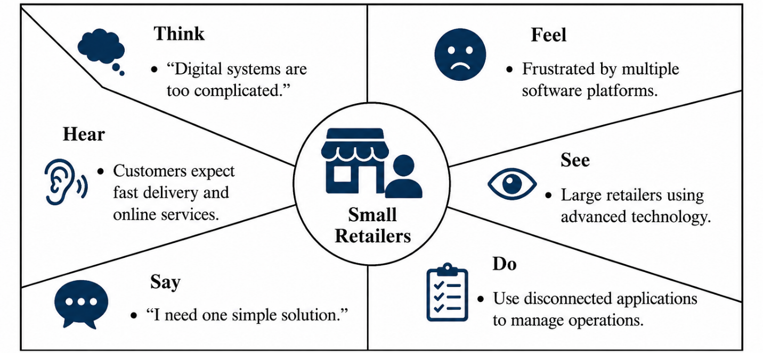
Figure: Empathy Map for Small Retailers

Define:
This learning then gets codified as the statement of problem that will then inform the building of the design (Dam and Siang, 2023). The primary problem discovered is that in UK, a lot of SMEs utilize different and various online selling, stock, customer communication, payment and shipping systems. They exist as separate platforms, can be expensive, difficult to integrate and require additional manual effort, and all these delays and are costly to the business. Consequently, SMEs are facing challenges in competing with the bigger retailers using more sophisticated digital technologies and there is a need for a low priced, integrated and user-friendly digital solution.
Root Causes:
Financial constraints
Limited digital skills
Disconnected business systems
Rising customer expectations (Brynjolfsson and McAfee, 2022)
How Might We (HMW) Questions:
Which was pointed out as the problem in the way of making Digital Management easier for SMEs?
What do you do with cuts to investments in technology?
What are possible ways to connect retailers with local delivery companies?

Ideate:
The Ideate stage is a generation, evaluation and selection of innovative solutions, effective in addressing user needs and business challenges (Brown, 2019). A few concepts were considered such as website builders, digital marketing agency and building a local delivery platform. With the aim of creating, however, is a built-in digital platform specifically for the UK SME – Smart Local Connect. All the basic business tools you need under one roof: online store builder, inventory management, customer relationship management (CRM), online payment integration, local shipping management, AI-powered sales analytics and mobile app. They will be more economical and efficient, cost less to operate and be more competitive with this integrated approach.
Value Proposition:
"Helping UK SMEs grow digitally through one affordable platform that combines e-commerce, payments, inventory management and local delivery."
Business Model Canvas:
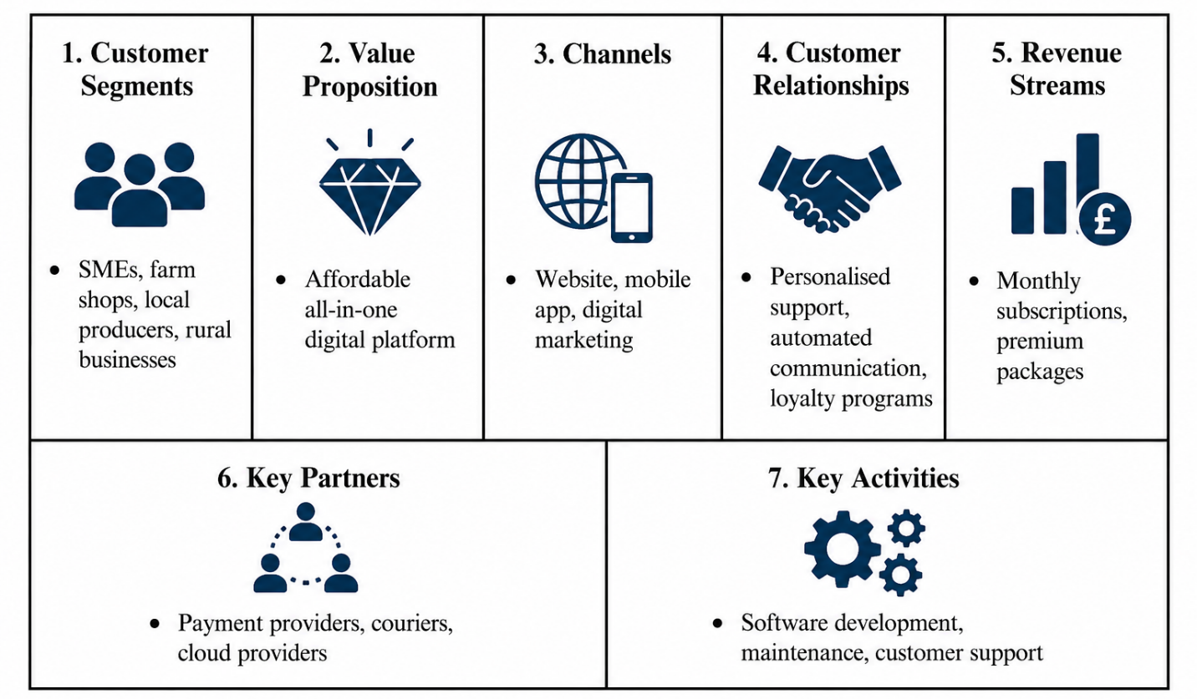
Figure: Business Model Canvas

The smart local connectivity proposed venture - Smart Local Connect - will aim to be a commercially viable end-to-end digital solution that will be scalable to meet the needs of UK SMEs. A single cloud platform consisting of ecommerce, inventory management, customer relationship management (CRM) and digital payments and local delivery can make it less difficult to run a business and decrease cost and boost productivity (Westerman, Bonnet and McAfee, 2014). The Design Thinking methodology will be used to further enhance the platform encouraging user-centered innovation and addressing the real needs of the users. It is an “subscription model” and provides cloud and AI-powered capabilities which are advantageous for long-term sustainability and growth. This translates to the increased competitiveness of the SMEs and more Digital transformation in the UK economy, according to Osterwalder and Pigneur (2010).
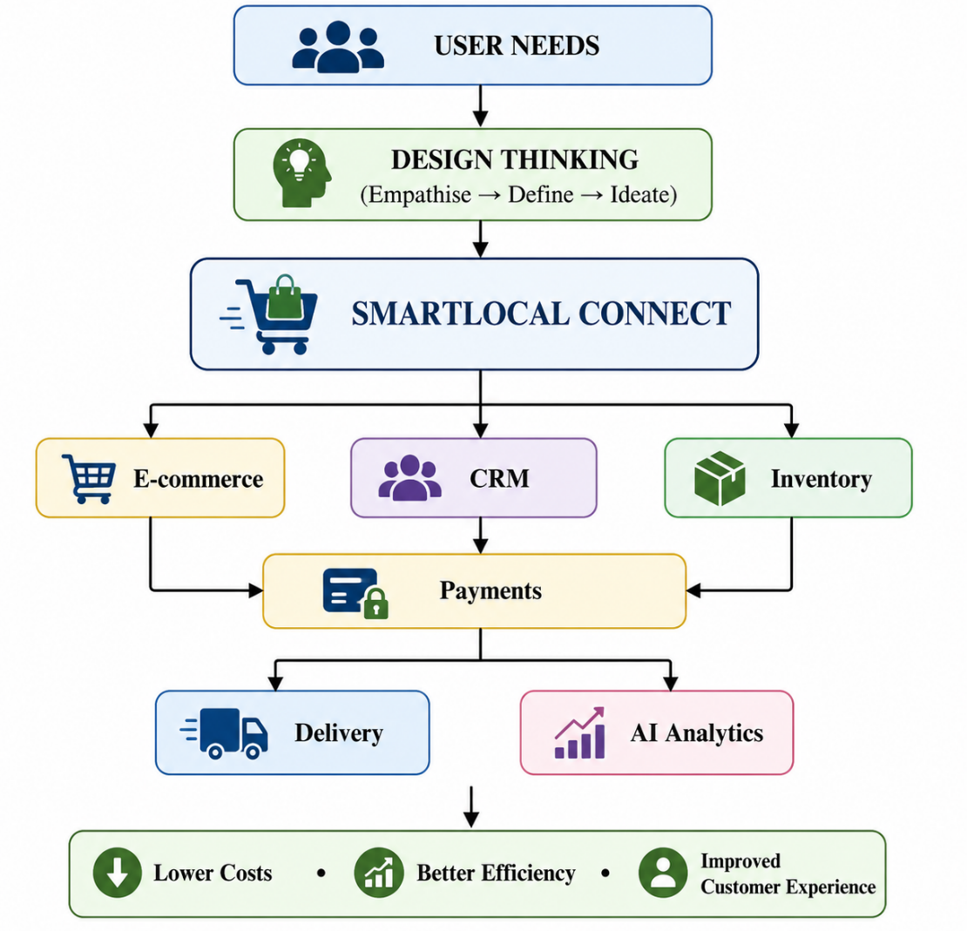
Figure: SmartLocal Connect Concept Diagram

Prototype (Minimum Viable Product - MVP):
The Prototype stage is the fourth stage of Dt, at this stage an idea is developed into a prototype which is tested and developed further with the users (Brown, 2019). In the case of the proposed venture, Smart Local Connect, only the most essential features would be included, and this would be the Minimum Viable Product (MVP) that would solve core problems that the UK SME faces. They would include on-line store builder, inventory management system, built-in eCommerce payment processing system, customer database and neighborhood delivery planning service. The platform would also have a user-friendly dashboard for the business owners to keep a real-time track of their orders, inventory levels and sales. This is beneficial as the company can save their investment in creating the features and gain valuable feedback from users before they invest in the features (Ries, 2020).

Testing and Refinement:
Test is the 5th stage of DT which presents the prototype to real users and further iterations are made based on the feedback from the testers (Dam and Siang, 2023). Smart Local Connect will be trial listed with a small number of independent shops in farm shops or local food producers within rural areas throughout the UK. Customer Interviews, Online Surveys, Usability Testing and System Performance reports were used to collect data. How long orders take to process, user feedback to resolve technical issues, increase user experience, add additional capabilities such as automation marketing tools, add a customer loyalty application, sales growth etc. would be some of the key performance indicators. Continuous improvements help keep the focus on the platform remaining customer-centric, and responsive to market needs (Liedtka, 2021).

Lean Startup and Double Diamond Frameworks:
The proposed enterprise is also implementing the Lean Startup cycle; under which entrepreneurs go through Build–Measure–Learn cycle (Ries, 2020). The Minimum Viable Product (MVP) has been designed with users’ feedback in mind and tested and tweaked accordingly and continuously developed. This will reduce the financial risks and increase the likelihood of success in the market. The Double Diamond Framework also helps to facilitate innovation, as demonstrated in the four different stages of Discover, Define, Develop and Deliver (Design Council, 2021). When the user discovers the stage, he/she realizes a need for the stage. Explain the word Stage: When a problem comes to a point then it is the most important problem. Use "Develop"-creation, development of new ideas and "Deliver"- get the solution to market. Design Thinking process is a defined process that is user-centered and combines aspects of the Lean Startup and Double Diamond Framework to provide innovation.
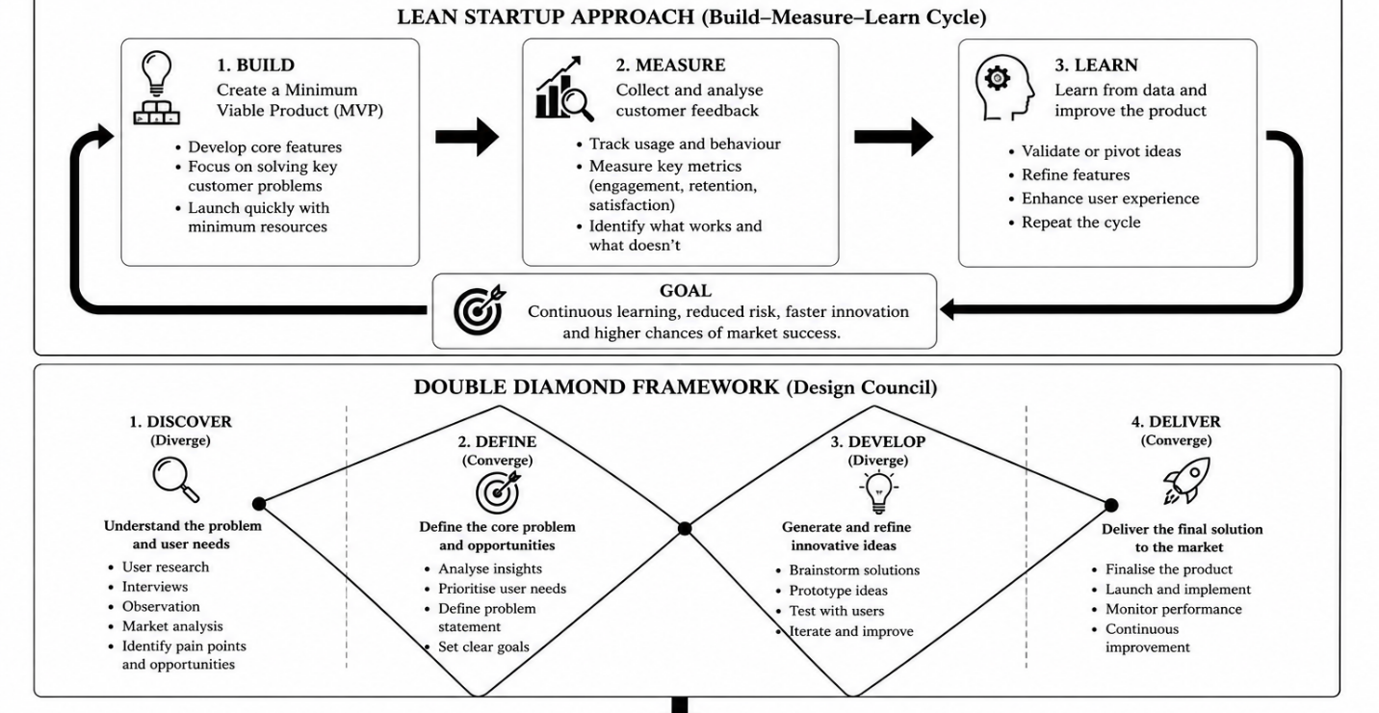
Source: (Ries, 2020)

Evaluation, Critical Reflection and Conclusion:
Smart Local Connect is a Software-as-a-Service (SaaS), a very scalable solution, does not need any additional infrastructures in the UK. The benefits of the subscription business model are Business Model with Recurring Revenue; Cloud Technology – easy to add additional users (Tidd and Bessant, 2020). Other sustainability targets for this business include fostering local purchasing as well as removing unneeded travel due to co-ordination of deliveries and for SMEs to be part of the digital economy. However, there are still several issues that need to be addressed for the venture to come to fruition. The limited digital skills or cost (impracticability) to use newer tech could be the reason for SMEs not adopting newer tech. Market penetration also may be impacted by competition with other software rivals, like Shopify and Square. Therefore, customer support, training and affordable pricing are required, to ensure the goals of long-term success (Kotler et al., 2021). Finally, the DT process is a process of innovating which does not necessarily begin with technology development, but with knowing the needs of customers. Smart Local Connect takes a realistic and pragmatic approach towards the digital issues faced by the UK SMEs, through design thinking (DT) and Lean Startup/Double Diamond methods. The proposed project may enhance effectiveness in companies, enhance customers' experiences and help with the UK's digital transformation.

References:
- Brown, T. (2019) Change by design: How design thinking transforms organizations and inspires innovation. Rev. and updated edn. New York: Harper Business.
- Brynjolfsson, E. and McAfee, A. (2022) The second machine age: Work, progress, and prosperity in a time of brilliant technologies. New York: W.W. Norton & Company.
- Chaffey, D., Hemphill, T. and Edmundson-Bird, D. (2019) Digital business and e-commerce management: Strategy, implementation and practice. 7th edn. Harlow: Pearson.
- Dam, R. and Siang, T. (2023) What is Design Thinking? Interaction Design Foundation. Available at: https://www.interaction-design.org/literature/topics/design-thinking (Accessed: 17 July 2026).
- Department for Business and Trade (2023) Business population estimates for the UK and regions 2023: Statistical release. London: Department for Business and Trade. Available at: https://www.gov.uk/government/statistics/business-population-estimates-2023 (Accessed: 17 July 2026).
- Design Council (2021) Framework for innovation: Design Council’s evolved Double Diamond. Available at: https://www.designcouncil.org.uk/our-resources/the-double-diamond/ (Accessed: 17 July 2026).
- Interaction Design Foundation (2025) The five stages in the design thinking process. Available at: https://www.interaction-design.org/literature/article/5-stages-in-the-design-thinking-process (Accessed: 17 July 2026).
- Kotler, P., Kartajaya, H. and Setiawan, I. (2021) Marketing 5.0: Technology for humanity. Hoboken, NJ: John Wiley & Sons.
- Liedtka, J. (2021) ‘Putting technology in its place: Design thinking’s social technology at work’, California Management Review, 63(2), pp. 53–83.
- OECD (2021) The digital transformation of SMEs. Paris: OECD Publishing. Available at: https://doi.org/10.1787/bdb9256a-en
- Osterwalder, A. and Pigneur, Y. (2010) Business model generation: A handbook for visionaries, game changers, and challengers. Hoboken, NJ: John Wiley & Sons.
- Ries, E. (2011) The lean startup: How today's entrepreneurs use continuous innovation to create radically successful businesses. New York: Crown Business.
- Tidd, J. and Bessant, J.R. (2020) Managing innovation: Integrating technological, market and organizational change. 7th edn. Hoboken, NJ: John Wiley & Sons.
- Trott, P. (2021) Innovation Management and New Product Development. 7th edn. Harlow: Pearson.
- Westerman, G., Bonnet, D. and McAfee, A. (2014) Leading Digital: Turning Technology into Business Transformation. Boston, MA: Harvard Business Review Press.
- World Bank (2022) The Global Findex Database 2021: Financial inclusion, digital payments, and resilience in the age of COVID-19. Washington, DC: World Bank.

