Assignment 1
Google Headquarters Project in London, UK

Module Name: Project Management

Module code: LCBB5005

Student: Marius Scorcea (1921886)
Lecturer: Prof. Dr. Faizu Edu
Contents
Module Name: Project Management 1
1. Introduction 4
What is Project Management? 4
2. Google Headquarters Project Management Stages 6
2.1 Phase 1: Project Conception and Initiation 8
What are the deliverables of Google Headquarter project? 8
GOOGLE SWOT Assessment 9
2.2 Phase 2: Project Planning 9
What is the scope of Google Headquarter project? 10
Budget allocation 10
Time allocation 11
Resources allocation 11
Communication management plan 11
Stakeholders and Risk Analysis 12
Risk Assessment 13
Quality Assesment 13
A sustainable and flexible workplace 14
2.3 Phase 3: Project Execution 14
2.4 Phase 4: Project Monitoring and Control 14
2.5 Phase 5: Project Closure 15
3. Conclusion 16
4. References 16

Introduction
The purpose of this essay is to analyze and evaluate Google Headquarters UK project from a project manager perspective. Characteristics such as budget, time, quality stakeholders and risk factors are of utmost importance for any project, big or not so big, as those factors can determine the success or the failure of the project.
That is why Project Management is becoming a complex science in which terms like stages, phases, milestones, business case, Gantt Chart and project methodologies are becoming the very essence of the whole project transforming the individuals into successful project managers if they get to own this knowledge.

What is Project Management?
According to Kashyap (2019), Project management is the process of preparing and allocating resources for a specific project, event, or function. It involves using multiple methods, tools, skills, and strategies to fulfill project requirements. Projects consist of scope, deliverables, time, and capital, and the goal is to deliver work within the time frame, scope, and budget.
PMI (Project Management Institute) argues that project management is using skills, knowledge, tools, and methods to deliver value to people. It involves organizing a team, planning, monitoring, communication, and documentation to complete tasks within a set timeframe, scope, and budget. (Harned, 2023)
There is no argue that Google Headquarters UK it is a project that is developed on a huge scale and its approach worth analyzing from a Project Management point of view.

The development of a massive rooftop garden for Google's planned 1 million square foot headquarters, which will encompass 650,000 square feet in central London. It will be the first skyscraper outside of the US that Google designed and owns solely. (Gillespie, n.d)
According to recent plans, Google's £1 billion "groundscraper" headquarters in Kings Cross will feature 250m2 of retail space in addition to a community event area. Designed by British architect Thomas Heatherwick in partnership with Danish architects BIG, the world's largest one million square foot skyscraper is scheduled for completing later this year and is expected to be populated by 2024. (Prynn, 2022)
The methodology adopted for this project Traditional Approach . Traditional project management, commonly referred to as the Waterfall methodology, is a process-oriented method of managing projects that involves examining and setting up a project from start to finish. Processes assist you in anticipating and managing risks during the requirements stage. You can step back and let your teams concentrate on finishing the task at hand by completing the majority of the planning ahead of time. Conventional project management refers to a broad methodology or set of principles for managing your project rather than a specific framework. (Tawfik, 2022)

Google Headquarters Project Management Stages
The five stages in the project management process that specify the project deliverables to ensure it can be labeled a successful project once it is finished are known as the "5 Phases of Project Management," "Project Life Cycle," or "5 Phases of Project Management." (London Corporate Training, 2023)
These five phases are:
- Initiation
- Planning
- Execution
- Monitoring & Controlling
- Closure
The success of the Project Management is ensured by the so called PMBOK – Project Management Body of Knowledge, a book by the Project Management Institute (PMI) which gathers together the main concepts of project management.
In other words, if the PM stages are horizontal the knowledge area is vertical and it is a collection of essential topics that project managers need to know in order to successfully schedule, plan, coordinate, oversee, and complete projects with the cooperation of project teams and stakeholders. (Landau, 2023).
There are 10 Knowledge areas which will offer the most important information and skillsets that needs to be considered for a project to run smoothly, to satisfy the stakeholders and maintain a steady position. (Adobe Communication Team, 2022)
1. Project integration management
2. Project scope management
3. Project time management
4. Project cost management
5. Project quality management
6. Project resource management
7. Project communications management
8. Project risk management
9. Project procurement management
10. Project stakeholder management
Analyzing Google Headquarters Project we can discover, one by one, these 5 phases in order to identify strong points which can become references for future projects.

2.1 Phase 1: Project Conception and Initiation
In this stage you develop an executive summary of your project during the project initiation stage to show its commercial value. You enter the project planning stage after gaining the support of key stakeholders and confirming that your project is feasible. In this section, you define your project's specific goals, deliverables, and project plan in more depth. (MacNeil, 2022). This is the stage that requires a thorough research and at this moment analysis like SWOT, STEEPLE and Feasibility study are conducted in order to determine the future plan of action.

What are the deliverables of Google Headquarter project?

The structure will have a natural theme, and Google's healthy materials program will provide all of the materials. The complex, which has a third building on the site, will be constructed alongside the current building at 6 Pancras Square and was designed by Heatherwick Studio. Created from the ground up, the new Google office building will house up to 7,000 Google employees. It will support the expansion of the knowledge-based economy in the region as well as the development of the Knowledge Quarter.

GOOGLE SWOT Assessment
The fact that Google has the support of Camden local community, the innovation that they are bringing, the opportunities they are creating for people to work and small businesses to develop by the help of their brand is giving a Green Light to the project. Nevertheless they still need to improve their attitude towards the employees and adapt a bit more to the UK style and peoples personality.
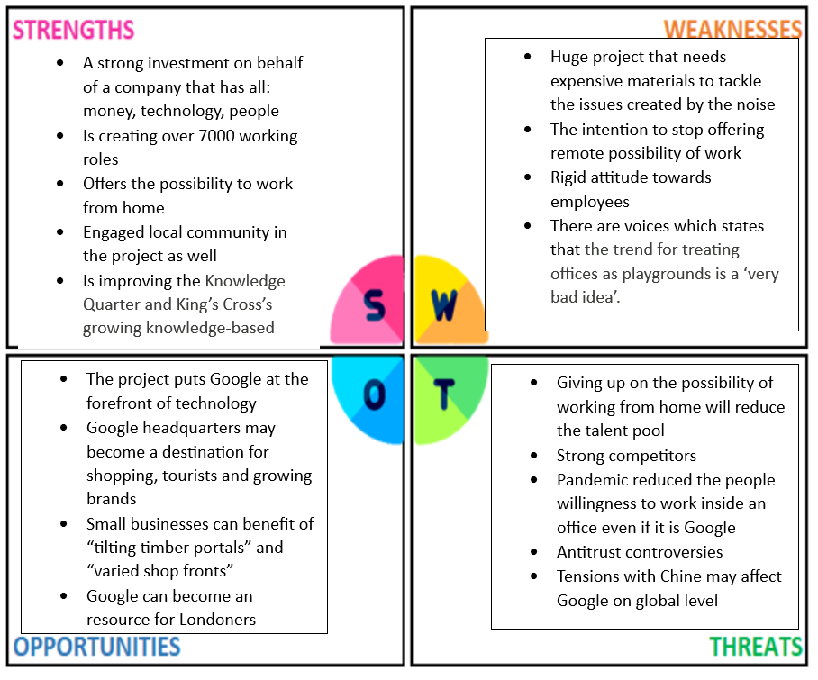

2.2 Phase 2: Project Planning
At this phase, the main tasks are to determine the technical requirements, drafting a thorough project plan, come up with a communication plan, and setting goals and outputs . The objectives have to be SMART and CLEAR which allows managers to reduce risks and achieve their goals. (Kissflow, 2023)

What is the scope of Google Headquarter project?
In an interview with the BBC, Google’s CEO Sundar Pichai said the company sees “massive opportunities” in the UK, despite the country’s decision to leave the EU in June. This has led many big companies to consider relocating their European HQs from London to continental Europe.
The new headquarters will be based on the Google King’s Cross campus, which consists of three buildings, two of which are leased. The entire campus will accommodate 7,000 employees, including the recently built 650,000 sq ft headquarters. Google currently employs 4,000 people in the UK. (O’Reilly, n.d.)
Google plans to support new ideas and provide shop units to brands. They will also have a community, education, and event space, a market hall, and a roof garden. They are working with Camden borough and London Wildlife Trust to conserve native species.. (Parsons, 2022)

Budget allocation
The modern office building in London was purchased by Google for $1 billion as the company was waiting for the construction of its much-anticipated UK headquarters to be completed. The massive search engine company announced that it had bought the entire building at Central St. Giles in London's West End, where they already occupy multiple floors.
The budget is generous and is meeting the expectations of such an ambitious project. (Shead, 2022)

Time allocation
The project started in 2018 and it is expected to be completed by 2024. Considering the complexity of the design, the multiple facilities that will bring into the area the project will have to use numerous resources and the innovative side of whole campus is requiring a high standard of quality.

Resources allocation
The innovative architectural proposals brought with them a number of key challenges and opportunities for environmental comfort in the building. While the triple height spaces allow deep daylight to reach the main office accommodation floors, they have also brought with them a significant amount of work in terms of thermal gain and loss as well as sun and glare control. Given the climate and location of the building, the decision to provide full fresh air ventilation and to regulate the temperature for the workplace through displacement ventilation is a good practice.
That is why Google is working with top architecture and design companies like Bjarke Ingels Group and Heatherwick Studio.

Communication management plan
Google is really investing in the communication management plan and his focus is not only on the Internal Communication Strategy but also on the External Communication Strategy.
Information sharing amongst individuals within an organization is the main focus of internal communication. Google's understanding-building philosophy encourages engagement and collaboration between management and employees, leading to its recognition as one of the Best Places to Work.
As for external communication, Google prioritizes and identifies stakeholders, and then uses appropriate CSR policies to address those interests in accordance with international standards and expectations. Meeting the needs of all stakeholders is crucial because it establishes an organization's reputation and determines its commercial value. As an illustration, Google gives its employees, who are the primary stakeholders, exceptional care. Google offers competitive pay, steady job growth over the long term, a range of benefits, rewards and compensation, rewards and a perfect work environment, safety precautions, health insurance, etc. Google looks out for the interests of its investors. Investors receive recompense when required, shared price growth, and assurances that the company's profit will continue to rise.

Stakeholders and Risk Analysis
Common interests serve as the organizing principle for Google's stakeholder groups. The social responsibility initiatives of the company are customized for these stakeholder groups. The majority of them are related with Google's online advertising and consumer electronics businesses. Google considers the following stakeholder groups:
- The primary stakeholders are the employees. Google’s creative and innovative mindset is rooted in its talented workforce. Google recognizes its employees as its main stakeholders and demonstrates ongoing efforts to enhance employee satisfaction and well-being.
- The essential stakeholders are the users of google platform as they are influencing the popularity of the company.
- Customers and advertisers
- Investors
- Communities
- Government

Risk Assessment
The potential risks associated to the project can be technical, financial, environmental, legal and organizational.
Google headquarter is a huge and ambitious project, the surface its developed is enormous and the stakeholders involved are numerous as well.
There might be construction delays due to unexpected site conditions, budget overruns, changes in the Camden zone regulations, environmental impact concerns such as strong noise due to the construction works, supply chain disruption considering it is a busy area and lot of incidents may happen and the last but not the least regulatory approval delays.
Another risk that should Google should not neglect is the people desire after Pandemic to ;work again in a close office, no matter the high class facilities Google is providing,

Quality Assesment
Project management teams use quality management plans (QMPs) to establish quality assurance, control, and planning procedures to guarantee that standards of quality are upheld throughout the course of a project.
Lyons & Annoot, the contractors building Google's UK headquarters, selected Lignacite as their concrete block partner. Superior building materials are needed for Google's UK headquarters in order to fulfill the architectural vision. The new headquarters will take 'multi-use' to the next level, with cafés, an indoor games area with a basketball court, a 25m pool, a gym and a rooftop garden with a running track.
Google's dedication to using sustainable materials and clean air is reflected in the building's design, which highlights the company's focus on worker health and safety.

A sustainable and flexible workplace
Google introduces new office technologies and collaborative spaces for hybrid work, with a focus on sustainability and carbon-neutral future. Electric kitchen and onsite facilities, 13,500 connected devices, solar shading, and low-carbon materials will reduce carbon footprint by 20%.

2.3 Phase 3: Project Execution

The primary goals of this stage are to finish the work (get the job done) and achieve the project’s goals. As a project manager, the project manager will be responsible for tasks such as planning, budgeting and risk management.
Google Project so far is on the right track. Working for this with renown companies such as AJ100 big-hitter BDP as executive architect, engineers AKT2 and landscape specialists from Gillespies they ensure the project execution is following the high standards and the time frame. (Waite, 2022)

2.4 Phase 4: Project Monitoring and Control

The section of the project management process that is responsible for keeping an eye on project performance and making sure that the project plan is followed is called project monitoring and control, or PMCC. Project managers participate in PMCC by keeping a close eye on the project's performance and progression, evaluating its present condition, spotting potential issues, and taking necessary steps if required to make sure that it is finished on schedule and within budget.
Bjarke Ingels, Founding Partner at Bjarke Ingels said that Google's new location in King's Cross is designed with local character in mind, utilizing a contextually outlined building envelope and cascading workspaces. The ground floor has market halls, auditoriums, and retail spaces, while the roof has terraced gardens.
Rory Keating, Chair of the Knowledge Quarter considers that Google's new headquarters building in London's Knowledge Quarter will bring thousands of employees together with scientists, historians, academics, and students, solidifying its position as a top innovation hub.
The stakeholders involved in the process are determined to deliver a unique job, a project that is highly appreciated and all the aspects are verified as this campus will create a plus value for all the parts involved in this project.

2.5 Phase 5: Project Closure
The last stage of a project is called the project closure phase. It's when you close any loose ends, report your findings to your group, and offer a well-defined plan of action for what comes next. Your project comes to an end during the project closure phase, which also provides you with a detailed plan for what comes next. This might consist of: giving a new team ownership of the project Launch a fresh undertaking Boost the quality of your work. Incorporate the knowledge gained into upcoming endeavors.
As the Google Headquarter project is still ongoing we cannot talk about a project closure.
Nevertheless considering the size of the project, the impact over environment, the sustainability strategies adopted Google Headquarter Uk King Kross will become a reference model for future projects as huge as this one.

Conclusion
Google Headquarter UK is a project that is characterized by innovation, Corporate Responsibility, Sustainability and Community engagement.
All the elements involved in the process are of utmost quality, starting with stakeholders and ending with the design of the project and materials that were used along the process.
Nevertheless, without a sound Project Management in which the Business Case is generated accordingly, the Project Charter is with no falls from the beginning, the budget and the risks are correctly evaluated and all the stakeholders are willing to invest money, time in effort for the success of the project, all this factors if they are missed the project is doomed to fail.

References
Eightify, (2023), Google's $1B UK HQ: A Game-Changer in Tech, Available at: https://eightify.app/summary/technology-and-business/google-s-1b-uk-hq-a-game-changer-in-tech, (Accessed: 22 November 2023)
Gillespies, (n.d), Google Headquarters King’s Cross, London, UK, Available at:
https://www.gillespies.co.uk/projects/google-headquarters, (Accessed: 21 November 2023)
Harned, B. (2023), What Is Project Management? Definitions & Terms, Available at: https://www.teamgantt.com/project-management-guide/what-is-project-management, (Accessed: 22 November 2023)
Highlights, (2022), Google HQ: Bearing the weight of a grand vision, Available at:
https://constructionmaguk.co.uk/google-hq-bearing-the-weight-of-a-grand-vision/, (Accessed: 22 November 2023)
Insider, (2022), Google New London Hq, Available at: https://www.insiderlondon.com/blog/google-new-london-hq/, (Accessed: 23 November 2023)
Internal and External Communication Google’s Strategies. [online]. Available at: https://edubirdie.com/examples/internal-and-external-communication-googles-strategies/, (Accessed: 23 November 2023)
Kashyap, S. (2019), What is Project Management – Definition, Best Practices, Benefits and Features, Available at: https://www.proofhub.com/articles/what-is-project-management, (Accessed: 21 November 2023)
King Kros, (n.d), GOOGLE, The first, wholly owned and designed Google building outside the US, Available at: https://www.kingscross.co.uk/google, (Accessed: 23 November 2023)
Adobe Communication Team, (2022), 10 Project Management Areas What you need to Know, Available at: https://Business.adobe.com/blog/basics/knowledge-areas, (Accessed: 23 November 2023)
KissFlow, (2023), 5 Phases of Project Management – A Complete Breakdown, Available at:
https://kissflow.com/project/five-phases-of-project-management/, (Accessed: 23 November 2023)
Landau, P. (2023), The 10 project Management Knowledge Areas (PMBOK), Available at: https://www.projectmanager.com/blog/10-project-management-knowledge-areas, (Accessed: 23 November 2023)
LCT, (2023), 5 Stages of Project Management: The Corporate Guide, Available at: https://www.lct.co.uk/5-stages-of-project-management/, (Accessed: 23 November 2023)
MacNeil, C. (2022), Project initiation: The first step to successful project management, Available at: https://asana.com/resources/project-initiation, (Accessed: 23 November 2023)
O’Reilly, L. (n.d.), Google Will Open a New U.K. Headquarters With 3,000 Employees, Available at: https://www.inc.com/business-insider/google-uk-london-headquarters.html, (Accessed: 23 November 2023)
Parsons, J. (2023), Google is opening a new HQ in London that will span 11 floors and 1,000,000 sq ft, Available at: https://metro.co.uk/2022/04/19/googles-massive-kings-cross-hq-will-span-11-floors-and-1000000-sq-ft-16494552/, (Accessed: 23 November 2023)
Prynn, J. (2022), New pictures of £1bn Google HQ bringing retail parade, community space and rooftop running trail to King’s Cross, Available at: https://www.standard.co.uk/homesandproperty/property-news/google-hq-new-office-kings-cross-london-plans-b994436.html, (Accessed: 21 November 2023)
Shead, S. (2022), Google expands London property empire with $1 billion office purchase, Available at: https://www.cnbc.com/2022/01/14/google-expands-london-property-empire-with-1-billion-office-purchase.html, (Accessed: 23 November 2023)
Sienkiewicz, A. (2022), 7 Steps to ace your Project Execution phase, Available at: https://bigpicture.one/blog/plan-execute-project-bigpicture/, (Accessed: 22 November 2023)
SpeedyPaper. (2019). Google Stakeholder Analysis: All You Need to Know in This Free Essay. [Online]. Available at: https://speedypaper.com/essays/stakeholder-analysis-for-google, (Accessed: 23 November 2023)
Tawfik, D. (2022), Traditional project management vs. Agile: how to choose, Available at:
https://monday.com/blog/project-management/traditional-project-management/, (Accessed: 22 November 2023)
Tristancho, C. (2023), Project Monitoring and Control: Tools & Steps, Available at: https://www.projectmanager.com/blog/project-monitoring-and-control, (Accessed: 22 November 2023)
Waite, R. (2017), Council gives go-ahead for Heatherwick and BIG’s £600m Google HQ at King’s Cross, Available at: https://www.architectsjournal.co.uk/news/council-gives-go-ahead-for-heatherwick-and-bigs-600m-google-hq-at-kings-cross, (Accessed: 22 November 2023)

