Natalie Davies

Digital Technology

Contents Page

Introduction- 1

Literature Review- 2

Selection and Justification of Tool- 7

Application of Chosen Learning Tool- 11

Evaluation and Reflection- 15

Reference List- 19

Appendix 1- lesson Plan-

Introduction

Within this assignment a literature review to look at the use of digital technology within the post 16 setting and whether there is a positive impact on learners will be conducted. The results will then assist the author to look at different ways in which implementing digital technology within their own teaching practice may benefit the learners.

The second stage of this assignment will focus on the selection and justification of using a particular digital tool of choice to enhance teaching practice and learner engagement. When looking at different frameworks for embedding digital technology into teaching, the author will decide what model is best suited to help establish and justify the use of a chosen tool. The different frameworks used for embedding technology into education include, SAMR, TPACK, RAT and TIM (Puentedura, 2012).

Following this, the assignment will document how the author came to the decision to use the chosen tool and how it would be implemented into the lesson. Here there are screenshots of the app in use within the classroom and snapshots of evaluation forms that were completed by students following the lesson.

The above experience of using the digital technology within the post 16 classroom and the completed feedback forms will inform the evaluation of the whole process and purpose of this assignment. Here a reflective account using Driscolls reflective cycle (1994) will establish if using the tool within the classroom was effective and if so, to what extent. An action plan and recommendations for future practice aligned to the Professional Standards of Wales (WAG, 2023) will be formulated at the end.

Literature Review

Historical Perspective of Digital Innovation in Education
Much literature suggests that the incorporation of digital tools in education can be traced back to the introduction of computers in the classroom during the late 20th century (Howard and Mozeiko, 2015; Haleem at al., 2022; Timotheou et al., 2023). According to Passey (2016), a researcher previously involved in initial studies centred on the use of technology in education in the 1980’s, initially, when the first computers were wheeled into the classroom in 1975, were utilised in isolated occurrences. Passey (2016) documents that in the mid-1980s concern grew in the United Kingdom (UK) about the need to align education with the evolving industry, and joint initiatives over the following decade by the Department of Trade and Industry, the Department of Employment, and the Department of Education and Science, set in motion the development of technologies within educational institutions. Lee (2016) maintains, however, that it was not until the mid-1990s that the realities of technologies within the classroom were re-focussed as neither learning experiences nor pedagogies had been significant drivers in their initial implementation. By the 1990s, the Internet began to revolutionise education, offering, informs Harasim (2000), new avenues for information access and communication. The early 2000s saw the rise of e-learning platforms, which Means et al. (2010) document allowed for more interactive and flexible learning experiences to develop.

In Wales, the integration of digital technology in education has mirrored global trends, with significant investments in Information and Computer Technology (ICT) infrastructure and resources. The Welsh Government (2012) supported initiatives such as the Hwb, a digital learning platform launched in 2012, which provides access to a wide range of digital tools and resources for teachers and students. In 2020 Ofcom Published the Connected Nations 2020: Wales Report, in which they documented that 89% of schools in Wales had access to reliable high-speed internet, reflecting the widespread adoption of digital technologies.

In recent years, the increased use of mobile devices and advancements in artificial intelligence (AI) have further expanded the possibilities for digital innovation in education; technologies such as virtual reality (VR) and augmented reality (AR) are documented with frequency in recent literature as having introduced immersive learning environments (Al-Ansi et al., 2023; Yang, 2023; Hamad and Jia, 2022), while AI-driven tools, according to Selwyn (2017) offer personalised learning experiences. Norris et al. (2022) explain that the emergence of ‘Massive Online Open Courses’ has made high-quality learning materials accessible to a global audience. These developments highlight the evolving nature of digital innovation and its increasing impact on educational practices in Wales and beyond.

Integration of Technology and Pedagogy
The integration of technology and pedagogy is crucial, advise Makarova and Makarova (2018), for maximising the benefits of digital innovation in education. According to Ballale (2024) effective pedagogical strategies that incorporate digital tools can enhance student engagement, facilitate deeper learning, and promote creativity, adding that interactive whiteboards and AI applications are being more commonly integrated into educational institutions; Vallo Hult et al. (2023) however argue that affordability, time and access constraints exist for these establishments and this can be restrictive in what can be therefore offered to students. The Technological Pedagogical Content Knowledge (TPACK) framework promoted by Mishra and Koehler (2006) emphasises the importance of balancing technological knowledge with pedagogical knowledge to create meaningful learning experiences whilst mitigating the barriers that Vallo Hult et al. (2023) highlight.

In Wales, the Digital Competence Framework (DCF), introduced in 2016, sets out clear expectations for digital competence across the curriculum for learners aged 3 to 16. This framework supports the integration of technology into teaching and learning, ensuring that students develop the necessary skills to thrive in a digital world (Welsh Government, 2018).
Research indicates that technology can support various pedagogical approaches, such as constructivist and collaborative learning. Constructivist learning theories, which advocate for active, student-centred learning (Piaget, 1952; Vygotsky, 1978), align well with digital technologies that facilitate exploration and discovery. For instance, digital platforms enable collaborative projects and peer-to-peer learning, fostering a more interactive and participatory classroom environment, advises Selfa-Satre et al. (2022). Both Laurillard (2012) and Poore (2016) share a similar view, maintaining that tools like Google Docs and Padlet allow students to work together in real-time, promoting a sense of community and shared knowledge.

Digital tools can also support differentiated levels of instruction within the classroom, allowing educators to tailor their teaching to meet the diverse needs of students (Tomlinson, 2014). Adaptive learning technologies (ALT’s) use programming algorithms to personalise content delivery based on individual student performance, which Baker and Siemans (2014) report, will provide targeted support and challenges for each learner. This approach can help address the varying learning paces and styles within a classroom, ensuring that all students have the opportunity to succeed, however the majority of these adaptive technologies do require a fee to be paid as an annual subscription. The most frequently utilised ATS in Canada and America include tools such as DreamBox, Scootpad, and Knewton, in contrast to the UK where the @TeacherToolkit, by Ross McGill is extremely popular and used within schools, colleges and universities.

It is essential however, to recognise that technology is not a solution for all educational challenges. The effectiveness of digital tools depends on their thoughtful implementation and alignment with pedagogical goals. Literature promotes educators to be adequately trained to integrate technology into their teaching practices and continuously evaluate its impact on student learning outcomes (Ertmer & Ottenbreit-Leftwich, 2010; Ventouris et al., 2021). For educators to adequately achieve this, Lawless and Pellegrino (2007) advise professional development programs and ongoing support are vital to help teachers develop the skills and confidence needed to effectively use technology in their classrooms.

Ethical Considerations in Digital Innovation
The integration of digital innovation in education also raises several well documented ethical considerations. Researchers, including Williamson (2017) and Livingstone and Sefton-Green (2016) highlight privacy and data security as primary concerns, especially with the increased use of online platforms and data-driven technologies. Educators and institutions must ensure that student data is protected and that digital tools comply with legal regulations, such as the General Data Protection Regulation (GDPR) in the UK (Department for Education, 2023) which dictates that the collection and analysis of student data must be conducted transparently, with clear guidelines on data usage and consent.

Another ethical issue is the digital divide, which refers to the gap between those who have access to digital technologies and those who do not. Selwyn (2017) argues that this divide can exacerbate existing educational inequalities, particularly among disadvantaged or rural communities. In Wales, efforts have been made to address this issue through initiatives like the Welsh Government’s Digital Communities Wales program, which aims to improve digital inclusion by providing support and training to individuals and communities (Welsh Government, 2021). Research has shown that students from low-income households are less likely to have access to high-quality digital devices and reliable internet connections, which can hinder their educational opportunities (Miah, 2024; Hohlfeld et al., 2010). To address this issue, policymakers and educators must work towards providing equitable access to digital resources and ensuring that all students can benefit from digital innovation.

Furthermore, the use of AI in education raises ethical questions regarding both bias and fairness. An example can be illustrated among the generative AI tools available, where ‘Chat GPT’ is arguably one of the most well-known; Schwartz et al. (2022) caution that Open AI, the company who have created Chat GPT could, whilst developing the machine learning software, train on a dataset that underrepresents groups based on gender or ethnicity, leading to generated information which can be both socially and historically biased, or stem from human, systemic and institutional sources. Baker and Hawn (2021) maintain that AI can lead to discriminatory practices in education, suggesting that predictive analytics used to identify at-risk students may unfairly target certain demographic groups, reinforcing stereotypes and limiting opportunities. O'Neil (2016) and Binns (2018) discuss strategies to develop transparent and accountable AI systems that promote fairness and inclusivity in educational settings and advise that efforts must be made to ensure that AI technologies are designed and implemented with ethical considerations in mind, including the involvement of diverse stakeholders in the development process.

Ramos-Salazar, Peeples and Brooks (2024) inform that the rise in students utilising generative tools like Chat GPT is significant, noting that in their review of over 1,000 colleges from the UK and the US, 43% of the students said they used the tool for homework and to revise for tests. Mhlanga (2023) and Chan (2023) discuss student’s over-reliance on the use of generative AI, warning that critical thinking skills, research skills, and academic writing skills can deteriorate as the learners seek immediate answers; Tam et al (2023) support this adding that many students are prioritising short term, rather than life-long learning.

Future Potential of Emerging Technologies
Emerging technologies hold much potential for transforming education in the future. Innovations such as AI, VR, and AR can create more immersive and personalised learning experiences. AI-powered adaptive learning systems can analyse student performance data and provide customised feedback, which Holmes et al. (2019) promote to help students learn at their own pace. Luckin et al. (2016) add another advantage is that these systems can identify knowledge gaps and recommend targeted interventions, thus enabling more efficient and effective learning.

The Welsh Government’s Digital 2030 strategy sets out a vision for the future of digital learning in post-16 education in Wales. This strategic framework aims to ensure that both further education and higher education institutions are equipped to harness digital technologies to enhance teaching, learning, and institutional effectiveness (Welsh Government, 2019). The Digital 2030 outlines several key objectives, including: enhancing digital skills and capabilities among learners and staff, ensuring equitable access to digital resources and infrastructure, promoting innovation in teaching, and learning through the use of digital technologies, supporting the development of digital leadership and governance within institutions, and encouraging collaboration and knowledge sharing across the education sector. The strategy highlights the importance of digital inclusion, recognising that access to digital technologies and skills is essential for enabling all learners to succeed in a rapidly changing world. It also emphasises the need for ongoing investment in digital infrastructure and professional development to support the effective integration of technology into teaching and learning practices. The strategy also encourages institutions to adopt a learner-centred approach, using digital tools to personalise learning and support individual needs.

Selection and Justification of appropriate teaching tool(s)/resources

As highlighted in the 21st Century Skills (Fidel, 2008), the integration of digital tools in educational settings has become increasingly essential in facilitating effective teaching and learning experiences. The Professional Standards for Further Education Teachers, work-based learning practitioners and Adult Learner Practitioners in Wales (2023) highlight specific standards that educators must personally commit to promoting within their teaching practice. One of these Standards is to ‘Plan and deliver effective learning, teaching and assessment using a range of media, including digital, effectively to enhance the learning process’. With this in mind, the author will now explore the use of VEVOX, a digital technology tool, within the post-16 classroom.

VEVOX is an interactive educational platform that is designed to enhance engagement in educational environments through various digital tools (VEVOX, 2023). Among these, Word Cloud stands out as a visual representation where word frequency determines font size. Students contribute words or phrases in response to prompts, with prevalent terms displayed prominently. This dynamic display serves as an instant summary of collective input, promoting collaboration and active learning (Wise, Greenwood and Davis, 2011).

The VEVOX Word Cloud presents multiple pedagogical benefits for adult learners embarking on higher education, particularly those who may lack confidence. Firstly, it enhances engagement by transforming traditional passive learning methods into dynamic, interactive sessions, as noted by Hattie (2012). This active participation helps sustain student interest and involvement. Word clouds offer instant feedback through their visual representation, enabling both students and educators to quickly assess comprehension and feelings about specific subjects (Chou, 2017). Sullivan (2014) suggest that anonymity afforded by word clouds can empower quieter students to contribute without fear of public speaking, thus promoting inclusivity within the classroom. The VEVOX Word Cloud tool not only encourages collaboration by visually merging individual contributions into a collective display but also fosters a sense of community and shared learning, as highlighted by Laurillard (2012). Additionally, word clouds cater to visual learners by simplifying complex concepts into digestible visual formats, aiding information processing and retention (it is Felder & Brent, 2005). It is essential however, to recognise potential drawbacks.

Selwyn (2011) supposes that integrating digital tools can present teachers with some problems, primarily technical issues. Connectivity disruptions, platform glitches, or software malfunctions can disrupt the learning process. Educators and students must cultivate resilience and adaptability, recognising that technology is not infallible (Beetham, 2019). Preparedness for such challenges ensures continuity in the learning journey.

Enomoto (2018) argues that digital tools, such as word clouds, have the potential to inadvertently encourage surface-level engagement among students. Beetham & Sharpe (2013) add that while these tools foster active participation, they may hinder deeper critical thinking. Educators must be aware of this and design pedagogical approaches that encourage both interaction and intellectual depth (Johnston, 2019).

Acknowledging the benefits of digital tools, educators find themselves confused as how to integrate technology without overshadowing traditional teaching methods (Race and Pickford, 2007). By balancing technology with tradition, navigating technical obstacles, and contextualising visual representations, educators can harness the power of digital tools while fostering deep learning experiences (Johnston, 2019).

According to Chigona and Tunjera (2020), the use of a framework to help educators understand how digital technology may benefit or enhance learning within the classroom and is recommended when lesson planning. There are numerous different types of frameworks that have been developed for this purpose such as RAT, TPACK, SAMR and TIM. For the purpose of this assignment, the author has decided to concentrate on one. SAMR has been chosen to assist the author when deciding and justifying what digital tool to use. The reason for choosing SAMR is because the author has found it to be simple and straightforward to use as well as being flexible in its use and focused on transformation (Arantes, 2022).

The SAMR model, developed by Dr. Ruben Puentedura (2012) provides a framework for integrating technology into education through four levels: Substitution, Augmentation, Modification, and Redefinition. Arantes (2022) explains how the first two stages represent how the digital tool can enhance the lesson compared to using traditional teaching methods, whereas the last two stages represent the transformative effect the tool can have on the lesson.

Looking at VEVOX Word Cloud within the substitution level of this framework, it can be argued that it is able to replace traditional brainstorming methods such as whiteboards or flip charts. The tool performs the same task but in a digital format (Puentedura, 2012). The augmentation stage of the framework demonstrates how VEVOX Word Cloud enhances traditional methods by providing additional features like real-time visual feedback and the ability for students to contribute anonymously, thus increasing participation and inclusivity (Hamilton et al., 2016). With regards to the modification stage, VEVOX Word Cloud allows for significant task redesign. For instance, as Puentedura (2012) outlines, educators can use it to facilitate more dynamic discussions, where the emerging word cloud shapes the direction of the conversation, making learning more adaptive and responsive. At the level of redefinition, the tool enables the creation of entirely new learning experiences that were previously inconceivable. For example, educators can integrate word clouds into collaborative projects where students from different locations contribute to a shared word cloud, promoting global learning communities (Puentedura, 2012). By utilising this model, the author can justify the use of the VEVOX word cloud within her lesson.

Jean Piaget’s Constructivist Theory (1972) emphasises the importance of building on what students already know and can do, fostering active and experiential learning. VEVOX Word Cloud aligns with this theory in several ways. The tool can be used at the beginning of a lesson to assess students’ existing knowledge on a topic. By analysing the word cloud, educators can tailor subsequent instruction to address gaps and build on known concepts (Piaget, 1972). It promotes active engagement as students actively contribute and reflect on their inputs. This aligns with Piaget's idea that knowledge is constructed through active involvement (Piaget, 1972). Finally, educators can use the word cloud to provide scaffolding, gradually introducing more complex concepts based on the foundational knowledge displayed in the word cloud (Bruner, 1966). The visual representation of collective input supports peer learning, as students see and learn from each other's contributions, fostering a collaborative learning environment (Vygotsky, 1978).

Incorporating VEVOX Word Cloud into the teaching practice for post-16 adults offers a modern, interactive approach to learning that aligns well with both the SAMR model and Piaget's Constructivist Theory. Despite potential drawbacks, the benefits of enhanced engagement, inclusivity, and immediate feedback make it a valuable tool for contemporary education. Careful implementation and facilitation by educators will ensure that the tool is used effectively to enhance the learning experience.

Application of The Chosen Learning Tool

Screenshot 1:

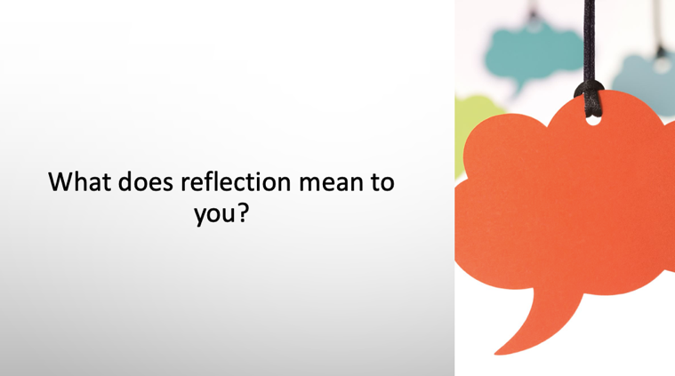

This was the first slide following the aims and objectives within my Reflective Practice PowerPoint. I opened the lesson by asking this question. This is the first introduction to reflection and reflective practice within my teaching module and I had no idea at this point whether any students within my class had prior knowledge or understanding of the topic.

Screenshot 2


This is a screenshot of the VEVOX app QR code. This will allow people to enter into the participant part of the app. This code is linked to my specific reflective practice topic question. If the students are unable to use the QR code then they can follow the instructions above and enter the session ID number into the web page if they are using a laptop.

Screenshot 3:

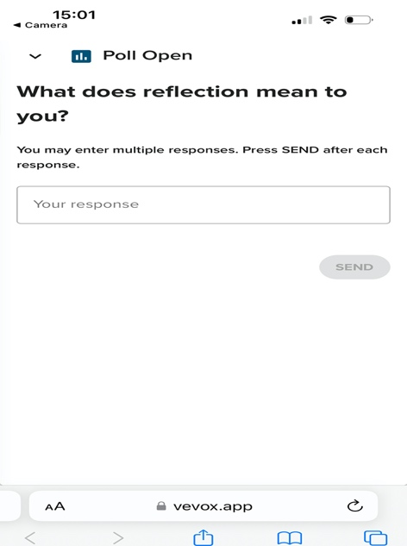

This is a screenshot of what participants will see once they have logged into the app. It prompts them to write as many words as they wish. Each word needs to be submitted first before another one can be sent.

Screenshot 4:



This is the view from my side of the VEVOX webpage. I am logged into my account and I have manually ‘started’ the poll which opens it up for participants to join. This shows that I made the poll question within the VEVOX app on 13/11/23. As you can see the session ID links to the one on the QR code within the PowerPoint.

Screenshot 5:

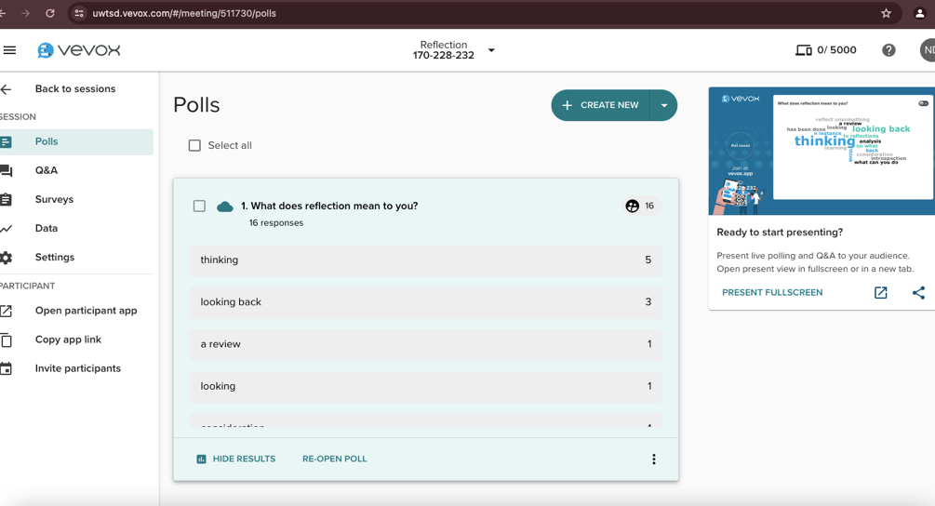

This screenshot shows some of the answers that the participants have written within a list. At the right-hand side, it shows how many times the same word was entered, e.g ‘Thinking’ was entered by 5 participants. The top number shows that there were 16 responses in total.

Screenshot 6:

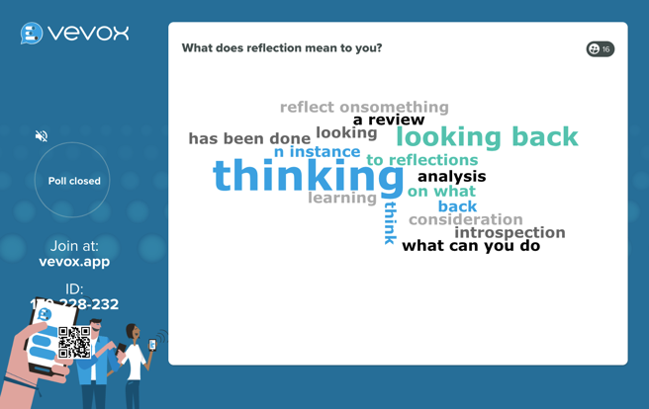

This is the final screenshot showing the Word Cloud that was created by the students after they had entered their words to the VEVOX app. As you can see the computer generates the picture. The bigger word sizes represent how many times the word was entered. E.g ‘Thinking’ is visually larger than ‘Consideration’ for example. This word cloud was presented on the large screen at the front of the class, and we then proceeded to discuss the contents of it.

Feedback Forms

Below are screenshots of my student feedback forms. The answers will inform my evaluation and reflective account.

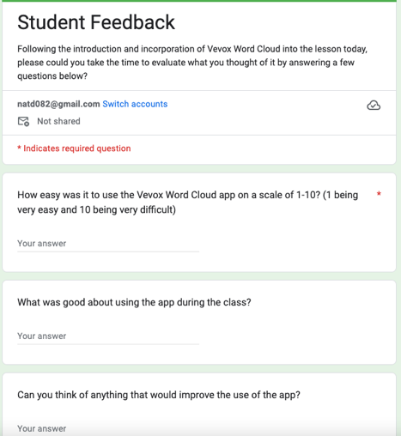
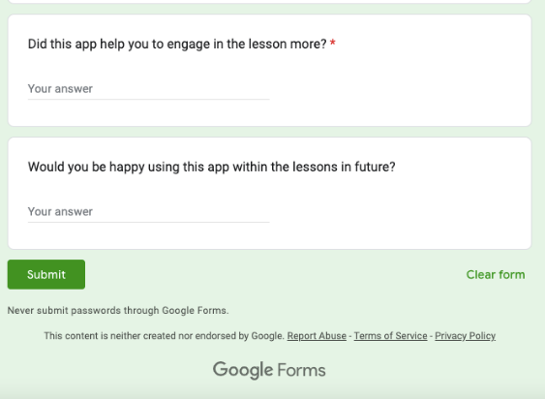

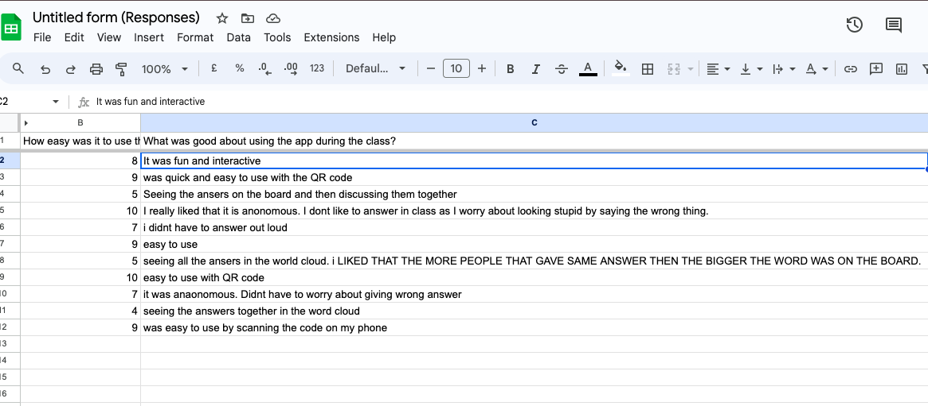

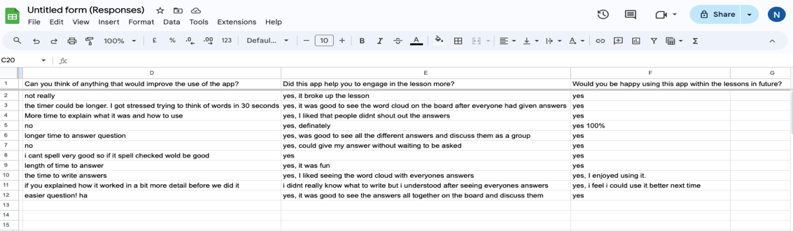

Evaluation and Reflection

Driscoll’s Model of Reflection (Driscoll, 1994) will provide a structured approach for evaluating the use of the digital learning tool, Vevox Word Cloud in my post-16 classroom. The model consists of three stages: “What?”, “So what?”, and “Now what?”. Educators use these stages to systematically reflect on their experiences, understand implications, and identify future actions (University of Edinburgh, 2020). By applying this model, I will be able to assess the digital tool’s effectiveness, student engagement with the tool, and the alignment with pedagogical goals. I will also establish an action plan for future practice.

What?
On the 26^{th of} January 2024 I completed a three-hour teaching session within the Nursing Studies and Health, HE Certificate programme in UWTSD. The module was ‘Personal and Academic Development’ (PAD), and the subject was ‘Reflective Practice’. There are 15 students enrolled on the course, however, there were only 11 students present during this lecture. I decided to utilise digital technology within this session after completing the literature review and justification of appropriate tool sections of this assignment. I used Vevox Word cloud (2023) at the beginning of the lesson to assess students background knowledge on Reflective practice. The results from this aided group discussion and affirmed that the content I had prepared was suitable for my learners’ level of prior knowledge.

I took time to demonstrate how the Vevox app worked by showing them the QR code within the PowerPoint and opening it up on my mobile phone. I informed the class that they had 60 seconds to write their answer within the answer box that appears on their phone. The question I wanted them to answer was ‘What does Reflection mean to you?’. I then clarified that once everyone had input an answer/s, a word cloud would be created and shown on the screen and we would then discuss the results within the class. The class appeared to understand my instructions. Once the Word Cloud was created, we discussed each word that emerged within it and considered how they were related to reflection/reflective practice. Feedback forms were completed at the end of the lesson.

So What?
The students appeared to be able to use the VEVOX app with relative ease. Within the feedback form, 72% gave a 7-9 out of 10, with 10 being very easy to use. The Welsh Governments Digital 2030 (2019) framework proposes that incorporating digital technology that is easy to use within the classroom, enhances learner engagement. Another main point highlighted within the positive feedback regarding the use of the app within the classroom was the fact that participants remain anonymous. This means that students can give their answers, points of view, opinions without fear of being judged (BallaIe, 2024). I explained when introducing them to the VEVOX word cloud app that it was going to be a quick way to assess their prior knowledge and that it didn’t matter if they didn’t know the right answer’s as they hadn’t yet been taught about the subject. Marshall (2020) reports, words such as ‘assess’ or ‘assessment’ can automatically trigger fear in students that they are going to be tested. I had to reiterate numerous times to my students that the purpose of the poll was to inform me as the educator about how much the students already knew about the subject.

Although students felt it was easy to use in terms of logging into the app with their mobile devices, one of the things highlighted in the feedback that could be improved, was having more time to input their answers. This is something that I hadn’t even thought about prior to setting up the poll. Race (2020) highlights the importance of being well prepared prior to the lesson, and this advice could be heeded with regards to setting up the digital technology and trialling it before the lesson. I had set it to 60 seconds and in hindsight this is not enough time for students to think and process the question before giving answers. However, this type of student engagement is meant to be a snapshot of information only. It is designed to be used as a quick way of generating answers via a digital platform (VEVOX, 2023). I explained to the class that it was like shouting out the answers within a class discussion and then the lecturer writing them on the board. The only difference being less chaos and noise and the result is a much better visual picture in the form of a word cloud. This allowed for us to discuss the results more clearly.

One student felt that the VEVOX platform did not accommodate for poor spelling. This made me reflect and realise that the use of the interactive VEVOX word cloud may not be inclusive for all. There are clear barriers to its use for those who have poor spelling, dyslexia or where writing in English is difficult when English is a second language for the student. As there is no spell check function, whatever is submitted into the poll by the participants will be included in the word cloud. The professional standards of Wales emphasise the need for educators to ‘value and promote diversity, equality of opportunity and inclusivity’ (WAG, 2023). With this in mind it could be argued that the VEVOX app is not catered to be used by all.

Now What?
Having implemented the digital tool into my classroom and then reflected on the process I feel there are areas in which I could improve. I will, however, continue to learn and develop my digital technology skills and aim to continue implementing digital tools within my lessons. Research clearly shows that there is a place for it in education, especially now, within the new digital era (Ballale, 2024).

I will plan to give more time to my learners to answer the question within the Vevox app. This can be controlled within the main Vevox setting although recognising that it is intended to be a quick response poll (VEVOX, 2023).

Preparing fully for the lesson and knowing how to use the technology confidently before bringing it into the classroom is imperative (Selwyn, 2017).

Embed technology into my practice where applicable but only if this enhances the learner experience. (Ventouris et al, 2021).

Be aware of inclusivity and always promote equal opportunity within the classroom Welsh as outlined in the Professional Standards for further education in Wales (Welsh Government, 2023). I will incorporate alternative element’s within Vevox such as a poll or multichoice questions that may be a more inclusive option.

Reference List
Al-Ansi, A. M., Jaboob, M., Garad, A. and Al-Ansi, A. (2023) ‘Analyzing augmented reality (AR) and virtual reality (VR): recent development in education’, Social Sciences and Humanities Open, 8(1). Available at: https://doi.org/10.1016/j.ssaho.2023.100532.
Arantes, J. (2022) The SAMR model as a framework for scaffolding online chat: a theoretical discussion of the SAMR model as a research method during these “interesting” times. Qualitative Research Journal. 22 (3), 294-306.
Baker, R. S. and Siemens, G. (2014) Educational data mining and learning analytics: Cambridge Handbook of the Learning Sciences (2nd edn). Cambridge: Cambridge University Press.
Baker, T. and Hawn, A. (2021) ‘Algorithmic fairness in education’, Journal of Educational Data Science, 1(1), pp. 1-24. Available at: https://doi-org.databases.wtamu.edu/10.1007/s40593-021-00285-9.
Ballale, H. (2024) ‘Exploring student engagement in technology-based education in relation to gamification, online/distance learning, and other factors: A systematic literature review’, Social Sciences and Humanities Open, 9. Available at: https://doi.org/10.1016/j.ssaho.2024.100870.
Beetham, H. (2019) Rethinking Pedagogy for a Digital Age. London: Routledge.
Beetham, H., & Sharpe, R. (2013). Rethinking Pedagogy for a Digital Age: Designing for 21st Century Learning. London: Routledge.
Binns, R. (2018) ‘Fairness in machine learning: Lessons from political philosophy’, Proceedings of the 2018 Conference on Fairness, Accountability, and Transparency, 81, pp. 149-159.
Bruner, J. (1966) Toward a Theory of Instruction. New York: Harvard University Press.
Chan, C. K. (2023) ‘A comprehensive AI policy education framework for university teaching and learning’, International Journal of Education Technology in Higher Education, 20(38). Available at: https://doi.org/10.1186/s41239-023-00408-3.
Chigona, A. and Tunjera, N. (2020) Teacher Educators' Appropriation of TPACK-SAMR Models for 21st Century Pre-Service Teacher Preparation. International Journal of Information and Communication Technology Education. 16 (3), 126-140.
Chou, C.-Y. (2017). 'Word clouds: A review'. Journal of Educational Technology Development and Exchange, 10 (1), 15-21.
Department for Education (2023) Data Protection in Schools. Available at: https://www.gov.uk/guidance/data-protection-in-schools (Accessed on 23rd May 2024).
Driscoll J. (1994) Reflective practice for practise. Senior Nurse. 13, 47 -50.
Enomoto, K. (2018) Innovative Technology and Learning Practices in Higher Education. Farringdon: Libri Publishing.
Ertmer, P. A. and Ottenbreit-Leftwich, A. T. (2010) ‘Teacher technology change: How knowledge, confidence, beliefs, and culture intersect’, Journal of Research on Technology in Education, 42(3), pp. 255-284.
Felder, R. M., and Brent, R. (2005) 'Understanding student differences'. Journal of Engineering Education, 94(1), 57-72.
Fidel, C. (2008) 21st Century Sills: How Can You Prepare Students For The New Global Economy? Cisco.
Haleem, A., Javaid, M., Asim-Qadri, M. and Suman, R. (2022) ‘Understanding the role of digital technologies in education: A review’, Sustainable Operations and Computers, 3(15), pp. 275-285. Available at: doi.org/10.1016/j.susoc.2022.05.004.
Hamad, A. and Jia, B. (2022) ‘How Virtual Reality Technology Has Changed Our Lives: An Overview of the Current and Potential Applications and Limitations’, International Journal of Environmental Research and Public Health, 19(18). Available at: https://doi.org/10.3390%2Fijerph191811278.
Hamilton, E., Rosenberg, J. M., and Akcaoglu, M. (2016) 'The Substitution Augmentation Modification Redefinition (SAMR) Model: A Critical Review and Suggestions for its Use'. TechTrends. 60, 433-441.
Harasim, L. (2000) ‘Shift happens: Online education as a new paradigm in learning’, The Internet and Higher Education, 3(1-2), pp. 41-61.
Hattie, J. (2012) Visible Learning for Teachers: Maximizing Impact on Learning. London: Routledge.
Hohlfeld, T. N., Ritzhaupt, A. D., Barron, A. E. and Kemker, K. (2010) ‘Examining the digital divide in K-12 public schools: Four-year trends for supporting ICT literacy’, Journal of Computers and Education, 55(4), pp. 1520-1535.
Holmes, W., Bialik, M. and Fadel, C. (2019) Artificial intelligence in education: Promises and implications for teaching and learning. Boston: Centre for Curriculum Redesign.
Howard, S. K. and Mozejko, A. (2015) Considering the history of digital technologies in education. In Henderson, M. and Romero, G (Eds.) Teaching and Digital Technologies: Big Issues and Critical Questions (pp. 157-168). Port Melbourne, Australia: Cambridge University Press.
Johnston, B. (2019) Conceptualising the Digital University: The Intersection of Policy, Pedagogy and Practice. London: Palgrave McMillan.
Laurillard, D. (2012) Teaching as a design science: Building pedagogical patterns for learning and technology. New York: Routledge.
Lawless, K. A. and Pellegrino, J. W. (2007) ‘Professional development in integrating technology into teaching and learning: Knowns, unknowns, and ways to pursue better questions and answers’, Review of Educational Research, 77(4), pp. 575-614.
Lee, J. A. (2016) ‘History of Computing in Education: An Overview’, International Federation for Information Processing Digital Library, 14(7).
Livingstone, S. and Sefton-Green, J. (2016) The class: Living and learning in the digital age. New York: New York University Press.
Luckin, R., Holmes, W., Griffiths, M. and Forcier, L. B. (2016) Intelligence unleashed: An argument for AI in education. London: Pearson Education.
Makarova, E. and Makarova, S. (2018) ‘Blending pedagogy and digital technology to transform educational environment’, International Journal of Cognitive Research in Science Engineering and Education, 6(65). Available at: 10.5937/ijcrsee1802057M.
Marshall, S. (2020) A handbook for teaching and learning in higher education; enhancing academic practice (5th Edn). Oxon: Routledge.
Means, B., Toyama, Y., Murphy, R., Bakia, M. and Jones, K. (2010) ‘Evaluation of evidence-based practices in online learning: A meta-analysis and review of online learning studies’, ED-Tech.
Mhlanga, D. (2023) ‘Open AI in education, the responsible and ethical use of ChatGPT toward lifelong learning’, SSRN Electronic Journal. Available at: https://doi.org/10.2139/ssrn.4354422.
Miah, M. (2024) Digital Inequality: ‘The Digital Divide and Educational Outcomes’, Information Technology and Management Science.
Mishra, P. and Koehler, M. J. (2006) ‘Technological pedagogical content knowledge: A framework for teacher knowledge’, Teachers College Record, 108(6), pp. 1017-1054.
Norris, N. P., Ivancheva, M., Coop, T., Moggliacci, R. and Swinnerton, B. (2022) ‘Negotiating growth of online education in higher education’, International Journal of Education and Technology in Higher Education, 17(48). Available at: https://doi.org/10.1186/s41239-020-00227-w.
Ofcom (2020) Connected Nations 2020: Wales Report. Cardiff: Ofcom.
O'Neil, C. (2016) Weapons of math destruction: How big data increases inequality and threatens democracy. Sussex: Crown Publishing Group.
Passey, D. (2016) ‘Early Uses of Computers in Schools in the United Kingdom: Shaping Factors and Influencing Directions’, HAL Open Science, pp. 131-149.
Piaget, J. (1952) The origins of intelligence in children. New York: W. W. Norton & Co.
Piaget, J. (1972) The Psychology of the Child. New York. Basic Books.
Poore, M. (2016) Using social media in the classroom: A best practice guide. Newcastle: SAGE Publications.
Puentedura, R. R. (2012) 'The SAMR Model: Background and Exemplars'. Available at: http://www.hippasus.com/rrpweblog/archives/2012/08/23/SAMR_BackgroundExemplars.pdf (Accessed on 29th May 2024).
Race, P. (2020) The lecturer's toolkit: a practical guide to assessment, learning and teaching (5th Edn). London: Routledge.
Race, P., and Pickford, R. (2007) Making Technology Work: Teaching Smarter in post-Compulsory Education. London: Sage.
Ramos-Salazar, L., Peeples, S. F. and Brooks, M. E. (2024) ‘Generative AI ethical considerations and discriminatory biases on diverse students within the classroom’. In S. Elmoudden, S. and Wrench, J. (Eds) The role of generative AI in the communication classroom. New York: IGI Global.
Schwartz, R., Vassilev, A., Greene, K., Perine, L., Burt, A. and Hall, P. (2022) ‘Towards a standard for identifying and managing bias in artificial intelligence’, National Institute of Standards and Technology. Available at: https://doi.org/10.6028/nist.sp.1270.
Selfa-Sastre, M., Pifarré, M., Cujba, A., Cutillas, L. and Falguera, E. (2022) ‘The Role of Digital Technologies to Promote Collaborative Creativity in Language Education’, Frontiers in Psychology, 9(13). Available at: doi: 10.3389/fpsyg.2022.828981.
Selwyn, N. (2011) Education and Technology: Key Issues and Debates. London: Bloomsbury.
Selwyn, N. (2017) Education and technology: Key issues and debates (2nd edn). London: Bloomsbury Publishing.
Sullivan, P. (2014) The Elements of Online Research: Studying the Internet. London: Sage.
Tam, W., Huynh, T., Tang, A., Luong, S., Khatri, Y. and Zhou, W. (2023) ‘Nursing education in the age of artificial intelligence powered Chatbots (AI-chatbots): Are we ready yet?’ Nurse Education Today, 129. Available at: https://doi.org/10.1016/j.nedt.2023.105917.
Timotheou, S., Miliou, O., Dimitriadis, Y., Sobrino, S. V., Giannoutsou, N., Cachia, R., Monés, A. M. and Ioannou, A. (2023) ‘Impacts of digital technologies on education and factors influencing schools' digital capacity and transformation: A literature revie’, Education Information Technology, 28(6), pp. 6695-6726. Available at: doi: 10.1007/s10639-022-11431-8.
Tomlinson, C. A. (2014) The differentiated classroom: Responding to the needs of all learners (2nd edn). Alexandria: ASCD.
University of Edinburgh (2020) Reflection Toolkit. Available at: https://www.ed.ac.uk/reflection. (Accessed on 24th May 2024)
Vallo-Hult, H., Master-Östlund, C., Pålsson, P. and Jood, K. (2023) ‘Designing for digital transformation of residency education – a post-pandemic pedagogical response’, BMC Medical Education, 23(1), pp. 421-427. Available at: 10.1186/s12909-023-04390-2.
Ventouris, A., Panourgia, C., Cook, R. and Hodge, B. (2021) ‘Teachers’ perceptions of the impact of technology on children and young people's emotions and behaviours’, International Journal of Educational Research Open, 2(22). Available at: http//doi:100081.
Vevox (2023) 'Word Clouds'. Available at: https://www.vevox.com/features/word-cloud. Accessed on 14th May 2024).
Vygotsky, L. S. (1978) Mind in society: The development of higher psychological processes. Massachusetts: Harvard University Press.
Welsh Government (2012) Written Statement – Learning in Digital Wales. Available at: https://www.gov.wales/written-statement-learning-digital-wales. (Accessed on 28th March 2024).
Welsh Government (2018) Digital Competence Framework: Your Questions Answered – An update. Cardiff: Welsh Government.
Welsh Government (2019) Digital 2030: A digital standards framework for post-16 education in Wales - Teaching & learning related roles. Available at: chrome-extension://efaidnbmnnnibpcajpcglclefindmkaj/https://digital2030wales.jisc.ac.uk/assets/documents/Digital%202030%20-%20Digital%20Standards.pdf (Accessed on 2nd June 2024).
Welsh Government (2021) Digital Communities Wales Programme Extended Until 2025. Available at: https://www.digitalcommunities.gov.wales/blog/dcw-extended-until-2025/#:~:text=The%20National%20Survey%20for%20Wales,become%20a%20digitally%20inclusive%20nation (Accessed on 1st June 2024).
Welsh Government (2023) Professional standards for further education teachers, work-based learning practitioners and adult learning practitioners in Wales. Available at: https://educators.wales/sites/default/files/2023-07/Professional%20standards%20for%20FE%20%20WBL%20and%20ACL%20Practitioners%20-%20June%202023.pdf (Accessed on 30th May 2024).
Wise, S., Greenwood, J. and Davis, N. (2011) ‘Teachers' use of digital technology in secondary music education: illustrations of changing classroom'. British Journal of Music Education, 28(2), 117-134.
Yang, B. (2023) ‘Virtual Reality and Augmented Reality for Immersive Learning: A Framework of Education Environment Design’, International Journal of Emerging Technologies in Learning, 18(20). Available at: https://doi.org/10.3991/ijet.v18i20.44209.

Appendix 1- Lesson Plan



Lesson Plan

Topic: Reflection and Reflective Practice |  | Class: Nursing Studies and Health  Personal and Academic Development (PAD)
Date: 26/01/2024 | Length of lesson: 180 minutes |  | Number of students: 10-15
Resources required:
PowerPoint
Grab sheets (Gibb’s reflective cycle)
Vevox interactive poll
Aim of Lesson:

To understand what reflection is
To gain an introduction to reflective theorists and cycles of reflections
To complete tasks to familiarise ourselves with ‘Gibbs’ Reflective Cycle’
To be able to discuss why reflective practice in a healthcare setting is important

Learning Outcomes – The Learners Should Be Able To:

Write a reflective account for portfolio assessment/reflective essay using Gibbs model of Reflection

Previous student knowledge required for the session:

Nil required; however, some may have more knowledge than others prior to lesson.

Anticipated difficulties (if applicable):

Time frame/management
Different levels of understanding prior to lesson.
Student participation.
English is 2nd language for some students

Professional Standards (where are these being met within the session)
Demonstrate commitment to learners, their learning, safety and well-being-
Promoting positive attitudes to learning Supporting learners to identify their learner needs and aims Ensuring learners are supported and taught in a safe learning environment, taking appropriate action where required using relevant policies and guidance Using a range of teaching and assessment methods, making best use of knowledge and skills to support learners.
Demonstrate dignity, courtesy and respect towards others-
Treating all learners and colleagues equally and fairly, ensuring all have an equal opportunity to be heard. Listening to and responding positively to others’ views.
Behaving professionally at all times.
Reviewing own professional and personal attitudes and beliefs.
Value and promote diversity, equality of opportunity and inclusion-
Promoting diversity and opportunity
Creating an environment in which leaners feel safe to challenge discrimination
Encouraging learners to understand the benefits of diversity Treating all learners equally and fairly
Challenging unacceptable behaviour.
Maintain and update knowledge of my subject(s) and how best to teach and assess them-
Actively participating in professional development activities. Keeping abreast of developments on own subject/vocational area ensuring learners benefit from the latest knowledge and skills.
Plan and deliver effective learning, teaching, and assessment-
Making use of digital teaching and learning platforms to support teaching, learning and assessment Creating and planning learning environments where learners are active participants as individuals and as members of collaborative groups
Demonstrate a commitment to sustainability-
being mindful of the resources we use day-to-day. reducing high carbon resources in favour of low carbon alternatives

Lesson Detail:

Stage | Focus | Strategy | Time
Introduction  Development  Plenary/conclusion | Introduce myself.  Explain reasons for topic.  Ask about prior knowledge.  Aims and Objective/  Learning Outcomes  Reflective practice introduction (What, why, when)  Vevox word cloud &  Class discussion of results  Reflective models/cycles  BREAK  Theorists  Writing Tasks 1  Reflective practice in healthcare  Writing task 2  assess student knowledge  Review learning outcomes.  Questions  What is happening in next lesson | Chalk and talk  Q+A  PowerPoint slides  Slides  Slides/chalk and talk  Slides  Slides/chalk + talk  interactive app/participation.  Slides and chalk and talk.  Group work and class discussion  Slides  Group work and class discussion  Q+A  Slides | 20 minutes  30 minutes  20mins  10 mins  30 mins  10 minutes  30 mins  20mins

