

University Of Wales
Swansea Metropolitan University

A critical analysis of ethical risks in relation to online pharmaceutical websites.

Christopher James Gibbins P084397,
BSC (Hons) Business Information Technology
Supervised By Karen Jones
May 2010

Declaration

I, Christopher James Gibbins declare that I am the sole author of this research; that all references cited have been consulted; that I have conducted all work of which this is a record, and that the finished work lies within the prescribed word limits.
This has not previously been accepted as part of any other degree submission.
Signed: .............................
Christopher Gibbins
Date: ....../......../..............

Permission to copy

I, Christopher James Gibbins hereby consent that my dissertation, submitted in canditure for the B.Sc.(Hons) Business Information Technology degree, if successful, may be made available for inter-library loan or photocopying (subject to the law of copyright) and that the title and abstract may be made available to outside organisations.
Signed: ...................................
Christopher Gibbins
Date: ......../........./................

Acknowledgements

I would firstly like to express my appreciation to my friends, and in particular Katy Harris and Joshua Bolton. Without their help, encouragement and support this dissertation wouldn’t have been achievable.
I would also like to acknowledge the huge amount of support I have received from my family and friends throughout my final year of study and in particular the last few months of the course.
Finally, I would like to show my biggest thanks and gratitude to my project supervisor Karen Jones, for her enormous levels of support and encouragement whilst I have been completing my dissertation. Karen has demonstrated a huge amount of patience and guidance throughout my time in University but in particular for the generosity and help she has offered during the past 8 months which have presented me with the best possible opportunity to complete this dissertation.

Table of contents

Declaration 2
Permission to copy 3
Acknowledgements 4
Table of contents 5
List of figures 7
Abstract 8
Chapter 1 9
Introduction 9
1.1. Internet 9
1.2. Pharmaceuticals 11
1.3. Ethics 12
1.4 Research aim and Objectives 15
Chapter 2 17
Review of Literature 17
2.1 Ethical implications of the internet 17
2.1.1 Anonymity 20
2.1.2 Interactivity 21
2.1.3 Reproducibility 21
2.1.4 Uncontrollability 22
2.1.5 Van Den Hoven’s Model 22
2.2 pharmaceuticals 23
2.2.1 Online Pharmaceuticals 25
2.2.2 Ethics and Pharmaceuticals 27
Chapter 3 29
Research Methods 29
3.1 Influences on methodology 30
3.2 Research Onion 31
3.3 Research Design Process 32
3.4 Credibility of Research 37
3.5 Ethical Implications 38
3.6 Analysing Results 39
3.7 Design of the Original Framework for Evaluation 39
Chapter 4 43
Analysis of Results 43
4.1 Selection of Original Criteria 43
4.2 The websites for the Cross-Case Analysis 47
4.2.1 Webmedshop 48
4.2.2 Legalgodhealth 48
4.2.3 Rowlands Pharmacy 49
4.2.4 Boots Pharmacy 50
4.2.5. Pharmland 51
4.2.6 Magicpharma 52
4.3 Results of Analysis 53
4.3.1. Age verification present 53
4.3.2 Health and safety guidelines? 54
4.3.3 Access to doctor/medical advice 56
4.3.4 Anonymity of customer 57
4.3.5 Is the website a registered Pharmaceutical institution? 58
4.3.6 Is there a limit to the quantity of medicines that can be purchased? 59
4.3.7 Self diagnosis option? 60
4.3.8 Creation of user account? 61
4.3.9 Websites privacy/ethics policy? 63
4.3.10 Do they offer cheaper generic drugs as oppose to the well known drug name? 63
4.4 Analysis of websites 64
4.4.1 Webmedshop 65
4.4.2 Legalgodhealth 65
4.4.3 Rowlands Pharmacy 66
4.4.4 Boots Pharmacy 67
4.4.5 Pharmland 67
4.4.6 Magicpharma 68
4.5 Content Analysis table 69
Chapter 5 72
Conclusion & Recommendations 72
5.1 Ethical dilemmas associated with online pharmaceuticals 72
5.2 To create an original framework to aid a content analysis of online pharmaceutical websites with regard to ethical risk to users 73
5.3 To evaluate ethical risk to users of pharmaceutical websites and the control mechanisms implemented by the pharmaceutical organisations, as evidenced by a content analysis of their websites. 77
5.4 Conclusions 79
5.5 Limitations of research 82
5.6 Recommendations for further research 82
Bibliography 84
Appendix 1 88
Dissertation proposal 88
Bibliography 99
Appendix 2 103
Ethics approval Form 103

List of figures

Fig: 1 Internet World stats Pg. 10
Fig: 2 Research Onion Pg.31
Fig: 3 features of phenomenology Pg.34
Fig: 4 Scoring method used to analyse website Pg.41
Fig: 5 Ten criteria used to analyse website Pg.41
Fig: 6 Webmedshop homepage Pg.48
Fig: 7 Legalgodhealth homepage Pg.49
Fig: 8 Rowlands homepage Pg.50
Fig: 9 Boots homepage Pg.51
Fig: 10 Pharmland homepage Pg.52
Fig: 11 Magicpharma homepage Pg.52
Fig: 12 Rowlands age checker Pg.54
Fig: 13 Boots terms and conditions Pg.55
Fig: 14 Boots online symptom checker Pg.56
Fig: 15 Online chat from Webmedshop Pg.57
Fig: 16 Rowland registration form Pg.58
Fig: 17 Registered pharmacy logo from Boots Pg.59
Fig: 18 Chart showing quantity of drugs available from Webmedshop Pg.60
Fig: 19 Boots symptom checker Pg.61
Fig: 20 Billing information page from Webmedshop Pg.62
Fig: 21 Boots log in/register page Pg.62
Fig: 22 Final ranking of each website Pg.64
Fig: 23 Matrix displaying criteria shown Pg.70
By cross section of pharmaceutical websites

Abstract

The following dissertation is a critical analysis of pharmaceutical websites for evidence of ethical risks they may pose to the user. This topic was chosen as the pharmaceutical industry is continuously growing and one reason for this is the development of online pharmaceuticals. The pharmaceutical market is predicted to be worth £14.1 billion by 2013. The growth in pharmaceuticals has also seen a growth in online pharmaceuticals with companies developing generic drugs which can be sold for up to 40% cheaper than their brand name counterpart and these sales are usually achieved over the internet through cross border trade. After the decision was made to research online pharmaceuticals then a literature review was undertaken to research any academic texts and journals on the topic of the internet, ethics and pharmaceuticals. After the research it was decided that a content analysis would be used to evaluate a cross section of online pharmaceutical websites. The frame work for the content analysis was an original framework created by the researcher using information gathered and identified from the literature review. Once the content analysis was complete then an analysis of the results was conducted to determine whether the issues identified in the literature review and analysed were present in the websites and if the ethical risks were present or not. The final piece of work carried out was to determine whether the results which were found matched the results that were expected this was achieved by discussing the results and then identifying any conclusions and recommendations of the work. In relation to this study it was found that the ethical issues identified from the literature presented themselves in the websites and appropriate conclusions were drawn and recommendations made.

Chapter 1

Introduction

The following research will evaluate many online pharmaceutical websites in relation to the computer and internet ethics that must be considered by online businesses. The rationale for the research is that the research topic is very topical at present. Due to the current economic climate people are purchasing what they perceive to be harmless drugs such as sleeping tablets as they are easier to purchase online than going to a doctors/GP for a diagnosis and receiving a prescription, also it can be a lot cheaper to purchase drugs from foreign internet companies than it is from recognised from retailers such as boots pharmacy.
As the research is concerned with online pharmaceuticals there are three different themes that have been identified and will need to be discussed. The themes identified are the internet, pharmaceuticals and ethics.

Internet
As the project is focused with online pharmaceutical websites, the research must firstly identify the rise in use and the popularity of the internet. According to De George, the internet is a global network of computer systems that is not owned, controlled by any government, business or organisation and it is not operated for profit (1). Coffman and Odlyzko suggest that because of the internet’s versatility it penetrates deeply into the economy, affecting all of society, and therefore attracts inordinate amount of public attention (2). According to national statistics in 2008 over 16 million UK households (65%) had internet access (3). Globally the situation is not much different with the internet world stats reporting that as of October 2009 there was an estimated 1,668,870,408 internet users in the world (4).
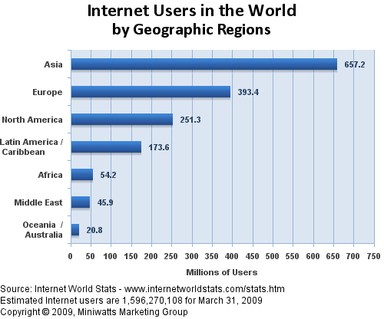

Fig 1. Internet usage stats

With the huge rise in connectivity to the internet there is no surprise that the e-commerce business has also rose in recent years. According to the Office for National Statistics internet sales for all UK businesses rose to £163bn in 2007 a 30% increase on 2006 (5).
Laudon and Traver define e-Commerce as “The use of the internet and web to transact business. More formally, digital enabled commercial transactions between and among organisations and individual” (6). Langdon (7) claims that the 21st Century will become the age of digitally enabled social and commercial life, however, Smith and Chaffey (8) contend that that e-Commerce’s days are numbered and that e-Commerce is being substituted by e-Business, they argue that e-Business has a broader perspective, involving the automation of all the business processes in the value chain giving the ability to run a business online.

Pharmaceuticals

The pharmaceutical business is an important business sector to the society and the economy. According to data monitor (9) the United Kingdom’s pharmaceutical market grew by 5% in 2008 to reach a value of £12.5 billion and it is estimated that by 2013 the market would have increased in value again to reach £14.1 billion with a compound annual growth in this period of 2.4%. The global pharmaceutical market is also in a period of growth. Data monitor (10) identifies that in 2008 the global pharmaceutical market value grew by 3.8% to stand at $615.1, and it is estimated that by 2013 the market value will have grown by a further 19.3% to stand at $734 billion.
With the growth of internet usage and e-commerce business there is no surprise that the online pharmaceutical business has also seen an increase of popularity and demand. Online pharmaceuticals refer to the selling of drugs whether prescribed or not over the internet. Pharmaceuticals can be defined as:-
“Substances that are aimed to cure, prevent, or recognize diseases and relieve pains through their application in the organism.” (11)
According to Quinn and Narayanan (12) the global market for online pharmaceuticals stood at $650bn in 2006 and a major contributor to this was the emergence of online cross border pharmacies. Cross border pharmacies are internet sites that offer drugs and medicines to people from other countries. One of the main online cross border trades is that of Canada selling drugs to Americans this is because the proximity of the countries makes distribution easier and there is much cross border trade between Canada and America as prescription prices in Canada can be up to 40% cheaper (13). The price difference between the countries is so great as the Canadian pharmaceutical business deals mainly in the generic pharmaceutical field as opposed to the American pharmaceutical business which primarily deals with the patented medicines. Generic medicines will be discussed in more detail at a later part of the study.
The range of pharmacy services on the internet varies; on one end of the spectrum there are pharmacies that use the internet as an advertising tool and the other end there are the pharmacies such as pharmacy2u which offers complete pharmacy services from distribution of drugs to health care plans and even baby care (13). Online pharmaceutical websites that operate from within the UK are thought of as safe sites as they are governed by the same laws that govern UK pharmacies. The Royal Pharmaceutical Society of Great Britain (RPSGB) is the professional and regulatory body for pharmacists in England, Scotland and Wales (14). As the RPSGB only governs UK sites, customers who wish to purchase ready available drugs without prescription and with no information on implications to health can do so from any non UK based online organisation (13).

Ethics

Ethics has been defined by Barger (15) as ‘the discipline dealing with what is good and bad or right and wrong or with the moral duty and obligation’. Ethical behaviour refers to behaviour that conforms to generally accepted social norms (16). There are two identified aspects to ethics; being able to determine what is right or wrong and committing to doing what is morally good (17). Computer ethics can be understood as a branch of ethics which studies and analyses the social and ethical impacts of ICT (18).De George (19) suggests that the Internet creates new ethical issues and dilemmas. However Weckert (20) argues that the problems might not be new, but the context is, and so it is important to examine the issues in their new context, to see if new answers are required. This leads to the understanding of computer ethics. Computer ethics has been recognised by Moor (cited in Tavani) (21) as:-
‘The analysis of the nature and social impact of computer technology and the corresponding formulation and justification of policies for the ethical use of such technology.’
With the introduction of the online pharmaceutical business it is critical to determine whether the internet has created new ethical dilemmas for the facilitation of online pharmaceutical websites. Van Den Hoven (22) believes that ethical problems are bound to arise given the speed that technology is developing and as this technology develops it will bring new ethical issues that will have to be addressed. Van Den Hoven suggests that his four category model can be used to evaluate moral issues and their relation to the internet, some issues may be caused by the internet and others maybe completely independent and occur in the real world without internet participation (22). The four categories of this model are:
- Internet related – moral problems that can occur both in the offline and online world.
- Internet dependant – relevant technology is necessary for moral problems to arise.
- Internet determined – moral problems that arise when internet technology is used.
- Internet specific – moral problems that do not exist outside the internet domain.
Van Den Hoven’s four category model will be discussed in more detail in chapter 2.
Alongside the ethical issues that may arise from pharmaceutical websites there are also the fundamentals of website design that must be considered by the web designer/computer professional for these websites. According to Sitepoint.com (23), when creating a web site there are web design concepts and fundamentals that should be taken into account such as usability, accessibility, consistency, optimisation and creativity. As the websites being looked at are pharmaceutical websites there are also some other features that must be taken into consideration when evaluating the websites. These features are in regards to consumer segmentation, what people are going to use the site. Is the user someone who has just been diagnosed and wants to find out more information, is it someone with a chronic disease who needs a particular service to manage the disease, is it a caregiver who wants to know how to better assist the patient or is it someone who is perfectly well but has a health concern (24)?

This research aim is to analyse whether the internet has created new ethical risks in the online pharmaceutical world. Using Van Den Hoven’s framework the internet pharmaceutical websites are analysed with the view to indentifying any new ethical dilemmas that have arisen since the inception of pharmaceutical websites. To achieve this, the research will take the form of a content analysis. The content analysis will be an original framework and will aim to identify ethical risks of pharmaceutical websites and how they are managed. This was achieved by using the literature to identify the assessment criteria that formed the basis of the content analysis. The content analysis was then applied to the selected cross section of websites to evaluate whether they were ethically compliant pharmaceutical websites.

1.4 Research aim and Objectives

The research aim of the project is to critically analyse the ethical issues of online pharmaceutical websites. This aim was guided by three objectives:
- To evaluate the ethical risks associated with online pharmaceutical websites.
This objective was achieved by reviewing the literature available on online pharmaceuticals and identifying the ethical risks associated to pharmaceuticals.

- To create an original framework to aid a content analysis of online pharmaceutical websites with regard to ethical risk to users.

To achieve this objective an original framework was devised by the researcher. The framework was designed using information gathered from the literature and was used to establish the ethical implications of online pharmaceutical websites.

- To evaluate ethical risk to users of pharmaceutical websites and the control mechanisms implemented by the pharmaceutical organisations, as evidenced by a content analysis of their websites.
To achieve this objective the results generated from the original framework for objective two will be gathered and reviewed with the intention of identifying ethical or unethical risk of pharmaceutical websites and what mechanisms are in place to reduce this risk.

This chapter has outlined the aims and objectives of the research. The subsequent chapter, Chapter 2: Review of Literature will the review the published literature and accredited websites associated with online pharmaceuticals and the ethical considerations of the internet.

Chapter 2

Review of Literature

This chapter analyses critically the literature associated with online pharmaceuticals and ethical considerations. The literature sources include journal articles, journals, related web site articles as well as books relevant to the research topic. The chapter is organised and relates to the themes drawn from the objectives of the research identified below:
- Ethical implications of the Internet
- Pharmaceuticals
- Online pharmaceuticals
- Ethics and pharmaceuticals

2.1 Ethical implications of the internet

Ferrell and Fraedrich (25) refer to ethics as the study and philosophy of human conduct, with an emphasis on the determination of right and wrong. Ethics are concerned with what one ought to do to fulfil one’s moral duty. There are two aspects to ethics; being able to determine what is right or wrong and committing to doing what is right and good (17). According to De George (26) the internet is a kind of anarchy with no one in charge, and to that extent it makes users vulnerable in ways that they are not in organised society. As there is no true governance of the internet there is no surprise that there are ethical implications to be considered with almost everything that occurs online. De George (26) argues that although some of the ethical issues found on the internet such as fraud and theft are familiar to society, others are new. De George (26) also recognises that what is called cyber space is not a separate space but part of the world in which we live. The same moral and ethical rules apply as apply in other aspects of society. It has been suggested that individuals who are vulnerable, as characterised by a history of impulse control and addictive disorders, are especially at risk of using the internet in a problematic way (27). This seems to be relevant to online pharmaceuticals as people who may be used to obtaining medicines easily on the internet may become addicted to the medicine and continue to order them even when there is no need.
As stated by Langford (28) ‘the internet is a global medium, allowing easy personal and international communications’. As the internet is a global medium there is major difficulty in regulating what happens on the web, therefore many factors must be considered to keep the internet as ethical as possible (28). These factors include sensitivity to cultural differences, legislation differences and customer service. Langford (28) contends that every internet website should have a code of ethics about how users should conduct themselves on the site and how to use the website. Ferrell and Fraedrich (29) argue that many organisations have established strong codes of ethics or policies as well as strategies for enforcing them. This is an important issue in reference to pharmaceuticals as a code of ethics should explain how the users should use and interprets the information they find on the site as well as inform users of the risks associated with the site and the drugs they offer.
Van Den Hoven (30) suggests that moral aspects on the internet have to deal with four general problems:
- Problems of jurisdiction
- Problems of application
- Problems of individuation
- Problems of moral ignorance
Each of the four problems is discussed below but the two that have most relevance to the internet and online pharmaceuticals are problems of jurisdiction and problems of moral ignorance.
Firstly, as outlined by Van den Hoven (30) the internet cuts across the territorial borders of sovereign nation states, which makes geographical boundaries as delineations of jurisdictions inadequate. Whereas physical borders between countries have always determined which set of normative rules apply to individual behaviour it is now unclear under which jurisdiction ones actions fall and which laws apply to ones actions. This moral problem affects online pharmaceuticals as at present any website is able to offer pharmaceuticals to a UK customer but only UK websites are governed as to what they can offer by the RSPGB (14). This creates a problem as a customer is able to buy what they want when they want and in whatever quantity they want from an overseas website over internet without anyone asking questions. The second moral problem, that of moral ignorance is also important in online pharmaceuticals. Van Den Hoven (30) defines moral ignorance as problems that result from the unforseeability of consequences of our actions given the interdependencies in networks and the concurrent actions in a casually intransparent network environment. More simply put individuals may simply be unable to predict the future consequences of their individual actions. This is a moral problem faced by online pharmaceuticals as the seller companies of the pharmaceuticals will not know the affect the drugs they sell will have on a customer in the future, also the buyer of the drugs may become addicted to the drugs and continue to buy them which could again have future health implications.
Other ethical problems have frequently been raised in connection with the internet as stated by Weckert (31). These four problems are outlined below.

2.1.1 Anonymity

Anonymity has become an important issue on the internet for several reasons. One of these reasons is its relationship with privacy (31). A certain degree of privacy on the internet is desirable as it allows users to use the internet without being identified by anyone (31). It has also been argued that anonymity is a good tool for a user if they need to disclose personal information; for example a user may be more willing to admit to addictions if they are hiding behind a mask of anonymity. However there is another side to anonymity and that is that an anonymous person cannot be held accountable for his or her actions, which clearly must make it easier for law breakers and criminals (31). There are three issues regarding anonymity on the internet. The first issue is giving the technology available can there be any real anonymity on the internet. Technology is usually a double edged sword, and undoubtedly as new and more sophisticated methods are developed that enhance anonymity capabilities, parallel developments will provide ways of discovering the sources of the anonymity, however on the internet if one wants to stay anonymous it is quite possible without too much trouble (31). The second issue is the purposes of the anonymity. The main use for anonymity is to protect privacy. Visits to Web sites can be easily recorded, and the records used for a variety of purposes, not all of them necessarily in the best interests of the user. Visiting sites anonymously, whilst cumbersome grants a degree of protection (31). The final issue of anonymity to be considered is the most important that is, what are the moral questions raised by internet anonymity? There is a sense in which the desires for anonymity seems morally dubious, if you have nothing to hide why act anonymously (31)? This poses an issue with regards to online pharmaceuticals as an internet user can anonymously log onto the sites to buy drugs with no one knowing who they are and also anonymity allows the same person to use more than one anonymous alias to purchase drugs. Anonymity is also an issue for pharmaceuticals as by enabling users to remain anonymous there is no way of knowing the age of the customers which could result in users under the age of 16 using the websites to buy drugs from the internet without anyone knowing they are doing it. The legal age in the UK to buy paracetamol and other drugs from a chemist is 16; the internet could allow any person to buy drugs irrelevant of age so long as it is done anonymously.

2.1.2 Interactivity

Weckert (31) suggests the internet is a medium that enables easy and rapid communication between people who are geographically remote from each other. In addition to one-to-one contact the internet allows one-to-many as well as many-to-many interaction. This can be a huge advantage as it allows users that cannot physically meet up to communicate. However there is also a down side to interactivity. The interactivity created by the internet, could, somewhat paradoxically, lead to greater bigotry (31). In reference to online pharmaceuticals this ethical issue needs to be considered as enabling a user to connect with anyone anywhere in the world gives the user the opportunity to purchase what might be prescription only drugs in the UK from a country where the drugs are not prescription only.

2.1.3 Reproducibility

Weckert (31) defines reproducibility as copying and distributing material that is stored electronically. It is easy, quick and inexpensive; moreover the copying is indistinguishable from the original. There are a number of problems with reproducibility especially related to preservation, altering and copying of material.

2.1.4 Uncontrollability

Many people are genuinely concerned about cultural invasion and the spread of undesirable material such as pornography (31). With the global nature of the internet it is difficult to decide on who makes the rules and who will enforce them. The main problem is trying to filter out the unwanted and undesirable content without degrading the service from the other users (31).

2.1.5 Van Den Hoven’s Model

Van Den Hoven (32) contends that his four category model can be used to evaluate different moral issues and their relationship to the internet. By proposing a framework like this, Van Den Hoven suggests that we may be able to more easily identify just where existing rules and models of ethical behaviour may be deficient (33). Some of the issues identified may be caused by the internet and others may be completely independent and still occur in the real world without the need of internet participation (32). The four categories that the moral issues can be categorised into have been identified as Internet-Related, Internet-Dependant, Internet-determined and internet-specific.
Internet-related moral issues are issues that occur in both the online and offline environment. The internet is neither necessary nor sufficient for the issue to arise (32). Van Den Hoven (32) contends that examples of internet-related issue those such as truthful advertising and fraud. The same moral issues concerning truthful advertising and honesty in business are typically involved in traditional media as well (32). This category of the model is appropriate to pharmaceuticals as the way that pharmaceuticals are advertised has to be achieved truthfully and to not give false hope to customers that they will achieve something that they cannot. The second category internet-dependant, relates to those moral issues that need the relevant technology for the moral problems to arise (32). Certain moral problems would not exist today if the technology was not available. Examples of internet dependant moral issues include such things as viruses, e-mail spamming and hacking (32). The third category in the model internet-determined, are the moral problems that are bound to arise if the relevant computer applications are introduced or put to work (32). An example of this proposed by Van Den Hoven (32) is the moral issue of equal access, will the presence of the internet help to increase or reduce the distribution of wealth. This category is also influential in online pharmaceuticals as the moral issue of self diagnosis or purchasing unprescribed drugs has become more relevant as technologies have improved, if there was no internet there would be little opportunity to purchase the drugs. The final category of Van Den Hoven’s (32) four category model is the category of internet-specific moral issues. These moral issues are problems that do not arise outside the internet domain, these problems are bound to arise given the speed at which the technology develops and this technology will create new ethical issues that will have to be addressed (32). Steinhart cited in Langdon (32) suggests that as technology develops these moral issues will be related to artificial intelligence and new emergent values.

2.2 pharmaceuticals

Before online pharmaceuticals can be studied and evaluated, the market and industry of pharmaceuticals in general must be analysed. Pharmaceuticals are substances that are aimed to cure, prevent or recognise diseases and relieve pains through their application in the organism (34). Both globally and within the UK the pharmaceutical business is continually growing. According to data monitor in 2008 the UK pharmaceutical market grew by 5% to an estimated value of £12.5bn with the predictions that the market will continue to grow by a further 2.4% and reach a value of £14.1bn by the year 2013 (35). The global pharmaceutical market is also seeing growths, in 2008 the global pharmaceutical market rose by 3.8% to an estimated value of $615.1bn with the expectancy that by 2013 the market would have grown by a further 19.3% to a value of $734bn (36). The pharmaceutical industry is the most profitable in the business sector, with an average 16.2% profit, ahead of financial companies (11.6%) and beverages (10%) (37).when talking about the growth of the market the research was based on legalised, patented drugs only and not on any illegal or pain relief drugs. When a brand or company develop a new drug, the drug is covered by a patent. A patent is a licence granted to an inventor, which gives the inventor the legal right to stop anyone else from making, using or selling the invention without his or her permission (38). Patents typically run for 20 years from the date when the patent application was submitted, or filed; an additional five years’ exclusivity can sometimes be obtained through a supplementary protection certificate (SPC) or similar measure (39). A main driving force behind the growth in the pharmaceutical market is the generic market. When a patent on a pharmaceutical product has expired, its active constituent may be manufactured and sold under its generic name or a new brand name, by anyone satisfying regulatory controls relating to manufacture and marketing (39). Companies who have worked in this way have helped to develop the generic pharmaceutical market. It has been argued that even after patent protection on a drug has expired the original drug should still be the only drug available as there is suggestion that the generic companies work on a shoestring band create low cost, shoddy imitations of the originals which are not as effective (39). As generic drugs are produced at a lower cost, they are also sold for lower cost, this has led to there being global use of the once thought of shoddy imitation drugs. By 2000 the generic medicine market accounted for 44% of the European pharmaceutical market and 33% of the American pharmaceutical market (39). The global generic market looks set to increase by 10-15% per annum compared to the expected 7-9% increase of the pharmaceutical sector as a whole (39). These figures are important as they suggest that over time the pharmaceutical sector will become more and more heavily dependent on the development and selling of the generic drugs to continue to grow and create profits. The generic medicine market is also significant to this research as the more competitors that develop drugs and compete in the generic market the better from the view of the customer. Not only will there be more drugs readily available for purchase but also the price of the drugs will become lower as the battling companies will be fighting to gain their market share and so a price war between the companies will drive the buying price of the drugs down, meaning that not only can the customer buy cheaper drugs they can also buy more quantity of the drugs which could ultimately be harmful to the customer.

2.2.1 Online Pharmaceuticals

As previously identified the use of the internet is increasing year on year, the increase in internet usage also sees an increase in e-commerce on the internet. E-commerce is the sale of products and services over the internet (40). E-commerce plays a major role in online pharmaceuticals as without e-commerce people would not be able to purchase the drugs they require from the websites. According to Quinn and Narayanan (12) the global market for online pharmaceuticals stood at $650bn in 2006. The concept of online pharmaceuticals does not only refer to the selling of drugs over the internet. The internet has been used in many ways to support the pharmaceutical market. According to Lerner (24) the pharmaceutical websites available today fall into three main categories: websites providing health and medical information (health portal), websites that allow sufferers from an illness the opportunity to talk to another sufferer (patient group) and finally websites that have the information on the company behind the drugs, and where the drugs can be bought from (pharmaceutical company sites). Many of the pharmaceutical websites available today will try to incorporate the above mentioned features to try and provide the complete service to the customer.
There are two types of online pharmaceutical websites. The first type is the websites that are supported by trusted names in the business sector; these websites are usually country specific and only sell to consumers from that country. Examples of these websites are websites like Boots pharmacy and Superdrugs. These websites are generally considered as the safest method of buying pharmaceuticals online because they are governed. Online pharmaceutical websites that operate from within the UK are thought of as safe sites as they are governed by the same laws that govern UK pharmacies. The Royal Pharmaceutical Society of Great Britain (RPSGB) is the professional and regulatory body for pharmacists in England, Scotland and Wales (14). These websites are the websites that offer everything from the selling and distribution of drugs to health care and baby plans (13). The one stop shop. Most of the problems associated with online pharmaceuticals are the problems that arise from the second type of website, cross border websites. As suggested by their name cross border websites are websites that sell drugs and medicines from country to country (13). One of the biggest cross border selling markets is that of Canada to America. This is due to the proximity of the two nations. There is a demand for cross border trade, this is mainly price driven as a customer buying drugs from a Canadian organisation can get drugs up to 40% cheaper than if they bought them from an American organisation (13). The problems that could be caused by the cross border trade have been identified by the international journal of health (41); they state that although online pharmacies provide benefits to consumers, when compared with traditional pharmacies patients’ safety may be compromised. Purchasing prescription drugs online may pose a risk to consumers because they cannot tell whether the site is offering drugs of the same quality offered by a retail pharmacy. There is also a possibility that prescription drugs purchased online may be counterfeit, illegal or unapproved. As well as the above mentioned problems as there is no governance of the websites there is no control over a customer’s usage, for example there is no limit to the amount of drugs a customer could purchase and the number of different drugs they can purchase. This could be a problem as without any information on drugs by purchasing two or more different drugs the customer does not know how the different drugs will react together and so could end up doing more damage to them.

2.2.2 Ethics and Pharmaceuticals

To identify the ethics related to pharmaceuticals a table structure is used to identify the ethical/unethical issues against the legal/illegal issues. The table is a modification of the legal Vs ethical table proposed by Henderson (42).

 | ETHICAL | UNETHICAL
LEGAL | Receiving prescribed medicines.  Buying pain relief tablets for personal use to treat the pain. | Buying large quantities of medicines to distribute/sell on to other people.  Buying prescription only drugs via cross border pharmacy trade.
ILLEGAL | Buying prescription drugs in a country with poor health care facilities. | Using a false name to obtain prescription drugs.  Buying recreational drugs for resale  Obtaining new/untested drugs and using them without knowing what they are for or the possible side effects.

This chapter has critically analysed the literature related to the topics of pharmaceuticals and ethics. Academic texts, journals and websites have been exercised in the review. The chapter has also identified the best possible way to continue with the study and how to obtain the best possible results. The following chapter will explain the research process undertaken, and the reasons justifying the research methods chosen.

Chapter 3

Research Methods

This chapter describes and justifies the research design, data collection tools, the research process and the data analysis techniques employed to achieve the research objectives:
- To evaluate the ethical dilemmas associated with online pharmaceutical websites.
- To create an original framework to aid a content analysis of online pharmaceutical websites with regard to ethical risk to users.
- To evaluate ethical risk to users of pharmaceutical websites and the control mechanisms implemented by the pharmaceutical organisations, as evidenced by a content analysis of their websites.
This chapter has been organised under key themes which will be discussed before a research methodology decision is made. The themes are:
- Influences on methodology
- Research design process
- Credibility of research
- Analysis of results
- Design of original framework
The primary research aim was to identify the current ethical issues with online pharmaceuticals. The secondary research aim is to determine whether the internet has enhanced the problems associated with pharmaceuticals and to ascertain whether the internet has created new problems.

Influences on methodology

Collis and Hussey (43) define research as “a process of enquiry and investigation that is systematic and methodical and increases knowledge”. Research methodology according to Hussey (44) refers “to the overall approach to the research, from the theoretical under pinning to the collection and analysis of the data.”
It is vital to select the most efficient ways to analyse, collect and present the data. By ensuring that the right method is selected, the best possible results from the research can be concluded. The research design, data collection tools, the research process and the data analysis techniques selected to achieve the research objectives must be justified (43). Within the research process there are six fundamental stages of the research which are common to all scientifically based investigations (43). After each stage of the process it is important that the researcher reflects and refers back to the research topic and objectives. The stages of the research can be seen below (43): -
Identify research topic
Define research problem
Determine how to conduct research
Collect research data
Analyse and interpret research data
Write dissertation/thesis

Research Onion

To gather and analyse the research material needed to complete the study an appropriate framework must be adopted. Saunders et al (45) describe the research process as an ‘onion’ that depicts the issues underlying the choice of data collection methods.

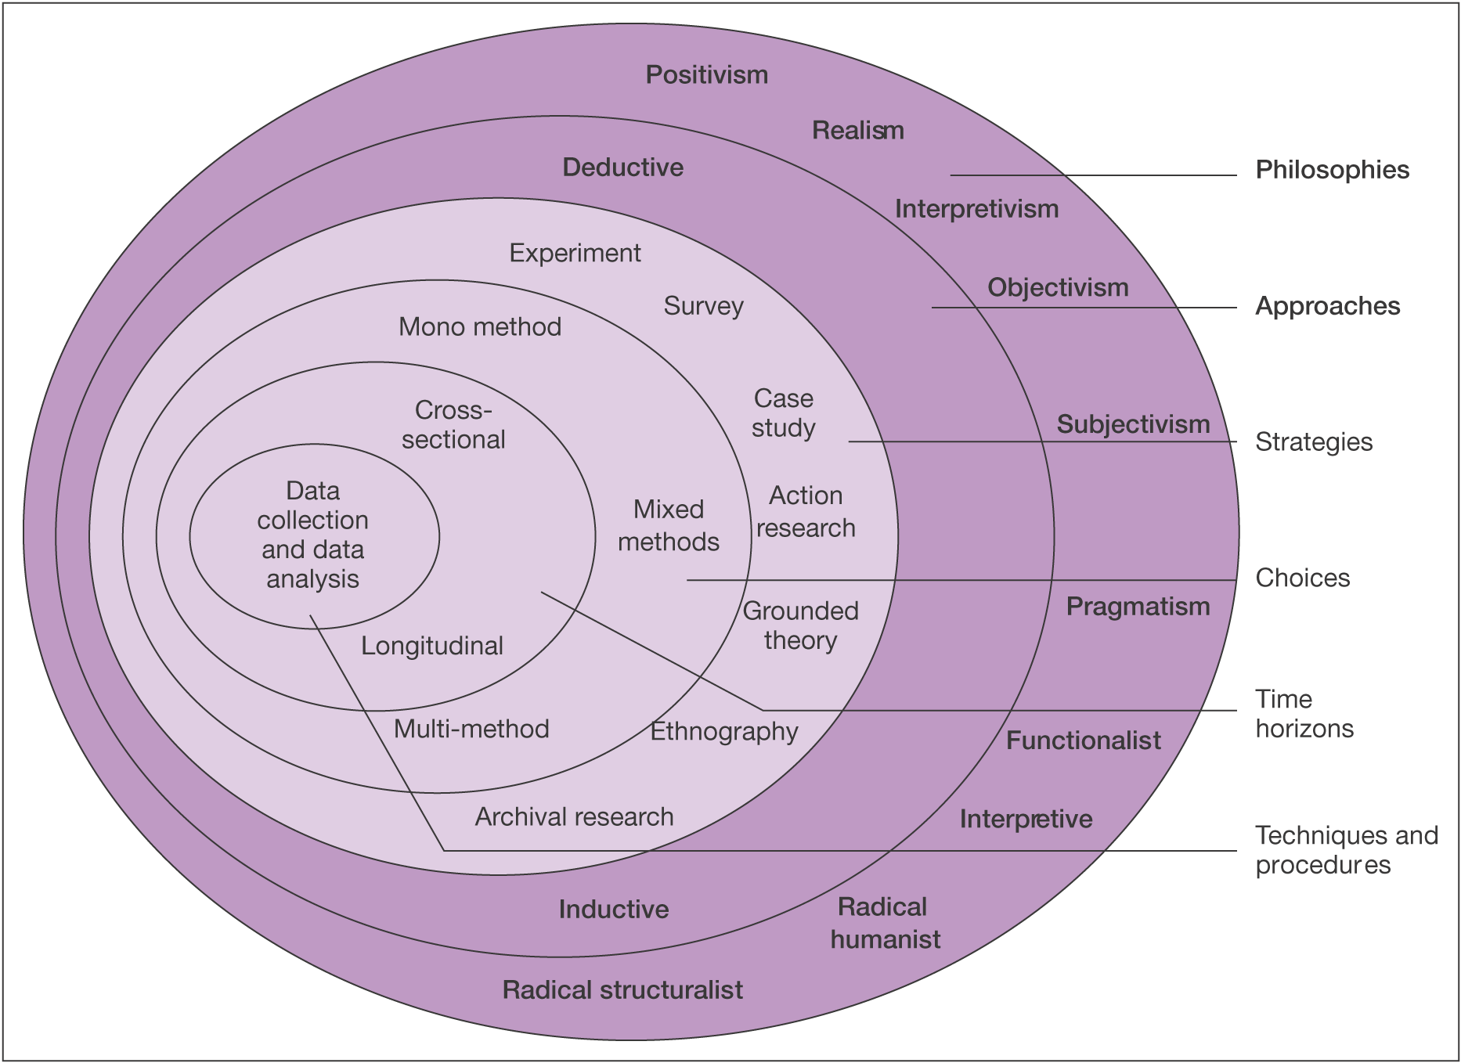

Fig 2. Research onion
Source: © Mark Saunders, Philip Lewis and Adrian Thornhill 2006 (45)
Before deciding on which method to adopt each layer of the ‘onion’ has to be peeled away and discussed. The first layer of the onion relates to the philosophy chosen that underpins the research. The second layer identifies the research approach that follows on from the philosophy. The third layer defines the research strategy, what strategy is used to conduct the research. The fourth layer determines the research choices of the research, what method is used. The fifth layer identifies the time horizons of the study. Finally the centre of the onion will show a culmination of all of the layers and show the data collection methods and data analysis techniques.

Research Design Process

There were two types of research that could have been used for the research; they are the positivism and phenomenology. Collis and Hussey (43) contend that the positivist approach “seeks the facts or causes of social phenomena with little regard to the subjective state.” Thus logical reasoning is applied to the research so that precision, objectivity and rigour replace hunches, experience and intuition as a means of investigating the research problem (43). Cornford and Smithson (46)state positivists believe that knowledge that is gained is based on observation or experience of real phenomena in an objective and real world. The positivist method is a quantitative, experimentalist approach which usually relies on the gathering of hard facts and statistics. According to positivists laws provide the basis of explanation, permit the anticipation of phenomena, predict their occurrence and therefore allow them to be controlled (43). They focus on the on the measuring of social phenomena rather than the meaning. The second type of research that could have been used is that of phenomenology. Phenomenology has been identified by Collis and Hussey (43) as :-
“The phenomenological paradigm is concerned with understanding human behaviour. This approach stresses the subjective aspects of human activity by focusing on the meaning, rather than measurement of social phenomena”
Within phenomenology the researchers aim is build knowledge of an event based on how they perceive it through their own eyes (43). Saunders et al (45) contend that reality is socially constructed, based on participants’ perceptions, and needs to be understood rather than trying to generate facts.
After reviewing both of the identified research methods the phenomenological paradigm was selected as the research method, this was decided upon as the research is aims to understand rather than measure the ethical concerns created by the internet in relation to online pharmaceuticals.
This approach is suited to the research as by looking at and analysing online pharmaceutical websites the research gathered will be subjective to human interpretation behaviours and feelings rather than a set of guidelines or rules.
The research also suits the phenomenological philosophy as the research will be conducted using small sample, the research will be conducted in the natural setting of the internet and also in the study the researcher is part of the study meaning the results will be subjective. All of which are key features of the phenomenological philosophy.
Some of the key features of the phenomenological approach are shown below:

Phenomenological
Tends to produce qualitative data
Uses small samples
Concerned with generating theory (inductive approach)
Data is rich and subjective
The location is natural
Reliability is low
Validity is high
Generalises from one setting to another

Fig 3. Features of phenomenology. Source: Collis and Hussey (43)

An original framework for this research has been developed using criteria identified from the literature. As a result the study will produce qualitative rich data that will be quantified into a tabular format based on the interpretation of the researcher. This data can then be interpreted by the researcher to identify which websites are the most and least responsible for the ethical risks identified. As a result the logic of this research is inductive; this logic is closely linked to phenomenology. The inductive approach aims to build the theory rather than use the existing theory, it does this by collecting data, analysing it and then developing the theory from the data analysis results (43). The outcome of the approach is to add the knowledge found to the existing body of knowledge already present in that area. Collis and Hussey (43) state that an inductive approach is necessary when the study contains qualitative data.
There were many strategies available that could have been used during the research and all would have been appropriate to the nature of the research. Of the strategies available the two which are most appropriate are that of a cross-sectional study and that of a case study. According to Collis and Hussey (43) a cross-sectional study is traditionally a positivist methodology designed to gather information on different variables in different contexts, but at the same time. Cross-sectional studies are conducted when the researcher is faced with constraints of time and/or resources. The data is collected once, over a short period of time and is then later analysed and reported (43). Conversely a case study approach is more associated with the phenomenological methodology (43). Eisenhardt cited in Collis and Hussey (43) refers to a case study as a research study which focuses on understanding the dynamics present within a single setting. Case studies are often described as exploratory research, used in areas where there are little previous theories or a deficient body of knowledge (43). The chosen strategy for the research was to use a case study approach. a selection of six UK and international pharmaceutical websites were chosen and analysed to produce a rich in depth analysis of the ethical risks and the mechanisms in place to minimise the risks. A case study would also be useful in this research as the research does focus on the dynamics within a single setting in this case the internet, as mentioned this research could be described as exploratory as there is very little if any previous study that this research can be based on.
The time horizon of the research is cross-sectional as opposed to longitudinal. This is because the research will analyse the websites in a ‘snapshot’ of time rather than studying the websites over a substantial period of time. All of the websites used will be analysed from pre taken screenshots of the site, rather than how the website looks at the time of the completion of the research, given the short span of time for academic dissertation research.
There are two main sources of research data that was collected for this research, these being primary data and secondary data. Primary data is the data that is collected by the researcher at source (43), secondary data is data that has been collected by somebody else and already exists such as books and journals (43). The secondary data that was used during this research can be found in the review of literature where academic texts, journals, books and websites were used to identify and analyse the topic of this research. The primary data used was obtained from the reviewing of the chosen pharmaceutical websites; this was achieved by using the criteria identified from the literature to create an original framework for the research.
In order to decide upon which data collection and analysis method was best for the research a number of different strategies were considered and reviewed, the method that was selected for use was that of a content analysis. Holsti (47) defines content analysis as ‘any technique for making inferences by objectively and systematically identifying specified characteristics of messages’. Another definition of content analysis is proposed by Babbie (48) content analysis is the study of recorded human communications, such as books, websites, paintings and laws. Although traditionally thought of as a positivist approach in this instance it could be argued that the research for which it is used is more of a phenomenological paradigm as the researcher is trying to understand the phenomena of the human behaviour rather than measure it. According to George cited in Krippendorf et al (49) content analysis can consist of both quantitative and qualitative data. Quantitative content analysis is, in the first instance, a statistical technique for obtaining descriptive data on content variables (49). Quantitative content analysis is concerned with the frequency of occurrence of given content characteristics. Qualitative content analysis is concerned with analysis where communication content is categorised and classified. For this research a qualitative content analysis was conducted. The content analysis will produce qualitative data which will be quantified for analysis purposes as once the framework is complete and the websites scored, an in depth look at each website will be carried out to measure the communication content of the websites. There have been many advantages recognised of using a content analysis approach. A content analysis is unobtrusive, it can deal with large volumes of data, it is systematic and finally content analysis allows for flexibility, they can be used with other data to produce results and conclusions (50).
The fact that an advantage of a content analysis is the ability to deal with large amounts of data is relevant to this study as there will be a lot of information generated from the chosen websites that needed to be analysed to help provide results for analysis. The research will also produce lots of qualitative data so the use of a content analysis framework will help to categorise the ethical risks identified. Although it is an advantage that a content analysis can deal with a large amount of data which is what the research requires there are some that argue that a content analysis is not feasible when studying websites. McMillan (51) states that very few have applied the use of a content analysis to the internet and identifies that a problem with conducting an internet based content analysis is related to the question “what does the term website mean”. If the term website is not fully understood then how can a website are analysed. In reference to this research this issue is not a hindrance to the results as the websites selected will be scrutinised and analysed as a whole with special attention being paid to the issues that relate to the decided upon criteria that will make up the content analysis framework.

Credibility of Research

It is imperative that the results and findings of the research are credible. If results are not credible then they will not be acknowledged and will not produce accurate results to the research. Robson (52) has identified that the two main tests of research credibility they are reliability and validity. However when dealing with qualitative data Lincoln and Guba (53) prefer the terms credibility, transferability, dependability and conformability as tests to measure credibility of the research. With relation to this research a case study approach was adopted which could be seen to be unreliable, this is because the study may will be unrepeatable this is due largely to the issue of subjectivity of the researcher. If a separate researcher was to conduct the same study the results they conclude may differ to the results concluded from this study. In regards to validity this research could be accepted as valid as the research finding will represent what is actually happening, this is because the criteria for observation was generated from the academic texts discussed in chapter 2 of the research. The research will also have high validity as case studies are high in validity as they go in depth into a small number of separate cases producing rich data (qualitative)

Ethical Implications

As the research strategy being used is content analysis there are very few research ethical issues that can affect the research this is because there are no participants of the research it is entirely internet based. One risk that the research may face is data integrity, to overcome this it has been decided as previously mentioned that the screen shots of the websites will be recorded for use at a later date. A second risk is the effects of the research on the researcher, the researcher has to ensure that they do not become too involved in the research and find that the topic is causing them any harm. To ensure that all ethical issues are met then appended to this proposal there is a completed ethics approval form.

Analysing Results

Once the websites have been evaluated using the indentified criteria then the results generated can determine whether the objectives of the research have been met. During the content analysis the websites will be given a score for each of the evaluation criteria with one being the worst and five being the best. Once the framework is complete a more in depth discussion of the websites will be carried out to identify any ethical risks that may have arisen from the websites.

Design of the Original Framework for Evaluation

The framework for the evaluation of the websites was created by identifying and defining research criteria which came from the theory and literature on the topic. Once identified these criterion formed the original framework for the research and is displayed in a matrix. The original framework was then used to analyse a selected cross section of pharmaceutical websites via screen shots for evidence of ethical risk and mechanisms in place to minimise risk to users. Once the data collection stage was complete all the information gathered was organised and evaluated. At the data analysis stage of the research the accessed content of the selected websites was reviewed to identify the similarities and differences between each individual website. Robson (52) states that reliability in qualitative research is represented by the dependability or consistency of the findings. As a result it was important that the research carried out remained consistent this was achieved by ensuring each of the selected websites was analysed using the same criteria from the original framework. The websites that were selected for analysis were a cross section of sites from the UK and America and are a mix of both well known pharmaceutical companies and less well known companies. The sites were selected as it is assumed that the more well known pharmaceutical company websites will conform to stricter ethical standards as oppose to the less well known sites, this will give an opportunity to compare the sites in relation to their ethical standards and easily identify any ethical shortcomings they may have.
The sites that were chosen to be analysed were:
- www.webmedshop.net
- Legalgodhealth.com
- www.rowlandspharmcay.co.uk
- www.boots.com
- www.pharmland.net
- www.magicpharma.com
As part of the analysis a numerical score system of 0-5 was used to measure the features of each website, an example of this is if there is a clear link to an online doctor or medical advice team to help a user if they are unsure of what drugs they need to use to help an ailment or to find information on the side effects of drugs. If this link and information is clearly available and can be located within a minute of visiting the site then the site will score 5, if the information is not available after an extensive search then the website will score 0.
Rating | Reasoning
1 | - No information  - Hard to find information  - No control of ethical risk
2 | - Limited information  - Information found within 11 – 15 minutes of accessing site  - Poor control of ethical risk
3 | - Small amount of clear information  - Information found within 6 – 10 minutes of accessing site  - Acceptable control of ethical risk
4 | - Clear and appropriate information found  - Information found within first 5 minutes of accessing site  - Good control of ethical risk
5 | - Detailed information found  - Information found immediately upon accessing site  - High control of ethical risk
Fig 4. Scoring method used to analyse websites.
Using a scoring system will allow the results of the analysis to be grouped and displayed clearly, it will also separate the websites from one another, and it is possible that the established websites will score higher than the less established websites. The criteria that will be used for the research will be outlined below and then a discussion as to why these criteria were selected will be carried out in the following chapter.
 | Criteria
1 | Age verification present?
2 | Health and safety guidelines?
3 | Access to doctor/medical advice?
4 | Anonymity of customer?
5 | Is the website a registered Pharmaceutical institution?
6 | Quantity of drugs that can be purchased?
7 | Self diagnosis option?
8 | Creation of user account?
9 | Websites privacy/ethics policy?
10 | Do they offer cheaper generic drugs as oppose to the well known drug name?
Fig 5. The ten criteria used to analyse the selected websites
The results generated will help to determine how ethical the websites are and indentify any weaknesses with the websites. Screenshots will be used to illustrate both the ethical and non-ethical features of the chosen websites.
This chapter has discussed the different research methods available and has identified the one most appropriate to the study. This section has explained the research process and the underlying reasons justifying any research methods chosen. The following chapter “Analysis of results” will produce the results and interpret all the data gathered during the primary research stages.

Chapter 4

Analysis of Results

This chapter critically analyses and presents the results obtained from the content analysis of six online pharmaceutical websites in relation to the following three research objectives:
- To evaluate the ethical dilemmas associated with pharmaceutical E-Commerce.
- To create an original framework to aid a content analysis of online pharmaceutical websites with regard to ethical risk to users.
- To evaluate ethical risk to users of pharmaceutical websites and the control mechanisms implemented by the pharmaceutical organisations, as evidenced by a content analysis of their websites.

The following sections will analyse the collected results in relation to the objectives that guided the study.

4.1 Selection of Original Criteria

All the criteria that were selected to compose the content analysis came from Chapter 2 Review of Literature and the literature on the topic of Pharmaceuticals and Online Pharmaceuticals. There appears to have been no previous study of this nature, however certain themes that were discussed in chapter 2 have been adopted in this study. These themes include the ethical issues related to the internet identified by Weckert (31) such as anonymity if a person can use a pharmaceutical website anonymously will they be tempted to buy more or behave differently knowing that they are not being watched and monitored. Another of the themes adopted was that of Van Den Hoven (32) and his four category model which is used to identify whether ethical issues occur in the internet world, outside the internet world or both. Using the aforementioned theories enabled the researcher to identify ethical concerns with the websites and discuss these concerns.
As mentioned the list of evaluation criteria was devised from the literature and the criteria are discussed in detail below:
- Age verification present – this criterion was derived from the issues of anonymity identified by Weckert (31). Age is an ethical issue as you have to be over the age of 16 to by over the counter pharmaceuticals in UK. By using the internet anonymously any person will be able to obtain pharmaceuticals no matter how old they are. A higher score will be awarded to the sites that have age verification in place.
- Health and safety guidelines- it is assumed that most pharmaceutical websites have a code of ethics about how users should treat the site as mentioned by Ferrell and Fraedrich (29). Also pharmaceutical sites should have a clearly noticeable and easy to locate safety guidelines informing the customer of the information on the site and how the customer should treat any information that the find on the site. Not all sites may have a code of ethics or safety guidelines and this may have implications for the users of a site. A higher score will be awarded to sites where the codes of ethics are easily identifiable and easy to locate.
- Access to doctor/medical advice- this criteria was developed with reference to one of the four problems identified by Hoven (30) problem of moral ignorance, a customer may not know the underlying side effects of a drug they buy from the internet and over time without support a customer may become addicted to a drug or even use the wrong drug, by having the ability to talk to an doctor online a customer can ensure they are taking the right drugs and that they are not causing any lasting damage to the customer, the doctor will also be able to advise the customer on the quantity of drugs needed.
- Anonymity of customer- this criterion was again devised from Weckert (31)and the problem of anonymity. By maintaining an anonymous persona on the internet a user will be able to have more freedom over how they operate whilst on pharmaceutical websites. A customer could anonymously use pharmaceutical websites to buy drugs without having to disclose to anyone why they are buying the drugs and what are they for. A higher score will be awarded to sites that encourage customers to create user accounts.
- Is the website a registered pharmaceutical institution- this criteria was developed as it was identified in the literature that pharmaceutical that operate from within UK have to be registered with the RPSGB (14) this is a governing body that regulates the pharmaceutical industry and ensures nothing is wrong, they will also have information on what is legal to sell and what quantities can be sold. If a website is not registered with the RPSGB then they are not governed and so can sell any quality drug legal or illegal without any opposition. A higher score will be awarded to a website that is registered and governed by the RPSGB.
- Quantity of drugs that can be purchased- this criteria was developed from multiple theories investigated in chapter 2, firstly it could be argued that a customer would purchase a large sum of pharmaceuticals with the intention of selling them on which as identified by Henderson (42) is considered unethical. This criteria also relates to the ethical issue of Uncontrollability discussed by Weckert (31), who is in control of the sites is it ethical for one customer to purchase any quantity they desire.
- Self diagnosis option- this criteria has links to another of the chosen evaluation criteria Access to doctor/medical advice in the way it relates to the issue of moral ignorance. This criterion also arose from the fact that it has been argued by De George (19) that people who are venerable are at risk of using the internet in a problematic way. It could be argued that venerable people are the sort of people that use these sites and so if a non accurate self diagnosis tool is used or a self diagnosis tool is not available then these venerable people could end up doing more damage to their bodies. It is also important to ensure an accurate diagnosis tool is used as the popularity on online pharmaceuticals is growing and more people use the sites (12) so a poor diagnostic tool could cause issues for many people.
- Creation of user account- this criteria was identified as being of use to the research as previously identified by Weckert (31) anonymity is an issue with the internet. Anonymity is also an issue with pharmaceuticals as if someone can purchase pharmaceuticals anonymously there may be more temptation to buy a variety of medicines that may or may not be beneficial as the identity of the customer remains anonymous so there is little pressure to do what is right. Also this criterion will identify whether a customer will have to create an account by registering personal details, this would indicate stronger security measures and also eliminate the anonymity of customers using the websites.
- Websites privacy/ethics policy- this criterion was developed as Langford (28) states that all internet websites should have a code of ethics of how users should behave? The websites codes of ethics and privacy should be available easily so the users can access them and read up on any ethical issues with the site.
- Do they offer cheaper generic drugs as oppose to the well known drug name – as identified in chapter 2 the introduction and development of generic drugs has helped the pharmaceutical market to grow and for more websites to sell generic drugs. This could be a problem as mentioned as generic drugs are often made with cheaper imitation substances which do not always contain the same properties as the original drug, so generic drugs could be harmful.

4.2 The websites for the Cross-Case Analysis
The websites for analysis were all first visited when research was being collected for the study prior to the content analysis stage in March 2010. At that time the desired screen shots of the websites were taken and saved ready for when the analysis of the sites would take place. The following is a description of the cross-section of the websites that were used for the analysis stage.

4.2.1 Webmedshop

URL : http://www.webmedshop.net
Webmedshop is a US based pharmaceutical website. The website specialises in selling of generic medicines from the US around the World. They offer drugs on almost any illness and also offer prescription drugs without prescription. Features of the site include testimonials where other users have left comments as well as a live support to talk to someone from the site with any queries.
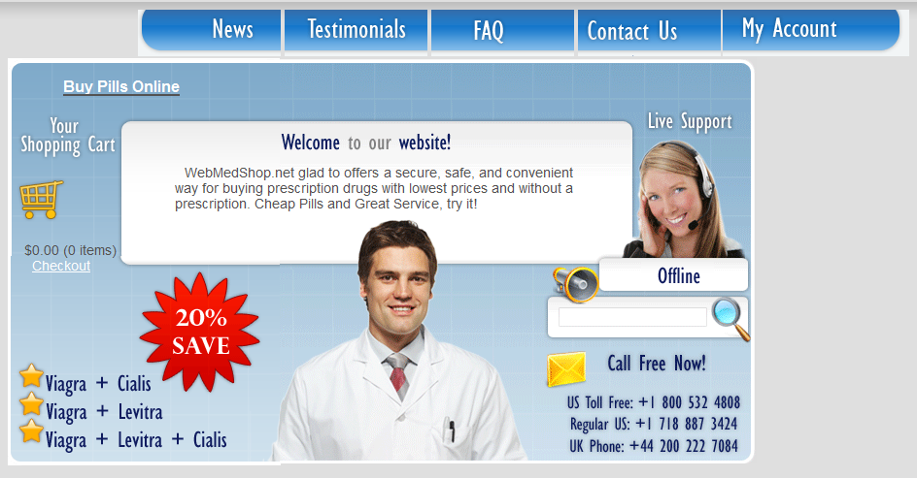

Fig 6. Webmedshop homepage (54)

4.2.2 Legalgodhealth

URL: http://legalgodhealth.com
Legalgodhealth is an internet pharmaceutical website whose office is based in Nicosia, Cyprus but their main target market is the American market, the website also targets Europe and Asia but most promotion is targeting America. Again as with Webmedshop the site offers only generic drugs, without the need of prescription. Features of the site include testimonials, a track order function and online support; they also have a search function where a user can search for a specific medicine if they are unable to find it on the site.
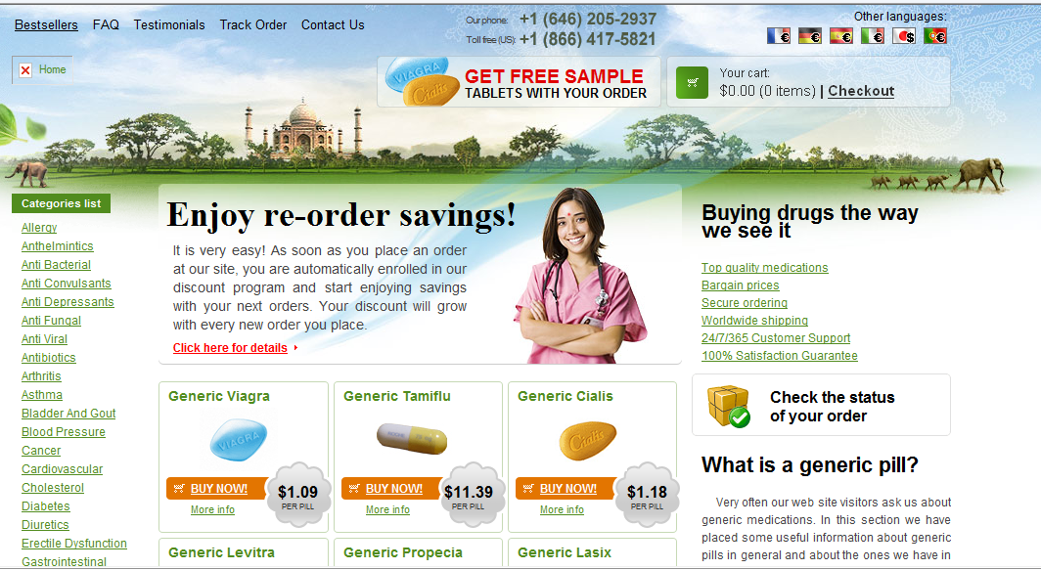

Fig 7. Legalgodhealth homepage (55)

4.2.3 Rowlands Pharmacy
URL: http://www.rowlandspharmacy.co.uk
Rowlands pharmacy is a UK based website that only supplies customers within the UK with medicines. The website does not deal with generic medicines only the brand name. The website is linked to a well known pharmacy company within the UK Rowlands Pharmacies. The website offers over the counter drugs as well as prescription drugs, however it does not offer prescription only drugs to people without a prescription. The website has several features including testimonials, customer care, contact us. As well as the general features the website also allows the customer to have their prescriptions delivered to their house, the website also allows the customer to locate their local high street Rowlands pharmacy in case they need to visit them.

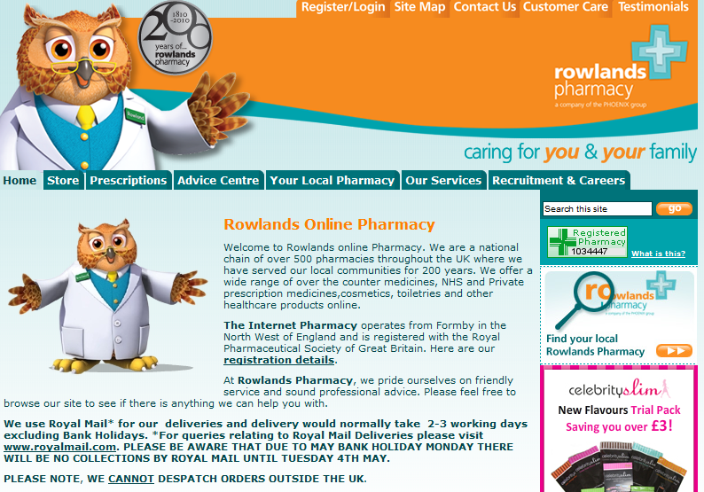
Fig 8. Rowlands homepage (56)

4.2.4 Boots Pharmacy
URL: http://www.boots.com
Boots pharmacy is another UK based pharmacy that only offers its services to customers within the UK. The website again only deals with brand name medicines not generic medicines and prescription only drugs are only given to customers who have a prescription for those drugs. It does offer over the counter medicines but these are medicines needed for general health issues such as cold and flu. As well as offering medicines the websites also offers a wide range of health products, it does more than just sell pills. The online community of boots is heavily linked with the well known high street shop of the same name. The website has many features, much the same as the features previously identified testimonials, order tracker, home delivery, access to support, store locator. This website however does have a unique feature and this is health news this is a section where a customer can look and find up to the minute news that is released in the industry whether it be on new drug releases or recalls.

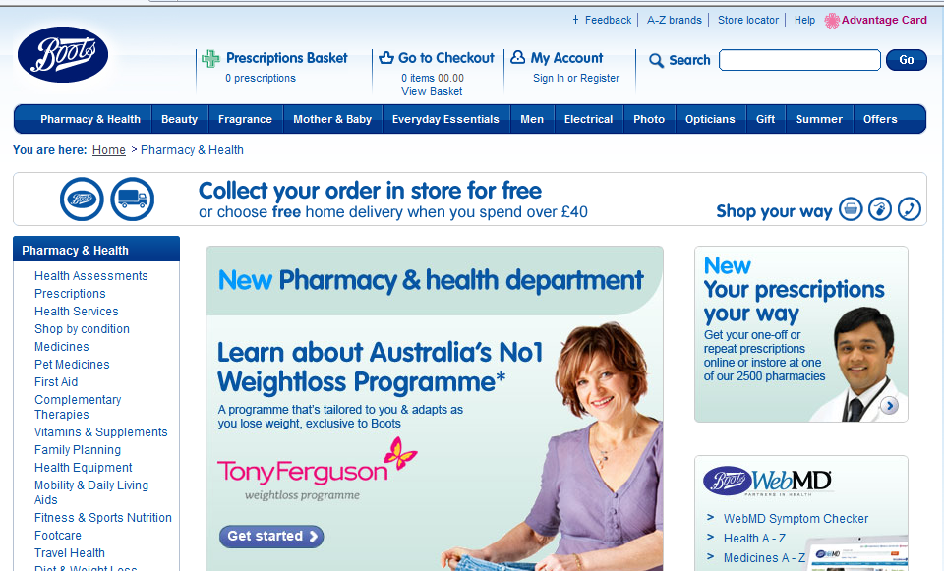

Fig 9. Boots homepage (57)

4.2.5. Pharmland

URL: http://www.pharmland.net
Pharmland is a website only pharmacy that is run from and based in Cyprus but targets mainly the American and European markets. Pharmland deals solely in the generic medicine market. It allows the customer to buy prescription medicines and over the counter medicines off the website with no queries. The website does not have as many features as other sites as the only additional feature available is contact us, however the website does offer extras, at the time of analysis the website was offering an extra 20% of pills free on a customers’ next order.

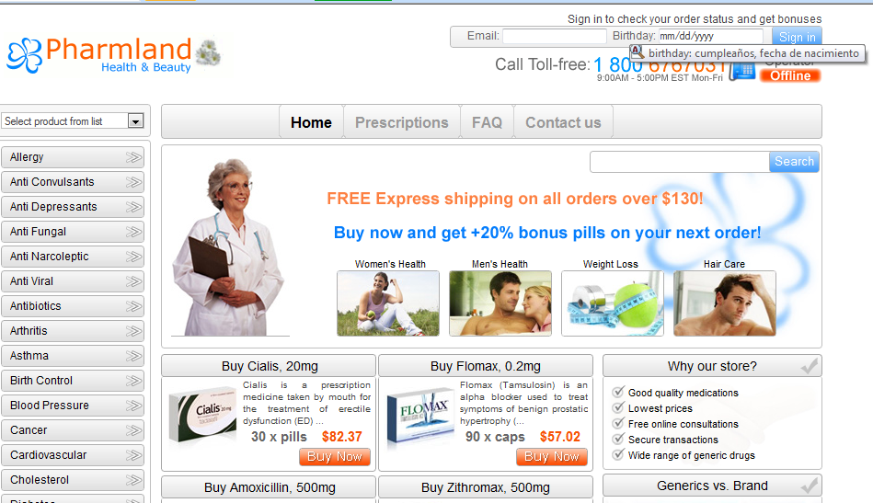

Fig 10. Pharmland homepage (58)

4.2.6 Magicpharma

URL: http://www.magicpharma.com
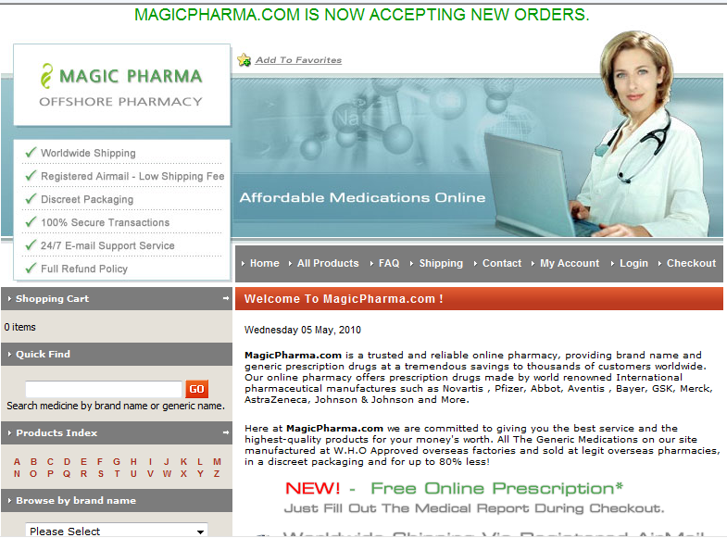
Magicpharma is an international offshore website only pharmacy. Its main target is again the US and UK. The website offers any medicines through their website prescription or otherwise. The website offers both the generic and brand name medicines. The features of the website are typical of the features found on the other sites already identified. This site also states that medicines will be delivered in discreet packaging as to ensure that the delivery company do not know what a customer is buying.

Fig 11. Magicpharma homepage (59)

4.3 Results of Analysis

The following subsections will contain a discussion relating to each of the criteria and the findings of the content analysis on the pharmaceutical websites. Ten criteria were selected that when applied to the websites would help to identify how ethical the website is. From the pharmaceutical websites analysed, Legalgodhealth.com scored the lowest with 15 points and Boots.com scored the highest with 38 points out of a possible 40. Thus according to the research it can be assumed that out of the websites analysed that Boots is the most ethical site based on the criteria.

4.3.1. Age verification present
Website | Age verification
Webmedshop | 1
Legalgodhealth | 1
Rowlands | 4
Boots | 4
Pharmland | 3
Magicpharma | 3

After analysing the websites only four of the six websites had information on a minimum age and a tool for ensuring that a customer’s age is identified. No site achieved a 5 point rating on these criteria as it was not clearly visible on any site that a customer needed to input their age or that once an age was entered is was verified. The two sites that scored 4 points on this criterion are Boots and Rowlands pharmacy both sites required a user to create an account before a purchase could be made and during the registration process a customer was required to input their date of birth.

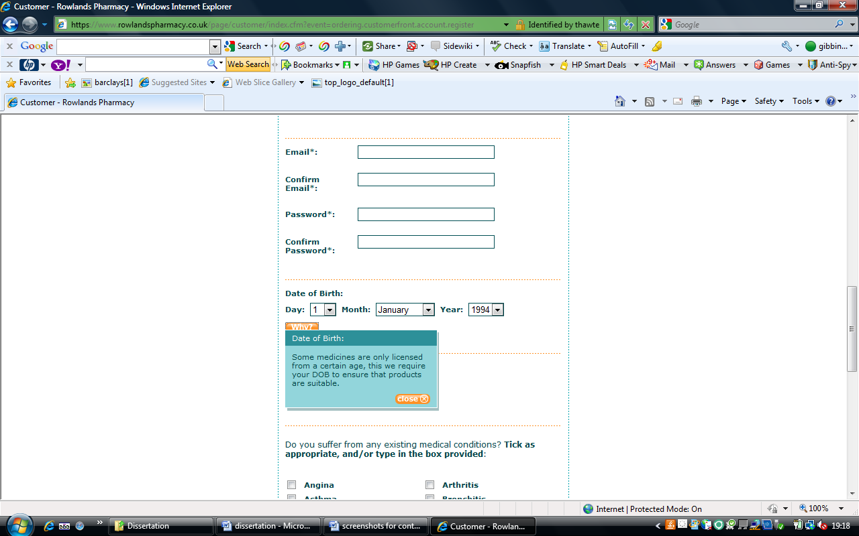
Fig: 12
Date of birth entry on the Rowlands registration form (60)

Other sites such as Webmedshop and Legalgodhealth scored a 1 in relation to this criterion this indicates that there was no evidence of a customer needing to identify their age when using the site after an extensive search of the site. This has the potential to be a problem as if there is no age verification then a customer of any age could use the site to purchase medicines which could be harmful and dangerous as some medicines are only licensed to be used by people over a certain age. Although Boots and Rowlands required the user to enter a date of birth there was no clear information as to whether the age was being verified, to eliminate the ethical risk a website has to ensure age is verified this can be done in many ways firstly the payment could verify age, if the user is opting to pay by credit card then their age is verified as adults not children can only have a credit card, however is payment is made by PayPal then there is opportunity for a child to purchase medicines through their PayPal account

4.3.2 Health and safety guidelines?

Website | Health and safety guidelines
Webmedshop | 2
Legalgodhealth | 1
Rowlands | 4
Boots | 5
Pharmland | 3
Magicpharma | 4

All of the websites analysed apart from one had an ethical statement and website code of practice, as well as safety guidelines informing the customer of how to treat the information they find on the site. The highest scoring website on this criterion was again Boots website on the main pharmacy page there is a link to the websites code of ethics and website code of practice. This is what was expected as the boots website is linked to the main high street store which a well trusted name so it was assumed that the website would have high ethical compliance and a strong code of practice. The site that only scored 1 on this criterion was Legalgodhealth although the website had policies none of them related to an ethical statement of the site or code of practice with no ethical statement visible the website cannot be deemed ethical.
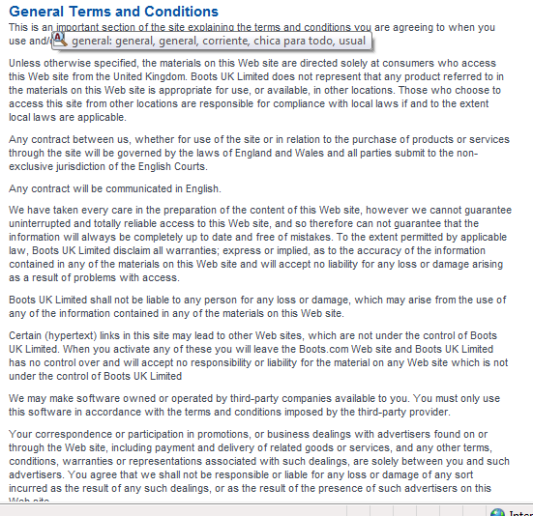
Fig: 13
Terms and conditions from Boots website (61)

Boots also scored highly as the guidelines and statements are in depth and informative ensuring the customer knows all they need to know in relation to the website. The more information the more reduced ethical risk experienced from the site so websites who have a very small word count on their safety guidelines and ethics code could be presenting more ethical risk to the user.

4.3.3 Access to doctor/medical advice
Website | Access to doctor/medical advice
Webmedshop | 2
Legalgodhealth | 2
Rowlands | 4
Boots | 5
Pharmland | 2
Magicpharma | 2

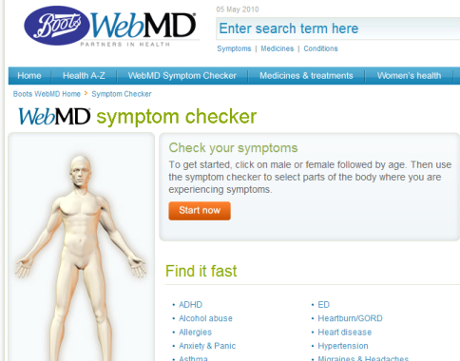
All of the websites analysed in some capacity allow customer’s access to an online doctor or medical advice to help them in the decision making. Again the best site is Boots closely followed by Rowlands both of these sites offer the customers the chance to speak to a qualified pharmacist who can answer any queries they have. All the other sites have scored two points as all have advertised a option to talk to a professional online however this option is achieved through an instant chat window, not only is there a possibility the chat not work due to the global location of the sites but also there is no proof that the professional that is available for chat is qualified so the advice the customer has could be biased. As well as having online advice the Boots website also has on online symptom checker where a customer can check their symptoms’ without the need to speak to another person.
Fig: 14
The boots website online symptom checker (62)

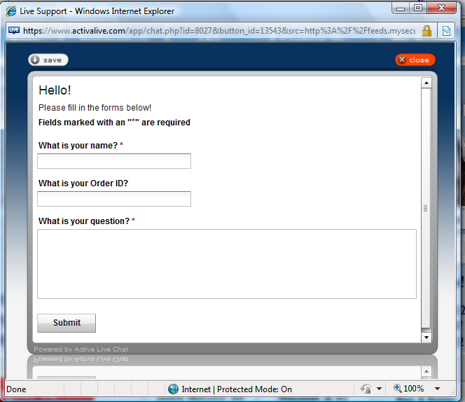
Fig: 15
The online chat option available
on Webmedshop (63).

4.3.4 Anonymity of customer
Website | Anonymity of customer
Webmedshop | 3
Legalgodhealth | 2
Rowlands | 5
Boots | 5
Pharmland | 4
Magicpharma | 4

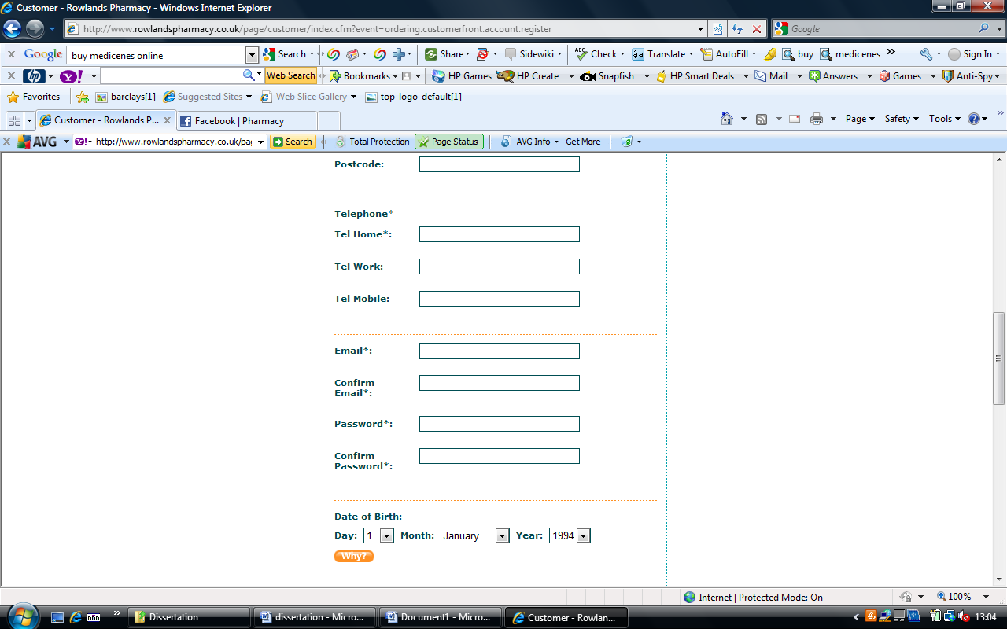
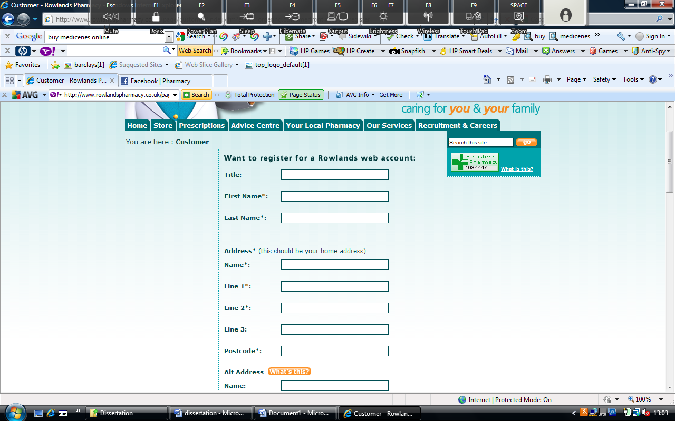
Again all websites have scored points in relation to this criterion; however the sites show different levels of customer anonymity. As identified by Weckert (31) anonymity is an issue online so a site with a low score on this criterion allows the user a high level of anonymity and a site with a high score eliminates user anonymity. Again as with many criterions the highest scoring websites are Boots and Rowlands who both score a 5. This is due to the fact that both sites require a customer to register with the site before any purchases can be made and when registering the customer has to provide their first names and surname, thus ensuring a user has no anonymity on the site. Pharmland and Magicpharma have also scored quite highly as although a customer is able to search and add medicines to cart anonymously a first name and surname along with other information is required before purchasing. Again Webmedshop and Legalgodhealth score the lowest with 2 each as these sites allow a user to remain anonymous throughout the purchasing process, the only time a name is required is for the delivery page where a delivery name and address is needed. The sites who have only scored 2 can be seen as less ethical as by allowing customers to remain anonymous you are also presenting customers the opportunity to behave in a manner that may be discouraged if their identity is known.
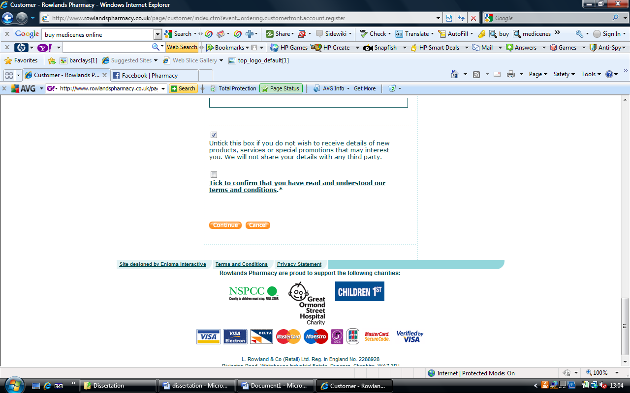
Fig: 16 Rowlands pharmacy registration form (64)

4.3.5 Is the website a registered Pharmaceutical institution?
Website | Registered pharmaceutical institution
Webmedshop | 1
Legalgodhealth | 1
Rowlands | 5
Boots | 5
Pharmland | 1
Magicpharma | 1

Unsurprisingly only two of the analysed websites are registered pharmaceutical institutions. The two sites are Rowlands pharmacy and Boots pharmacy, the two sites that are based and run from within the UK. As stated by the RSPGB (14) any pharmaceutical website that operates from within the UK has to be registered and operate within the RSPGB guidelines. Being registered pharmaceutical websites has also reduced the ethical risks that these websites pose as they are governed to ensure they are acting and promoting pharmaceuticals responsibly and ethically. None of the other sites analysed are registered and so there is more chance of there being ethical risks related to the sites. It is not surprising to discover that all of the unregistered sites are cross border trade pharmacies and as a result are not governed by the strict rules that the UK sites have to adhere to. As they are not governed they are able to sell any medicine prescription or not and any quantity which is unethical and could be of danger to the customer.
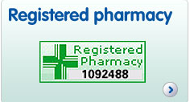
Fig: 17 registered pharmacy logo and registration
number of Boots (65)

4.3.6 Is there a limit to the quantity of medicines that can be purchased?
Website | Limit to quantity of drugs purchased
Webmedshop | 2
Legalgodhealth | 3
Rowlands | 5
Boots | 5
Pharmland | 3
Magicpharma | 3

There is an ethical risk associated with quantity of medicines available to buy. The more medicines that a customer can buy the more ethical risks are attached to the purchase. The ethical risk associated to this criterion is that identified by Weckert (31) of uncontrollability, who is in charge. Allowing a user to purchase in quantity does not only ask the question who is in control but also the user could be buying in quantity and taking more medicines than recommended or worse could be buying the medicines to sell on to their friends which has ethical implications for the user and the friends as they might not be the right medicines that the person needs. The two highest scoring websites are once again Rowlands and Boots pharmacies who both scored 5 points as they have limits on the quantity of drugs that can be bought this is mainly achieved through the fact that they do not offer prescription only medicines to customers without a prescription so when medicines are dispensed an agreed quantity of the drugs are distributed only. All of the other analysed sites scored points with relation to this criterion as all websites do have a limit to the quantity of medicines they sell however the sites all offer the medicines in a larger quantity than is available via prescription, this is an ethical risk as previously mentioned allowing a customer to buy in bulk could be harmful to the customer, as well as being unethical.
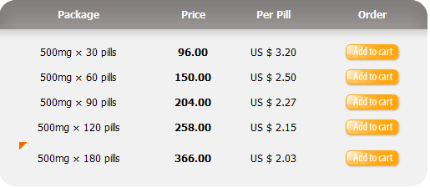
Fig: 18
Chart showing the quantities of medicines
Available from Webmedshop (66).

4.3.7 Self diagnosis option?
Website | Self diagnosis option
Webmedshop | 1
Legalgodhealth | 1
Rowlands | 3
Boots | 4
Pharmland | 2
Magicpharma | 2

Out of the analysed websites none of them scored the maximum 5 points in relation to this criterion. The highest achieved score was 4 points and that was by the Boots website. As with all of the criteria there is an ethical risk attached to the criterion. If there is no self diagnosis available then the customer may not know what medicines they have to purchase and could by the wrong medicines which could be damaging to their health. The highest scoring website was Boots, although they did not score a 5 they still scored highly this was due to their symptom checker function, which allows a customer to check their symptoms online and can then inform them of the most problem illness and what medicines should be used to treat the illness. Again the two lowest scoring websites are Webmedshop and Legalgodhealth who both scored the lowest possible score of 1 neither of the websites offer any form of self diagnosis which suggests high ethical risk as they offer customers medicines in large quantities without a diagnosis tool which could have health implications for the customer.

Fig: 19
Boots symptom checker (62)

4.3.8 Creation of user account?
Website | Creation of user account
Webmedshop | 1
Legalgodhealth | 1
Rowlands | 5
Boots | 5
Pharmland | 3
Magicpharma | 4

The ethical risk attached to this criterion relates to the ethical issue of anonymity as discussed by Weckert (31). If a customer can use the website without having to create an account they can remain anonymous and therefore fell under less pressure to conform to the ethical statements of the website, also by ensuring a customer account is created the website administrators are able to keep a record of what medicines are being purchased and how often so they can act on any suspicious activity. The highest scoring websites were Boots and Rowlands pharmacies who both scored 5 and require a customer to create a user account before they can make a purchase. Magicpharma and Pharmland are the second two highest scorers with scores of 4 and 3 respectively. These sites do not require a customer to create an account to purchase medicines but do require the customer to enter their name on the payment screen before a payment can be processed. The lowest scoring websites were Webmedshop and Legalgodhealth with a score of 1 this is because these sites allow a customer to use the sites completely anonymously without requiring a customer to enter their name even at the payment stage all that is required is a billing name and address.

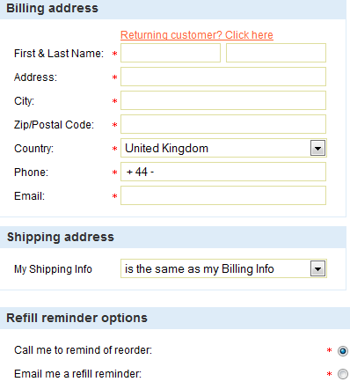
Fig: 20 Billing information page from Webmedshop (67).

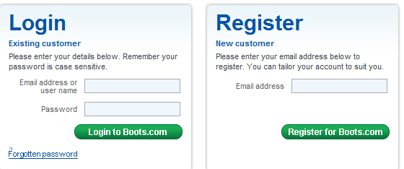

Fig: 21 The log in page for customer
accounts on Boots website (68)

4.3.9 Websites privacy/ethics policy?

Website | Ethics/privacy policy
Webmedshop | 4
Legalgodhealth | 4
Rowlands | 4
Boots | 5
Pharmland | 4
Magicpharma | 5

The ethical risk related to this criterion is that as stated by Langford (28) identifies that every internet website should have a code of ethics about how to use the website. The websites policies should be easy for the user to find so that the users know how they are expected to treat the information they find on the websites and how they should behave whilst using the websites. With relation to this criterion all the websites analysed scored highly as all of the websites had the policies clearly labelled and locatable on the websites home pages.

4.3.10 Do they offer cheaper generic drugs as oppose to the well known drug name?
Website | Generic Vs Brand name drugs
Webmedshop | Generic
Legalgodhealth | Generic
Rowlands | Brand
Boots | Brand
Pharmland | Generic
Magicpharma | Both
There is an ethical risk associated to generic drugs and this is that some people see generic medicines cheap shoddy imitations (39) that sometimes may contain harmful properties. Generic medicine is sold at a lot cheaper price which is why it is often seen as more desirable. Out of the websites analysed three websites sell generic medicines, two sell brand name medicines and one sells a combination of both medicines. The two sites that sell brand name only drugs are Boots and Rowlands. This is not surprising as these are also the only two websites that are registered pharmaceutical practices and are governed by a set of rules and so the medicines they offer have to comply with standards. The sites that are not registered are the sites that sell the generic drugs and are typically cross border traders so they sell the cheaper drugs across the world as its cheaper for these websites and businesses to succeed.

4.4 Analysis of websites
Name of  website | Overall Score out of a maximum of  40 | Ranking (highest to lowest)
WEBMEDSHOP | 17 | 5
LEGALGODHEALTH | 16 | 6
ROWLANDS | 39 | 2
BOOTS | 43 | 1
PHARMLAND | 25 | 4
MAGICPHARMA | 28 | 3
TOTALS (30)

After the websites have been analysed in relation to the criteria they can also be analysed as a website with the cumulative score for each website giving an indication to the ethical risks of each website and also what mechanisms the websites have in place to minimise these risks.

Fig 22 ranking of each individual website
As can be seen from the above caption the lowest scoring website as such the site with most ethical risk is Legalgodhealth scoring a low 16 points out of 45, in comparison Boots online pharmacy is the highest scoring website with 43 points out of 45 indicating that it is the website that has the lowest ethical risk and also the website with the best mechanisms in place to reduce the ethical risk to the user. As can be seen the remaining websites were spread out between the highest and lowest scoring websites with Webmedshop appearing to have the same low standards as Legalgodhealth and Rowlands pharmacy being the 2nd highest scorer of the analysed websites.

4.4.1 Webmedshop
After the analysis Webmedshop was identified as the 2nd lowest scoring website with a total of just 17 points out of 45. The highest mark achieved by the website was a score of 4 for the criteria websites ethics/privacy policy this was because the website did have a clear link and navigation to the sites policy from the homepage which the user could follow to find the policies. On the majority of the other criteria the website scored a lowly 1 or 2 points, remembering that 1 means no information or no control over the ethical risk identified. The website scored a 1 on both Age verification and registered pharmaceutical. With regards to age verification the website allowed a user to search the site and purchase medicines without ever asking for the user to identify their age and verify it. Scoring a 1 on registered pharmaceutical indicates that the website is not registered and therefore is not governed by rules meaning they are able behave and act differently to a registered pharmaceutical site.

4.4.2 Legalgodhealth
Legalgodhealth was identified as being the worse website and scoring the lowest total of just 16 points. The highest score achieved was a 4 whilst analysing in terms of the criteria websites ethics/privacy policy again the website had the relevant policies and they were easy to locate from the homepage. The websites other scores consisted of 1 point and 2 point scores. The website only achieved a 1 point score on 50% of the analysed criteria there was no information or control of ethical risk on the website in relation to Age verification, health and safety guidelines, registered pharmaceutical institution, self diagnosis and creation of user account. This suggests that the website poses many ethical risks to its users and that the website have very little if any mechanisms in place to manage these ethical risks.

4.4.3 Rowlands Pharmacy
Rowlands pharmacy was the second highest scoring pharmaceutical website with a total point’s tally of 39 out of 45. The lowest score achieved by the website was a score of three for self diagnosis which suggests that there was clear information found in relation to the criterion and that the website had acceptable mechanisms in place to control the risk. Although the website did not have an option for self diagnosis it does have an extensive advice centre where the website can give advice on most medical ailments and what symptoms are linked with these ailments. In relation to every other criterion the website achieved a score of 4 or 5 points indicating that the website has extensive and clear information and a high control over the ethical risks posed. Rowlands pharmacy was also only one of two websites that were registered pharmaceutical organisations which as previously discussed means they are governed by the guidelines of the RSPGB and as a result as evidenced by the website provide a better ethical environment for the user.

4.4.4 Boots Pharmacy
Boots online pharmacy was the highest scoring website, scoring 43 points out of a possible 45. This score identifies that the website has the most control and best mechanisms in place to reduce the ethical risk for the users, it also identifies that the website is very detailed and give relevant clear information on each of the criteria used for analysis. The lowest score achieved by the website was a score of 4; this was scored in relation to the criterions Age verification & Self diagnosis. A score of 4 is a high score in relation to the study as it means that the website has clear and appropriate information as well as a good control of the ethical risk. For every other criterion the website achieved a score of 5. Boots was the only website who achieved a score of 5 in relation to the criteria’s Health and safety guidelines & Ethics/privacy policy. This is because there was detailed information on both the health and safety guidelines and policies. They could be found easily from the homepage and had links to access them. The website also requires a new user to agree to the terms and conditions of the website when they register to use the site. Boots is the second of the registered pharmaceutical industries and as such is regulated and maintained in accordance with the RSPGB guidelines and only sells name brand medicines all of which help to control the ethical risk to the user.

4.4.5 Pharmland
Pharmland pharmacy was the fourth placed website scoring 25 points out of 45. The website only achieved a score of 1 in relation to registered pharmaceutical institution and this was due to the fact that the website was not registered. This allows the site to behave how they like as there is no one who can regulate them. This allows the website to sell generic medicines in high quantities and partake in cross border trade, as identified previously all of which can cause ethical risk to a user of the website. For every other criteria the website achieved a minimum score of 2 identifying that the website does have some information on the ethical risks analysed however in some instances it may be unclear or irrelevant to the user and that the website does have in place mechanisms to reduce ethical risk however they could be developed to improve the website. The two criteria which only scored 2 were Self diagnosis and Access to a doctor. The website scored low on these issues as there is access to medical advice however this is achieved through an email which may put the user off using as they will want immediate answers not to have to wait for a reply so the user of the site could go ahead and use the site without having any knowledge on what they should do or what medicines they should buy. Conversely the website scored a high score of 4 in reference to the criteria Anonymity of user, as the website insists that the user creates a user account which includes details such as name and address, reducing the ethical risk of anonymity.

4.4.6 Magicpharma
The final website analysed Magicpharma scored third highest overall with a total of 28 points out of 45. The website achieved only one score of 1 and again as with many of the other sites this was because the website is not a registered pharmaceutical website so it can sell generic drugs in high quantity and through cross border trade, there is no regulation. The website also achieved a score of 2 in relation to Access to doctor and self diagnosis, this is because there is an option to access medical advice but this is achieved through leaving a voicemail or email and then waiting for a response and there is no clear information on symptoms or a self diagnosis option. The website only achieved a score of 3 with regards to Age verification as although the user is required to input their age when they register to the site there does not appear to be a verification check and as payment can be made by visa electron as well as visa there is an opportunity for youths between the ages of 16 and 18 which could cause ethical risks. The website also scored a 4 in relation to anonymity of customer and necessity of user account, as the website required the user to create a user account before any medicines could be bought and also when registering the user had to enter their name and address reducing the level of anonymity the user has and thus reducing the ethical risk of anonymity.

4.5 Content Analysis table
The following table will contain the information relating to the findings of the content analysis on the chosen pharmaceutical websites. Ten criteria were selected that when applied to the websites would help to identify the ethical risks of each website. The frame work for the content analysis is an original framework created by the researcher based on issues identified from the literature discussed in chapter 2.

Name of  website | Age verification | Health and safety guidelines | Doctor  medical advice | Level of Anonymity | registered pharmaceutical institution | quantity of drugs that can be purchased | Does the website offer self diagnosis | Necessity of user account | access the websites privacy/ethics policy | Do they offer cheaper generic drugs as oppose to the well known drug name or both | Overall Score out of a maximum of  45 | Ranking (highest to lowest)
WEBMEDSHOP | 1 | 2 | 2 | 3 | 1 | 2 | 1 | 1 | 4 | Generic | 17 | 5
LEGALGODHEALTH | 1 | 1 | 2 | 2 | 1 | 3 | 1 | 1 | 4 | Generic | 16 | 6
ROWLANDS | 4 | 4 | 4 | 5 | 5 | 5 | 3 | 5 | 4 | Brand | 39 | 2
BOOTS | 4 | 5 | 5 | 5 | 5 | 5 | 4 | 5 | 5 | Brand | 43 | 1
PHARMLAND | 3 | 3 | 2 | 4 | 1 | 3 | 2 | 3 | 4 | Generic | 25 | 4
MAGICPHARMA | 3 | 4 | 2 | 4 | 1 | 3 | 2 | 4 | 5 | Both | 28 | 3
TOTALS (30) | 16 | 19 | 17 | 23 | 10 | 21 | 13 | 19 | 26
Fig: 23 Matrix displaying criterion shown by cross section of pharmaceutical websites

From the analysis of the websites it is clear that ethical risks are present in the online pharmaceutical world. The internet has created new ethical risks in relation to online pharmaceuticals such as anonymity of the user as well as drug buying habits and quantities. Another ethical risk to be considered is that that of age restrictions on buying pharmaceuticals. Therefore the results from the analysis support issues from the theory that the internet can create ethical risks in the pharmaceutical industry.
This chapter has presented and analysed the primary research of the study, that of the content analysis in relation to online pharmaceuticals. Chapter five will synthesise the published literature, determine whether the objectives of the research were met and make recommendations about possible future research of this type.

Chapter 5

Conclusion & Recommendations

This chapter synthesises the published literature relating to online pharmaceuticals with the primary research conducted in chapter 4 by means of a content analysis. The chapter is organised around the three objectives that guided the research. The objectives are as follows:
- To evaluate the ethical dilemmas associated with online pharmaceuticals.
- To create an original framework to aid a content analysis of online pharmaceutical websites with regard to ethical risk to users.
- To evaluate ethical risk to users of pharmaceutical websites and the control mechanisms implemented by the pharmaceutical organisations, as evidenced by a content analysis of their websites.

5.1 Ethical dilemmas associated with online pharmaceuticals
Chapter 2- Review of Literature discussed the ethical issues relating to the internet and online pharmaceuticals. As the topic of online pharmaceuticals is a broad issue it was decided to identify the main ethical issues relating to internet and then apply them to the topic of online pharmaceuticals. There were ethical issues relating to the internet and pharmaceuticals that would need to be considered during the research and these issues were identified by the published literature discussed in chapter 2. The published literature that was most valuable to the study was the work by Weckert (31) and Van Den Hoven (32) both of whom identified multiple ethical concerns of the internet and their theory was then applied to the world of online pharmaceuticals. Weckert (31) stated there were four main ethical concerns of the internet to its users these were identified as anonymity, interactivity, reproducibility and uncontrollability whereas Van Den Hoven developed his four category model of ethical issues as well as identifying four moral aspects of the internet which are Problems of jurisdiction, Problems of application, Problems of individuation and Problems of moral ignorance. After these ethical concerns had been identified they were then applied to the world of online pharmaceuticals and the risks they pose to the users of the pharmaceutical websites.
As there was very little previous work carried out in relation to ethics and online pharmaceuticals it was hard to determine how much weight the identified ethical concerns discussed in chapter 2 carried in relation to the online pharmaceutical world and it was for this reason that it was decided to use a framework for analysis of pharmaceutical websites to identify how relative the internet ethical concerns were to the pharmaceutical websites.

5.2 To create an original framework to aid a content analysis of online pharmaceutical websites with regard to ethical risk to users
As previously mentioned Chapter 2 of the research identified the ethical concerns of the internet and applied these concerns to the online pharmaceutical world, however as mentioned as there was little previous work in the area it was hard to determine how relative the ethical concerns were in relation to online pharmaceuticals. For this an original framework was created and used to analyse a cross section of the available online pharmaceutical websites for evidence of ethical risk they posed to a user. After the discussion stage in chapter 2 the criteria that would be used for analysis were selected. A total of ten criteria were selected to be used and all came from issues identified in the literature. The ten selected criteria were as follows:
Age verification present this criterion was selected as it was identified early in the literature by Weckert (31) as a product of anonymity as by remaining anonymous a user can hide their age which would allow any person of any age to buy medicines from the medicines so it was decided that this should form a criteria as the websites have to control the ethical risk of age to ensure children are not using the website to purchase medicines.
Health and safety guidelines this criterion was also selected to be used as discussed by Ferrell and Fraedrich (29) a website should have guidelines of how users should use the website and the information contained within it. The pharmaceutical websites should have health and safety guidelines available to users so the users know how to treat any information that they find on the website in reference to such issues as medicines and illness. It was decided that this should create a criterion as the websites should ensure that they clearly inform its users of the ethical risks associated to the websites and the medicines which are sold.
Access to doctor/medical advice this criterion was developed from the argument proposed by Van Den Hoven (30) of the four issues of the internet in this case the problem of moral ignorance. If a customer is buying a generic drug from one of the analysed websites then is no guarantee that the customer will know what the generic drug is actually used to treat. It was decided that this should create a criterion as each website; especially the ones who specialise in generic medicines should have an option available where a customer can talk to a medical practitioner and ask any questions they have or query any issues they may have with the products, reducing the ethical risk.
Anonymity of customer this criterion was again developed from the work of Weckert (31) in relation to anonymity on the internet. By remaining anonymous a user of the website may feel less pressure to conform to the social norms, this could result in them using the website for the wrong reasons, as no one knows who they are no one can control them and so the anonymous user may find them becoming heavily dependent on the medicines they can purchase on the website which will ultimately lead to health problems for the user. It was decided that this should form a criterion as each website should ensure there are measures in place to reduce the level of anonymity a customer can maintain when using the sites at the same time reducing the ethical risks linked to anonymity.
Is the website a registered pharmaceutical institution this criterion was developed as it was identified during the literature review that websites that operate from within the UK have to be registered with the RSPGB which will regulate the website and what is sold by the website. It was decided that this should form a criterion as the difference between how a registered pharmaceutical website will behave in relation to an unregistered pharmaceutical website should be measured to see if it will affect the ethical risk of the websites.
Quantity of drugs that can be purchased this criterion was developed from two arguments discussed in the literature firstly it was identified by Henderson (42) that it may be legal to purchase in quantity but it is not ethical to do so due to the affects the medicines could have. Also the ethical issue of uncontrollability as discussed by Weckert (31) who has control of the websites is it ethical for one customer to buy large quantities of medicines. The websites should ensure there are limits on the quantity of drugs that can be bought to ensure they are not creating an environment for users to behave unethically.
Self diagnosis option this criterion was developed from the work by De George (19) who argues that venerable people are at risk of using the internet in a problematic way. Venerable people who prefer to remain anonymous may be more at risk of buying miracle medicines which state they can cure an ailment without actually knowing what the medicine is or does. The websites need to ensure there is an option available which allows the user to check their symptoms against a library of symptoms so they can best decide on what ailment they have and what medicine is the best at curing the ailment. By ensuring a self diagnosis is available the websites are putting in place a mechanism to reduce the ethical risks of the websites.
Creation of user account this criterion was developed from the work of Weckert (31) in relation to anonymity. A website has to ensure they reduce the level of anonymity a user has, some websites do this by allowing to use the use the website under a user name however this still allows a certain degree of anonymity as a user name could still allow the user to remain anonymous. This criterion was developed analyse the websites in terms of how they try to stop the user using the site anonymously and get them to create a user account, thus reducing the ethical risk of anonymity
Websites ethics/privacy policy this criterion was developed from the literature and the argument proposed by Langford (28) who states that all internet websites should have a code of ethics. The websites should have a code of ethics that inform the customers how to act whilst on the site and should also inform the user of any ethical risks the site may pose. The site should also include a privacy policy to inform the user of how the data gathered will be used by the website. Each website should ensure that these policies are available to all users and easy to locate from the homepage.
Do they offer generic drugs as opposed to the brand name drug this criterion was developed from the literature and in particular the work conducted in relation to the pharmaceutical industry. As identified from the literature the growth in the pharmaceutical industry is being driven by the emergence of the generic medicine market. This criterion was developed to identify the emergence of generic drugs and measure the different ethical risks associated to generic drugs as opposed to their brand name alternatives.

5.3 To evaluate ethical risk to users of pharmaceutical websites and the control mechanisms implemented by the pharmaceutical organisations, as evidenced by a content analysis of their websites.

Following content analysis of the websites in chapter 4 an analysis of websites was conducted to identify the ethical risks of each website and any mechanisms in place to control these risks. As was identified from the content analysis one ethical risk that scored the lowest possible score of 1 on all websites apart from two was registered pharmaceutical institution. Four of the analysed six websites were not registered and as such there was no sign of regulation within these sites they were able to sell generic medicines in large quantities to users from all over the world via their cross border trades all of which issues were identified in the literature as being ethical risks to user of online pharmaceutical websites. There did not appear to be any control mechanisms in place on the four websites that could be implemented to manage the ethical risks they present. The two exceptions to this score were Boots and Rowlands online pharmacies. As both are run from the UK they are by law required to be regulated and monitored by the RSPGB, as such these websites only offer brand name drugs and have limits on quantity and can only sell to customers within the UK, thus by being registered the websites have control mechanisms in place to reduce the ethical risks of the websites. From the content analysis another ethical risk which presented itself in each of the analysed websites was the in relation to the measuring criteria of self diagnosis. As a criterion this was the second lowest scoring overall only achieving 13 points from all six websites. Only one website, Boots had the relevant information available on the site and control mechanisms to manage this ethical risk. The Boots website allowed a user to use a symptoms checker where they could enter their symptoms and then be informed to the most probable ailment that they could be suffering from and what medicines are best for that ailment. The control mechanism in place is also the symptom checker as this allows user to purchase the appropriate medicines and steer them away from medicines that could cause the user harm. The highest scoring criterion that was analysed on the websites was that of ethics/privacy policy. This criterion scored 26 points between all six analysed websites. None of the websites scored lower than 4 on this criterion which indicates that all websites have a high level of control over this ethical risk and have mechanisms in place to control the risk. All websites analysed had clear direction from the homepage to the code of ethics or privacy policy and have links which direct the user to these pages, some websites scored higher than others such as Boots and Rowlands which had an extra mechanism in place where the user had to check a check box to say they had read the code of ethics and policy of the websites. The second highest scoring criterion across all the analysed websites was the criterion of anonymity of user which scored 23 points between all the analysed websites. All websites apart from two had mechanisms in place to reduce user anonymity and control the ethical risk of anonymity, most websites required for the user to reduce their anonymity by creating a user account and making themselves identifiable. The two websites that had poor control of anonymity were Webmedshop and Legalgodhealth who allowed the users of the websites to search the site and purchase medicines whilst remaining largely anonymous only having to enter a billing address when placing a payment, on the other end of the spectrum Boots and Rowlands pharmacies showed the highest score and most control of the ethical risk. Both websites requires a user to create a user account before any medicines can be placed into a basket and the user proceeding to the checkout and payment page. The following chart will show each criterion analysed and the total points scored for those criteria across all the websites.
Assessed criteria | Totals (out of 30)
Age verification | 16
Health and safety guidelines | 19
Access to doctor/medical advice | 17
Anonymity of customer | 23
Is the website a registered pharmaceutical institution | 10
Quantity of drugs that can be purchased | 21
Self diagnosis option | 13
Creation of user account | 19
Websites privacy/ethical policy | 26
Do they offer generic drugs as opposed to brand name drugs

5.4 Conclusions
At this stage of the research, it is important to identify whether the outcome of the research is as expected, whether the ethical concerns identified from the literature in chapter 2 were present in the results of the primary research in chapter 4. All of the ethical concerns identified in relation to the internet were found to be present in at least one of the analysed websites. One of the main ethical issues identified which presented itself as an ethical risk in most of the websites if the ethical issue of anonymity (31). Anonymity was identified as a major ethical issue and presented itself as such in the primary research stage. It was argued that anonymity is an ethical issue for websites as allowing a user to act anonymously may influence the user’s behaviour and leading to them acting more unethically in terms of drugs they purchase and quantity. From the results there are many conclusions that can be drawn into this research area.
Conclusion: the two most ethical websites are what is known as clicks and bricks pharmacies, they are pharmacies that operate on the internet as well as having a real world business.
Recommendation: to introduce a system that ensures that the internet pure play websites conform to the same standards that the clicks and bricks pharmacies adhere to.
Conclusion: there is an issue relating to the sale of generic vs brand drugs, brand name drugs have been identified as more ethical however the pharmaceutical industry argue that generic drugs are cheaper to produce and are what is driving the pharmaceutical industry forward.
Recommendation: to ensure that generic medicines are fully identified on the website so there can be no confusion over what the medicines are used for so that when they are purchased the user knows exactly what they are buying.
conclusion is that a there should be a development on all the pharmaceutical websites to ensure that regulation is occurring to protect the users who are using the websites, as was identified the two websites that are governed by the RSPGB provide a better ethical environment than the other analysed websites, so a system to regulate all sites could improve all pharmaceutical website ethical environment.
Recommendation: to introduce a registration process where every pharmaceutical website has to be registered before they can sell medicines over the internet. This would ensure all websites are behaving ethically; this can be achieved either by a governing body to oversee the registration or for all websites or for all websites to agree to a self regulate themselves to maintain ethical standards.
Conclusion: there is an issue between the geography and jurisdiction of the websites. Many websites are geographically spread out across the world and offer medicine delivery to across the world, these websites fall under no jurisdiction and so have no regulations they have to meet.
Recommendation: to ensure all pharmaceutical websites are governed and regulated by a governing body to ensure compliance to the high ethical standards evidenced by the already regulated websites.
Conclusion: although many of the websites analysed required the user to enter their date of birth very few had the ability to verify age so anyone could use the website by entering a false date of birth.
Recommendation: to ensure every website has an age verification tool present this could be achieved by conducting verification with the credit card issuer when details are entered or by checking with national records, this would insure no children are using the site as many medicines are for people over sixteen years of age.
Conclusion: many of the websites allowed for the customer to buy medicines in bulk orders, allowing the customer to obtain more medicines than they need to cure or ease an ailment at any one go, this could have an effect on the customer as they could overdose or sell the medicines on for profit.
Recommendation: to have a limit to the number of medicines that can be purchased. This could be included in the regulation of the websites where once registered there is a limit to how many medicines a website can allow a user to buy within a specified time period.

5.5 Limitations of research

There were several limitations to the study which became apparent during the research. The first limitation was the lack of previous academic research, as there were no previous studies there was little work or ideas that could have been used as a basis to help direct the research. Also as the research was conducted using a content analysis the researcher did not have any direct contact with the websites or the website administrators, if contact was possible then more information could have been gathered on the websites which would have made the analysis of the websites easier, and added to the legitimacy of the results.

5.6 Recommendations for further research
Following the completion of the research there are multiple areas for further research that have been identified. The first recommendation for further research is to build this research; the analysed websites could be revisited after a period of time and re analysed using the same measurable criterion ad scoring system to see whether the websites have developed over that time and themselves improved their ethical environment. A second option for further research is that research could be undertaken to focus the development and success of cross border pharmaceutical trade and the ethical implications associated with them. As this research concluded the majority of pharmaceutical websites are cross border trade and these were also the websites who posed the most ethical risk to its users so further research into this area could help to determine and identify why these sites are so ethically poor and what can be done to improve them. A final area of further research could be conducted in the area of generic drugs. As discussed the biggest area of growth in the pharmaceutical world is the development and use of generic drugs, they are produced cheaper and sold cheaper which in itself can have ethical implications. A research could be conducted to identify any ethical risks associated to the development and distribution of generic drugs.

Bibliography
1. R.T.De.George. The ethics of information technology and Business. UK : Blackwell Publishing, 2003.
2. Growth of the internet. K. Coffman, A.M. Odlyzko. s.l. : A.T & T Labs Research Paper, June 2001, pp. 2-8.
3. internet access. national statistics. [Online] [Cited: 23 October 2009.] http://www.statistics.gov.uk/CCI/nugget.asp?ID=8.
4. internet usage statistics. internet world stats. [Online] [Cited: 23 October 2009.] http://www.internetworldstats.com/stats.htm.
5. e-commerce survey of business. national statistics. [Online] [Cited: 23 October 2009.] http://www.statistics.gov.uk/statbase/Product.asp?vlnk=6645.
6. K.Laudon, C.G.Traver. E-Commerce: Business, Technology and Society. s.l. : Pearson/Prentice Hall, 2008.
7. K.C.Laudon, C.G.Traver. E-commerce: Business, Technology, Society. s.l. : Pearson/Prentice Hall, 2008.
8. D, Chaffey, P.R. Smith. E-Marketing excellence: The Heart of eBusines. Oxford, UK : Elsevier Ltd, 2002.
9. Pharmaceuticals in the United Kingdom. s.l. : datamonitor, 2008 .
10. Global Pharmaceuticals. s.l. : Datamonitor, 2008.
11. Biodefinitions. Biotechmedia. [Online] [Cited: 23 October 2009.] http://www.biotechmedia.com/definitions-p.html#Pharmaceuticals.
12. Narayan, Jack Quin & Prakah. International Trade in Pharmaceuticals - Is Online Out of Line? Blakes. [Online] 1 May 2006. [Cited: 14 May 2009.] http://www.blakes.com/english/view_disc.asp?ID=222.
13. Kayne, Steven B. Pharmacy Business Management. s.l. : pharmaceutical press, 2005. pp. 294 - 300.
14. RPSGB welcome. Royal Pharmaceutical Society of Great Britain. [Online] [Cited: 23 October 2009.] http://www.rpsgb.org.uk/.
15. Barger.R.N. Computer ethics: a case based approach. s.l. : Cambridge universtiy press, 2008.
16. Reynolds, R. Ethics in Information Technology. s.l. : Thomson Learning, Canada, 2003.
17. Resources - Ethics. ACCT. [Online] [Cited: 16 November 2009.] http://www.acct.org/resources/centerethics/.
18. Bynum, Teryll. Computer and Information ethics. Stanford Encyclopedia of Philosophy. [Online] 23 October 2008. [Cited: 15 May 2009.] http://plato.stanford.edu/entries/ethics-computer/.
19. George, R.T. De. The Ethics of Information Technology and Business. s.l. : Blackwell Publishing, Uk, 2003.
20. Weckert, J. “Intellectual Property Rights and Computer Software”. . Business Ethics: A European Review in Langford .D. “Internet Ethics”. s.l. : Macmillan Press Ltd, 2000.
21. .H.T, Tavani. Ethics & Technology: ethical issues in an age of information communication technology. s.l. : jon wiley & sons inc, 2007.
22. .J, Van Den Hoven. The internet and varieties of moral wrong doing. Basingstoke : Macmillan Press, 2000. pp. 127-157.
23. Tuck, Mike. Practical Web Design - Fundamentals of Web Design. Sitepoint. [Online] 7 February 2003. [Cited: 16 November 2009.] fundamentals-web-design.
24. Pharmaceutical marketing segmentation in the age of the internet. Lerner, Leonard. Fontainebleau : Henry Stewart Publications, 2002, International Journal of Medical Marketing, Vols. 2,2.
25. O.C. Ferrel, J. Fraedrich. Business Ethics: Ethical Decision Making and Cases. s.l. : Houghton Mifflin Company, 2007.
26. George, R.T. The Ethics of Information Technology& Business. s.l. : Blackwell, 2003. p. 205.
27. Computers in Human Behaviour. P.M.Yellowlees, S.Marks. 3, s.l. : Elsevier Ltd, May 2007, Problematic Internt use or Internet addiction, Vol. 23, pp. 1447-1453.
28. Langford, D. Internet Ethics. s.l. : Macmillan Press Ltd, 2000.
29. O.C. Ferrell, J. Fraedrich. Business Ethics:Ethical Decision Making and Cases. 3rd Edition. New York : Houghton Mifflin company, 1997.
30. Hooven, J.Van Den. the Internet and varieties of Moral Wrongdoing. [book auth.] D.Langford. Internet Ethics. s.l. : Macmillan Press Ltd, 2000.
31. Weckert, J. What is new or unique about internet Activities. [book auth.] D. Langford. Internet Ethics. s.l. : Macmillan Press Ltd, 2000.
32. Hooven, Van Den. The internet and varieties of moral wrong doing. [book auth.] D.Langford. Internet Ethics. s.l. : Macmillan Press, 2000.
33. Ethical Problems for e-Government: An Evaluative Framework. H. Mullen, D.S. Horner. 3, s.l. : Academic Conferences Ltd, 2004, Electronic Journal of e-Government, Vol. 2, pp. 187-196.
34. Biodefinitions. Biotechmedia. [Online] [Cited: 18 December 2009.] http://www.biotechmedia.com/definitions-phtml#Pharmaceuticals...
35. Pharmaceuticals in the United Kingdom, Industry Profile. Datamonitor. nov : s.n., 2008.
36. Global Pharmaceuticals, Industry Profile. Datamonitor. s.l. : Datamonitor, 2008.
37. The pharmaceutical industry as a medicenes provider. David Henry, Joel Lexchin. 2002, The Lancet, Vol. 360, pp. 1590-95.
38. Janson-Smith, Dedrie. What is Patent? The human Genome. [Online] 19 July 2002. [Cited: 24 January 2010.] http://genome.welcome.ac.uk/doc_WTD021006.html.
39. Evers, Paul. The Generics Outlook 2001. London : Business Insights Ltd, 2001.
40. state, US department of. Entrepreneurship: glossary of terms. America.gov. [Online] US department of state, 9 November 2007. [Cited: 24 January 2010.] http://www.america.gov/st/econ-english/2008/May/20080604000521eaifas0.386593.html.
41. Online Pharmacies: Safety and Regulatory Considerations. Isaac D.Montoya, Elda Jano. 2007, International journal of health services, Vol. 37.
42. Henderson. Business Ethics legal Vs ethical classification of actions. unpublished source SMU blackboard. 1982.
43. Collis J, Hussey R. Business Research, a practical guide for undergraduate and postgraduate students. 2nd Edition. Basingstoke : Palgrave Macmillan, 2003.
44. Hussey, J & Hussey, R. Business Research. London : Macmillan, 1997.
45. Saunders M, Lewis P & Thornhill A. Research Methods for Business Students. 3rd Edition. Edinburgh : Prentice Hall, 2003.
46. Cornford, T and Smithson, S. Project Research in Information Systems: A Student's Guide. s.l. : Palgrave Macmillan, 2006.
47. Holsti, O.R. Content Analysis for the Social Sciences and Humanities. Mass, US : s.n., 1969.
48. E, Babbie. The practice of social research. 12th Edition. Michigan : Wadsworth, 2009. p. 333.
49. Krippendorf, K and Bock, M.A. The Content Analysis Reader. California : Sage, 2009.
50. United States General Accounting Office. Content Analysis: A Methodology for structuringa nd analyzing written material. s.l. : GAO, 1996.
51. Who Pays for Content? Mcmillan, S.J. 1, s.l. : Journals of Computer-mediated Communication, 1998, Vol. 4.
52. Robson, C. Real World Research. 2nd. s.l. : Blackwell, 2002.
53. Guba, Lincoln &. [book auth.] C. Robson. Real World Research. s.l. : Blackwell, 2002, p. 170.
54. webmedshop. [Online] [Cited: 8 May 2010.] http://www.webmedshop.net/.
55. Legalgodhealth. [Online] [Cited: 8 May 2010.] http://www.legalgodhealth.com/.
56. Rowlandspharmacy. [Online] [Cited: 8 May 2010.] http://www.rowlandspharmacy.co.uk/page/index.cfm.
57. Bootspharmacy. [Online] [Cited: 8 May 2010.] http://www.boots.com/.
58. Pharmland. [Online] [Cited: 8 May 2010.] http://pharmland.net/customer_module/customer/main.jsp.
59. Magicpharma. [Online] [Cited: 8 May 2010.] http://www.magicpharma.com/.
60. register for web account. Rowlandspharmacy. [Online] [Cited: 9 May 2010.] https://www.rowlandspharmacy.co.uk/page/customer/index.cfm?event=ordering.customerfront.account.register.
61. General terms and conditions. Boots. [Online] [Cited: 9 May 2010.] http://www.boots.com/en/Help/About-Boots.com/.
62. Sympton Checker. Boots. [Online] [Cited: 9 May 2010.] http://www.webmd.boots.com/symptoms/default.htm?langId=-1&storeId=10052&catalogId=11051.
63. live chat. Webmedshop. [Online] [Cited: 9 May 2010.] https://www.activalive.com/app/chat.php?id=8027&button_id=13543&src=http%3A%2F%2Ffeeds.mysecurebilling.com%2Flivesupport%2F#license_id=14047&deployment_id=8027&button_id=13543&session_id=1ca2e5547-ec3c-42fa-926f-586a8c558292&tracking_id=7989-1a9a19dd1-da1.
64. registration. Rowlandspharmacy. [Online] [Cited: 9 May 2010.] https://www.rowlandspharmacy.co.uk/page/customer/index.cfm.
65. Healthservices. Boots. [Online] [Cited: 9 May 2010.] http://www.boots.com/en/Pharmacy-Health/Health-Services/.
66. webmedshop. [Online] [Cited: 9 May 2010.] http://www.webmedshop.net/prescriptiondrugs/buy-cheap-cialis-without-prescription.html.
67. webmedshop.net secure billing page. webmedshop. [Online] [Cited: 9 May 2010.] https://mysecurebilling.com/checkout.php.
68. Login/register. Boots. [Online] [Cited: 9 May 2010.] https://www.boots.com/webapp/wcs/stores/servlet/LogonForm?storeId=10052&langId=-1&catalogId=11051.

Appendix 1

Dissertation proposal

Table of Contents

Title | Pg. 3
Background Research and research aims/objectives | Pg. 3
The Internet | Pg. 3
Online Pharmaceuticals | Pg. 4
Computer/IT ethics | Pg. 4
Rationale for study | Pg. 6
Research Aim | Pg. 7
Research Objectives | Pg. 7
Research and Development Methods | Pg. 8
Research Philosophy | Pg. 9
Inductive/Deductive Research approach | Pg. 10
Research Strategy | Pg. 11
Research data collection method | Pg. 11
Risks/imitation/ethical issues | Pg. 12
Evaluating results | Pg. 12
Resources | Pg. 12
Planning | Pg. 12
Bibliography | Pg.14

Title

A critical analysis of ethical issues in relation to online pharmaceutical websites.
Background research and research aim/objectives
The Internet

As the project is focused with online pharmaceutical websites, the research must firstly identify the rise in use and the popularity of the internet. According to national statistics in 2008 over 16 million households (65%) had internet access (69). Globally the situation is not much different with the internet world stats reporting that as of March 2009 there was an estimated 1,596,270,108 internet users in the world (70).

With the huge rise in connectivity to the internet there is no surprise that the e-commerce business has also risen in recent years. According to the Office for National Statistics internet sales for all UK businesses rose to £163bn in 2007 a 30% increase on 2006 (71).

Online Pharmaceuticals

With the growth of internet usage and e-commerce business there is no surprise that the online pharmaceutical business has also seen an increase of popularity and demand. Online pharmaceuticals refer to the selling of drugs whether prescribed or not over the internet. Pharmaceuticals can be defined as:-
“Pharmaceuticals are substances that are aimed to cure, prevent, or recognize diseases and relieve pains through their application in the organism.” (72)
According to Quinn and Narayanan (12) the global market for online pharmaceuticals stood at 650bn in 2006 and a major contributor to this was the emergence of online cross border pharmacies. Cross border pharmacies refers to the internet sites that offer drugs and medicines to people from other countries. One of the main online cross border trades is that of Canada selling drugs to Americans this is because of the proximity of the countries distribution is easy. There is much cross border trade between Canada and America as prescription prices in Canada can be up to 40% cheaper (13).
The range of pharmacy services on the internet ranges on one end of the spectrum there are pharmacies that use the internet as an advertising tool and the other end there are the pharmacies such as pharmacy2u which offers complete pharmacy services from distribution of drugs to health care plans and even baby care (13). Online pharmaceutical websites that operate from within the UK are thought of as safe sites as they are governed by the same laws that govern UK pharmacies the Royal Pharmaceutical Society of Great Britain (RPSGB) is the professional and regulatory body for pharmacists in England, Scotland and Wales (73). As the RPSGB only governs UK sites then customers who wish to purchase ready available drugs without prescription and with no information on implications to health can do so from any non UK based online organisation (13).
Computer/IT ethics

There are ethical issues involved with online pharmaceuticals, many of these issues stem from the unlicensed companies that are offering drugs to the UK market.
Ethics in general has been defined by Barger (15) as
‘The discipline dealing with what is good and bad or right and wrong or with the moral duty and obligation’.
Computer ethics can be understood as a branch of ethics which studies and analyses the social and ethical impacts of ICT (18). Computer ethics has been recognised by Moor (cited in Tavani) (21) as:-
‘The analysis of the nature and social impact of computer technology and the corresponding formulation and justification of policies for the ethical use of such technology.’

With the introduction of the online pharmaceutical business it is critical to determine whether the internet has created new ethical dilemmas for the facilitation of online pharmaceutical websites. A way to determine the ethical issues is to use Van Den Hovens four category model (22). Van Den Hoven suggests that his four category model can be used to evaluate moral issues and their relation to the internet, some issues may be caused by the internet and others maybe completely independent and occur in the real world without internet participation (22). The four categories of this model are identified as: -
- Internet related
- Internet dependant
- Internet determined
- Internet specific

Internet related issues are issues that occur in both the online and offline world. The first category of the ethical issues refers to when the internet does not add to any present ethical issues as they occur in the offline world of traditional media. As Van Den Hoven states (22): -
‘When Con.com does not deliver the goods, the moral issue is ‘wrongful appropriation’, ‘deception’ or ’negligence’ not ‘Internet fraud’ in any special sense…the internet is not necessary for some moral problems to arise.’
In terms of pharmaceuticals there has always been a moral issue with obtaining and administering of unprescribed drugs. The internet has simply made these unprescribed drugs easier to obtain.

Internet dependant issues are the moral and ethical issues that occur solely from the use of the internet where the relevant network technology is available for the moral issues to occur (22). Such issues have been identified as security of transactions over the internet such as card fraud. In relation to pharmaceutical websites such issues have major importance as not only are products bought over the internet but also there has to be age validation as you have to be over the age of 18 to purchase pharmaceuticals and these age validation checks have to have a way to ensure that the ages of customers are correct.

Internet determined issues are the moral dilemma that is bound to occur where the internet is concerned as identified by Van Den Hoven (22). Some examples of these issues are distribution of wealth and other factors that can limit a person’s use of the internet. For example, most websites are written in English, excluding the non-English speakers and the illiterate, while most e-commerce transactions require a credit card as the payment method, excluding those who have limited incomes or a past credit problem. Persons without an ‘electronic identity’ may have no socially recognised identity at all. Therefore social justice and economic prosperity requires that society develop policies to more fully include people who have limited access to the Internet. These are all moral/ethical issues that occur from the introduction of the internet.

The final category of the four category model is internet specific ethical issues. These are issues that do not arise outside of the internet world. Van Den Hoven (22) concludes that that such problems are bound to arise, given the speed technology is developing and as this technology develops it will bring new ethical issues that have to be addressed. In terms of pharmaceuticals one internet dependant issue that has arisen is self diagnosis, customers may be purchasing drugs off the internet that are unprescribed not knowing the true use of the drugs or the side effects and could lead to the customers health getting worse after taking them.

Rationale for study

The chosen area of topic for this proposal is online pharmaceuticals. As has been identified there are many ethical issues which surround both online pharmaceuticals and the internet as a service provider. This study was chosen to evaluate online pharmaceutical websites in terms of how they advertise and sell but also how they deal with the delicate ethical issues of pharmaceuticals. This study is very topical at present as due to the current economic climate people are purchasing what they perceive to be harmless drugs such as sleeping tablets as they are easier to purchase online than going to a doctors/GP for a diagnosis and receiving a prescription, also it can be a lot cheaper to purchase drugs from foreign internet companies than it is from recognised from retailers such as boots pharmacy.

Research Aim

The research aim of the project is to critically analyse the ethical issues of online pharmaceutical websites.

Research Objectives

The main objectives for this project are:-
- To create an evaluative framework of criteria to aid the ethical evaluation of the online pharmaceutical websites.

- To analytically review six online pharmaceutical websites for evidence of ethical or unethical behaviour.

- To critically evaluate the different ethical issues raised from cross border vs. home grown pharmaceutical websites.

Research and Development Methods

Research has been defined by Collis and Hussey (74) as: -
“a process of enquiry and investigation [that]…is systematic and methodical…[and] increases knowledge”
Research methodology refers to the way in which the data is collected for the research project. To gather and analyse the research material needed to complete the study an appropriate framework must be adopted. For this study the framework that has been chosen to be followed is the ‘research onion’ proposed by Saunders et al (75). The frame work is known as the research onion as Saunders et al (75) liken research to the layers of an onion.
Figure 4.1 The research ‘onion’
Source: © Mark Saunders, Philip Lewis and Adrian Thornhill 2006

Now that a frame work has been chosen it is time to decide on the approach and start to work through the layers of the onion.

Research Philosophy

The research philosophy/paradigm that will be used during the work is the phenomenological approach. This approach is identified by Collis and Hussey (74) as:-
‘The phenomenological paradigm is concerned with understanding human behaviour. This approach stresses the subjective aspects of human activity by focusing on the meaning, rather than measurement of social phenomena’
This approach is suited to the research as by looking at and analysing online pharmaceutical websites the research gathered will be subjective to human interpretation behaviours and feelings rather than a set of guidelines or rules.
The research also suits the phenomenological philosophy as the research will be conducted using small sample, the research will be conducted in the natural setting of the internet and also in the study the researcher is part of the study meaning the results will be subjective. All of which are key features of the phenomenological philosophy.
Some of the key features of the phenomenological approach are shown below:
Phenomenological
Tends to produce qualitative data
Uses small samples
Concerned with generating theory (inductive approach)
Data is rich and subjective
The location is natural
Reliability is low
Validity is high
Generalises from one setting to another

Source : Collis & Hussey 2003

There are also many associated methods of phenomenology research they have been identified by Collis and Hussey (74) as:-
- Action research
- Case studies
- Etnography
- Content analysis
- Unstructured interviews
- Focus groups.
The chosen associated method to be used during this research is Content Analysis.

Inductive/Deductive Research Approach

There are two main types of research approach, the inductive approach and the deductive approach. The approach used for this research will be the inductive approach as this approach is closely linked to phenomenology. The inductive approach aims to build the theory rather than use the existing theory, it does this by collecting data, analysing it and then developing the theory form the data analysis results. The outcome of the approach is to add the knowledge found to the existing body of knowledge already present in that area.
Inductive research emphasises: -
- Gaining an understanding of the meanings humans attach to events
- A close understanding of the research context
- The collection of qualitative data
- A more flexible structure to permit changes of research emphasis as the research progresses
- A realisation that the researcher is part of the research process
- Less concern with the need to generalise (74)
The inductive approach was chosen for the research as there is very little theory on the ethical issues of online pharmaceuticals, as a result there is very little existing theory that can be used to evaluate such websites and generate enough qualitative results on which to base the research. Also by using the inductive approach it allows flexibility to change the research emphasis, as there is little current theory at some point during the research the research emphasis may need to be changed depending on what results are found.

Research Strategy

The research strategy that will be used during the research is that of content analysis (also known as textual analysis). Holsti defines content analysis as:-
‘any technique for making inferences by objectively and systematically identifying specified characteristics of messages’ (76).
Another definition of content analysis is the one proposed by Babbie (77):-
’The study of recorded human communications, such as books, web sites, paintings and laws’.
Content analysis enables the researcher to evaluate large amounts of textual information and systematically identify its properties, e.g. the frequencies of most used keywords. This textual information must be categorized according to a theoretical framework, which will inform the data analysis, providing at the end a meaningful reading of content under scrutiny.
Content Analysis can be used to generate both quantitative and qualitative results. In this research the content analysis will be used to generate qualitative data.
Qualitatively, content analysis can involve any kind of analysis where communication content (speech, written text, interviews, images ...) is categorized and classified.
Although a qualitative content analysis will categorize and classify the research, its focus is more on the intentionality and implications of the research found rather than the tally/occurrence number of the quantitative content analysis.
A content analysis was chosen as by using this strategy the pharmaceutical websites can be evaluated using a specific frame work of criteria which can then be analyzed to produce qualitative results which can be used to evaluate the websites and meet the aims of the research.

Research data collection method

As mentioned previously the data collection method will be to conduct a content analysis of several different pharmaceutical websites. The framework that will be used will be an original framework of different evaluative criteria that will be decided upon from the literature. This framework will then be used to analyse the websites. To meet the objectives of the proposal the websites chosen will have to represent both the local UK pharmacies and the cross border pharmacy trade. The websites once chosen will all be recorded on the same day via screen shots so that they can be analysed at a later date. This is to ensure that the information evaluated is kept the same for the duration of the work.
Risks/Limitations/Ethical Issues

As the research strategy being used is content analysis there are very few research ethical issues that can affect the research this is because there are no participants of the research it is entirely internet based. One risk that the research may face is data integrity, to overcome this it has been decided as previously mentioned that the screen shots of the websites will be recorded for use at a later date. To ensure that all ethical issues are met then appended to this proposal there is a completed ethics approval form.
Evaluating results

Once the original framework has been used to evaluate the websites using the indentified criteria then the results generated will be used to determine whether the objectives of the proposal have been met. During the content analysis the websites will be evaluated by being given a score for each of the evaluation criteria with one being the best and five being the worst.

Resources & Planning

The only resources that are needed to complete the project are to have a computer with internet access so that the websites can be accessed and as a result from that the evaluation of these websites can take place.

Bibliography
1. R.T.De.George. The ethics of information technology and Business. UK : Blackwell Publishing, 2003.
2. Growth of the internet. K. Coffman, A.M. Odlyzko. s.l. : A.T & T Labs Research Paper, June 2001, pp. 2-8.
3. internet access. national statistics. [Online] [Cited: 23 October 2009.] http://www.statistics.gov.uk/CCI/nugget.asp?ID=8.
4. internet usage statistics. internet world stats. [Online] [Cited: 23 October 2009.] http://www.internetworldstats.com/stats.htm.
5. e-commerce survey of business. national statistics. [Online] [Cited: 23 October 2009.] http://www.statistics.gov.uk/statbase/Product.asp?vlnk=6645.
6. K.Laudon, C.G.Traver. E-Commerce: Business, Technology and Society. s.l. : Pearson/Prentice Hall, 2008.
7. K.C.Laudon, C.G.Traver. E-commerce: Business, Technology, Society. s.l. : Pearson/Prentice Hall, 2008.
8. D, Chaffey, P.R. Smith. E-Marketing excellence: The Heart of eBusines. Oxford, UK : Elsevier Ltd, 2002.
9. Pharmaceuticals in the United Kingdom. s.l. : datamonitor, 2008 .
10. Global Pharmaceuticals. s.l. : Datamonitor, 2008.
11. Biodefinitions. Biotechmedia. [Online] [Cited: 23 October 2009.] http://www.biotechmedia.com/definitions-p.html#Pharmaceuticals.
12. Narayan, Jack Quin & Prakah. International Trade in Pharmaceuticals - Is Online Out of Line? Blakes. [Online] 1 May 2006. [Cited: 14 May 2009.] http://www.blakes.com/english/view_disc.asp?ID=222.
13. Kayne, Steven B. Pharmacy Business Management. s.l. : pharmaceutical press, 2005. pp. 294 - 300.
14. RPSGB welcome. Royal Pharmaceutical Society of Great Britain. [Online] [Cited: 23 October 2009.] http://www.rpsgb.org.uk/.
15. Barger.R.N. Computer ethics: a case based approach. s.l. : Cambridge universtiy press, 2008.
16. Reynolds, R. Ethics in Information Technology. s.l. : Thomson Learning, Canada, 2003.
17. Resources - Ethics. ACCT. [Online] [Cited: 16 November 2009.] http://www.acct.org/resources/centerethics/.
18. Bynum, Teryll. Computer and Information ethics. Stanford Encyclopedia of Philosophy. [Online] 23 October 2008. [Cited: 15 May 2009.] http://plato.stanford.edu/entries/ethics-computer/.
19. George, R.T. De. The Ethics of Information Technology and Business. s.l. : Blackwell Publishing, Uk, 2003.
20. Weckert, J. “Intellectual Property Rights and Computer Software”. . Business Ethics: A European Review in Langford .D. “Internet Ethics”. s.l. : Macmillan Press Ltd, 2000.
21. .H.T, Tavani. Ethics & Technology: ethical issues in an age of information communication technology. s.l. : jon wiley & sons inc, 2007.
22. .J, Van Den Hoven. The internet and varieties of moral wrong doing. Basingstoke : Macmillan Press, 2000. pp. 127-157.
23. Tuck, Mike. Practical Web Design - Fundamentals of Web Design. Sitepoint. [Online] 7 February 2003. [Cited: 16 November 2009.] fundamentals-web-design.
24. Pharmaceutical marketing segmentation in the age of the internet. Lerner, Leonard. Fontainebleau : Henry Stewart Publications, 2002, International Journal of Medical Marketing, Vols. 2,2.
25. O.C. Ferrel, J. Fraedrich. Business Ethics: Ethical Decision Making and Cases. s.l. : Houghton Mifflin Company, 2007.
26. George, R.T. The Ethics of Information Technology& Business. s.l. : Blackwell, 2003. p. 205.
27. Computers in Human Behaviour. P.M.Yellowlees, S.Marks. 3, s.l. : Elsevier Ltd, May 2007, Problematic Internt use or Internet addiction, Vol. 23, pp. 1447-1453.
28. Langford, D. Internet Ethics. s.l. : Macmillan Press Ltd, 2000.
29. O.C. Ferrell, J. Fraedrich. Business Ethics:Ethical Decision Making and Cases. 3rd Edition. New York : Houghton Mifflin company, 1997.
30. Hooven, J.Van Den. the Internet and varieties of Moral Wrongdoing. [book auth.] D.Langford. Internet Ethics. s.l. : Macmillan Press Ltd, 2000.
31. Weckert, J. What is new or unique about internet Activities. [book auth.] D. Langford. Internet Ethics. s.l. : Macmillan Press Ltd, 2000.
32. Hooven, Van Den. The internet and varieties of moral wrong doing. [book auth.] D.Langford. Internet Ethics. s.l. : Macmillan Press, 2000.
33. Ethical Problems for e-Government: An Evaluative Framework. H. Mullen, D.S. Horner. 3, s.l. : Academic Conferences Ltd, 2004, Electronic Journal of e-Government, Vol. 2, pp. 187-196.
34. Biodefinitions. Biotechmedia. [Online] [Cited: 18 December 2009.] http://www.biotechmedia.com/definitions-phtml#Pharmaceuticals...
35. Pharmaceuticals in the United Kingdom, Industry Profile. Datamonitor. nov : s.n., 2008.
36. Global Pharmaceuticals, Industry Profile. Datamonitor. s.l. : Datamonitor, 2008.
37. The pharmaceutical industry as a medicenes provider. David Henry, Joel Lexchin. 2002, The Lancet, Vol. 360, pp. 1590-95.
38. Janson-Smith, Dedrie. What is Patent? The human Genome. [Online] 19 July 2002. [Cited: 24 January 2010.] http://genome.welcome.ac.uk/doc_WTD021006.html.
39. Evers, Paul. The Generics Outlook 2001. London : Business Insights Ltd, 2001.
40. state, US department of. Entrepreneurship: glossary of terms. America.gov. [Online] US department of state, 9 November 2007. [Cited: 24 January 2010.] http://www.america.gov/st/econ-english/2008/May/20080604000521eaifas0.386593.html.
41. Online Pharmacies: Safety and Regulatory Considerations. Isaac D.Montoya, Elda Jano. 2007, International journal of health services, Vol. 37.
42. Henderson. Business Ethics legal Vs ethical classification of actions. unpublished source SMU blackboard. 1982.
43. Collis J, Hussey R. Business Research, a practical guide for undergraduate and postgraduate students. 2nd Edition. Basingstoke : Palgrave Macmillan, 2003.
44. Hussey, J & Hussey, R. Business Research. London : Macmillan, 1997.
45. Saunders M, Lewis P & Thornhill A. Research Methods for Business Students. 3rd Edition. Edinburgh : Prentice Hall, 2003.
46. Cornford, T and Smithson, S. Project Research in Information Systems: A Student's Guide. s.l. : Palgrave Macmillan, 2006.
47. Holsti, O.R. Content Analysis for the Social Sciences and Humanities. Mass, US : s.n., 1969.
48. E, Babbie. The practice of social research. 12th Edition. Michigan : Wadsworth, 2009. p. 333.
49. Krippendorf, K and Bock, M.A. The Content Analysis Reader. California : Sage, 2009.
50. United States General Accounting Office. Content Analysis: A Methodology for structuringa nd analyzing written material. s.l. : GAO, 1996.
51. Who Pays for Content? Mcmillan, S.J. 1, s.l. : Journals of Computer-mediated Communication, 1998, Vol. 4.
52. Robson, C. Real World Research. 2nd. s.l. : Blackwell, 2002.
53. Guba, Lincoln &. [book auth.] C. Robson. Real World Research. s.l. : Blackwell, 2002, p. 170.
54. webmedshop. [Online] [Cited: 8 May 2010.] http://www.webmedshop.net/.
55. Legalgodhealth. [Online] [Cited: 8 May 2010.] http://www.legalgodhealth.com/.
56. Rowlandspharmacy. [Online] [Cited: 8 May 2010.] http://www.rowlandspharmacy.co.uk/page/index.cfm.
57. Bootspharmacy. [Online] [Cited: 8 May 2010.] http://www.boots.com/.
58. Pharmland. [Online] [Cited: 8 May 2010.] http://pharmland.net/customer_module/customer/main.jsp.
59. Magicpharma. [Online] [Cited: 8 May 2010.] http://www.magicpharma.com/.
60. register for web account. Rowlandspharmacy. [Online] [Cited: 9 May 2010.] https://www.rowlandspharmacy.co.uk/page/customer/index.cfm?event=ordering.customerfront.account.register.
61. General terms and conditions. Boots. [Online] [Cited: 9 May 2010.] http://www.boots.com/en/Help/About-Boots.com/.
62. Sympton Checker. Boots. [Online] [Cited: 9 May 2010.] http://www.webmd.boots.com/symptoms/default.htm?langId=-1&storeId=10052&catalogId=11051.
63. live chat. Webmedshop. [Online] [Cited: 9 May 2010.] https://www.activalive.com/app/chat.php?id=8027&button_id=13543&src=http%3A%2F%2Ffeeds.mysecurebilling.com%2Flivesupport%2F#license_id=14047&deployment_id=8027&button_id=13543&session_id=1ca2e5547-ec3c-42fa-926f-586a8c558292&tracking_id=7989-1a9a19dd1-da1.
64. registration. Rowlandspharmacy. [Online] [Cited: 9 May 2010.] https://www.rowlandspharmacy.co.uk/page/customer/index.cfm.
65. Healthservices. Boots. [Online] [Cited: 9 May 2010.] http://www.boots.com/en/Pharmacy-Health/Health-Services/.
66. webmedshop. [Online] [Cited: 9 May 2010.] http://www.webmedshop.net/prescriptiondrugs/buy-cheap-cialis-without-prescription.html.
67. webmedshop.net secure billing page. webmedshop. [Online] [Cited: 9 May 2010.] https://mysecurebilling.com/checkout.php.
68. Login/register. Boots. [Online] [Cited: 9 May 2010.] https://www.boots.com/webapp/wcs/stores/servlet/LogonForm?storeId=10052&langId=-1&catalogId=11051.
69. internet access. national statistics. [Online] [Cited: 14 May 2009 .] http://www.statistics.gov.uk/CCI/nugget.asp?ID=8.
70. internet usage statistics. internet world stats. [Online] [Cited: 14 May 2009.] http://www.internetworldstats.com/stats.htm.
71. e-commerce survey of business. national statistics. [Online] [Cited: 14 May 2009.] http://www.statistics.gov.uk/statbase/Product.asp?vlnk=6645.
72. Biodefinitions. Biotechmedia. [Online] [Cited: 14 May 2009.] http://www.biotechmedia.com/definitions-p.html#Pharmaceuticals.
73. RPSGB welcome. Royal Pharmaceutical Society of Great Britain . [Online] [Cited: 15 May 2009.] http://www.rpsgb.org.uk/.
74. Collis .J, Hussey .S. Business Research: a practical guide for undergraduate & postgraduate students. Basingstoke : Macmillan, 2003. 2nd ed.
75. Saunders .M., Lewis .P. and Thornhill .A. Research methods for business students. Harlow : Prentice Hall, 2007. 4th edition.
76. Holsti, O.R. Content Analysis for the Social Sciences and Humanities. Mass, US : s.n., 1969.
77. E, Babbie. The practice of social research. Michigan : Wadsworth/Thomson Learning, 2001. 9th edition.
78. Krippendorff, K. Content Analysis: An introduction to its methodology. 2nd Edition. California : Sage Publications, 2004.
79. Cornford, T and Smithson, S. Project Research in Information Systems: A Student's Guide. 2nd Edition. s.l. : Palgrave Macmillan, 2006.

Appendix 2

Ethics approval Form

