VOLUNTOURISM: HARMFUL HELPING?

You might have a few questions when you hear the term ‘voluntourism’, the first of course being, what on earth does it mean? Voluntourism is the commonly used term for the growing industry of Volunteer Tourism. So how can it be harmful? Surely volunteering programs are good? Well, Yes, they are not inherently bad, and a lot of good has come from international aid programmes, but there can be many economic, ethical, and legal issues that often go ignored (Lyons and Wearing 2008).

Lets look at the experience in sections:

First; You fly across the world to where your volunteer programme is based, say your flight is from London to Marrakech, a short distance compared to most programmes. One air mile produces approximately 53 pounds of CO2, so that flight has produced an estimated 75843 pounds of CO2, that’s 34.4 tonnes. This is a huge problem for pollution, and you still need to fly back.

If you’re interested in finding out more about the impact of flying, a good summary can be found here. (Whitelegg 2000)

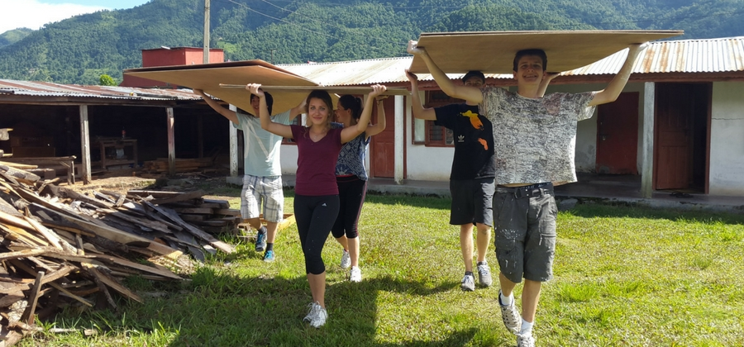
Second; When you arrive, you immediately start work building facilities, like a sports centre, for example. The work that you’re putting into the project could have easily been done by a team from the local community, provided they had the funding, therefore contributing not only to those people’s wellbeing, but by extent to the local economy as well. The potential inconsistency of volunteer programmes can unintentionally harm communities. As put by Clost; ‘Transient volunteer populations may do more harm that good to the stability of a developing economy’ (Clost 2011:17)

Third; You’ve finished Building your facility, only now you’ve left the community does not have a strong enough economy to provide the resources required to keep the place running, and all your hard work has become unusable after a couple years. The sustainability of volunteer projects can often be neglected by the organisations who run the programmes, but there is work being done to combat the problem.

Voluntourism is largely considered a good thing, but with so many problems hiding around the corner, it could not be more important to do your research before choosing your trip. Helping build an orphanage in Nepal may sound like an attractive, altruistic use of your time, but in reality, UNICEF estimate that in Nepal 85% of children in orphanages have at least one living parent. The staff and volunteers go largely unchecked making the ‘orphans’ particularly vulnerable to abuse, and on top of that it’s illegal to volunteer on a tourist visa in the first place (UNICEF 2015).

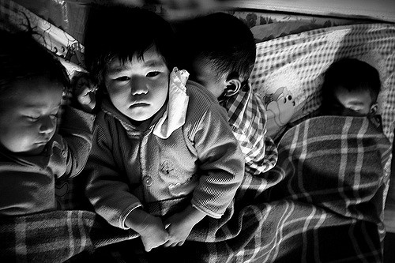

© Fred Beard --- Beard, F. 2007. Orphanage near Kathmandu - Nepal. Available at: https://www.flickr.com/photos/fredericbeard/4200249995/

Exploitation of the Voluntourism market is only possible because of a lack of regulation, so it is important to do your part to avoid accidentally contributing to the problem.

Bibliography
1 air mile · BlueSkyModel. [no date]. Available at: https://blueskymodel.org/air-mile [Accessed: 15 March 2019].
Air Travel’s Impact on Climate Change. [no date]. Available at: https://www.eta.co.uk/environmental-info/air-travels-impact-on-climate-change/ [Accessed: 15 March 2019].
Clost, E. 2011. Voluntourism: The Visual Economy of International Volunteer Programs., p. 169.
Lyons, K.D. and Wearing, S. 2008. Journeys of Discovery in Volunteer Tourism: International Case Study Perspectives. CABI.
Smith, V.L. and Font, X. 2014. Volunteer tourism, greenwashing and understanding responsible marketing using market signalling theory. Journal of Sustainable Tourism 22(6), pp. 942–963. doi: 10.1080/09669582.2013.871021.
UNICEF 2015. Volunteering in orphanages. Available at: https://www.unicef.org/rosa/what-we-do/child-protection/volunteering-orphanages [Accessed: 11 March 2019].
Whitelegg, P.J. 2000. AVIATION: the social, economic and environmental impact of flying., p. 28.
Withrow, B. 2019. The Hidden Dangers of Volunteer Tourism. 23 February. Available at: https://www.thedailybeast.com/the-hidden-dangers-of-volunteer-tourism [Accessed: 11 March 2019].
(Images Referenced where I could find the source)
(Gobbit on next page)

Gobbit - Source 2.

Lévi-Strauss, C. 1963. Structural Anthropology. New York: Basic Books. p.337.

“Actually, Marx and Engels frequently express the idea that primitive, or allegedly primitive, societies are governed by “blood ties” (which, today, we call kinship systems) and not by economic relationships. If these societies were not destroyed from without, they might endure indefinitely. The temporal category applicable to them has nothing to do with the one we employ to understand the development of our own society. Nor does this conception contradict in the least the famous dictum of the Communist Manifesto that “the history of all hitherto existing society is the history of class struggles.” In the light of Hegel’s philosophy of the State, this dictum does not mean that the class struggle is co-extensive with humanity, but that the ideas of history and society can be applied, in the full sense which Marx gives them, only from the time when the class struggle first appeared. The letter to Weydemeyer clearly supports this: “What I did that was new,” Marx wrote, “was prove . . . that the existence of classes is only bound up with particular historical phases in the development of production.”

The above extract is from volume one of Claude Levi-Strauss’s 1963 book entitled ‘Structural Anthropology’. It places notions of Karl Marx and Friedrich Engels within the framework of structural anthropology, and can be found within the post script for the chapter ‘Social Structure’ (Levi-Strauss 1963). Structural Anthropology was one of Levi-Strauss’ most pivotal books, along with his works on totemism and kinship. Since the release of this book structural anthropology has become a core concept in anthropological thinking, as it was so influential, both in its time and now.
The post script this passage comes from covers Levi-Strauss’s response to the criticism that he got in response to the chapter ‘Social Structure’. This particular passage forms part of his response to a criticism of his work by a French Marxist historian by the name of Maxime Rodinson. His intention is to illustrate that his own views can in fact line up with those of Marx and Engels, as Rodinson’s critique of the chapter took a Marxist approach (Levi-Strauss 1963). He does not provide any specific analysis, as the passage functions to demonstrate that structuralism and Marxism can go hand in hand, not to provide any personal opinion on Marxism and its place in anthropology.
The start of the extract establishes Marx and Engels’s position on ‘allegedly primitive’ societies, suggesting that as they are ‘governed by ‘blood ties’ and not by economic relationships’(Levi-Strauss 1963:337), the observations they have previously made about the development of society cannot be applied. For Levi-Strauss, this analysis of ‘primitive’ society exemplifies Marx and Engels using a structuralist approach to apply their views, which begins to support his attempt to align the two modes of thinking.
Levi-Strauss then refers to the Communist Manifesto. ‘The Manifesto of the Communist Party’ was originally published by Marx and Engels in 1848 as a political pamphlet in which they present their theory surrounding class struggle and capitalist modes of production (Marx and Engels 1848). It provides a concise summary of their views so is an ideal source for Levi-Strauss to use to back up his statements.
The observation Levi-Strauss makes purposefully outlines how the Communist Manifesto’s dictum, ‘history of all hitherto existing society is the history of class struggles’ (Marx and Engels 1848) does not contradict Marx and Engels, if you take their view placing ‘primitive’ society in a separate ‘temporal category’ from our own (Levi-Strauss 1963:337). This enables them to treat ‘primitive’ society as an entirely separate phenomenon and exclude it from any viewpoints that do not line up easily with typical Marxism. However, while Levi-Strauss does not address the issue here, if you were to apply that dictum to ‘primitive’ society, it would only need a slight edit to be successful. To swap ‘class struggles’ with ‘power struggles’ would be the first step towards including society without a class system within a Marxist structure. These societies are proof that a society without class struggles is not a guarantee of peace.
The next point of reference for Levi-Strauss is Georg W.F. Hegel’s philosophy of the state. This can be summarised as follows - each stage of history is the logical progression from the previous stage. The positive elements of a stage are the ‘thesis’ and the negative the ‘antithesis’, the next stage if the product of how the two interact, or the ‘synthesis’. This synthesis then becomes the thesis of the next stage of history (Humanities - Leiden University 2017). To apply this to Marxist theory, as above, you limit its reach to only society where class struggle is present. For Marx and Engels, that is the start of history. Indeed, as Marx is quoted stating, he believes that class ‘is only bound up with particular historical phases’, therefore the time the he considers to be outside of history are either ‘pre-class-struggle’ - ‘pre-history’, or ‘post-class-struggle’ – ‘post-history’(Humanities - Leiden University 2017). It is with this assessment that he places ‘primitive’ society as pre-history, and communism as the end of history.
In some ways, this summary of the view of Marx and Engels in relation to Hegel could be seen as a successful demonstration of how to apply Levi-Strauss’s theory of structuralism, as he intended it to be. As he would suggest, a thing only has meaning with relation to the structure in which it exists (Levi-Strauss 1963). Here he uses Marx and ‘primitive’ societies as an example of how a single society can be interpreted very differently if placed into a different frame of reference. However it could be interpreted as a demonstration of the shortcomings of Marxist theory in the field of anthropology. Those ‘primitive’ cultures, especially at the time, are one of the main focuses of anthropology, so any theory that discounts their culture and history has very limited use for an anthropologist. However, though Marx’s own application of his theory does appear to discount ‘primitive’ society in this way, there are still many anthropologists who find a way to make Marxism inclusive.
Levi-Strauss seems to somewhat unintentionally expose Marx and Engels’ short-sightedness in their theory as their assumptions about the nature of ‘primitive’ society becomes evident (Levi-Strauss 1963). Essentially they establish a romanticised view of these societies, in which as there is no class system or struggles, it must be a peaceful, inherently different culture, described almost as pre-societal or in a state of ‘pre-history’(Levi-Strauss 1963). This view comes across as ignorant of any possible dispute that may come of a ‘blood ties’ based society, and of the development that such societies presumably went through to establish such a system. It could be considered an example of ‘othering’, a problem which we go to great lengths to avoid in more recent anthropological thinking (Krumer-Nevo and Sidi 2012). ‘Othering’ was not yet an established debate when Marx was writing in the 1800’s, or when Levi-Strauss was writing in the 60’s.
The finishing reference to Marx’s correspondence with Weydemeyer uses Marx’s own words to solidify the way in which Marx uses his own framework, in a structuralist manner, to exclude ‘primitive’ society (Levi-Strauss 1963:337).
Levi-Strauss’s lack of explicit opinion does not mean there is no conclusion to be drawn, the extract can be interpreted with respects to Marxist theory in both structuralist anthropology and by extension anthropology as a discipline. The way Marxism is portrayed here it intentionally excludes a huge area of anthropology, and it is only with structuralism that ‘primitive’ society is recognised. The term ‘primitive’ would not be used today as it encourages ‘othering’ and discrimination (Krumer-Nevo and Sidi 2012). Anthropological thinking has changed since these scholars were in their prime, and though their theories are still well referenced, modifications have been made.
Bibliography
Humanities - Leiden University 2017a. Chapter 3.3: Hegel, the logic of History - YouTube. Available at: https://www.youtube.com/watch?v=6QTy2VLBzwk [Accessed: 9 March 2019].
Humanities - Leiden University 2017b. Chapter 3.4: Karl Marx, the end of history. Available at: https://www.youtube.com/watch?v=L-vaLuEfRnA [Accessed: 9 March 2019].
Karl Marx | Biography, Books, Theory, & Facts. [no date]. Available at: https://www.britannica.com/biography/Karl-Marx [Accessed: 12 March 2019].
Krumer-Nevo, M. and Sidi, M. 2012. Writing Against Othering. Qualitative Inquiry 18(4), pp. 299–309. doi: 10.1177/1077800411433546.
Levi-strauss, C. 1963. Structural Anthropology. Hachette UK.
Marx, K. 1852. Letters: Marx to J. Weydemeyer in New York [abstract]. Available at: https://www.marxists.org/archive/marx/works/1852/letters/52_03_05-ab.htm [Accessed: 13 March 2019].
Marx, K. and Engels, F. 1848. Manifesto of the Communist Party., p. 68.
Wolff, J. 2017. Karl Marx. In: Zalta, E. N. ed. The Stanford Encyclopedia of Philosophy. Winter 2017. Metaphysics Research Lab, Stanford University. Available at: https://plato.stanford.edu/archives/win2017/entries/marx/ [Accessed: 12 March 2019].

