Wyndham Hotel & Resorts: A Case Study in Strategic Growth and Brand Expansion

Student name: Alexandra Anghel (2226451)
Tutor name: Daniel Payne
Module: Management and Organisational Behaviour (BMIH5004)
Word count: 2197 words

I confirm that I have not used any AI tools in the research and creation of this assignment. I confirm that I have not presented any AI generated materials as my own work. I confirm I have copies of my drafts, notes, and other resources I used, which I may be asked to provide in evidence.

Executive summary

Wyndham Hotels & Resorts is headquartered in Parsippany, New Jersey. This is working as a prominent hotel franchisor with more than 9,000 properties in almost 95 nations. This organisation operates with a decentralised structure, supporting every hotel to adapt to local demands in market while following the corporate standards as promotes operational efficiency with innovation. The corporate culture of Wyndham's is centred around consumer-centric values, focusing on inclusivity with innovation through involvement of "Count on Me" service philosophy.
​The report will emphasis to analyse Wyndham's corporate as well as operational strategies, exploring the organisational structure, culture, and strategic direction.​ Recent initiatives are named as the expansion of the Microtel brand in India and a sustainability campaign emphasised at reducing environmental impact. These initiatives are aligned with strategic frameworks like Ansoff’s Market Development and Porter’s Generic Strategies, reinforcing Wyndham's commitment to growth, technical integration, and sustainability.
To strengthen its position in market the report recommends improvement of brand differentiation, strengthening green initiatives, improving engagement with employees, and investing in digital transformation. These strategies will improve operational effectiveness and improve experience of customer, ensuring Wyndham maintains its status like a leading global hotel franchisor. Through emphasising on adaptation with innovation the Wyndham is well-positioned to navigate the evolving hospitality landscape and cater to different customer requirements.

Table of Contents
1. Introduction 4
1.1 Overview of Wyndham Hotels & Resorts 4
1.2 Aim of the Report 5
2. Organizational Structure, Culture, and Goals 5
2.1 Organizational Structure 5
2.2 Corporate Culture 7
2.3 Organizational Goals 8
3. Recent Change Initiatives 9
3.1 Overview of Change Initiatives 9
3.2 Impact of Initiatives 9
3.3 Change Management Evaluation 10
4. Strategic Direction 10
4.1 Strategic Objectives and Long-Term Goals 10
4.2 Strategy Implementation 11
5. Conclusions 12
6. Recommendations 12
6.1 Brand Differentiation ……………………………………………………..………………12
6.2 Invest in Digital Transformation………………………………………..…………..……13
References 14

1. Introduction
1.1 Overview of Wyndham Hotels & Resorts
Headquarter of Wyndham Hotels & Resorts is situated in Parsippany, New Jersey. This is recognised as a leading hotel franchisor. The organisation operates with diverse types of brand segments named as economy, midscale, and upscale segments. This is catering to attract huge number of business travellers and leisure travellers. The franchise business model is referred as a contractual agreement in which a franchisor licenses their business model, brand, and intellectual property to a franchisee (Heitzman, 2023). Wyndham's with strong franchise model supports rapid expansion with emphasis to maintaining brand consistency and making it an important player within the competitive international hospitality market (Wyndham Hotels and Resorts, 2024). Wyndham has a wide portfolio with more than 6,036 properties within the region such as U.S. and 1,761 properties in the Asia Pacific region (Parsippany, 2022)
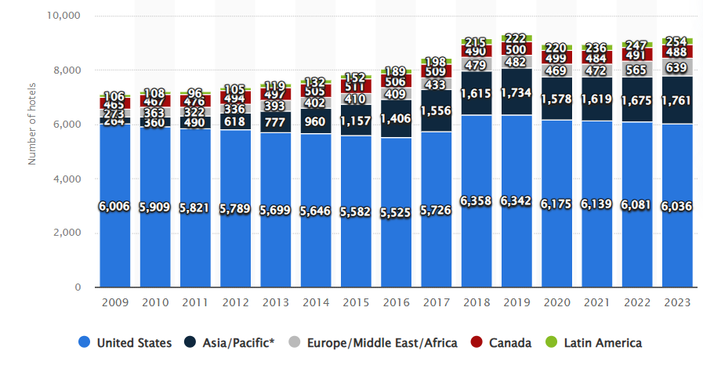 (Statista Research Department, 2024)
Through involvement of a strong emphasis on service and value to customer Wyndham has positioned itself like an important and reliable choice for travellers looking for qualitative accommodations at diverse points of price. The organisation has garnered a loyal base of customer and contributing to positive level of growth with stability within a competitive industry.
1.2 Aim of the Report
The report aims to assess, analyse, and evaluate Wyndham’s corporate as well as operational strategies at the corporate hotel levels and individual hotel levels. This will emphasize to explore Wyndham's organizational structure, culture, goals, recent initiatives of change, and strategic direction with emphasis to providing practical recommendations to improve competitive positioning of Wyndham’s within the hospitality sector. The report will ensure to evaluate external factors representing impact on Wyndham’s operational strategies as well as how these factors align with the mission and vision of company.
2. Organizational Structure, Culture, and Goals
2.1 Organizational Structure
Wyndham is operating with involvement of a decentralised structure characterised through the involvement of mix of franchise as well as managed properties (Parsippany, 2024). The divisional model promotes higher level of flexibility and allowing every individual hotel to respond to local level market demands and adhering to diverse corporate level standards.
Divisional Model: Wyndham's defictionalized structure involves alignment with Mintzberg’s organisational forms because every brand leads to operates autonomously and under a unified corporate umbrella. The structure supports operational efficiency with emphasis to promoting innovation tailored to local markets.
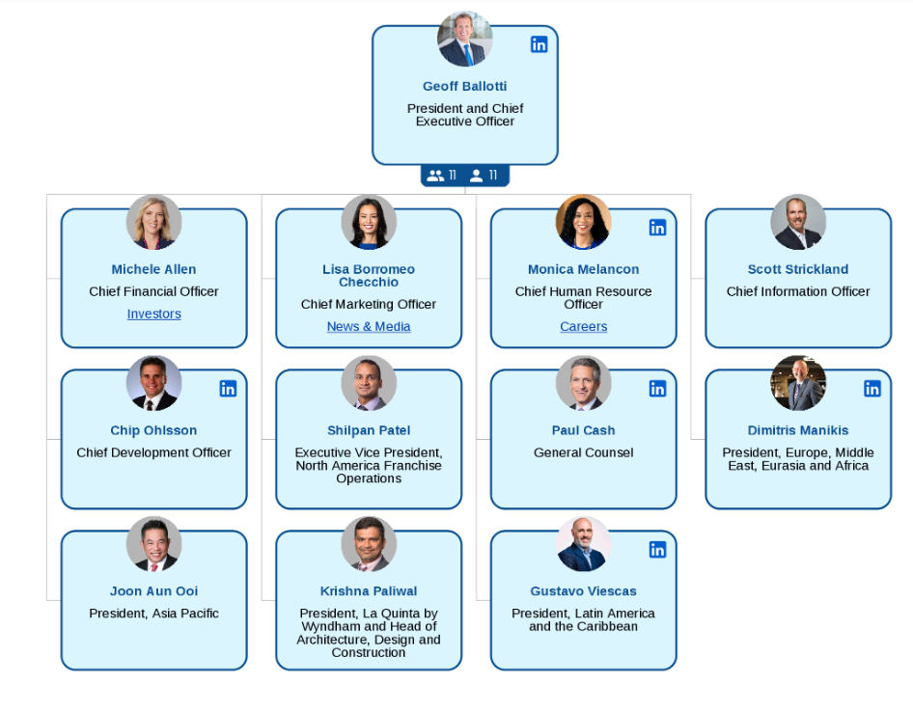 (Organimi, 2024)
For instance, competitive brands such as Super 8 as well as Days Inn have diverse types of marketing strategies which resonate with diverse segments of consumer (Glion, 2024). In relation to competing with competitors the organisational structure of Wyndham is supporting to maintain almost 497,583 hotel rooms in the U.S. as well as 205,702 rooms within the Asia Pacific region.
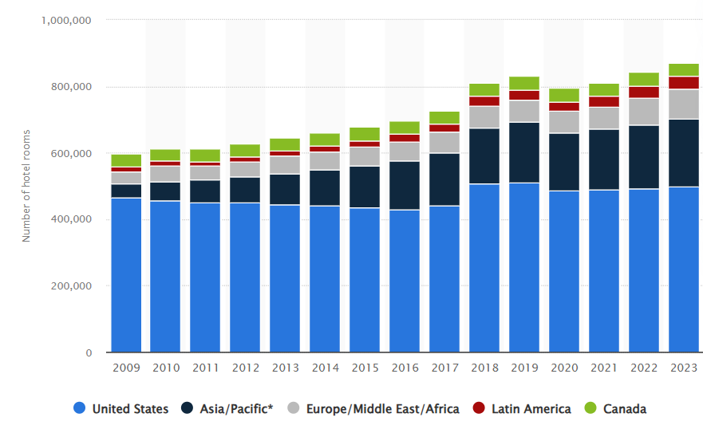 (Statista Research Department, 2024)
Burns and Stalker’s mechanistic model represents a formal and hierarchical structure with clearly defined roles as well as responsibilities (Valuebasedmanagement, 2024). This is highly structured and processes-oriented and contrasted with the organic organisation which is more flexible and adaptive. The application of Burns and Stalker’s mechanistic model in relation to Wyndham's structure supports stability with defined roles and developing positive level of adaptability within different portfolio. The adaptability is critical within the fast-changing hospitality environment and allowing Wyndham to quickly pivot within the response to demands of market or shifts within behaviour of consumer (Talking About Organisations, 2024).
2.2 Corporate Culture
The culture associated with Wyndham is primarily consumer-focused, emphasizing principles identified as inclusivity, innovation, and engagement. The "Count on Me" service philosophy focuses on delivering outstanding service to customers by enabling employees to take appropriate ownership of guest experiences (GRI Report, 2020).
Hofstede’s Cultural Dimensions Theory is acknowledged as a significant framework that helps to comprehend cultural variations among countries and the diverse approaches to business operations across various cultures (Wale, 2024). Hofstede’s cultural dimensions highlight Wyndham's focus on collectivism and long-term orientation, which enhance teamwork and foster customer loyalty. The organisation encourages every employee to work altogether towards accomplishment of common goals, developing a sense of belonging and shared purpose (Creately, 2024).
Cameron and Quinn indicated that how organizations rank the competing values outlined in their model will help identify the types of cultures that will develop within them (The World of Work Project, 2019). Cameron and Quinn’s Competing Values Framework classifies Wyndham as an “adhocracy,” fostering a high degree of creativity and adaptability that remain crucial in the continually changing hospitality sector. The culture encourages innovation through adaptability, enabling Wyndham to remain at the forefront of industry trends and consumer expectations (Globetrender, 2021).
2.3 Organizational Goals
Corporate Level Goals
The balanced scorecard (BSC) method is acknowledged as a strategic management tool that helps organizations monitor and assess performance across various domains to enhance outcomes (Tucci, 2024). Wyndham's primary corporate objectives include broadening its global presence, enhancing franchise growth, and establishing itself as a leading figure in sustainability practices (Wyndham Hotels Corporate, 2024). The objectives correspond with the Balanced Scorecard framework, focusing on financial development, customer contentment, operational efficiency, and learning through innovation. For instance, Wyndham highlights the importance of creating a diverse and inclusive workplace to safeguard human rights. Wyndham's initiatives focus on community support through the Green Certification Program, highlighting energy, water, and efficiency across various business operations (Wyndham Social Responsibility Report, 2020).

Unit-Level Goals:
Each hotel unit strives to guarantee and deliver exceptional experiences for guests, comply with brand standards, and enhance operational efficiency. Wyndham's dual focus on corporate directives and local adaptability helps hotels maintain competitiveness in their markets (Wyndham Hotels and Resorts, 2024). Each hotel is advised to create its own performance metrics based on local market conditions while aligning with Wyndham's broader strategic goals. For instance, Wyndham recognized that data could help enhance the understanding of guests, their stays, and various preferences at Wyndham locations, as well as positively impact the overall guest experience and loyalty (PWC, 2024).
3. Recent Change Initiatives
3.1 Overview of Recent Change Initiatives
Wyndham has ensured and applied diverse types of change initiatives as aimed at improving level of its competitive position and operational effectiveness:
Expansion in India: Wyndham has announced diverse types of plans to introduce the Microtel brand in India, targeting the rising demand level for affordable and quality accommodations within the region (Davis, 2024). The Indian hospitality market is projected to grow significantly and the initiative is emphasised at capturing a share of this expanding market.
Sustainability Efforts: The "Green and Efficient" campaign is a significant initiative focused on reducing the environmental impact of Wyndham through energy-saving operations, waste minimization, and responsible water management (Our Commitment to Sustainability, 2024). The initiative tackles environmental issues and highlights appeals to the increasing group of eco-aware consumers.
3.2 Impact of the Initiatives
The Ansoff Matrix, known as the Product/Market Expansion Grid, is a two-by-two framework employed by management teams and analysts to assist in planning and evaluating their growth strategies (Peterdy, 2024). The initiative for expansion in India corresponds with Ansoff’s Market Development strategy by reaching out to the expanding middle-class population in areas like India. With the rise in travel demand, the launch of Microtel enables Wyndham to take advantage of a profitable market segment, specifically enhancing revenue and brand loyalty (Staff Writer, 2024). The growth will enable Wyndham to utilize local partnerships and adjust all services to align with regional tastes.
Wyndham's dedication to sustainability enhances its brand reputation and aligns with the growing consumer demand for environmentally responsible practices (Betterbuildingssolutioncenter, 2024). The initiative could result in cost savings through energy efficiency and waste reduction, ultimately enhancing the bottom line. Studies indicate that hotels implementing sustainable practices experience higher guest satisfaction and loyalty, as travelers are increasingly opting for environmentally friendly choices.
3.3 Change Management Evaluation
Kurt Lewin's change management model, known as Unfreeze, Change, Refreeze, is acknowledged as a crucial framework for comprehending and managing organizational change (Awati, 2024). India's growth by utilizing Lewin’s Change Model can be divided into three stages: “unfreezing” current market strategies, “changing” by launching new hotel brands, and “refreezing” as the Microtel brand establishes its footprint in areas like India. The unfreezing phase involves getting the organisation and all stakeholders ready for change, which entails performing market research and comprehending local regulations (Our Commitment to Sustainability, 2024).
4. Strategic Direction
4.1 Strategic Objectives and Long-Term Goals
Wyndham’s strategic direction is defined by a strong dedication to growth, technological advancement, and sustainability.
Global Market Expansion: Wyndham is focused on entering emerging markets while also enhancing its footprint in key areas, as the demand for budget-friendly lodging is increasing (IANS, 2024). For instance, the organization seeks to strategically align the brands to meet various customer needs across all these markets.
Technological Progress: By emphasizing the incorporation of various digital resources for bookings and customer interaction, Wyndham seeks to enhance guest experiences and optimize operations (Sustainablehospitalityalliance, 2024). Investing in technology will enhance operational efficiency, reduce costs, and create a more tailored experience for guests.
Sustainable Development: The organization is focused on implementing sustainable practices that reduce its carbon footprint and enhance operational efficiency while aligning with broader environmental objectives (Salesforce, 2024). For instance, by incorporating sustainability into its business model, Wyndham can attract socially aware customers and set itself apart from competitors.
Strategic Analysis - Porter’s Generic Strategies: Porter's generic strategies are acknowledged as significant methods for obtaining a competitive edge (De Bruin, 2021). Wyndham adopts a hybrid strategy by applying cost leadership for the economy and midscale segments while focusing on achieving differentiation in its upscale brands. The organizational strategy enhances the ability to meet various consumer needs and market segments (Dieffenbacher, 2024). The cost leadership strategy concerning organizations is particularly effective in drawing in budget-conscious travelers, just as differentiation efforts in high-end segments help foster strong brand loyalty among selective guests.
4.2 Strategy Implementation
Wyndham has ensured and implemented at successful level different digital tools to improve interactions as well as operational efficiency of consumers. The expansion strategy focuses on practices of adapting brand offerings to meet local level demands of market as well as adherence in relation to maintaining the corporate level standards.
Implementation Challenges:
Cultural Adaptation: In todays’ time of entering new markets organisation such as Wyndham ensures the brands resonate with local cultures as well as preferences (Smartling, 2024). This requires a right level of balance approach between global brand standards and local customisation. Organisational practices with focus on conducting thorough market research as well as employing local expertise will remain crucial within the business process.
Technological Integration: Right practices of adopting new tools across diverse locations can lead to pose challenges, referring staff training and ensuring consistent services quality. Emphasis on providing right comprehensive training programs with availability of right ongoing support for employees will be important in right practices of overcoming from these challenges and ensuring application successfully.

5. Conclusion
In the limelight of the discussion, it can be concluded that Wyndham Hotels & Resorts operates in a competitive hospitality landscape, characterized through its diverse portfolio, consumer-centric culture, and commitment to sustainability. The report has evaluated Wyndham's organizational structure, corporate culture, and strategic direction with emphasis to highlighting recent initiatives of change. The analysis represents Wyndham’s proactive approach to market challenges, focusing on the significance of adaptation and innovation. The recommendations outlined within the report will support Wyndham to strengthen level of market positioning as well as operational effectiveness, ensuring sustainable level growth within an evolving industry. Through improving brand differentiation, prioritizing green initiatives, improving employee engagement, and investing within digital transformation, Wyndham can continue to ensure exceptional value to diverse consumers and maintain the status like a leading international level hotel franchisor.
6. Recommendations
6.1 Brand Differentiation
Wyndham’s corporate marketing teams must focus on creating a unique identity for each brand over the next two years, particularly in emerging markets and areas with intense competition. Wyndham must customize its marketing campaigns to emphasize distinct value propositions for various customer segments (Sameh, 2024). For instance, they may concentrate on budget-friendly luxury for moderate-income tourists or eco-friendliness alongside wellness for environmentally aware visitors. Cooperative partnerships with local organizations can be established to address regional preferences, such as integrating local cultural elements into marketing content and hotel experiences. Utilizing digital marketing platforms and social media can help engage potential customers through targeted ads, user-generated content, and promotional campaigns. Consistent gathering of customer opinions through surveys and reviews can enhance marketing approaches and better meet regional needs.
6.2 Invest in Digital Transformation
To maintain competitiveness and enhance operational efficiency, Wyndham's IT and operations teams must start a phased digital transformation strategy right away, aiming for completion within two years. It entails utilizing sophisticated booking systems that ensure smooth user interactions and incorporating tailored Customer Relationship Management (CRM) tools to appropriately grasp and predict guest preferences (White, 2024). Investments in data analytics can enhance more focused marketing initiatives, providing personalized promotions tailored to historical behaviors and local trends. Wyndham must investigate advanced hotel technologies such as mobile check-ins, voice-activated room management, and chatbots for immediate assistance to guests. Training staff to utilize these digital tools will help guarantee seamless implementation while maximizing the benefits of enhanced operational capabilities. By adopting these innovations, Wyndham can guarantee to provide exceptional experiences to guests and preserve a competitive advantage in a quickly changing industry.

Reference List:
Awati, R., 2024. Techtarget. Available at: https://www.techtarget.com/whatis/definition/Kurt-Lewins-Change-Management-Model-Unfreeze-Change-Refreeze
[Accessed 07 11 2024].
Betterbuildingssolutioncenter, 2024. Wyndham Hotels and Resorts: Wyndham Green Program. Available at: https://betterbuildingssolutioncenter.energy.gov/implementation-models/wyndham-hotels-and-resorts-wyndham-green-program
[Accessed 28 10 2024].
Creately, 2024. Utilise Hofstede's Cultural Dimensions for Effective Team Collaboration. Available at:https://creately.com/guides/hofstede-cultural-dimension/
[Accessed 28 10 2024].
Davis, C., 2024. Wyndham to Launch Microtel Brand in India.
Available at: https://www.businesstravelnews.com/Lodging/Wyndham-to-Launch-Microtel-Brand-in-India#:~:text=Wyndham%20Hotels%20%26%20Resorts%20will%20introduce,the%20hotel%20company%20announced%20Thursday.
[Accessed 17 10 2024].
De Bruin, L., 2021. Porter’s Generic Strategies: Differentiation, Cost Leadership and Focus.
Available at: https://www.business-to-you.com/porter-generic-strategies-differentiation-cost-leadership-focus/
[Accessed 07 11 2024].
Dieffenbacher, S. F., 2024. Porter’s Generic Strategies Tips for Business Competitive Strategy.
Available at: https://digitalleadership.com/blog/porters-generic-strategies/
[Accessed 28 10 2024].
Glion, 2024. The importance of hotel marketing strategies. Available at: https://www.glion.edu/magazine/importance-of-hotel-marketing-strategies/
[Accessed 28 10 2024].
Globetrender, 2021. Sponsored Content. Available at:
https://globetrender.com/2021/02/24/wyndham-enhances-digital-experience-hotel-guests/
[Accessed 28 10 2024].
GRI Report, 2020. Wyndhamhotels. Available at: https://corporate.wyndhamhotels.com/wp-content/uploads/2020/08/GRI-Report-2020-Final.pdf
[Accessed 28 10 2024].
Heitzman, A., 2023. Types of Franchise Models Explained. Available at: https://www.highervisibility.com/industries/franchise/learn/franchise-models-explained/
[Accessed 07 11 2024].
IANS, 2024. Economictimes. Available at:
https://hospitality.economictimes.indiatimes.com/news/hotels/looking-for-right-partners-to-expand-india-footprint-wyndham-hotels-dimitris-manikis/113163725
[Accessed 28 10 2024].
Organimi, 2024. Wyndham Hotels & Resorts’ Organizational Structure. Available at: https://www.organimi.com/organizational-structures/wyndham-hotels-and-resorts/
[Accessed 06 11 2024].
Our Commitment to Sustainability, 2024. Wyndhamhotels. Available at: https://www.wyndhamhotels.com/wyndham-green-sustainability
[Accessed 28 10 2024].
Our Commitment to Sustainability, 2024. Wyndhamhotels. Available at: https://www.wyndhamhotels.com/hotel-deals/eco
[Accessed 28 10 2024].
Parsippany, N. J., 2022. Wyndham Hotels & Resorts Announces the First Wyndham Grand in Mexico.
Available at: https://corporate.wyndhamhotels.com/news-releases/wyndham-hotels-resorts-announces-the-first-wyndham-grand-in-mexico/
[Accessed 28 10 2024].
Parsippany, N. J., 2024. Corporate Wyndham Hotels. Available at: https://corporate.wyndhamhotels.com/news-brands/wyndham-hotels-and-resorts/
[Accessed 28 10 2024].
Peterdy, K., 2024. Ansoff Matrix.
Available at: https://corporatefinanceinstitute.com/resources/management/ansoff-matrix/
[Accessed 07 11 2024].
PWC, 2024. How Wyndham Hotels & Resorts improved their data capabilities to get to know
their guests better. Available at: https://www.pwc.com/us/en/library/case-studies/wyndham-data-architecture.html
[Accessed 07 11 2024].
Salesforce, 2024. Wyndham Expedites Guest Bookings with Salesforce Data Cloud, Delivering Enhanced Guest Experiences and Boosting Revenue.
Available at: https://www.salesforce.com/in/news/stories/wyndham-data-cloud-expedited-bookings/
[Accessed 28 10 2024].
Sameh, E., 2024. Profiletree. Available at: https://profiletree.com/regional-marketing-strategies-across-the-us/
[Accessed 28 10 2024].
Smartling, 2024. 10 top international market entry strategies for global expansion.
Available at: https://www.smartling.com/resources/101/your-guide-to-market-entry-strategy/
[Accessed 28 10 2024].
Social Responsibility Report of Wyndham, 2020. GRI-Report-2020. Available at: https://corporate.wyndhamhotels.com/wp-content/uploads/2020/08/GRI-Report-2020-Final.pdf
[Accessed 07 11 2024].
Staff Writer, 2024. Wyndham launched its eighth brand in India.
Available at: https://www.hotelierindia.com/operations/nile-hospitality-to-bring-microtel-by-wyndham-brand-to-india
[Accessed 28 10 2024].
Statista Research Department, 2024. Number of Wyndham Hotels & Resorts Inc. hotel rooms
worldwide 2009-2023, by region. Available at:
https://www.statista.com/statistics/247306/number-of-wyndham-hotels-and-resorts-inc-hotel-rooms-worldwide/
[Accessed 06 11 2024].
Statista Research Department, 2024. Statista.
Available at: https://www.statista.com/statistics/247286/number-of-wyndham-hotels-and-resorts-inc-hotels-worldwide/
[Accessed 11 06 2024].
Sustainablehospitalityalliance, 2024. Environment, Social, and Governance Report.
Available at: https://sustainablehospitalityalliance.org/wp-content/uploads/2024/09/2024ES1-1.pdf
[Accessed 28 10 2024].
Talking About Organisations, 2024. 98: Managing Innovation — Burns & Stalker.
Available at: https://www.talkingaboutorganizations.com/98-managing-innovation-burns-stalker/
[Accessed 28 10 2024].
The World of Work Project, 2019. The Cameron and Quinn Competing Values Culture Model.
Available at: https://worldofwork.io/2019/10/cameron-quinns-competing-values-culture-model/
[Accessed 07 11 2024].
Tucci, L., 2024. Balanced scorecard.
Available at: https://www.techtarget.com/searchcio/definition/balanced-scorecard-methodology
[Accessed 07 11 2024].
Valuebasedmanagement, 2024. Management System. Available at: https://www.valuebasedmanagement.net/methods_burns_mechanistic_organic_systems.html [Accessed 07 11 2024].
Wale, H., 2024. Hofstede’s Cultural Dimensions Theory.
Available at: https://corporatefinanceinstitute.com/resources/management/hofstedes-cultural-dimensions-theory/
[Accessed 07 11 2024].
White, C., 2024. A Beginner’s Guide to CRM System.
Available at: https://www.salesforce.com/eu/crm/what-is-crm/crm-systems/
[Accessed 28 10 2024].
Wyndham Hotels and Resorts, 2024. Committed to Doing What’s Right.
Available at: https://corporate.wyndhamhotels.com/social-responsibility/
[Accessed 28 10 2024].
Wyndham Hotels and Resorts, 2024. Wyndham's Phenomenal Growth Spans EMEA, Setting the Stage for Continued Success in 2024.
Available at: https://www.hospitalityinvestor.com/sponsored/wyndham-achieves-milestone-growth-across-europe-middle-east-eurasia-and-africa-2023
[Accessed 28 10 2024].
Wyndham Hotels Corporate , 2024. Going Global: Wingate by Wyndham Expands in Three Countries with 14 Hotels. [Online]
Available at: https://corporate.wyndhamhotels.com/news-releases/going-global-wingate-by-wyndham-expands-in-three-countries-with-14-hotels/
[Accessed 28 10 2024].

