- Student Number : 2030521
- STUDENT NAME : Samiriwet Tariku
- Module: Academic And Employability Skills
- Module title : BMSW4001
- Module leader : Sylvia Hoffmann

Time management

The Oxford Languages defines time management as “the ability to use one's time effectively or productively, especially at work”. Time management is frequently described as having the ability to manage time in the most useful and intensive way whilst fulfilling duties; it is viewed as the key to effective working (Cemaloglu,2010).
When trying to manage time, I will need to think about the setting of priorities, organization of work, the distribution of tasks as well as cooperation with others.

We live in a dynamic society which can sometimes require us needing to fulfil several tasks as quickly as possible. Having a personal calendar, list, and programs such as Microsoft Outlook, the use of modern-day cell phones and technology means getting things done doesn’t always mean staying in one place. We are now able to do more on the go, for example, sending and replying to emails without needing to be plugged into a laptop, interviews and class sessions are now being done by zoom without the need to attend an office setting. This allows us more time to do other things, cutting out the time and cost for travel, making more use of our time (Claessens, 2005).

Planning out my day/ tasks is extremely important when it comes to time management, good time management means I am able to work smarter and not always harder, getting more done in less amount of time even when under pressure.
Motivation, focus and control are factors that have a huge impact on a person’s time management (Mudrack,1997).
When you fail to manage your time well, it can cause a lot of stress and anxiety, tasks that should have been completed begin to build up, deadlines are missed, this can lead to stress or being burned out, it can also lead to Inefficient work flow and Poor work quality being submitted.

Some of the benefits of time management include greater productivities, less stress, achievement of goals and more opportunities for advancement (Antonovsky,1979).
There are several different theorists who speak about the ways in which to manage time best, one of which being Lothar J. Seiwert who developed the ALPEN method.
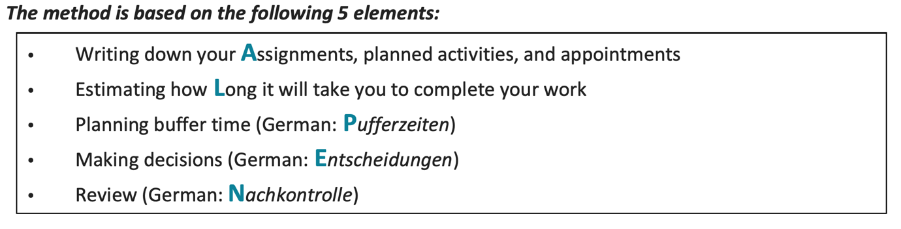

The Alpen method is one of many theories and strategies created to optimize our days, it is best to find one which best suits you and the way you work.
We cannot always do everything ourselves, sometimes delegating tasks to others to achieve a set goal might be necessary, it is also a skill of effective time management. I found that the delegation, especially when working in a group, helps save time as it allows more work to be completed faster, it gave me time to focus on high-level tasks and to make conscious choices.
As we can see, time is a precious commodity that cannot be brought, we must therefore use our time wisely to achieve our set out goals and be as productive as possible; those who master how to best manage their time effectively achieve success, however, if it is not done properly It can also cause problems (Alleen2003).
Modern-day technology makes it easier for us to achieve good time management, however, technology can also be a distraction that we should be aware of when using it. We should also be aware of ineffective task schedules that do not work and must adapt and change them if needed (Bauer,2019).

Online learning experience
Online learning is the process of studying without the need to attend a physical classroom, it is 100% virtual, it is the newest form of learning. Due to technology, we have more options when it comes to how we learn, no longer requiring just the traditional classroom and whiteboard style (Dowmin.2008).
Technology plays such a huge part in today’s society, so much so that it has now been incorporated into the school’s curriculum. More and more schools use I-pads when teaching.
Traditional classroom learning has a limitation on the number of students who can attend a class session at a given time, technology allows us to extend this number.
Resources for learning has also changed, the need to attend a library isn’t always necessary as online journals and books are available using technology to enhance classroom lessons (Kim,2009).

Online learning gives you the opportunity to study at your own pace, those who live too far from their school/ university have the prospect to learn from home and therefore cut down on travel time; there is also that extra added flexibility of being able to set a schedule that works with everyone’s time making work-study balance easier (Ash, 2010).

In 2020, The World Health Organization declared Covid-19 a threat to humanity, the covid-19 pandemic resulted in schools closing and people learning and working from home, online learning became the educational platform.
It has been estimated that over 1.2 billion children were out of the classroom
(https://www.who.int), as a result of the pandemic, education had to change dramatically. Online learning gave children the opportunity to learn in the comfort of their own homes.

Although we can see the benefits of online/mobile learning there are still strong benefits that the traditional method of learning has. Some people would rather be in a physical classroom when learning, online interaction isn’t always as engaging as classroom interactions with other students and teachers. Not all learners understand through the same methods, some students require the traditional method (Kebritchi,2017).

When you’re in a classroom you can ask questions right there and then not just to teachers but also other students, not all students find it easy to use technology and technology isn’t always reliable. Students can also begin to procrastinate, lose focus, lack discipline, motivation, leaving due work last minute, this is when one-on-one interaction with a teacher can be necessary. Although online learning helps the individual in terms of time management and convenance, A face-to-face interaction with a teacher adds personality, experience and compassion, you are not always able to achieve this through technology alone.

The question of whether online learning or traditional learning is better depends on the individual and their preferred way of learning.

Academic writing
Academic writing is often used in universities and scholarly publications, research, ideas and information are all communicated to the wider community. knowing how to write in an academic style is an important skill to have especially when writing is the main form of communication within the academic world.
You may find academic writing in academic topics and books. In education, you are expected to write research papers, essays as well as dissertations in an academic style (Burnard, 2002).
It can be difficult for some students to master writing in an academic style, although academic writing is similar to other types of writing, it has a certain convention in terms of style, content and structure. For example, academic writing is often found to be, 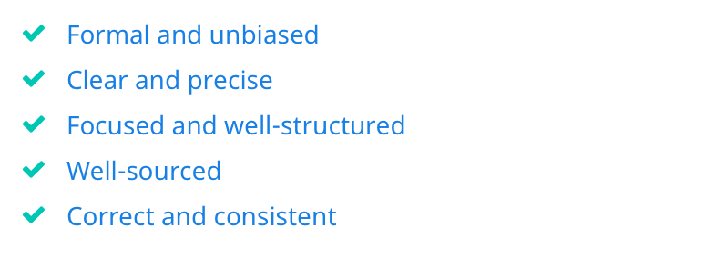
It does not tend to be personal and long winded as well as emotive.
Academic writings can be challenged, it is important that it is formal and unbiased, providing the audience with information of both side of the spectrum in an impartial way (Anderson,2004).

It is vital that things are based on evidences and are factual, when representing your own work, doing so without being biased, this can be done by highlighting the limitation of your work.
Academic writing such as journals and books are usually done for publications. Below you will find a table with the most common types of academic writing and its definition (Bean J. 2001).

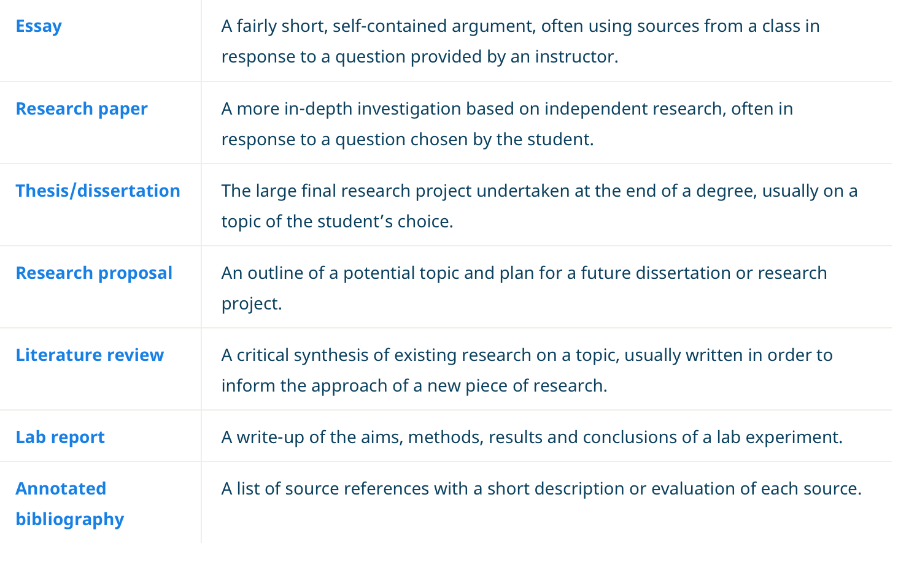

Academic writing should have a clear structure, depending on what field you are studying, there will be priorities in different areas. For example, a scientific study emphasises the importance of the method and accurately recording results, Other subjects may focus on having textual evidence which backs up your research (Donnelly,2012).
When writing an academic paper, you should avoid using slang as well as an informal language, your choice of language should be clear and specific. Your work should be well-sourced helping support your claims, academic writing is often built on previous researches. Not all sources are credible, for example using sites such as Wikipedia is not recommended as it is often edited by the public, instead, library, books and academic database is recommended (Cory,2003).

It is extremely important to cite your source and have references, this highlights your acknowledgement when using the works and ideas of others. Referencing your work can also mean in-text citation as well as having a reference section.
Analysing and evaluating your work is fundamental, this is similar to critical writing as it requires a great deal of research which helps in developing a deep understanding of the topic you have chosen to write about.
It is recommended that you plan out your work before writing, this ensures that the final product is well structured and clear (Cory,2003).

Whilst studying I’ve had the chance to learn more about academic writing through set tasks and regular assignments. I found that the more you practice the better you develop your skills in academic writing.

Cover letter writing
A cover letter is often seen as a letter of introduction, allowing the employer the opportunity to have a better understanding of who the human being behind the accomplishments might be.
Cover letters tend to accompany a cv, providing a brief detail about the skills and experiences you may have and how they support the job role you are applying for (Autor,2001).

Within a cover letter it is important to be specific, relating your skills and experience to the job role, highlighting how you will be an asset; first impressions matter, a cover letter is where an employer will have an indication about you and your skills based on what you have chosen to write (Stevenson, 2008).
When applying for a job, some employers will favour cv’s that contain cover letters. Cover letters tend to be one-page documents, you can share your personality within a cover letter, presenting yourself in the best form.
Having a good cover letter can increase the chances of you gaining an interview/job, cover letters must be made clear because understating a candidate's past success can give a prediction of his or her future successes (Holzer,1996).
Although cover letters can be beneficial, they also have their cons, having a faulty cover letter can mean an employee can choose to dismiss your cv before even reading it.
There is also a chance that you may give off the wrong impression, causing your cv to once again be overlooked. Cover letters should be tailored to the specific job that you are applying for, this makes it longer when applying for a job.

References
- Armstrong, D. (2011). Students’ perceptions of online learning and instructional tools: Florida: CRC Press.
- Antonovsky, A. (1979). Health, Stress & Coping. San Francisco: Jossey-Bass.
- Anderson, T. (2004). Role and function of theory in online education development and delivery. Canada: Athabasca University.
- Allee V. (2003), The future of knowledge: Increasing prosperity through value networks. Butterworth: Heinemann.
- Ash, K. (2010). ‘Blended’ learning seeks the right mix: School combine virtual and face-to-face teachers to meet student needs. London: Oxford University Press
- Autor, A. (2001). Writing the Labour Market. Journal of Economic Prospect,
- Bauer, T. (2019). Organizational Behavior. Theories of Motivation,
- Burnard, P. (2002). All your own work? Essays and the Internet. Nurse Educator
- Bean, J. (2001) Engaging Ideas. San Francisco, CA: Jossey-Bass.
- Cemaloglu, N. (2010). The relation between time management skills and academic achievement of potential teachers.
- Claessens, B. (2005). A review of the time management literature
- Cory, H. (2003). Advanced writing with English in use. Oxford: Oxford University Press
- Dowmin Yeh (2008). Computers & Education
- Donnelly, D. (2012). Key issues in creative writing. Bristol: Multilingual Matters.
- Holzer, H. (1996). What Employees Want: Job Prospects for Less- Educated Workers. New York: Russell Sage Foundation.
- Mudrack, P. (1997). The structure of perceptions of time. Educational and Psychological Measurement,
- Kim, K. (2009). Motivational challenges of adult learners in self-directed E-Learning.
- Kebritchi, M. (2017). Issues and challenges for teaching successful online courses in higher education: A literature review. Journal of Educational Technology,
- Stevenson B. (2008). The Internet and Job Search. London: Pan Books
- Time Management Theories

(https://sereneapp.com/7-time-management-theories-reviewed/ (Access

date: 16/7/21).

- Spencer, J. (2008) : A teacher's guide to principles and practice. Reading: Garnet Publishing Ltd.

- Staffordshire University (2021) Academic writing.
https://libguides.staffs.ac.uk/academic_writing/explained (Access date: 16/7/21).

