UNIVERSITY OF WALES
TRINITY SAINT DAVID

MODULE CODE: LCBB6000
MODULE NAME: DISSERTATION
DISSERTATION TITLE: IMPACTS OF SOCIAL MEDIA MARKETING ON TESCO CUSTOMER BEHAVIOR
PROGRAMME: BA BUSINESS MANAGEMENT
LEVEL 6/ TERM 2/ GROUP 2
LECTURER NAME: TUSHARA BALENDRAN

STUDENT NAME: SABINA-ANDREEA SABAU
STUDENT NUMBER: 1917334

Declaration
I declare that the work in this dissertation titled IMPACTS OF SOCIAL MEDIA MARKETING ON TESCO CUSTOMER BEHAVIOR has been carried out by me, Sabina-Andreea Sabau. It has not previously submitted for any degree in any university previously.

Acknowledgement
The completion of this academic research could not have been possible without my lecturer, Tushara Balendran, to which I am deeply grateful. I also want to thank you to all my lecturer from the past three years for sharing their knowledge and experience. And I did not forget to thank you to my family for their unconditional support.
Without all of you, I will not be where I am today!

Table of Contents
Acknowledgement .................................................................................................................................3
Abstract 6
CHAPTER 1- INTRODUCTION 7
1.1 Research background 7
1.2 Rationale of the study 8
1.4 Aims and Objectives: 9
1.5 Research Questions 9
1.6 Chapter Overview 10
2.2 Definition of key terms 10
2.2.1 Digital Marketing 10
2.2.2 Consumer Behaviour 11
2.3 Digital marketing types and about strategies that Tesco is using in relation with digital marketing 12
2.4 Consumer behaviour and the impact that social marketing has on consumer behaviour (related to Tesco) 13
2.5 Chapter Overview 17
CHAPTER 3: RESEARCH METHODOLOGY 17
3.1 Introduction 17
3.2 Research philosophy 18
3.3 Research approach 19
3.4 Research strategy 19
3.5 Research technique 19
3.6 Type of Investigation 20
3.7 Time Horizons 20
3.8 Data collection 21
3.8.1 Introduction 21
3.8.2 Data sampling 21
3.8.3 Data collection methods 21
3.8.4 Questionnaire 22
3.8.5 Primary Research Obstacles 22
3.9 Ethical consideration 22
3.10 Chapter Overview 22
CHAPTER 4: DATA ANALYSIS 23
4.1 Introduction 23
4.2 Inclusion and Exclusion Criteria 23
4.3 Questionnaire Analysis 23
CHAPTER 5: FINDING AND DISCUSSION 33
5.1 Introduction 33
5.2 Findings 34
5.3 Discussion 35
CHAPTER 6: RECOMMENDATION AND CONCLUSION 37
6.1 Summary of findings 37
6.2 Addressing the Objectives 37
6.2 Limitations 37
6.3 Recommendations 37
6.4 Future Implications 38
6. 5 Recommendations for Future Research 38
LIST OF REFERENCES 39

Abstract

The study aims to examine the impact of Tesco's social media marketing strategy on the purchasing behaviours of its customers. Additionally, it seeks to understand how Tesco's social media advertising campaigns affect consumers' buying habits and preferences to better cater to its core clientele. The study also intends to provide insight into the connection between social media marketing and consumer behaviours, and to help companies like Tesco improve their customer outreach and interaction strategies. Primary data were gathered from customers of Tesco in the United Kingdom. The study was carried out using a survey questionnaire. The researcher employed a simple random sampling technique and reached a sample of 50 respondents. According to the study's findings, the use of social media as a strategy for promoting products and services significantly impacts consumers' behaviour.

CHAPTER 1- INTRODUCTION

1.1 Research background

Human interaction has been significantly impacted by social media usage. The quick development of these platforms for online social connection has substantially changed interactions and human behaviour.
Advertising on various social media platforms such as Facebook, Twitter, and Instagram has grown significantly in recent years as a means for companies to connect with and learn more about their target audiences. The proliferation of social media sites like Facebook, Twitter, and Instagram has given companies fresh opportunities to reach out to customers and market their wares (Nuseir, 2020). In a significant sense, this has altered consumer habits and companies' promotion and sale methods. Furthermore, consumers' decision-making processes about allocating their finite resources (time, money, and energy) toward the acquisition of consumable goods is an important research topic in consumer behaviour. It includes the individual, environmental, and cultural influences on a consumer's attitude and behaviour and the psychological, social, and physical influences on their decision-making process (Rajagopal, 2019). For organizations, knowing how consumers behave is essential for creating effective marketing campaigns that appeal to specific demographics.
Tesco is a global grocery and general merchandise retailer with a strong presence in the UK and international markets. Tesco, one of the biggest retail chains in the world, has taken advantage of the widespread use of social media marketing to communicate with its customers and promote its wares (Sohail & Al-Jabri, 2017). The study intends to analyse the effects of Tesco's social media advertising campaigns. The study aims to learn how Tesco's social media marketing campaigns affect consumers' buying habits and preferences so that the retailer can better cater to its core clientele. The ultimate goal of the research was to provide light on the connection between social media marketing and consumer behaviour, therefore helping companies like Tesco improve their customer outreach and interaction strategies.

1.2 Rationale of the study

This study examines how Tesco's social media marketing strategy has affected the purchase behaviour of its customers. Multiple factors make this research crucial. First, companies cannot afford to ignore social media marketing if they want to connect and interact with their target audience. Therefore, it is essential for companies that want to maximize their marketing efforts and boost sales to comprehend the effect social media marketing has on customer conduct (Agnihotri, 2020). The study intends to help companies like Tesco improve customer service by highlighting how social media marketing influences consumer behaviour.
Second, Tesco is a major player in the retail marketplaces of the United Kingdom and beyond. For this reason, it might be useful to comprehend the effects of social media marketing on Tesco customers' behaviours since this knowledge could be generalized to other companies and sectors (Arango Botero et al., 2020). This research is to help effectively comprehend the connection between social media marketing and consumer behaviour, and to give useful information that companies across industries can utilize to improve their customer engagement and acquisition efforts.
Finally, this study aspires to fill a gap in the literature by expanding the understanding of the link between social media marketing and clients' behaviours. The study will contribute to the literature on the issue and provide the basis for future studies in this area by thoroughly examining the effect social media marketing has had on Tesco customers' purchasing behaviour.
1.3 Literature gap
An avalanche of research exist on the impact of social media on consumer behaviour. However, few tend to tie individual company strategies to challenges with the final output deciphering possible solutions. Social media marketing is important, however, it is important to examine every approach and deduce the possible drawbacks of each practice. The approach play an important role in establishing long term gains as opposed to the happenings of COVID 19 where all marketing approaches failed (Krajčovič, 2022). Corporate marketers can benefit from this research by using it to guide their selection of effective promotion tactics and strategies. On the basis of this data, retailers like Tesco can also conduct marketing campaigns and brand promotions.

1.4 Aims and Objectives:
This research aims to analyse the effects of Tesco's social media marketing strategies on customer behaviours and to draw conclusions about the effectiveness of these strategies. The objectives include:
- To examine the current social media marketing approach executed by Tesco.
- To assess the problems that Tesco may experience using social media marketing tactics.
- To analyse the effect of social media marketing initiatives on customer behaviour.

1.5 Research Questions
To achieve the main objective of this research, the following research questions are addressed:
- How does Tesco's social media marketing strategy impact the behaviour of its customers?
- What are the most effective social media marketing tactics used by Tesco in terms of influencing customer behaviour?
- How can Tesco improve its social media marketing strategy to influence customer behavior more effectively?

1.6 Chapter Overview
Chapter 1 provided an overview of the research project by critically evaluating its context, which included the degree to which social media marketing has become an essential tool for businesses seeking to communicate successfully with their clients. In this chapter, the researcher covered the research's rationale, the gap in the existing literature, and the study's goals and objectives. This chapter has laid the groundwork for the analysis of the connection between social media marketing and Tesco consumer behaviours that will take place in Chapter 2.
CHAPTER 2 – LITERATURE REVIEW
2.1 Introduction
The section offers a review of the relevant literature with respect impact of social media on consumer behaviour narrow narrowing down to Tesco as a major player. Most importantly, the section offers a perfect platform to evaluate the impact of social media marketing strategies on consumer behaviour. The section starts with definition of terms, different types of digital marketing and the impact on consumer behaviour. Thereafter an analysis of the honeycomb, Race, and ACCD model in relation to Tesco helps put the problem into context. This is not forgetting Maslow hierarchy of needs as a key theory of understanding consumer behaviour.

2.2 Definition of key terms

2.2.1 Digital Marketing
Digital marketing is advertising a firm's products and services using the internet, social media, mobile apps, and other kinds of digital media to boost the business's exposure, raise brand awareness, and create customer connections. According to Lammenett (2021), digital marketing encompasses influencer marketing, search engine optimization (SEO), email marketing, pay-per-click (PPC) advertising, social media marketing, content marketing, affiliate marketing, and many other types of marketing. Additionally, Juska (2021) defines digital marketing as promoting a product or service via digital technology, particularly the World Wide Web, mobile phones, and display advertising.
Digital marketing, at its core, is the practice of promoting a brand or product online in a manner that is user-friendly, interesting, and accessible to the target audience. As a result of digital marketing, Santos et al. (2022) assert that companies can now monitor and analyse the efficacy of their marketing campaigns in real-time, while reaching a wider and more varied audience than ever with their content. Shin et al. (2020) state that increasing sales and income, enhancing brand recognition and reputation, generating leads and conversions, and enhancing customer loyalty and retention are just some of the many aims that can be pursued with the help of digital marketing, which has become an integral part of contemporary businesses. It's an excellent tool for companies of all sizes and in any sector to connect with and sell to their online audience.

2.2.2 Consumer Behaviour
Consumer behaviour describes the patterns and choices people make when they shop for, buy, and utilize products and services, including the processes they go through before, during, and after making a purchase. According to Chhabra (2018), consumer behaviour includes the psychological, social, and physical factors that influence a consumer's decision-making process and the personal, situational, and cultural factors that shape their attitudes and behaviours. Yildirim (2020) opines that consumer behaviour focuses on understanding the behaviours and decisions of consumers in the marketplace. It aims to understand how consumers choose and utilize products and services and how they are affected by various variables, including personal, social, and cultural influences and marketing efforts.
Santosa (2021) outlines some common factors that influence consumer behaviour including Firstly, personal characteristics, such as age, gender, income, education, and personality. Secondly, situational factors, such as the time and place of the purchase, the presence of others, and the purpose of the purchase. Thirdly, cultural factors, such as values, beliefs, and customs. Finally, marketing efforts, such as advertising, promotions, and pricing strategies.

2.3 Digital marketing types and about strategies that Tesco is using in relation with digital marketing
A wide variety of digital marketing strategies exist for businesses to utilize in connecting with and retaining clients. Some common tactics include:
- Search engine optimization (SEO): Patel (2022) defines Search engine optimization as the act of modifying a website's content and architecture to increase its exposure in search engine results. The usage of certain keywords and other strategies, such as internal linking, may help with this.
- Social media marketing: Willis (2022) suggest that to advertise goods and services and foster consumer relationships, businesses may take advantage of social media marketing by posting on sites like Facebook, Twitter, and Instagram. Some examples of this include making announcements, promoting products, and handling customer service requests.
- Email marketing: Malkani (2022) defines email marketing is the practice of communicating with a target audience by means of electronic mail, often to disseminate advertising or news updates. This strategy has the potential to effectively reach target audiences and increase sales.
- Content marketing: According to Lammenett (2021), content marketing involves producing and distributing articles, videos, infographics, and other forms of media that are both interesting and useful to that demographic to attract and keep a certain target audience.
Tesco, like many other businesses, employs a wide range of online promotional strategies to find and connect with its target audience. The firm has a sizable following on social media sites like Facebook and Twitter, where it often posts news and special offers. Tesco also offers a mobile app that makes shopping and keeping track of purchases simpler for its consumers.

2.4 Consumer behaviour and the impact that social marketing has on consumer behaviour (related to Tesco)
Digital marketing can have a significant impact on consumer behaviour, as it allows companies to interact and engage with clients in various innovative approaches. MZ A. Tarabieh (2022) asserts that social media marketing can help companies build brand awareness and loyalty, as well as gather valuable customer feedback. Malkani (2022) suggests that email marketing can be used to drive sales and loyalty programs can be used to encourage repeat purchases. Mobile advertising can be used to deliver personalized and timely messages to customers, which can influence their purchasing decisions.
According to Indriyani (2021), some of the ways in which Tesco's digital marketing has impacted consumer behaviour include: Increased convenience in which digital marketing has made it easier for consumers to research and purchase products and services online, without having to physically visit a store or business. This has led to an increase in online shopping and the growth of e-commerce platforms like Tesco Online. Mesra B et al. (2022) adds that greater access to information has given consumers accessibility to a significant amount of information about products and services, such as reviews, ratings, and recommendations from other consumers. This has made it easier for consumers to make informed purchasing decisions and has increased transparency in the marketplace. Through personalization, Montaguti et al. (2016) depicts that digital marketing has allowed businesses to gather and analyse data about their customers' preferences and behaviours, which can be used to personalize marketing messages and offers. This can make marketing more relevant and effective for consumers and can help businesses like Tesco to build stronger relationships with their customers. Through greater engagement, digital marketing enables businesses to interact and engage with consumers via social media, email, and various digital channels. This can aid businesses to build brand loyalty and create a community of engaged customers.
  - Honeycomb Model related to Tesco
The Honeycomb model is the process of reorganising all marketing forces to focus on one social media ecology. The formation is strategic and ensures maximum effect. In the case of Tesco, for example, it is about setting and organising all resources in a specific social media platform. The company can make one topic trend for the longest time through sharing and ensuring continued presence. It is also about building relationships and creating an identity beyond competition. Most importantly, the process involves maintaining the conversations, reputation long-term groups.
    - Advantages of Honeycomb model
For Tesco, the honeycomb model comes with various benefits including the ability to focus on the target audience. In many instances, companies waste resources talking to everyone. This model allows concentration of resources hence return on investment. Additionally, it gives people the laxity of scrutinising different channels to use before settling on one. Notably, not all digital platforms suit specific messages. B2B products or services, for example, may work better in LinkedIn as opposed to Twitter (Jayasuriya et al., 2018). The model also save money and helps build new relationships. Another advantage is the ability to monitor returns progressively as opposed to investing in oblivion as seen in other approaches such as Television. Subsequently, the data from the honeycomb model can apply in the future. Tesco, for example, has control of the information as opposed to third parties (Rosnizam et al., 2020). In this respect, companies do not need to start operations from scratch.
    - Disadvantages of Honeycomb model
The honeycomb model, however, is very expensive and required professionalism for meaningful returns. However, it saves money in the end. The initial stages require adequate preparation and screening. In the modern world, for example, two dissatisfied customers in the social media can drive away an entire new set of customers (Andreozzi et al., 2018). The impact of social media is not comparable to the expensive mass media budgets. Conceivably, this is because customers cannot verify authenticity even as most like TVs lack a two-way engagement offered by social media.
  - RACE Model related to Tesco
RACE model is a concept in digital marketing involving planning, reaching out, acting, converting then engaging the respective audience (Kunkel et al., 2019). The planning phase is about setting the right environment and resources necessary for the project. Reaching takes place via awareness creation in online and offline platforms (Henrique, Sobreiro and Kimura, 2019). The maximum reach help build interactions in readiness for the next stage involving interactions. Based on the many visits, it is imperative to convert the same into sales. Paying customers, for example receive additional bonus or specialised attention. Notably, this is by engaging, repeat sale or sharing content from the benchmark market.
  - Similarities and differences between RACE and HONEYCOMB model
Both RACE and Honeycomb model need prior assessment and planning for effectiveness of the outcome. Each prefer consistent engagement and focus on specific audience for return on investment. The ‘Prices that take you back’ by Tesco is an example of RACE and Honeycomb model. The company was able to drive different messages, public relations, which reflected in sales. The company nearly sold half a million Freddo bars in a week smashing the performance benchmarks Tesco recorded the highest ROI.
  - ACCD model related to Tesco
This model is about looking for strangers and turning them into customers through different stages. Notably, this includes attract, convert, close and delight. The simple step is about creating attractive messages and products capturing the attention of prospective customers. The following process is about targeting the same customers and converting them into new customers. It is important to close and repel any attempt to remove the customers from the fold at this point by continually sending promising messages. The last stage is about delights and long lasting impression. Tesco here can use social media through harsh tags and reach new customers.
  - Maslow hierarchy of needs
Maslow’s hierarchy of needs divides human wants in terms of growth and deficiency. Apparently, any company that can understand these needs can make meaningful sales. Deficiency needs include the psychological, safety, sense of belonging and esteem (Hale et al., 2019). The growth needs, on the other hand, has self-actualisation. Tesco success in digital marketing in this regards depends on how the approach address self-esteem and reassures customers of their safety. A gender-biased message on twitter, for example, is likely to create negativity and throw the women clientele into a defensive mode. As social media occupies the rightful position and the upsurge become part of company budgets, it is crucial to look beyond the future (Krajčovič, 2022). People must not stop at the importance of social media in increasing remote access to consumers

2.5 Chapter Overview
In summary, Chapter 2 of this dissertation has provided a literature review on the effect of social media marketing on Tesco customer behaviour. It has defined the key terms of digital marketing and consumer behaviour and has discussed the various types of digital marketing and strategies that Tesco is using in relation to digital marketing. The effects of digital marketing on consumer patterns have also been analysed, highlighting the ways in which digital marketing has changed the way businesses, including Tesco, reach and engage with their customers. . An analysis of the honeycomb, Race, and ACCD model in relation to Tesco helps put the problem into context. This is not forgetting Maslow hierarchy of needs as a key theory of understanding consumer behaviour. This chapter has provided a foundation for the research that will be conducted in Chapter 3 to further explore the link between social media marketing and Tesco customer behaviour.

CHAPTER 3: RESEARCH METHODOLOGY

3.1 Introduction
This chapter details methods used to analyse Tesco's social media marketing's impact on customer behaviours. This research will use the research onion model. Below, the researcher discusses the study's guiding research philosophy, research strategy, research procedures, and data gathering methods. Both the research's ethical implications and its inherent limits are addressed in this chapter. Survey and data collecting techniques, as well as sample size computations, are all discussed in detail. The chapter concludes with a description of the methods used to analyse the data. This chapter's objective is to ensure that the results are credible and accurate by providing a clear and detailed overview of the research methodologies that were used.

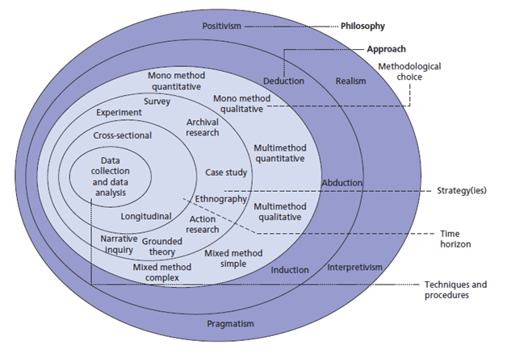
Figure 1.Source: Saunders, M., P. & Thornhill, A. (2012) Research Methods for Business students

3.2 Research philosophy
Research philosophy is the underlying assumptions and beliefs that guide the research process. Fuchs (2021) depicts that research philosophy determines the way in which data is collected and analysed, and it influences the interpretation of the results. There are three main research philosophies: positivism, interpretivism, and critical theory. Positivism assumes that there is a single objective reality that can be studied objectively, while interpretivism believes that reality is constructed through individual interpretation and meaning making. Critical theory, conversely, focuses on the power dynamics and social structures that shape the research process (Fuchs, 2021). This study adopted a positivism research philosophy, which assumes that reality is objective and that research findings can be explained using scientific methods.

3.3 Research approach
Research approach entails the general strategy used to conduct the research, such as experimental, qualitative, or quantitative. An experimental approach involves manipulating variables and measuring the effects on a particular outcome, while a qualitative approach focuses on understanding the meaning and experiences of individuals through open-ended data collection methods such as interviews and focus groups (Baker & Chenery-Morris, 2020). A quantitative approach involves collecting and analysing numerical data through methods such as surveys and experiments (Jones, 2022). This study adopted a quantitative research approach, as the research aims to gather and analyse numerical data on the impact of social media marketing on Tesco customer behaviour.

3.4 Research strategy
Research strategy is used to describe the whole plan or method used to complete a study. This section covers how the study was planned, how the data was gathered, and how it was analysed (Ioppolo & Wooding, 2022). This study used a survey research strategy, which included gathering data by questionnaire, then categorizing responses into quantitative variables for analysis.

3.5 Research technique
Research techniques refer to the specific tools and methods used to collect and analyse data. There are two main types of research techniques: qualitative and quantitative. Quantitative data refers to any kind of measurable numerical information amenable to statistical analysis. It is frequently collected via techniques such as surveys and experiments and may be used to test a hypothesis and generalize about a population (Titus, 2021). Conversely, qualitative data refers to non-numerical data, such as words, images, and videos, that cannot be easily quantified. In-depth focus groups are common methods of gathering this data, which is then utilised to deduce people's motivations and opinions.
In this dissertation, quantitative data was collected through surveys administered to Tesco customers. The use of quantitative data allows for the testing of hypotheses and the ability to generalize about social media marketing impacts on Tesco customer behaviour. It also allows for the use of statistical analysis to identify trends and patterns in the data. The use of quantitative data allows for a more objective and systematic approach to the research and allows for the use of standardized data collection and analysis methods.

3.6 Type of Investigation
Primary research is research that is conducted first-hand, via methods including surveys, interviews, and experiments. Advantages of primary research include the ability to collect specific and up-to-date data that is useful to the research objectives, and the opportunity to interact with and gather insights from participants directly (Cobb, 2016). Disadvantages of primary research include the time and cost required to conduct the research, and the potential for bias in the data collection process.
Secondary research is research that is conducted using existing data sources, such as published research studies, government reports, and online databases. Advantages of secondary research include the cost and time savings compared to primary research, and the availability of a wide range of data sources. Disadvantages of secondary research include the potential for outdated or irrelevant data, and the lack of control over the data collection process (Sarhan & Manu, 2021). This study adopted a primary research type of investigation as the data will be collected directly from Tesco customers by a questionnaire.

3.7 Time Horizons
Time horizon refers to the time frame within which the research is conducted. In this dissertation, the time horizon will be the period during which Tesco has been using social media marketing. The timeframe of this examination is cross-sectional; therefore, data was collected at a single instant in time (Smithers, 2022). This paves the way for the researcher to collect data on the topic's present status and to analyse the effect of social media marketing on the behaviours of Tesco customers at a given period.

3.8 Data collection
Collection of data refers to the steps used to amass relevant information for a study. It entails selecting a sample, using suitable data gathering techniques, then documenting and analysing the results (Martens, 2022).

3.8.1 Introduction
A questionnaire was used to gather information from Tesco clients for this research. Quantitative data was gathered by a survey that contained questions about the effect of social media marketing on customer behaviour.

3.8.2 Data sampling
Data sampling refers to the selection of a representative sample of the target population for the study (Hanlon et al., 2022). In this dissertation, the target population was Tesco customers who have interacted with the company's social media marketing efforts. The questionnaires were created and distributed to Tesco clients at random. The respondents were requested to fill the questionnaires and drop them at designated points. After allowing time for filling the questionnaires, the data were collected and recorded in an excel sheet. The selected method for data sampling is a simple random sampling. The sample was considered to be representative of the whole since it was selected at random.

3.8.3 Data collection methods
A questionnaire was used for data collection in this research. The questionnaire was composed of 10 closed-ended questions to get at the impacts of social media marketing on consumers' behaviours. The survey questions were distributed randomly to Tesco customers who filled the questionnaire in their own will and submitted the form.

3.8.4 Questionnaire
A questionnaire is a tool used to collect data through structured questions (Sloan, 2018). In this dissertation, a questionnaire was used to collect data from Tesco customers. The questionnaire included ten closed-ended questions, and was designed to gather information on the impact of Tesco's social media marketing efforts on customer behaviour.

3.8.5 Primary Research Obstacles
There may be several obstacles encountered in the data collection process, such as a low response rate, difficulties in accessing the target population, and potential bias in the responses. These obstacles were addressed through the use of a large sample size, as well as by carefully designing the questionnaire to minimize bias. The questionnaires were distributed to as many potential respondents as can be reached by the researcher. This way, the researcher improved the chance of getting a larger sample size. Moreover, the questions were set as simple multiple choice making it easy for the respondents to fill the answers.

3.9 Ethical consideration
Ethical considerations refer to the principles and guidelines that govern the conduct of research in a responsible and respectful manner (Tulyakul & Meepring, 2020). Ethical issues in this dissertation involved getting participants' informed consent, keeping their privacy and confidentiality, and doing the study in a way that does not damage or distress them.

3.10 Chapter Overview
This chapter details the research process that were used to evaluate how social media advertising affected the buying patterns of Tesco consumers. The study's research philosophy, approach, strategy, techniques, and data collection procedures have all been laid forth for audiences. Ethical concerns and research constraints have been addressed in this chapter as well. The data collection process, including the data sampling method, data collection methods, and questionnaire design, has been outlined. Finally, the chapter has outlined the data analysis techniques that will be used to analyse the collected data.

CHAPTER 4: DATA ANALYSIS

4.1 Introduction
Data analysis is the act of organizing, analysing, and making meaning of the obtained data in order to answer the research questions and fulfil the study goals. In this research, the obtained data was evaluated in order to assess the influence of social media marketing on Tesco consumer behaviour.

4.2 Inclusion and Exclusion Criteria
Inclusion and exclusion criteria refer to the criteria used to determine which data will be included in the analysis and which will be excluded. In this study, the inclusion criteria were based on the research objectives and the target population. Data from respondents who do not meet the inclusion criteria, such as those who are not Tesco customers or who have not interacted with the company's social media marketing efforts, were excluded from the analysis. This ensured that the study used data that is both applicable to and reflective of the demographic of interest.

4.3 Questionnaire Analysis
After collecting the data, the researcher recorded the observations in an excel sheet and used visualizations to observe the trend in the answers provided by the respondents. First, the analyst looked at the demographics of the sample data. Figure 1 summarises the respondents' age distribution
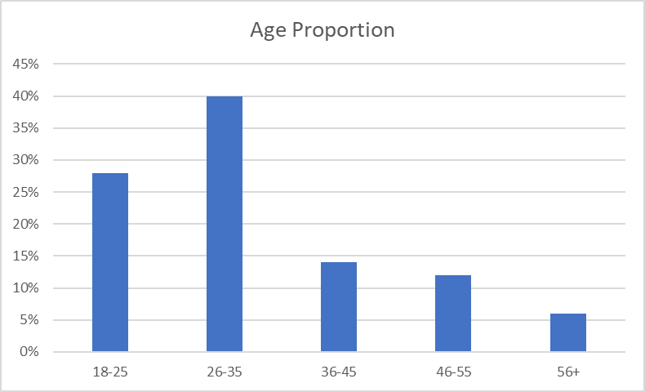
Figure 2. (Source: Created by the student)

1.What is your age?
Answers | Participants 50
18-25 | 28%
26-35 | 40%
36-45 | 14%
46-55 | 12%
56+ | 6%
Table 1. (Source: Created by the student)

Observation of figure 2 shows that the majority of the clients at Tesco are between 26 and 35 years, followed by the age bracket 18 to 25. Based on the observation, the company needs to select a marketing strategy most appealing to the youthful generation. Moreover, the firm should also establish other means to reach the older generation, who might not be attracted to the strategies more popular among the youth.

Figure 3. (Source: Created by the student)

2.What is your gender?
Answers | Participants 50
Male | 38%
Female | 62%
Table 2. (Source: Created by the student)

The gender distribution shows that females are the dominant clients (62%) against 38% male. Going by the distribution, Tesco management must initiate measures to improve the quality of products and services that the male clients prefer.
Analysis of the digital marketing strategies popular among Tesco clients is summarised in figure 4.
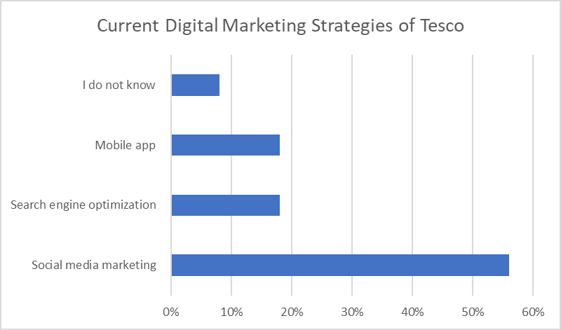
Figure 4. (Source: Created by the student)

3.What are the current digital marketing strategies of Tesco?
Answers | Participants 50
Social media marketing | 56%
Search engine optimization | 18%
Mobile app | 18%
I do not know | 8%
Table 3. (Source: Created by the student)

Figure 4 shows that social media marketing is the most preferred strategy among clients besides search engine optimization. Moreover, a sizeable proportion of the clients (18%) prefer the use of mobile apps in marketing. Social media is more popular among the youth. The youthful nature of Tesco clients shows why the strategy is the optimum option. The responses to the consumer loyalty question are summarised in figure 5.
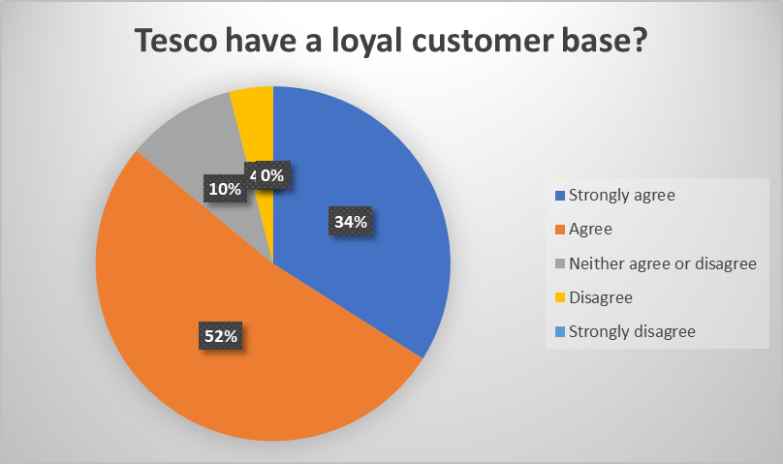
Figure 5. (Source: Created by the student)

4.Do you think Tesco have a loyal customer base?
Answers | Participants 50
Strongly agree | 34%
Agree | 52%
Neither agree or disagree | 10%
Disagree | 4%
Strongly disagree | 0%
Table 4. (Source: Created by the student)

Figure 5 indicates that 34% of the respondents strongly agree that Tesco clients are loyal to the organization's brand, with another 52% falling under the "agree" category. Over 80% of the sample agreed that the firm had created a loyal customer base. The organization should keep a close relationship with its clients to ensure competitors do not poach them. As observed by the research, one way of doing this is by having an active social media marketing campaign. The firm should also apply measures to attract other clients who use Tesco products and services but have yet to commit their loyalty to the firm.
Besides loyalty to the firm, the respondents agreed that the company has a positive brand image, as shown in figure 6.
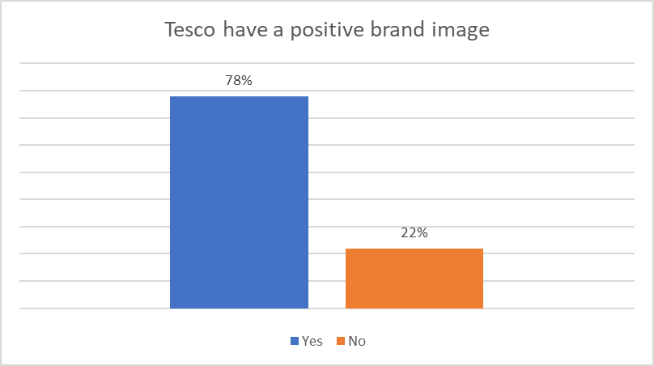
Figure 6. (Source: Created by the student)

5. Does Tesco have a positive brand image?
Answers | Participants 50
Yes | 78%
No | 22%
Table 5. (Source: Created by the student)

78% of the respondents agreed that the organization's brand image is positive.
According to table 5, 66% of the respondents have observed that Tesco is developing
a digital marketing strategy. Another 20% are yet to experience the new digital strategies, while 14% are unaware of what is happening at the firm.
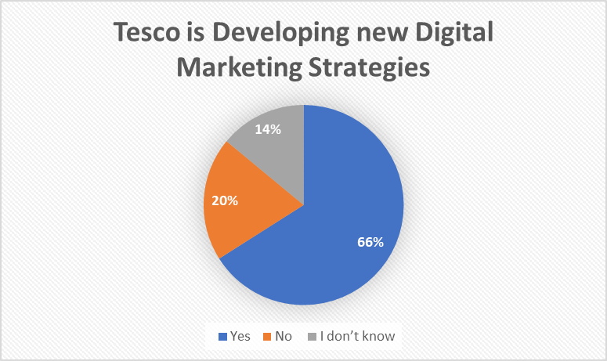
Figure 7. Tesco is developing a digital marketing strategy, especially on social media?
6. Tesco is is developing a digital marketing strategy?
Answers | Participants 50
Yes | 66%
No | 20%
I do not know | 14%
Table 6. (Source: Created by the student)

Some of the top competitors of the organization are Sainsbury and Asda. Based on the respondents, 34% feel Sainsbury offers the most substantial competition to Tesco, with another 22% routing for Asda. Morrison (16%) and Waitrose (14%) are other top competitors. Market competitiveness means that Tesco must constantly engage with its clients to keep the company's brand image strong and retain the clients' loyalty.
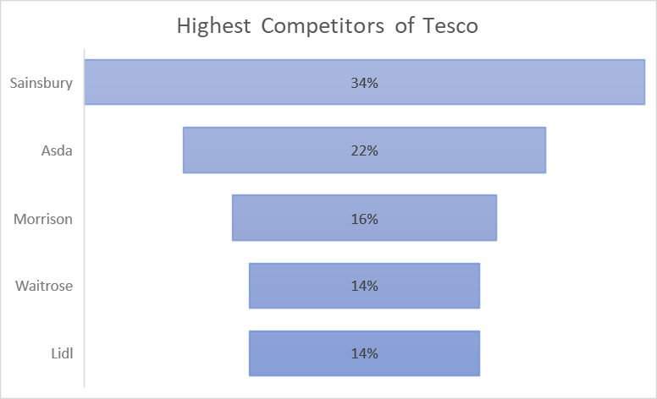
Figure 8. (Source: Created by the student)

7.Who are the highest competitors of Tesco?
Answers | Participants 50
Sainsbury’s | 32%
Asda | 22%
Morrison’s | 16%
Waitrose | 14%
Lidl | 14%
Table 7. (Source: Created by the student)
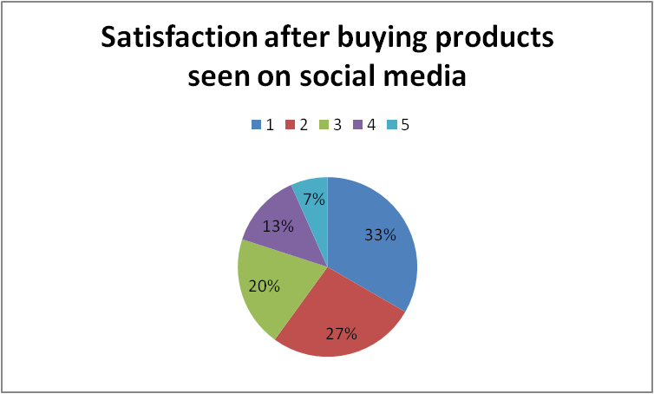
Figure 9. (Source: Created by the student)

8.How satisfied were you after buying products from Tesco after you see them on social media? (5-high, 1-low)
Answer | Participants 50
1 | 7%
2 | 13%
3 | 20%
4 | 27%
5 | 33%
Table 8. (Source: Created by the student)

The purpose of this question was to see if social media is usefull for Tesco. The answer is yes. 33% agreed that what they are satisfied after they buy products seen on social media, giving the highest mark,5, and 27% giving the 4 mark. Anyway there is still 20% of people who were not really satisfied giving 1,2 marks, Tesco need to pay attention to this, Tesco still need to find new ways to improve.
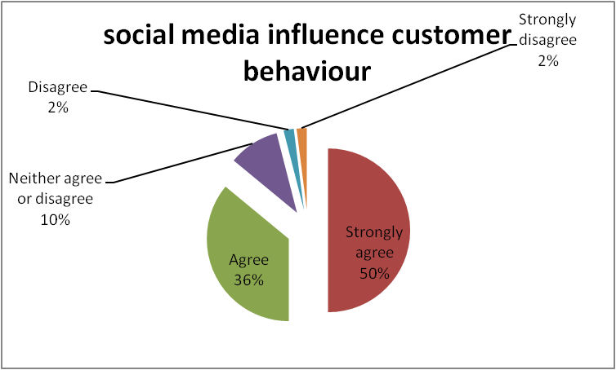
Figure 10. (Source: Created by the student)
9. Are you agree that social media influence customer behaviour?
Answer | Participants 50
Strongly Agree | 50%
Agree | 36%
Neither agree or disagree | 10%
disagree | 2%
Strongly disagree | 2%
Table 9. (Source: Created by the student)

From the figure number ten can be understood that social media influence customer behaviour more than 80% are agree and strongly agree with this statement. Tesco needs to put more advertisements on social media platforms to have more customers.
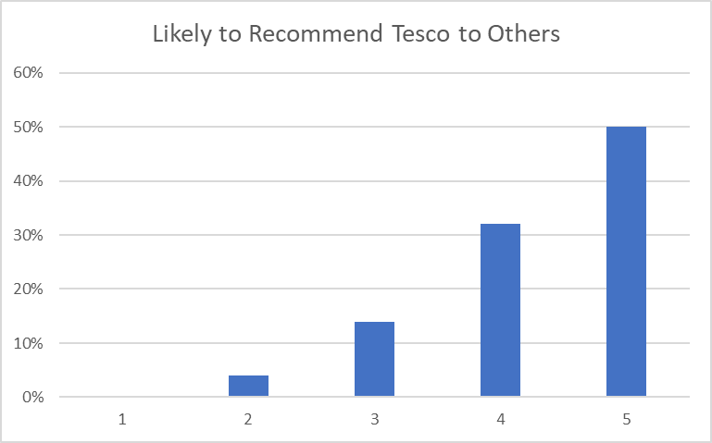
Figure 11. (Source: Created by the student)

10. How likely you recommend to others Tesco? (5-high, 1-low)
Answer | Participants 50
1 | 0%
2 | 4%
3 | 14%
4 | 32%
5 | 50%
Table 10. (Source: Created by the student)

CHAPTER 5: FINDING AND DISCUSSION

5.1 Introduction
The findings from the study's data analysis are presented in this section. The data, the research techniques, and the study's conclusions are all described in detail. The data collected through surveys with Tesco customers is analysed to determine the extent to which Tesco's social media marketing campaigns affected consumers' buying habits and preferences. The data is also analysed to identify any patterns or trends in consumer behaviour in relation to social media marketing. The chapter also includes any figures, and charts that are used to present the findings of the study. An overview of the key results and discussion is provided at the end of the chapter.

5.2 Findings
Based on the data presented in Figures 1-8, it is evident that Tesco has a strong customer base and positive brand image. It is clear that the majority of Tesco's customers are between the ages of 26 and 35, and are primarily female. The data also shows that social media marketing is the most popular digital marketing strategy among Tesco's customers, followed by search engine optimization. Additionally, a significant number of customers (18%) prefer the use of mobile apps in marketing.
The data also indicates that Tesco has a loyal customer base, with over 80% of the sample agreeing that the company has created a loyal customer base. Furthermore, the majority of respondents agree that Tesco has a positive brand image.
In addition, the data suggests that 66% of the respondents have observed that Tesco is developing a digital marketing strategy, and 50% of the clients are highly likely to refer others to the company. However, there is also some indication that the company has limitations that need to be addressed, as 4% of the respondents are not likely to refer others to the company.
Based on these findings, the study concludes that social media marketing is an effective strategy for Tesco to connect with and learn more about its target audience, and that Tesco has been successful in creating a loyal customer base and maintaining a positive brand image. However, the study also suggests that there is room for improvement and suggests that Tesco should focus on targeting older generations and male customers, continue to develop its digital marketing strategy, and address any limitations in order to further improve its relationship with customers.

5.3 Discussion
These days, social media platforms provide one of the most significant audiences for marketers anywhere. As a result, companies may utilize social media sites like Facebook, Twitter, and Instagram to reach out to customers and sell their products (Blair, 2017). The effectiveness of social media marketing may be linked to the enhanced accessibility it gives to customers. The demand for socialism and socialist views among the general population, according to Boulianne & Lee (2022), was responsible for the development and spread of social media platforms. Kasemsap (2018) estimated that over half of the worldwide population utilizes some type of social media, with regular daily usage in marketing reaching 65%.
Because of this widespread access to the internet, social media marketing has risen to prominence as a viable advertising channel for businesses like Tesco, UK. Marketing through social media is used by them for many different aims. According to Trivedi & Malik (2022), the over 2.23 billion monthly active users of social media platforms like Facebook help marketers to attract more customers than any other old and traditional marketing methods.
The outcomes of this research give useful insights into the contemporary social media marketing method conducted by Tesco. The analysis indicated that Tesco utilizes a number of social media channels such as Facebook, Instagram and Twitter to communicate with consumers and advertise its goods. The study also identified the challenges faced by Tesco in using social media marketing tactics such as managing negative comments and feedback from customers.
However, the analysis also revealed some challenges that Tesco may experience using social media marketing tactics. For example, the analysis showed that there is an emergence of new competitors and the existence of other competitive firms.
The research findings depict that social media advertising has a substantial influence on the way consumers engage with the firm, including increased website visits and transactions. Customers who follow Tesco on social media are also more likely to be loyal shoppers and to suggest the retailer to their friends and family, according to the study.
These results are consistent with the literature reviewed on the power of social media marketing to affect customer behaviours. There is evidence that advertising on social media may boost sales by raising brand recognition and website traffic. Consistent with research on the connection between social media participation and brand loyalty, it is clear that consumers who follow a brand on social media are more likely to be loyal customers and promote the company to others. This research contributes to the current literature by giving concrete evidence of the influence of Tesco's social media marketing strategy on consumers' purchasing habits and by illuminating the difficulties the firm has encountered in using social media marketing strategies.
In conclusion, this study has successfully achieved its aims and objectives by providing a thorough examination of the present social media marketing approach executed by Tesco, assessing the problems faced by the company in using social media marketing tactics, analysing the effect of social media marketing initiatives on customer behaviour and providing valuable insights for companies looking to improve their customer outreach and interaction strategies.

CHAPTER 6: RECOMMENDATION AND CONCLUSION

6.1 Summary of findings
The purpose of the research was to determine whether and how Tesco's social media marketing approach affected consumer buying behaviours. Customers reported being more inclined to buy items after seeing them promoted on social media platforms, suggesting that social media marketing has a substantial effect on consumer behaviours. Additionally, the study found that Tesco's social media marketing campaigns were effective in reaching and engaging with their target audience.

6.2 Addressing the Objectives
The research aims to assess the influence of Tesco's social media marketing strategy on the buying behaviour of its consumers. Via the analysis of data acquired through questionnaires, the research was able to establish the extent to which Tesco's social media marketing initiatives influenced customers' purchasing patterns and preferences. The research also aims to give insight into the relationship between social media marketing and consumer behaviour, and to assist firms like Tesco improve their customer outreach and engagement methods.

6.2 Limitations
This study is not without limitations. Firstly, the research is limited to customers of Tesco in the United Kingdom, and the results may not be generalizable to other countries. Secondly, the study focused on a single retail company, and the findings may not be applicable to other industries

6.3 Recommendations
Based on the findings of this study, the following recommendations are offered for Tesco and other companies in the retail industry:
- Tesco should continue to use social media as a marketing tool to reach out to customers and market their products. However, they should also be mindful of the privacy concerns that consumers may have and ensure that their data is collected and used in an ethical and transparent manner.
- Tesco should focus on creating engaging and interactive social media campaigns that will appeal to their target audience and encourage them to engage with the brand. This can be done by using a variety of content formats such as videos, images, and user-generated content.
- Tesco should also focus on using social media to provide valuable information and insights to customers, such as information on new products, discounts, and promotions. This will help to build trust and loyalty among customers, and encourage them to make repeat purchases.
- Tesco should also consider using social media to gather feedback and insights from customers, as this will help to identify areas where they can improve their customer service and overall customer experience.

6.4 Future Implications
The findings of this study have important implications for companies like Tesco, as they can use the information to improve their social media marketing campaigns and better target their core customers. The study also has implications for other companies and industries, as the findings can be generalized to other businesses looking to improve their customer engagement and acquisition efforts through social media marketing. Additionally, this study contributes to the literature on the relationship between social media marketing and consumer behaviour and provides a basis for future research in this area.

6. 5 Recommendations for Future Research
To further understand the connection between social media marketing and consumer behaviours, future studies should investigate the effects of social media marketing across sectors and geographies. Other sectors, or even certain facets of social media advertising like influencer marketing, could be the focus of future research.

LIST OF REFERENCES
Agnihotri, R. (2020) "Social Media, customer engagement, and sales organizations: A research agenda," Industrial Marketing Management, 90, pp. 291–299. Arango Botero, D. et al. (2020) "Factors that promote social media marketing in retail companies," Contaduría y Administración, 66(1), p. 233.
Baker, B. and Chenery-Morris, S. (2020) "Understanding research: 8. methods of data collection in qualitative methodologies: Observation, interviews and focus groups," The Practising midwife, 23(11).
Blair, M.K. (2017) "Using digital and social media platforms for social marketing," Oxford Medicine Online [Preprint]. Available at: https://doi.org/10.1093/med/9780198717690.003.0012.
Boulianne, S. and Lee, S. (2022) "Conspiracy beliefs, misinformation, social media platforms, and protest participation," Media and Communication, 10(4). Available at: https://doi.org/10.17645/mac.v10i4.5667.
Chhabra, D. (2018) "Factors affecting consumer buying behaviour and decision making process towards FMCG products," Journal of Advances and Scholarly Researches in Allied Education, 15(6), pp. 131–139.
Cobb, W. (2016) "Research methods: How will I collect the data?," Researching Primary Education, pp. 72–92.
Fuchs, C. (2021) "From Digital positivism and administrative big data analytics towards critical digital and Social Media Research," Digital Capitalism, pp. 177–192
Hanlon, P. et al. (2022) "Multimorbidity in a selected cohort compared to a representative sample: Does selection bias influence outcomes?," Big data [Preprint]. Available at:
Indriyani, D. (2021) "E-commerce & online marketing: Risks associated with online shopping," Dinasti International Journal of Digital Business Management, 2(3), pp. 524–530.
Ioppolo, B. and Wooding, S. (2022) "How academic sabbaticals are used and how they contribute to research – a small-scale study of the University of Cambridge using interviews and analysis of Administrative Data," F1000Research, 11, p. 36
Jones, I. (2022) "Analysing data I: Quantitative data analysis," Research Methods for Sports Studies, pp. 247–275.
Juska, J.M. (2021) "Digital Media strategies," Integrated Marketing Communication, pp. 153–182.
Kasemsap, K. (2018) "The roles of social media marketing and Brand Management in global marketing," Social Media Marketing, pp. 425–453.
Lammenett, E. (2021) “Content-marketing,” Praxiswissen Online-Marketing, pp. 337–364..
Lammenett, E. (2021) “Mobiles internet und mobile-marketing,” Praxiswissen Online-Marketing, pp. 523–534.
MZ A. Tarabieh, S. (2022) "The impact of social-media marketing activities on consumers' loyalty intentions: The mediating roles of brand awareness, consumer brand engagement and Brand Image," Jordan Journal of Business Administration, 18(4).
Malkani, A. (2022) "Reinventing email marketing through a personalisation strategy," The SAGE Handbook of Digital Marketing, pp. 181–197.
Martens, D. (2022) "Ethical data gathering," Data Science Ethics, pp. 31–84.
Mesra B, Hernawaty and Surya Asih (2022) "Improving online purchasing decisions through product assessments on Shopee Marketplace consumers," World Journal of Advanced Research and Reviews, 15(2), pp. 459–466.
Montaguti, E., Neslin, S.A. and Valentini, S. (2016) "Can marketing campaigns induce multichannel buying and more profitable customers? A field experiment," Marketing Science, 35(2), pp. 201–217.
Nuseir, M.T. (2020) "Is advertising on social media effective an empirical study on the growth of advertisements on the big four (Facebook, Twitter, Instagram, WhatsApp)," International Journal of Procurement Management, 13(1), p. 134.
Patel, J. (2022) "Review for 'Search Engine Optimization (SEO) for digital marketers: Exploring determinants of online search visibility for blood bank service.'" Available at: https://doi.org/10.1108/oir-05-2022-0276/v1/review1.
Rajagopal (2019) "Consumer behavior: Internal factors," Contemporary Marketing Strategy, pp. 3–33.
Santos, S., Gonçalves, H.M. and Teles, M. (2022) "Social Media Engagement and real‐time marketing: Using Net‐effects and set‐theoretic approaches to understand audience and content‐related effects," Psychology & Marketing [Preprint]. Available at: https://doi.org/10.1002/mar.21756.
Santosa, R. (2021) "The influence of cultural factors, social factors, and personal factors against customer purchase decisions in using wedding services organizer in Surabaya," International Journal of Review Management Business and Entrepreneurship (RMBE), 1(2), pp. 77–90.
Sarhan, S. and Manu, E. (2021) "When does published literature constitute data for secondary research and how should the data be analysed?," Secondary Research Methods in the Built Environment, pp. 69–87.
Shin, M. et al. (2020) "Enhancing customer-brand relationship by leveraging loyalty program experiences that Foster customer-brand identification," International Journal of Contemporary Hospitality Management, 32(12), pp. 3991–4016.
Sloan, M.M. (2018) "The work experiences questionnaire: Using mail survey research to collect data from a large sample of workers." Available at: https://doi.org/10.4135/9781526430755.
Smithers, A. (2022) "The Time Horizon at which investors will prefer equities to Bonds," The Economics of the Stock Market, pp. 59–60.
Sohail, M.S. and Al-Jabri, I.M. (2017) "Evolving factors influencing consumers' attitudes toward social media marketing and its impact on social media usage," SSRN Electronic Journal . Available at: https://doi.org/10.2139/ssrn.3921988.
Titus, M. (2021) "Advanced statistical techniques: I," Higher Education Policy Analysis Using Quantitative Techniques, pp. 145–180.
Trivedi, S. and Malik, R. (2022) "Social media marketing as New Marketing Tool," Research Anthology on Social Media Advertising and Building Consumer Relationships, pp. 18–33.
Tulyakul, P. and Meepring, S. (2020) "Ethical issues of informed consent: Students as participants in Faculty Research," Global Journal of Health Science, 12(3), p. 86..
Willis, M. (2022) "The dynamics of social media marketing content and customer retention," Research Anthology on Social Media Advertising and Building Consumer Relationships, pp. 217–237.
Yildirim, S. (2020) "The consumer role for Sustainable Development," Advances in Marketing, Customer Relationship Management, and E-Services, pp. 325–341.

