Control Technology
ACMA 6001

Factory Control 2
Bryony Stanfield
2008682

Contents
List of figures 3
1.0 Introduction 4
2.0 Factory system design 5
2.1 PLC Tags 5
2.2 HMI Screen design 6
2.3 Factory IO design 9
3.0 System design 10
3.1 Operational Flow Chart 10
3.2 Alarm and warning strategy 11
3.3 Ladder logic program 12
4.0 References 30

List of figures

Figure 1 Factory layout 4
Figure 2 PLC Tags 5
Figure 3 HMI Root screen 6
Figure 4 HMI Warning screen 7
Figure 5 HMI Engineers screen 8
Figure 6 Factory Layout 1 9
Figure 7 Factory Layout 1.1 9
Figure 8 Factory Layout 1.2 9
Figure 9 Systems operational flow chart 10

Introduction

In this report I am going to develop an automated process using Factory IO, S7 PLC Simulation & TIA Portal to simulate a system that machines, assembles, stacks, and packages. This system will manufacture lids and bases, assemble them by placing the lid onto the base and then pick and place the assembled item into the shipping container box. Below I have written the process that I have gone through to build the process.

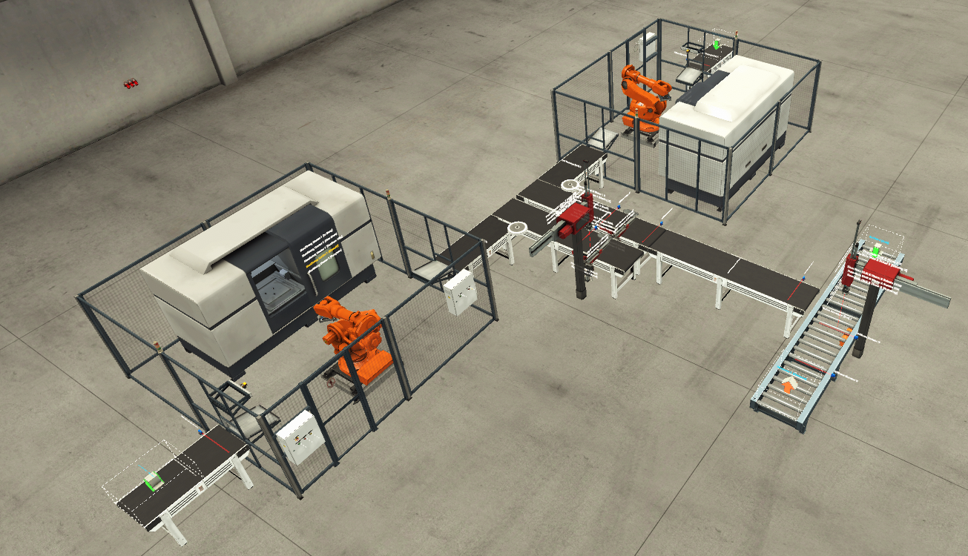
Figure 1 Factory layout

2.0 Factory system design

2.1 PLC Tags
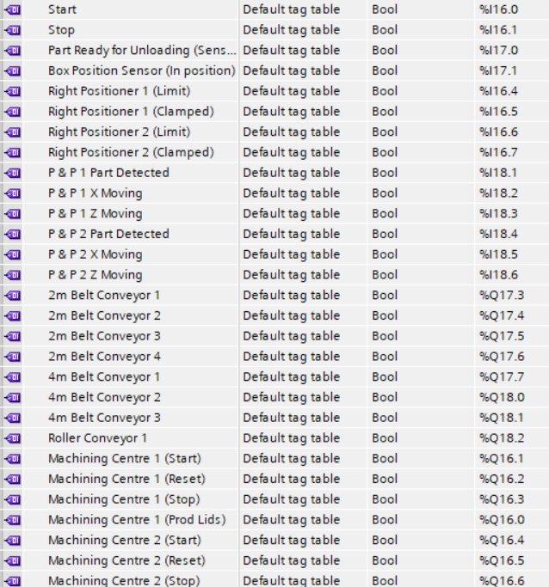
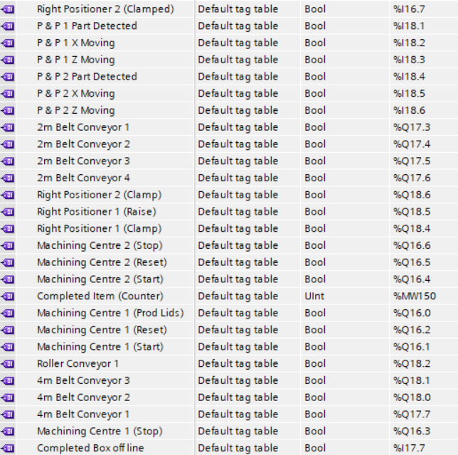
Figure 2 PLC Tags

2.2 HMI Screen design
Root Screen
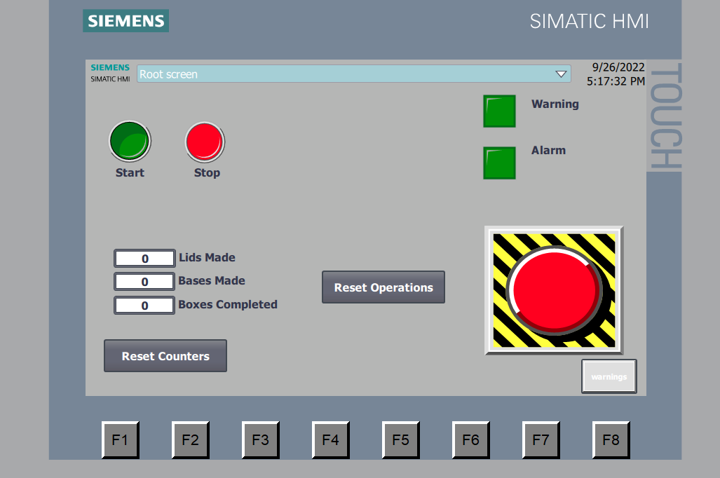
Figure 3 HMI Root screen
This is the main operating screen this gives you all your controls, indictors and navigation buttons as stated below
- Warning light
- Alarm light
- Start button (light up)
- Stop button (Light up)
- E-Stop button
- Lids made count
- Bases made count
- Boxes complete count
- Re-set counters button
- Re-set operations button
- Warnings button

Warning screen
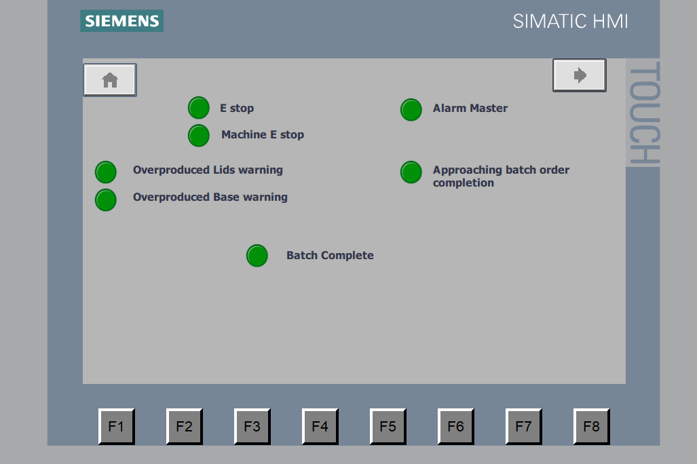
Figure 4 HMI Warning screen
This screen is the warning screen, this screen shows all the alarms given by the system which is shown by Light up indicators. It shows lights for overproduced lids and bases, approaching batch order completion and batch complete. It will also indicate if either estop is active or the alarm master is active. Its also has two navigation buttons. (Home, Engineer screen)
Engineers screen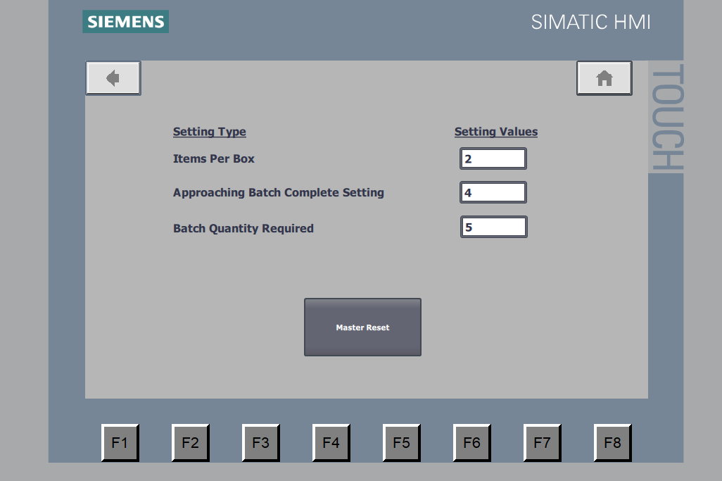
Figure 5 HMI Engineers screen
This screen is the engineer’s screen. This screen is purely for the use of an engineer to set values for warnings and errors and to also master reset and alarms. It also has 2 navigation buttons, Home and back to the warnings screen. This screen can be password protected for the security of the system.

2.3 Factory IO design
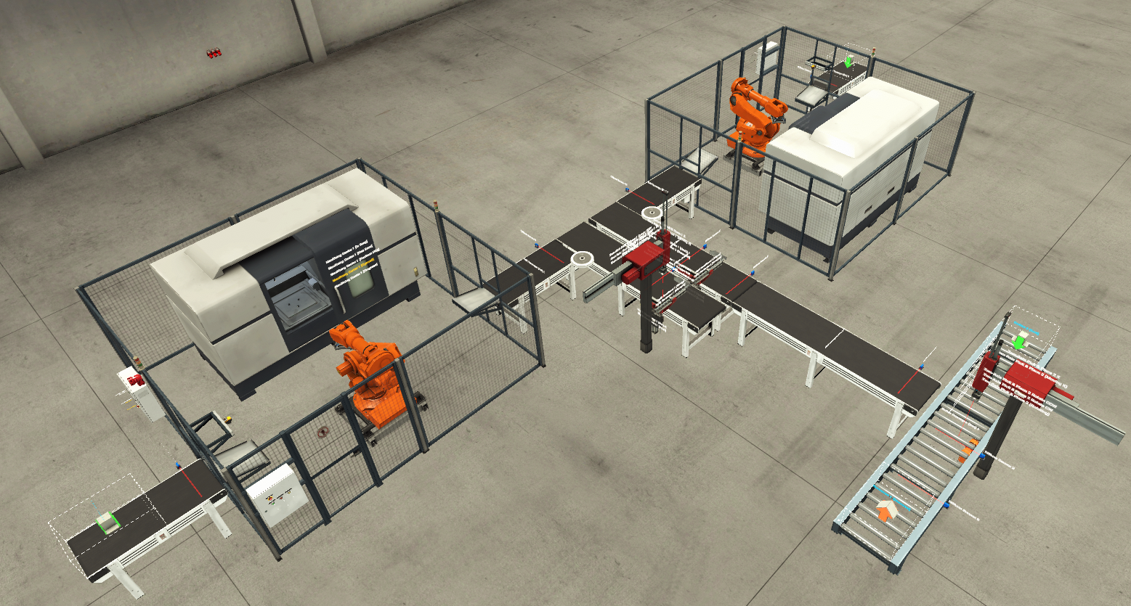
Figure 6 Factory Layout 1
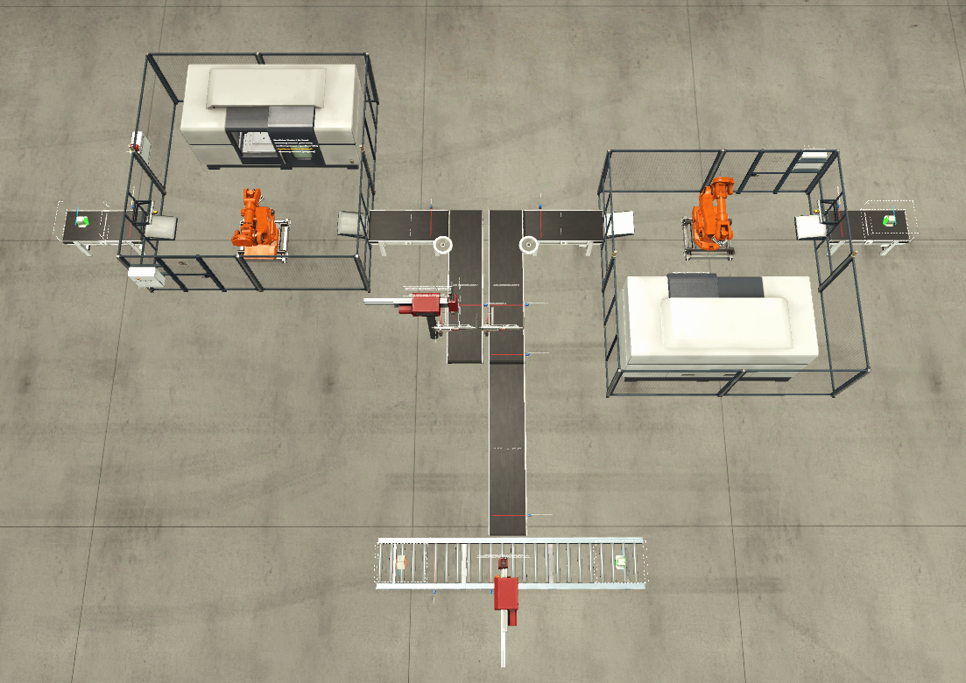
Figure 7 Factory Layout 1.1
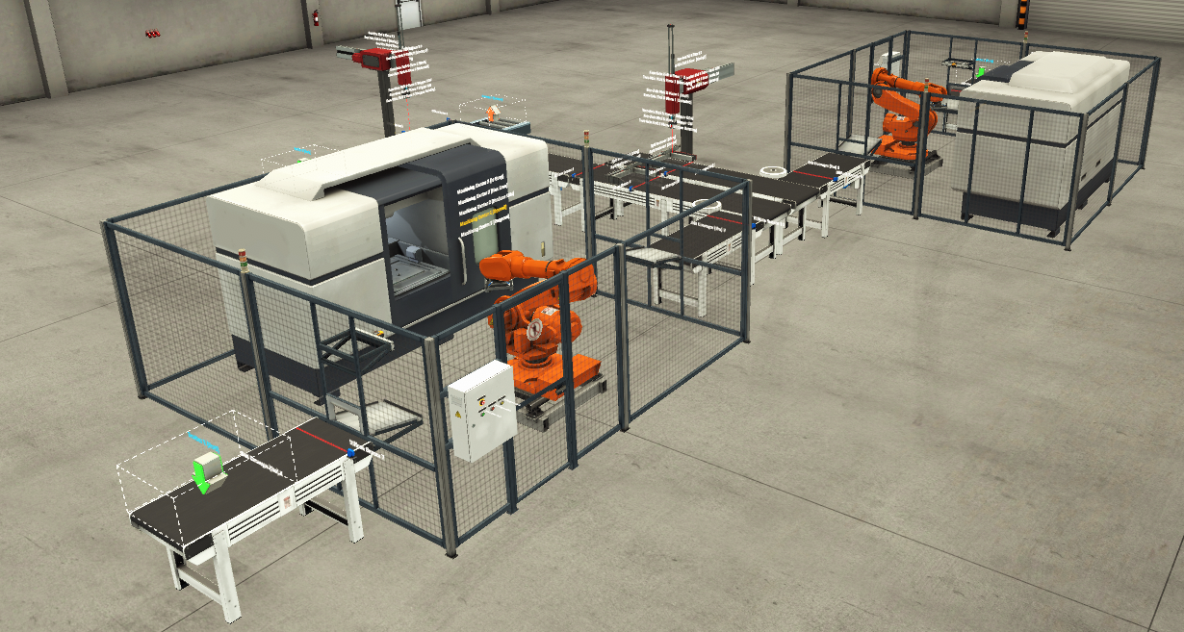
Figure 8 Factory Layout 1.2

3.0 System design

3.1 Systems Operational Flow Chart

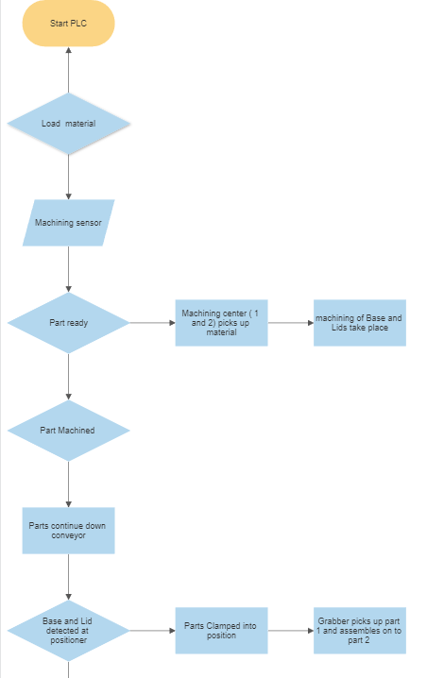
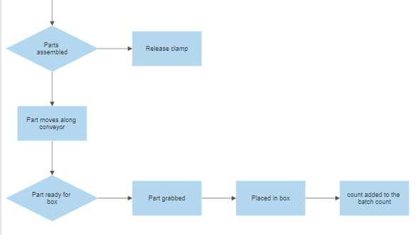

Figure 9 Systems operational flow chart

3.2 Alarm and warning strategy

Warnings
Warning Light
If there is any warning the warning byte not equal to 0 (greater than) will activate the warning present signal which will be shown on the HMI. This is a flag for the HMI root screen.
Over production of lids
If the lid made sensor is active and either part as P&P1 or right positioner 1 this means that there has been a lid produced by the machining sensor and there is also still a part present at pick and place 1 to stop the lid from causing issues at the pick and place unit, this creates an overproduction of lids warning used to stop the out-feed conveyor.
Over production of bases
If the base made sensor is active and either part as P&P2 or right positioner 2 this means that there has been a base produced by the machining sensor and there is also still a part present at pick and place 2 to stop the base from causing issues at the pick and place unit, this creates an overproduction of bases warning used to stop the out-feed conveyor.
Approaching Batch order completion
When the approaching batch complete setting on the boxes completed counter, this gives the near batch complete warning on the HMI.

Alarms
Alarm master
The Alarm master will be activated if an error occurs, and an alarm is raised. This alarm in the system will retain/latch so that it cannot be overridden and must be cleared by an engineer manually.
Boxes completed count alarm
The Boxes completed count alarm will be activated if the count reaches the figure set in the system, which has been defined by the user. This will illuminate the alarm light and stop the line.
E-Stop
If the E-Stop is activated this will call for the alarm light to be illuminated and the line is stopped immediately.
Machine E-Stop
If the machines E-Stop is activated this will call for the alarm light to be illuminated and the line is stopped immediately.

3.3 Ladder logic program
All Networks
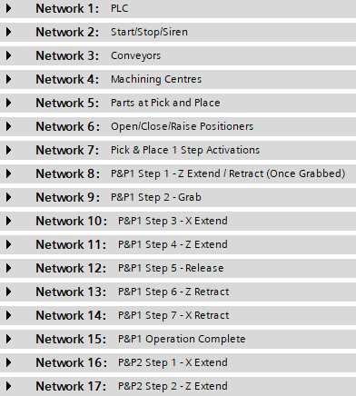
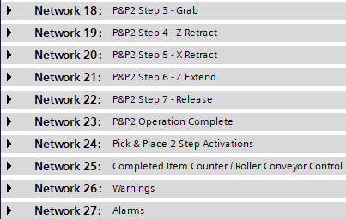

Network 1
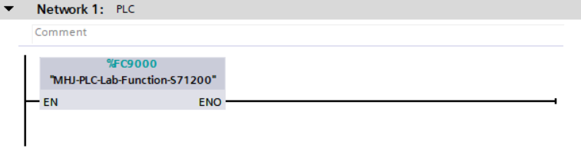
This is the link between Siemens TIA V16 and Factory IO. This will allow live simulation.
Network 2
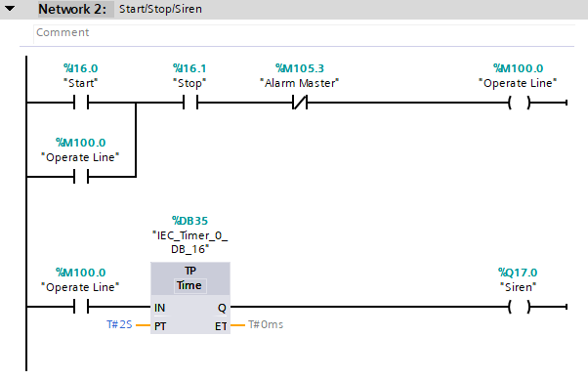
- N/O contact to start button
- Reverse logic on N/O stop button, Stop button will stop the line when activated
- N/C Alarm master to stop line when alarm is active
- When the three above are true this will then energise the operate signal and create a latch on the operate N/O contact to bypass the start button
- The Latch will break when it sees the signal of the alarm master or stop button
- When operate is true, there is then a 2second pluse timer which then sounds the siren for 2 second before the coveyor starts.

Network 3 – Conveyors
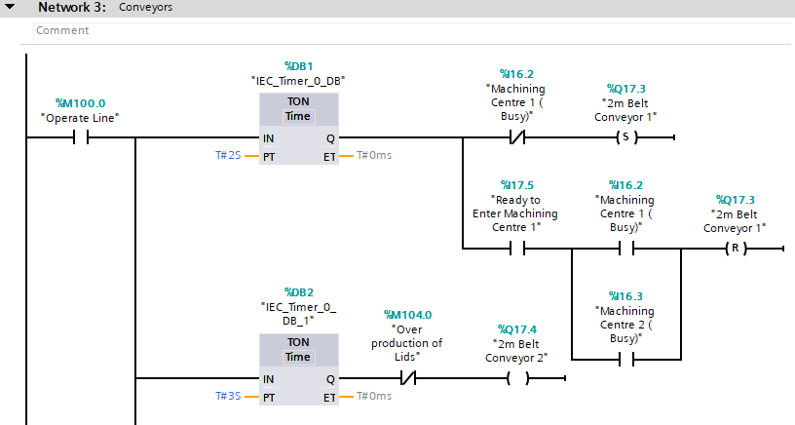
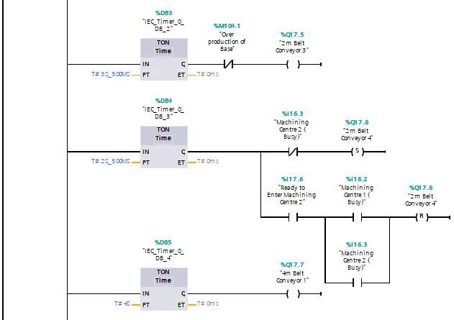
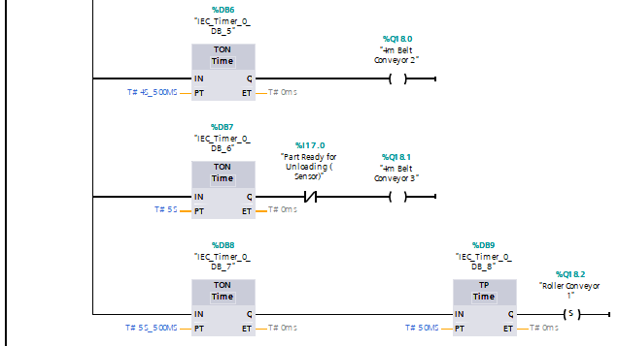
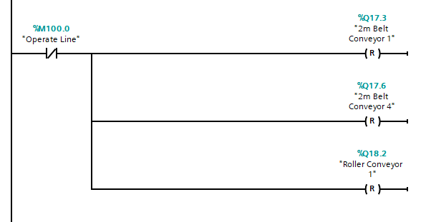

- NO contact which operates line which starts all conveyors
For each conveyor there is a 0.5 second delay between each conveyor to prevent a surge on start up.
- If machine center 1 is not bussy the conveyor is set, so it will run. However, if a part is ready at “part ready to enter mahcing centre 1” and either machine needs to to be ready before it feeds onto the line.
If either conveyor 1 or 2 is busy “2m belt convyor 1” will not run.
- Both over production contact will loose a signal if an alarm is raised and this will then stop the feed into the machine centers.
- All other conveyors (4) run contiunusly when operate is true.
- If machine center 2 is not bussy the conveyor is set, so it will run. However, if a part is ready at “part ready to enter mahcing centre 2” and either machine needs to to be ready before it feeds onto the line.
- If either conveyor 1 or 2 is busy “2m belt convyor 4” will not run.
- “4m belt conveyor 3” this runs unless its sees that a part is at the end “part ready for unloading sensor”. If a part is seen it stops, this is when the NC opens and the signal is lost.
- All other conveyors (4) run contiunusly when operate is true.
- When the operate line looses it signal it will the reset each conveyor and the roller conveyor due to its other signals and sets.
Network 4 –
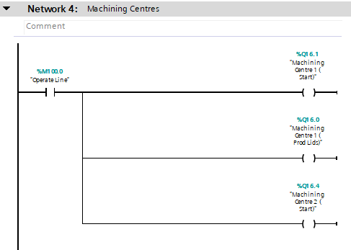
- “Operate line” NO contact closes which “starts machining centre 1 start” which also closes a contact which tells the machine to start producing Lids. Which in turn closes “machining centre 2 start” contact to start machine.

Network 5 –
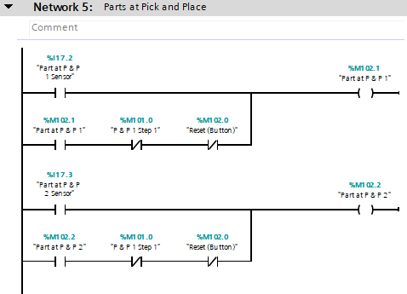
- NO “part reaches pick and place sensor” closes and give the tag at “part at pick and place 1”
- This also then latches “part at pick and place 1”
the 2 resets for this network are, when “pick and place 1 step 1” signal is true it will reset or if the “reset button” is press this contact will lose its signal.
- NO “part reaches pick and place sensor” closes and give the tag at “part at pick and place 2” This also then latches “part at pick and place 2” the 2 resets for this network are, when “pick and place 1 step 1” signal is true it will reset or if the “reset button” is press this contact will lose its signal.

Network 6 –
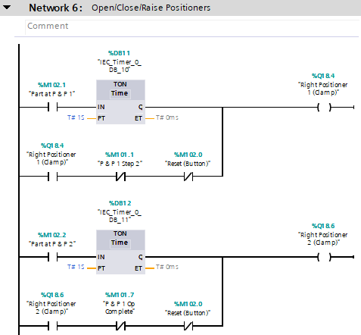
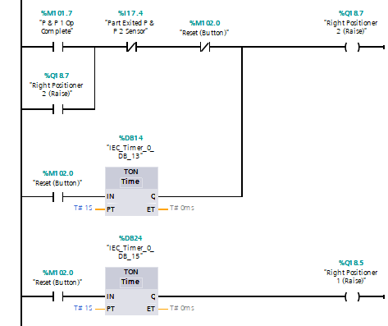
- “Part at pick and place 1” tag when activated starts a 1 sec timer which then cause “right position 1” to clamp holding the lid in place.
- It is then latched with a NO contact at right positioner 1 clamp, the latch remains until either the reset button is activated or the “pick and place 1 step 2” is active
- As soon as I get pick and place step 2 (which grab the part, Lid) it breaks the latch and releases from the clamp.
- “Part at pick and place 2” tag when activated starts a 1 sec timer which then cause “right position 2” to clamp holding the base in place.
- It is then latched with a NO contact at right positioner 2 clamp, the latch remains until either the reset button is activated or the “pick and place 1operation complete” is active. All other steps are complete (at home position).
pick and place 1 operation complete is then true it then releases from the clamp.
- pick and place 1 operation complete NO is true the positioner (right positioner 2 raise) will raise this then latches keeping the positioner at high level until part moves through NC “part exited pick and place 2 sensor” sensor which then losses its signal and move the position to its home position.
Network 7 –
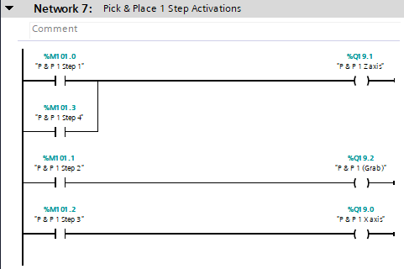
- Control each of the p & p movements using different steps
- When step 1 or 4 is active the P&P is extended in the z axis.
- When step 2 only the grab function is active
- When step 3 is active pick and place is extended in the x axis
Network 8 –
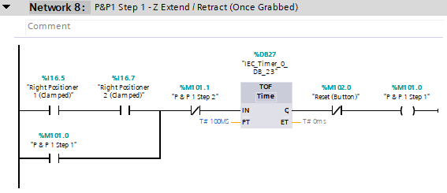
- In order for the pick and place unit to move both clamps need to need to be true to ensure that both parts are present and ready for assembly.
- Once both are positioners are clamped, pick and place 1 step 1 activates, this is then latched and stays in place until pick and place step 2 begins. The 100ms time starts when pick and place step 2 is active which allows the grabber to fully engage.
- Reset button NC contact opens and loses signal to “pick and place 1 step 1”

Network 9 –
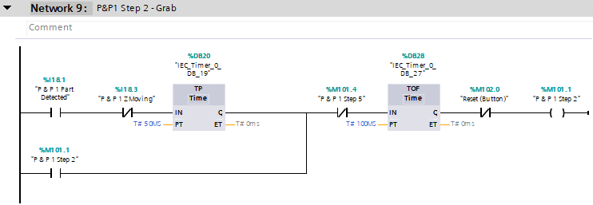
- When “pick and place 1 part detected” has seen a part and “pick and place 1 z moving” is stationary this will then start a 15ms pulse (stops sequencing issues when releasing) which activates step which then latches. The pulse means that this step then solely relies on the latch to prevent sequencing issues.
- The latch remains until step 5 which this is the release step. Same as above it has 100ms timer to ensure that it releases.
- Reset button NC contact opens and loses signal to “pick and place 1 step 1”
Network 10 –
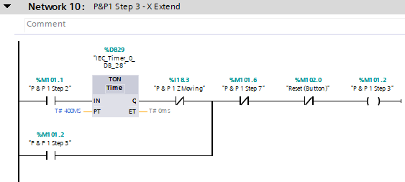
- Once P&P step 2 is active this then starts a 400ms timer, this allows the pick and place to begin moving, once it has stopped moving, pick and place step 3 activates.
- Pick and place step 3 is extent in the x axis, this latches and remains until step 7, this is when X needs to retract.
- Reset button NC contact opens and loses signal to “pick and place 1 step 1”

Network 11 –
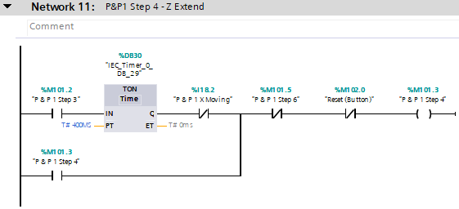
- Pick and place step 3 is activated which activates a 400ms timer, this allows the pick and place to begin moving in the X direction before it can continue in the rung. To prevent diagonal movement.
- Pick and place step 4 is extent in the Z axis, this latches and remains until step 6, this is when Z needs to retract.
- Reset button NC contact opens and loses signal to “pick and place 1 step 1”

Network 12 –
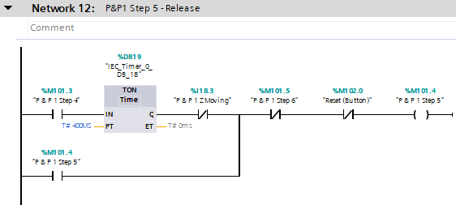
- Pick and place step 4 is activated which activates a 400ms timer, this allows the pick and place to begin moving in the Z direction.
- Step 5 does not activate until the Z axis stops moving, this allows the grabber to release. This then latches and remains until step 6, this is when Z needs to retract.
- Reset button NC contact opens and loses signal to “pick and place 1 step 1”

Network 13 –
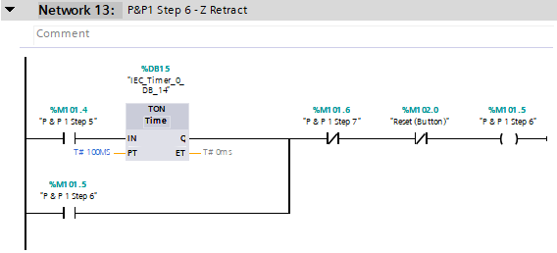
- Pick and place step 5 is activated which activates a 100ms timer which allows the grabber to release in a consistent fashion.
- Step 6 activates which then allows the z axis to retract.
- Reset button NC contact opens and loses signal to “pick and place 1 step 7”

Network 14 –
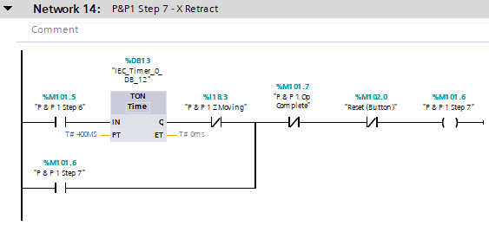
- Pick and place step 6 activates which starts a 400ms timer this allows the pick and place to begin moving in the z direction before it can continue in the rung.
- Once z has stopped moving this then activates step 7 which then latches and allows x to retract.
- Step 7 also unlatches when NC contact open for pick and place operation complete.
- Reset button NC contact opens and loses signal to “pick and place 1 step 7”

Network 15 –
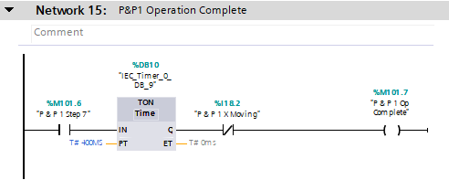
- Pick and place 7 activates which starts a 400ms timer this allows the pick and place to begin moving in the X direction before it can continue in the rung. This then activates a reset for pick and place step 7 to give a blank slate for the next part.
Network 16 –
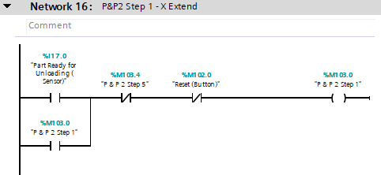
- When part ready for unloading has seen a part, this makes the NO contact true, this then latches step P&P 2 step 1 and this will not be unlatched until it either see’s P&P step 5 loose its signal or the reset loose its signal.
Network 17 –
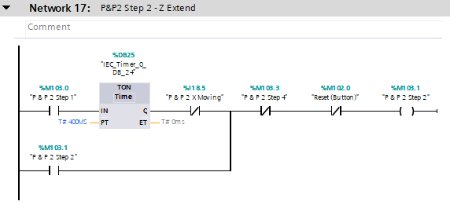
- Step 1 needs to be active moving in the x axis, a 400ms timer to allow the P&P 2 x moving this stops the movement being diagonally moving towards the part. Its stays latched until it sees step 4 or reset button.

Network 18 –
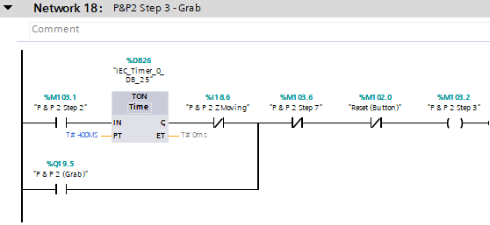
- P&P step 2 becomes active, then there is a delay of 400ms timers give it time to get to the part and then activate step 3, which is the grab action. Its stays latched until it sees step 7 or reset button.

Network 19 –
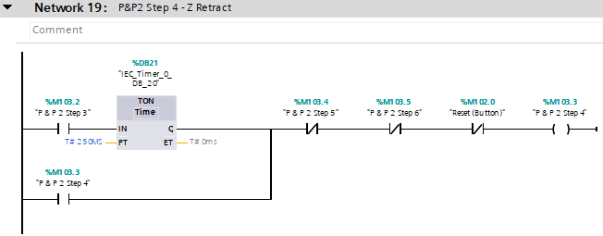
- When P&P step 3 is active this then gives a 250ms timer, which latches step 4. If step 5, step 6 or reset loses its signal it will stop step 4.

Network 20 –
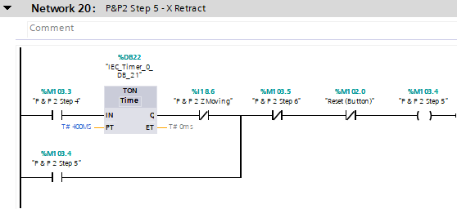
- When P&P step 4 is active this then gives a 400ms timer, which latches step 5. If the NC contact for moving z loses it signal this then means that it will start moving in the z axis, until then it will remain stationary. If step 6 or reset loses its signal it will stop step 5.

Network 21 –
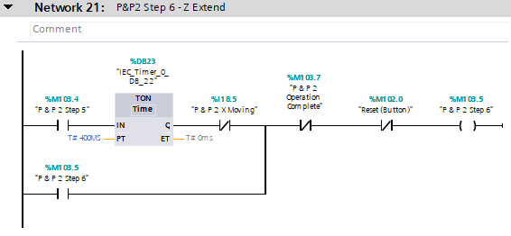
- When P&P step 5 is active this then gives a 400ms timer, which latches step 6. If the NC contact for moving x loses it signal this then means that it will start moving in the x axis, until then it will remain stationary. If P&P operation complete or reset loses its signal it will stop step 6.

Network 22 –
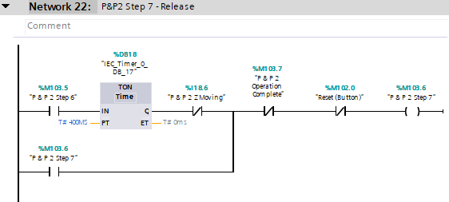
- When P&P step 6 is active this then gives a 400ms timer, which latches step 7. If the NC contact for moving z loses it signal this then means that it will start moving in the z axis, until then it will remain stationary. If P&P operation complete or reset loses its signal it will stop step 7.
Network 23 –
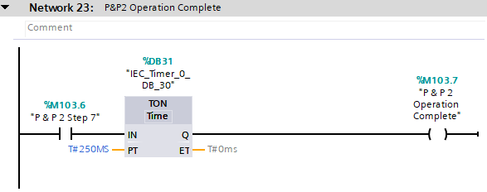
- When P&P step 7 is active this then starts a 250ms timer to give time for the grabber to release which will give you operation complete which will then in turn reset.

Network 24 –
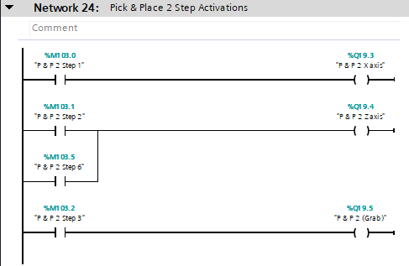
- Control each of the p & p movements using different steps
- When step 2 or 6 is active the P&P is extended in the z axis.
- When step 3 only the grab function is active
- When step 1 is active pick and place is extended in the x axis

Network 25 –
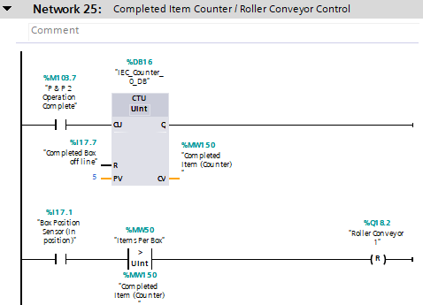
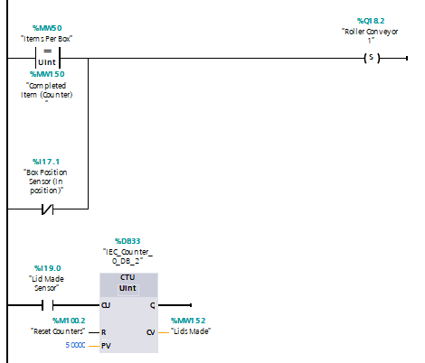
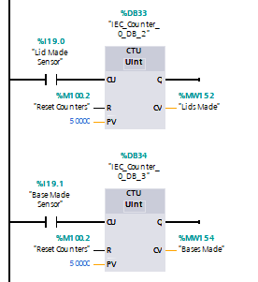
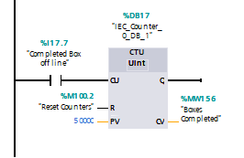
- When operation complete is active the counter then counts up by 1 every time it sees this signal. It resets when the box reaches the end of the roller conveyor which is completed box offline.
- When box position sensor (in position) is active and the items per box setting is greater than the completed item counter the roller conveyor will reset and stop. Once the completed items counter is equal to items per box setting this breaks this rung to allow the roller conveyor to be set again.
- When operate line is active, items per box setting is equal to completed item counter the roller conveyor will be set and will turn its back on to be active.
- When lid made sensor is active the counter then counts up by 1 every time is sees this signal. It resets when the reset button is pressed on the HMI
- When bases made sensor is active the counter then counts up by 1 every time is sees this signal. It resets when the reset button is pressed on the HMI
- When completed box offline sensor is active the counter then counts up by 1 every time is sees this signal. It resets when the reset button is pressed on the HMI
Network 26
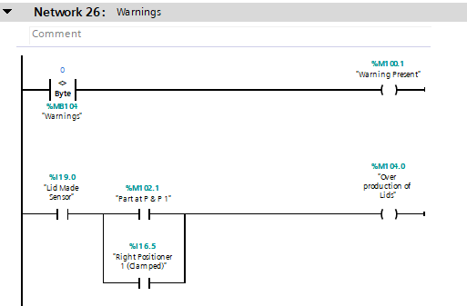
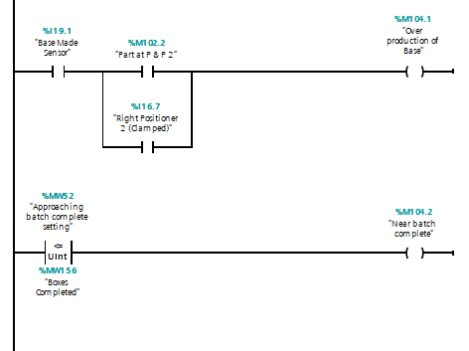
- If there is any warning the warning byte not equal to 0 (greater than) will activate the warning present signal which will be shown on the HMI.
- If the lid made sensor is active and either part as P&P1 or right positioner 1 this means that there has been a lid produced by the machining sensor and there is also still a part present at pick and place 1 to stop the lid from causing issues at the pick and place unit, this creates an overproduction of lids warning used to stop the out feed conveyor.
- If the base made sensor is active and either part as P&P2 or right positioner 2 this means that there has been a base produced by the machining sensor and there is also still a part present at pick and place 2 to stop the base from causing issues at the pick and place unit, this creates an overproduction of bases warning used to stop the out feed conveyor.
- When the “approaching batch complete” setting is less than or equal to the boxes completed counter this gives the near batch complete warning on the HMI.
Network 27
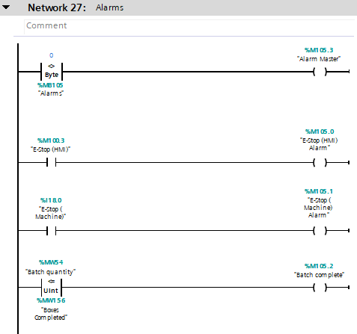
- When alarms byte is not equal to 0 this activates the alarm master. As the alarms master is a bit in the alarms byte this will act as a permanent latch. This can be only reset with the master reset on the engineers screen on the HMI
- When the ESTOP HMI this will activate the estop HMI alarm
- Estop machine is reverse logic due to the way factory I/O works
- When batch quantity is greater than or equal to the boxes completed counter with will give the batch complete alarm and stop the machine. This can only be reset using master reset on the engineers screen on the HMI.
- Alarm master can only be reset using master reset.

4.0 References

YouTube, Factory I/O Assembly Process, July 2016, Robert L.
Factory I/O Assembly Process - YouTube

The Automation Blog. 2022. S7 PLCsim | The Automation Blog. [ONLINE] Available at: https://theautomationblog.com/siemens-s7-plcsim/.
Real Games. 2022. Manual - FACTORY I/O. [ONLINE] Available at: https://docs.factoryio.com/manual/.
siemens.com Global Website. 2022. TIA Portal Modules: Basics of PLC Programming | SCE Learning & Training Documents | Siemens Global. [ONLINE] Available at: https://new.siemens.com/global/en/company/sustainability/education/sce/learning-training-documents/basics-of-plc-programming.html.
The Automation Blog. 2022. S7 PLCsim | The Automation Blog. [ONLINE] Available at: https://theautomationblog.com/siemens-s7-plcsim/.
Real Games. 2022. About - FACTORY I/O. [ONLINE] Available at: https://docs.factoryio.com/.

