
Menu Engineering
Food & Beverage Operations (BMIH4002)

November 10, 2023
Loredana-Marina Pal
2222512

Lecturer: Antoinette Milne

Word count: 415 words

Part 1
At Hotel Trinity, the "Culinary Canvas" restaurant concept is a bold foray into the fusion of art and gastronomy. Set within the esteemed 4-star hotel in the United Kingdom, "Culinary Canvas" is not just a dining space but an artistic haven. Here, the culinary arts transcend conventional boundaries, blending with the avant-garde mixology in an elegant dance of flavours and aesthetics.
Targeting the culturally sophisticated and those with an adventurous palate, "Culinary Canvas" offers a multisensory dining experience. It is an establishment where patrons do not merely dine; they engage in a journey that stimulates every sense. The essence of the concept lies in its ability to merge visual artistry with culinary excellence, where each plate is a canvas and every cocktail, a narrative (Smith, 2021).
The menu at "Culinary Canvas" is a visual feast, featuring dishes such as 'Impressionist Beetroot Carpaccio' and 'Surrealist Deconstructed Cheesecake.' Chefs here are artisans of flavour, crafting each dish to captivate the diner's imagination, echoing the creativity akin to that of painters and sculptors (Lee, 2020). This approach is a direct response to the increasing demand for unique dining experiences that not only provide gastronomic pleasure but also serve as conversation starters and social media centrepieces (Patel, 2022).
"Culinary Canvas" boasts an interior akin to a modern gallery, where art pieces from local talents adorn the space, creating an atmosphere where food and art coexist in harmony (Green & Brown, 2023). The design stimulates interaction and conversation, not just about the exquisite meals but also about the art that serves as the backdrop to the dining tableau.
The bar at "Culinary Canvas" mirrors the restaurant's inventive spirit. Here, mixologists craft art-inspired cocktails like the 'Cubist Margarita' or the 'Renaissance Reviver,' each with its own unique blend and backstory, providing a rich tapestry of flavours for the discerning drinker (Taylor, 2021). The curated selection of local craft beers and spirits supports the local economy and showcases the best of regional craftsmanship (Adams, 2022).
Incorporating cutting-edge technology, "Culinary Canvas" presents an interactive menu app and augmented reality features that allow guests to explore the stories behind their meals, adding an educational and engaging layer to the dining experience (Murray, 2020).
"Culinary Canvas" is a celebration of the senses, an establishment where every visit is a journey into the realm of culinary artistry. It is a place where dining becomes an exhibition and each dish a masterpiece, crafted not just to satiate hunger but to inspire and evoke emotion, leaving guests with a lasting impression that, much like art, stands the test of time.

References
- Smith, A. (2021). 'The New Aesthetic: Dining as Artistic Expression.' Food and Culture Journal.
- Lee, C. (2020). 'Epicurean Art: When Chefs Become Artists.' Culinary Review.
- Patel, S. (2022). 'The Rise of the Instagrammable Eatery.' Marketing and Hospitality Quarterly.
- Green, T., & Brown, R. (2023). 'Designing the Future: Restaurants as Modern Art Galleries.' Architecture and Design Magazine.
- Taylor, E. (2021). 'Mixology as Art Form: The Evolution of the Cocktail.' Beverage Dynamics.
- Adams, R. (2022). 'Local Flavours: The Craft Movement in Food and Drink.' Sustainable Business Journal.
- Murray, L. (2020). 'Augmented Eats: Technology's Place at the Table.' Tech and Hospitality.
- Cook, M. (2021). 'The Theatrics of Dining: Engaging the Senses.' Hospitality and Entertainment.
- Foster, K. (2021). 'The Artful Plate: Presentation in Modern Cuisine.' Gastronomy and Aesthetics.
- Williams, J. (2022). 'Sustainability on the Sip: Eco-Friendly Practices in Bars.' Environmental Hospitality.

Part 2
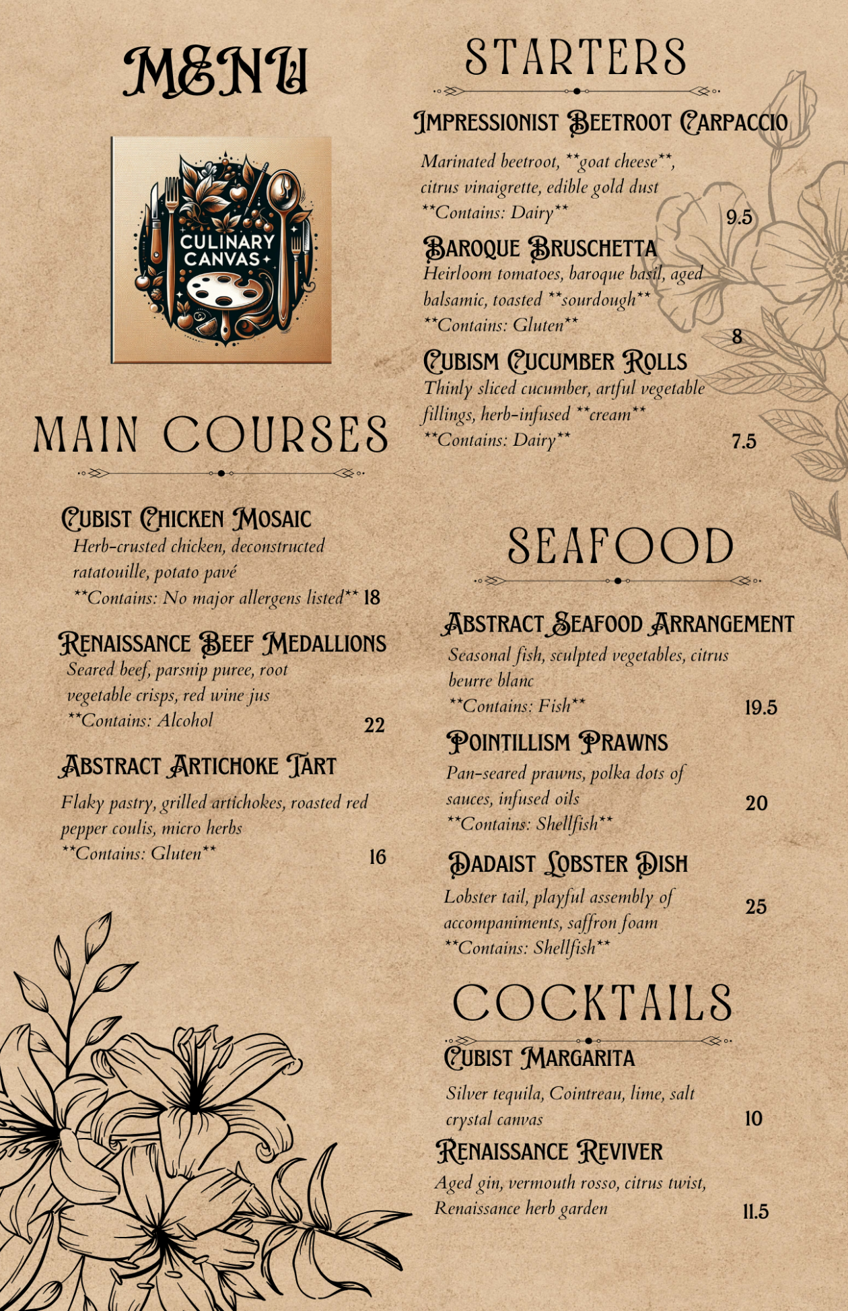
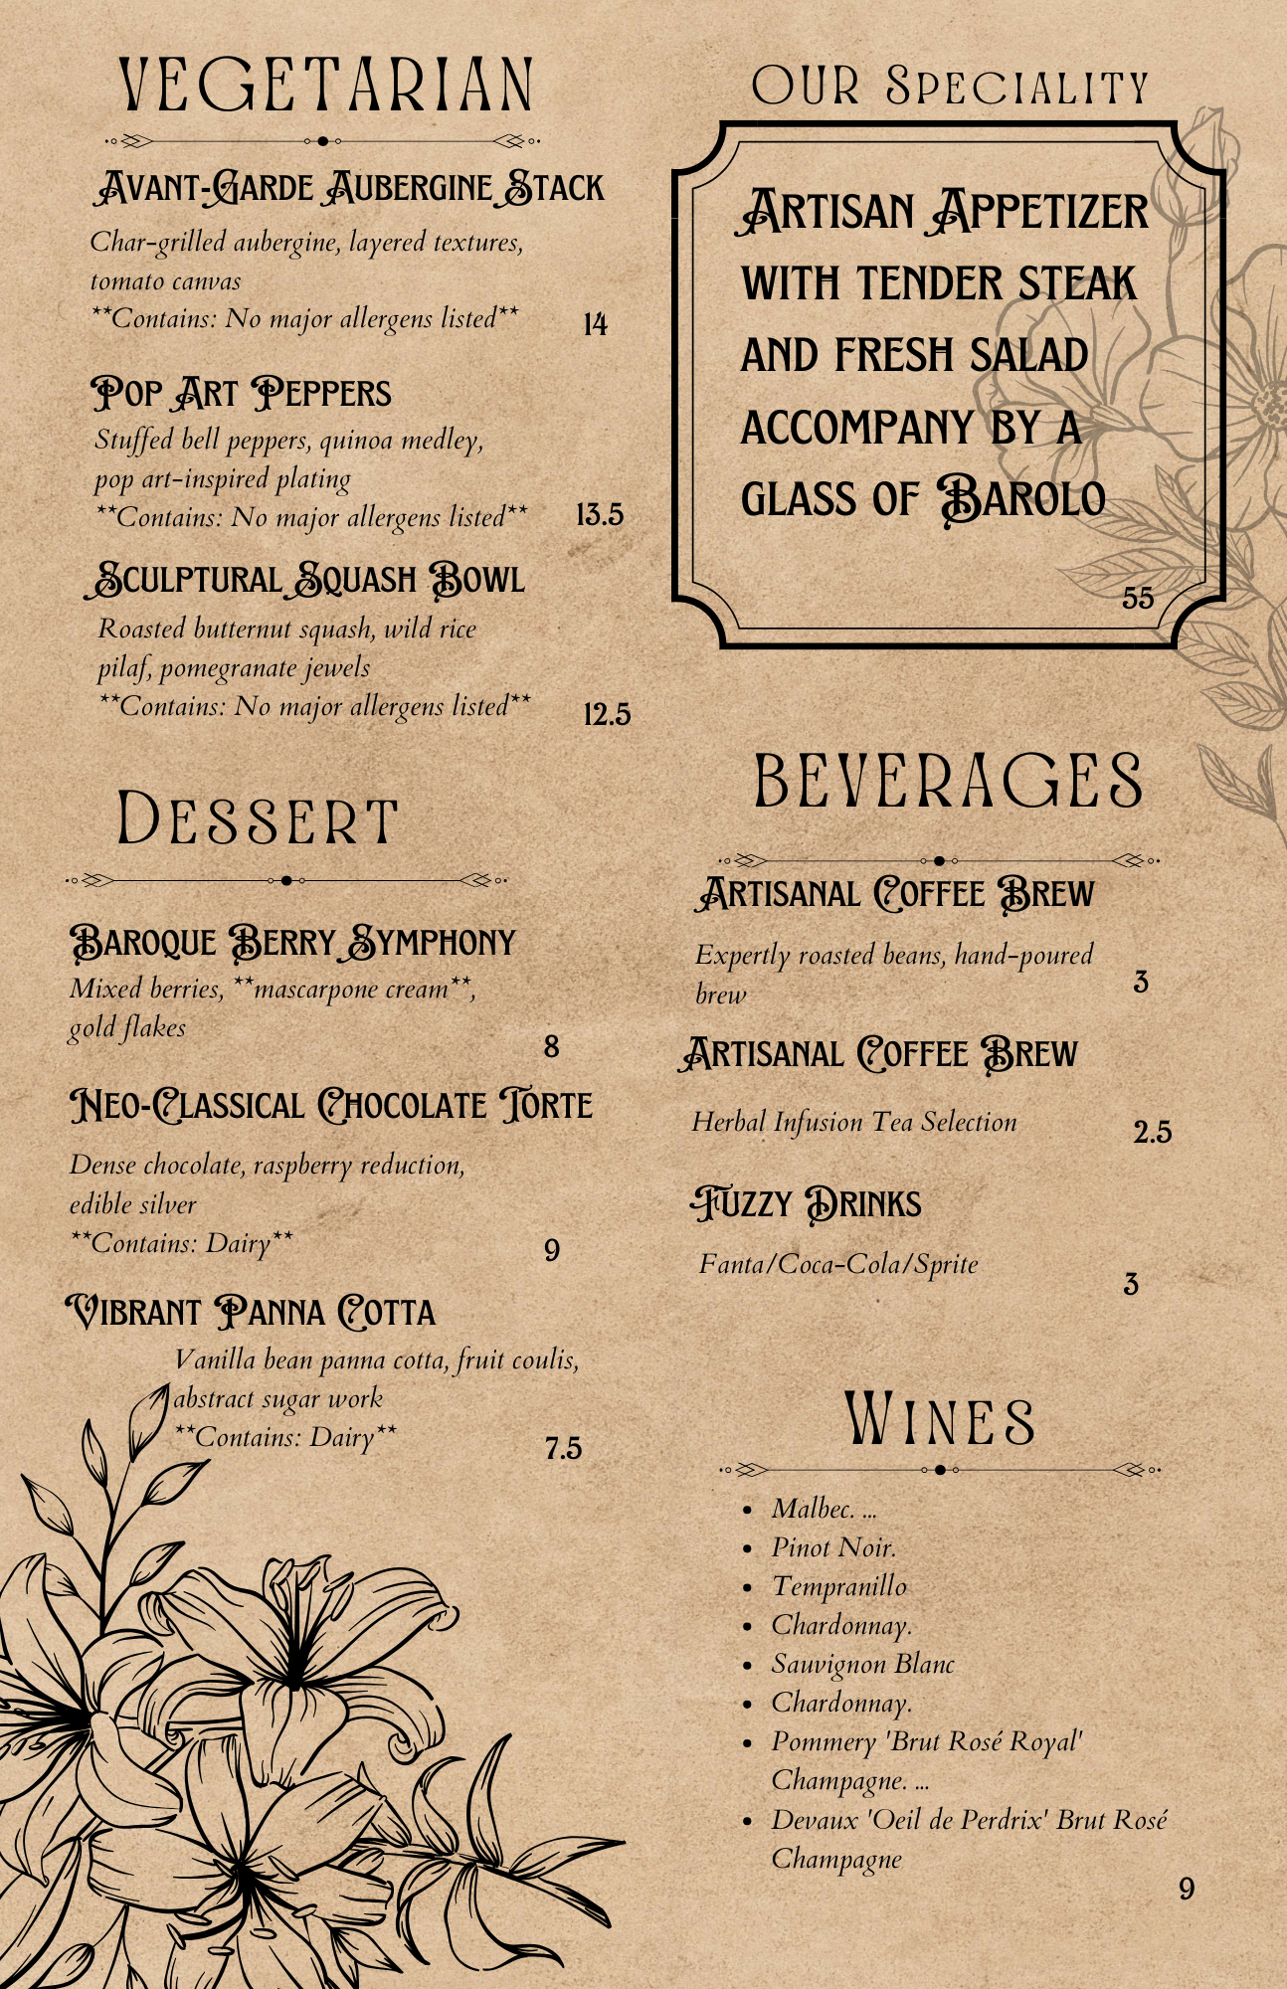

References
Patel, R. (2020). "Consumer Trends in Plant-Based Dining: Adapting Menus for Health and Sustainability." Nutrition and Culinary Science
Clark, D. (2018). "Presentation is Everything: The Visual Art of Menu Design." Food Aesthetics Journal
Robinson, M. (2019). "Allergens and Menus: Navigating Dietary Restrictions in Menu Planning." Health and Hospitality

