Professional Career Development in Health and Social Care (LCHS 4009)

ASSIGNMENT 2

Name of Student: Susan Isabella Pinto Alvarez
I.D. Number: 2440431
Module code: LCHS4009
Assignment Title: Personal Development Portfolio
Lecturer name: Christopher Mafuva

Acknowledgement of AI use: I confirm that I have not used AI to complete my work. GIVE REFERENCE SUCH AS GRAMMERLY FOR EXAMPLE……TO………PROOF READ FOR EXAMPLE).

Table of Contents
1. Introduction 3
2. Task 1: Professional CV for a Health and Social Care Role 3
3. Task 2: Personal Statement for a Health and Social Care Role 3
4. Task 3: SWOT Analysis and Personal Development Plan (PDP) 4
1. SWOT Analysis 4
2. Personal Development Plan (PDP) (Health & Social Care (Mental Health Role)) 6
5. Task 4: Gibbs Reflective Evaluation of Presentation 7
6. Conclusion 9
References 10

1. Introduction
A portfolio is a document and a collection of work that shows the skills of a person, their experience, education and their achievements in an apparent and organised way. It helps in demonstrating abilities, learning, and career development evidence (Lejeune, et al., 2021). This portfolio will include a CV on a health and social care position, a personal statement, a SWOT analysis, a Personal Development Plan (PDP) and a reflection based on the Gibbs model to reflect on my presentation and identify what strengths and weaknesses I possess and what I can work on.
Job Role Chosen:
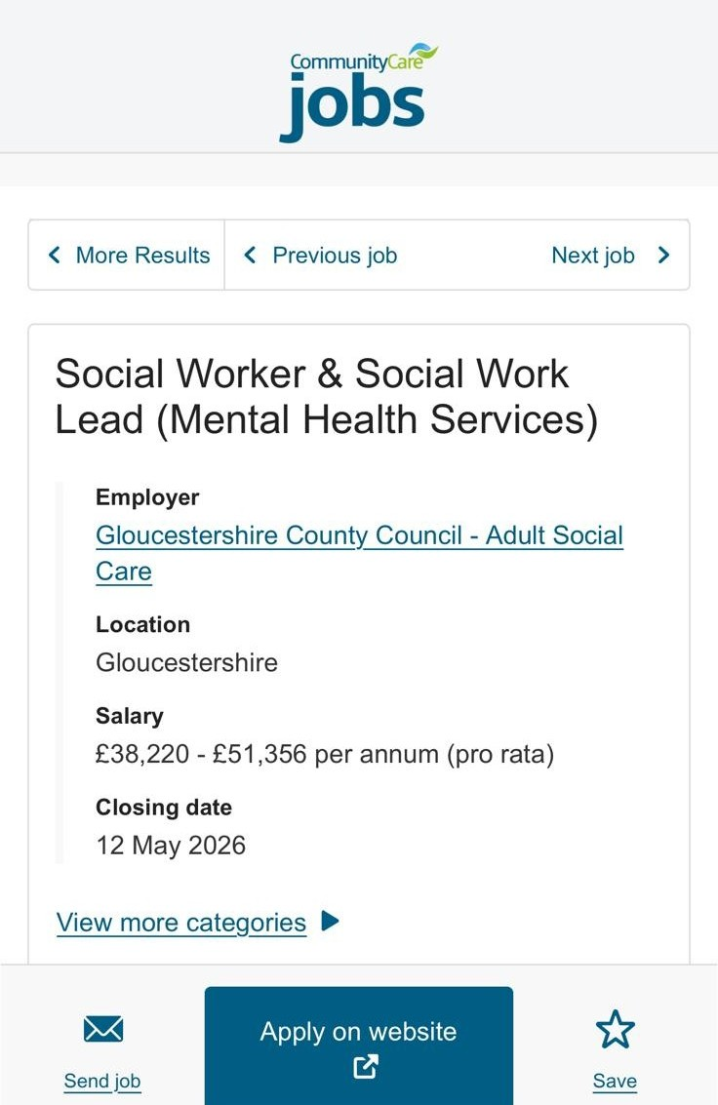

2. Task 1: Professional CV for a Health and Social Care Role
The section contains my professional CV, which is position specific (in the health and social care industry), and which summarises my skills and personal strengths, education and experience.

Susan Isabella Pinto Alvarez
07392386095 – isabelladefrancisco295@gmail.com
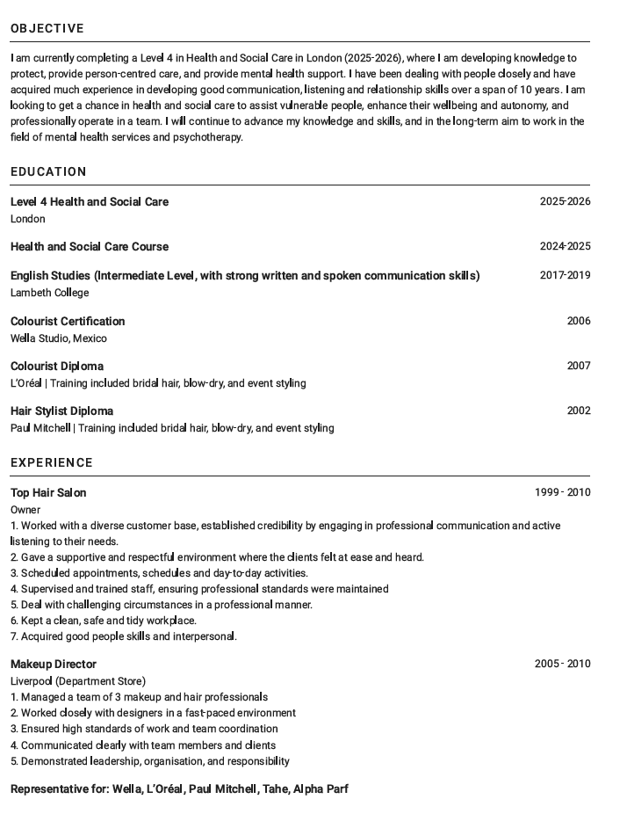
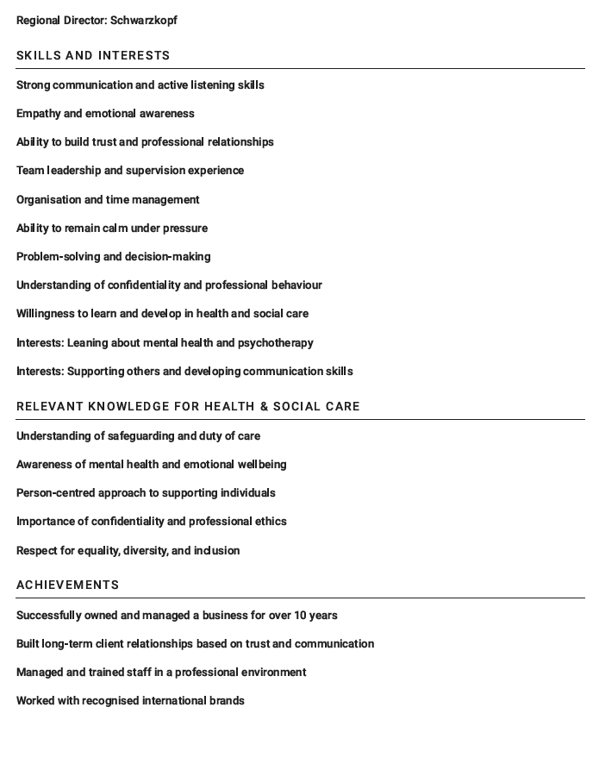

3. Task 2: Personal Statement for a Health and Social Care Role
Before applying for this job (Social Worker & Social Work Lead (Mental Health Services)), I went through the job description in detail just to have an idea of the level of responsibility, skills and values required to be in the field of mental health and adult social care services. I am applying to this position because it is a step towards my transition into the health and social care sector, and my long-term goals are to work in the area of mental health and psychotherapy. I have been undertaking a Level 4 qualification in Health and Social Care (2025-2026), which means that I am gaining knowledge in the areas of safeguarding, person-centred care and professional practice. I also studied a preceding course in Health and Social Care (2024-2025) that made me aware of the values of working with people, as well as a course on English studies in Lambeth College (2017-2019), which improved my communication skills.
I have also gained several relevant and transferable skills that can be directly utilised in this job. My asset is communication, and in particular, active listening. Working as a salon owner in my previous employment, I was responding to the emotional needs of the clients on a regular basis. As an instance, a client, who stated his problems on his own part, and I had to answer that client in a calm, respectful and professional manner, such that the client would feel that I heard him, yet I would be cautious not to be too pushy on the aspect of being a professional. The experience helped me to understand the importance of empathy, emotional sensitivity, and appropriate professional boundaries (Sip, 2025). I am also very organised and capable of handling the tasks because I was required to schedule, run the staff, and manage the day-to-day operations in my previous job, which lasted more than 10 years. Though I am aware that I cannot apply my digital abilities, I would be interested in improving my skills in this area to make my contribution towards meeting the professional standards possible.
Despite the lack of personal mental health experience, I do have a nice idea of the values that are needed in health and social care. It is also through my research that I have become aware of the need to protect confidentiality and the role of a person-centred approach. The experience I have had previously has assisted me in developing a base in dealing with individuals of diverse backgrounds, handling delicate circumstances and being a professional at all times.
Being a business owner and a team leader, I had to collaborate closely with other individuals in a team environment, managing the rest of the employees and ensuring high quality of service. I additionally had to handle unpleasant situations (such as clients being unhappy) that required me to remain calm, decide, and attend to clients and employees. To conclude, my education, skills and previous work experience have provided me with a foundation in this position. I understand that I do not have a lot of first-hand experience in mental health yet, but I am willing to learn and do it (Hormazábal-Salgado, et al., 2024)

4. Task 3: SWOT Analysis and Personal Development Plan (PDP)

1. SWOT Analysis
This SWOT analysis evaluates my strengths, weaknesses, opportunities, and threats to a health and social care job and recognises that well-developed communication is a critical aspect in patient safety and reducing the error rate in care administration (Lee and Jang, 2023).
Strengths | Weaknesses
- The listening skills have developed through the years of such one-on-one interaction with clients, whereby people are more likely to open up about intimate and sensitive matters.  - Good empathy and emotional intelligence enable one to comprehend the feelings and react properly in work-related scenarios.  - Demonstration of building trust and long-term professional relationships has been demonstrated in the previous positions.  - The management of a salon and supervision of staff have helped to build leadership and responsibility.  - A clear long-term objective of becoming a psychotherapist shows a good level of motivation and dedication to the profession. | - There is currently a lack of formal mental health or social care direct experience.  - Development of digital skills should be enhanced, particularly on professional systems and record-keeping used in care settings.  - Self-esteem in writing and putting theoretical information into practice based on studies of Health and Social Care is under development.  - To transform the beauty industry into the sphere of health and social care, the new professional standards and expectations will need to be changed.
Opportunities | Threats
- The education in the areas of safeguarding, communication, and person-centred care is being facilitated by obtaining a Level 4 qualification in Health and Social Care (2025-2026).  - Entry-level opportunities are also provided to gain some practical experience in the sphere of health and social care.  - Further education and training can help in the development of mental health as a step towards psychotherapy.  - The professional and digital skills will be constantly developed to improve the employability. | - Competition is high, considering that there are applicants with experience in social care or mental health jobs.  - Employers may have a bias towards candidates with little experience in the care setting.  - The experience of working with vulnerable people may also present a challenge, particularly when one is handling a person who is still a young individual.  - The new professional environment and expectations might take time to adapt, and experience and confidence can be built.
Source: (Self-Created)
Overall, this SWOT analysis shows that communication, empathy, and relationship-building are considered assets of the work of a social worker in the field of mental health services, especially when working with vulnerable individuals and working in multidisciplinary teams. Effective cooperation and communication have proven to positively impact patient safety and care outcomes in care settings (Sherwood, 2024). Nevertheless, real-life experience, digital skills, and confidence have yet to be acquired to advance.

2. Personal Development Plan (PDP) (Health & Social Care (Mental Health Role))
Personal Development Plan (PDP) is a systematic approach that assists individuals to define their personal goals, evaluate their proficiencies, and strategise career development in the long-term (Dziak, 2024). The PDP will help me in identifying my strengths and weaknesses, and set specific goals and plan on how I can use my strengths to develop my skills in health and social care.
Goal | SMART Description | Importance | Development & Evaluation
Develop practical experience in mental health settings | By June 2027, gain experience in a health and social care environment through part-time work, volunteering, or placement in a care setting. | Practical experience is essential to understand real-life situations, support vulnerable individuals effectively, and apply theoretical knowledge in practice (Atinga, et al., 2024). | Find a way to volunteer or work in care facilities at an entry-level position. The evaluation of progress will be done based on the feedback of supervisors and the reflection of experiences.
Improve digital and professional documentation skills. | By December 2026, improve the ability to use basic IT systems, including email, Word, and record-keeping tools used in care environments. | Digital skills are important for maintaining accurate records, communication, and following professional procedures in health and social care (Oung, et al., 2021). | Regularly use digital tools and undertake basic IT training. Check progress by working on tasks on their own and enhancing accuracy in written work and documentation.
Strengthen knowledge of mental health and communication skills | By June 2027, develop a deeper understanding of mental health and improve communication skills in professional settings. | Strong knowledge and communication are essential for supporting individuals, building trust, and working effectively within a team (Howick, et al., 2024). | Keep on learning Level 4 Health and Social Care and revising learning materials on a regular basis. Keep track of progress and provide feedback on assignments and reflection on how you interact with others.
Source: (Self-Created)
Overall, this PDP provides a map of the development of my abilities, experience, and self-confidence, with the help of which I will be able to pursue my career.

5. Task 4: Gibbs Reflective Evaluation of Presentation
Gibbs reflective model is a systematic approach that helps individuals to reflect on the experience by following different steps such as description, feelings, evaluation, analysis, conclusion and action plan (Praveena, et al., 2025).
Description
Communication and organisation are two essential issues in health and social care, which I have emphasised as part of my presentation. I have defined communication as the act of sharing information with people and noted that communication is vital in both practice and everyday life (Sherwood, 2024). I have also added the Tuckman model to show how teams go through stages of forming, storming, norming, performing and adjourning. In addition, I also presented a real-life scenario of how communication and organisation can be applied to care environments, especially when a patient is in the care of different professionals, and accurate documentation ought to be maintained.
Feelings
Before my presentation, I was worried about talking about academic material and offering theoretical foundations. However, I was also sure about speaking about communication, as this is one of the skills that I trained in for several years of work with clients, being a hairdresser. The presentation boosted my confidence since I was able to relate theory to my own experience.
Evaluation
In my presentation, I was able to clearly describe the definition of communication and the importance of communication to health and social care. I applied the real-life experience to demonstrate good interpersonal skills, and this made the material more significant and easier to comprehend. I have also included teamwork and record-keeping as measures of knowledge of professional responsibility and patient safety. It is a well-known fact that effective communication is the key to providing safe care that will contribute to a reduction in the number of errors and improvement in patient outcomes (Shrivastava, et al., 2025).
My presentation was descriptive, however. I wrote about the Tuckman model, but I have not discussed how this model is utilised in real care situations. The risks of ineffective communication were not explained in sufficient detail, even though they may result in safety concerns. There was some repetition, which reduced the overall quality and depth of the critique (Atinga, et al., 2024).
Analysis
I also applied good communication skills in my presentation, and it is very necessary in health and social care. I understand that safe practice is reinforced with the help of communication and teamwork, as people realise that insufficient communication can lead to errors and injuries to patients. I have used the Tuckman model to define teamwork. But I realise that I have not put enough critical discussion. One more fact is that communication is directly related to patient safety, which shows that I need to further develop my analysis (Howick, et al., 2024).
Conclusion
Overall, I think that my presentation was a good demonstration of my knowledge of communication, collaboration, and organisation. I had the opportunity to use my personal experience to demonstrate my points and render the topic at hand more prominent. Nonetheless, I understand that I should enhance my critical thinking and gain more insight into the analysis of theory.
Action Plan
To further improve my practice, I will be more attentive to the analysis of theories and how they can be specified concerning their application to practice. I will also read more to increase my understanding of the key concepts, such as teamwork and communication. My work will also be supported by the input of the feedback of my lecturer to improve the structure and critical depth of my work. It is through practice that I will be able to have confidence in delivering and discussing academic material more effectively.

6. Conclusion
Overall, this portfolio shows that I have learned, gained skills and self-awareness to pursue a career in the field of health and social care. It demonstrates my advantages in aspects such as communication and empathy, and some weak points, such as practical experience and academic skills. By reflecting and planning, I have been capable of identifying specific stepping stones of progress on my pathway to reaching my goal of landing a job in the mental health and psychotherapy field.

References
Atinga, R.A., Gmaligan, M.N., Ayawine, A. and Yambah, J.K., 2024. “It's the patient that suffers from poor communication”: Analyzing communication gaps and associated consequences in handover events from nurses’ experiences. SSM-Qualitative Research in Health, 6, p.100482. https://www.sciencedirect.com/science/article/pii/S266732152400091X
Dziak, M., 2024. Personal development planning. [online] Available at: https://www.ebsco.com/research-starters/psychology/personal-development-planning [Accessed 15 April 2026].
Hormazábal-Salgado, R., Whitehead, D., Osman, A.D. and Hills, D., 2024. Person-centred decision-making in mental health: A scoping review. Issues in Mental Health Nursing, 45(3), pp.294-310. https://www.tandfonline.com/doi/pdf/10.1080/01612840.2023.2288181
Howick, J., Bennett-Weston, A., Solomon, J., Nockels, K., Bostock, J. and Keshtkar, L., 2024. How does communication affect patient safety? Protocol for a systematic review and logic model. BMJ open, 14(5), p.e085312. https://bmjopen.bmj.com/content/bmjopen/14/5/e085312.full.pdf
Lee, W. and Jang, I., 2023. Effect of nurses’ professionalism, work environment, and communication with health professionals on patient safety culture (AHRQ 2.0.): a cross‐sectional multicenter study. Journal of Nursing Management, 2023(1), p.1591128. https://onlinelibrary.wiley.com/doi/pdf/10.1155/2023/1591128
Lejeune, C., Beausaert, S. and Raemdonck, I., 2021. The impact on employees’ job performance of exercising self-directed learning within personal development plan practice. The international journal of human resource management, 32(5), pp.1086-1112. https://d1wqtxts1xzle7.cloudfront.net/114124953/09585192.2018.151084820240504-1-g3ms5h-libre.pdf?1714819525=&response-content-disposition=inline%3B+filename%3DThe_impact_on_employees_job_performance.pdf&Expires=1776261720&Signature=RxbeV5AbbCPOWxuPAv~go2Q4~zBY2vS5gbD1doeJAyDJkDut8tDMwUytkln5qB8nDMeVHAGh036ObFggjpLijrqNsEt~we3jbjUfMoVW3IJddwjcpR4RrnGkvFL0bp0hi~RThEbY~nYH6I6d4nLd42vGukOeOuBp75w-DUxiw~huQwkPoAZqlwtNfJAl0AT416eZ-sLGE7kTdU6CMWrS5a0ks8bLPmE8IlPXsN6ogyI0Yj0OHw1CJ-5jnmJq7MKbrrcOKzK82wndlMPbdZJwhNBMl5z8fDrMVUKQJBEszMOmGATPlEm0~NCHE53HgEZaF8xFMl5docJpeUAUfbiCQg__&Key-Pair-Id=APKAJLOHF5GGSLRBV4ZA
Oung, C., Rolewicz, L., Crellin, N. and Kumpunen, S., 2021. Developing the digital skills of the social care workforce. Research Summary. Nuffield Foundation. Available online at: https://www. nuffieldtrust. org. uk/research/developing-the-digital-skills-of-the-social-care-workforce (Accessed December 11, 2024). https://www.nuffieldtrust.org.uk/sites/default/files/2021-09/workforce-research-summary-final.pdf
Praveena, K.S., Juslin, F., Patil, C.M. and Bhargavi, K., 2025. Using gibb's reflective model approach for enhancing project-based learning among students through reflective assessment. Journal of Engineering Education Transformations, pp.148-155. https://journaleet.in/index.php/jeet/article/download/2071/2016
Sherwood, G., 2024. Reflective practice and knowledge development: Transforming research for a practice-based discipline. International journal of nursing sciences, 11(4), pp.399-404. https://www.sciencedirect.com/science/article/pii/S2352013224000760
Shrivastava, S.R., Chong, S.V. and Bobhate, P.S., 2025. Facilitating effective communication through the adoption of SBAR tool in medical training. Journal of Education and Health Promotion, 14(1), p.249. https://journals.lww.com/jehp/fulltext/2025/07040/facilitating_effective_communication_through_the.249.aspx
Šip, M., 2025. Communication as a tool in social work within an interdisciplinary approach to clients with health disabilities. Studia Socialia Cracoviensia, 13(1), pp.37-58. https://czasopisma.upjp2.edu.pl/studiasocialiacracoviensia/article/view/5562/5183

