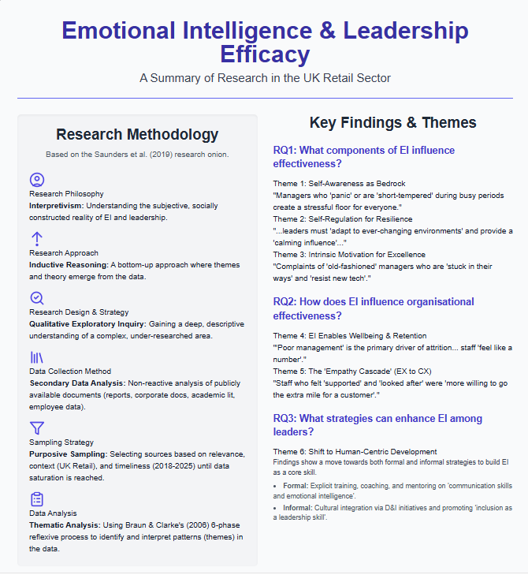
Element 3: Methodology and Findings Poster
Student name : Dan Alexandru Tudose
Student ID 2226963
Lecture Name :Samuel Ofori
This poster represents a thorough visual overview of a research project that is aimed at studying the topic of Emotional Intelligence and Leadership Efficacy with regard to the specifics of the UK Retail Sector. In a clean, professional and academic style, it has logically broken down the research into two main columns Research Methodology and Key Findings and Themes, which makes the structure and results of the study easy to digest.
The left column, titled Research Methodology, is organised in accordance with the principles of the Saunders et al. (2019) research onion. It divides each element of the methodological framework into a number of specific icon-based cards. It starts with the definition of the Research Philosophy of the study being Interpretivism, which focuses on the aim to comprehend the subjective, socially constructed reality of leadership instead of some objective truth. It is then followed by the Research Approach, which is the Inductive Reasoning, a bottom-up approach, in which themes and theory are left to develop out of the data.
The next section of the poster describes the Research Design as a Qualitative Exploratory Inquiry, which was selected in order to understand this complicated and poorly studied field deeply and descriptively. The Data Collection Method is declared to be the Secondary Data Analysis, which is a non-reactive method that presupposes the review of publicly available documents, including industry reports, corporate literature, and academic studies as well as aggregated employee data. The strategy of Purposive Sampling was used to select these sources, selecting the documents according to their direct relevance, the context of the UK retail, and their timeliness (the publication date falls within 2018-2025). Lastly, this part also ends with the naming of Thematic Analysis (in particular, the 6-step process of Braun and Clarke) as the approach in which patterns are identified and interpreted in the collected data in a systematic manner.
The findings of this analysis are presented in the right-hand column, "Key Findings & Themes" according to the three core research questions of the study. Every finding is described in a "theme-card" containing a clear theme title, and illustrative extract of data or quote, to give the abstract finding a base in real evidence.
Regarding Research Question 1 (What components of EI influence effectiveness?), the poster presents three themes, Self-Awareness as Bedrock (contrasting managers who panic), Self-Regulation for Resilience (giving them a calming influence), and Intrinsic Motivation for Excellence (instead of managers stuck in their ways).
In the case of Research Question 2, (How does EI influence organisational effectiveness?), two themes were identified. Theme 4 is a direct connexion between EI and Employee Wellbeing and Retention, stating that bad management is a key cause of attrition. Theme 5 presents the theme of the Empathy Cascade, which demonstrates that the staff supported is more inclined to go the extra mile with a customer.
Lastly, in the case of Research Question 3 (What strategies can improve EI?) Theme 6 is a Shift to Human-Centric Development, which suggests that retailers currently employ both formal (training, coaching) and informal (D&I initiatives, cultural integration) approaches to developing emotional intelligence as a key leadership skill.

