Hazel dormice Muscardinus avellanarius and development – surveying, mitigation and post-construction monitoring.
An MSc dissertation
Rebecca Blackman
Student No. 1709562
MSc Environmental Conservation and Management
Submission deadline: 4th May 2020

Supervisor: Rhian Jenkins

Abstract
Hazel dormice Muscardinus avellanarius have declined by as much as 72% across the UK, despite being offered the highest level of wildlife protection as a European Protected Species under the Habitats Regulations 2017. Recent legislation requires all new developments to demonstrate a net gain in wildlife and ensure biodiversity is maintained and enhanced. To make certain appropriate measures are taken to reduce any impacts on existing dormouse populations from development and, to promote appropriate enhancement measures to help to reverse overall population decline, it must first be established how dormice are being surveyed and mitigated for and how well these methods are working in terms of their objectives. Data was collected through over-the-phone interviews together with the distribution of a questionnaire, both aimed at practitioners with experience in dealing with dormice and development proposals. Many respondents expressed the requirement for a landscape scale approach to dormouse conservation, to ensure connectivity and resilience, and highlighted the role development and planning could play in achieving this. Another re-occurring theme was eagerness to adopt new methodologies for detecting presence of dormice on potential development sites, however, a lack of guidance and acceptance has prevented many from using these methods thus far. This study also highlighted the requirement for post-construction monitoring to be undertaken, to ensure further understanding of what mitigation methods work well in terms of continued dormouse presence, in order to inform future development. Using the responses from the questionnaires and interviews, a framework has been developed which incorporates steps to address recurring concerns and recommendations from the questionnaire data. Further to the framework, several recommendations have been made which aim to promote further understanding and improvement of how dormouse presence can be established, their habitats and how to ensure development meets the requirements of recent legislation where dormice are present or could be so in the future.



Author’s Declaration
I declare that the work in this dissertation was carried out in accordance with the regulations of the University of Wales, Trinity Saint David. The work is original except where indicated by special references in the text and no part of the dissertation has been submitted for any other degree.
Any views expressed in the dissertation are those of the author and in no way represent those of the University of Wales, Trinity Saint David.
The dissertation has not been presented to any other University for examination either in the United Kingdom or overseas.
I hereby give permission for my work, if accepted, to be available for photocopying and inter-library loan, and for the title and summary to be made available to outside organisations.

Signed: R.Blackman
Date: 23/04/2020

Table of Contents
1 Introduction 1
1.1 Research Aim 1
1.2 Research Objectives 2
2 Literature Review 3
2.1 Dormice in the UK 3
2.2 Dormouse ecology 3
2.2.1 Current population trend 4
2.2.2 Movement 5
2.2.3 Effects of habitat fragmentation and crossing of open spaces 5
2.2.4 Habitat preference 6
2.2.5 Nest preference 6
2.2.6 Lifecycle and hibernation 7
2.2.7 Predation 7
2.2.8 Dormice and Climate change 8
2.3 Legislation 8
2.3.1 European protected species licensing 9
2.4 Dormice and development 10
2.5 Mitigation/compensation 11
2.5.1 Dormouse bridges 11
2.5.2 Hedgerow translocation and hedgerow/habitat enhancement and planting 12
2.5.3 Tunnels and underpasses 12
2.6 Post Construction Monitoring 13
2.7 Surveying dormice 13
2.8 Summary 15
3 Methodology 17
3.1 General research approach 18
3.2 Semi structured Interviews 18
3.2.1 Interview design 18
3.2.2 Sample size 19
3.2.3 Data Collection 19
3.2.4 Participant recruitment 20
3.2.5 Pilot Survey 20
3.3 Questionnaires 20
3.3.1 Justification 20
3.3.2 Questionnaire Design 20
3.3.3 Sample size 21
3.3.4 Participant recruitment 21
3.3.5 Data collection methods 21
3.3.6 Data Analysis 21
3.3.7 Quantitative data analysis 21
3.3.8 Qualitative data analysis 22
3.4 Climatic and UK dormouse population data 22
3.4.1 UK dormouse population data 22
3.4.2 Climatic data 22
3.4.3 Data analysis 22
3.5 Limitations 22
4 Results 24
4.1 Interviews 24
4.1.1 Responses 24
4.1.2 Experience 24
4.1.3 Surveying 24
4.1.4 Mitigation 25
4.1.5 Post-construction monitoring 26
4.1.6 Improvements 27
4.2 Questionnaire responses 28
4.2.1 Responses 28
4.2.2 Experience 28
4.2.3 Surveying 28
4.2.4 Mitigation 32
4.2.5 Post-Construction monitoring 34
4.2.6 Improvement 38
4.3 Climate data results 39
5 Discussion 42
5.1 Demographic of responses 42
5.2 Objectives One and Two 42
5.3 Objective Three 44
5.3.1 Where to look 44
5.3.2 Presence/absence surveying methods 45
5.4 Objective Four 46
5.4.1 Landscape scale connectivity 46
5.4.2 Climate change 47
6 Conclusion and Recommendations 49
6.1 Summary Overview 49
6.2 Recommendations 51
6.3 Conclusion 52
7 References 53
8 Appendices 59
8.1 Appendix 1 – Letter requesting interviews 59
8.2 Appendix 2 – Message requesting participation of surveys 60
8.3 Appendix 3 - Questionnaire 61
8.4 Appendix 4 – Frequency of Welsh and English responses. 66

Tables
Table 4.1 Mitigation methods used by interview respondents 25
Table 4.2 Interview responses to how well different methods work for establishing dormouse 26
Table 4.4 Post-construction monitoring question responses 27
Table 4.5 Interview responses to what could be done to improve how dormice are dealt with in the planning system. 27
Table 4.6 Chi-Squared results for the effect of holding a dormouse license on surveying methods used. 29
Table 4.7 Chi-Squared results for the effect of country the respondent survey in on the survey method used. 29
Table 4.8 Ordinal scale responses to how well different methods work for establishing dormouse 30
Table 4.9 Chi-Squared results for the effect of country on the use of hedgerow translocation as mitigation. 32
Table 4.10 Ordinal scale responses to how well different methods of mitigation/compensation work. 34
Table 4.11 Responses to post-construction monitoring split into demographic data. 34
Table 4.12 r² value of regression line for seasonal rainfall compared to mean adult dormice. 40
Table 4.13 r² value of regression line for mean seasonal temperature compared to mean adult dormice. 40
Table 4.14 Pearson’s correlation coefficient 2-tailed significance value for seasonal rainfall compared to mean adult dormice. 41
Table 4.15 Pearson’s correlation coefficient 2-tailed significance value for mean seasonal temperatures compared to mean adult dormice. 41

Figures
Figure 2.1 Jacqueline Hartley (n.d.), Hazel dormouse. 4
Figure 2.2 Jacqueline Hartley (n.d.), Dormouse nest box in-situ. 14
Figure 2.3 Jacqueline Hartley (n.d.), Dormouse tube in-situ. 14
Figure 2.4 Jacqueline Hartley (n.d.), Hazel nut nibbled by hazel dormouse. 14
Figure 3.1 Outline of research approach 17
Figure 4.1 Interview responses to habitats dormice have been found in. 25
Figure 4.2 Methods for establishing dormouse presence. 28
Figure 4.3 Responses to how dormouse presence surveys could be improved 31
Figure 4.4 Habitats where dormice have been found. 32
Figure 4.5 No. of respondents that have used methods for mitigation 33
Figure 4.6 Mitigation used for post-construction monitoring sites 35
Figure 4.7 Length of time post construction monitoring has been undertaken for 35
Figure 4.8 Mitigation dormice were found to be present post construction 36
Figure 4.9 Length of time between construction and finding dormice to be present within retained/managed/ mitigation areas. 37
Figure 4.10 Answers to ‘What do you think could be done to improve how dormice are dealt with in the planning system?’ 38
Figure 4.11 Trends in annual adult dormice counts across England and Wales monitored sites 1988 – 2014 39
Figure 4.12 Trends in annual adult dormice counts across England and Wales monitored sites 1988 – 2014 40
Figure 6.1 Framework for considering dormouse habitat landscape scale connectivity as enhancement for planning applications 50

Introduction
The hazel dormouse Muscardinus avellanarius has been well studied since the 1990’s (Bright and Morris, 1990, 1993 and 1996 and Bright, Mitchel and Morris, 1994) and is now regarded as a recognisable indicator species for high quality woodland habitat in many parts of the UK. With the large-scale long-term National Dormouse Monitoring Programme (NDMP) covering over 400 sites since 1993 (sites have been part of the project for varying lengths of time) data has unfortunately shown that dormouse numbers continue to decline across the UK (Goodwin et al., 2017).
This decline is likely due to: habitat loss; changes in managed habitat; fragmentation of habitats and their sensitivity to extreme weather events; with further difficulties potentially arising from changes in climate conditions due to climate change (Bright and Morris, 1996).
As a European Protected Species, dormice are offered the highest protection under the Habitats Directive (Council Directive 92/43/EEC), which is transposed into UK law under The Conservation of Habitats and Species Regulations 2017. The Favourable Conservation Status (FCS) of dormice must be preserved at all times, including where development is proposed.
The Dormouse Conservation Handbook (Bright, Morris and Mitchel-Jones, 2006) is the leading UK guidance for surveying dormice on development sites and mitigating for its potential impacts. These guidelines are also used by the European Protected Species (EPS) licensing authorities to ensure best practice is followed.
Despite guidance on surveying and mitigation for many UK protected species, there continues to be a lack of evidence and literature discussing how well mitigation measures are working to ensure the FCS of species is maintained and what appears to be working best for ensuring the continued presence of the species post-development.
Post-construction monitoring is often made a condition of planning consent and there should, therefore, be a wealth of knowledge and information on mitigation success from professionals working within ecology. This study seeks to gather some of this existing information; begin to understand what mitigation appears to be working well when considering post-construction presence of dormice; and what can be done to improve how dormice are dealt with in the planning system. The study aims and objectives are listed below.

Research Aim
To create a management framework for the conservation of dormice in light of the recent legislative changes to the planning system.
To this end, it is necessary to investigate how dormice presence and absence is being established on sites proposed for development and how the negative effects of development are mitigated for dormice, where they are present. An analysis of which survey and mitigation methods as working well in terms of their objectives is required as well as what steps/measures can be taken to continue to provide appropriate mitigation and enhancement measures for dormice in the planning system.

Research Objectives
To achieve the project aim four objectives were chosen to ensure the research focus:
- Identify any current gaps in planning/mitigation process for dormice protection
- Establish consensus and whether survey improvements are needed when establishing dormouse presence and how best to mitigate the effects of development where presence is confirmed.

- Establish whether post-construction monitoring is being undertaken as required and, if so, how dormice are benefitting from the mitigation methods used.

- Use the results and interpretation of the research to generate a list of recommendations.

Understanding what is currently working well and how best practices could be improved upon is essential to ensuring the present decline in dormouse numbers is reversed. Meeting the above objectives will allow appropriate recommendations for promoting further study and how the development process could assist with reducing some of the current causes of decline.

Literature Review
To understand how dormice can be better protected in planning and development, it is necessary to be aware of the significant impact their ecology has on their presence in an area and how they move between suitable habitats. This can then help to inform how best to establish their presence on and close to potential development sites and how best to mitigate for any potential impacts. Establishing what is currently working well in terms of mitigation and ensuring the continued presence of dormice where development has already occurred, can help to guide future decision-makers in how best to ensure the maintenance, enhancement and resilience of dormouse populations. This chapter aims to investigate the ecology of dormice, what protection is afforded to them through legislation and how this is dealt with in the planning system.

Dormice in the UK
Dormice are now recognised in the UK as indicators of native woodland habitats, acting as a sensitive indicator of high species diversity within a habitat (Bright and Morris, 1996) with habitats that are known to support dormice also supporting a diverse botanical structure and a wide range of fauna. Presence of dormice in an area is also an indication of a well-functioning landscape-scale ecosystem, due to their requirement for around 20ha of suitable habitat to ensure there is a sufficient supply of year-round food and resting places (Morris, 2003). Continuous roadside hedgerows and land parcels create this habitat connectivity on a landscape scale (Encarnacao and Becker, 2015).
Despite substantial protection and considerable amounts of publicity and attention, UK populations continue to decline, for reasons not fully understood (Goodwin et al., 2017). Consequently, in Britain dormice are classed as ‘Vulnerable’ to extinction under IUCN Red List Criteria (Mathews et al., 2018).
Dormice are absent in Scotland and Ireland (Goodwin et al., 2017) and, in England, they are almost completely confined to the area south of a line between Suffolk and Shropshire (Wembridge et al., 2019). Anglesey is the only county in Wales they are thought not to be present (Natural Resources Wales (NRW), 2019). This is likely due to climatic conditions and increased frequency of adverse weather conditions in the north of the UK (Bright and Morris, 1996).

Dormouse ecology
The hazel dormouse (Figure 2.1) is a small mammal of the order Rodentia (rodents) and the family Gliridae (dormouse) (Juskaitis, 2008). They are easily identified by their long furry tail of around 6.5cm and small body length of roughly 8cm, weighing on average 30-40g, depending on the time of year (PTES, n.d.).
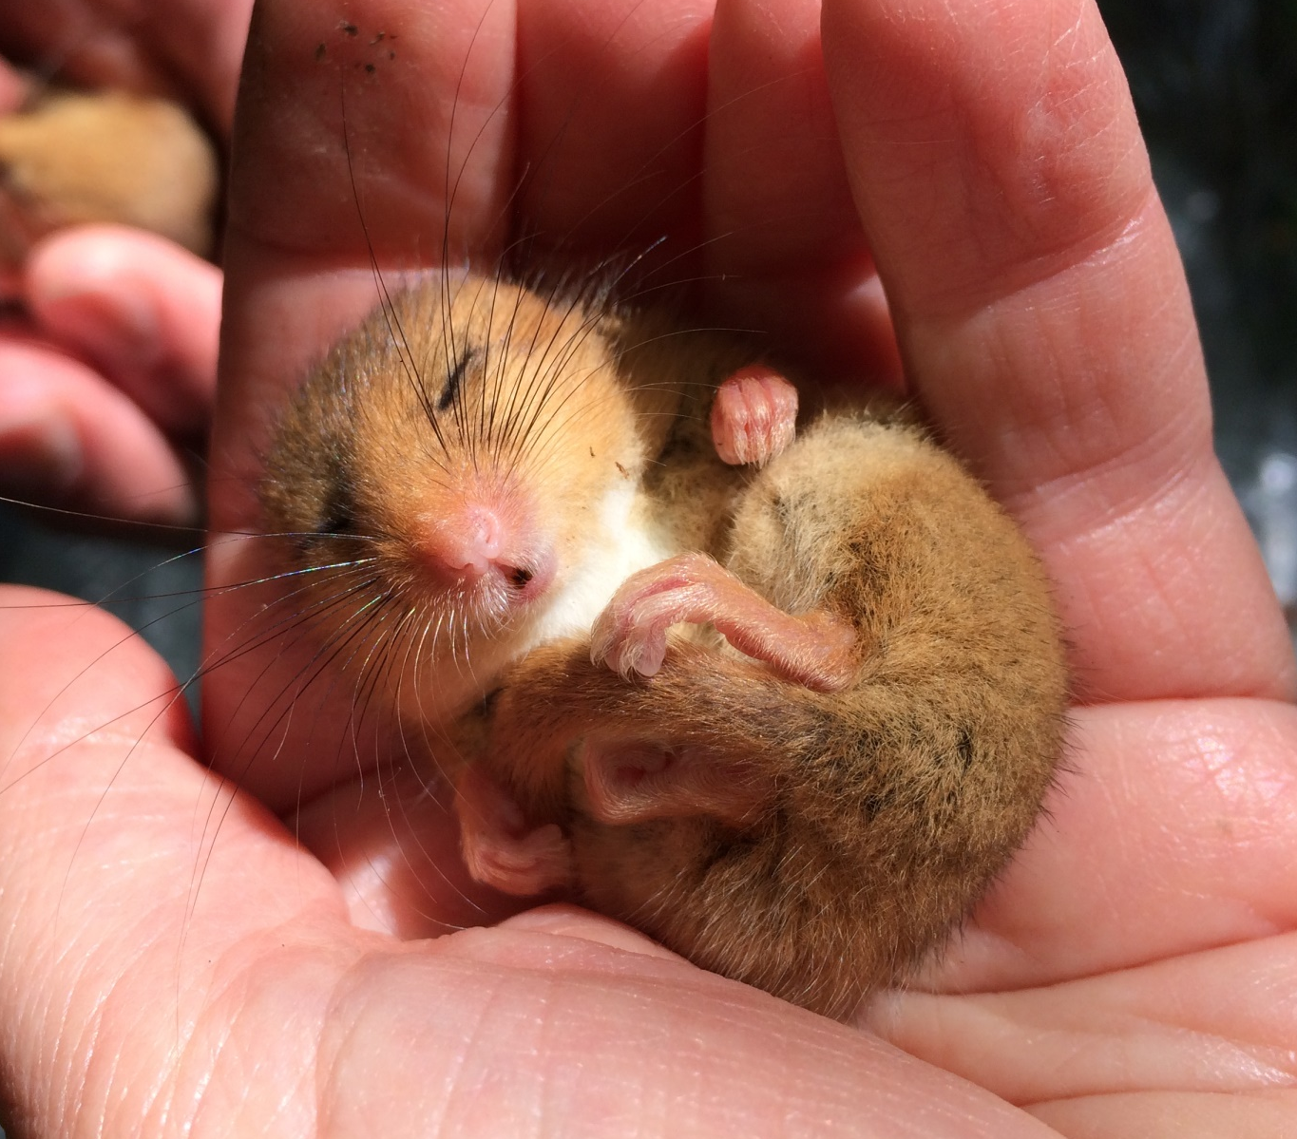
Figure 2.1 Jacqueline Hartley (n.d.), Hazel dormouse.

Current population trend
Dormice rely heavily on a select few food plants, making them vulnerable to localised changes in habitat composition. Natural successional changes in modern-day woodland management practices have resulted in optimal habitat loss and degradation of large areas of UK woodland. Furthermore, dormice are restricted in where they can reside by their vulnerability to changes in climate, thus high frequencies of adverse weather events can have a detrimental impact upon their populations (Bright and Morris, 1996).f
Goodwin et al. (2017) found that despite the attention the hazel dormouse receives (in terms of conservation and species protection) populations have declined by 72% in the UK, according to data derived from the long term (1993-2014) NDMP surveys. This highlights the need for further research and measures to be put in place to ensure that the FCS of the species is prioritised (Goodwin et al., 2017).
The State of Britain’s Dormice 2019 report by the Peoples Trust for Endangered Species (PTES) revealed that, although the impacts of climate change and habitat fragmentation are difficult to establish, loss of good-quality, favourable habitat is a clear factor influencing the decline in dormice populations (Wembridge et al., 2019). This report also states that where dormice have been monitored as part of the NDMP, there has been an overall decline of 51% since 2000.

Movement
Dormice are often described as arboreal, with a lot of early studies on their movements. Bright (1998) found evidence to suggest that gaps in habitat limit the ability of dormice to move within networks of habitat. Studies showed a clear aversion by dormice to moving at ground level, including reluctance to cross hedgerow gaps. A 2017 study, which looked into the use of whisker touch by dormice in gap crossing, found that even small canopy gaps can have a significant effect on behaviour. This is partly due to the fact that although larger gap crossings which required jumping were observed, these were only seen in a few individuals, suggesting that this behaviour is attributable to the “personality” of the individual (Arkley et al., 2017). The preference for arboreal travel in dormice further increases the risk of isolation as British woodlands become smaller and more isolated and dispersal corridors such as hedgerows become less suitable for cover and food sources (Bright and Morris, 2009).
Although the construction of roads plays a significant role in habitat fragmentation, existing roads can also play a key role in ensuring connectivity to the wider landscape. Using existing infrastructure to connect habitats to the wider landscape should be promoted in light of the new move towards green infrastructure (GI) in landscape and environmental planning.
Green infrastructure is described in Planning Policy Wales 19 (PPW10, 2018) section 6.2.1 as:
“the network of natural and semi-natural features, green spaces, rivers and lakes that intersperse and connect places”
This is also reflected in Natural England’s GI guidance (2009). Both of these documents recognise the benefits GI can deliver to the natural environment, through improving ecosystem resilience by improving connectivity, as well as providing wider benefits to human well-being including air quality, flood management and the benefits of open spaces (PPW10, 2018). Section 6.2.5 of PPW 10 goes on to describe how GI should be integrated into the built environment and encourages local planning authorities to adopt a GI assessment.

Effects of habitat fragmentation and crossing of open spaces
Despite early research into the arboreal preferences of dormice, Kelm et al, (2015) found evidence to suggest that individuals will cross roads and, in some cases, large roads of up to 30m with high proportions of the studied dormice evidencing road crossing behaviour. However, these crossings were only undertaken when habitats surrounding the road were of high suitability for dormice and the roads experienced periods of low traffic levels during the times when dormice are active. This evidence suggests that further enhancing roadside habitats may assist in the maintenance of dormouse populations and their ability to adapt to changes in their environment. It does however remain unclear what circumstances can lead to dormice crossing roads. Chanin and Gubert (2012) also found dormice in small habitat areas, fragmented by roads up to 12m across, suggesting again that dormice can and will cross even large roads. Their study suggested that maximising beneficial planting as close to the road edge as possible, would then reduce the open-ground distance between suitable habitats and may be a viable alternative to the time and expense that would be required to construct dormouse bridges over the road.
Although there are conflicting results regarding the willingness of dormice to cross open spaces, there does seem to be agreement that minimising the distance will increase the likelihood of crossings between suitable habitats and planting up road verges would offer opportunities for foraging, nesting and commuting between fragmented habitats.

Habitat preference
It is thought that changes in the management of woodland practices are integral to the decline of dormice. Goodwin et al. (2018) found that the conservation status of dormice can be hugely influenced by woodland management, with increased abundance in habitats including: honeysuckle Lonicera periclymenum; hazel Corylus avellana; bramble Rubus sp.; willow Salix sp.; birch Betula sp.; and shrubs, providing nesting material and year-round food (Bright and Morris, 1990).
Ideal woodland habitats must include an appropriate composition of food plants in the shrub layer along with a varied age structure of trees, scrub and shrubs present within close proximity to each other. It is also widely known that a rotation of coppicing cycles allows for this type of structure to be developed and ensures the maintenance of appropriate nesting, cover and sustenance features (Sozio et al., 2016). A preference for woodland edge habitat in particular has been observed, as this is where the desired structure is most likely to occur (Goodwin et al., 2018).
Dormice are also known to be present within mixed woodland and coniferous plantations. Studies have shown that they make use both of the plantation and broadleaved edge habitat. Where tracks are present, dormice use overhanging branches to cross rather than risk crossing the un-vegetated ground and stacked timber logs can offer hibernation sites (Quine, Shore and Trout, 2004). Understanding how best to manage plantation woodlands for dormice has increased in the past few years following several studies (Trout et al., 2018 and 2012).
Although dormice are generally thought of as a woodland species, a layer of scrub habitat is required for foraging and commuting within a range. This promotes the idea that scrubby habitats, the result of site clearance or neglect, can relatively quickly become suitable for dormice (Goodwin et al., 2018). These scrubby habitats can also be the areas where dormouse nests are easiest to find, therefore discovering their presence in this type of habitat may be easier and quicker than in naturally suitable woodlands.

Nest preference
In woodlands where the understorey is less dense, bramble and scrubby vegetation, tree cavities, birds’ nests and squirrel dreys in large trees are often used by dormice for nesting (Goodwin et al., 2018).
A combination of factors including proximity to a mix of food plants and woodland edge are key to the nest selection of both natural nests and boxes. In some locations nest boxes may provide shelter where young, thin trees do not offer the complex structure required for natural nesting opportunities (Williams et al., 2013).
Natural nests can also be found in low-growing bramble and scrub habitats, however it is likely that, although these are the most frequently found natural nests, these are the sites where nests are easiest to find and more likely to be seen by humans (Bright and Morris, 2009). It is therefore likely that natural nests in woodlands with suitably complex tree structures are difficult to detect.

Lifecycle and hibernation
Hazel dormice can hibernate for up to 7 months, beginning to emerge in March and by April usually around half of the population has woken from hibernation, (PTES, n.d.). With an average summer body weight of 18-20g adult dormice weight increases to around 30g in autumn (Juskaitis, 2014).
Dormice are unable to exploit abundant food sources, such as leaves, as they are not as well adapted to digesting cellulose as other small mammals. Their diet is therefore limited to: flowers; fruits and seeds; flower buds; and insects (Bright and Morris 1993). Juskaitis (2014) revealed the importance of availability of food sources with high calorie content throughout autumn to ensure an accumulation of fat reserves for hibernation. Dormice are known to travel to specific plants to feed, rather than feeding opportunistically from their immediate surroundings. This suggests a high reliance on specific food sources that, even if rare in the immediate environment, will still be sought out even if this requires travelling further (Bright and Morris, 1996). However, more recent studies have shown that on years where their preferred food sources are sparse (such as hazel, which may not fruit every year), dormice will adapt and feed on alternative food sources. This can have a knock-on impact on hibernation weight, suggesting that certain preferred food sources provide better opportunities for weight gain and increased fat reserves (Juskaitis, Baltrunaite and Kitrytie, 2016).
Most dormouse mortality occurs during the early active season in May. Likely due to: reduced fat reserves following a long hibernation; low food availability at this time of year; and the high energy demands of reproduction, all of which leads to increased exposure to predators when out foraging (Bieber et al., 2012). Survival rates of most hibernators are highest during the winter months, when the absence of foraging reduces likelihood of predation (Turbill, et al., 2011).
In comparison to other small rodents inhabiting the same area in a woodland (such as wood mice Apodemus sylvaticus and yellow-necked mice Apodemus flavicollis), the hazel dormouse has a long life span of up to six years, however, reproduction rates are low. Typically, dormice have one or two litters per year with an average litter size of four. This is likely to be a contributing factor to the low population density of dormice in a given area (Juskaitis 2008). In the UK, occasional litters are recorded in late May and early June, however the majority of litters occur in August and September (PTES, n.d.). Young dormice become sexually mature at around 8-10 weeks, resulting in young from early litters able to breed later in the same year. This is more likely to happen in years where population density is already low, due to greater opportunities for finding free territories suitable for breeding (Juskaitis, 2013).

Predation
Bright and Morris (1996) describe Wood mouse, Weasel Mustela nivalis, Stoat Mustela erminea, corvids, squirrels Sciurus carolinesis, Foxes Vulpus vulpus and Badgers Meles meles as potential predators to dormice. These predators have not been documented in any great numbers and it is likely that the dormouse’s nocturnal, arboreal and low density nature means that they do not make up a significant proportion of any UK predator’s diet.
In 1974 a study by Glue found that, of the items found within barn owl pellets, remains of dormice comprised less than 1%. A more recent study in Lithuania found dormice comprised less than 4% of small mammals preyed upon by Tawny Owls Strix aluco (Balčiauskienė and Balčiauskas, 2008).
A 1997 study on domestic cats Felis Catus in Great Britain revealed that out of 986 cats, dormice represented just 0.08% (n=12) of the prey items brought home (Woods, McDonald and Harris, 2003).
Despite low risk of predation resulting from dormice living in such low densities, it is likely even a small number of predation incidences could have a large negative impact on a population (Bright and Morris, 1996).

Dormice and Climate change
Hazel dormice are sensitive to fluctuations in weather patterns leading to changes in food availability (Juskaitis, 2008) and changes to both winter and summer temperatures are likely to alter their activity patterns, potentially affecting survival rates (Bright and Morris, 1996). Bright, Morris and Wiles (1994) observed activity levels of hazel dormice being directly impacted by rainfall, with reduced activity observed during periods of rainfall, particularly moderate to heavy rain, when dormouse fur can become waterlogged.
Increased temperatures during deep hibernation months (November-February) can cause dormice to awaken causing high levels of energy expenditure and increased risk to winter survival. However, studies have revealed that dormice can adapt to earlier springs and by waking up as temperatures increase, may profit from earlier food availability due to earlier vegetation growth. This could then lead to earlier reproduction, increasing likelihood of a multiple litter year (Pretzlaff and Dausmann, 2012).
Overall, literature on the impacts of climate change on dormice specifically is limited, however their sensitivity to an unpredictable climate described by Bright and Morris (1996) is likely to be exacerbated by changing climatic conditions.

Legislation
Annexes II and IV of the Habitats Directive list those species which are offered the highest levels of protection. These are known as European Protected Species (EPS) of which the hazel dormouse is one. This directive is transposed into British law under The Conservation of Habitats and Species Regulations 2017, where dormice are listed under Schedule 2. Under this, all EPS species are protected from: killing; injury; disturbance (both resting places and breeding sites); damage to both breeding sites and resting places; transportation; selling; exchanging and possession/control, as well as making it an offence to impair their ability to survive, reproduce, nurture their young and hibernate. As part of this, the Favourable Conservation Status (FCS) must at all times be preserved. The FCS of EPS species is most often assessed on a local scale, with the assumption that development must result in no negative impacts on the FCS at a local level and therefore nationally (Wards, Dendy and Cowan, 2015).
Dormice are also listed under Schedule 5 of the Wildlife and Countryside Act 1989, protected from disturbance or obstruction of a structure used for shelter or protection and it is an offence to sell, possess and transport dormice.
In addition, dormice are offered enhanced protection through legislation covering biodiversity and its role within the environment as a whole. The Environment (Wales) Act 2016 is the driving legislation in Wales, ensuring biodiversity is considered as a vital part of planning and decision-making process by local authorities, Welsh Ministers, public bodies and statuary undertakers (Welsh Government, 2016). Under the Act all public bodies must not only seek to maintain biodiversity, but also enhance and promote ecosystem resilience. Particular attention should be paid to all species and habitats listed under Section 7 of the Act and all reasonable steps must be taken to ensure the species and habitats are maintained and enhanced. Dormice, woodlands and hedgerows (the two main habitats which dormice rely on for movement) are all listed within the Section 7 lists.
With this in mind, Planning Policy Wales 10 Section 6.4.3 emphasises that this must be considered an integral part of the planning process:
“The planning system has a key role to play in helping to reverse the decline in biodiversity and increasing the resilience of ecosystems, at various scales, by ensuring appropriate mechanisms are in place to both protect against loss and to secure enhancement.”
Further to the above legislative requirements, and to ensure continued compliance, a letter from the Head of Planning in Welsh Government was sent out to all local Welsh planning authorities in October 2019, clarifying the requirement not only to maintain, but also to enhance biodiversity and supporting the view that a lack of biodiversity enhancement within development could be a reason for application refusal.
The Environment Bill for England was presented by the UK Government in October 2019, and conveys the message that biodiversity net gain will be a requirement of all developments, as will post-construction evidence that the net gain has been achieved and is continuing to function successfully. This requirement is due to come into force in October 2021 and a ‘Biodiversity Metric 2.0’ by DEFRA will ensure that all developments achieve at least a 10% net gain (RTPI, 2019).
With such emphasis on the requirement to ensure enhancement as a result of the planning process, it is important that appropriate biodiversity enhancements are delivered in the appropriate place and enhancement proposals offer stepping-stones for nature, thereby increasing connectivity. Increased connectivity leads to more robust, wider populations of species, allowing freedom of movement and sharing of genetics (Naim et al., 2011). Enhancement with dormice in mind may, therefore, provide multi-species benefits for landscape scale populations. As already discussed, dormice are known as an indicator species of well-functioning ecosystems (Morris, 2003).

European protected species licensing
Under Regulation 55 of the Habitats Regulations, Natural Resources Wales (NRW) can issue licenses to allow works, such as development, which will impact on dormice in any of the above-mentioned ways, to be undertaken within the confines of the law. Licenses will only be granted if there is no alternative and if confidence can be given that the works will not impact upon the FCS of the dormice (NRW, 2019(B)).
Hull et al. (2001) found that many land managers are under the impression that minimizing human intervention, the woodland will, in time, manage itself, through natural ecological processes. This thought process may be being strengthened by legal requirements for the consideration of how any alteration or management of suitable habitat would disturb dormice. The need for a license to undertake woodland management may be interpreted as a discouragement of management. This concern for short-term disturbance of individual dormice may be having a negative impact on larger populations as suitable habitat is not being managed appropriately and favourable conditions may be lost as a result (Goodwin et al., 2018 (B). This may, in time, result in failure to comply with legal requirements of the Habitats Directive, where a necessary amount of human intervention/management may be required to ensure the FCS of the protected species is met (Epstein et al., 2015).

Dormice and development
Planning Policy Wales (2018) provides a clear message that planning can play a critical role in reducing or reversing biodiversity loss as well as improving ecosystem resilience. Considerations for biodiversity and its maintenance and enhancement, as well as overall resilience of functioning ecosystems should be considered at an early stage of development, ensuring there are no significant losses in species, their populations and their supporting habitats (PPW 10).
Any works to a site possessing suitable dormouse habitat holds the potential to cause an offence under the Habitats Regulations. Dormouse surveys are required, to establish their presence or absence on a site where suitable habitat is present, particularly where there are strong ecological connectivity features to known populations. In the UK, it is currently standard practice for ecologists to follow the guidance for surveying set out in The Dormouse Conservation Handbook 2nd edition (Bright, Morris and Mitchel-Jones; 2006).
When dormice are found on site, a mitigation license is required to undertake works. In Wales the license is given by NRW and in England the licensing authority is Natural England (NE). The mitigation license must include how the habitats already present on site will be cleared/changed and/or managed as a result of the proposal and how new habitat will be created and managed (Peoples Trust for Endangered Species, 2020)
In order to mitigate its effects on wildlife effectively, it is important to understand how species are impacted by development. Several studies have been undertaken to understand the impacts of road development and the effect that large linear features within the landscape have on wildlife, including those of Forman and Alexander (1998), Ward et al., (2015) and Rytwinski et al., (2015). In road ecology, it is accepted that further research into the effectiveness of mitigation measures is required to move forwards and continue to understand how best to protect wildlife from the impacts of new roads (Rytwinski et al., 2015).
A combination of tunnels, culverts and bridges are recommended to mitigate the identified impacts. However, to ensure this approach is consistent and effective, this must be done collaboratively between policy makers, engineers and the developers at national and local scales (Forman and Alexander, 1998).
Understanding effectiveness of mitigation measures is needed in order to continually increase the success and protection of wildlife, however, at present there is not enough information post-construction to fully evidence what measures are most effective and therefore provide up-to-date, useful guidance to developers (Rytwinski et al., 2015). It has been recognised that governments and regulatory planning authorities should be continually assessing the evidence base for small-scale local level mitigation measures for developments, such as road schemes, to ensure these measures continue to benefit the FCS of the dormouse (Ward et al., 2015).

Mitigation/compensation
Mitigation or compensation is required once dormouse presence has been established and this can be achieved through: replacement planting; enhancing corridors and existing habitats; buffers; bridges and ropeways; and underpasses (Carroll, 2014).
In an ecological context it is important to understand what is meant by mitigation and compensation. The term mitigation is the act of reducing the severity of the effects on something. In this context it relates to the reduction of the impact development will have on dormice. Compensation, on the other hand, is something that counterbalances or offsets an undesirable outcome (Oxford English Dictionary, 2019). In this context, compensation means to make up for the loss of dormouse habitat and/or connectivity by replacing it.
Bridges, for example, would be classed as mitigation measures, as they are put in place to reduce the severity of habitat fragmentation, whereas an area of newly planted woodland would be classed as compensation for the loss of woodland habitat.
The Dormouse Conservation Handbook (2006) discusses several methods for mitigation: planting hedges; translocation of hedges; planting new habitat; erecting nest boxes to increase the carrying capacity of newly planted habitat; green bridges; rope bridges; dormouse-specific bridges; and planting in tunnels and culverts. It is worth noting that the latter four methods were all described as having received little research and therefore little evidence of success at the time of writing the handbook (Bright et al., 2006). Since then, trials in Japan and England have shown use of purpose-built bridges by dormice crossing roads up to 30m wide (White and Hughes, 2019 and Minato, Ohtake and Morris, 2012).
It is known that in order to maintain high-quality dormouse habitat and therefore connectivity and resilience, management is required within woodlands to ensure provision of mid-height scrubby habitats preferred by dormice and to allow for connection between preferred sources of food and nesting materials (Bright and Morris, 1990 and Goodwin et al., 2018). This requirement should be considered when looking at mitigation and compensation measures as it is known habitat suitability will affect dormouse behaviour in terms of crossings and movements (Kelm et al., 2015). Where planning and landscape-scale conservation is concerned, continuous roadside hedges and parcels of suitable woodland should be promoted as stepping stones and corridors for dormice (Encarnacao and Becker, 2015). However, Mortelliti (2011) suggested that using hedgerows as a mechanism for connected habitat may only be effective where pockets of suitable habitat are relatively frequent. This further evidences the effect that fragmentation of habitat has on dormice and the need for suitable mitigation measures to be put in place where development divides and fragments existing pockets of habitat.

Dormouse bridges
There is very little UK-based evidence for the use of dormice-specific arboreal bridges by dormice. The Dormouse Conservation Handbook (2006) acknowledges the lack of evidence proving the use of rope bridges by dormice but it does suggest that a cylindrical or tubular wire cage surrounding the rope may provide enough protection and stability to encourage use by dormice.
The most successful, but also expensive bridge structures used for encourage wildlife to cross roads are green bridges. Currently the only example of dormice not only using but also breeding on green bridges in the United Kingdom is the A21 Lamberhurst bypass which was completed in 2005. In 2011 dormice were observed and recorded breeding on the bridge in nest boxes (Songhurst, 2012). It is unclear if it took dormice six years to begin using the bridge or if monitoring had simply not picked them up before this point.
A bridge in Japan was successfully recorded being used by Japanese dormice however it was only 10m wide over a road which does not see heavy traffic flows (Minato et al., 2012 cited by White and Hughes, 2019). A recent study in the Isle of White is thought to be the first recorded example of hazel dormice crossing a purpose-built bridge in the UK. This design consisted of a wooden or aluminium platform, suspended from an ‘A’ frame’ which provided covered access straight from vegetation on either side of the road. The design and location of the bridge was considered in great detail and, as a result, it is thought it will provide a suitable arboreal pathway for dormice to cross roads of up to 30m (White and Hughes, 2019). As this bridge design continues to be promoted and built, further research will be required to understand success where the bridge is installed within an area where the existing dormouse population is much lower than where the trial bridge was installed.
Despite a lack of substantial, clear evidence that bridges are used by dormice, they continue to be offered up as mitigation, particularly on road developments. This comes at huge expense to the developer and, with it, a considerable amount of negative publicity, particularly where ongoing repair works are required to maintain the functionality of the bridge.

Hedgerow translocation and hedgerow/habitat enhancement and planting
The Dormouse Conservation Handbook (2006) describes the importance of hedgerows and methods for maintaining their function pre-, during and post-construction through a mixture of planting up gaps in connectivity and transplanting (hereafter referred to as translocation) of existing vegetation. The translocation of hedgerows, particularly those with hazel stools, offers an alternative to removal and re-planting, where planting can take several years to produce desired vegetation cover, translocation can see results much earlier. However, this method is restricted to winter months, when rain is more frequent and success more likely. Appropriate aftercare is required to ensure a high survival rate of translocated vegetation and quick establishment and re-growth.
Where new planting is proposed as mitigation, this should be done as soon as possible, prior to site clearance, in order to allow time for plants to establish fruit and provide cover. This can take some time and it can be several years before it provides favourable conditions for dormice to forage and commute in.

Tunnels and underpasses
Along with bridges, tunnels are another form of mitigation suggested by the Dormouse Conservation Handbook (2006) that has little evidence of success. It is suggested that it may be possible to achieve habitat connectivity where suitable habitats and features for commuting and foraging have been severed through the planting of tunnels and culverts. However, this relies on the tunnel/culvert being short enough that sufficient light and water can penetrate into the feature to sustain plants.

Post Construction Monitoring
Post-construction monitoring of dormice is frequently a condition of the granting of a license for works to be undertaken where dormice are known to be present. Where monitoring has been undertaken, failure to forward records to Local Records Centres (LRCs) is commonplace. This impacts understanding of the effectiveness of mitigation measures (Carroll, 2014).
Williams (2014) found dormice present in boxes during construction and post-development, particularly where existing hedgerows have been retained and protected. This study also acknowledged that having access to records from other developments and evidence of how well mitigation has worked following construction, would be useful in understanding how well the measures are working and what measures are most likely to be successful in ensuring continued presence and the FCS of dormice.
In NRW’s protected species licensing application guidance document, monitoring of sites must be clearly set out in a method statement and undertaken to ensure that the migration has worked as expected (and if it has not, remedial actions must be stated) and to inform and improve guidance and advice on future development sites/license applications. However, the length of time this monitoring should be undertaken is not stated (NRW download, n.d.).
There appears to be a consensus that sharing the results of post-construction monitoring reports would aid in improving knowledge and understanding of successful mitigation or compensation and how to avoid adverse impacts on dormice during and post-development. However, to date, there does not appear to be a significant amount of evidence to suggest that the results are being published or shared amongst dormouse professionals.

Surveying dormice
As understanding of dormice habitat preferences strengthens, it is likely need for presence surveys will increase, leading to investigations into quicker, cheaper survey methods. Providing alternative methodologies allows ecologists to choose the survey technique most appropriate to their time and budget, whilst ensuring absence or presence is accurately determined (Mills et al., 2016).
The Dormouse Conservation Handbook (2006) outlines accepted survey methods and it is expected any surveys submitted in support of a planning application are undertaken in accordance with the handbook guidance. Recommended methods for survey include gnawed hazelnut searches (Figure 2.2), nest boxes (Figure 2.3) and nest tubes (Figure 2.4). The handbook describes pros and cons of each method and recommendations are made as to the amount of survey effort required in order to provide confidence in the results.

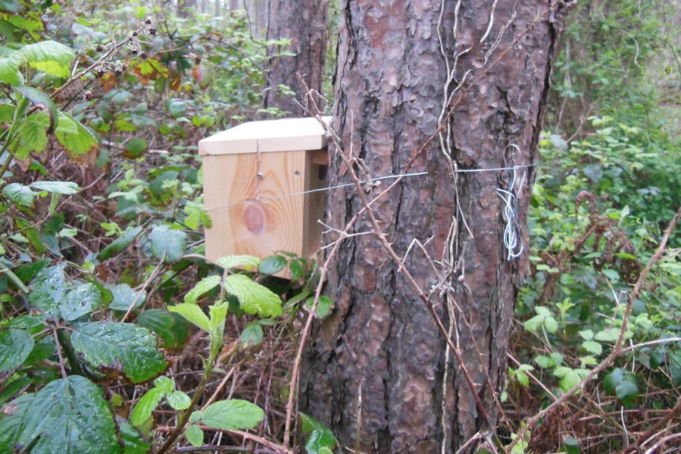
Figure 2.2 Jacqueline Hartley (n.d.), Dormouse nest box in-situ.
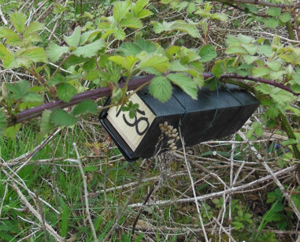
Figure 2.3 Jacqueline Hartley (n.d.), Dormouse tube in-situ.
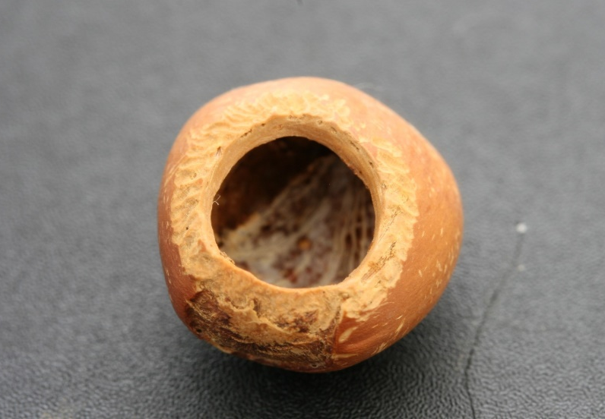
Figure 2.4 Jacqueline Hartley (n.d.), Hazel nut nibbled by hazel dormouse.
Although nest tubes may play a useful role in establishing presence of dormice, it has been found that, given the choice, they prefer nest boxes. This suggests that when surveying a site for dormice it would be useful to use a combination of tubes and boxes to increase the chances of detection and potentially reduce the time taken to establish presence (Chanin and Gubert, 2011). In contrast to the above study, Lang et al. (2018) found that the hazel dormouse showed a clear preference for tubes over boxes. However, it was acknowledged this may be due to a high number of nest box competitor species such as wood mice and yellow-necked mice, which may have resulted in fewer boxes being vacant, leaving the lesser-used tubes more available for dormice.
It has been suggested that a lack of dormice in monitored nest boxes may not be a reflection of a decreasing population, but rather a reflection of food availability in that area at the time. For example, in years where there is less food and cover in areas where nest boxes are situated, dormice may simply be moving to other unmonitored areas/habitats which offer more food at that time (Verbeylan, 2012). Furthermore, Channin and Woods (2003) (cited by Mills et al., 2016) found that where natural nesting site availability is high, nest boxes and tubes may be used less frequently. This, along with seasonality and their elusive nature, low populations densities and behaviour means that dormice are notoriously difficult to survey and monitor and establishing the presence of species can take several months or years (Bright et al., 2006). This could result In false negative surveys, where dormice are present, just in low a low population density and using natural habitats to nest in, rather than the tubes or boxes used for surveying.
However, a survey undertaken in Dorset found that the use of bait and camera traps and specially designed foot-print tunnels detected dormouse presence quickly, could be deployed in several habitat types, and did not rely on the dormice exhibiting nesting behaviours to confirm presence. This study was, however, undertaken in an area where dormice were already known to be present, with no comparison of the length of time it might take for these techniques to be useful where presence is not currently known or where density is low (Mills, Godley and Hodgson, 2016).
Much like the recent developments in using thermal imaging for surveying bats (Fawcett Williams, 2019), it has been suggested that thermal imagery could be used for monitoring surveying dormice (Worrall and Trout, 2017). Although, to date, the only published literature found on this was use of thermal imaging cameras for searching for dormice in nest boxes, rather than as a tool for establishing presence on a site.

Summary
Despite substantial literature surrounding dormice, their behaviour, movements and habitat preferences, there still does not appear to be definitive advice on how well mitigation and compensation measures are working. NRW and NE clearly set out a requirement for post construction monitoring to be undertaken, not only for site-specific purposes, but also to improve understanding of techniques used. Assuming this is being undertaken, there still appears to be a gap in knowledge and a requirement for information to be shared amongst dormouse professionals and those influencing mitigation decision-making.
This report will therefore seek to understand how dormouse presence is established, how it can be improved as well as what mitigation/compensation measures are most frequently used and how and if they are monitored post-construction. The submission of results of this monitoring and the sharing of data and information will also be investigated in order to understand how this knowledge gap can be filled moving forward.
Furthermore, the results of the investigation will be drawn together to create a framework that local planning authorities could follow to ensure that enhancement is fully considered with dormice in mind, even on sites where either presence has not been established or no surveys were deemed necessary due to lack of close records.

Methodology
To achieve the aims and objectives of the study a mixed methodologies approach was used.
Objective 1:
Identify any current gaps in planning/mitigation process for dormice protection.

Objective 2:
Establish consensus and whether survey improvements are needed when establishing dormouse presence and how best to mitigate the effects of development where presence is confirmed.

Objective 4:
Use the results and interpretation of the research to generate a list of recommendations.

Research aim: To create a management framework for the conservation of dormice in light of the recent legislative changes to the planning system.

Mixed methodologies research
Categorization/coding of qualitative data from open-ended/ free text response questions and data analysis.
Results
Online Questionnaires
Discussion and interpretation
Recommendations
Phone Interviews
Objective 3:
Establish whether post-construction monitoring is being undertaken as required and, if so, how dormice are benefitting from the mitigation methods used.

Figure 3.1 Outline of research approach

General research approach
A mix of methodologies is common in research and using both questionnaires and interviews allows a detailed perspective on issues raised within the questionnaires which may become clearer through a more open-ended interview structure. It also allows for both qualitative and quantitative data to be combined (Baxter et al., 2010). Furthermore, the use of both interviews and questionnaires allows for more data to be gathered where time is restricted and undertaking enough interviews to make the research viable is not practical.

Semi structured Interviews

Interview design
A semi-structured interview was developed, intended to be undertaken over the phone. Phone interviews were chosen due to practicalities of time and distance. It was also decided to keep the interview to a maximum of 30 minutes, in order to avoid discouraging ecologists from taking part due to time constraints. The interview questions were designed to gather both qualitative and quantitative data.
It was explained to the respondents that all data presented in the study would remain anonymous and any information regarding specific sites would be removed to avoid any potential for identification.
Due to practicalities, interviews were not recorded and note taking was used to record all relevant information. A system for recording answers to the questions quickly in order to avoid awkward delays was developed. This involved using a printed copy of the questions and using circling, single letter answers and only noting relevant sentences.
Closed questions are most often used in interview questions as they are efficient and often reliable. The uniform data produced from specified options allows for data which is easy to score and analyse (Fink, 2017). Furthermore, they are often much quicker to respond to, meaning more questions can be asked if time is needed to be kept to a minimum (Oppenheim, 1978). Open-ended questions offer opportunities for the interviewees to expand on their answers and give reasons why this is their opinion (Fink, 2017). Where closed questions asked for an opinion on something (e.g. surveying methodologies) which offered a yes, no or ordinal scale response, this was followed by a free test response question asking ‘why’. This ensures the context of their opinion is recorded, enabling increased accuracy of results interpretation (Oppenheim, 1978).
Quantitative research methods allow for quick and easy establishment of interactions among variables; however, it cannot be clear on the reasons for the outcomes. Qualitative data, on the other hand, can fill that gap and help in understanding the reasons for the relationship between variables. These two methods can then be combined in order to achieve a general representation of the research (Baxter et al., 2010). These different lines of inquiry should complement and reinforce each other, providing confidence in the results (Robson, 1993 cited by Long, 2007).
Consideration must be given to how the interview is ‘sold’ to the ecologists contacted in order to encourage participation. The title and initial description are important to ensure there is a positive feeling towards the research. Assurance of anonymity, an attractive title and evidence of an understanding of the subject can all contribute towards increased participation and a more open respondent (Oppenheim, 1978).
Beginning the interview with easy, relevant questions allows for a rapport to build between the interviewer and the interviewee prior to asking more sensitive questions. With a mixture of both open-and closed-ended questions it must be established whether it would be easier for the respondent to answer all quick-fire closed-ended questions together, at the start, followed by the free-answering open-ended questions at the end, or maintain the logical flow, ensuring the context of each question is maintained as required (Oppenheim, 1978).
The use of field coding was considered for use in the interviews. Field coding is used to code respondents' answers, however the respondent does not see the possible answers and the interviewer codes the answers accordingly (Oppenhim, 1978). This technique was not chosen on this occasion as the possible answers to questions relating to dormouse mitigation are already limited to those recommended in the mitigation guidelines.
Ordinal scale attitude questions were used to assess the respondent’s opinion on how well they feel different methods for surveying and mitigation delivered the desired outcome. Only four answers for respondents to select from were used, one of which was ‘don’t know’. It was decided that ‘don’t know’ needed to be provided as an option to avoid respondents giving false opinions of methodologies they had not come across or used; forcing the respondents to express an opinion on a method they are not familiar with, which would not have uncovered the truth of their views on the subject (Fink, 2017). ‘Don’t know’ responses were followed up with a ‘why’ question.
A ‘Checklists’ or verbal ‘listing’ approach was used to allow respondents to choose one or more of the options available for some questions, such as those relating to the different mitigation methods used in the past. This method can ensure respondents are aware of all possibilities, reducing the likelihood of them forgetting answers that may have been relevant if it had been left as an open-ended question (Fink, 2017, p. 54). This was followed up with an opportunity for the respondent to provide information on options not already mentioned, in the event that a respondent had an option that had not been identified in the literature review or piloting.

Sample size
Within Wales, the number of ecologists or experts with the specific knowledge and experience required for this topic is limited. It was therefore decided that an internet search for ecologists working within Wales would be used to acquire as many e-mail addresses as possible to contact. The sample size was dependent upon suitably experienced individuals showing a willingness to volunteer.

Data Collection
When conducting the interviews, a printed copy of the questions was available for notes to be written directly on during the phone call conversation. Where free text/open ended responses were recorded, the researcher noted these down as soon as possible. Some context may have been lost using this method as the intentions or tone of the interviewee may have been lost in transcription or misinterpreted by the interviewer (Long, 2007).

Participant recruitment
Internet searches were under taken to establish a list of ecologists working within Wales. E-mail addresses were noted down and all were sent the same e-mail (Appendix 1) requesting participation. E-mails were sent using BCC to ensure confidentiality among participants.

Pilot Survey
Piloting allows the interview design to be tested and, if necessary, modified accordingly (Blaxter, Hughes and Tight, 2010). Furthermore, pilot testing assists in ensuring all relevant topics and options are included within the final questionnaire. This will lead to increased reliability and validity of the results and ensuring that the questionnaire will result in answers which assist in achieving the research aim (Fink, 2017).
Due to the small number of expected participants with the relevant knowledge, the pilot testing was undertaken on an individual experienced ecologist. This is in line with the recommendation that, in pilot testing, it is best to choose a respondent similar to those who will complete the questionnaire (Fink, 2017).
The pilot was undertaken over the phone and was timed to give an idea as to the realistic time commitment requested of participants. Several changes were made following the pilot including: question order; additional options (surveying and mitigation techniques); and question wording.

Questionnaires

Justification
The use of multiple survey techniques, such as interviews and questionnaires, can improve how the survey sample is represented and increase confidence in the findings. Where time and resources are limited, online surveys can offer a fast alternative to other forms of questionnaire distribution and can be quickly distributed amongst a specific target group (Yun and Trumbo, 2000).

Questionnaire Design
The questionnaire design was based on the interview design, to enable any of the transcripts from the interviews to be submitted as questionnaire data, as required, to allow for a larger sample size when analysing the results.
A thorough description of the research the questionnaire is contributing to is vital, questionnaire recipients will not benefit from receiving an over-the-phone description of the aims of the research. The questionnaire description should address: the aims of the study; who the questionnaire is aimed at; the potential benefits of the research; and what will happen to the information provided (Kelley et al., 2003).
In designing the online questionnaire, it was important to consider the available space for writing the answers to the open-ended questions. Too few ‘lines or ‘spaces’ available may indicate to the respondent that a short, sparsely worded answer is required (Oppenheim, 1978, p. 41). ‘Long’ answer text boxes were chosen for all open-ended questions to, to ensure that all opinions and thoughts on the subject in question could be expressed freely without a limit.
An electronic questionnaire was designed through Microsoft forms. This creates a link directly to the questionnaire and can be filled out at any time, without a time limit.
The questionnaire link was first disseminated through social media and by e-mail on 31st January 2020. It was requested that all responses are made by 23rd February 2020. Any responses after this were still used up until 6th March, 2020.
The survey and mitigation techniques identified in the questionnaire for participants to select were informed by The Dormouse Conservation Handbook (2006) and any additional, new techniques not available or developed at the time the handbook was written were introduced as a result of the pilot survey of the questionnaires.
The questionnaire can be found in Appendix 3.

Sample size
As with the phone interviews, sample size for the questionnaire was largely determined by the number of people with relevant knowledge and the number of those willing to participate. The aim was to disperse the questionnaire to as many people as possible and gather as many responses as possible in the time frame.

Participant recruitment
Online surveys allow researchers to access groups of similar people with specific interests (Wright, 2006). The restricted range of dormice within the UK results in a smaller field of ecologists with experience working with and surveying for dormice. Therefore, the sample size is already restricted by a lack of individuals with relevant knowledge. The use of social media to disseminate questionnaires is fast becoming seen as a cost-and time-effective for researchers, with those engaged responsive and eager to take part where relevant (to the research) social media forums/pages are targeted (Kayam, 2012).
The questionnaire was shared through Facebook, as a social media platform which hosts several relevant dormouse conservation pages, networks and forums (the message requesting participants can be found in Appendix 2). The questionnaire was also e-mailed to individuals who had a network of relevant contacts to which it could be distributed. It was made clear that the questionnaire was aimed at anyone with any experience with dormice and planning.

Data collection methods
The questionnaire results were collected using Microsoft Forms and in Microsoft Excel.

Data Analysis
Data analysis is required in order to summarise the findings of the study and provide the answers to the research aims and objectives. Where quantitative data has been collected, appropriate statistical tests must be applied (Kelly et al., 2003). Where qualitative data has been collected, appropriate coding and categorisation of responses must be established in order to undertake an analysis (Long, 2007).

Quantitative data analysis
All of the Quantitative data analysis came in the form of closed-question responses. SPSS (IBM SPSS Statistics, 2017) was used for all statistical analysis. Primarily, descriptive statistics were used to calculate and demonstrate frequencies. Each question was analysed separately and where necessary, cross tabulation was used to demonstrate where themes occurred.
Demographic data (country and license) was assessed using cross-tabulations to highlight any significant difference between preferences for surveying methods. This was done using a Chi-squared test with a significant value of .05. Chi-squared was deemed appropriate as it was not expected that there would be more than 20% of cells with an expected frequency of less than 5.

Qualitative data analysis
The qualitative data received from the open-ended/free text responses of both the interviews and questionnaires showed recurring themes, therefore categories were established. This allowed for natural categories to form as a result of the responses, rather than forcing answers to match preconceptions (Long, 2007, p. 145). The coding of the qualitative data allowed for data analysis using SPSS.

Climatic and UK dormouse population data
Although the focus of this study is on development and the planning process, any impacts from climate change could affect how best to approach dormouse conservation. Exploring any potential trends in dormouse populations compared to climatic data may assist in directing the framework towards a more lasting and resilient approach.

UK dormouse population data
Data was used from the 2015 study by Goodwin et al. (2015) on dormouse population trends in the UK (England and Wales sites only). For this, population trends were measured using data from the long-term National Dormouse Box Scheme and the average number of adult dormice found each year between 1998 and 2014 was taken from this study to compare with climatic data for England and Wales

Climatic data
The MET office National Climate Information Centre provides up-to-date climatic data for England and Wales (combined) monthly, seasonal and annual average rainfall (Met Office, 2020a) and temperatures (Met Office, 2020b). The seasonal averages of both rainfall and temperatures were used due to the dormouse’s relatively predictable changes in behaviour depending on season and weather.

Data analysis
As the population and climatic data is interval data, the Pearson’s correlation co-efficient analysis was undertaken in order to test for a statistically significant relationship between any of the data sets. The regression line was also calculated to offer a visual representation of any tends. The r² values were also used to show any significance in the trend (Long, 2007). SPSS was again used for all data analysis.

Limitations
Sample size was a clear limitation of this study and this was overcome by adopting a mixed methodological approach and using two sources of data collection to inform, support and provide confidence in the findings.
Ecologists were only contacted for interview if working within Wales. This limited the number of potential individuals willing to be interviewed. Particularly as there are areas in England that have many more sites where dormice are known to be present and, can occur in higher population densities than in Wales. There may, therefore be a higher proportion of ecologists working within England with the required experience and knowledge to take part in the interviews. However, the questionnaire was distributed without the requirement for respondents to be Wales-based and results from England were captured as a result.
Understanding what mitigation works best for dormice is highly dependent upon the experience of the respondents and whether or not post-construction has been undertaken. A lack of respondents having undertaking post-construction monitoring will further reduce the sample size. Therefore, by far the biggest limitation in achieving the research objectives for this study may be lack of current knowledge.
Where questionnaires did not allow for respondents to expand on their answer and explain their thought process, this was also not applied to the interviews, where the interviewer did not press the respondents for further information if it was not given freely. Further encouragement may have yielded further understanding of the reasoning behind data gathered.
The change in population compared to weather was based on a relatively small data set, which can result in difficulties when seeking statistical significance. Furthermore, the data for the number of adult dormice came from a single source; the limitations listed within that study should also be relevant to here, when using data derived from this source. Also, changes in weather patterns such as temperature and rainfall are seen over a very long period of time, much longer than the number of years this study used.

Results
This chapter will present and analyse the results of both the interview and questionnaire responses, highlighting key findings in readiness for further discussion. In line with the research aim, the results will demonstrate how dormouse presence is established on sites proposed for development and how confidence in negative results can be improved. Furthermore, the findings will also seek to clarify what mitigation is being used, what is currently thought to be working and again what could be done to improve how dormice are mitigated for and dealt with in the planning system.
The questions from both the interviews and the questionnaire have been grouped into types of questions to aid analysis and discussions. These are:
- Questions 1 – 3; experience;
- Questions 4 – 8; surveying;
- Questions 9 – 10; mitigation;
- Questions 11 – 23; post-construction monitoring; and
- Questions 24 – 25; improvements.

Interviews

Responses
Four ecologists responded to the e-mails requesting interviews, each having some experience in dormice and planning. Times were arranged for discussions over the phone and all four were completed within a 30-minute time frame. All data was valid and included within the results.

Experience
All four respondents were dormouse license holders and three worked exclusively within Wales. A dormouse license enables the individual license holder to undertake activities affecting dormice that would otherwise be unlawful (UK Government, 2014). Two respondents were employees of a larger consultancy, one was a self-employed consultant and one was a local authority ecologist, having previously worked in a consultancy.

Surveying
Analysis of interview data demonstrated that nut searches were highly thought of by all four ecologists, all admitted that this was only useful during the fruiting season and could not be relied upon all year round. Interestingly, one respondent, who had previously worked in Somerset and Devon but since moved to work solely in Wales felt that “all methodologies seemed reliable in Somerset and Devon”. However, in their experience, when working in Wales, both boxes and tubes appeared to be hit and miss when it came to detection reliability. Overall, three of the four respondents felt that boxes and tubes were ‘hit and miss’, with one respondent only using tubes for development investigations.
When asked how surveying for dormice could be improved, two out of the four respondents expressed the opinion that no survey method should be used in isolation and a combination of tubes/boxes and nut searching is preferred. However, one respondent did mention that, although boxes would be used in an ideal world, they were too heavy and expensive to use on short-term surveying projects. Two respondents expressed an interest in thermal imaging, both of which said they are not currently using it because of a lack of guidance. Furthermore, one applicant commented that “thermal imaging is reliable, but there is no guidance and acceptance in the planning system yet”. Another felt that surveying methodologies do not need to be improved; “the handbook is good as it is. Although challenging, the advice is good provided it is applied effectively”.
When asked in which habitats dormice have been found, respondents suggested that hedgerows, scrub and woodland environments are favoured. Figure 4.1, below, details these responses.

Figure 4.1 Interview responses to habitats dormice have been found in.

Mitigation
Responses to mitigation methods used is demonstrated in table 4.1, including extra notes where information was offered freely by the respondent.
Table 4.1 Mitigation methods used by interview respondents
Mitigation methods | No. of responses
Newly planted habitats | 4
Newly planted hedgerows | 4
Buffers | 4
Boxes | 3
Bridges | 1  (+1 with experience but not as the lead ecologist)
Hedgerow translocation | 3
Underpasses | 2  (1 of which was multiple species including otter Lutra lutra and badger as well as dormice)

When asked how well they feel the different mitigation methodologies work, the interviewer offered the same four answer options available to the questionnaire respondents, that is: ‘very well, ‘OK’, ‘Not good’ and ‘Don’t know’ and the reasons were occasionally explained in greater detail, providing further insight into the reasoning behind the results that the questionnaire data did not gather. Table 4.2 represents the data collected and includes applicable quotes from the respondents explaining their answers. These reasons were offered voluntarily and the interviewer did not specifically encourage respondents to elaborate on any of their responses to this subject.
Table 4.2 Interview responses to how well different methods work for establishing dormouse
 | Number of responses (percentage of total responses)
 | Very well | OK | Not good | Don’t know
Hedgerow translocation | 3 (75%)  2 x “when done well”  1 x “short sections only” | 0 | 0 | 1 (25%)
New hedgerow planting | 1 (25%)  1 x “relies on appropriate management” | 3 (75%)  1 x “but a very long process” | 0 | 0
Bridges | 0 | 1 (25%)  1 x “needed for future proofing” | 0 | 3 (75%)
Underpasses | 0 | 0 | 0 | 4 (100%)  1 x “difficult to know, depends on design, but could help with future proofing”
Buffers | 1 (25%) | 3 (75%) | 0 | 0
New habitat planting | 0 | 3 (75%)  1 x “It’s down to how well it is done and managed” | 0 | 1 (25%)
Management of existing habitat | 4 (100%) | 0 | 0 | 0
Boxes | 0 | 4 (100%) | 0 | 0

Post-construction monitoring
All respondents had undertaken post-construction monitoring, responses to further questions on this topic in Table 4.3. With any extra information received from respondents included. The interviewer did not follow up with further questions to encourage the respondents to answer more specifically and so, the level of detail in the answer to this subject was not consistent and was left to the respondents to offer the information freely.

Table 4.3 Post-construction monitoring question responses
Question | Respondent 1 | Respondent 2 | Respondent 3 | Respondent 4
Q.13 How long did you monitor for post-construction? | 3 sites 5 years (some ongoing)  1 site 1 year | 5 years (some sites ongoing) | Varying lengths of time (some ongoing) | 5 years (ongoing)
Q14. Was dormouse presence established post-construction in any of the cases? | 1 x “Yes, on two out of four sites”  1 x “Yes”  1 x “Once”  1 x “Sometimes” | Sometimes | Once | No
Q.15 Where were they found? | In managed habitat | Within boxes in retained and managed habitats | In boxes and retained hedgerows and habitats | Were in existing and adjacent habitats on site before but not found again post-construction
Q.16 How long was it before presence was established? | Within 1 year | Within 1st year of monitoring | Within 1 year | N/A

When asked if data from surveying and monitoring sites is shared, all four respondents share their data on the necessary platforms (NRW, NE, PTES and LRC’s). However, two went further to say that another platform for sharing post construction data would be useful. Interestingly, both of those respondents had very similar answers, feeling that some sort of app with a simplistic data entry system would be useful to compare information between sites in order to assist with understanding what is working well and where.

Improvements
When asked what could be done to improve how dormice are dealt with in the planning system, all respondents gave several answers as well as expanding on their reasoning behind this. Responses have been tabulated and are presented along with the reasons given for the response in table 4.4.
Table 4.4 Interview responses to what could be done to improve how dormice are dealt with in the planning system.
Response | No. of responses | Reasons for response
Landscape scale (dormouse protected zones) | 3 | - Good for guiding enhancements  - May increase specific site significance if connected to other areas within the ‘zone’  - Closing ‘breaks’ between suitable habitat  - Assist in focusing resources on areas for management  - Future proofing by increasing resilience
Supplementary guidance on when dormouse surveys are required | 1 | To reduce the number of sites ‘presuming presence’ as a lack of surveying also results in a lack of records and then a presumption that they are not in the area.
Continuity of surveys | 1 | For longer term monitoring
Evidence based approach | 1 | To ensure knowledge is shared between ecologists to further understand what mitigation is working well and where.

Questionnaire responses
Questionnaire responses were grouped with the interview responses to provide a greater amount of data when undertaking statistical tests.

Responses
A total of 31 responses were received through the online questionnaires and all responses were valid, although varying in detail and in the number of questions answered. All provided data where applicable.

Experience
Of the 35 responses (including the interview data), 16 were based in Wales and 19 in England. Of these 77.1% (n=27) recorded themselves as professional ecologists, 11.4% (n=4) as volunteers and 11.4% (n=4) as ‘other’ (including post graduate students and academics). Seventy one point four percent (n=25) of total respondents hold an NRW or NE dormouse licence with only 28.6% (n=10) not having one. The onerous measures required to obtain a dormouse license would suggest that license holders have a high level of knowledge and expertise on dormice (UK Government, 2019). It could therefore be assumed that those with a licence may have a higher level of experience than those without. However, data was not gathered to verify the participant’s licence and it cannot be presumed that all of those without a license are not experienced due to reasons such as lapsed qualifications, retirement or no requirement in current role.

Surveying

Frequency of use
Figure 4.2 indicates the responses received for methods used for establishing dormouse presence.

Figure 4.2 Methods for establishing dormouse presence.
There was very little difference in responses between countries when using nut searches with only three respondents from England (8.6% of total response) and one from Wales (2.7% of total responses) not using this method to establish presence. The association between the method used for surveying and the country of survey work and whether or not the respondent was licensed was not in any case significant (Table 4.5). Although searching for nests was very close to being significant, with a P-Value of 0.06 (significance value is 0.05). With fewer respondents from England (n=7) compared to Wales (n=11) claiming to use nest searches for surveying dormice. On this occasion, the Chi-Squared test did calculate the data to be reliable with 0 (0.0%) cells have an expected count of less than 5 (Table 4.6).
Table 4.5 Chi-Squared results for the effect of holding a dormouse license on surveying methods used.
Method | X² | P-Value
Boxes | 1.762 | .184
Tubes | 1.629 | .202
Footprint Tunnels | 1.313 | .252
Thermal Imaging | 2.574 | .109
Nut Searches | .28 | .867
Nest Searches | 2.574 | .109

Table 4.6 Chi-Squared results for the effect of country the respondent survey in on the survey method used.
Method | X² | P-Value
Boxes | 1.861 | .172
Tubes | .054 | .817
Footprint Tunnels | .077 | .782
Thermal Imaging | 1.222 | .269
Nut Searches | .781 | .377
Nest Searches | 3.540 | 0.06

Reliability of surveying methods
Nest boxes were seen as the most reliable method for establishing dormice presence, at 40.0% (n=14) (Table 4.7). However, as with the interview responses (discussed above), questionnaire respondents expressed how, although more reliable as means for assessing dormouse presence, they are not the most practical tool for surveying large sites for short periods.
“…dormice are more likely to use them (boxes). However, I only use them for monitoring sites where dormice have been confirmed present as they are costly and time-consuming to put up.”
“I like nest boxes as they last longer than tubes. Tubes are easier to carry so, if you have a large site and you’re just confirming presence/likely absence, tubes are the easiest, cheapest solution.”
The next most popular answer for reliability was nut searches at 37.1% (n=13).
Overall, the number of negative (‘not good’) responses for any method was relatively low, with only nest searches receiving a higher percentage of negative responses at 31.4% (n=11) (footprint tunnels received 11.4% (n=4), which was the next highest response).
Table 4.7 Ordinal scale responses to how well different methods work for establishing dormouse
 | Number of responses (percentage of total responses)
 | Reliable | Hit and Miss | Not good | Don’t know
Boxes | 14 (40%) | 17 (48.6%) | 0 | 4 (11.4%)
Tubes | 12 (34.3%) | 21 (60%) | 1 (2.9%) | 1 (2.9%)
Footprint tunnels | 6 (17.1%) | 7 (20%) | 4 (11.4%) | 18 (51.4%)
Thermal imaging | 3 (8.6%) | 2 (5.7%) | 3 (8.6%) | 27 (77.1%)
Nut search | 13 (37.1%) | 19 (54.3%) | 3 (8.6%) | 0
Nest Search | 3 (8.6%) | 15 (42.9%) | 11 (31.4%) | 6 (17.1%)

Preference
When asked what their preferred method for establishing presence is and why, 37.1% (n=13) clearly stated that they have no single preferred approach, as a mixture of usually two methods should be used to complement each other in establishing presence.
Four respondents expressed an interest in footprint tunnels, however, due to lack of guidance do not use this method at present. Those that have used footprint tunnels expressed their opinion strongly, both positive and negative:
“…they have been very rigorously tested to a high level of confidence and can accurately indicate absence as well presence, far quicker than other methods…”
“I’ve found footprint tunnels tricky to work with as there are limited places you can put them as they’re quite large and need to be horizontal.”
Two respondents expressed interest in using thermal imaging, however, as with the footprint tunnels, the lack of guidance is a factor in this technique not currently being used widely.

Improvements to surveying
When asked what could be done to improve identification of dormice on site (Figure 4.3), a total of 44 responses were received with several respondents providing more than one answer. The use of thermal imaging received the highest score with 20.5% (n=9). Despite thermal imaging receiving very low scores when asked about what methods are currently used, it appears respondents are keen to make use of new technologies. Interestingly, of the nine respondents who felt that thermal imaging could improve surveying of dormice, 77.8% (n=7) of these were from Wales and only two from England. Of the six respondents who felt footprint tunnels could improve surveying, 66.7% (n=4) were from England only 33.3% (n=2) from Wales. Although sample sizes are small, this is suggestive that the two countries are tending to lean towards differing methods for improvement of dormouse survey.

Figure 4.3 Responses to how dormouse presence surveys could be improved

When asked to list the habitats the respondents had found dormice in (Figure 4.4), 104 responses were received, with a majority of respondents listing more than one habitat. Woodland, scrub and hedgerow were by far the most popular answers, together representing 61.9% (n=65) of the total responses. As expected from the literature review, coppiced hazel woodland was also a popular response, along with highway verges. Molinia grassland was restricted to responses from Wales only (n=5), representing 4.8% of the total responses and 31.3% of those that responded were from Wales.

When looking at the more ‘unusual’ responses (those with two or less positive response), 78.6% were from dormouse licence holders (excluding conifer plantations), suggesting that these cases were likely to be from trustworthy sources and less likely to be a case of misidentification. Conifer plantations were excluded from this analysis, as the literature review identified use of conifer plantations as well known to support dormice by ecologists and experts.

Figure 4.4 Habitats where dormice have been found.

Mitigation
When asked what mitigation measures respondents have used for dormice, thirty responses were received (Figure 4.5). Five either did not respond or stated that the question was not applicable given their current experience. Of those that responded (n=30), 93.3% (n=28) have used management of existing habitats as mitigation for dormice. This is followed by nest boxes with 86.7% (n=26), newly planted hedgerow with 76.7% (n=23) and newly planted habitat with 70.0% (n=21). Bridges have been used the least with just 23.3% (n=7) of respondents selecting this option.
To establish any potential preferences for certain methodologies for those working in different countries, 56.25% (n=9) of those responding from Wales have used hedgerow translocation as mitigation compared to 15.8% (n=3) from England. A chi-squared test was undertaken to establish statistical significance (Table 4.8). Although not significant it was very close to being so.
Table 4.8 Chi-Squared results for the effect of country on the use of hedgerow translocation as mitigation.
Mitigation | X² | P-Value
Hedgerow Translocation | 3.665 | .056

Figure 4.5 No. of respondents that have used methods for mitigation

Thirty three point six percent (n=94) of the 280 total responses to all the ordinal scale questions relating to effectiveness of mitigation techniques, were ‘don’t know’. The highest number of ‘don’t know’ responses being bridges at 21.3% (n=20) of total ‘don’t knows’ (Table 4.9). At 60.0% of the 35 total responses, management of existing habitat received the highest responses for working ‘very well’. This was followed by hedgerow translocation scoring 28.6%. Bridges, underpasses, buffers and new planting all received 3 or fewer votes representing less than 9% of the total 35 responses respectively. Bridges (n=20) and underpasses (n=19) also received the lowest responses for this question.
Management of existing habitat received the greatest number of ‘Very well’ responses at 60.0% (n=21) of the 35 respondents answering this question. The next best was hedgerow translocation which received 28.6% (n=10) responses for ‘very well’. Both management of existing habitat and hedgerow translocation received zero ‘not good’ responses.

Underpasses received the most votes for ‘not good’ with 24.4% (n=12) of the 35 responses; this was followed by new hedgerow planting with 22.9% (n=8) and bridges, 20.0% (n=7).

Table 4.9 Ordinal scale responses to how well different methods of mitigation/compensation work.
 | Number of responses (percentage of total responses for each method)
 | Very Well | ok | Not good | Don’t know
Hedgerow translocation | 10 (28.6%) | 11 (31.4%) | 0 | 14 (40%)
New hedgerow planting | 5 (14.3%) | 12 (34.3%) | 8 (22.9%) | 10 (28.6%)
Bridges | 1 (2.9%) | 7 (20%) | 7 (20%) | 20 (57.1%)
Underpasses | 1 (2.9%) | 3 (8.6%) | 12 (34.3%) | 19 (54.3%)
Buffers | 2 (5.7%) | 19 (54.3%) | 2 (5.7%) | 12 (34.3%)
New habitat planting | 3 (8.6%) | 19 (54.3%) | 3 (8.6%) | 10 (28.6%)
Management of existing habitat | 21 (60%) | 9 (25.7%) | 0 | 5 (14.3%)
Boxes | 9 (25.7%) | 18 (51.4%) | 2 (5.7%) | 4 (17.1%)

Post-Construction monitoring
Total responses by those claiming to have undertaken post-constructing monitoring are shown in Table 4.10. In addition, those responses in the Table 4.10, two respondents claimed to have agreed post-construction monitoring but it is currently too early to have collected any data
Table 4.10 Responses to post-construction monitoring split into demographic data.
 | No. of overall ‘Yes’ responses | No. of ‘yes’ responses split into ‘ecologists’ and ‘volunteers’ |  | No. of Yes Reponses split into ‘England’ and ‘Wales’.
Q11. Have you undertaken any post-construction monitoring? | 17 (48.6% of total 35 respondents) | Ecologist | 15 | England | 10
Q11. Have you undertaken any post-construction monitoring? | 17 (48.6% of total 35 respondents) | Volunteer | 2 | Wales | 7

Following coding of the qualitative responses to the question on what mitigation measures were used for the monitored development, seven categories were established from recurring responses. These were: boxes; management of existing habitat; newly planted hedgerow; underpass; hedgerow translocation; and buffers (Figure 4.6).

Figure 4.6 Mitigation used for post-construction monitoring sites
Figure 4.7 indicates the length of time monitoring was undertaken for post-construction. Twenty three responses were received in total as several respondents listed more than one length of timing, depending on the project. Up to 5 years was the most common answer at 47.3% (n=11).

Figure 4.7 Length of time post construction monitoring has been undertaken for
Despite 17 respondents claiming to have undertaken post-construction monitoring, 21 responses were received to the question asking if dormouse presence was established post-construction. Seventy six point two percent (n=16) of these responses claimed to have found dormice post-construction. This was followed by 16 responses detailing what habitats/mitigation the confirmed dormice post-construction were found (Figure 4.8). Retained habitat and management of existing habitat were coded as the same response for figure 4.8. This was by far the most popular mitigation to find dormice in post construction at 50% (n=9). The respondent who chose newly planted habitat stated that dormice were found present “…once it had established.”
When asked how long after construction dormice were found to be present, 70% (n=14) of those that respondent to this question, responded ‘within 1 year’ post development (Figure 4.9). The categories represented in figure 4.9 have been categorised using the open-ended question responses. Numbers were much lower for within five and seven years and one responded stated there were “… no records because of lag between vegetation gaining maturity and timescales for receiving monitoring results.”

Figure 4.8 Mitigation dormice were found to be present post construction

Figure 4.9 Length of time between construction and finding dormice to be present within retained/ managed/ mitigation areas.
Ninety point five percent (n=19) of the 21 of those who responded to the question regarding sharing of data, claimed to have shared their data and 84.2% (n=16) of those who 19 shared their results with local records centres. Only four of the seven respondents from Wales having undertaken post-construction monitoring have shared their results with NRW and half of those from England shared their results with NE.
Responses to the question ‘how would make it easier to share data be improved?’ varied considerably making it difficult to code effectively. Three of the 16 responses did mention time as a limiting factor in being able to share data and three thought that existing platforms already work well for sharing this sort of information. Two respondents did, however, both mention the use of a template, both of which were interviewed:
“…having some sort of template that could be measurable against other post construction monitoring projects on a like for like basis.”
“It would be useful to have one central place where data could be viewable such as an app. It needs to be easy and quick to use. Tick boxes, dates, and comparable data.”
All respondents stated the developer paid for the monitoring and 17 respondents stated whether or not payment for post-construction monitoring was agreed before or after planning consent was granted. Fifty eight point eight percent (n=10) of these 17 said the source of payment was agreed after planning consent was granted. Of the 15 who responded to being asked if they have ever had a problem with receiving post-construction monitoring payments, 53.3% (n=8) said yes and 47.7% (n=7) said no.
When asked if the source of payment was agreed ‘before’ or ‘after’ gaining planning permission, of the 10 responses for ‘after’, six of these were from Wales and four from England and from those that responded ‘before’ consent four were from England and three from Wales.

Of the 8 respondents who reported having problems with getting payment for post-construction monitoring, there was an equal geographical split with four responses each from England and Wales and 6 out of the eight were agreed after planning consent was granted. Meaning that in 75% of cases where payment was agreed after consent, problems occurred with receiving payments. Where payment was agreed prior to consent, only two out of the eight respondents had problems receiving payments, so only 25%.

Improvement
When asking the respondents what they think could be done to improve how dormice are dealt with in the planning system, the most popular answer was a landscape-scale approach. The interview responses (above) explained the landscape-scale approach in greater detail compared to the typed, questionnaire responses.
The two respondents stating that all local planning authorities should have planning ecologists were both from England. All other responses along with frequencies are shown in Figure 4.10. Interestingly, only four respondents listed ‘updated guidelines’, considering that both thermal imaging and footprint tunnels have previously been identified as new techniques that respondents would like to embrace, however are being prevented from doing so due to lack of guidance and acceptance by licensing authorities.

Figure 4.10 Answers to ‘What do you think could be done to improve how dormice are dealt with in the planning system?’

Climate data results
Climate data for England and Wales was compared with the results of Goodwin et al. (2017) in order to check for correlations between the known decreases in dormice populations 1988 – 2014 and weather data for both rainfall and temperature for the same years.
Both rainfall and weather averages were analysed seasonally and annually, having already been calculated into these categories by the Met Office National Climate Information Centre (2019).
Neither seasonal temperatures nor seasonal rainfall were statistically significant compared to the number of adult dormice when using Pearson’s correlation coefficient to test for significance in the trends identified in the scatter graphs. This could be due to the small data set, with climate changes taking place over a long period of time, the 27-year snapshot may not be representative of the true changing trends in UK climate. The R values have been tabulated and can be viewed in Tables 4.11 – 4.14.
a) b)
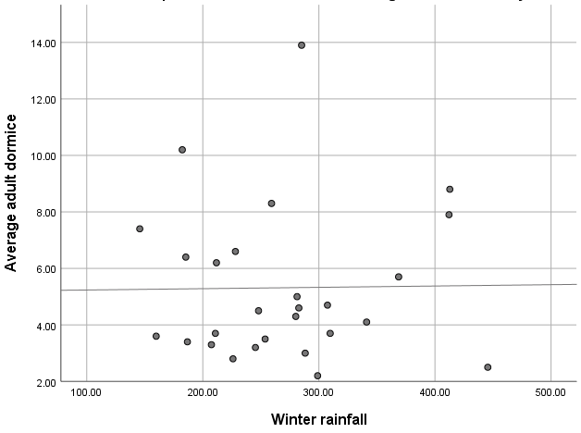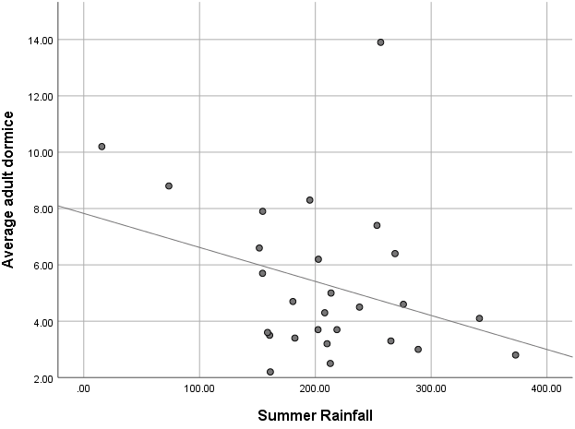
c) d)
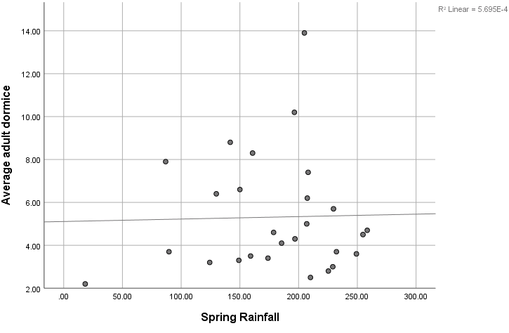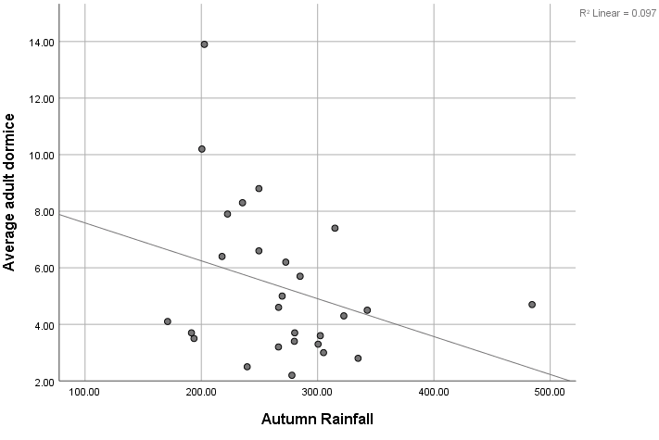
Figure 4.11 Trends in annual adult dormice counts across England and Wales monitored sites 1988 – 2014
(Goodwin et al., 2017), compared to a) average winter rainfall, b) average summer rainfall, c) average spring rainfall and d) average autumn rainfall (all rainfall data MET Office, 2019).

a) b)
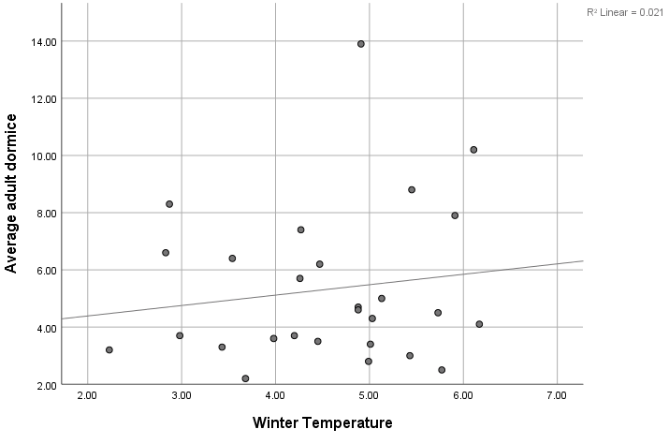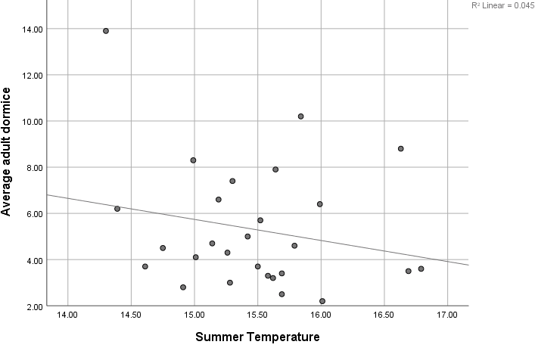
c) d)
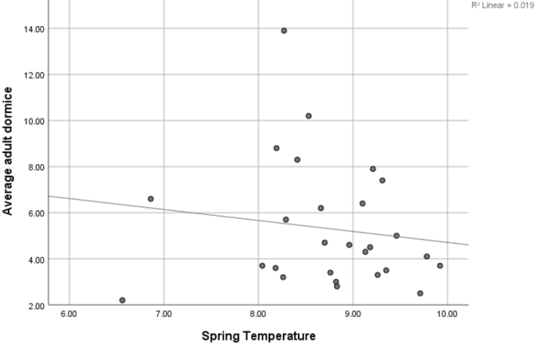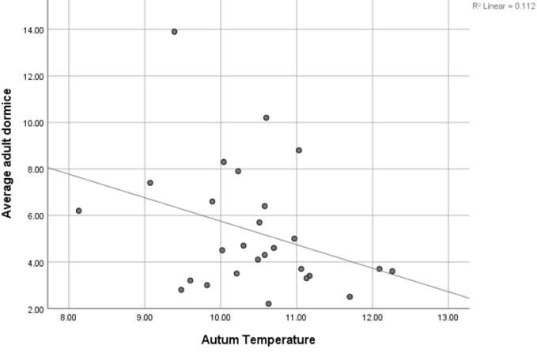
Figure 4.12 Trends in annual adult dormice counts across England and Wales monitored sites 1988 – 2014
(Goodwin et al., 2017), compared to a) average winter temperatures, b) average summer temperature, c) average spring temperature and d) average autumn temperature (all temperature data MET Office, 2019, in ⁰C).
The r² values of the regression line (or line of best fit) represents the strength of the relationship between the two variables (Tables 4.8 and 4.9), where +1 represents a good positive correlation, 0 represents no relationship and -1 represents a good negative correlation (Long, 2007). Where the r² value is above 1, this represents a lack of logical meaning which, again, may be due to the small sample size.
Table 4.11 r² value of regression line for seasonal rainfall compared to mean adult dormice.
 | Winter rainfall | Spring rainfall | Summer rainfall | Autumn rainfall
Average adult dormice (r²) | 1.818 | 5.695 | 0.108 | 0.097

Table 4.12 r² value of regression line for mean seasonal temperature compared to mean adult dormice.
 | Winter temperatures | Spring temperature | Summer temperature | Autumn temperature
Average adult dormice (r²) | 0.021 | 0.019 | 0.045 | 0.112

A Pearson’s correlation coefficient test was also undertaken in SPSS to check for statistical significance in the correlation between the seasonal temperature and rainfall, the 2-tailed significance values are showing in Tables 4.9 and 4.10.
Table 4.13 Pearson’s correlation coefficient 2-tailed significance value for seasonal rainfall compared to mean adult dormice.
 | Winter rainfall | Spring rainfall | Summer rainfall | Autumn rainfall
Average adult dormice | 0.947 | 0.906 | 0.906 | 0.114

Table 4.14 Pearson’s correlation coefficient 2-tailed significance value for mean seasonal temperatures compared to mean adult dormice.
 | Winter temperatures | Spring temperature | Summer temperature | Autumn temperature
Average adult dormice | 0.472 | 0.495 | 0.286 | 0.088

All sig. (2-Tailed) values of the Pearson’s correlation coefficient statistic tests are greater than .05 and it can therefore be concluded that there is no statistical significance.
The statistic that came closest to being statistically significant compared to the number of adult dormice is autumn temperature with a 2-tailed Pearson’s correlation coefficient of 0.088 and a r² value of 0.112, with the number of adult dormice appearing to go down as autumn temperatures increase.

Discussion
The results for both the interviews and the questionnaire data demonstrate the possibility of new methods for improving confidence in negative dormouse presence results on sites proposed for development. The need for further and continued post construction monitoring is also highlighted by the lack of data and knowledge available and lack of understanding of what works well. Furthermore, the results have highlighted a shared view from respondents that a landscape scale approach to dormouse conservation should be taken (Table 4.4 and Figure 4.10).
Although results for the climatic data was not significant (Tables 4.11 – 4.14), the need to consider climate change impacts on dormice is worth considering, particularly where a landscape-scale approach is considered.
This section will discuss the results of the study in order to achieve the research aim:
To create a management framework for the conservation of dormice in light of the recent legislative changes to the planning system.

Demographic of responses
Fewer responses were received from ecologists based in Wales (Appendix 4); this is to be expected as the total area of land in Wales where dormice are present is considerably smaller than that of England (Wembridge, Al-Fulaij and Langton, 2016).

Objectives One and Two
Identify any current gaps in planning/mitigation process for dormice protection
Establish consensus and whether survey improvements are needed when establishing dormouse presence and how best to mitigate the effects of development where presence is confirmed.

Results demonstrated that post-construction monitoring is being undertaken, however, only just under half (48.6%) of respondents claimed to have done so.
Just over a third of total responses to the question relating to the effectiveness of mitigation techniques, were ‘don’t know’ and many of these came from respondents that had used the mitigation technique in question (Table 4.9). This is likely due to a lack of monitoring and potentially a lack of knowledge and information-sharing amongst ecologists. As monitoring is often a condition of any consent put in place by the licensing authority, a lack of monitoring suggests a lack of enforcement.
There were no reports of bridges being used by dormice post-construction, although this could be due to a lack of monitoring. However, information regarding where dormice were not reported as present post-construction was not gathered. The findings of this survey are consistent with the lack of evidence of bridge use discussed in The Dormouse Conservation Handbook (Bright et al., 2006). Having said this, opinions were expressed within the questionnaire on more than one occasion that dormouse bridges, when designed and installed correctly, can future-proof an area and work well in maintaining connectivity. With the new dormouse bridge design described by White and Hughes (2019) having been studied and deemed a success, more developments may opt for this bridge design in the future. This design ensures arboreal connectivity to vegetation on either side of the road compared to previous rope type bridges that require access at ground level. The need for monitoring of such structures is supported by both the lack of evidence gathered in the literature review and the lack of information gathered as part of this research.
The results of this study are consistent with recommendations made within The Dormouse Conservation Handbook (2006) to prioritise maintaining and enhancing existing habitat where possible. A methodology for translocating hedgerows is made in The Dormouse Conservation Handbook (2006). The discrepancies between the use of hedgerow translocations in England and Wales (Table 4.8) could be a result of differing climatic conditions. Western UK regions received considerably more rainfall that those in the East (Met Office., 2020), therefore, apart from Cornwall and Devon, most other UK counties where dormice are known to be present receive much less rain. The need for constant moisture for translocation to be successful makes it unsuitable in the summer months and may reduce success in drier English counties in the winter months. Having said this, where hedgerow translocations were used, the survey results suggested that it is successful in replicating the habitat in-situ much quicker than planting new habitat. Replacement habitat, or newly planted habitat, is likely to result in a loss of biodiversity due to the time lag between planting and maturity. It is therefore important for ecologists to work with developers to promote the use of habitat translocations where appropriate and work together to ensure the risk of failure is minimised through correct methodology and timing of works (Box, 2013).
Less information was gathered on the use of underpasses (Table 4.9); with a very mixed response from the questionnaire data and little further information gathered from the free text responses and interviews. There were no incidences of dormice being found to be present or using underpasses from respondents of this study, however, it is not clear if this is through lack of dormouse presence or lack of monitoring. There is also not currently any mechanism for quantifying how many underpasses have been constructed for the purpose of maintaining connectivity for dormice. A 2015 study by Ward, Dendy and Cowan commented on limited information regarding the success of road crossing structures for dormice and advocated for continued monitoring of, and sharing of data on, these structures.
The length of time sites have been monitored for varied in the questionnaire and interview responses (Figure 4.7), however, it is not clear if this is due to the condition of the license or that the full monitoring period agreed has not yet been undertaken. However, the results demonstrate that, where dormice are found to be present post-construction, this is most often within the first year and most likely to be in retained and enhanced habitats (Figure 4.8 and 4.9). This suggests that dormice do not tend to move away from an area due to disturbance and, provided the habitat remains the same, or enhanced, then they will continue to exist in the area. Studies have, however, also suggested that specific human disturbance to habitat in the immediate area during the breeding season can cause litter abandonment by females (Juskaitis., 2008), which suggests that a buffer would reduce impacts upon breeding dormice during construction.
It is not clear how dormice are using mitigation put in place as a result of development as the questionnaire did not gather information on: 1) how many sites the respondents monitored post-construction; 2) of the sites that were monitored, on how many of these was presence established post-construction; and 3) on how many of these monitored sites has post-construction presence not been established and is monitoring still on-going? To really understand success rates of mitigation these questions would need to be explored.
Furthermore, longer-term monitoring is required to measure success where new planting of habitat and hedgerows has been used, as there will be a lag between construction and vegetation growth allowing the area to provide adequate cover for dormice.
What is encouraging is that on many sites where existing habitat has been managed or translocated, dormice continue to persist post-development and are regularly recorded within the first year post-construction.
The results of the study and the literature review also appear to suggest that the larger, more expensive mitigation measures such as bridges can be successful, despite a lack of a significant amount of literature on this strategy. Their success seems largely due to how they are constructed and the connecting habitats surrounding the structure (Georgii et al., 2011). It could be that a combination of the two (bridge design and adjacent habitat) would allow for more resilient, future-proof connectivity, reducing the barrier effect of linear developments such as roads.
The results also suggested that problems with payment for post-construction monitoring occurred more frequently where payment was agreed after planning consent was granted. With 75% of those having agreed payment after consent was granted reporting problems receiving payment, where only 25% of those agreeing prior to planning consent had a problem with payment for post-construction monitoring. The Dormouse Conservation Handbook (2006) does not appear to have any specific guidance on when and how to monitor post-construction, there is, therefore, no guidance on best practice for securing monitoring with developers.

Objective Three
Establish whether post-construction monitoring is being undertaken as required and, if so, how dormice are benefitting from the mitigation methods used.

Where to look
Typical dormouse habitat preference has long been described as broadleaved woodland of varying age structure, with particular requirements for hazel, honeysuckle and bramble (Bright and Morris, 1990). However, dormouse presence in woodland edge, scrub habitats and even mixed woodland and coniferous plantations has been observed (Trout et al, 2018 and Goodwin et al., 2018).
The results of this study have shown dormice to be present in habitats not recorded as part of the literature review, with confirmed presence in saltmarsh, gorse, heathland, bracken, gardens, Japanese knotweed Reynoutria japonica, reed beds and rhododendron sp. (Figure 4.4). Interestingly, there were also several reports, all in Wales, of dormice in Molinia grassland. This reporting could be due to the much higher distribution of this habitat type in Wales, particularly Western and Central Wales. The only area in England where dormouse presence coincides with Molinia grassland is Southwest England (JNCC, n.d.).
A study on hazel dormice in Lithuania concurs with these findings, having identified dormice in many habitats not described in the earlier studies. While they do not appear to have suffered a decline, they are living in low population densities, and are distributed throughout the country, despite an almost complete absence of the ‘typical’ habitat requirements (Juskaitis, 2007).
The results of this research, along with other research that has identified the presence of dormice in what would typically be regarded as unsuitable habitats (Juskaitis, 2007 and Goodwin, et al., 2018), suggests that dormice are much more adaptable than previously thought. It may also be the case that dormice have not been recorded often in certain habitats, because they have not been surveyed in these locations. However, to achieve higher population densities, the mixed woodland understorey habitat described by Bright and Morris (1990) may be preferable.
Only a small number of respondents thought updating the current Dormouse Conservation Handbook guidelines would assist them in improving how dormice are dealt with in the planning system. However, a large proportion of respondents, representing 34.1% of responses to that question, said guidelines for new techniques such as footprint tunnels and thermal imaging would help with establishing presence (Figure 4.3).
Although a full review of the handbook may not necessarily be required, updates to the guidance may be practical as and when new techniques become tested and gain in popularity (such as footprint tunnels). This would allow for quicker acceptance by licensing authorities and allow for keeping pace with any legislative changes.

Presence/absence surveying methods
It has been known for a long time that where an abundance of hazel is present, nut searches can accurately identify the presence of dormice on a site (Bright, Mitchel and Morris, 1994). This is mirrored in the results of this survey, with nut searches proving to be a popular means for detecting dormouse presence (Figure 4.2). That said, this was always in combination with another method such as tubes, boxes or footprint tunnels. This proves that nut searching continues to be a viable method for detection, however, as discussed, dormice may not always be present in habitats where hazel occurs, therefore reliance on this method alone should not be encouraged.
Although 20.5% of respondents believed dormouse surveying could be improved through the use of thermal imaging (if guidance is provided), there is very little literature to support the use of this method, which is likely explains its lack of acceptance by licensing authorities. One study on the use of handheld thermal imaging cameras to detect dormice in nest boxes did return positive results. However, this was simply used as a ‘warning’ to volunteers that dormice are likely present in the box and care should be taken to ensure the box is secure before being removed from the tree. It is not clear if this study has been peer reviewed (Worrall, Hughes and Trout, 2017).
There has been success in using thermal imagery for ecological surveying of bats and guidance is now available for practitioners to download and is accepted by the Bat Conservation Trust (BCT) (Fawcett Williams, 2019). With the backing of the BCT, licensing authorities have also been quicker to accept this method for confirming presence or absence of bats in structures.
Some studies have had success with standard camera traps for hazel dormice and Japanese dormice, both baited and un-baited (Mills, Godley and Hodgson, 2016 and Suzuki and Ando 2019). Both of these studies concluded that further refinement of the technique is still required in order to increase detection rates. This could be done through using different types of camera traps, baiting and seasonality (Suzuki and Ando, 2019). This is likely to also be the case for thermal imaging, with further refinement of research techniques required before guidance can be published and accepted.
Nest searching was the only method that received a high number of ‘not good’ responses (31.4%) (Table 4.7). This reflects the advice given by Bright et al., (2006) that nest searching is time-consuming and cannot give confidence of absence due to dormice regularly nesting in existing structures, such as tree holes, to avoid constructing their own.
Overall, boxes were preferred to tubes for finding dormice and boxes were also popular for enhancing habitat through providing more nesting opportunities (Table 4.7). However, when considering dormice in the planning system, and the requirement to establish their presence, tubes were considered to be more practical by many questionnaire and interview respondents. This conclusion is supported by Chanin and Gubert (2011), in a study comparing tubes and boxes, which concluded, although dormice were seen to nest in boxes more frequently (for longer periods and for breeding) than tubes, tubes nevertheless are valuable and useful in the short term where simply presence or likely absence is required. One respondent also suggested including a few boxes in short-term surveys along with the usual tubes may reduce time taken to find dormice on site or increase chances of doing so. Again, this coincides with results of the questionnaire, in which several respondents (20%) suggested that a mixed methodological approach would be useful in improving how dormice are surveyed for presence or absence (Figure 4.3).
Considering the conclusions of the literature review and results of the questionnaire, several recommendations for further study and updates to guidance can be made.

Objective Four
Use the results and interpretation of the research to generate a list of recommendations.

Landscape scale connectivity
Isolation and fragmentation of woodlands is thought to have been a driving factor in the extinction of the dormouse from certain areas in Britain (Bright, Mitchell and Morris, 1994).
Several respondents raised the adoption of a more landscape-scale approach when dealing with dormice in the planning system. The interviews in particular shared the opinion that it would be of benefit to identify large landscape areas or zones where dormice are likely to be present or where maintaining and creating connectivity is important to ensure the retention of large, resilient populations (Table 4.4). Limited landscape connectivity reduces the rate of evolutionary adaptation as genetics are not shared between populations. This leaves species vulnerable to changes in habitat and climate and reduces population resilience (Razgour et al., 2017).
In order to inform planning applications and appropriate mitigation, ideally thorough surveys on a landscape scale would be undertaken to accurately identify where populations are present. Although such large-scale surveys are not realistic due to lack of funding, predicting the presence of species within a large area is important to informing their conservation (Greaves, Sanderson and Rushton, 2006). In some circumstances this may also assist in informing planning application mitigation and enhancement opportunities.
Information-theoretic approaches can be used to predict the probability of dormice in an area, with increased wood size, temperature, soil drainage and soil nutrients playing a key role in the computer modelling selection of sites for likely dormouse presence (Greaves, Sanderson and Rushton, 2006). This, combined with local knowledge, could assist in creating zones within which dormouse are likely to be present but are currently unconnected and could help to guide decision making.
This makes a clear link with the Environment (Wales) Act’s duty to maintain, enhance and promote resilience and the Environment Bill for England to achieve a minimum of 10% net gain in biodiversity. Taking a landscape or zoned approach could allow planning applications within these zones to strongly consider dormouse habitat when proposing enhancement opportunities for the site, whether dormouse presence on site has been established or not. It would also provide local planning authorities with further justification for insisting on specific enhancement measures, such as buffers, habitat management or creation of certain habitat types. The need for enhancement of habitats is further emphasised in a study by Georgii et al. (2011) which observes wildlife use of road crossing structures in Germany. One of the concluding recommendations of this study proposes that enhancement of existing surrounding habitats will increase population sizes and increase the likelihood that road crossing structures will be used. Therefore, taking a landscape-scale enhancement approach will also increase the effectiveness of mitigation measures put in place to reduce the barrier effect of fragmenting structures such as roads.
A framework could be used by ecologists and local planning authorities that incorporates the requirement for biodiversity enhancements in planning applications. Further, the multi-species benefits of dormouse habitats would assist in improving landscape connectivity, increasing the resilience of currently isolated populations.

Climate change
Although the results of the analysis undertaken as part of this research did not show statistical significance (Tables 4.11 – 4.14), this is likely due to the small data set for dormouse population trends. A 27-year study is long-term in terms of dormouse studies, and even this is likely not enough time to show changing climatic trends.
In Central England, the 21st Century has so far been warmer than any of the three previous centuries and, since 1990, the UK has experienced its top 10 warmest years on record. Substantial and widespread snow has been rare for several decades, with just a few exceptional years and the UK’s average annual rainfall has been increasing over the past few decades (Kendon et al., 2017). These shifting trends in the UK climate are likely to impact biodiversity.
Landscape connectivity and building resilience is likely to play a key role in allowing populations to respond to climate change, through allowing a species range to adapt where habitat suitability might change and through the sharing of adaptive genes between populations (Razgour et al., 2017). This approach, supported by legislation, policies, compliance and enforcement, will also benefit a broad range of species, leading to a more resilient ecosystem overall (Mawdsley, O’Malley and Ojima, 2009).
Increased winter temperatures may result in the depletion of fat reserves as dormice are woken more frequently by mild weather. However, the seasonal synchronisation of food plants may result in more food availability in autumn, allowing dormice to increase their fat reserves prior to hibernation. Although not significant, Figure 4.12 indicates a reduction in dormice numbers as the autumn temperatures increases. The impacts on dormice of increased temperatures is likely to be a result of the time of year and the level of changes in temperature occur (Pretzlaff and Dausmann, 2012).
It is likely that dormice will continue to be impacted by unseasonable weather extremes such as increased temperatures, increased rainfall and increased extreme weather events, which impact on hibernation and affect when food sources such as insects, flowers and fruits are available (PTES, 2020). The current climate change and dormouse population trends (Goodwin et al., 2017) further justify the need for a landscape-scale approach to dormouse conservation. This can be assisted through the planning system; through the use of a framework and cross county approaches, ensuring dormice and their habitats are considered and, where applicable, connected.
Access to suitable habitats, along with appropriate management, may assist with overcoming the impacts of climate change. Larger woodlands and sites with more woodland and other suitable habitats within the surrounding area are associated with higher dormouse abundance and breeding (Goodwin et al, 2018). This evidences the need for a landscape-scale approach to dormouse conservation in terms of connectivity and climate change resilience.
The State of Britain’s Dormice 2016 Report (Wembridge, Al-Fulaij and Langton, 2016) describes how dormice behave differently depending on the habitat, with those residing in oak-dominated woodlands benefitting from warm, dry summers, whereas, for those in hazel woodlands, there is more food later in the year and they benefit from a cool, dry autumn. This suggests that ensuring oak is available in dormouse habitat will ensure resilience by providing a valuable food source for dormice as weather patterns change. Emphasising the need for local knowledge and a framework that can be adapted to suit habitats, weather patterns and dormouse population densities of the area.

Conclusion and Recommendations
Following the literature review, the results of this study and the discussion in relation to the results, several recommendations for further study and consideration can be made.

Summary Overview
Legislation discussed in the literature review has led to ecological enhancement becoming an essential part of the planning process in recent times (Environment (Wales) Act 2016, Environment Bill for England and PPW 10). Ensuring appropriate, practical and useful enhancement measures are provided is essential to ensuring ecological resilience in light of climate change and increased development pressures. Dormice can act as indicators of species diversity within a habitat (Bright and Morris, 1996) and dormouse habitat can provide multi-species benefits. To assist with both dormouse conservation and biodiversity as a whole, landscape-scale connectivity of suitable habitats should be encouraged (Razgour et al., 2017).
Where possible, dormice and their habitats should be considered within planning applications, even where suitable habitat does not currently exist or where the site is several miles away from any known records confirming presence in the area. The result of this study has enabled the development of a framework for ecologists and local authorities to use (Figure 6.1) and therefore achieving the research aim. Compliance will ensure appropriate steps are taken to embed dormouse-appropriate biodiversity enhancements and dormouse consideration into the planning system, ensuring development results in an overall net gain for biodiversity and continues to improve landscape connectivity. Improvements in landscape connectivity will also increase dormouse resilience in light of climate change, when habitat use is likely to change depending on seasonal and annual fluctuations in local climatic conditions. Ensuring populations have the ability to move within a landscape allows them to seek out the most appropriate food and shelter sources depending on weather changes.
New advances in technology can provide useful tools in ecological surveying, provided there is testing and guidance published to ensure that licensing authorities are assured that these methods can provide confidence in proving presence/absence of species. The Bat Conservation Trust, for example, has released guidance on the use of thermal imaging for bat surveys, in order to give stakeholders a better understanding of how the method can be applied to produce meaningful survey data (Fawcett-Williams, 2019). A similar document for dormice could prove to be a useful tool where dormice may not necessarily be using the tubes or boxes usually relied upon. Where thermal imaging appears to be lacking in data, footprint tunnels have been tested vigorously, particularly in England. Seventeen percent of respondents showed a desire to use footprint tunnels more regularly; however, a lack of clear guidance and acceptance from licensing authorities is resulting in a slow uptake of the use of footprint tunnels. Published and accepted guidance by expert organisations such as The Peoples Trust for Endangered Species would assist with acceptance.
The findings of this study also highlighted the many habitat types where dormice have been found. A full review of literature and data from local records centres, NE, NRW and local knowledge may shed light on where dormice have been found, suggest possible reasons for this and provide justification for searching for dormice in atypical habitats. This could be particularly useful on development sites where areas of existing habitats may not be typical of dormice, but dormouse presence has been recorded close by.
Figure 6.1 Framework for considering dormouse habitat landscape scale connectivity as enhancement for planning applications
ESTABLISH
Habitats and species on site
CONNECT
Look for opportunities to connect habitats and species on a landscape scale
PROPOSE
Recommend enhancement opportunities that provide connectivity
MANAGE
Management plans for recommendations must be included

AGREE
Establish how enhancements will be delivered and managed and who will be paying for the post-construction monitoring.

DELIVER
Begin establishment of enhancements as early as possible

MONITOR
Where required

ENFORCE
Ensure delivery and management of agreed enhancements and monitoring
FEEDBACK
Share data and observations (this could be on habitat management successes as well as records)
INFORM
LPA keeps records of feedback and where connectivity and enhancements have been proposed and delivered to inform future schemes
Finally, the results of this study, in combination with a lack of evidence, strongly suggests that post-construction monitoring is essential to ensuring appropriate steps are taken to ensure continued dormouse presence and the post-construction monitoring should therefore be enforced. The need for this was also highlighted in the literature review, with Rytwinski et al. (2015) indicating the lack of evidence demonstrating the effectiveness of mitigation structures post-construction and figure4.10 demonstrating that some practitioners recognise there is a lack of enforcement. The duties under the Environment Act (Wales) 2016 is particularly strong in its clear requirement to maintain and enhance biodiversity as are the requirements under the Environment Bill for England to ensure biodiversity net gain by October 2021. In Wales, in particular, this should provide a strong justification for ensuring monitoring and enforcement are being undertaken where necessary. The results of this study also suggest that an important factor in ensuring post-construction monitoring is undertaken, is the agreement of who, when and how those conducting the monitoring will be paid prior to the granting of planning consent.
The framework has been created to overcome problems and incorporate recurring suggestions gathered from the questionnaires and interviews. The simple framework for including dormouse-appropriate enhancement measures into development schemes includes the need for early consideration for dormice, even in areas where they are not currently known to be present and improving connectivity through management, monitoring, enforcing and informing other interested parties e.g. NRW, NE, LPAs and ecologists. The results of the study also highlighted the need to ensure that an agreement for management and monitoring is made prior to the granting of planning consent and this is addressed within the framework.
Adoption of the framework by ecologists (both consultant and LPA) will ensure that every opportunity to include dormouse habitat within enhancement schemes is taken where appropriate and the appropriate steps are taken to ensure this will be delivered and continue to offer long-term biodiversity opportunities, gradually improving landscape connectivity and improving resilience to climate change.

Recommendations
In summary, this study has led to in the following list of recommendations:
- LPAs and ecologists should follow the framework (Figure 6.1) to ensure dormouse habitat enhancement opportunities are considered in all planning applications, even where there are no records of dormouse presence within close proximity, taking into account landscape connectivity and population resilience;
- New methodologies for establishing dormouse presence such as foot print tunnels and thermal imagery should be tested and guidance published to allow licensing authorities to accept of them as viable methodologies;
- A full review of literature and existing data should be undertaken to gain a comprehensive understanding of the habitats dormice are likely to be present in across the UK;
- The Dormouse Conservation Handbook should be updated to include new survey methodologies and evidence of mitigation use;
- Enhancement of road side habitats to increase likelihood of use crossing structure use;
- Post-construction monitoring should be enforced; and
- The delivery and payment of post-construction monitoring should be agreed prior to the granting of planning permission.

Conclusion
As dormouse populations appear to be declining, and wildlife legislation continues to gain traction and enforceability, the planning system can play an important role in assisting landscape-scale connectivity through appropriate survey, mitigation and enhancement strategies. This ties in with the UK Governments focus to achieve a net gain in biodiversity from all planning developments. The monitoring of habitats and structures post-construction is vital to ensuring knowledge and understanding of this enigmatic species continues to grow and appropriate measures for ensuring their continued presence are put in place. The above recommendations will assist in providing opportunities to ensure there is no loss of habitat and connectivity for dormice as a result of development and assist in informing decision-making regarding the most appropriate approach.

References
Balčiauskienė, L. and Balčiauskas, L. (2008) Common Dormouse as a Prey Item of Breeding Tawny Owls in Five Districts of Lithuania. Acta Zoologica Lituanica, 18(1), pp.61-65.
Baxter, L., Hughes C., and Tight, M., 2010. How to Research. Edition 4. Open University Press. Maidenhead.
Bieber, C., Juškaitis, R., Turbill, C. and Ruf, T. (2011) High survival during hibernation affects onset and timing of reproduction. Oecologia, 169(1), pp.155-166.
Box, J. (2013) Habitat translocation, rebuilding biodiversity and no net loss of biodiversity. Water and Environment Journal, 28(4), pp.540-546.
Bright, P. and Morris, P. (1990) Habitat requirements of dormice Muscardinus avellanarius in relation to woodland management in Southwest England. Biological Conservation, 54(4), pp.307-326.
Bright, P. and Morris, P. (1991) Ranging and nesting behaviour of the dormouse, Muscardinus avellanarius, in diverse low-growing woodland. Journal of Zoology, 224(2), pp.177-190.
Bright, P. and Morris, P. (1993) Foraging behaviour of dormice Muscardinus avellanarius in two contrasting habitats. Journal of Zoology, 230(1), pp.69-85.
Bright, P. and Morris, P., 1996. Why are Dormice rare? A case study in conservation biology. Mammal Review, 26(4), pp.157-187.
Bright, P., Mitchell, P. and Morris, P. (1994) Dormouse Distribution: Survey Techniques, Insular Ecology and Selection of Sites for Conservation. The Journal of Applied Ecology, 31(2), p.329.
Bright, P., Morris, P. and Mitchel-Jones, T. (2006) The Dormouse Conservation Handbook. [online] Ptes.org. Available at: https://ptes.org/wp-content/uploads/2014/06/Dormouse-Conservation-Handbook.pdf (Accessed 21 October 2019)
Bright, P., Morris, P., and Wiles, N. (1994) Effects of weather and season on the summer activity of dormice Muscardinus avellanarius. Journal of Zoology. 238, pp. 521-530
Carol, S., 2014. The Dormouse Monitor. Winter 2014 Edition. [online]The Peoples Trust for Endangered Species Available at: https://ptes.org/wp-content/uploads/2015/01/DM-2014-For-web. (Accessed 21 October 2019)
Chanin, P., and Gubert, L. (2011) Surveying hazel dormice (Muscardinus avellanarius) with tubes and boxes: a comparison [online]. The Mammal Society. Mammal Notes. http://www.mammal.org.uk/sites/default/files/Note%204%20%20dormice%20Chanin%20Gubert.pdf (Accessed 5 November 2019)
Chanin, P., and Gubert, L. (2012) Common dormouse (Muscardinus avellanarius) movements in a landscape fragmented by road. Lutra, 55(1), pp. 3-15.
Chanin, p., and Woods, M, J. (2003) Surveying dormice using nest tubes: results and experience from the South West Dormouse Project. Research report No 524. English Nature, Peterborough.
Encarnação, J. and Becker, N. (2015) Stealthy at the roadside: Connecting role of roadside hedges and copse for silvicolous, small mammal populations. Journal for Nature Conservation, 27, pp.37-43.
Epstein, Y., López-Bao, J. and Chapron, G. (2015) A Legal-Ecological Understanding of Favourable Conservation Status for Species in Europe. Conservation Letters, 9(2), pp.81-88.
Fawcett Williams, K. (2019) Thermal Imaging: Bat Survey Guidelines [online] Available at: https://cdn.bats.org.uk/pdf/Thermal-Imaging-Bat-SurveyGuidelines_KFW_BCT_2019.pdf?mtime=20190919170616 (Accessed 28 March 2020)
Fink, A., (2017) How to Conduct Surveys. A step by step guide. Edition 6. Sage Publications. London.
Forman, R. and Alexander, L. (1998) Roads and their major ecological effects. Annual Review of Ecology and Systematics, 29(1), pp.207-231.
Georgii, B., Keller, V., Pfister, H, P., Reck, H., Peters-Ostenberg, E., Henneberg, M., Herrmann, M., Mueller-Stiess, H., and Bach, L. (2011) Use of wildlife passages by invertebrate and vertebrate species. [online] Available at: http://www.forumochranyprirody.cz/sites/default/files/zahranicni-inspirace/gruenbruecke11.pdf (Accessed on 17 March 2019)
Glue, D. (1974) Food of the Barn Owl in Britain and Ireland. Bird Study, 21(3), pp.200-210.
Goodwin, C., Hodgson, D., Al-Fulaij, N., Bailey, S., Langton, S. and McDonald, R. (2017) Voluntary recording scheme reveals ongoing decline in the United Kingdom hazel dormouse Muscardinus avellanarius population. Mammal Review, 47(3), pp.183-197.
Goodwin, C., Suggitt, A., Bennie, J., Silk, M., Duffy, J., Al-Fulaij, N., Bailey, S., Hodgson, D. and McDonald, R. (2018) Climate, landscape, habitat, and woodland management associations with hazel dormouse Muscardinus avellanarius population status. Mammal Review, 48(3), pp.209-223.
Goodwin, C., Hodgson, D., Bailey, S., Bennie, J. and McDonald, R. (2018) Habitat preferences of hazel dormice Muscardinus avellanarius and the effects of tree-felling on their movement. Forest Ecology and Management, 427, pp.190-199.
Greaves, R, K., Sanderson, R, A and Rushton, S, P. (2006) Predicting species occurrence using information-theoretic approaches and significance testing: An example of dormouse distribution in Cumbria, UK. Biological Conservation. 130, p. 239–250.
Hull, R., Robertson, D., Buhyoff, G., Seekamp, E. and Buhyoff, G. (2002) Assumptions about Ecological Scale and Nature Knowing Best Hiding in Environmental Decisions. Conservation Ecology, 6(2).
JNCC. (n.d.) Molinia meadows on calcareous, peaty and clayey-silt-laden soils (Molinion caeruleae) [online] Available at: https://sac.jncc.gov.uk/habitat/H6410/ (Accessed 17 March 2019)
Juškaitis, R. (2007) Peculiarities of habitats of the common dormouse, Muscardinus avellanarius, within its distributional range in Lithuania: a review. Folia Zoologica. 56 (4), p. 337-348.
Juškaitis, R. (2008) Long-term common dormouse monitoring: effects of forest management on abundance. Biodiversity Conservation. 17, pp. 3559–3565
Juškaitis, R. (2013) Summer mortality in the hazel dormouse (Muscardinus avellanarius) and its effect on population dynamics. Acta Theriologica, 59(2), pp.311-316.
Juškaitis, R. (2014). The common dormouse Muscardinus avellanarius: ecology, population structure and dynamics, 2nd edition. Nature Research Centre, Vilnius.
Juskaitis R., Baltrunaite, L., and Kitryte, N. (2016) Feeding in an unpredictable environment: yearly variations in the diet of the hazel dormouse Muscardinus avellanarius. Mammal Research. 61: 367-372.
Kayam, O. (2012). Using Social Media Networks to Conduct Questionnaire Based Research in Social Studies Case Study: Family Language Policy. Journal of Sociological Research. Vol 3 (2).
Kelly, K., Clark, B., Brown, V., and Sitza, J. (2003) Good practice in the conduct and reporting of survey research. International journal for Quality in Health Care. Vol 15 (3), pp. 261-266
Kendon, M., McCarthy, M., Jevrejeva, S., Mathews, A., and Legg, T. (2017). The state of the UK climate 2017. Internal Journal of Climatology. 2018;38 (Suppl. 2) p. 1-35.
Long, J. (2007) Researching Leisure, Sport and Tourism. The Essential Guide. Sage Publications. London.
Mathews F, Kubasiewicz LM, Gurnell J, Harrower CA, McDonald RA, Shore RF. (2018) A Review of the Population and Conservation Status of British Mammals. A report by the Mammal Society under contract to Natural England, Natural Resources Wales and Scottish Natural Heritage. Natural England, Peterborough. ISBN 978-1-78354-469-1. Natural England Access to Evidence Catalogue code JP025
Mawdsley, J., O’Malley, R. And Ojima, D. (2009) A Review of Climate-Change Adaptation Strategies for Wildlife Management and Biodiversity Conservation. Conservation Biology, 23(5), pp.1080-1089.
Met Office (2020) How Much Does it Rain in the UK? [online] Available at: https://www.metoffice.gov.uk/weather/learn-about/weather/types-of-weather/rain/how-much-does-it-rain-in-the-uk (Accessed 16 March 2020)
MET Office (2020a) Monthly, seasonal an annual total precipitation amount for England and Wales [online]. Available at: https://www.metoffice.gov.uk/pub/data/weather/uk/climate/datasets/Rainfall/date/England_and_Wales.txt (accessed on 5th April 2020)
MET Office (2020b) Monthly, seasonal and annual mean air temperature for England and Wales [online] Available at: https://www.metoffice.gov.uk/pub/data/weather/uk/climate/datasets/Tmean/date/England_and_Wales.txt (accessed on 5th April 2020)
Mills, C., Godley, B. and Hodgson, D. (2016) Take Only Photographs, Leave Only Footprints: Novel Applications of Non-Invasive Survey Methods for Rapid Detection of Small, Arboreal Animals. PLOS ONE, 11(1), p.e0146142.
Minato, S., Ohtake, K., and Morris, P. (2012) Cited by White and Hughes (2019). Helping (Japanese) dormice to cross the road. Oryx. 46, pp. 153-157.
Morris, P, A. (2003) A Review of Research of British Dormice (Gliridae) and the Effect of Increasing Public and Scientific Awareness of these Animals. Acta Zoologica Academiae Scientiarum Hungaricae. 49: pp. 123-130.
Natural England. (2009) Green Infrastructure Guidance [online] Available at: file:///C:/Users/Becky/Downloads/NE176[1]%20(1).pdf (Accessed 10 March 2020)
Naim, D., Telfer, S., Tatman, S., Bird, S., Kemp, S., Hughes, R. and Watts, P. (2011) Patterns of genetic divergence among populations of the common dormouse, Muscardinus avellanarius in the UK. Molecular Biology Reports, 39(2), pp.1205-1215.
NRW. (2019) Natural Resources Wales / Dormouse. [online] Available at: https://naturalresources.wales/guidance-and-advice/environmental-topics/wildlife-and-biodiversity/european-protected-species/dormouse/?lang=en (Accessed 12 January 2020)
NRW. (2019b) Natural Resources Wales / Information on European Protected Species Licensing. [online] Available at: <https://naturalresources.wales/guidance-and-advice/environmental-topics/wildlife-and-biodiversity/european-protected-species/information-on-european-protected-species-licensing/?lang=en> [Accessed 11 February 2020].
NRW. (2020) Natural Resources Wales/ Information to be provided in a European Protected Species license application. [online] Download. Available at: https://naturalresources.wales/permits-and-permissions/species-licensing/european-protected-species-licensing/dormouse-licensing/?lang=en (Accessed 12 January 2020)
Oppenheim, A, N. (1966) Questionnaire Design and Attitude Measurement. Heinmann Educational Books Ltd. London.
PTES, People's Trust for Endangered Species (2020) Hazel Dormice Mitigation License - People's Trust for Endangered Species. [online] Available at: https://ptes.org/campaigns/dormice/protection-for-hazel-dormice/hazel-dormice-mitigation-license/ (Accessed 11 January 2020)
PTES. (2020) Peoples Trust for Endangered Species. The State of Britain’s Dormice 2019 [online] Available at: https://ptes.org/wp-content/uploads/2019/11/SoBD-2019.pdf (Accessed 17 March 2020)
PTES, People Trust for Endangered Species. (n.d.) Hazel dormouse ecology. [online] Available at: <https://ptes.org/campaigns/dormice/about-hazel-dormice/hazel-dormouse-ecology/> (Accessed 15 March 2020)
Planning Policy Wales, Edition 10, December 2018. Welsh Government. Available at: https://gov.wales/sites/default/files/publications/2018-12/planning-policy-wales-edition-10.pdf (Accessed 23 November 2019)
Pretzlaff, I., and Dausmann, K, H. (2012) Impacts of climatic Variation on the hibernation physiology of Muscardinus avellanarius in: Ruf T, Bieber, C., Arnold, W., and Millesi, E (eds) Living in a seasonal word: thermoregulatory and metabolic adaptations. Springer, Berlin, pp. 85-97.
Quinnem C, P., Shore, R, F., and Trout, R, C. (2004) Managing Woodlands and their mammals. Forestry Commission. Edinburgh. P. 1–106. [online] Available at: https://www.forestresearch.gov.uk/research/managing-woodlands-and-their-mammals/ (Accessed 23rd November 2019)
Razgour, O., Taggart, J., Manel, S., Juste, J., Ibáñez, C., Rebelo, H., Alberdi, A., Jones, G. and Park, K. (2017) An integrated framework to identify wildlife populations under threat from climate change. Molecular Ecology Resources, 18(1), pp.18-31.
RTPI, 2019. Royal Town Planning Institute [online]. Biodiversity in the planning system. Available at: https://www.biodiversityinplanning.org/wp-content/uploads/2020/03/biodiversityinplanningpracticeadvice2019-15.11.19.pdf (accessed on: 20th February 2020)
Rytwinski, T., van der Ree, R., Cunnington, G., Fahrig, L., Findlay, C., Houlahan, J., Jaeger, J., Soanes, K. and van der Grift, E. (2015). Experimental study designs to improve the evaluation of road mitigation measures for wildlife. Journal of Environmental Management, 154, pp.48-64.
Sozio, G., Iannarilli, F., Melcore, I., Boschetti, M., Fipaldini, D., Luciani, M., Roviani, D., Schiavano, A. and Mortelliti, A. (2016 Forest management affects individual and population parameters of the hazel dormouse Muscardinus avellanarius. Mammalian Biology, 81(1), pp.96-103.
Suzuki, K, K., and Ando, M. (2019) Tree trunk camera trapping for small dormouse. Mammal Research. 64, pp. 479–484
Trout, R., Brooks, S., Rudlin, P. and Neil, J. (2012) The effects of restoring a conifer Plantation on an Ancient Woodland Site (PAWS) in the UK on the habitat and local population of the Hazel Dormouse (Muscardinus avellanarius). European Journal of Wildlife Research, 58(4), pp.635-643.
Trout, R., Brooks, S., Combe, F. and Rudlin, P. (2018) The different effects of periodic experimental tree removal patterns on the population demography of the hazel dormice (Muscardinus avellanarius) in a conifer plantation. Folia Zoologica, 67(2), pp.110-119.
Turbill, C., Bieber, C. and Ruf, T. (2011) Hibernation is associated with increased survival and the evolution of slow life histories among mammals. Proceedings of the Royal Society B: Biological Sciences, 278(1723), pp.3355-3363.
UK Government. (2014) Dormice licences [online]. Available at: https://www.gov.uk/government/collections/dormice-licences (Accessed on 14th April 2020)
UK Government. (2019) References and experienced needed to support your protected species application or registration [online]. Available at: https://www.gov.uk/government/publications/reference-to-support-a-protected-species-licence/protected-species-licences-guidance-on-getting-references-to-support-applications (Accessed 4th April 2020)
Verbeylen, G. (2012) Monitoring and a population study of the common dormouse (Muscardinus avellanarius) in Flanders (Belgium). Peckiana. 9: pp.95-102.
Ward, A., Dendy, J. and Cowan, D. (2015) Mitigating impacts of roads on wildlife: an agenda for the conservation of priority European protected species in Great Britain. European Journal of Wildlife Research, 61(2), pp.199-211.
Welsh Government. (2016) Environment (Wales) Act 2016 Factsheet. [online] Available at: https://gov.wales/sites/default/files/publications/2019-05/environment-wales-act-2016-overview.pdf (Accessed 17 February 2020)
Wembridge, D., White, I., Al-Fulaij, N., Marnham, E and Langton. (2019) The State of Britain’s Dormice 2019 [online]. The peoples trust for endangered species. Available at: https://ptes.org/wp-content/uploads/2019/11/SoBD-2019.pdf (Accessed 12 January 2019)
White, I, C., and Hughes, S, A. (2019). Trial of a bridge for reconnecting fragmented arboreal habitat for hazel dormice Muscardinus avellanarius at Briddleford Nature Reserve, Isle of Wight, UK. Conservation Evidence. 16, pp. 6-11.
Williams, L, L. (2014) The Dormouse Monitor. Winter 2014 edition. [online] The peoples trust for endangered species. Available at: https://ptes.org/wp-content/uploads/2015/01/DM-2014-For-web.pdf (Accessed 21October 2019)
Williams, R., Goodenough, A., Hart, A. and Stafford, R. (2013) Using Long-Term Volunteer Records to Examine Dormouse (Muscardinus avellanarius) Nestbox Selection. PLoS ONE, 8(6), p.e67986.
Woods, M., McDonald, R. and Harris, S. (2003) Predation of wildlife by domestic cats Felis catus in Great Britain. Mammal Review, 33(2), pp.174-188.
Worrall, P, A., Hughes, W, P., and Trout, R, C. (2017) An evaluation of handheld thermal imaging cameras as novel tools for detecting nest box occupancy of hazel dormice Muscardinus avellanarius and edible dormice Glis glis. Hadlow Research [online] Available at: https://www.hadlow.ac.uk/docs/default-source/university-research/2017_-_research_booklet.pdf?sfvrsn=4dc3a901_4 (Accessed 17 March 2020)
Wright, K, B. (2006) Researching Internet-Based Populations: Advantages and Disadvantages of Online Survey Research, Online Questionnaire Authoring Software Packages, and Web Survey Services. Journal of Computer-Mediated Communication. 10 (3)
Yun, G. and Trumbo, C. (2006) Comparative Response to a Survey Executed by Post, E-mail, & Web Form. Journal of Computer-Mediated Communication, 6(1), pp.0-0.

Appendices

Appendix 1 – Letter requesting interviews
Hello,
I’m doing a much-needed dissertation looking dormouse survey and mitigation. You may have received an e-mail from me several months ago regarding this.
I’m now on to the next stage of my MSc research and looking to conduct over the phone interviews with ecologists. My MSc dissertation research topic is an investigation into how dormice are using mitigation/compensation measures put in place as a result of development, how dormice are surveyed and what measures/steps can be taken to improve our understanding of how dormice are using mitigation/compensation.
To achieve this, I am undertaking over the phone interviews, only 30 minutes long. The questions will cover preferred monitoring techniques, post construction monitoring and how the data is shared and what (in your opinion) works well in terms of mitigation/compensation.
All information will remain anonymous and names and personal details will not be shared. Site specific information will also not be required.
I am looking to speak to anyone working within ecology that have any sort of experience with dormice and planning applications.
Please let me know if you would be happy to have a chat with and forward this e-mail on to anybody who you think may be interested and willing. I have designed the interview to take no longer than 30 minutes over the phone.
If you would like more information please do get in touch, I am happy to speak informally over the phone prior to any agreement to part in the interviews.
Thank you
Becky Blackman

Appendix 2 – Message requesting participation of surveys
Hello,
I am currently undertaking an MSc dissertation research project investigating how dormice are surveyed; how/what mitigation/compensation measures are put in place as a result of development; and finally, what measures/steps can be improved to continue to provide appropriate mitigation and enhancement opportunities for dormice.
I am currently looking for anyone with any experience of dealing with dormice and planning to fill out a questionnaire. It should take less than 15 minutes and will remain totally anonymous. Site specific details are not required.
As this Facebook group is likely to engage with ecologists with dormouse experience, would it be possible for the link to be shared on the page? If not, do you know of anywhere I may be able to post the link? I have copied it in below. Any help would be hugely appreciated.
https://forms.office.com/Pages/ResponsePage.aspx?id=-REPTm4EBUWcuNshUjEeIe0skWdygidNkYiiTWNhOvJUNk05Rk5TSEJTRVQ1QU5aUTQxTk9GQ01OQi4u
If you would like more information please do get in touch.
Thank you
Becky Blackman

Appendix 3 - Questionnaire
Dormouse surveying and mitigation
This survey is part of an MSc dissertation investigating how dormice are monitored; how/what mitigation/compensation measures are instigated as a result of development; and finally what measures/steps can be improved to continue to provide appropriate mitigation and enhancement opportunities for dormice. All data collected will remain anonymous and is for educational purposes only. Site specific details are also not required. If you have any involvement with dormice and planning applications. your experiences and thoughts would be very useful. This research project is about looking at where and how there are opportunities to improve things for practitioners to help wildlife, therefore, if you would like to receive a summary of the findings, there is an opportunity at the end of the questionnaire to leave you're e-mail address.
1.Where do you undertake a majority of dormouse surveys and monitoring?
Wales
England
2.Which of the following best describes your role with dormouse surveying?
Ecologist
Volunteer
3.Do you hold an NRW or Natural England Dormouse license?
Yes
No
4.What methods do you use for establishing presence of dormice?
Boxes
Tubes
Footprint Tunnels
Thermal imaging
Nut search
Nest searches
5.How well do you feel the following survey techniques pick up dormice?
 | Reliable | Hit and Miss | Not good | Don't know
Boxes
Tubes
Footprint Tunnels
Thermal Imaging
Nut search
Nest searches
6.What is your preferred method and why?
7.How do you think establishing presence could be improved?
8.What habitat types have you found dormice in?
9.Which of the following forms of mitigation have you used?
Hedgerow translocation
Newly planted hedgerow
Bridges
Underpasses
Newly planted habitat
Management of existing habitat (habitat enhancement)
Buffers
Boxes
10.How well do you feel the following mitigation measures work?
 | Very well | OK | Not good | Don't know
Hedgerow translocation
Newly planted hedgerow
Bridges
Underpasses
Buffers
Newly planted habitat
Management of existing habitat
Boxes
11.Have you undertaken any post-construction monitoring? (if No continue to question 24)
Yes
No
12.What mitigation/compensation measure were used for the developments which were monitored post construction?
13.How long did you monitor for post construction?
14.Was dormouse presence established post construction in any of the cases? (If No go to question 17)
Yes
No
15.Where were they found?
16.How long was it before presence was established? (post construction)
17.Did you share the data/results anywhere?
Yes
No
18.If yes, on what platform? (e.g. local records centres)
19.What would make it easier for you to share your data on mitigation success stories?
20.What monitoring went into the license (how much monitoring was agreed or requested by NRW/NE, including number of visits per year etc.)?
21.Who was paying for the monitoring (e.g. developer)?
22.Was the source of payment agreed to prior to planning or after consent was granted?
Before planning consent
After planning consent
23.Have you ever had problems with payments for post-construction monitoring?
24.What do you think could be done to improve how dormice are dealt with in the planning system?
25.Any other comments
26.If you would be interested in receiving a summary of the research findings, please leave your e-mail address in the box below:
Submit

Appendix 4 – Frequency of Welsh and English responses.

Country
 |  | Frequency | Percent | Valid Percent | Cumulative Percent
 | England | 19 | 54.3 | 54.3 | 54.3
 | Wales | 16 | 45.7 | 45.7 | 100.0
 | Total | 35 | 100.0 | 100.0

