Student Name; Rex Amu
Student Id; 2028603
Module; BMSW4005

Personal Reflection My Career Development Planning.

Introduction
Professional Development Planning (PDP) is a process that helps us figure out what we want - our personal goals – and what we need to do to get there. Depending on what we put into it, the depth of that process and where it leads is up to each of us. Self-awareness If we start with a firm foundation, it will be simpler to create a vision for the future, establish objectives, stay motivated, and adjust to changing circumstances. That comes from gaining a deep understanding of ourselves – not just the surface, obvious things that come to mind, but the more profound insights that come from recurrent, structured self-reflection, self-questioning, broadening of experience, learning from new challenges, and being open to feedback. All of this contributes to increased self-awareness and self-confidence. When our objectives excite us, when they align with our ambitions, beliefs, and interests, and when we are being true to ourselves, it is simpler to achieve them. Personal accomplishments When we understand the various aspects that influence our own performance, we are better able to create the optimum circumstances for achieving our objectives in the most effective and stress-free manner possible, whether for school, job, or personal aspirations.
Vision.
Being a student, I make sacrifices to attend college or university, with the expectation of a brighter future consequently. Despite this, most students are unsure what to do when their degree is over. While this does not have to be a problem, it is beneficial to consider your goals in life so that you have a clearer sense of direction, can make more informed decisions, and are better positioned to take advantage of the correct chances when they happen. Base on my career my vision is to face a challenge to become top person in my career with the used of my skill and time management to expand my knowledge in my career. Sometime knowing yourself help to develop a better knowledge of your own role in the drama of your own life It is an opportunity to consider what has created you as a person, as well as how you respond to current events, the skills you have gained thus far, and how you may use it in new situations.
Reflection in my career.
All encounters in everyday life, at work, and in school may flow more smoothly because of these qualities, and everyone benefits from thoughtfulness, encouragement, and respect. These abilities allow us to create more productive, fun, and efficient settings, as well as better manage challenging circumstances, which is why so many individuals and companies regard them so highly. Being a graduate student help me a lot to gain more skill from people and make me to be effectively.

Objective.
- Obtaining professional qualifications or equivalents.
- Enhancing their career through promotion.
- Change of role or moving to a better job.
- Obtaining greater job satisfaction and expertise in current employment.
- Launching their first substantial job as a first career ladder
- Gaining more employment experience through internship or graduate scheme.

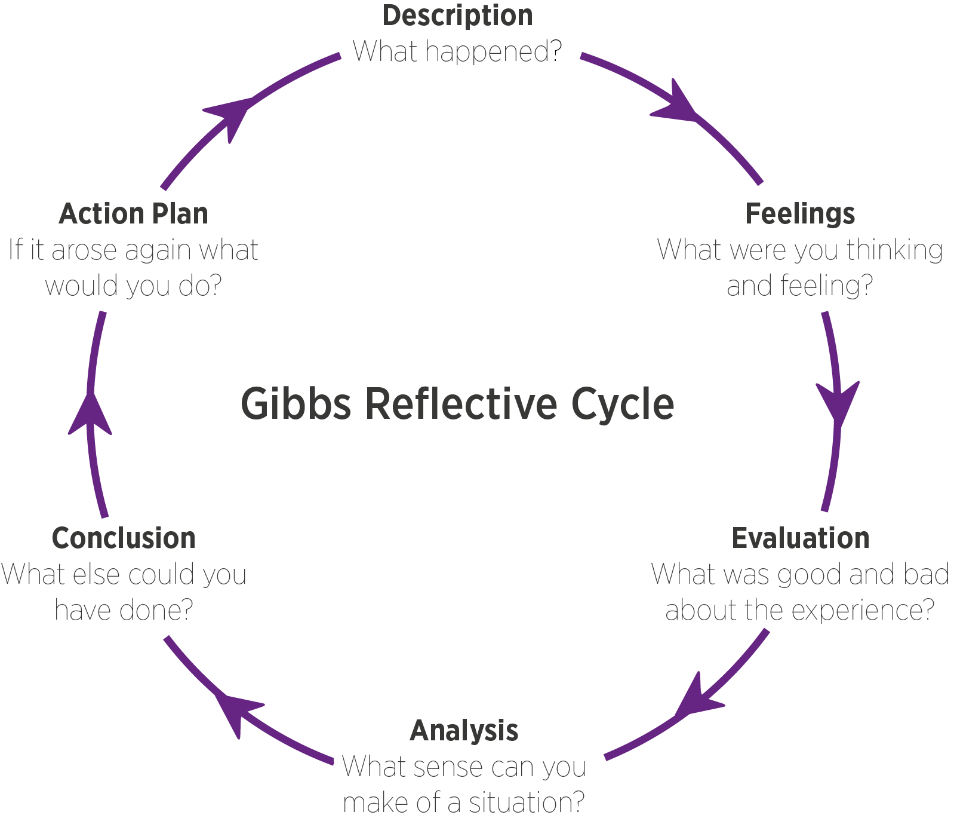 image source. https://www.leaplikeasalmon.com/wp-content/uploads/2018/02/gibbs.png
The above diagram Gibbs reflective circle help us to know who you are, and were you want to be in the next five year.
The Benefits
Reflection has a positive influence on professionalism, which is one of its advantages. We become more aware, in control, and able to understand our strengths and growth needs by reflecting on our practise. We can begin to progress from novice to expert status by reflecting. This act of questioning or self-questioning to reconstruct what happened – or design what could happen – is what allows a student to advance from novice to expert. It does, in fact, aid the expert's development and growth. It could also allow the expert to pass on their knowledge to other professionals by sharing their reflections. Meanwhile with the past situation and the present situation due the covid 19 pandemic with my professional career I have learn new skill from online with the communication skill, time management which reflect on my professional career from my weak to strength. The covid 19 was another way of your awareness and how to handle any situation and critical thinking of any situation a head. I will personally agree that during covid 19 I have gain more skills to my professional development planning with the user of new strategies and visual learning skill with the use of communicating with your lecture and other course mate.
It is critical to recognise that professionalism entails much more than 'what you do.' It is also about how you go about it and the ideals that accompany it. It is all about how you act, who you are, and how you view yourself. Our values, as well as what we feel is 'right,' 'just,' and 'fair,' impact our behaviours and attitudes. We can become so engrossed in our own perceptions of the world that we fail to notice some of the alternative 'possibilities.' Given our significant effect on young people's lives, it is critical to be mindful of how the values we convey, whether consciously or subconsciously, are appropriate. We might be able to gain a better understanding of them. We do not often recognise we share some of these beliefs until we have to pause and think about what we did/said, why we did/said it, and what impact it could have on people in our care. Being a university student is one of the biggest values I have added to my career from novice to expert .it help you to develop knowledge and skill for the next level of working effectively, and the chance of becoming a better job for the career and you also share your knowledge to other people by adding value to their daily activities both school and workplace. Professional development empowers us to make use of our ideal and what we are doing and were we want to be in your career.
You will have spent a major chunk of your life up to this point pursuing success through academic credentials and grades. Nobody will be able to take away this monumental success from you. The difficulty is competing for work with many people who will have performed similarly to you, better than you, or worse than you in terms of grades. Qualifications are required for job consideration, but they are only one of six elements that will lead to an interview and an appointment. The improper degree class, or even the wrong university, may exclude you from being considered for a restricted number of jobs. Even if you have a strong application, most companies will not consider you until you have a strong application. Sustained self-confidence is essential for determining the best job path and position for your future. It may also be the most difficult aspect of employability for many, especially in difficult employment markets. 'Whether you think you can or think you can't, you're correct,' Henry Ford is reported as saying. 'Vision without execution is merely delusion,' he is allegedly supposed to have declared. So, even if we have a clear notion of what we want to achieve with our lives, we must be persistent and believe in ourselves. Some employers want solid interpersonal skills, as simple as they may appear, in or der to interact successfully to other people and throughout the organisation. Jane Hadfield, Head of Learning & Development, North Bristol NHS Trust, emphasised the importance of values and personal qualities in the recruiting process, as well as academic and technical talents.

Conclusion.
I personally agree with use of Gibb tools professional development planning is form of brainstorming process gathering information about yourself strength and weakness and what you want to improve on your career and your readiness for employment, being a student is a step ahead for development career planning. Sometimes we ask ourselves why we are studying, but will should understand that knowledge is the key to success.
Personal action Plan
Meanwhile with Gibb reflective cycle knowing my strength and weakness. To achieve those goals professional development must be continuous and supported to have a better grade, what is required for success in professional development is clear and compelling vision of improvement needed, combine with the explicit ideas on the organizational characteristic and attributes necessary for success. With the believe will bring about positive change in employment performance.

Reference
Gustkey, T.R., 2000. Evaluating professional development. Corwin press.
Cottrell, S. (2021) Skills for success: personal development and employability. 4th edition. Red Globe Press, London:
Tarrant, P. (2017) Reflective practice and professional development. First edition. SAGE Publications, Thousand Oaks, CA
: Neugebauer, J. (2016) Employability: making the most of your career development. SAGE, London; Thousand Oaks; New Delhi; Singapore: London; Thousand Oaks; New Delhi; Singapore: London; Thousand Oaks; New Delhi; Singapore: London; Thousand Oaks; New Delhi; Singapore:

Recruitment and Selection
The role paly was a preparation of being a confident and more effectiveness for job interview.my role paly was all about me trying to sell my knowledge and experience for an employer. The job title was the role of a supervisor for engineer department for an employer. Introducing myself to employer and I appreciate for inviting and giving me the opportunity for attending this interview, some of the question was a bit challenges like why the organization should hire me as their staff, Base on my professional development and my experience from past workplace which it was helpful. Going through the job description [ personally believe I am the perfect candidate going through skill and qualification as supervisor gaining experience from past job which stand as a supporting skill and weapon for my supporting my role play, like my strength and my weakness which most of the employer will like to know ,telling them your positive side , from my strength side was I like working in team ,learning new skill, and sharing my ideals to my team. Communication skill and time management skill which play a vital role in any organization. With the benefit of my professional career which added value to my career by gaining the time management skill and communication skill and leadership skill. Leadership role has to do with how to manger people from different nation and showing your styling leader position and your value the team will be expecting from you being reliable and integrity. With the help of offering to support the team whenever I can. I consider myself to be a coach style team leader because I focus on identifying individual strength of each of the team member on my team. By implementing my strategies that will encourage teamwork by delegating tasks base on team members expertise .my technical background for this role along with motivational and time management skill to effectively lead my lead, the role play was like a foundation for my career base on the knowledge I have archive during the class and how to make perfect to become expertise for future, knowing your mistake, sometime we say practice make perfect. How to overcome question and giving the right answer at the right time. Many people become unsuccess on their interview due to some reason, no professional skill and no practise was conducted before the interview which may lead to no confident to descript, he/her personal career and skill. The main issue was to how to become a winner in your career with the use of your professional strategies and skill which stand as an advantage for the candidate. Why you choose the role and what change is going to bring to your career.
.

