Reflective Lean Manufacturing Project Report
Gareth Herbert (2011678)
ACMA5009
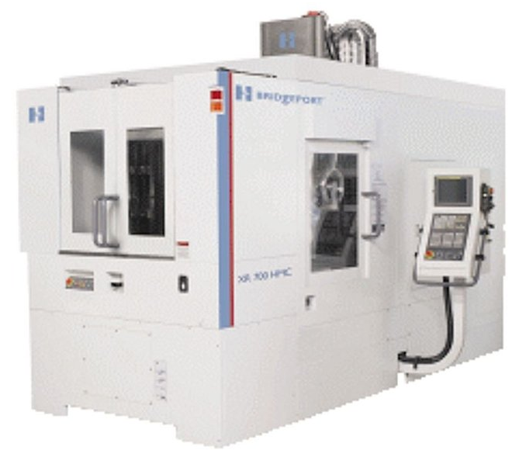

Abstract
This report shares my industry experience for an improvement project of the changeover process through a Single-Minute Exchange Die (SMED) method and other process improvement tools. This project was looking to improve efficiency on the changeover and set up activities for three CNC machines. 5 whys analysis and cause and effect techniques and the use of SMED were applied in this improvement project.

This report will look at a project from a reflective view point, looking at before and after states, the main aim of the project and what worked well and not so well. Cost and timing analysis will be covered and will show an improvement in setting times and manufacturing costs as well as utilising three new horizontal CNC machines. I will research lean manufacturing techniques within CNC machining and also show how I progressed this reflective project by the way of a Gantt chart (See Appendix 1).
I was involved in a project to implement lean manufacturing techniques and increase the utilisation of a group of horizontal CNC milling machines within the machine shop at Safran Seats GB. My job title at the time of being involved in this project was as a CNC setter/programmer so I felt I was in good position to help implement this project.

Contents
Front Cover Page 1
Abstract Page 2
Contents Page 3
List of figures Page 4
Introduction Page 5
Research Page 6 to Page 7
Methodology Page 8 to Page 19
Analysis Page 20 to Page 23
Conclusion Page 24
Recommendation for further study Page 25 to page 28
References Page 29 to page 30
Appendices Page 31 to page 32
List of Figures
FIG 1 Demand Schedule v Capacity chart
FIG 2 Fishbone Diagram
FIG 3 5 Whys
FIG 4 Vice base plate set up
FIG 5 Vice set up on base plate
FIG 6 Trial of loading vices onto machines
FIG 7 Solution for transfer of vices onto machines
FIG 8 Lifting equipment
FIG 9 Sling and eyelet set up
FIG 10 Vice set up with sling and eyelets
FIG 11 Time comparison chart
FIG 12 Ideas for new tombstone
FIG 13 Tombstone design
FIG 14 Vices on new tombstone layout
FIG 15 Nested component simulation
FIG 16 Time comparison chart
FIG 17 Analysis chart of breakdown in 2011
FIG 18 Machine downtime of machine 46 in 2011
FIG 19 Analysis chart of breakdown in 2013
FIG 20 Machine downtime of machine 46 in 2013
FIG 21 Total machine down time chart for machine 46 2011-2012
FIG 22 Vice storage area
FIG 23 Shelving unit design sketch
FIG 24 Shelving unit design in machine area sketch
FIG 25 CAD drawing of storage rack
FIG 26 CAD drawing of machine side cabinet
FIG 27 CAD of proposed area layout
Introduction
Safran Seats GB specializes in the design and manufacture of business and first class aircraft seats. For more than 80 years Safran Seats GB have been designing, manufacturing, certifying and assembling innovatory, customizable, high added value aircraft seats for passengers travelling in business and first class. Safran Seats GB has a major presence in the United Kingdom and employs more than 1600 at three main sites: Cwmbran - Head office, engineering, design office, test centre, production and assembly. Camberley – Manufacture (with specialization in composite materials) and after sales. Brackley – engineering design office and test centre [14].

A group of three identical Bridgeport XR700 HMC (horizontal CNC) machines were purchased in August 2008 to support high volume production of the Aura project mainframes. These machines are twin pallet tombstone machines. At the time the ‘Aura’ project was the main company focus as it was to be an offer able product to multiple customers. However due to a change in Safran Seats GB’s strategy in 2011 all high volume work had now been outsourced. As a result of this the machine shop within Safran seats GB were left with three high performance machines with only enough demand to keep one of them running to capacity. The challenge was to see whether this spare resource can be utilised with work from older, slower machines whilst maintaining the existing work holding methods that had been introduced and developed for lean manufacturing purposes to great effect over a period of a few years.
Everything was looked at to provide a slick operation, reduce production time and reduce scrap. Different set ups were looked at to run multiple parts on each machine, from double vice work to single vice work. The machines can hold up to 60 different tools within the carousel, this was also analysed to reduce the amount of tool changes per set up which would also help reduce set up times.
Improvements to the layout around the XR700 machines to aid the supply of material to the machines and to provide an effective day to day working area was also looked at. Time studies and comparisons were made to show before and after states and to gauge whether each stage of this project was a success or not.
This reflective report through showing the methods used within the project and research of other lean manufacturing techniques I will analyse what worked, what didn’t work and if I were to be involved with the project again what I would have done differently.

Research
The application of Lean methods, concepts and tools to the production and manufacture of products is referred to as Lean manufacturing. Many companies are implementing Lean manufacturing concepts to minimize waste, improve process, reduce costs, increase innovation, and shorten lead time to customers.
Motorola created the Six Sigma process improvement technique in 1987 in order to achieve “world-class” efficiency, quality, and complete customer satisfaction. Since then, at least 25% of Fortune 200 companies have adopted a Six Sigma program, including Motorola, General Electric, Ford, Boeing, Allied Signal, Toyota, Honeywell, Kodak, Raytheon, and Bank of America, to name a few. [1].

Though new approaches and innovations are constantly being developed in Lean Manufacturing, its origins can be traced back to groundbreaking work done at Toyota that resulted in what was called the “Toyota Production System” (TPS). During Japan's post-World War II reconstruction era, Toyota executives Taiichi Ohno and Eiji Toyoda designed the TPS. Because of Toyota's Japanese origins, several Japanese terms are used to define Lean Principles and Tools. Design out ‘Muri’ (overburden), Design out ‘Mura’ (inconsistency) and Eliminate ‘Muda’ (waste) [4].
There are a variety of Lean Manufacturing tools available:
5S: The 5S method focuses on managing the work environment to reduce waste. According to many sources, it is the most widely used Lean Methodology and a perfect way to get started on the Lean implementation [2].
Kaizen: Kaizen is the method of asking others to work together proactively to achieve Continuous Improvement. Over time, regular incremental improvements to processes will yield incredible results. Kaizen encourages a more inclusive approach to change, and it includes "Gemba," or the idea of leaving the office to go down to the shop floor and observe firsthand [2].
Value Stream Mapping: A Kaizen-related platform for identifying and analyzing waste. It was classified as "Material and Information Flow Mapping" at Toyota [2].
Standardized Work and Takt Time: Standardized Work is simply another term for recording and following Best Practices, which are subject to continuous improvement as new waste-reduction strategies are discovered. Takt Time refers to the process of timing production to meet the needs of customers [2].
Single Minute Exchange of Die: SMED is the ability to quickly set up a machine or line for a different task. It can be applied to any machine or line, not just Die-related operations. Some companies refer to the acronym "SMED" as "Setup Reduction." [2]. SMED is something that we focused on when implementing our lean manufacturing techniques to the three CNC machines to enable a quicker set up time and making the machines more efficient.
Poka-Yoke: Poka-Yoke stands for "Error Proofing". Poka-Yoke is preventative in nature, since it prevents errors from occurring in the first place rather than detecting and fixing them after the fact. Wherever feasible, we want to achieve the ideal of Zero Defects to minimize the waste associated with defects and errors [2].
Visual Factory: Improving knowledge sharing by making the state of manufacturing processes readily available and very transparent to all. [2]

Define, Measure, Analyse, Improve and Control: (DMAIC) Six Sigma implementation uses five step DMAIC (Define, Measure, Analyse, Improve and Control) methodology tool, which is similar to the Plan-Do-Check-Act problem-solving methodology tool. DMADV (Define, Measure, Analyse, Design and Verify) methodology tool is used in the development of new products [3].
SMED (Single Minute Exchange of Die) was a the main improvement tool that we focused on in the project, by reducing set up times enabled the machines to be more efficient and have less down time.
For the majority of the manufacturing shop floors and cnc workshops / machine shops, an effective and productive changeover process is critical and supports the production management process. It's also much more crucial if the market is extremely complex or the products are not mass produced. Safran Seats don’t produce thousands of the same parts. Assembling bespoke, first class and business class aircraft seating means that there are lots of different parts which means lots of different set ups and small batch sizes. Having the ability to reduce set up times, produce right first time parts and reduce production lead times help to achieve higher standards.

The reduction in batch size in a production system is the most important benefit of providing a short changeover period [11, 12]. What this in turn means is that SMED can continuously promote the ‘one-piece-flow’ principle, which is important for a high variety of parts demand for production and assembly lines.

Studies concerning the traditional SMED application are described in a variety of formats. According to research, case studies from the automotive industry favor the conventional SMED application. Deros et al. [5] described how the use of SMED technique helped to reduce the setup time on an assembly line manufacturing batteries for the automotive industry. Desai [6] researched how the SMED method was used to increase efficiency in the Indian automotive industry. Kumar and Abuthakeer [7] also reported that in the car industry, the SMED process was often used to reduce setup time.
Moreira and Pais [10] produced yet another case study from the manufacturing sector where the SMED technique was used to minimize setup time in a manufacturing company in Portugal. The performance of the SMED application has been documented by other types of industries. Sayem et al. [13] who reported that using SMED in the furniture industry is one of the best ways to increase efficiency by reducing changeover time.
Methodology
In this section I will show how the lean manufacturing methods were applied in the improvement project. The methodology steps discuss in this section applied two general process improvement approaches from Lean and Six Sigma. It is followed by applying various process improvement concepts and tools such as production “wastes,” value and non-value added, and SMED.

The three Bridgeport XR700 HMC (horizontal CNC) machines had been running fixture work only for the previous 3 years so due to a change within the company to outsource this type of work a big capacity gap was left on these relatively new machines. A challenge was put to the engineering team within the machine shop to come up with a way of utilising these three machines.
There were certain milestone gateways that had to be complete before we were able to move onto the next part of the project. A project milestone gateway objectives plan was developed to help us stay on track and meet project deadlines (See Appendix 2).
To define the problem, the first thing we looked at was demand schedule v capacity for the whole machine shop. This data came from our MRP (material requirement planning) software, it is able to look out as far as 6 months in advance to help plan raw materials and organise work to certain machines to deliver parts on time.
FIG 1

A list of parts was created and every component with over thirty hours of demand was highlighted. Three components with high demand hours were selected to be re-engineered and run on the machining trial with new vice set up.

Through the use of a fishbone diagram which is a cause and effect analysis, we were able to look more deeply into the cause and effect of what was preventing us utilising the machines and helped identify the problem root cause. Fishbone (Ishikawa) diagrams are a form of suggestive presentation that shows the relationships between an event (effect) and its many triggers. The diagrams' arrangement aids team members in thinking in a structured manner [8].
FIG 2
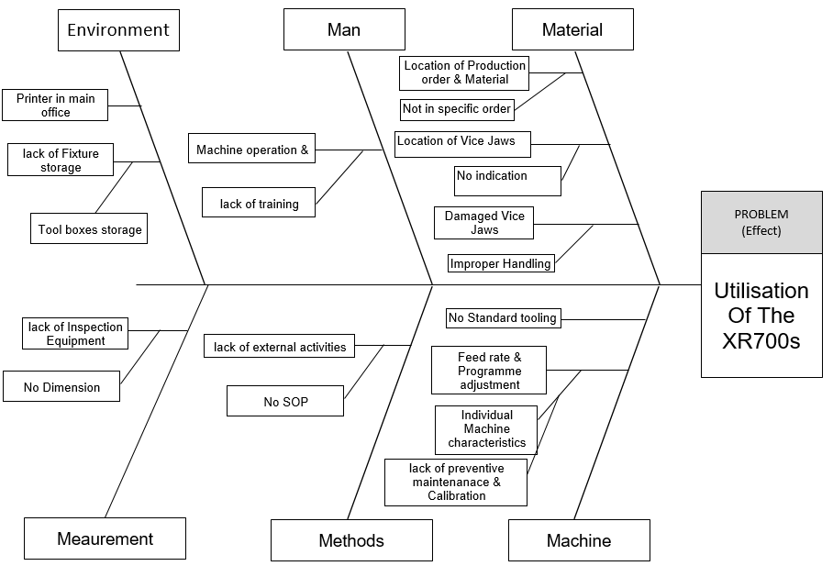

It was also identified through using ‘the 5 whys’ technique we were able to dial down our root cause analysis. The 5-Whys approach is one way of determining the root cause of a problem. Former Toyota Executive Vice President Taiichi Ohno implemented this methodology on the factory floor, urging his employees to "observe the manufacturing floor without preconceptions. Ask ‘why’ five times about every matter” [9]. It's possible to find the answer with less than five whys, and it might take one or two more, but asking the question five times is typically enough to get the right answer.
FIG 3
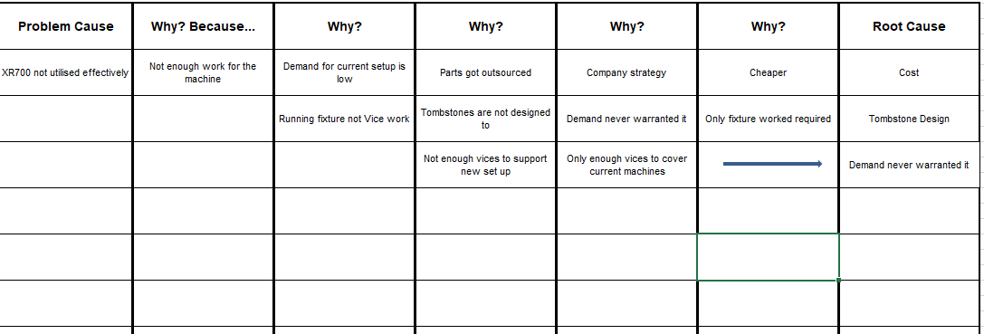

The tombstones had to be redesigned to be able to fit vices to them. We decided on one side to put one vice and on the other to trial a double vice set up which was planned to run multiple operation and multiple parts. A vice base plate was designed to fit to the tombstone via locating bushes, ensuring repeatability and reduce set up time which was keeping the ethos of lean manufacturing. The Vice Base Plate was designed to accept the current Kurt vices that we use, with two different Set up options. One vice (Set up J) and Two vices (Set up B)
FIG 4
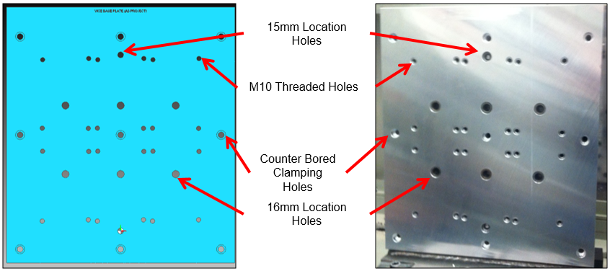
FIG 5
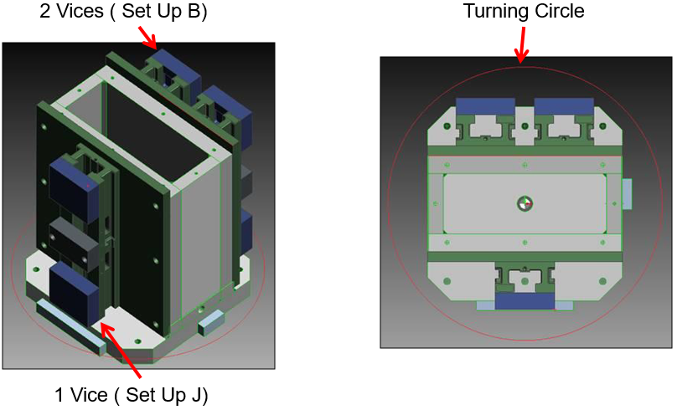

Health and safety was always at the forefront of our minds during each stage of the process. The most challenging part was the transfer of the baseplate and vices onto the tombstone in the machine. After assembly of Kurt vices to Base Plate, the Set Up was loaded to the electric truck ready to be mounted to the machine. The face of the machine cube needed to be stoned to ensure a flat mounting surface.

FIG 6
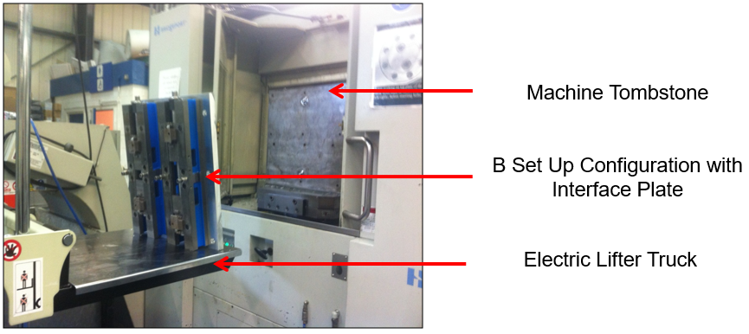
When attempting to transfer the new configuration to the machine by hand, it was discovered that due to the uneven resting points of the vices, the Set up could not be safely transfer onto the machine or align correctly.
FIG 7
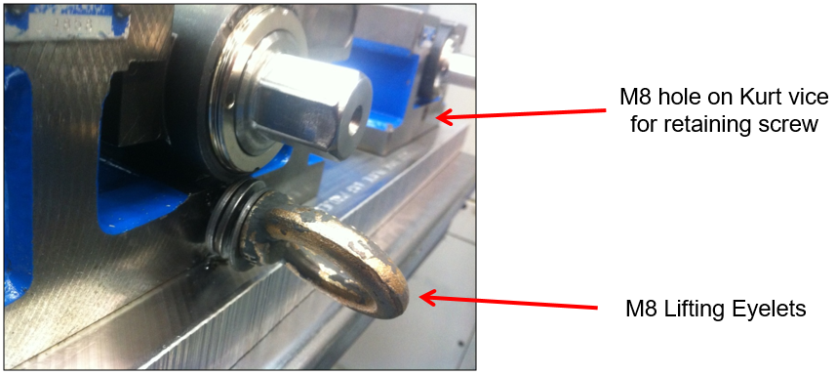

FIG 8
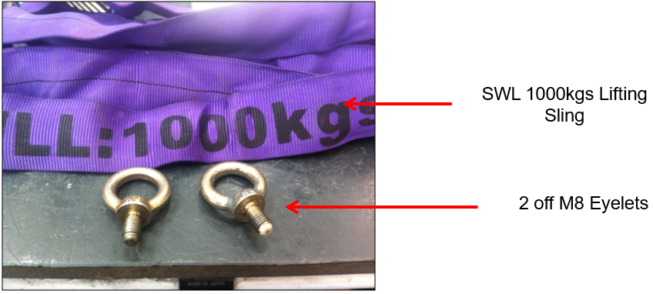

FIG 9
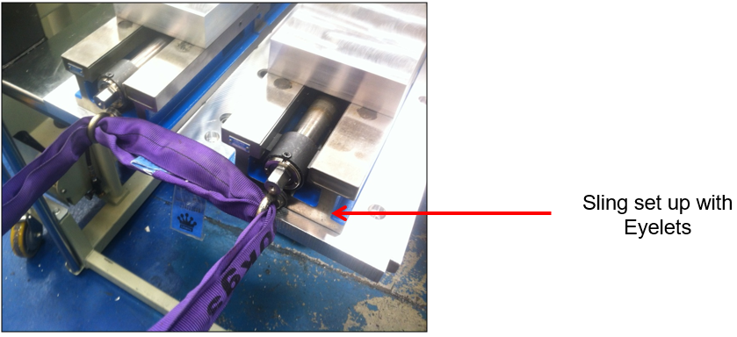

Due to having to change the way the vices and base plate were loaded onto the tombstone a forklift Truck was used, placing the slings over the forks to allow the Set up to be safely moved into position. The sling was then doubled up and looped through the eyelets. The base plate aligned easily with 15mm dowels and was secured using the 9 (off) x M12 Cap heads. The eyelets and Sling were removes and the retaining screws replaced.

FIG 10
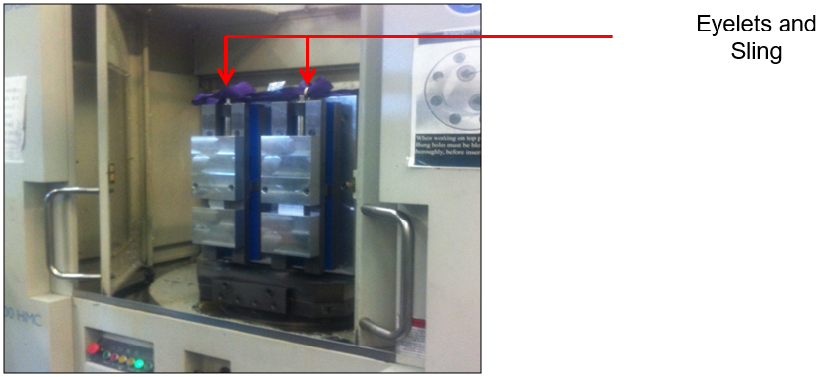

A list of work was created and every component with over thirty hours of demand was highlighted. Three components with high demand hours were selected to be re-engineered a run on the machining trial with new vice set up.
Safran seat GB use a production scheduling software called baan. This software controls data such as raw material stock, component stock, and can give production times and costs. With the improvement implemented it was time to trial the three identified parts. The machines can hold up to 60 different tools within the carousel, this was also analysed to reduce the amount of tool changes per set up which would also help reduce set up times. All the tooling was pre-set, and all the datum points came from one position giving each program or operation its own unique datum shift within the main program. By having pre-set tooling and a pre-set datum this cut down the setting time dramatically.
The three parts that were identified were run and a cycle time comparison was done to get an efficiency calculation: -
S31007-210-101
- Actual Machine Cycle Time = 16 minutes 58 seconds (2 off)
- Original Baan time = 20 minutes (1 off)
- Original time = 1200 seconds (1 off)
- New time = 1018 seconds (2 off)

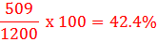

S31007-330-101
- Actual Machine Cycle Time = 25 minutes 56 seconds (2 off)
- Original Baan time = 25 minutes (1 off)
- Original time = 1500 seconds (1 off)
- New time = 1556 seconds (2 off)

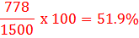

S34006-580-101
- Actual Machine Cycle Time = 11 minutes 31 seconds (10 off)
- Original Baan time = 20 minutes (5 off)
- Original time = 1200 seconds (5 off)
- New time = 691 seconds (10 off)

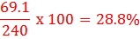

FIG 11

After running the trial using the Vice base plate with set up B configuration, we found that there was a decrease in cycle time with every component which was run. The Trial was a success with the components that were manufactured during the trial, but we would be limited with the variation of components we would be able to run on this tombstone and vice setup combination.
The next stage of the project was to look at changing the tombstone design to allow us to run a wide range of components on the XR700 HMC machines in single vice setups.
FIG 12
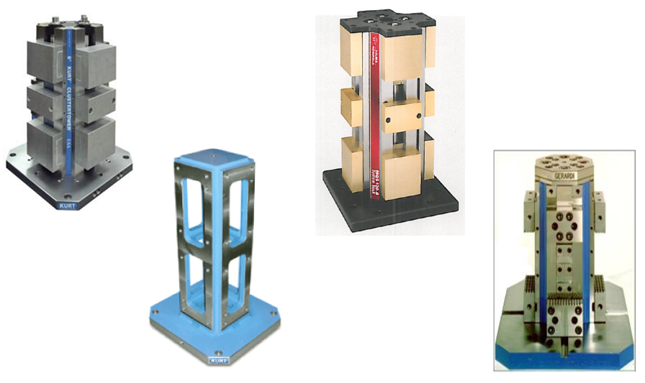
A tombstone was designed to accept x4 kurt vices (one on each face) which Safran seats GB currently use.

FIG 13
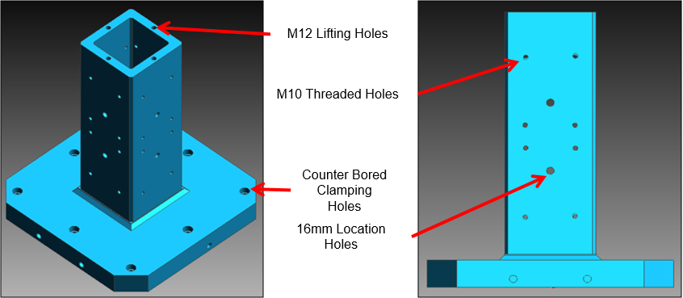

FIG 14
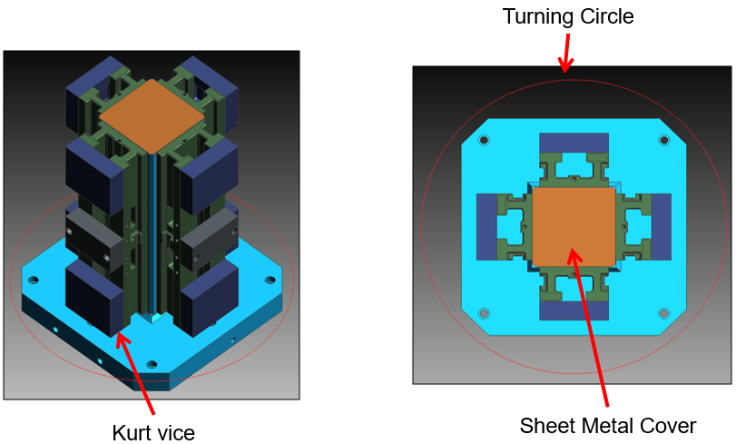

With a new tombstone design in place this meant a trial to run multiple parts and operations at the same time was ready to go. The same three identified components were trialled plus an additional component so that the tombstone was filled up.

FIG 15
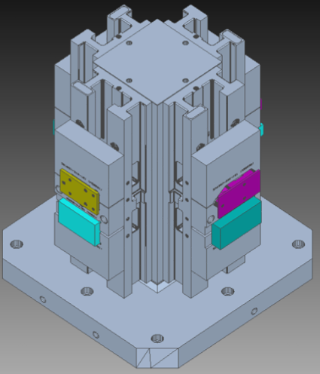
S31007-210-101 + S31007-330-101 + S34006-580-101 +F17134-153-101
- Actual Machine Cycle Time = 28 minutes
- Original Baan time = 79 minutes
- Original time = 4740 seconds
- New time = 1680 seconds
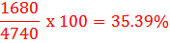

FIG 16

After running the trial using the Tombstone and vice configuration, we also found that there has decrease in cycle time with every component which was run. The Trial has successes with the components that were manufactured during the trial. We were happy with our finding during the trial and were happy now to run these components in production.
The next stage of development would have been to look at changing the area layout around the XR700's to aid the supply off material to the machines and provide an effective day to day layout. Also time studies will be implemented.

Analysis
FIG 17

FIG 18

FIG 19

FIG 20

The main aim of the project was to increase the utilisation of the three Bridgeport XR700 horizontal milling machines to their full capacity. There was an obvious improvement made in terms machine down time from 2011 where we started the project shown in FIG 17 and FIG 18, compared to 2013 where the project was fully implemented shown in FIG 19 and FIG 20.
Having no production orders meant that the machines were stood idle. As a result of this we had three high performance machines with only enough demand to keep one of them running to capacity. From the initial analysis it was clear there was potential to fill the machines with work so the challenge was to see whether this spare resource could have been utilised with work from older, slower machines and through the development of lean manufacturing techniques and Single Minute Exchange of Die (SMED) to improve cycle times and set up times.

FIG 21
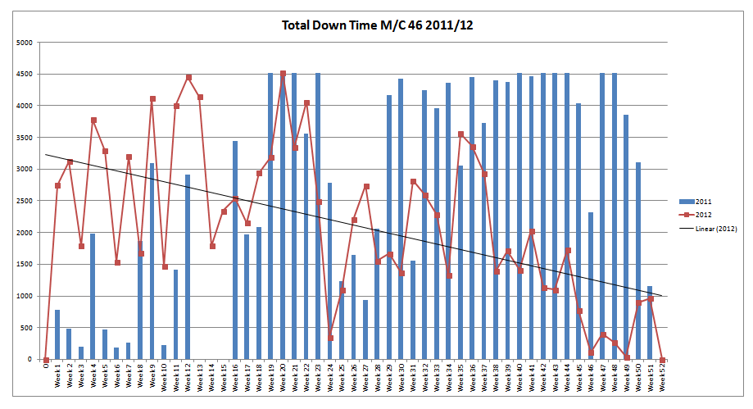
Time studies were taken and looking at the trend line in the graph (FIG 21) it is showing a gradual decrease in the time that the machine wasn’t being utilised which indicates that this project had made improvements.
After running a trial for four different part numbers using the Tombstone and vice configuration, we also found that there has decrease in cycle time with every component which was run (FIG 16). The Trial has successes with the components that were manufactured during the trial. We were happy with our finding during the initial trial and these changes were implemented to run components in production.
The results of the project show that there was a 40% reduction in cycle times through the reprogramming and tooling selections and a 75% reduction in set up times through the implementation of SMED processes. On top of these vast improvements to cycle times and set up times in week 27 of 2013 machine 46 showed a down time of just 20 hours shown in FIG 20, compared to a high of 4500 in 2011 shown in FIG 18. This clearly shows that the aim of the project to increase the utilisation of the three cnc milling machines to their full capacity was being met.
Health and safety was also a factor, due to the weight of the vices and tombstones for set ups and change overs, consideration of how to lift the heavy objects was trialled. This is maybe what didn’t work so well initially. When attempting to transfer the new configuration to the machine by hand, it was discovered that due to the uneven resting points of the vices, the Set up could not be safely transfer onto the machine or align correctly. It was decided that the only safe way to fit the Set Up to the XR700 HMC was to use a lifting Eyelet and Sling configuration rather than the electric truck. This method was adopted be used due to the weight of the setup and the need to position it correctly. A Forklift Truck was used, placing the slings over the forks to allow the Set up to be safely moved into position. The slings which had a lifting load of 1000kg were doubled up and looped through eyelets.

Conclusions
This reflective report showed how implementing lean manufacturing tools helped improve the day to day running and setting up of three cnc machines. To reduce the set up times for three horizontal cnc machines and to increase the utilisation of the Bridgeport XR700 horizontal milling machines to their full capacity. The following conclusions from this report are as follows.

- The aim of the project was achieved, the three cnc machines were utilized to their full capacity whilst reducing set up times and cycle times.
- The project implemented continuous improvement techniques such as 5 whys analysis, fishbone (cause and effect) analysis and the lean manufacturing tool SMED (Single Minute Exchange of Die) was introduced.
- From the continuous improvement tools used it assisted the improvement implementation team in identifying and prioritizing the best methods and solutions.
- According to current performance and time analysis, set up times have been reduced by 75%, and cycle times have reduced by 40%.
- Milestones and deadlines were set out from the beginning of the project and were consistently met throughout the project
- A big factor in the success of implementing this project was mixture of the right people on the team. From engineers and programmers to machine operators, everyone had an input and put forward ideas to help introduce the improvement activities.
- This project had given the blueprint for future continuous improvement projects involving cnc machines within the machine shop at Safran Seats GB.

One last point I would like to mention in final discussion point is related to the team structure and dynamics along with the management buy in to the project. I believe one of the main factors in the project's progress and success, in my opinion, is the collaboration of the project team members. With the ideas, knowledge, and experiences of these different members of the team it worked really well in first analysing the project then helping to implement it. Another big factor was the managers buy in of the project, the challenge was presented to the project team by the management team and supported fully throughout the process, all costs were questioned but were presented with data from trials to justify the cost versus reward.

Recommendations for Further Study
For long-term success with Lean manufacturing, the company needs to be dedicated to continuous improvement. Lean manufacturing is about improving goods and procedures while eliminating activities that are needless, excessive, or ineffective. Continuous improvement can be interpreted as a formal practice or as guidelines, but in order to make a real and enduring change, it must be well incorporated into the culture at Safran seats GB.

The next stage of development would have been to look at changing the area layout around the XR700's to aid the supply off material to the machines and provide an effective day to day layout. Unfortunately, this was not implemented so this is where I will discuss what I would have done differently.
After running a trial of the area layout in a production environment, I found that the layout was an issue when operating the machine and nesting the NC programs together. I would have looked at where the problems occurred and used creative ideas to get around them.
FIG 22
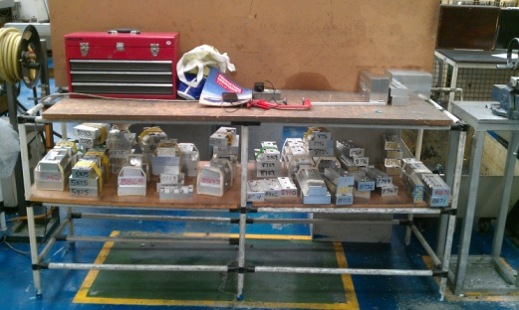

The storage of removable vice jaws which had been machined for particular part shapes have no dedicated area or system. To help improve this I would have planned this better by using a booking in and out type of system which would give the part number that the vice jaw was used for and a dedicated location. As more parts were being transferred onto the lean machine this would only get worse for the machine setter / operator in trying to locate the correct vice jaws.
The racks I would introduce would be labelled A, B, C, D and so on and each shelf given a number, from the work instructions that are given out with the production orders I would have the correct location for the vice jaw need to produce that particular part. This would eliminate wasted time looking for vice jaws and potentially time wasted to remake if the original vice jaw had been misplaced or lost.

FIG 23 FIG 24
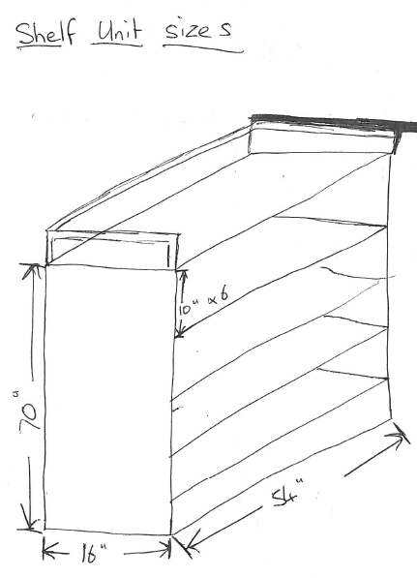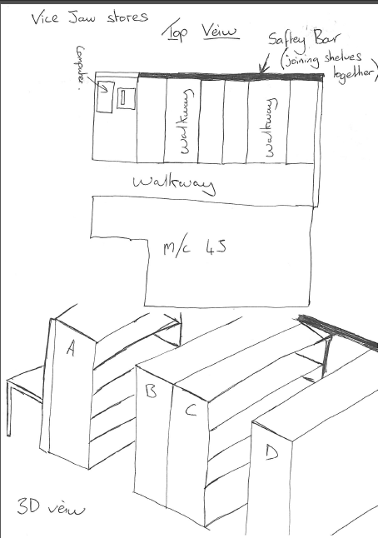

Another addition to the area that I would have implemented would have been the introduction of cabinets next to each machine. The purpose of these cabinets would have been to have priority shelves built in so that the raw material and production orders could have been loaded on to these cabinets in a priority order ensuring that production plans and schedules are kept on track by running the correct parts in the priority order.

As it stands raw material continues to be delivered to the machine but with no indication of the order of parts that need to be run in. This has a detrimental effect to the machine shops planning and scheduling. It is also not in the ethos of lean manufacturing.

I believe that the area would visually improve if a 5S activity was undertaken. 5S “A place for everything and everything in its place” is another lean manufacturing tool which guides companies to create and more importantly maintain clean, safe and organized work environments. For example, if the flooring was painted and outlined markings for swarf bins and storage racks were implemented, the area would look more professional and organised. This would in turn have a knock on effect and improved the flow of material in and components out of the area.
The implementation of a 5S activity around the three cnc machines would enhance or complement lean production methods already in place on a continuous basis. 5S is a system for reducing waste and increasing efficiency by keeping a clean and tidy workplace. 5S refers to five steps – Sort, Straighten, Sweep, standardize and sustain.
Sort - Identifying what is important and what is not, and getting rid of waste.
Straighten – Getting things in order so that the correct object can be picked up quickly (without wasting time) and easily by anyone. A place of everything, and everything is in its place.
Sweep - Create a safe work environment free of rubbish, dirt and dust so that issues can be detected more quickly (leaks, spills, damage).
Standardize - Creating guidelines for a tidy, safe workplace, for example shadow boards, visual control documents and 5S checklists.
Sustain - Implementing behaviors and habits that will enable the company to sustain the defined standards over time.
FIG 25
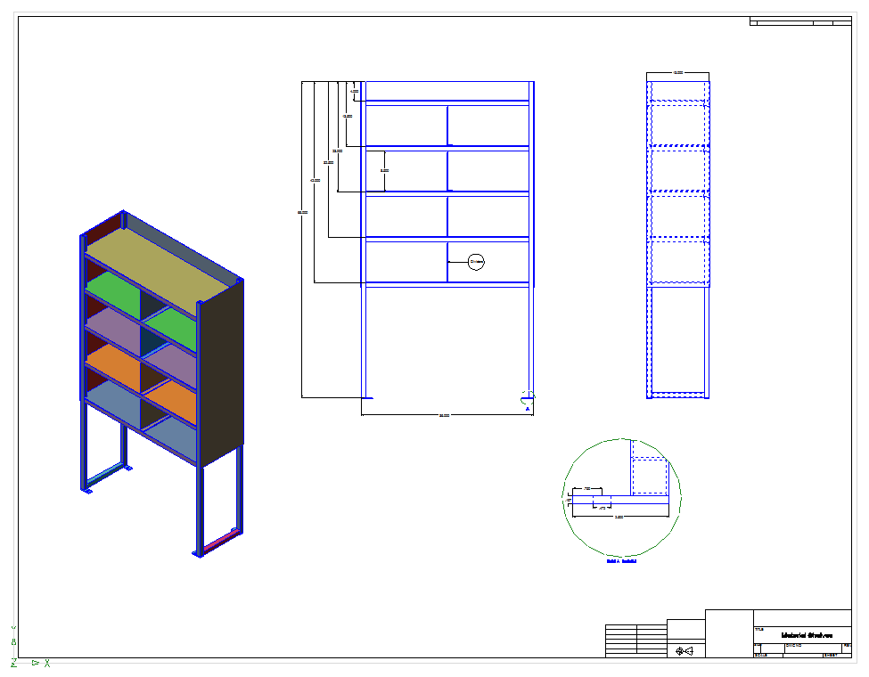

FIG 26
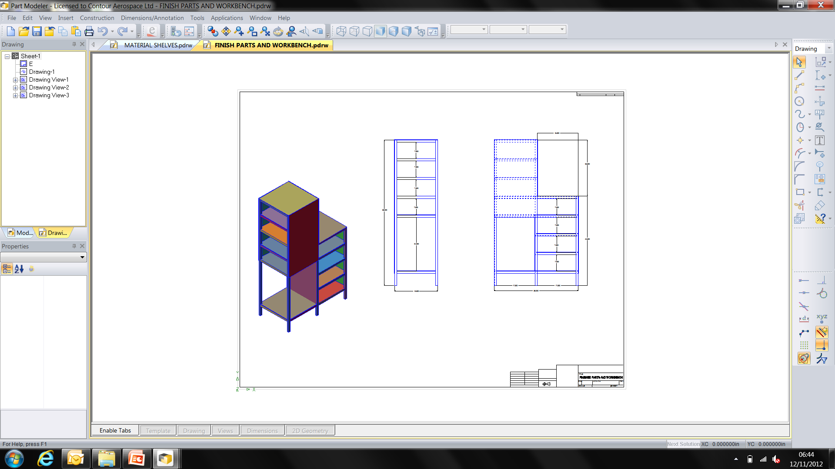

FIG 27
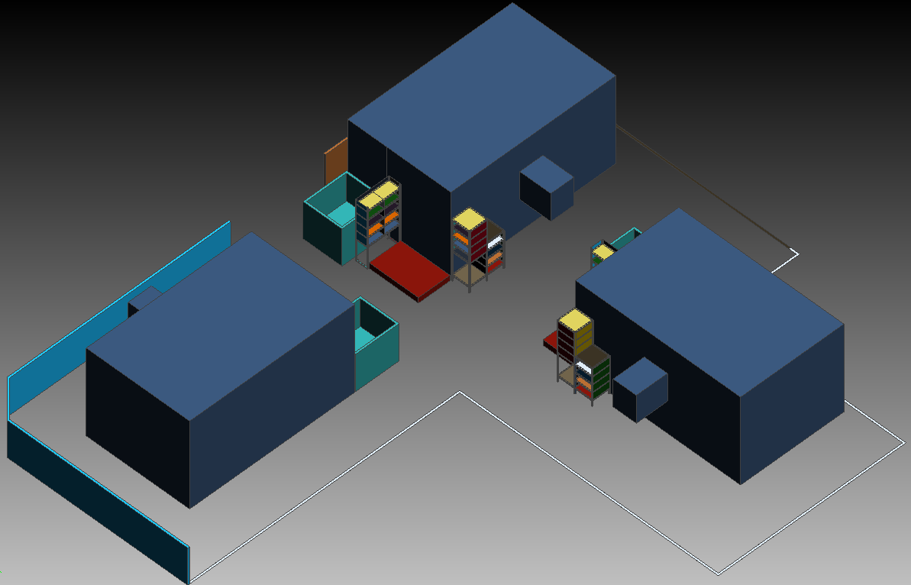
References

[1] Ansari, a et al. 2011. “Application of Six-Sigma in Finance : A Case Study.” Journal of Case research in business and economics 3: 1–14.

[2] https://www.cnccookbook.com/introduction-lean-manufacturing-principles-part-1-lean-manufacturing/ (Accessed April 2020)

[3] Raghunath, a, and R V Jayathirtha. 2012. “Lean and Six Sigma Approach for Manufacturing SMEs.” : 1–10.

[4] https://www.planview.com/resources/guide/what-is-lean-manufacturing/ (Accessed April 2021)

[5] 12. Deros BM, Mohammad D, Idris MHM, Rahman MNA, Ghani JA, Ismail AR (2011) Setup time reduction in an automobile battery assembly line. Int J Syst App Eng Dev 5(5):618–625

[6] DesaiMS (2012) Productivity enhancement by reducing setup time - SMED: case study in the automobile factory. Glob J Res Eng Mech Mechn Eng 12:5A

[7] Kumar BS, Abuthakeer SS (2012) Productivity enhancement by implementing lean tools and techniques in an automotive industry. Int J Eng 10:167–172

[8] Ilie, G., & Ciocoiu, C. N. (2010). Application of fishbone diagram to determone the risk of an event with multiple causes. Management Research and Practice, 2(1), 1–20.

[9] “Ask ‘why’ five times about every matter.” Toyota. www.toyotaglobal.com/company/toyota_traditions/quality/mar_apr_2006.html. (Accessed April 2021).

[10] Moreira AC, Pais GCS (2011) Single minute exchange of die. A case study implementation. J Technol Manag Innov 6(1):129–146.

[11] Allahverdi A, Soroush HM (2008) The significance of reducing setup times/setup costs. Eur J Oper Res 187:978–984.

[12] Mackelprang AW, Nair A (2010) Relationship between just-in-time manufacturing practices and performance. A meta-analytic investigation. J Oper Manag 28:283–302.

[13] Sayem A, Islam MA, Khan MMA (2014) Productivity enhancement through reduction of changeover time by implementing SMED technique—in furniture industry. Int J Ind Syst Eng 17(1).

[14] About us. Safran Seats GB. https://www.safran-seats.com/company/safran-seats-gb (Accessed April 2021)

Appendices
Appenix 1 – Project Gantt chart
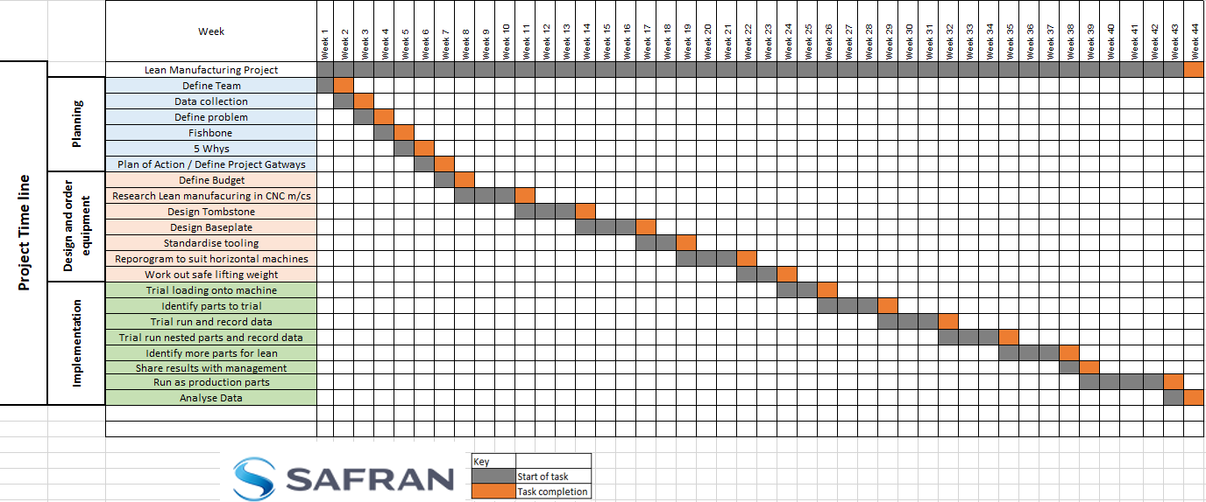
Appenix 2 – Project milestone gateway objectives


