
Master of Business Administration
Student Name: Akbar hossain
Student Number: 2519734
Module code: LCMB7023
Assessment Title: “Integrated Human Capital Blueprint: Aligning People, Performance, and Innovation at Aether Innovations.”
Course Name: Human Capital Management
Lecturer: Nerys Dosseh
Word Count: 2564
Submission Deadline: 20th March 2026

Table of Contents
Executive Summary: i
Introduction: 1
Part 1: Re-Engineering Performance and Job Design at Aether Innovations 2
1.1 Analysis of Performance Appraisal and Job Design in the Tech Sector: 2
1.2. Growth-Centred Performance Appraisal System Proposed: 3
1.3 Job Analysis and Redesign: The Leadership Core 4
1.4 The Strategic Connection: The Relation to Culture 6
Part 2: Reflective Analysis and Future Readiness 8
1. Reflective essay: Gibbs Reflective Cycle of Reflection on Learning Journey: 8
2. Staying Relevant in the Age of Artificial Intelligence: 12
Reference 14

Contents of Table
Table 1: Summary Table of Integrated Performance Framework 7

Contents of Figures
Figure 1: Strategic Human Resource Management 2
Figure 2: 360-Degree Feedback 3
Figure 3: Gibbs Reflective Cycle 8

Executive Summary:
This report is a proposal of an Integrated Human Capital Blueprint of Aether Innovations to curb the idle growth and high turnover. The strategy can match the output and the vision of the organization by reengineering performance management using Objectives and Key Results (OKRs) and 360-degree feedback. Moreover, it uses the Job Characteristics Model to redesign six core leadership positions, with the greater emphasis on autonomy and skill variety to inspire innovation. The blueprint was finalised with a personal reflection on the learning experience and a strategic approach to staying professionally relevant while pushing AI forward, thus creating a robust, high-performing culture that will lead to employee and customer excellence.

Introduction:
Aether Innovations is a 300-employee technology company that is currently in critical stagnation due to flat growth, high turnover, and customer dissatisfaction. Within this report, we have come up with an integrated human capital blueprint to turn these trends around. The strategy will attempt to re-engineer the job roles and performance systems by integrating high-performance work practices with the job characteristics model. The goal is to stop being disjointed in its operations and become an integrated, innovation-orientated culture that will restore not only the participation of the employees but also the quality-of-service delivery.

Part 1: Re-Engineering Performance and Job Design at Aether Innovations

1.1 Analysis of Performance Appraisal and Job Design in the Tech Sector:
In the modern digital economy, the classical human resource management (HRM) models are going through a radical change. This has been discovered by technology companies with high rates of creative destruction, with the result that legacy performance systems, which are often based on annual, top-down appraisals, do not reflect the dynamism of the modern labour market. Alp Consulting (2025) notes that more than 70% of fast-growing technology companies have moved to the concept of Continuous Performance Management (CPM). This change is required by the pace of technological obsolescence; what was important in January can become obsolete in June.
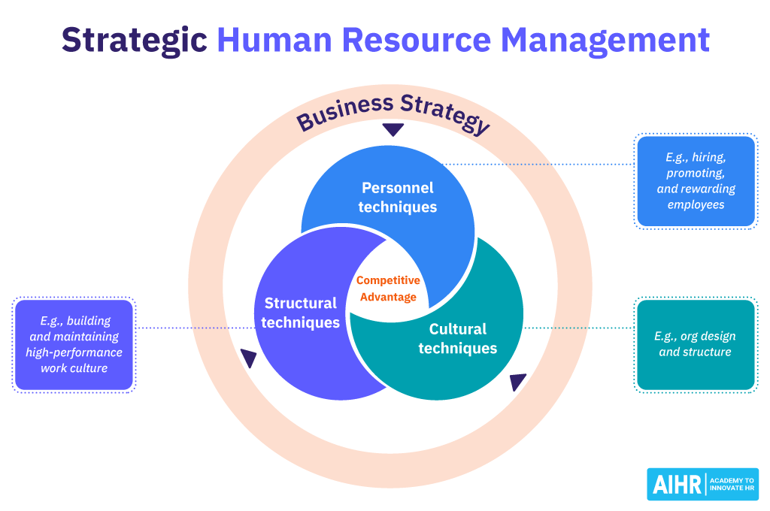
Figure 1: Strategic Human Resource Management
Source: (van Vulpen, 2023)
Current Job Design Trends:
The job design trend in modern technologies shifted to enrichment instead of specialisation (Taylorism). Skills-based design is currently being applied by companies, with job descriptions being determined by the dynamically applied skills as opposed to a predetermined set of responsibilities. The studies conducted by the World Economic Forum (2025) emphasise that the most important psychological needs in the field of technology are now analytical thinking and creative flexibility.
The following are the critical challenges that were found in tech HRM:
- The Feedback Gap: Static appraisals generate a recency effect, as managers can only recall the previous two weeks of the year of an employee.
- Siloed Job Design: The traditional job design tends to restrict autonomy, which is a key trait of the so-called intrapreneurial spirit needed to grow a 300-person company like Aether Innovations.
- Employee Burnout: High turnover is often associated with so-called 'role overload', when the job description is not defined, exposing employees to cognitive exhaustion (Frontiers in Psychology, 2025).

1.2. Growth-Centred Performance Appraisal System Proposed:
To eliminate the challenges of flat growth and high turnover at Aether Innovations, it is suggested to use a dual-integrated system of Objectives and Key Results (OKRs) to align with the mass strategy and 360-Degree Feedback to develop behavioural changes.
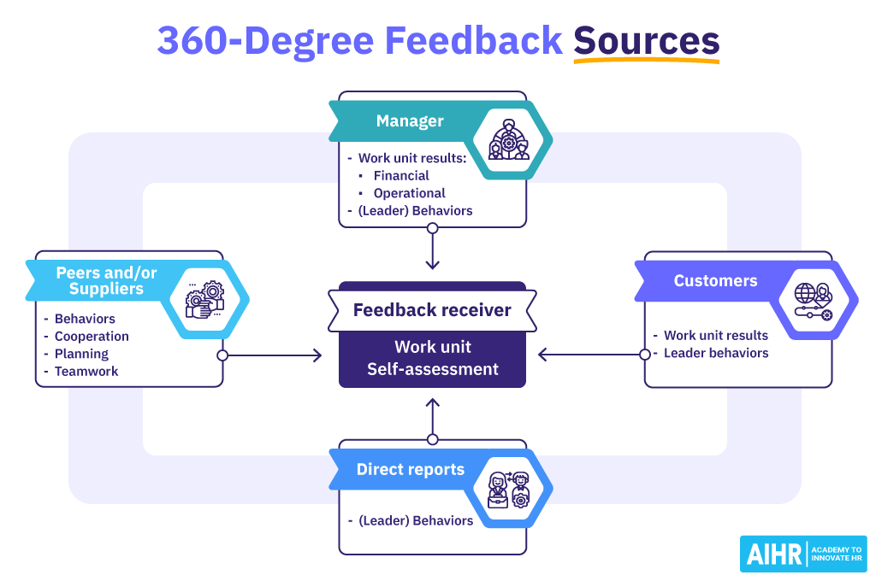
Figure 2: 360-Degree Feedback
Source: (AIHR, 2025)
A. Objectives and Key Results (OKPs)
In contrast to the traditional KPIs, the Oklahoma objectives are meant to be aggressive and open.
- The Mechanism: Objectives: These are what need to be accomplished, and Key Results: specific and measurable targets employed to monitor attainment.
- Growth Orientation: In the case of Aether, the OKRs must not be tied to the basic salary, as it will promote risk-taking. An engineer will never innovate in case he or she fears that they will fail to achieve a pay cut because of failing a stretch goal (PerformYard, 2022).
- Strategic Connection: This is to make sure that each person in Aether can see the role played by his daily coding or sales calls to the company in its North Star goal.
B. 360-Degree Feedback / Continuous Pulse Checks:
In order to restore the engagement, Aether will have to shift the manager-as-judge paradigm to a manager-as-coach one.
- Multi-Source Input: We gather feedback from peers, subordinates, and cross-functional leads. This is crucial in the field of technology, where a CTO may know the technical work of an employee, but a colleague knows the teamwork (AIHR, 2025).
- Frequency: Monthly pulse checks that are used in lieu of the annual review. This makes it possible to possess the knowledge of results required to make psychological meaningfulness of work (Humaans, 2024).

1.3 Job Analysis and Redesign: The Leadership Core
The following roles have been re-engineered using the Job Characteristics Model (JCM). Emphasis is put on augmenting autonomy (level of freedom in the job) and skill variety (variety of diverse activities).
CEO (Chief Executive Officer)
- Job Analysis: A change of an operational manager to become a Chief Visionary.
- Job Description: Makes strategic direction, establishing an innovation-first culture and high-level stakeholder relations.
- Job Specification: Digital Leadership: Skilled in digital leadership, crisis resilience and capacity to analyse intricate market information into a strategy that can be executed (IBM, 2025).
- JCM Application: High Task Significance – the choices made by the CEO have an impact on the sustainability of every employee of the 300 employees of the company and the satisfaction of a large client base.
CFO (Chief Financial Officer)
- Job Analysis: Over and out of the bookkeeping game to strategic value creation.
- Job Title: Capital allocation to manage R&D, management of ESG (Environmental, Social, and Governance) compliance, and predictive financial projections.
- Job Specification: A deep understanding of AI-based financial modelling and risk governance (Taggd, 2025).
- JCM Application: High Autonomy on how the budgeting innovation pods are financed to generate maximum ROI without suffocating innovativeness.
CTO (Chief Technology Officer)
- Job Analysis: The move: Lead Engineer to Technical Architect of the Future.
- Job Description: When it comes to the technology roadmap, scalability of the Aether platform, and technical debt, oversee the technology architecture.
- Job Specification: Cloud-native architecture (IaaS/SaaS) mastery and 15 or more years in rapidly expanding technology settings (Indeed, 2025).
- JCM Application: High Skill Variety – balancing between deep-dive reviews of code and deep-level architectural strategy.
CIO (Chief Innovation Officer)
- Job Analysis: The position will be a new occupation at Aether that will fill the gap between tech and customer needs.
- Job Description: Recognition of new market trends, the cross-departmental development of the new option of the company that is based on the process of innovative sprints, and control of the intellectual property (IP) of the company.
- Job Specification: Good experience in the field of design thinking and the development of products based on the data (Synergita, 2025).
- JCM Implementation: High Autonomy – The CIO is mandated to interfere with the normal processes within the company whenever they are impeding its growth.
Chief People Officer (HR Director)
- Job Analysis: Transferring out of Administrative/Compliance into Human Capital Strategist.
- Job Description: To design the EVP (Employee Value Proposition), to introduce the system of 360-degree feedback and to work on talent density.
- Job Specification: People Analytics and Strategic HRM (AIHR, 2024).
- JCM Application: High Feedback – The HR Director pivots people practices using real-time turnover and engagement information.
R&D Director (Research and Development)
- Job Analysis: Pay attention to creative destruction.
- Job Description: Head of the experimental laboratory, prototyping of the novelties and minimising the time-to-market of innovations.
- Qualification: PhD or higher degree in a tech-related area; familiarity with so-called Agile approaches to R&D (IBM, 2025).
- JCM Application: Task Identity – The head of R&D will be involved with a product starting with the napkin sketch to the prototype.

1.4 The Strategic Connection: The Relation to Culture
It is the modern appraisal (OKRs/360) used along with enriched job design (JCM) that produces a "performance-driven culture".
Closing the Meaning Gap: In case a CTO possesses high Autonomy and Task Significance (Job Design), he/she feels responsibility. Their OKRs confirm their contribution to the company's growth (Appraisal).
Psychological States: Humaans (2024) argues that to perform, an employee should have what is called 'experienced meaningfulness' and 'knowledge of results'. The 360-degree feedback offers the knowledge, while the jobs designed by JCM supply the meaning.
Element | Performance Appraisal (OKRs/360) | Job Design (JCM/Skills-Based) | Cultural Outcome
Focus | Results & Behaviors | Content & Autonomy | Accountability
Cadence | Monthly/Quarterly | Structural/Permanent | Agility
Driver | External Feedback | Internal Motivation | Innovation
Table 1: Summary Table of Integrated Performance Framework
Sources- Create by learner

Part 2: Reflective Analysis and Future Readiness

1. Reflective essay: Gibbs Reflective Cycle of Reflection on Learning Journey:
It is a well-known fact that reflective practice is one of the significant methods in professional learning, as it allows the person to assess the experience, enhance his/her knowledge and acquire professional skills. The Gibbs Reflective Cycle is one of the most popular reflective models in the field of education and professional development; it offers a systematic way of analysing the experience and learning through it. The model includes six steps: description, feelings, evaluation, analysis, conclusion and action plan, which allows the learners to make a critical judgement regarding the experiences and to develop a plan of actions to achieve improvement in the future (Harmon, 2024; Hughes, 2024).
In this reflective essay, I will explore my learning experience during this module and discuss how this new knowledge will give me a base in creating a proper Learning and Development (L&D) strategy to foster an innovative and growth attitude.
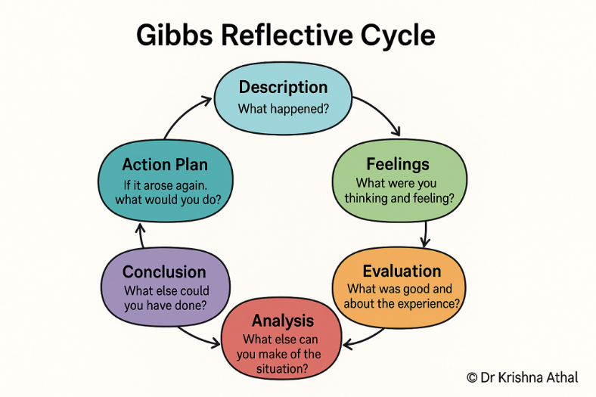
Figure 3: Gibbs Reflective Cycle
Source: (Athal, 2025)
Description
In this module, I learnt some of the most important concepts in terms of human resource management, organisational performance and talent development. The module was about learning how organisations can ensure that the human capital strategies are aligned to the business goals to realise sustainable growth. In the form of lectures, case studies and scholarly research, I would discuss the performance management systems, job design, innovation culture, and strategic leadership.
The most valuable learning experience was the analysis of organisational issues and the suggestion of HR measures to enhance employee engagement and innovation. It involved the use of theoretical frameworks, analysis of business problems in real life and development of viable HR solutions. Through reflective learning structures, people are encouraged to analyse such experiences in a more nuanced manner to permit a learning process to take place (High Point University, 2026).
Feelings
I was fascinated and overwhelmed at the start of the session since it required theoretical understanding and real-world organisational challenges. Strategic HR management first proved difficult since it required examining various organisational characteristics, including employee leadership, motivation, and innovation.
However, the training improved my comprehension and confidence in using HR theory. The Job Characteristics Model, performance management systems, and corporate culture showed me that employee conduct affects organisational performance.
The module promoted critical thinking and problem-solving. I found that strategic human capital management boosts employee engagement, creativity, and competitiveness in organisational case studies.
Evaluation
In general, this learning experience was very useful in this module. The module had several factors that played a positive role in my development:
Favourable elements in the learning process
- The module taught effective knowledge of strategic HR management and performance systems.
- Problem-solving and analytical skills were developed as a result of case study analysis.
- The practice-theory interaction enhanced my knowledge of HR strategies' role in organisational performance.
- The tasks promoted individual research and writing.
Nevertheless, not everything was that easy:
Challenges faced during the learning process
- Complex HR theories were associated with a lot of reading and critical analysis.
- Theoretical frameworks need more research in the application of the organisational situation.
- Academic assignments were very demanding, and that is why time management was necessary.
Nonetheless, the module helped me greatly gain knowledge of human capital strategy and innovation in organisations.
Analysis
Looking back at the learning process, it is essential to note the value of constant learning and professional growth. Contemporary organisations are working in highly dynamic climates where innovation and flexibility are the only ways to succeed. It consequently forces the employees to constantly maintain their knowledge and skills.
Learning and Development (L&D) is very vital in nurturing a growth mindset, which is an attitude that skills can be acquired through learning and effort. Companies that promote learning and experimentation are likely to develop innovation and employee involvement.
Reflective practice as such is also a strong means of learning since it enables people to make sense of experiences and enhance future performance. Studies have shown that guided reflection aids people to acquire skills in critical thinking and gain more insights into professional practice (Barr, Nabi and Andrei, 2025).
Besides, the module highlighted the significance of a culture of innovation within organisations. The companies where collaboration, sharing of knowledge and continuous learning are encouraged will have a higher chance of coming up with innovative solutions and stay ahead of competition.
On a personal level, the module has proven that an innovation culture should be developed by encouraging it through personal learning as well as organisational support systems. Training programs, mentoring, and performance feedback are some of the HR practices that are vital to supporting employee development.
Conclusion
In this reflective effort, I came to realise that this module has extensively helped me understand the concepts of strategic HR management and organisational performance. This is because the understanding of HR structures, theories of leadership, and innovation approaches has offered a solid base on how the development of talent-based strategies in human resources can be done.
More importantly, the module underscored the importance of continuous learning and adaptability in fostering professional development. Reflecting on the learning experience, I have realised that I need to constantly acquire new abilities and be open to new ideas to achieve success in the dynamic organisational setting.
Action Plan
According to this reflection, I will follow several steps to acquire and build further on my professional capacities and my growth mindset:
Personal Learning and Development Plan
- Acquiring knowledge in human resources management and organisational strategy on a continuous basis.
- Enhance analytical and research capabilities through literature from academic journals and industry reports.
- Engage in training and leadership development programs in your profession.
- Gain critical thinking by engaging in habitual reflection on learning.
- Request advice and support from the senior professionals.
These measures will assist me in reinforcing my professional skills and assist in organisational innovation and performance.

2. Staying Relevant in the Age of Artificial Intelligence:
The emergence of artificial intelligence (AI) is changing the nature of work in most industries due to the rapid evolution of this technology. The use of AI technologies is gaining more and more power to handle routine tasks like data analysis, customer support and administration. Consequently, most of the conventional work positions are changing or getting automated.
Nevertheless, instead of seeing AI as a threat, it is more productive to think of it as a means of people extending their abilities. It is proposed that AI will be able to aid learning and professional growth by offering individualised feedback and helping solve complicated tasks (Yuan and Hu, 2024).
To stay in the AI-based work environment, individuals should train on skills that can be used to supplement artificial intelligence instead of challenging it. These skills include:
Key Human Skills That AI Cannot Easily Replace
- Strategic decision-making and critical thinking.
- Creativity and innovation
- Emotional intelligence and leadership.
- Ethical judgement and problem-solving.
- Teamwork and interaction.
These are the competencies that are required in the leadership or strategic positions, where human judgement and inventiveness are vital.
I will use AI to improve my professional skills, not replace them. AI may assist analyse data, summarise research, and retrieve information, leaving strategic and creative duties to humans.
AI may help analyse organisational data and identify performance measurement trends, but managers must still analyse results, make strategic choices, and manage teams. Using human talents and AI-supported technology, they may boost productivity and maintain decision-making control.
Thus, lifelong learning, technological adaptability, and skill development are necessary to be relevant in the future workforce. AI as an assistant, not an adversary, will help people prosper in the new digital economy.

Reference
AIHR (2024) Strategic Human Resource Management: The Definitive Guide. Available at: https://www.aihr.com/blog/strategic-human-resource-management/ (Accessed: 15 March 2026).
AIHR (2025) 360 Degree Feedback: A Comprehensive Guide. Available at: https://www.aihr.com/blog/360-degree-feedback/ (Accessed: 15 March 2026).
Alp Consulting (2025) 10 Latest Performance Appraisal Trends for 2026. Available at: https://alp.consulting/performance-appraisal-trends/ (Accessed: 15 March 2026).
Eastasouth Management and Business (ESMB) (2025) ‘The Influence of the 360-Degree Feedback System on Employee Performance and Career Development in Technology Companies’, 4(1), pp. 108–118. Available at: https://esj.eastasouth-institute.com/index.php/esmb/article/download/755/574
Frontiers in Psychology (2025) ‘Digital leadership and employee innovative performance: the role of job crafting and person–job fit’, 16. Available at: https://www.frontiersin.org/journals/psychology/articles/10.3389/fpsyg.2025.1492264/full
Humaans (2024) Hackman and Oldham Model: The 5 Steps. Available at: https://humaans.io/hr-glossary/hackman-and-oldham-model (Accessed: 15 March 2026).
IBM Institute for Business Value (2025) 2025 CEO Study: 5 mindshifts to supercharge business growth. Available at: https://www.ibm.com/thought-leadership/institute-business-value/en-us/report/2025-ceo
Indeed (2025) Chief Technology Officer (CTO) Job Description [Updated for 2025]. Available at: https://www.indeed.com/hire/job-description/cto-chief-technology-officer (Accessed: 15 March 2026).
PerformYard (2022) 5 Modern Performance Appraisal Methods for 2025. Available at: https://www.performyard.com/articles/modern-performance-appraisal-methods (Accessed: 15 March 2026).
Synergita (2025) Performance Management Latest Trends 2026. Available at: https://www.synergita.com/blog/performance-management-latest-trends/ (Accessed: 15 March 2026).
Taggd (2025) C Level Executive: Definition, Roles, Responsibilities & Salary Guide 2025. Available at: https://taggd.in/hr-glossary/c-level-executive/ (Accessed: 15 March 2026).
World Economic Forum (2025) Future of Jobs Report 2025. Available at: https://www.weforum.org/publications/the-future-of-jobs-report-2025/
Barr, M., Nabi, S. and Andrei, O. (2025) The development of reflective practice on a work-based software engineering program. arXiv. Available at: https://arxiv.org/abs/2504.20956
Harmon, A. (2024) Gibbs’ reflective cycle. EBSCO Research Starters. Available at: https://www.ebsco.com/research-starters/education/gibbs-reflective-cycle
High Point University (2026) Gibbs’ reflective cycle: A practical tool for EQ in the classroom. Available at: https://www.highpoint.edu/qep/2026/02/16/gibbs-reflective-cycle-a-practical-tool-for-eq-in-the-classroom/
Hughes, M. (2024) Gibbs’ reflective cycle. MindTools. Available at: https://www.mindtools.com/ano9qiu/gibbs-reflective-cycle
Yuan, B. and Hu, J. (2024) Generative AI as a tool for enhancing reflective learning in students. arXiv. Available at: https://arxiv.org/abs/2412.02603
Athal, K. (2025) Gibbs reflective cycle explained: A framework for structured self-reflection. Available at: https://drkrishnaathal.com/blog/gibbs-reflective-cycle-explained-a-framework-for-structured-self-reflection/ (Accessed: 18 March 2026).
van Vulpen, E. (n.d.) 360-degree feedback: Definition, benefits, and examples. Available at: https://www.aihr.com/blog/360-degree-feedback/ (Accessed: 18 March 2026).
van Vulpen, E. (2023) Strategic human resource management: A complete guide. Available at: https://www.aihr.com/blog/strategic-human-resource-management/ (Accessed: 18 March 2026).

