Legal Risks for the Hotel Industry
Module Code M4X01917_BIRM
Student Name: Steluta Pascuta
Student Number: 1816339
Lecturer: Dale Clarke

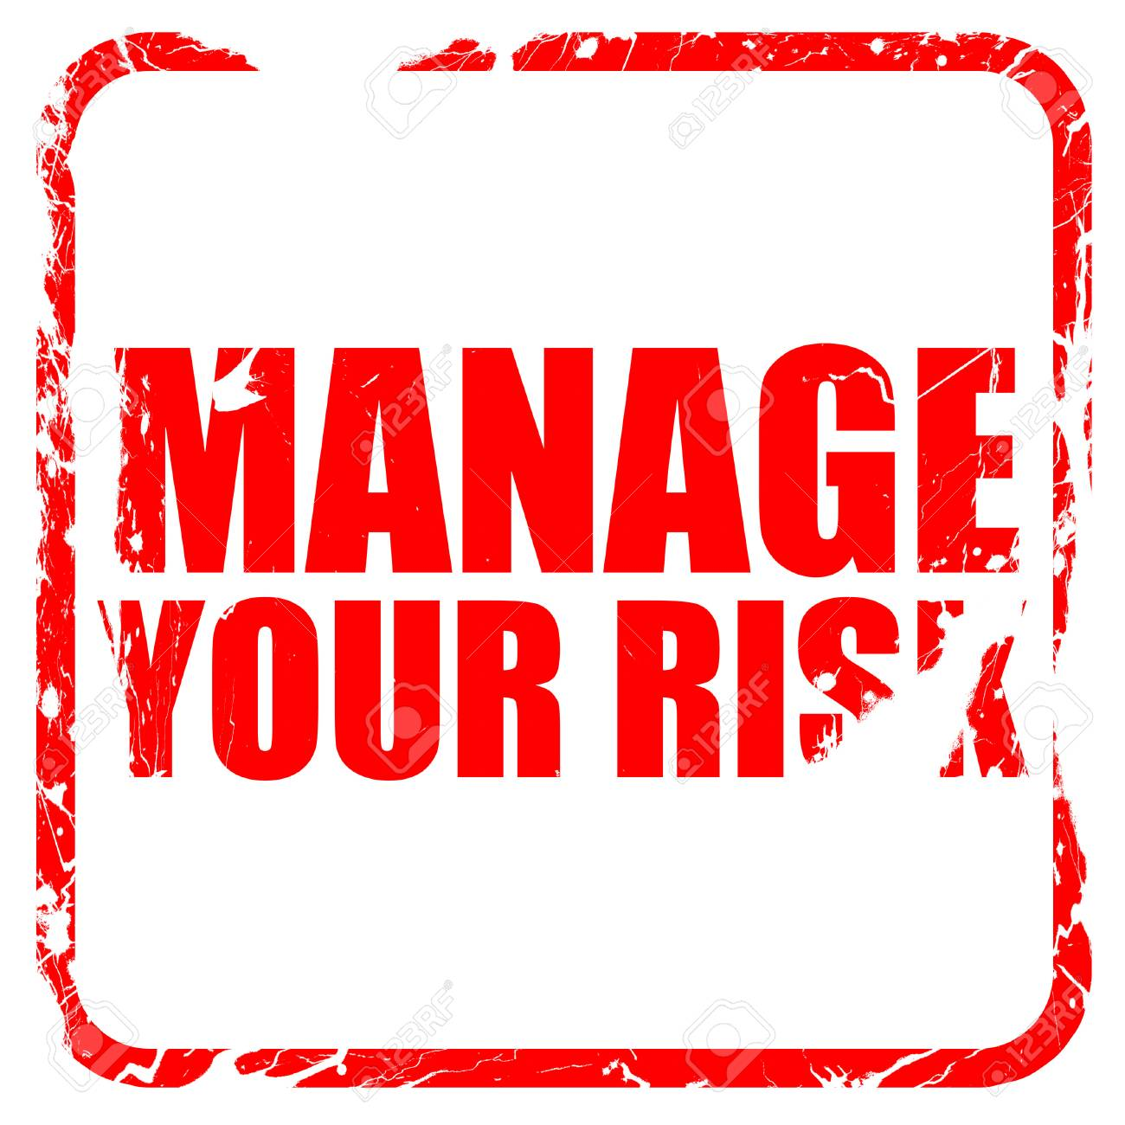

Table of Contents

Introduction……………………………………………………………Page 3
Risk Management…………………………………………………… Page 4
Health and safety……………………………………………………Page 4
Data Protection……………………………………………………… Page 5
Food Hygiene ………………………………………………………. Page 5
Licensing …………………………………………………………… Page 5
The Hotel Proprietors Act………………………………………. Page 6
Conclusion………………………………………………………… Page 6
References…………………………………………………………. Page 7

Introduction

In this assignment I have been asked to enumerate and describe the legal legislative risks which must be considered when a business in hospitality and tourism is ready to be opened. Aspects such as legal liability and risk, the data protection obtained and required to function, the health and safety policies of the staff and guests, food hygiene and hygiene in general, licensing and the matter of the Hotel Proprietors Act which has been introduced in 1956 will be analysed in this report.
A short explanation of the aspects would say that liability, data protection, health and safety, food hygiene are important things set by the law which cannot be avoided by none of the companies. If they are not touching the standards the company will be closed until the needed conditions are fulfilled.



Risk Management
Risk is something we meet at each step we do in our lives and Vaughan says: “Risk is a condition which there is a possibility of an adverse deviation from a desired outcome” (1997), but when it comes about Hotel Industry risk is much more because you are not only responsible for yourself, you are responsible for every guest coming and each member of staff which should work in safe conditions. Risk management is something that always has been needed for something to be successful for a long time. Even Garaczi said in 2013 that “the concept of risk is as old as a mankind” and this makes risks being so important not only in the Hotel Industry, but having in mind the idea that Hotel Industry has the most beneficial in economy risk management is so far the most important thing. There are different types of risks such as environmental risks, business risks and human resource risks and they can be managed through the mix of the risk management strategies which can always improve the way of managing the risks making the process a lot easier.
Health and safety
Health and safety in my mind look like the most important point when you talk about owning a hotel and this because the poor health and safety condition would cause accidents, illnesses, fires and many other issues which could affect either members of staff or guests. Hotels have always been expected to take all the practicable steps to offer the needed and wanted safety of their employees and of the person which surely are not in their employment those persons being guests as well. It is necessary to realize that the identity of the employer the owns the duty under health and safety legislation, it may not always be clear, given the range and combination of leadership, management and franchise structures operating in the modern strategies and technologies of the Hotel Industry. A hotel company must remark whether they are in fact the employer or whether the staff may be employed by other contractors. Maintaining health and safety may be very expensive, but it is cheaper that paying for everyone’s accidents or having issues at each step a then loosing guests because of the poof conditions about health and safety. There could be negative aspects even at the most well-checked and well-going hotels because “as unfortunate as it seems, there are times when there arises a possibility of violence” (Barth and Hayes, 2006). They could be small accidents, but big as well so you as an owner you need to be always ready for everything that could happen anytime. Most of the accidents in a hotel area could happen in the children playgrounds, fitness or adventure parks. All these accidents can be prevented of the hotel has a very good staff with an effective training and experience which are able to maintain a good management of the services that require safeties

Data Protection
Data Protection in the hotel industry is a needed strong marketing key to maintain the relationship with staff and guest and hotels must carefully plan how they are dealing with the private information they collect. “The General Data protection refers to lawful bases for the processing personal data, which is broadly similar to the conditions for processing” (Data Protection Act). The private information can be easy, but hard as well as there are video recordings on CCTV or information about the products, bookings, statements, passport numbers, credit cards detail and a lot of other components that need to be protected very carefully and safely. There are more than one person in charge of the Data protection depending on their purpose within the data for example there is a person securing the guest list while there is another person registering the money spend on the products and the budget left which is usually the profit of the hotel. Data is usually protected by being saved on a computer or memory card which is then secured with a password or security code.
Food hygiene
In my opinion, this is the most important service in a hotel because if it not well-checked there could be ,any illnesses because sometimes the food could be contaminated with toxic substances from outside and the contamination can be with biological, physical or chemical hazards and this is why it is very important that the person in the charge of buying food products knows exactly how that product is made and what it contains as it is a huge risk to buy something just because it is cheap without knowing what it actually is and if it contains toxic substances it will cost the Hotel a larger amount of money to pay for each person that got contaminated, so it is an important aspect in a Hotel Restaurant. “A hazard is an activity or process which can result in negative consequences and thereby provide a source of risk to receiving environment or population” (Yeung and Morris (2001). As the quote says the negative consequences can have a huge impact against the hotel itself and it can be getting a lot of negative feedback which will drive it to bankruptcy which means no more people, no more money, no more profit.
Licensing
To begin with, every hospitability place either restaurants, bars or hotels need to be fully licensed before selling anything even if it is food, drinks or anything. There are many licenses needed before opening a business based on Hotel Industry, those being; Food licence, Liquor License, Entertainment or Broadcast Licenses, General Business License.
When it comes about food licensing, each hotel from each county require licenses for every type of food business from food preparation to food consumption, handling and sanitation are essential to keep the public health and safety in a proper way. Liquor License is based on the sale of alcohol and it is very important that alcohol license is approved, but it might be tricky sometimes as it is not approved everywhere, because in some places the licensor will be aiming to sell your products to some specialist which will check what it is exactly made from and only if it contain non-toxic elements the Liquor License will be approved. The TV, broadcast and entertainment are very necessary in a Hotel as it is part of the services included in a package when people are booking an all-inclusive holiday, so therefore the Relevant Entertainment or Broadcast Licenses are very useful for the Hotel’s success. The General Business License will be needed before opening a business as the licensor needs to oversee checking if the company is going to give positive advantages and services to the public. This license is usually hard to obtain because it needs to be approved from both the state and the local authorities.
The Hotel Proprietors Act
Is as a well-structured diary which support the Hotel’s within the liability in terms of the customer’s goods or any other person mentioned within the structure. It was and still is an important Act to know especially if your business had a recent negative feedback from someone whom lost something while staying at your hotel you can show them the exact explanation from The Hotel Proprietors Act that you are only the Inn Keeper and you are not responsible for their goods. “Without prejudice to any other liability or right of his with respect thereto, the proprietor of an hotel shall not as an innkeeper be liable to make good to any guest of his any loss of or damage to, or have any lien on, any vehicle or any property left therein or any horse or other live animal or its harness or other equipment.” (The Hotel Proprietors Act). The mentioned quote demonstrates that the hotel’s head is not in the charge of none of the guest’s good he is only responsible for their experience while staying in which needs to be the best in the best conditions.
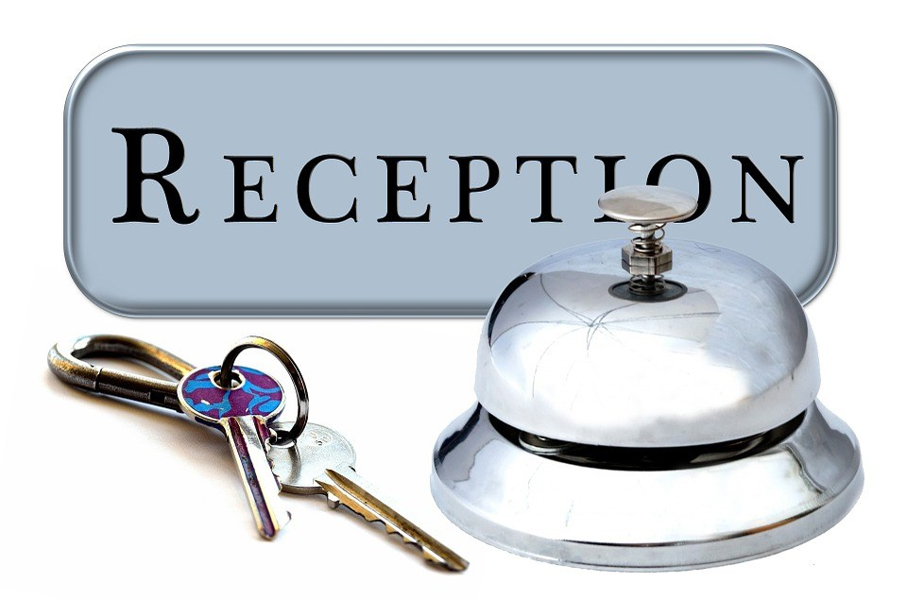

Conclusion
As I went through the legal risks I did realise that there are many aspects and important things that needs to be perfectly checked if you want the Hotel to be successful if the Legal Risks are not well analysed the hotel will be driven to the bottom line which will go with it to bankruptcy. Therefore, before opening a business in hotel industry you need to be aware of all the Legal Risks which will either drive you to success or failure.


References
Barth, S. C., & Hayes, D. K. (2006). Hospitality law: Managing legal issues in the hospitality industry. John Wiley & Sons.
Data Protection Act 1998 (c 29) United Kingdom Act of Parliament
Garaczi, I. (2013): Kockázati modellek és társadal-mi mozgások (Risk Models and Movements in soci-ety). Gazdaságetika. No. 5.
Hotel Proprietors Act 1956
Vaughan, E.J. (1997) “Risk Management.” New York: John Wiley & Sons, Inc. P. 27
Yeung, R. M. W., and Morris, J. (2001). Food safety risk: Consumer perception and purchase behaviour. British Food Journal, 103, (3), pp. 170-186.

