

ASSESMENT 1

MARIA GHEORGHE
2243301
ENTREPRENEURSHIP
LCBB5001
LECTURER AMER KAREEM

TABLE OF CONTENTS
INTRODUCTION
MAIN BODY
- TEAM MANAGEMENT AND COMPANY STRUCTURE
- SWOT ANALYSIS
- MARKETING PLAN
- FINANCIAL PLAN
CONCLUSION
REFERENCES

INTRODUCTION
Inspired by the desire of managing one’s own life, time and spendings, entrepreneurs are motivated to follow a process from the beginning to end in launching new ideas and focus on their ability to transform them into successful businesses. One of the main issues in launching a business is the capital. According to Barringer (2018), an entrepreneur uses all the financial and human resources to make an invention become a viable business, taking risks and creating business strategies. A business plan supports the entrepreneurs in defining goals regarding revenue and results (Dal Mas et. al, 2021).
The report presents the business plan of manufacturing waterproof trackable shoes for children, the market target being children and teens between 2 and 15 years old. There is the possibility of special orders for any different age. The tracking device is controlled by satellite through GPS apps, with no need for internet. It is also chargeable; the charger being provided along with the shoes. Therefore, the business plan will cover manufacturing industry.

MAIN BODY
TEAM MANAGEMENT AND COMPANY STRUCTURE
To provide owners with both asset safety, greater opportunity for their enterprise and liability protection, the enterprise will operate as a Limited Liability Company (LLC).
The management group includes:
CEO: The owner of the business, the entrepreneur, in charge with the process of installing the business idea in the business environment, making corporate decisions and providing directions to the management of the company.
Production Manager: Monitors factory efficiency oversees the manufacturing process and ensures the quality of products.
Marketing Manager: In charge of retail distribution, advertising, retail partnerships and ensures effective customer interaction.
Specialised staff employed by this business venture produce, package and distribute our products. To reduce initial investment costs, key processes such as factory operations and tools are outsourced.

Organizational structure of the company
The business will operate as a Limited Liability Company (LLC), a legal form chosen because it offers the best ground in which operational flexibility and asset protection can combine with entrepreneurial components. By respecting this legal framework, financial protection is assured and there is a way for the Company to grow. Therefore, all risks emanating from possible corporate liabilities are shelved onto owners' personal assets. The management team will consist of several people with a small but workable structure devoted to pursuing both operational excellence and market penetration. The Sales Manager has two roles: managing tactics for customer interaction (to foster loyalty and satisfaction) along with retail partnerships that will let the Brand take off like wildfire in markets devoid of mercy or regard for anything else. The efficiency of a company’s distribution network and first-class customer service in placing orders depend very heavily upon this role. The Production Manager is responsible for efficient and innovatory products. This means bringing factory productivity into line with latest quality requirements, while at the same time organising how processes of production can be continually improved and has an eye always upon consistency in strictness or live up to such standards. Efficient workflows and reduced production down time will directly impact the Company's long-term credibility and customer satisfaction. To ensure that output and marketing are in step and not conflict with one other, the Production and Sales Departments must also continue to work closely together. As the firm grows, the management team will expand. This will mean including experts in marketing, finance, and logistics to safeguard that organisation changes along the lines of what the company needs.

SWOT ANALYSIS
Before launching a business there needs to be conducted business environment analysis. One of the most important forms of industrial analyses is SWOT. It evaluates internal strengths and weaknesses, and external opportunities and threats.
Strengths
Its distinctive product, an all-weather sneaker for kids that you can follow anywhere is a main advantage of this company. Integrating its functionality with several safety features, this creation occupies a market gap, appealing to parents who greatly value keeping their offspring safe. The introduction of GPS tracker has long been a goal of ours, and with an added coherent means to recharge and does not require internet connection.
We have truly added value. In addition, the company is targeted at parents of children aged between 2 months old and 15 years and has a readily identifiable target market. Recent studies indicate that children's safety-oriented products are becoming increasingly popular, driven by technology (Gallagher, 2023). It is also a key strength that the business model is flexible enough to introduce new services or enlarge the target audience.
Weaknesses
The company has many problems, ranging from spending a lot of money on early marketing, tools and factory lease fees. Although outsourcing industrial operations can reduce long-term liabilities, it still demands a hefty initial investment in capital which can strain resources at the beginning. Another weakness is market awareness; a new product requires intensive marketing to inform potential customers about its advantages. According to a study by Lumley and Wilkinson (2022), young companies often struggle to build trust with customers, especially when introducing an innovative but unfamiliar item. This underscores the importance of allocating resources wisely to establish credibility.
Opportunities
A market that is constantly evolving means there are plenty of possibilities. The rise in demand for products providing safety and comfort of mind for anxious parents comes from an increased anxiety about the safety of their children. Recent studies have shown that technological advances and breakthroughs in GPS arrangements have cut the costs while enabling wider access to such solutions. Now it is possible for small businesses to compete and push on (Trought, 2023). By working with retailers, community organizations and educational institutions you can increase awareness and establish credibility in this sector. In addition, by using sustainable materials to make shoes, the trend toward sustainability in manufacturing creates opportunities for companies to appeal to environmentally conscious consumers.
Threats
The company faces substantial risks despite its growth prospects. Fierce competition from smaller firms and well-established brands is one of them. With the larger budgets that they enjoy, rivals can produce the same goods faster thus flooding markets. And then there is the state of the economy. In times of uncertainty, people may spend less money on non-essential items like trackable shoes (McGrady, 2024). Moreover, complying with regulations can be costly and time-consuming, as in the case of safety standards and certifications for GPS devices. To reduce the influence of these factors on the company, they must be properly managed.
MARKETING PLAN
These four Ps of marketing Product, Price, Place, and Promotion-are basic and essential. While all four factors are delicately balanced, businesses can thereby satisfy client wants, gain market distinction and attain their financial goals. The product ensures that what is fruitfully given meets customer expectations and is in touch with the problems faced by customers. This serves two functions. First, price ensures the company's long-term profit. Second, but equally important, price also defines the worth of a product as perceived by its consumer. Place by ensuring that its target customers can get hold of the product, anywhere from physical shops to online outlets, thus maximises distribution reach. Promotion uses good communication to increase public awareness, association and impulse buying. The 4Ps are tools for economic success; they work together helping such companies stay competitive, develop lasting relationships with customers and adapt to shifts in market conditions (Kottler and Keller, 2020).
Product
The main product is a trackable waterproof shoe with integrated GPS tracking function. The gadget does not require the internet and is charged by its own can seek satellite connection. In addition to over ten sizes and different colours for each pair, a charger is delivered free; special orders can be customized as well.
Price
While individual features or special requests will cost more, a competitive pricing strategy for shoes is now available starting at fifty pounds per pair. (Barringer et al. 2020)
Place
Online sales will be made through strategic partnerships with specific retail locations, successfully offering an own brand of products via the online platform. For these reasons, when entering into distribution cooperations that have factories located mainly in urban as well as suburban areas, it makes sense to focus on only one geographic market at first (Gallagher 2023).
Promotion
Another important part of publicity is the use of digital marketing on social media platforms, website optimisation, and cooperating with bloggers. Other tactics to induce word-of-mouth advertising include participation in trade fairs, and referrals for new subscribers.
FINANCIAL PLAN
Business Startup Costs Financial Plan:
We plan to rent the factory and equipment to save some start-up cash, to reduce the initial outlay of funds. The table below is a summary of our startup costs.

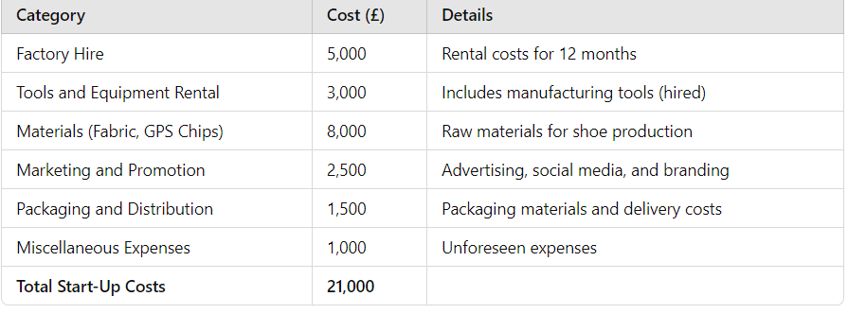
The financial plan table including start up spend and first year on-going expenses totals caters to all wants. The £21,000 start up expenditures covers crucial areas such as hiring a facility; tool and equipment leases and purchases of materials to make shoes, packaging, marketing et cetera. These expenses ensure that the company has a strong foundation for producing and selling its products. A further expected £5000 monthly operating expenses includes things like labour, utilities, all of which are regular and recurring costs necessary to the continuance of business. Emphasizing cost management, the company maintains a well- balance between revenue and expenses. It is expected that with its forecast shoe traffic on hand along with chances to custom orders, the company can produce a very considerable profit margin. By ensuring that start-up expenses are controllable and that the operating model is designed for long-term profitability, the financial plan demonstrates the business's viability. This system-based approach supports future expansion and secure growth.
Revenue table
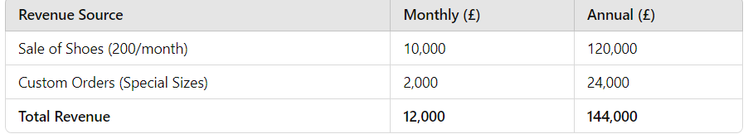
With sales of 200 pairs a month forecast at a price of £50 each, the company expects to do some brisk turnover with its marketing method. Therefore, ordinary sales create an income of £10,000. Custom orders are anticipated at an extra £2,000 per month, for a total monthly revenue of £12,000. During the year the company hopes to see £144,000 coming in. The company’s anticipated yearly profits of £63000 after deducting annual operating costs of £81000 demonstrate that it has robust cashflow and financial strength. This is cashflow neutral. Regular sales and other cash income mean the company’s cashflow remains unaffected. The forecast profit indicates the company's power to maintain service and reinvest in plans for expansion, thereby strengthening its position on the market.
CONCLUSION
Creativity, strategic planning, and an understanding of the market are all essential prerequisites for starting your own business. Representing an untapped market segment, this business model directed at infants' parents who value both convenience and security has the potential to take off on a huge scale in an emerging waterproof, trackable shoe market for children. If you set up your company in the form of a Limited Liability Company (LLC), you 'll have two benefits (Saunders et al., 2021). First, your business becomes scalable. Second, it's shielded from personal liabilities that could otherwise threaten its future growth. With its innovative design of items, competitive prices and effective advertising model (Kotler & Keller, 2020), the company is well placed to bring a lot of its target consumer groups. Expected annual profit: £63000. This number clearly shows that the Company can continue to operate after covering its own expenses and providing for growth opportunities. Any potential weaknesses that you can foresee now should also be addressed in the long term. To meet this end, we can take a variety of strategic marketing measures and establish relationships with the host country; these include raising awareness (Gallagher, 2023). The brand's market appeal can also be strengthened by sustainable production practices (Lumley & Wilkinson, 2022). Ultimately, this is a Business Plan that offers companies a clear path to starting and operating a commercial enterprise profitably, focusing on long-term growth prospects, financial reliability and innovation.

REFERENCES
Barringer, B. & Ireland, R.D. (2018), Entrepreneurship, Global Edition, Pearson Education. Available at: ProQuest eBook Central (accessed: 17.11.2024).
Barringer, B. & Ireland, R.D. (2020), Entrepreneurship: Successfully Launching new Ventures, Pearson. Available at: https://www.pearson.com (accessed: 21.11.2024).
Dal Mas, F., et al. (2021), Translating Knowledge in New Entrepreneurial ventures: the Role of business Plan Development, VINE Journal of Information and Knowledge management systems, Emerald Publishing, 53 (6), 1159-1177. Available at: https://www.scholar.google.com (accessed:22.11.2024)
Gallager, K. (2023), Essential Study and Employment Skills for Business and Management Students, Oxford University Press. Available at: https://www.oxford.com (accessed: 21.11.2024).
Kotler, P. & Keller, K.L. (2020), Marketing Management, Pearson education. Available at: https://www.pearson.com (accessed:21.11.2024).
Lumley, M. & Wilkinson, J. (2022), Developing Employability for Business, Oxford University Press. Available at: https://www.oxford.com (accessed: 21.11.2024).
McGrady, C. (2024), Energy Auditing Service. Available at: https://www.mcgradyclaeke,com (accessed:21.11.2024).
Saunders, M., Lewis, P., and Thornhill, A. (2021), Research Methods for Business students, FT Prentice Hall. Available at: https://www.ft.com (accessed:21.11.2024).
Trought, F. (2023), Brilliant Employability Skills: How to Stand Out from the Crowd, Pearson Education. Available at: https://www.pearson.com (accessed:21.11.2024).

