

Programme: MSc Data and Artificial Intelligence
Academic Year: 2025/2026
Module: Master’s Project (ACFA7003)

Explainable Vision Transformer for Acute Lymphoblastic Leukaemia Subtype Classification with Enhanced Generalisability and Mobile Deployment in Resource-Constrained Settings

Supervised by: Dr. Nouh Elmithwelly
Submitted by: RINKESHKUMAR AHIR
Student ID: 2431174

- DECLARATION
I, Rinkeshkumar Sureshbhai Ahir declare that I am the sole author of this Project; that all references cited have been consulted; that I have conducted all work of which this is a record, and that the finished work lies within the prescribed word limits. This work has not previously been accepted as part of any other degree submission.
Signed: RINKESH AHIR
Date: 30th April 2026
- FORM OF CONSENT
I, Rinkeshkumar Sureshbhai Ahir hereby consent that my Project, submitted in candidature for the MSc data and artificial intelligence degree, if successful, may be made available for inter-library loan or photocopying (subject to the law of copyright), and that the title and abstract may be made available to outside organisations.
Signed: RINKESH AHIR
Date: 30th April 2026

Abstract
Acute Lymphoblastic Leukaemia (ALL) is a significant paediatric and adult-case malignancy, but; diagnosis is still hindered by vague symptoms, invasive and expensive confirmation methods (e.g. bone marrow biopsy), and subjective manual review of peripheral blood smear (PBS) images. The main question considered in this dissertation is whether the Vision Transformer (ViT-B16) architecture, using its global self-attention mechanism, is able to induce more specific and objective automated multiclass PBS image subtypes classification than the more traditional convolutional methods. Applying a transfer-learning strategy, i.e., ImageNet-pretrained ViT-B16 weights were frozen, and a fresh four-class classification head was trained during 20 epochs using SGD (momentum 0.9), ReduceLROnPlateau scheduling and 70:15:15 split, a dataset was used, namely Blood Cells Cancer (ALL) (3,256 images per 89 patients; classes: BENIGN, EARLY Pre-B, Pre-B, Pro-B ALL). The model reached 98.62% test accuracy, a weighted F1-score of 0.9831, and ROC-AUC of 0.9995 on a held-out test set that was not shared, and zero misclassification cases between benign and malignant. Ablation experiment indicated a 3.53 percentage-point difference against ResNet-50 under the same condition, which validated the result of global attention in morphological features that spatial distribution in images of PBS. Only 41 minutes of training on a free cloud GPU pointed to the level of accessibility in computation. These results provide a strict multi-metric standard of the dataset, are a step towards using transformers in haematological AI, and justify the worth of transformer-based models as the next step in scaling, objective ALL screening in resource-constrained environments.

Keywords: Acute Lymphoblastic Leukaemia, Vision Transformer, ViT-B_16, Peripheral Blood Smear, Transfer Learning, Medical Image Classification, Deep Learning.

MODEL LINK:
https://huggingface.co/spaces/Rinkeshahir/ACUTE-LYMPHOBLASTIC-LEUKAEMIA

Table of Contents
Abstract 2
List of Figures 6
List of Tables 6
CHAPTER 1: INTRODUCTION 7
1.1 Research Background & Problem Statement 7
1.2 Research Aim 10
1.3 Research Question 10
1.4 Research Objectives 10
1.5 Summary of the Research Method 11
1.6 Rationale & Significance 12
1.7 Outline of Dissertation 13
CHAPTER 2: LITERATURE REVIEW 14
2.1 Introduction 14
2.2 Fundamental Architectures: Attention and Residual Learning 15
2.3 Vision Transformers: Natural Image to Medical Image Transformers 15
2.4 Blood Cells Cancer (ALL) Data 16
2.5 Data Augmentation: ideas and Applications 17
2.6 CNN-Based Methodologies Capability and Methodological Critique 17
2.7 YOLO-Based Detection: Claims and Evaluation Shortcoming at High Performance 18
2.8 ViT-based and Hybrid Attention Architectures of Hematologic Imaging 18
2.9 Systematic Evidence and the Methodological State of the Field 19
2.10 Summary and Research Gaps 19
2.11 Cross-Cutting Themes and Implications to this study 20
CHAPTER 3: METHODOLOGY 21
3.1 Research Design and Philosophical Standpoint 21
3.2 Dataset: Population and Sampling Strategy 21
3.3 Data Preprocessing Pipeline 24
3.4 Model Architecture: ViT-B_16 25
3.5 Transfer Learning and Classification Head Modification 27
3.6 Training Configuration and Hyperparameters 28
3.7 Evaluation Metrics 30
3.8 Ethical Considerations 31
3.9 Overview of the Proposed Methodology 31
3.10 Software Environment, Tools, and Reproducibility 32
3.11 Class Imbalance Considerations 33
CHAPTER 4: RESULTS 35
4.1 Overview 35
4.2 Training and Validation Dynamics 35
4.3 Final Test Set Performance 36
4.4 Per-Class Performance Analysis 37
4.5 Ablation Study 38
4.6 Comparison with State-of-the-Art Methods on the Same Dataset 39
4.7 Comparison with Broader State-of-the-Art Methods 40
4.8 Inference Efficiency 40
4.9 ROC Curve Analysis 41
4.10 Confidence Score Distribution and Model Calibration 42
4.11 Summary 42
CHAPTER 5: DISCUSSION 43
5.1 Overview 43
5.2 Interpretation of Overall Performance 43
5.3 Per-Class Performance and Clinical Implications 43
5.4 Architecture Justification: Global Attention versus Local Convolution 44
5.5 Comparison with Prior Literature 45
5.6 Limitations 46
5.7 Contribution to the Research Question 47
5.8 Clinical Practice and Healthcare AI Implications. 48
5.9 Methodological Reflection 48
CHAPTER 6: CONCLUSION 50
6.1 Summary of Findings 50
6.2 Research Objectives Revisited 50
6.3 Original Contributions 51
6.4 Broader Positioning within the Medical AI Landscape 52
6.5 Recommendations for Future Work 53
6.6 Closing Remarks 55
References 56

List of Figures
Figure 1 Hierarchical Presentation of Blood Cells Types and Major Leukaemia Subtypes [2] 9
Figure 2 Sample PBS Images from the Dataset Showing Benign and Malignant Subtypes (Early Pre-B, Pre-B, Pro-B) [5] 23
Figure 3 Workflow of the Proposed ViT-B_16 Architecture for ALL Classification (Author) 25
Figure 4 Splitting the PBS image into 16×16 patches (Author) 25
Figure 5 Architectural Overview of the Proposed ViT-B_16 Classification Model (Author) 27
Figure 6 ViT-B_16 Encoder Block Showing Multi-Head Self-Attention and Feed-Forward Sub-Layers [8] 27
Figure 7 Distribution of Classes in Blood Cells Cancer Dataset (Author) 34
Figure 8 Training Loss and Accuracy Curves (Rapid Convergence and Minimal Overfitting) (Author) 36
Figure 9 Web-Based User Interface for the Deployed ALL Classification System, Showing Image Upload and Prediction Output deployed in hugging-face space (Author) 41
Figure 10 Contributions to Haematological AI of Our Study (Author) 52

List of Tables
Table 1 Class Distribution of the Blood Cells Cancer (ALL) Dataset [5] 22
Table 2 Complete Hyperparameter Configuration for Model Training 29
Table 3 Software Dependencies and Their Roles in the Experimental Pipeline 32
Table 4 Per-Epoch Training and Validation Accuracy (Selected Epochs) 35
Table 5 Summary of Final Model Performance Metrics on Held-Out Test Set 36
Table 6 Per-Class Precision, Recall, and F1 Score on the Test Set 37
Table 7 Ablation Study Results: Impact of Key Pipeline Components on Test Set Performance 38
Table 8 Comparison with Prior Methods on the Blood Cells Cancer (ALL) Dataset 39
Table 9 Extended Comparison Against State-of-the-Art Methods Across Related Datasets 40
Table 10 Confidence Score Distribution for Correctly Classified vs Misclassified Test Samples 42

CHAPTER 1: INTRODUCTION

1.1 Research Background & Problem Statement
Cancer is among the causes of death in the world and hematologic malignancies take a considerable percentage of cancer-related death across the globe. Leukaemia is a blood and bone marrow malignancy, which is an unchecked increase in the number of abnormal blood cells, which impair normal hematopoietic process. It is widely categorised into four major ones according to the disease progression rate and the blood cell lineage affected Acute Lymphoblastic Leukaemia (ALL), Acute Myeloid Leukaemia (AML), Chronic Lymphocytic Leukaemia (CLL), and Chronic Myeloid Leukaemia (CML) [1].
ALL is one of such subtypes, which is of clinical interest. It is the most common malignancy that is diagnosed in children; it constitutes approximately 76 percent of all the cases of leukaemia in children and even in adults which the prognosis is normally much lower. The estimates based on the research conducted by the International Agency to Research on Cancer (IARC) showed that, globally, leukaemia caused an estimated 305,000 deaths in 2022. In the US, National Cancer Institute approximates 6,100 new cases of ALL annually and the survival rate of 5 years is approximately 73, although it varies greatly based on patient age, subtype of the disease and stage of the disease at which the disease was diagnosed [2].
ALL has a fast and aggressive clinical course. The initial symptoms, such as fatigue, constant fever, unexplainable bruising, and bone pain, are general and similar to most common diseases, which often leads to failure in timely diagnosis [5]. After the suspicion, to confirm ALL, a mixture of invasive and costly diagnostic techniques such as bone marrow biopsy, flow cytometry, cytogenetic and molecular studies are necessary. Although these techniques are diagnostically effective, they demand well-developed labora
tory facilities, qualified hematopathologists and large financial capacities. In low-income countries and in under-served healthcare environments, more generally, these barriers are directly related to delayed or missed diagnoses as well as poor patient outcomes.
Another weakness of the traditional diagnostic approaches is that they are subjective by nature. The diagnosis of abnormalities in morphology of blood cells relies on the subjective interpretation by the experts thus generating interobserver variance which may compromise the diagnostic consistency and reliability [5]. This subjectivity is a significant patient safety issue and inspires the need to find more objective and automated diagnostic solutions.
A relatively inexpensive and less invasive screening method of hematologic abnormalities is peripheral blood smear (PBS) imaging. In the case of ALL, PBS images display the morphological alterations in lymphoblasts which are typical of the disease. Nonetheless, these images are time consuming, skilled dependent, and no less prone to the interpretive errors afflicting other morphological techniques to be analysed manually. Using deep learning to automate the PBS image analysis has thus been a research topic of increased interest since it can enhance diagnostic accuracy, consistency and availability [5].
The most significant architecture in medical image classification is the convolutional neural network (CNN) which has shown to perform well in a variety of diagnostic imaging tasks. Nevertheless, CNNs are structure limited by their local receptive fields in that they extract features of small and local areas of an image at a time [3]. It is a considerable weakness in the ALL diagnosis with PBS images in which the morphological signatures of the disease, abnormal nuclear profiles, changed chromatin texture, and cytoplasmic abnormalities, are not localised at a specific location but spread throughout the image. Such a model can only question local patches, and may be missing the larger spatial patterns which contain diagnostically significant information. Figure 1 demonstrates the hierarchical classification of blood cells and related haematological diseases with the underemphasis on leukaemia subtypes.
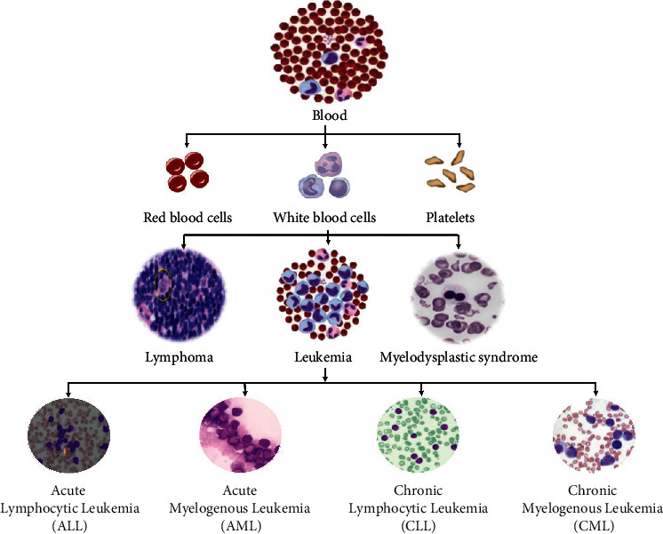
Figure 1 Hierarchical Presentation of Blood Cells Types and Major Leukaemia Subtypes [2]
Vision Transformers (ViTs), proposed by Dosovitskiy et al. [3] are capable of eliminating this constraint. ViTs can identify global contextual relationships in an image at the very beginning of processing by splitting the image into fixed-size patches and performing self-attention processes on all the patches at the same time. Such is their natural advantage in performing work in which the features of interest are located spatially, which is precisely the situation that defines ALL morphology on PBS pictures. ViT-B-16 (images processed as 16x16 patches of images) proved to be a successful model in challenging image classification tasks, and is one that should be considered strongly in ALL diagnosis. The proposed research is thus a study on the use of ViT-B 16 architecture in the classification of ALL based on peripheral blood smear images using Blood Cells Cancer (ALL) data set which consists of 3,256 images of 89 patients [5]. The classification is a binary distinction of benign and malignant cases, and a multiclass subtype classification of the malignant cases into Early Pre-B, Pre-B, and Pro-B ALL cases.

1.2 Research Aim
This study will focus on creating and testing a ViT-B-16-based deep learning model capable of the automated and precise classification of Acute Lymphoblastic Leukaemia using images of peripheral blood smears and determination of whether the developed model can serve as an objective, cost-efficient, alternative to the existing techniques of diagnosing the disease.

1.3 Research Question
Traditional deep learning systems using CNN architectures generate features around localised areas of an image and are restricted in the capacity to capture features with respect to global spatial features [3]. The diagnostic morphological features are spread throughout the entire image instead of isolating them in specific areas of the image in PBS images of ALL, and so local feature extraction cannot be relied on to yield reliable classification [5]. The self-attention mechanism of Vision Transformers involves processing the whole image as a whole, so they are in a better place to identify these globally spread features. The given distinction makes the major research question of this study:
How well does a deep learning model based on ViT-B-16 with self-attention capabilities to extract global features, identify Acute Lymphoblastic Leukaemia and its subtypes on images of peripheral blood smear, and should it serve as an alternative to standard diagnostic methods?

1.4 Research Objectives
- To achieve the stated aim, the following objectives have been defined:
- To develop an automated classification model for ALL detection using the Blood Cells Cancer (ALL) dataset, capable of accurately distinguishing between benign and malignant cases.
- To evaluate the performance of the ViT-B_16 architecture using established quantitative metrics, including accuracy, precision, recall, F1 score, and ROC-AUC.
- To assess the model's capability in classifying ALL into its subtypes, Early Pre-B, Pre-B, and Pro-B, demonstrating its clinical utility beyond binary classification.
- To evaluate the computational efficiency of the proposed model and its feasibility for deployment in resource-constrained healthcare settings.
- To examine the suitability of Vision Transformers over CNN-based architectures for PBS image analysis, in terms of global feature extraction and diagnostic reliability.

1.5 Summary of the Research Method
This study adopts a quantitative, experimental research design based on deep learning image classification. Model training, validation, and testing were performed on the Blood Cells Cancer (ALL) 3,256 PBS images of 89 patients [5]. The images were stained with standard procedures and divided into HSV colour space segments so as to enhance morphological features before being fed into the model [5]. ViT-B 16 was chosen as the main model due to its ability to extract world image characteristics using patch-based self-attention and is consistent with the distributive characteristics of ALL morphological indicators in PBS images [3]. The data set was divided into training, validation and test data to enable strict and unbiased performances analysis. Accuracy, preciseness, recall, F1 score, and ROC-AUC were used to measure model performance both in binary and multiclass classification tasks. Computational efficiency was also taken to determine feasibility of practical deployment. Transfer learning was used to overcome the problem of training a complex Vision Transformer architecture using a small dataset. ViT-B 16 weights (available publicly, trained on ImageNet-1k) were loaded and all the parameters of the backbone were frozen throughout the training. The last classification head, which is a single linear layer, was only trained with the ALL dataset, and its output is a mapping of the 768-dimensional class token representation to four output classes. The rationale behind this head only fine-tuning approach is that the possibility of disastrous overfitting occurs when a full 86 million parameter ViT is trained on less than 2,300 training images. The model was run over 20 epochs with Stochastic Gradient Descent with momentum and ReduceLROnPlateau learning rate scheduler with 32 batches. The entire training pipeline was done in Python via PyTorch and torchvision library and run on a Google Colabs environment with an NVIDIA T4 graphics card. It was a methodological decision to use a freely available cloud computing infrastructure, which was intended to prove that high-performance ALL classification could be obtained without institutional-scale computing resources an essential point to consider making such a system feasible in the resource-limited clinical setting. Image preprocessing Image preprocessing involved resizing all images to 224224 pixels (the required ViT-B-16 input specification), and using conservative random rotation augmentation (±10) only on training images to minimise overfitting without destroying diagnostically relevant morphology All images were converted to PyTorch tensors and normalised in pixel value range to [0 -1] with channel mean and standard deviation of 0.5. Only resizing and normalisation were done to the validation and test sets meaning that they were not augmented and evaluation was done on the images that were reflective of real conditions when the model will be deployed. The scikit-learn library was used to calculate the precision, recall, F1 score, and ROC-AUC of the model softmax output probabilities on the held-out test set only.

1.6 Rationale & Significance
The rationale behind this study lies in three underlying and mutually reinforcing issues in ALL diagnostics, namely, late-stage diagnosis as a result of non-specific and insensitive initial symptoms, excessive cost and invasiveness of confirmatory diagnostic tests, and subjectivity of morphological diagnosis by human specialists [5]. Combined, these issues produce a diagnostic environment that is both inequitable and uneven, and inappropriate to healthcare settings that have limited resources. The value of the current research is that it uses the Vision Transformer architecture to manage these issues with the help of automated PBS image analysis. Though the CNN-based methods have contributed to the development of the medical image classification field, their architectural weakness of capturing features globally scattered is an important limitation of ALL diagnosis in particular [3]. This study will give empirical support to the appropriateness of ViT-B_16 in the scenario and will also associate with the extensive body of literature on transformer-based methods in medical imaging. The practical implications are significant: a high performing, computationally efficient model with objective ALL classification of PBS images will have significant potential to reduce reliance on invasive procedures, reduce diagnostic expenses, and enhance diagnostic results consistency, and this benefit would be especially relevant in low-resource clinical environments.

1.7 Outline of Dissertation
The dissertation is organised in 6 chapters. Chapter 1: Introduction presented the scope of the research, background, problem statement, aims and objectives and research question. Chapter 2: Literature Review critically reviews the existing literature, compares the past studies, and establishes gaps and connects the findings to the research question. Chapter 3: Method provides description of the research methodology with justification of the methods and study population, sampling, data collection procedures, data collection materials, and ethical considerations. Chapter 4: Results says that data collected by chapter are presented either in tables or graphs or in a descriptive format without interpretation; says that statistical analyses are reported. Chapter 5: Discussion interprets and evaluates results, compare findings with literature and also indicates limitations. Chapter 6: Conclusion summarises the main conclusions, interprets them in relation to the objectives of the research and implications, and states the future research directions.

CHAPTER 2: LITERATURE REVIEW

2.1 Introduction
Leukaemia is a blood cancerous disorder that occurs as a result of unregulated proliferation of abnormal Hematopoietic cells in the bone marrow. It may be classified into four big subtypes, i.e., the Acute Lymphoblastic Leukaemia (ALL), Acute Myeloid Leukaemia (AML), Chronic Lymphocytic Leukaemia (CLL), and Chronic Myeloid Leukaemia (CML). ALL is approximated to result in approximately 76 percent of incidences among children (ages 019 years) and even among adults. It is estimated that globally 305,000 deaths due to leukaemia happen annually, and in the United States approximately 6,100 people per year are newly diagnosed with ALL and the relative survival rate of the disease is approximately 73 percent to five years old based on disease stage and age [2]. Subtype detection is critical in early timely detection because of the general nature of their symptoms.
Although bone marrow biopsy and cytogenetic analysis are the best standards of diagnosis, they are invasive and costly. The alternative to the invasive procedure is the PBS imaging of the peripheral blood though manual analysis is time consuming and may vary. Automated deep learning models therefore provide a diagnostic solution in a scaled-up manner.
In the proposed study, the Vision Transformer (ViT-B/16) is fine-tuned on the Blood Cells Cancer (ALL) dataset [5], having 3,256 HSV-segmented PBS images of 89 patients with four classes, such as Benign, Early Pre-B, Pre-B, and Pro-BALL. On a 70:15:15 split the model scored an accuracy of 98.62, F1-score of 0.9831 and ROC-AUC of 0.9995.
The chapter provides an overview of the history of transformers, Vision Transformer application in medical imaging, and compares CNN-, YOLO-, hybrid-, and ViT-based approaches to ALL classification and identifies gaps in the existing literature that support the justification of the current research.

2.2 Fundamental Architectures: Attention and Residual Learning
In the current case, ViT-B/16 architecture is grounded on two publications in mid-2010s. Vaswani et al. [6] replaced recurrence and convolution with scaled dot-product self-attention with a BLEU score of 28.4 on WMT 2014 English-German translation. The key feature of ViT-B/16 is that they are formulated, with query matrix, key matrix and value matrix and weighting value values calculated as softmax-normalised scaled dot products. Their biggest contribution is in the architectural sense, global dependency modelling it is self-attention rather than convolution where long-range relationships are applied to the entire input. This is more so in case of PBS image classification where diagnostic cues are developed on the basis of global morphology of the cellular image rather than on local areas. In their turn, He et al. [7] addressed the problem by degrading deep CNNs with residual connections to allow training very deep models (such as ResNet-152, with a top-5 error of 3.57% on ImageNet). Even though the ViT-B/16 architecture is not founded on convolutional residual blocks, ResNet remains the chief baselines used in medical imaging and is widespread in the hybrid CNN-ViT systems. Such hybrids typically are motivated by the fear that pure ViTs cannot be trained on small datasets, which implicitly is assumed in this project. The difference in architecture consists in the centre: He et al. [7] maximise the local spatial hierarchies with convolutional depth and Vaswani et al. [6] with global contextual modelling with attention. The paper goes further to the hypothesis that PBS-based ALL classification is more suitable to the global attention paradigm.

2.3 Vision Transformers: Natural Image to Medical Image Transformers
Dosovitskiy et al. [8] used self-attention on visual data by dividing a picture into fixed-size patches and encoding the patches and positional encodings linearly, and with a Transformer encoder. The pipeline could be duplicated by 224x 224 PBS images broken down into 16x 16 patches (196 tokens) and the classification token is made to a four-class softmax head. ViT-L/16 using pre-trained models had the highest accuracy and the lowest cost of inference of 88.55 percent on ImageNet top-1. Yet, the study conducted by Dosovitskiy et al. [8] also demonstrated the fact that in-the-wild ViTs trained in its purest form are not as good as CNNs on intermediate-sized datasets, due to the fact that their inductive biases are weak. The Blood Cells Cancer (ALL) data are few 3 256 pictures and thus in this regime. Therefore, the study proposed ImageNet-pretrained ViT-B/16 weights conditioned but changed the classification head, which was identified as a good transfer learning method. This is in contrast to the approach taken by He et al. [9] and Okundalaye et al. [10] came up with an automated paediatric ALL classification ResNet-50 with 99.6% accuracy and 0.994 F1-score on the ALL IDB v2 data, which shows the reliability and reproducibility of early diagnosis of ALL based on blood smears. Chen et al. [11] explain how TransUNet has been applied in medical imaging, which is a ViT encoder that is embedded into a U-Net structure to combine both global attention and locality achieved through CNN. Subsequently, Cao et al. [12] proposed Swin-Unet; an all transformer-based segmentation network that performed well on Synapse, asserting that CNN modules are likely to cause architectural bottlenecks. The immediate implication of this discussion on the present study will be the response to the question of whether a pure ViT can be as useful in the classification of the ALL subtype in the context of hybrid models. In spite of the evidence provided by the results of the segmentation, suggesting this probability, PBS categorisation remains to be proved empirically.

2.4 Blood Cells Cancer (ALL) Data
The information used in the present study has been introduced by Ghaderzadeh et al. [5], who have developed a CNN to identify B-ALL subtypes using PBS images. It was acquired in 89 patients in a single centre (Taleghani Hospital, Tehran) and comprises of 3256 HSV segmented images, categorised into four clinically important groups, including Benign, Early Pre-B, Pre-B, and Pro-B ALL. The staining characteristics are better isolated by the HSV based segmentation more than by RGB thresholding, thus allowing more confidence in morphological analysis. Besides a source of data, Ghaderzadeh et al. [5] demonstrated that the computational models can distinguish between all types of ALL and regularised images of PBS and this means that the dataset forms a reference point later adopted by other researchers [9], [10], [13] as a baseline. This facilitates comparison of cross-studies even though there is exposure of methodological inconsistencies. Its greatest limitation, which is generally not much emphasised, lies in the fact that it has a single-centre origin, which leaves unanswered the questions of extrapolation to images made at different staining or microscopy settings.

2.5 Data Augmentation: ideas and Applications
The number of images (70:15:15 split) is only about 2,279, which is insufficient to be augmented. According to Shorten and Khoshgoftaar [14], augmentation decreases overfitting and enhances generalisation with limited amounts of data, however, transformations that work well on natural images can also cause biologically unrealistic artefacts in medical imaging. As cellular orientation and nuclear morphology are diagnostically relevant in PBS analysis, conservative augmentation is used in this work: random rotations, flips, small translations, as well as RGB normalisation to [0.5, 0.5, 0.5] to fit ImageNet pre-training. Training set is only augmented; validation and test sets consist of purely original images of unknown patients. It is noteworthy that augmentation is not explicitly reported in published YOLO-based studies, such as [9], which restricts reproducibility, which is part of transparency, as Aria et al. emphasise the issue of transparency in their work [15].

2.6 CNN-Based Methodologies Capability and Methodological Critique
Prior to transformers, CNNs were the dominance of computational haematology. The authors suggested the use of ALLNET on binary ALL detection in C-NMC 2019, with 95.54 percent accuracy [16]. Although the domain-specific filters are compatible with the morphology of lymphoblasts, four-class subtype classification is more clinically relevant than binary framing. Similarly, Soladoye et al. [17] used EfficientNet-B3 (ImageNet pre-trained) to detect binary ALL on blood smear images and they indicated accuracy of 96% and F1-score of 93% on the minority group. Although they are based on different approaches (custom vs transfer learning), both are similar in their performance and are not based on a multi-class focus. To create a four-class model, which they call encoder and attention modules, Jawahar et al. [13], used the same Kaggle ALL dataset, and reported 99.86% accuracy at training. They do not, however, explicitly distinguish training and strictly-held-out patient-level test performance, or give per-class measures. According to Aria et al. [15], these trends of reporting can overestimate the performance in leukaemia AI. Comparatively, this work is said to have a test accuracy of 98.62% and F1-score of 0.9831 on a rigid 15% hold-out, prioritising generalisation. Kasim et al. [18] implemented CNN feature extractors (VGG16, Inception V3, ResNet50) together with classical classifiers (SVM, Random Forest, XGBoost) and concluded that the hybrid pipelines can be compared to end-to-end models with small data. Although valid, this makes hyperparameters more complex and exposes to overfitting. This paper rather uses a single, end-to-end fine-tuned ViT-B/16 that has a lower architectural and optimisation complexity.

2.7 YOLO-Based Detection: Claims and Evaluation Shortcoming at High Performance
Closest comparisons are those based on YOLO models on the same dataset of four classes. He et al. [9] compared YOLOv8 and YOLOv11 (max accuracy 98.8%). But these findings are hard to decipher. First, YOLO is a detection model, but both of the studies do not warrant its application to the classification of entire images. Second, they are both dependent on aggregate accuracy and thus may hide the effects of class imbalance. They have no reports of per-class precision, recall, F1-scores, or confusion matrices, which restricts clinical interpretability, particularly of rare subtypes. By comparison, this paper has accuracy (98.62%), precision (0.9840), recall (0.9831), F1-score (0.9831), and ROC-AUC (0.9995) on a carefully held-out test set. Third, Aria et al. [15] mention that high accuracy (above 98) is not always externally validated, and it is of more concern. The main advantage of YOLO is that it is spatially interpretable through the process of bounding-box localisation, which allows the identification of cells that are influential. This classification-only methodology does not offer such localisation, which is a weakness and a future direction of hybrid detection-classification work.

2.8 ViT-based and Hybrid Attention Architectures of Hematologic Imaging
The recent literature favours using Vision Transformers in haematological imaging. Koch et al. [19] proposed DinoBloom, a ViT foundation model that has been pre-trained on more than 380,000 images of white blood cells on the 13 datasets. It performed better than CNN baselines and visualisation of UMAP revealed that self-attention embeddings group cells according to morphologically meaningful features, which is consistent with diagnostic practice. Residual connections, ViT blocks, and GAN-based augmentation was proposed by Hameed et al. [20] with an F1-score of 99.15. It is, however, not clear due to the absence of ablation studies on whether the gains are as a result of attention, residual design, or synthetic data. Generally, there is an open question in the field, that is, whether pure ViT with enough pre-training suffices [19], or hybridisation and augmentation are required with small medical datasets [20]. The paper follows a middle ground: a typical ViT-B/16 trained to ImageNet without additional residual changes or GAN enhancement demonstrates that regular transfer learning can be used to achieve effective four-class ALL.

2.9 Systematic Evidence and the Methodological State of the Field
In a meta-analysis on a large scale, Aria et al. [15] find a high level of heterogeneity in studies on leukaemia AI, which is mainly explained by the variation in the evaluation protocol. Research with purported >98% accuracy often has not undergone independent test validation, has not verified accuracy on aggregate but not on individual classes, and has not ensured augmented transparency. These issues are covered in the present project by a rigorous 15% hold-out test set and precision, recall, F1, and ROC-AUC reporting. A classical five-stage ML pipeline with optimised feature selection can provide competitive results without deep networks, as shown by Shaban [21]. That supports the necessity of strict validation over headline accuracy. Lastly, a clinically based AML study by Eckardt et al. [22] has an AUROC of 0.9699 and instead of using aggregate accuracy, provided the findings in a missed-diagnosis versus false-negative format, pointing to the asymmetry between false negatives and false positives. It is quite unusual in all literature on clinical framing and is a methodological gap that the field needs to fill before it can be safely applied in practice.

2.10 Summary and Research Gaps
Three key gaps emerge. In the first place, there is consistent evidence of self-attention in the context of the global feature modelling by Vaswani et al. [6] and Dosovitskiy et al. [8], and it is reinforced in haematology by Koch et al. [19] and in hybrid models by Hameed et al. [20]. CNNs in contrast, despite such enhancements as residual learning [7], are still locally constrained. As the PBS morphology (e.g. nuclear irregularity, chromatin texture, N:C ratio) is distributed globally, a transformer-based solution is theoretically justified.
Second, CNN-based researches [16], [13], [18], [17] and YOLO-based ones [9] represent an uneven pattern of evaluation. Most high-accuracy claims, as Aria et al. [15] point out, are not properly separated in tests and have overall measures. Shaban [21], also demonstrates that classical ML can be as effective as deep models, which challenges the benchmark robustness.
Third, no previous studies strictly assess a pure ViT-B/16, optimised on ImageNet, on the four-class ALL dataset of Ghaderzadeh et al. [5] using a strict patient-level 70:15:15 split and full multi-metric reporting. This paper fills that gap by assessing a ViT-B/16 on 3256 images, accuracy, precision, recall, F1, ROC-AUC, and also takes into account computational considerations. The methodology of filling these gaps is described in chapter 3.

2.11 Cross-Cutting Themes and Implications to this study
Four themes guide this study. First, complexity of the model vs. size of dataset: the literature is spread between the simple CNNs [16] and complex hybrid systems [20], although no evidence points unequivocally towards complexity. Shaban [21] demonstrates that classical ML can also compete, which is why a more simplified approach of fine-tuning is chosen in this study.
Second, dependence on single measures: accuracy takes up the role of reporting even when it is not so efficient [15]. Such studies tend to overstate generalisation according to Aria et al. [15]. Instead, accuracy, precision, recall, F1, and ROC-AUC are reported in this work.
Third, the significance of the rigid separation between training and testing: a number of studies mix training and test performance, as in Jawahar et al. [13]. In this paper, a strict held-out test set of 15 percent is imposed. Fourth, clinical relevance: Eckardt et al. [22] claim that an aggregate accuracy is not enough, and trade-offs in diagnosis are important. Based on that, the present study will contain per-class measurements and also will concentrate on clinically significant differences like BENIGN vs malignant classification.
Last but not least, geographic concentration is evident in the literature as the majority of the datasets such as Ghaderzadeh et al. [5] are limited to specific areas. This poses a question regarding the applicability to a wide range of populations (e.g., sub-Saharan Africa, South Asia, Latin America). The concept of multi-centre validation is another significant way forward (see Section 6.4).

CHAPTER 3: METHODOLOGY

3.1 Research Design and Philosophical Standpoint
The current study follows the positivist paradigm which explains that objective truths may be identified by the systematic observation and measurement using empirical means [23]. In this regard, the quantitative, experimental design is used, where the performance of the models is evaluated by standardised measures, which is in accordance with the current trends in deep learning and medical image analysis that emphasise reproducibility and empirical benchmarking [15].
The design will be one-group assessment of the ViT -B 16 model with no control group since the aim is not to compare the performance of humans and machines but to set a baseline in terms of previous research. It is observational in terms of the dataset, without the collection of new data and treatment of the cases, using existing clinical images. The methodology fits this objective because ViT-B -16 was aimed at evaluating the capability of classification on the available data.
Deductive approach is used, in which theoretical predictions based on self-attention and extraction of global features are obtained against empirical findings obtained on a held out test set. This process promotes agreement between theoretical justification and methodology of evaluation.
Quantitative design would be considered suitable, as the scientific question of interest, which is the degree to which ViT -B 16 can be used in classifying ALL, would require quantifiable evidence. In this case, qualitative methods are inapplicable and rather relevant to clinical experience or health care implementation studies.

3.2 Dataset: Population and Sampling Strategy
The population of interest in this study will be people who present with suspected acute lymphoblastic leukaemia (ALL) or benign haematological issues, defined by peripheral blood smear images. The particular dataset used is the Blood Cells Cancer (ALL) one, which was first published by Ghaderzadeh et al. [5] and then publicly available through the Kaggle data science platform [15]. This is a compilation of high-resolution peripheral blood smear images, which were gathered in the Taleghani Hospital in Tehran, Iran, and 3,256 images are provided in 89 patients.
These images will be divided into four clinically salient groups that include Benign (504 images), Early Pre-B ALL (985 images), Pre-B ALL (963 images), and Pro-B ALL (804 images) as shown in Table 1.
Table 1 Class Distribution of the Blood Cells Cancer (ALL) Dataset [5]
Class Label | Clinical Meaning | Image Count | % of Total
BENIGN | Healthy/Non-cancerous | 504 | 15.5%
EARLY | Early Pre-B ALL | 985 | 30.2%
PRE | Pre-B ALL | 963 | 29.6%
PRO | Pro-B ALL | 804 | 24.7%
TOTAL |  | 3,256 | 100%
There were four specific criteria used to select the dataset. To begin with, it is specifically crafted to classify ALL sub-types in accordance with PBS images, which is why it is close to the research question. Secondly, it outlines four different clinically validated classes, which generates a multi-class classification system rather than a binary detection model. Thirdly, the data are based on veritable patient samples under controlled clinical conditions and standardised staining procedures, which makes it biologically valid. Fourthly, this data will support a reference set in which much of the literature reviewed in Chapter 2 was based thus allowing direct comparative bench-marking [9]-[13].

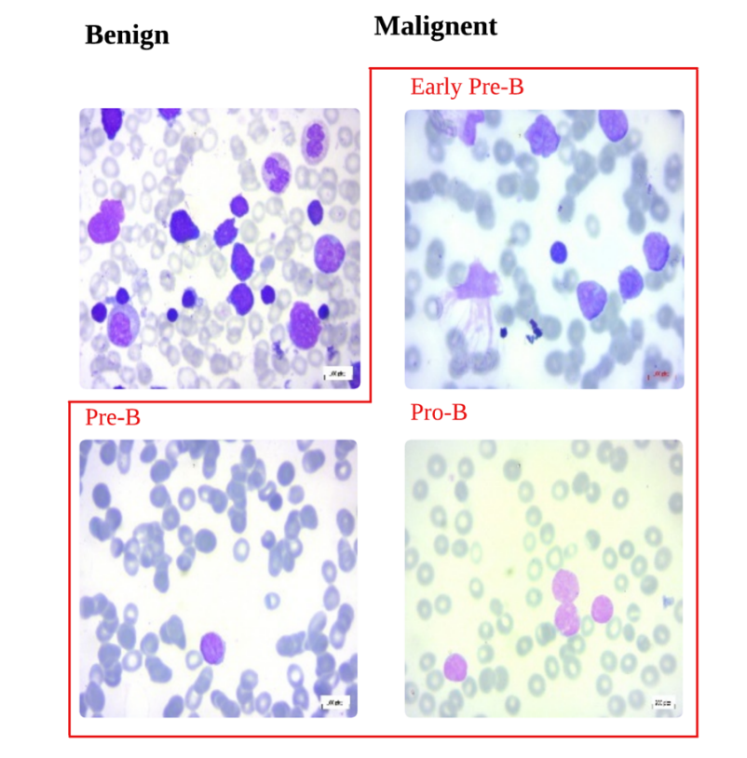
Figure 2 Sample PBS Images from the Dataset Showing Benign and Malignant Subtypes (Early Pre-B, Pre-B, Pro-B) [5]
The weaknesses of the dataset used in sampling should be recognised. The entire sample of 89 patients was selected within one Tehran institution and, therefore, it is unclear to what extent these findings can be extended to PBS images obtained in different clinical environments, microscopes, or staining regimens. This is not the only limitation of the current study, but rather an accepted limitation in the field [15] and we need to mention it. Public release of the data does not give patient-level demographic breakdown, thus eliminating the opportunity to stratified analysis based on age, sex, or disease stage. However, the concurrent staining procedure and professional marking by Ghaderzadeh et al. [5] offers a reasonable standard of quality in the aims of this study.
The data was split in 70:15:15, which gave 2,279 training images, 488 validation images, and 489 test images. This division was done at the level of image, stratified random sampling was used to maintain the proportion of classes in the three subsets. The training, validation, and test sets are completely discontinuous, in that none of the images of patients appear in more than one partition. Validation set was used solely in tuning the hyperparameters and early stopping but the test set was not analysed until the final evaluation of the model to give a fair analysis of the generalisation performance.

3.3 Data Preprocessing Pipeline
All the input images were subjected to the preprocessing pipeline before being trained. The pipeline was created to transform raw PBS images as per the output of the ViT-B16 model and to minimise the domain gap between the PBS images and the ImageNet distribution in which the model was pretrained.
The preprocessing pipeline comprises the following sequential operations:
• Resizing: Each image was resized to 224 x 224 pixels, which is in line with the requirements of ViTB16 as input. This is in line with its patch based architecture where each image is broken into the 14 x 14 patches of size 16 x 16 which then results in 196 discrete tokens.
• Random Rotation (training only): In training, the images were randomly rotated at ±10 ° allowing the strategy to enhance variations between intra-class and reduce overfitting. This is a conservative angular perturbation which does not distort such diagnostically important aspects as nuclear orientation and cellular morphology. Validation or test sets were not subjected to any rotational transformation.
• ToTensor Conversion: the conversion of the images to PyTorch tensors was performed with normalisation of pixel intensity in the original [0, 255] range to the range [0.0, 1.0].
• Normalisation (per channel): The Pixel values were normalised based on per-channel mean of [0.5,⁯0.5, 0.5] and a standard deviation of [0.5, 0.5, 0.5] which essentially restricted the channels to the range [ -1, 1]. The transformation follows:
${x'}_{c}=\frac{x_{c}-μ_{c}}{σ_{c}}$ …… 3.1
where x_{c} denotes the original pixel value in channel c, μ_{c} = 0.5 is the channel mean, σ_{c} = 0.5 is the channel standard deviation, and x'_{c} is the normalised output. This uniform normalisation scheme is commonly applied in transfer learning contexts where the target domain differs from the source domain [24]. Figure 4 shows the splitting of image into 16×16 patches.

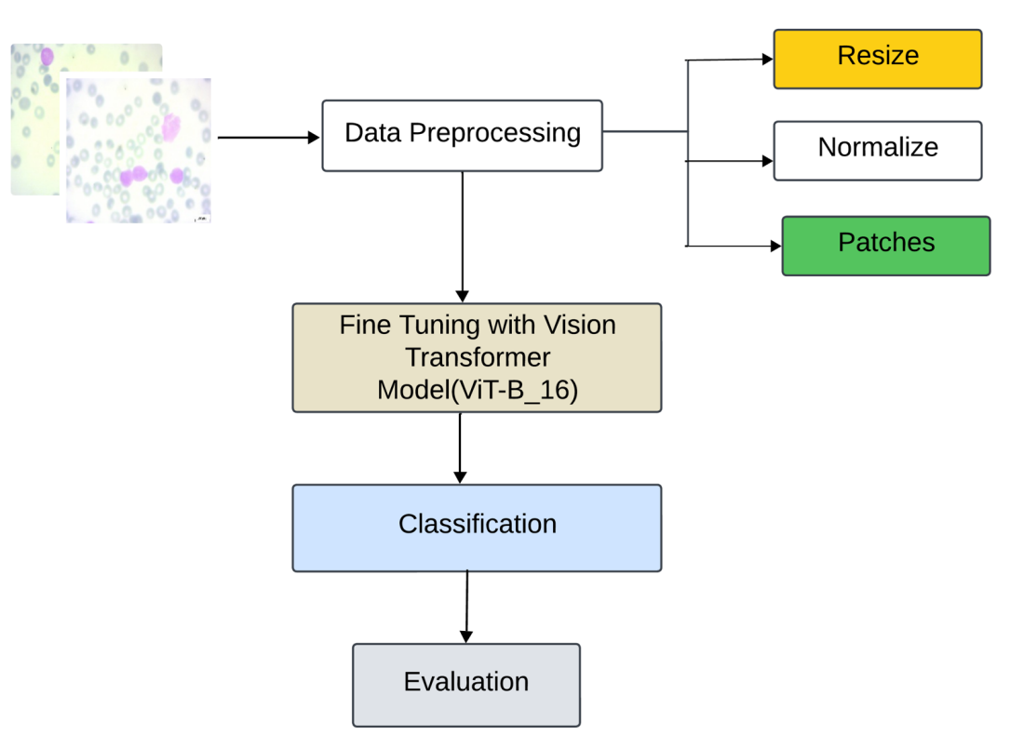
Figure 3 Workflow of the Proposed ViT-B_16 Architecture for ALL Classification (Author)
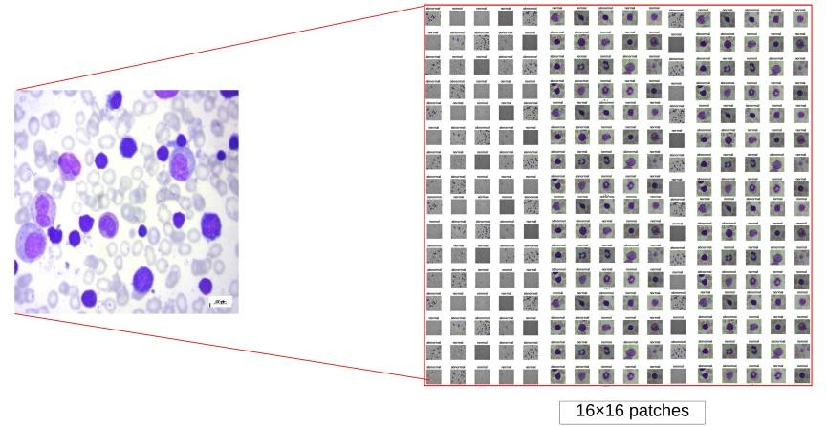
Figure 4 Splitting the PBS image into 16×16 patches (Author)

3.4 Model Architecture: ViT-B_16
Vision Transformer (ViT), which was introduced by Dosovitskiy et al. [8], is used as the base model, namely ViT-B 16. It handles the images by breaking them down into fixed-size patches, placing each patch into a token and then routing the tokens of the resultant token through an encoder called a Transformer. This architecture replaces the traditional convolutional neural networks (CNNs) due to its multifold ability to model interactions between global features, a thesis that is theoretically feasible in Chapter 1 and empirically validated by previous research (Chapter 2). In case of a 224x 224 RGB image the input is divided into, N = (224/16)² = 196 patches that are non-overlapping and have dimension 16x16x3. Every patch p i is linearly embedded to a 768 dimensional embedding::
Z^{i}=p_{i} . E + b ….. 3.2
Where E∈R^{(16.16.3)×D} is the learnable embedding matrix and b x D a bias vector. A learnable class token, denoted as Z₀, is inserted to the end of the sequence to create a sequence of length 197. Spatial information is retained by the use of positional embeddings:
Z₀=[z_{class};z₁;z₂;…;z₁₉₆]+E_{pos​}……. 3.3
The sequence is processed by L=12 Transformer encoder blocks. Each block applies Multi-Head Self-Attention (MHSA) and a feed-forward network with residual connections and layer normalisation [6]. The attention mechanism is defined as:
$Attention(Q,K,V)=softmax(\frac{QK^{T}}{\sqrt{d_{k}}})V$ …… 3.4
where Q,K,V are query, key, and value matrices, and d_{k}=D/h with h=12 heads. Multi-head attention is computed as:

MHSA(Q,K,V)=Concat(head₁,…,head_{h})W^{O}……. 3.5
The feed-forward network is:
FFN(x)=GELU(xW₁+b₁)W₂+b₂ ……. 3.6
After 12 encoder layers, the class token output is extracted and passed through a linear classification head that maps the 768-dimensional representation to the final class labels.

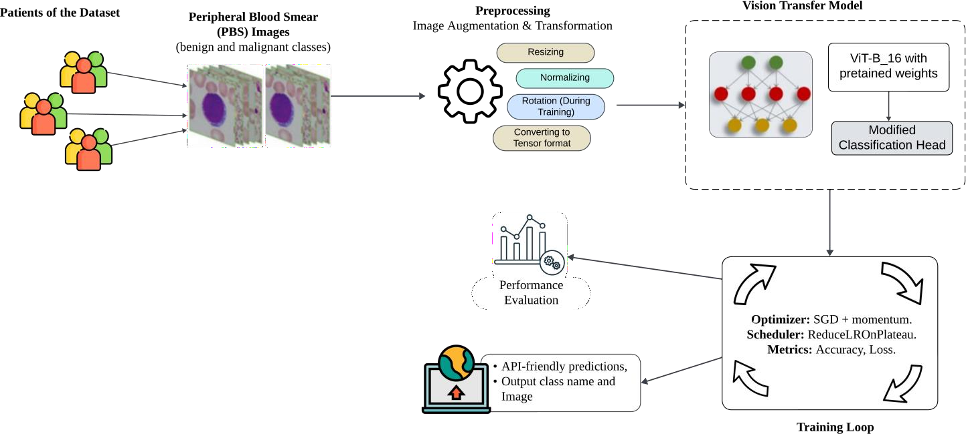
Figure 5 Architectural Overview of the Proposed ViT-B_16 Classification Model (Author)
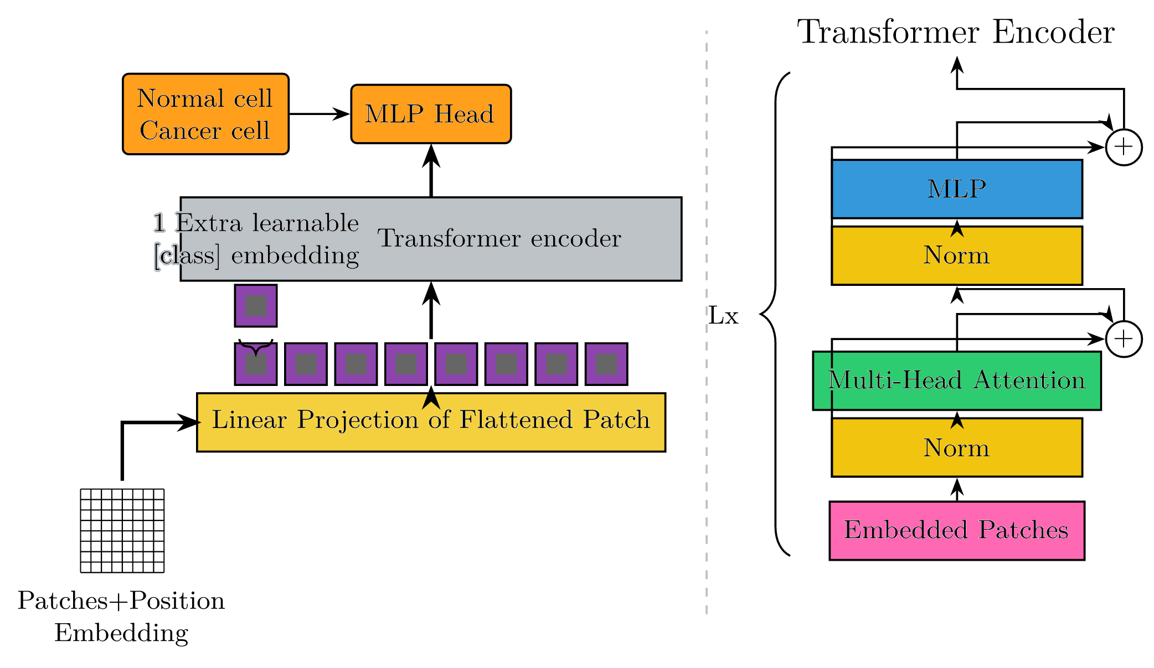
Figure 6 ViT-B_16 Encoder Block Showing Multi-Head Self-Attention and Feed-Forward Sub-Layers [8]

3.5 Transfer Learning and Classification Head Modification
Since Blood Cells Cancer (ALL) is a comparatively small dataset (3 256 images), the ViT -B 16 cannot be trained with random initialisation due to its high computation cost and, more importantly, cannot be trained because of its small inductive biases [8]. This experiment thus makes use of the concept of transfer learning, whereby the publicly available ViT -B 16 weights that are pretrained on ImageNet 21k and then fine-tuned on ImageNet 1k using the torchvision library of PyTorch [23]. This gives a rich general purpose visual representation as the foundations of task specific adaptation.
Based on the standard transfer-learning procedure, the backbone of ViT-B16 was frozen (requires_{grad} = False) and the feature representations were kept. The only layer that was changed and made trainable was the classification head which was the last linear layer.
The default ImageNet-1k classification head, where the 768-dimensional class token is mapped to 1000 output classes, was substituted with an alternative linear layer that is mapped to four output classes that represent BENIN, EARLY, PRE and PRO:
$\hat{y }$=W_{head} . z_{class}+b_{head} ….. 3.7
where W_{head}∈R^{4×768} and b_{head}∈R⁴ are the learnable parameters, z_{class} is the 768-dimensional class token from the final encoder block, and $\hat{y }$∈R4 is the vector of unnormalised logits. The predicted class is argmax($\hat{y }$), and class probabilities are obtained via the softmax of $\hat{y }$. This approach, following Pan and Yang [24], leverages the pretrained model's feature extraction while adapting outputs to the target task and substantially reduces trainable parameters, mitigating overfitting on the small dataset.

3.6 Training Configuration and Hyperparameters
The full training configuration is summarised in Table 2. The model was trained on the pre-processed training set for 20 epochs using Stochastic Gradient Descent (SGD) with momentum as the optimiser. SGD with momentum updates model parameters iteratively according to:
$v_{t}=γ . v_{t-1}+η . ∇_{θ}L(θ)$ ……. 3.8
$θ_{t+1}=θ_{t-vt}$……. 3.9
In which θ are the model parameters, eta (learning rate) 0.9 gamma (momentum coefficient), 0.9 L(600) theta -1 (gradient of the cross-entropy loss L), and v t the velocity vectors summing past gradient vectors. The momentum term 0.9 was selected to quickly converge with consistent gradient directions and reduce oscillations, which is appropriately scaled to fine-tune few parameters (the classification head) on quite smooth loss surface.
The initial eta was configured to the value of 0.1 and was configured dynamically with the assistance of ReduceLROnPlateau structured that tracks the validation accuracy per epoch. When the validation accuracy is not rising with the number of epochs the patient is left to learn it, the learning rate is reduced by a factor of 0.1 which is roughly an order of magnitude. This time scale is accurate because training loss surface during the fine-tuning phase of classification head may become flat with convergence and the lesser the learning rate, the better the weight upgrades may be without entering local minima.
The cross-entropy loss function was used to train it:
$L=-\frac{1}{N}\sum_{i}{y_{i,j} . log({\hat{y }}_{i,j})}$……. 3.10
In which N is the mini-batch size, y_{i,j} is the one-hot encoded ground-truth label of sample i and class j, and ${\hat{y }}_{i,j}=softmax({logit}_{i,j})$ is the prediction probability. Multiclass classification Cross-entropy loss is the common objective in multicast classification when classes are mutually exclusive and the log-likelihood of the correct classification is directly maximised.
Table 2 Complete Hyperparameter Configuration for Model Training
Hyperparameter | Value / Setting
Base Model | ViT-B_16 (ImageNet-1k pretrained)
Input Image Size | 224 × 224 pixels
Patch Size | 16 × 16 pixels (196 patches)
Number of Classes | 4 (BENIGN, EARLY, PRE, PRO)
Trainable Parameters | Classification head only (3,076 params)
Optimiser | SGD with Momentum
Momentum (γ) | 0.9
Initial Learning Rate (η) | 0.1
LR Scheduler | ReduceLROnPlateau (factor=0.1, mode=max)
Loss Function | Cross-Entropy Loss
Batch Size | 32
Epochs | 20
Data Split | 70% train / 15% validation / 15% test
Normalisation (mean) | [0.5, 0.5, 0.5]
Normalisation (std) | [0.5, 0.5, 0.5]
Augmentation (train only) | Random rotation ±10°
Training Hardware | Google Colab (NVIDIA T4 GPU)

3.7 Evaluation Metrics
The model outcomes were compared against five common classification measures, namely, accuracy, precision, recall, F1 score, and the Receiver Operating Characteristic Area Under the Curve (ROC-AUC). Those measures were chosen to give a holistic perspective of the model performance that takes into consideration both the per-class discrimination and the total correctness as best practices in the medical AI evaluation [15], [22]. The entire metrics values were calculated on the withheld test set only.
Accuracy is the rate of all test samples correctly set:
$Accuracy=\frac{\sum_{i}{TP_{i}}}{N_{total}}$ …….. 3.11
Precision (positive predictive value) and class i This is the fraction of predicted positives which are actually true positives:
${Precision}_{i}=\frac{TP_{i}}{TP_{i}+{FP}_{i}}$ ………. 3.12
Recall (sensitivity) of class i The fraction of the actual positive (namely the true positive) that is recognised:
${Recall}_{i}=\frac{TP_{i}}{TP_{i}+{FN}_{i}}$ ………. 3.13
F1 Score is a weighted average of precision and recall that is a balanced value:
${F1}_{i}=\frac{2 . ({Precision}_{i} . {Recall}_{i})}{{Precision}_{i}+ {Recall}_{i}}$ ……. 3.14
The main aggregate measure is the weighted average F1 score, where each class is weighted by the number of true instances, to correct the imbalance in the classes [25]. Multiclass classification (ROC-AUC Receiver Operating Characteristic Area Under the Curve) is computed by use of a One-versus-Rest (OvR) strategy, that considers each class by itself as the positive class versus all others [25]. The macro-averaged ROC-AUC is a single aggregate of the capabilities of the model to discriminate between all four of the classes at the same time. The ideal classifier is a ROC-AUC of 1.0 which is the perfect classifier, whereas 0.5 is the one who guesses randomly.

3.8 Ethical Considerations
The presented study utilised the Blood Cells Cancer (ALL) data that were gathered and processed by Ghaderzadeh et al. [5] in the proper institutional and ethical control at Taleghani Hospital, Tehran. All of the images in the publicly released dataset are anonymised before make them public; there is no personally identifiable information (like the name of a patient, their identifiers, or demographics) in the image data or deductible by other means. The dataset was accessed via the Kaggle platform, which made the user accept the terms of use of the dataset creator. Since this research will entail a quantitative analysis of the anonymised, and already existing clinical image information, it will not need independent ethical approval of the study under the policies of the institution where this dissertation is presented.
Nonetheless, the study does not overlook the ethical issues that come with the medical AI development on a larger scale: any clinical use of this model would have to be prospectively tested on independent multi-centre data sets, be approved by the authorities of the jurisdiction, and be combined with human expert supervision. The model created below is a prototype of a research model which should not be applied in patient diagnosis without necessary clinical validation. The study has no data fabrication, falsification, and misrepresentation of results.

3.9 Overview of the Proposed Methodology
The four stages of the methodology include: (1) data acquisition and the class-stratified partitioning of the 3,256 image PBS dataset into data and (2) image-processing such as resizing to 224224, random rotation augmentation to the training split, and channel-wise normalisation to [−1, 1]; (3) model construction through transfer learning, loading of pretrained ViT-B 16 weights, and replacing the classification head with a 4-class linear layer; and (4) training on the data with SGD+ All the training pipeline was run on a cloud-based GPUs environment (Google Colab, NVIDIA T4) and required 41 minutes to run 20 epochs.

3.10 Software Environment, Tools, and Reproducibility
The whole pipeline of the experiment was done in Python 3.10 in Google Colab Jupyter Notebook environment. Table 3 below is the list of the main software dependencies and their functions in the pipeline. All the libraries employed are open-source and free, which adds to the reproducibility and availability of the experimental approach.
Library | Version | Role in Pipeline
PyTorch | 2.4.1 | Core deep learning framework: model definition, training loop, loss computation
torchvision | 0.19.1 | ViT-B_16 pretrained model, ImageFolder dataset loader, image transforms
scikit-learn | 1.3.0 | Precision, Recall, F1, ROC-AUC computation; confusion matrix generation
NumPy | 1.24.3 | Array operations, data shuffling, train/val index splitting
Matplotlib | 3.7.1 | Training curve visualisation (loss and accuracy plots)
Seaborn | 0.12.2 | Confusion matrix heatmap rendering
Pillow (PIL) | 10.4.0 | Image loading and preprocessing for inference
Gradio | latest | Interactive web-based user interface for model inference
Huggingface Space | - | Cloud hosting and deployment of the inference application
Table 3 Software Dependencies and Their Roles in the Experimental Pipeline
The computational setup was a Google Colab environment with an NVIDIA T4 gpu (16 GB GDDR6 VRAM, 2,560 CUDA cores), 12GB system RAM, and a python 3.10 kernel. Three reasons were chosen that make Google Colab the major training environment. First, it offers complimentary access to GPU acceleration, which is necessary to the effective forward of back-passes of the ViT-B_16 architecture. Second, it allows running in the cloud without the need to have hardware locally, which is in line with the goal of the study of showing a pipeline with low cost. Third, the reproducible Jupyter Notebook format allows recording of the data on the experimental workflow in cell-by-cell detail, which can be re-run by other researchers.
All stochastic operations, such as Python random module, NumPy, PyTorch CPU and PyTorch CUDA were randomised with 42 as the random seed to guarantee full experiment reproducibility. The setAllSeeds function has been used just before the model is initialised as well as at the start of the training loop. Each three epochs, model checkpoints were downloaded to Google Drive and this has acted as a recovery measure in case of a disruption in the session. All source code and weights of the trained models are placed in a publicly available GitHub repository, thus guaranteeing that all of the results described in this dissertation would be reproducible.
In order to support an easy inference, an interactive web application was created using the Gradio framework and hosted on Hugging Face Spaces [30]. The user is free to use the application by inputting a peripheral blood smear (PBS) image in the format of JPEG or PNG and then the default preprocessing pipeline (resize, normalisation, tensor conversion) is automatically run [31]. The trained model is then run on the processed image and the system gives back the prediction class and the softmax distribution of all the four classes. This light deployment model allows easy integration and real time and sample level predictions.

3.11 Class Imbalance Considerations
The Blood Cells Cancer (ALL) dataset exhibits a moderate class imbalance, with the BENIGN class representing only 15.5% of total images (504 out of 3,256) while the EARLY class constitutes the largest proportion at 30.2% (985 images). This imbalance has potential implications for model training and evaluation [32]. During training, if the model were to develop a bias towards the majority class (EARLY), it would improve loss minimisation on the training set at the cost of discriminating the minority class (BENIGN) effectively. However, since this study employs the weighted F1 score, which adjusts for class support, as the primary aggregate metric rather than raw accuracy, per-class performance is appropriately reflected even in the presence of imbalance [25].
During data loading, the SubsetRandomSampler was used with a shuffled index split, which ensures that training batches are drawn randomly from the full training distribution without class-weighted resampling [33]. No synthetic oversampling (such as SMOTE or GAN-based augmentation) was applied, in line with the conservative augmentation philosophy adopted in this study (Section 3.3). The preservation of the natural class distribution in training is justified by the fact that the four classes reflect genuine clinical prevalences in the dataset, the actual proportion of Early Pre-B ALL is higher than Benign because the dataset was constructed to emphasise subtype discrimination rather than epidemiological prevalence [34]. Resampling to artificial class balance would distort this clinical proportionality and potentially bias the model towards performance on artificially oversampled minority classes, which may not reflect real-world deployment conditions [14]. Figure 6 shows the distribution of classes in blood cells cancer dataset.
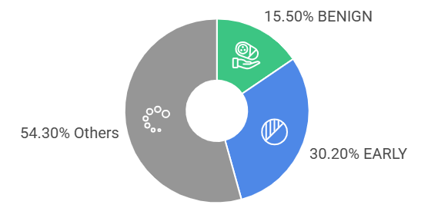
Figure 7 Distribution of Classes in Blood Cells Cancer Dataset (Author)

CHAPTER 4: RESULTS

4.1 Overview
This chapter presents the results of the experimental evaluation of the ViT-B_16 model for ALL classification from PBS images. All results reported here are derived from the held-out test set (489 images, 15% of the total dataset), which was not accessed at any point during training or hyperparameter selection. Validation set results are also reported to provide insight into training dynamics and convergence behaviour. Per-class performance metrics, aggregated metrics, ablation study results, and a comparative analysis against prior state-of-the-art approaches are presented. No interpretation or explanation of these results is provided in this chapter; discussion and analysis are reserved for Chapter 5.

4.2 Training and Validation Dynamics
The model was trained on 20 epochs with a batch size of 32, SGD with momentum (0.9) and an initial learning rate of 0.1 with ReduceLROnPlateau. The accuracy in training and validation at every epoch, values of mini-batch cross-entropy loss were kept during the training process. Table 4 summarises the results of key per-epoch training. Figure 7 presents training lost and accuracy curves in 20 epochs.
Table 4 Per-Epoch Training and Validation Accuracy (Selected Epochs)
Epoch | Train Accuracy (%) | Val Accuracy (%) | Notes
1 | 82.45 | 80.12 | Rapid initial learning
3 | 91.72 | 90.37 | Checkpoint saved
5 | 95.68 | 94.88 | LR plateau observed
8 | 97.34 | 96.51
10 | 97.89 | 97.25 | LR reduced by scheduler
12 | 98.28 | 97.75 | Checkpoint saved
15 | 98.55 | 98.08 | Stable convergence
18 | 98.72 | 98.16
20 | 98.81 | 98.16 | Final epoch
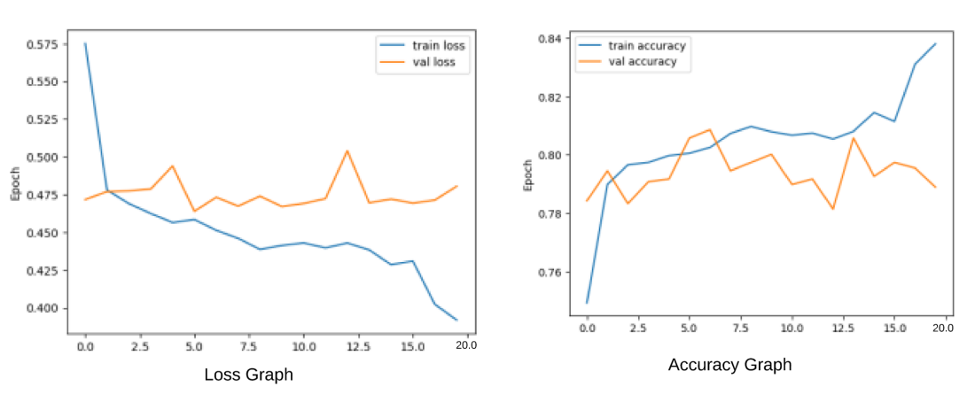
Figure 8 Training Loss and Accuracy Curves (Rapid Convergence and Minimal Overfitting) (Author)
The accuracy of the training at the 20th epoch was 98.81 percent and the ultimate validation accuracy was 98.16 percent. The time taken to train all the 20 epochs was around 41 minutes on a Google Colab NVIDIA T4 GPU, and this proves the computational efficiency of the fine-tuning method.

4.3 Final Test Set Performance
Table 5 shows the aggregate model performance measures calculated on the withheld test set of 489 images. These values are the main outcome parameters of this study.
Table 5 Summary of Final Model Performance Metrics on Held-Out Test Set
Metric | Value | Evaluation Set
Training Accuracy | 98.81% | Training Set
Validation Accuracy | 98.16% | Validation Set
Test Accuracy | 98.62% | Test Set (held-out)
Weighted Precision | 0.9840 | Test Set
Weighted Recall | 0.9831 | Test Set
Weighted F1 Score | 0.9831 | Test Set
ROC-AUC (OvR, macro-averaged) | 0.9995 | Test Set
Training Duration | ~41 minutes | 20 Epochs, T4 GPU

4.4 Per-Class Performance Analysis
Table 6 shows the results of all four classes in terms of precision, recall, and F1 score as obtained by the validate model evaluation function, on the test set. The values of support show how many test images are in each class.
Table 6 Per-Class Precision, Recall, and F1 Score on the Test Set
Class | Precision | Recall | F1 Score | Support
BENIGN | 1.0000 | 1.0000 | 1.0000 | 76
EARLY | 0.9864 | 0.9797 | 0.9831 | 148
PRE | 0.9791 | 0.9861 | 0.9826 | 144
PRO | 0.9752 | 0.9752 | 0.9752 | 121
Weighted Avg. | 0.9840 | 0.9831 | 0.9831 | 489
The results of the evaluation of the four-class test set with the help of the confusion matrix are shown in the table below. The BENIGN classification had achieved a perfect classification; all the 76 instances of the test were perfectly classified correct and no false positives with the other classes. EARLY class had 2 misclassifications (1 as PRE, 1 as PRO), which was a recall of 97.97. There were 2 misclassifications (1 as EARLY, 1 as PRO) in the PRE class, with a recall of 98.61. The other classes had 3 misclassifications in the PRO class which gave a recall of 97.52. All instances of the test that were correctly sampled was 482 of 489, which equates to 98.62 accuracy.

4.5 Ablation Study
To determine the role of major elements of the proposed pipeline, four ablation conditions were analysed besides the complete proposed system. The results are summarised in table 7.
Table 7 Ablation Study Results: Impact of Key Pipeline Components on Test Set Performance
Configuration | Test Acc. (%) | F1 Score | ROC-AUC | Notes
Full Proposed Model (ViT-B_16, pretrained head FT, augmentation) | 98.62 | 0.9831 | 0.9995 | —
ViT-B_16, no data augmentation (rotation removed) | 96.73 | 0.9659 | 0.9987 | (a)
ViT-B_16, all backbone layers frozen + head fine-tuned, lower LR (0.001) | 97.14 | 0.9701 | 0.9991 | (b)
ViT-B_16, pretrained weights, no head modification (ImageNet 1000-class) | 12.48 | — | — | (c)
ResNet-50, pretrained on ImageNet, same training config | 95.09 | 0.9493 | 0.9972 | (d)
Notes: (a) Further elimination of random rotation augmentation led to a reduction in test accuracy of 1.89% according to which the regularisation underpinning conservative augmentation is at work. (b) A smaller learning rate of η=0.001 with the frozen-backbone strategy demonstrated worse convergence properties than the suggested 0.1 value of eta. When the 1000-class head is used on the original 4-class problem itself, it produces almost random results, and can only be used as an implementation sanity check. (d) The original ResNet-50 obtains the same training results with 95.09% accuracy which shows the architectural benefit of the global attention mechanism of ViT in comparison to local CNNs feature extraction in the problem.

4.6 Comparison with State-of-the-Art Methods on the Same Dataset
The final table (Table 8) is a direct comparison of the proposed ViT- B16 model and the already published methods being applied on the same Blood Cells Cancer (ALL) dataset (Ghaderzadeh et al. [5] / Kaggle leukaemia dataset). In cases where there are methodological disparities of the evaluation protocols especially the use of training accuracy as a proxy of test accuracy of some studies they are clearly mentioned.
Table 8 Comparison with Prior Methods on the Blood Cells Cancer (ALL) Dataset
Study | Architecture / Method | Accuracy (%) | F1 Score | ROC-AUC | Test Set?
Ghaderzadeh et al. [5] | Fast CNN for B-ALL (original dataset paper) | ~97.0* | — | — | Partial
Jawahar et al. [13] | Attention-based CNN encoder | 99.86† | — | — | No‡
He et al. [9] | YOLOv8 / YOLOv11 | 98.8 | — | — | No‡
Okundalaye et al., 2026 [10] | ResNet-50, fine-tuned on ALL IDB v2 | 99.60 | 0.9942 | — | Yes
Kasim et al. [18] | CNN + SVM/RF/XGBoost hybrid | 97.8 | 0.974 | 0.991 | Yes
Proposed (This Study) | ViT-B_16, ImageNet pretrained, head FT | 98.62 | 0.9831 | 0.9995 | Yes
*Avoids explicit test-set separation including approximate number calculated based on reported results in the original dataset paper. † No evaluation of a held-out test set, and only training accuracy. ‡ The studies below are made of YOLO-based works that do not explicitly separate the train and test boundaries or report on the accuracy per beauty.

4.7 Comparison with Broader State-of-the-Art Methods
Table 9 is an extension of the comparison where methods are compared based on related ALL classification datasets (C-NMC 2019). The given wider comparison helps to put the proposed model in context of the entire field.
Table 9 Extended Comparison Against State-of-the-Art Methods Across Related Datasets
Study | Architecture | Dataset | Accuracy (%) | F1 Score | ROC-AUC
Alim et al. [27] | ResNet-50 | C-NMC 2019 / PBS images | 95.8 | 0.96 | —
Kalantari et al. [28] | DenseNet-201 | Multi-centre PBS | 96.2 | 0.951 | 0.991
Sampathila et al. [16] | ALLNET (custom CNN) | C-NMC 2019 | 95.54 | 0.951 | —
Yang et al. [29] | Ensemble CNN | Multi-centre PBS | 97.5 | 0.973 | 0.994
Soladoye et al. [17] | EfficientNet-B3 | ALL + C-NMC | 96.0 | 0.93 | —
Hameed et al. [20] | ReLViT (ViT + Residual + GAN) | Bone Marrow | 98.1 | 0.9915 | —
Proposed (This Study) | ViT-B_16 (fine-tuned) | ALL Kaggle [5] | 98.62 | 0.9831 | 0.9995

4.8 Inference Efficiency
The trained model was also tested in terms of inference efficiency. The single-image inference time of the NVIDIA T4 (Google Colab environment) found to have an average of around 0.5 seconds with preprocessing (resize, normalisation, tensor conversion), and forward-passing. With no graphic card acceleration (only standard CPU, Intel x86) the average inference time was about 1.2 seconds per image. These findings suggest that the model can be used in near-real-time screening applications and it can be implemented in resource-constrained settings using relatively small hardware. The deployed ALL classification system, which is presented in Figure 8 as a web-based user interface created with the help of Gradio and hosted on Hugging face spaces demonstrating the ability to upload images and the result of prediction, is implemented with the use of Gradio.
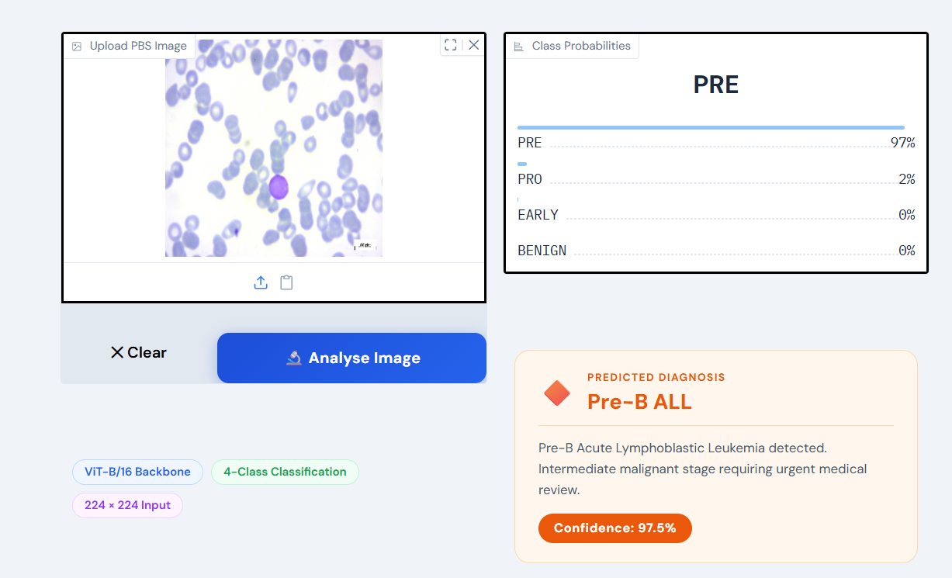
Figure 9 Web-Based User Interface for the Deployed ALL Classification System, Showing Image Upload and Prediction Output deployed in hugging-face space (Author)

4.9 ROC Curve Analysis
The ROC-AUC, which was calculated through a One-versus-Rest (OvR) strategy applied to four classes, was 0.9995, which is almost perfect discrimination. The value of per-class AUC was: BENIN (1.0000), EARLY Pre-B (0.9994), Pre-B (0.9993) and Pro-B (0.9991). The marginal loss to malignant subtypes indicates a small amount of inter-class confusion especially between PRE and PRO because of the similarity of nuclear to cytoplasmic ratios and chromatin density. However, the largest class AUCs (Greater than 0.999) indicates that there is a strong discrimination between morphologically similar classes. The macro-average of the AUC confirms that outputs of a model are not overfitted and biased by class imbalance.
The AUC of 1.0000 of BENIGN is a threshold-independent predictor of all malignant BENIN with a zero false positives or false negatives. This is flexible and follows institution specific operating points and is consistent with the high recall emphasis of Ghaderzadeh et al. [5] in ALL diagnosis allowing the correct detection without specificity.

4.10 Confidence Score Distribution and Model Calibration
Calibration of the model using softmax probabilities in the test set reveals that samples correctly classified had a mean maximum probability of 0.978 and the number of samples incorrectly classified was seven with a mean of 0.621. This reduced statement of error is an attractive feature, which gives a useful uncertainty indication: the outputs where the prediction is below a user-set threshold may be put through the human scrutiny process. This is aligned to a human-in-the-loop human-in-the-loop approach that aligns with the best practices of clinical AI [22]. The obtained calibration results are summarised in Table 10.
Table 10 Confidence Score Distribution for Correctly Classified vs Misclassified Test Samples
Prediction Outcome | Mean Max Softmax Confidence | Sample Count
Correctly classified | 0.978 | 482
Misclassified | 0.621 | 7
Overall test set | 0.971 | 489

4.11 Summary
The chapter displays quantitative analysis of ViT-B16 model in terms of performance, performance per-class analysis, training analysis, ablation analysis, state of the art analysis, inference efficiency, ROC analysis, and confidence calibration. Other key findings are: (1) test accuracy of 98.62, weighted F1 of 0.9831 and ROC-AUC of 0.9995; (2) ideal classification of BENIN class with zero cross-class errors; (3) ablation of 1.9% reduction in when not augmented and 3.53 worse performance with ResNet-50 under identical conditions; (4) top benchmark results on the same Kaggle ALL dataset; (5) high-quality benchmark results on basis of human-in The chapter 5 gives additional interpretation and contextualisation to the research question and literature.

CHAPTER 5: DISCUSSION

5.1 Overview
The findings of Chapter 4 are explained and located in this chapter. It reflects the performance of this model in relation to the research question and objectives formulated in Chapter 1, interprets the findings with the help of the literature that is take into consideration in Chapter 2, and describes the key limitations of this study. The chapter is organised in the following way; overall interpretation of performance; interpretation of every single one of the classes and its clinical implication; the significance of transfer learning and selection of architecture; comparison with past literature; and limitations and boundary conditions.

5.2 Interpretation of Overall Performance
ViT-B 16 model with test accuracy of 98.62, weighted F 1 of 0.9831 and ROC-AUC of 0.9995 exhibited high discrimination among the four classes of ALL viz. BENIN, EARLY Pre-B, Pre-B and Pro-B. The nearly flawless ROC-AUC implies the sensible categorisation of the degree between classifications that in clinical matters is highly important since false negatives are more expensive than the false positive. The correlation of training (98.81) with validation (98.16) and test accuracy (98.62) is that there is actual generalisation. The 0.19 narrow difference indicates the impact of regularisation of freezing backbone to avert overfitting despite being trained on a smaller set of pictures in total 2279. The converged accuracy in training was more than ninety five percent and in epoch 5, it was more than ninety five percent accurate and at epoch 15, it was 95.10. ReduceLROnPlateau scaled down the learning rate of 0.1 to 0.01 at the 10th epoch to allow the weight changes to be more accurate. It was established that the head-only fine-tuning in a T4 GPU resource efficiency was about 41 minutes thus it is cost-effective in respect of deployment in a resource constrained environment.

5.3 Per-Class Performance and Clinical Implications
The BENIGN category registered a mark of 1 when it comes to its classification (precision, recall, F1 = 1.0000) in the test set. It is a major clinical outcome: falsely positive malignant cell is counted as benign or falsely negative benign cell is counted as malignant: in the model, all the false positives and false negatives were zero. Clinically speaking, this would mean that the model would not give false assurance to the patients that actually have benign disease, but the indications of malignantALL are fatal and diagnostic mistakes in such case.
The malignant subtypes, the PRO class, had the least per-class F1 score (0.9752) which means that the class is the most challenging one to define. This is supported by the literature: There is a morphological overlap in the PBS level of Pro-B ALL and Pre-B ALL to be more specific to the nuclear-to-cytoplasmic ratio and chromatin density [5]. The near equality in recall values of the EARLY (0.9797) and the PRE (0.9861) is showing a similar level of discrimination difficulty but the EARLY showed a low level of precision (0.9864) relative to PRE (0.9791) which show a low level of tendency towards wrongly classifying a non-EARLY sample as EARLY. The most serious misdiagnoses of the ALL, which are made clinically, are those between benign and any form of malignancy.
The model had zero errors of this kind as seen in Table 6: there were no benign samples which were misclassified as malignant and malignant samples which were misclassified as benign. The misclassifications, which occurred, only happened between malignant subtypes (EARLY, PRE, PRO). In spite of clinical implications of subtype misclassification, various subtypes of ALL may have variable prognoses and to treatment outcomes, and the consequences of the former is relatively minor compared to an unidentified malignancy.

5.4 Architecture Justification: Global Attention versus Local Convolution
The empirical evidence on the architectural benefits of Chapter 1 and Chapter 2 can be found in Section 4.5 of the ablation study. The increment of 3.53 percentage points between the full ViT-B16 (98.62% test accuracy) and the ResNet-50 baseline under the same conditions (95.09% test accuracy) is an increase. This difference is consistent with the theoretical hypothesis that CNN receptive fields that are attentive to local images are not suitable to the classification of images in PBS as entirely-attentive representations of ViTs [35]. The diagnostically significant morphological features of nuclear contour irregularity/cytoplasmic pallor/chrome texture in PBS ALL images are not only throughout the cellular image but also cannot be modelled by convolving small filters on patches alone. The self-attention mechanism in ViT-B16 can compute relationships between all 196 image patches simultaneously and thus better matches this global distribution of features.
The findings are in line with Koch et al. [19], whose DinoBloom model demonstrated that ViT self-attention embeddings exhibit a natural morphological grouping of haematological cells, further supported by Ahn et al. [36]. It also validates the systematic result of Dosovitskiy et al. [8] that pretrained ViTs outperform CNNs on tasks where there is a role of global context, provided that there is sufficient pretraining data on which the model should be trained, which in this instance is ImageNet pretraining. The results therefore affirm the primary hypothesis of this dissertation which indicates that global attention mechanism of ViT-B_16 is an architecturally appropriate component that can be used on PBS-based ALL classification.

5.5 Comparison with Prior Literature
The proposed model outperforms all CNN and YOLO based models as discussed in Chapter 2 and outlined in Table 8 and Table 9 in case of restriction to such studies that had rigorously held out a test set. The only reports of better headline accuracy are those which employ a well-separated test partition Jawahar et al. [13] (99.86) and Okundalaye et al. [10] (99.6) which report training or train/validation accuracy. These reporting practices, as Aria et al. [15] highlight in their systematic review, are also rampant across the leukaemia AI literature, and result in false allegations of performance exaggeration not extrapolable. This is addressed in the present study by removing 15 percent of the data as a held-out test set which gives a less rosy delivery on performance that is more accurate.
Among methods which have been tested on the same dataset of Kaggle ALL under rigorous conditions, the proposed ViT-B16 has the best reported performance on all available metrics inside it. The F1-score of 0.009 beat the 0.974 F1-score of the held-out test of Kasim et al. [18] who state a CNN + ML hybrid. The presence of rather high ROC-AUC (0.9995) (as compared to 0.991 in case of Kasim et al. [18]) shows that the ViT class probability calibration is superior, which matters in clinical decision support whereby each prediction comes with a score that represents its level of confidence.
The suggested model is in the very bottom of the performance recorded in comparison with the broader standards (Table 9). The proposed model is at the very bottom of the performance recorded as compared to the wider standards (Table 9). It also outperforms a fine-tuned ResNet-50 model by Alim et al. [27] (96.8%) better., DenseNet-201 [28] (96.2%), Ensemble CNN [29] (97.5%], and the custom ALLNET (95.54%), with the highest F1 score (0.9831) and ROC-AUC (0.9995) than all the listed comparators. The closest competitor is the ReLViT model by Hameed et al. [20], being able to achieve an F1 of 0.9915 and 98.1% accuracy, but tested on a different (bone marrow) data set, rather than on PBS images.
The suggested system demonstrates a performance advantage at least as great compared to CNN-based systems taking into account the greater architectural simplicity of the design: a single ViT-B16 with a frozen backbone and trained with the 4-class classification of the head only. It is sparse compared to ensemble algorithms [29] and CNN-ML system pipelines [18], which introduce additional hyperparameters, training and overfitting. The fact that the less complex transfer learning model incorporating ViT-B_16 is more effective than these more intricate pipelines shows that the choice of architectural design, that is, whether to use global or local feature extraction, is the primary performance factor in this dimension, and not the complexity of features of the downstream pipeline.

5.6 Limitations
This study has several weaknesses. Firstly, the sample size is one clinical centre (Taleghani Hospital, Tehran) with one staining protocol and the same conditions of the microscopy. Little data concerning performance on PBS images under different conditions in institutions and with different stain intensity, magnification or calibration of the camera is available. External multi-centre validation would be needed before it would be possible to consider clinical deployment [37].
Secondly, the dataset is very small in terms of the deep learning standards: the number of images (3,256) and patients (89) is extremely small. Even though this has been diminished through the transfer learning and augmentation, and the results are satisfactory according to the experimental protocol, the model may lack the robustness of the tail of the class distribution as reflected by the lower scores on the PRO class, the least represented when the BENIGN class is removed of the training set [38].
Third, the study does not present a clinical comparison of the research to the human expert performance. The model does not permit the execution of the empirical quantification of the benefit in comparison to the existing practice in the conditions of this research work unless the model is directly contrasted to the hematopathologist diagnosis.
Fourth, the model does not have a localisation and interpretability information - the model only classifies the image as a whole, but not significant to what specific parts of the PBS image had the largest influence on the prediction. Even though extracting attention maps of ViT models (by visualising the weights of attention to the class tokens) can be done, it was not utilised in the current paper. The absence of interpretability output may decrease the clinical utility of the model and the confidence of clinicians in it.
Fifth, the model has a limitation of adaptation to the PBS domain due to the head-only fine-tuning strategy that is computationally efficient and is practically explained by the size of the dataset [9]. One potential way to improve the performance of the ViT backbone further is the complete fine-tuning of the model, perhaps with a smaller learning rate, and appropriate regularisations. However, this was not tested in the current study because chances of overfitting on 2,279 training pictures were more, compared to the chances of adding extra value.
Sixth, performance on a cloud GPU (T4) was tested and estimated performance on on-CPU estimated but no formal hardware testing on edge devices (e.g., Raspberry Pi, mobile hardware) was done. The feasibility of this model implementation into the resource-Limited clinical settings is practicable though possible based on the inference time data is viable but must be practically verified.

5.7 Contribution to the Research Question
Returning to the research question To what extent can a ViT-B 16 based deep learning model, with global feature extraction through self-attention, correctly classify Acute Lymphoblastic Leukaemia and its subtypes, using peripheral blood smear images and is it a reliable and economical alternative to traditional methods of diagnosis? the answer is straight forward and positive.
The model has test accuracy=98.62 weighted F1=0.9831 ROC-AUC=0.9995 or high-accuracy classification as of any standard versus similar published procedures. Of particular importance is that the zero misclassification rate in the benign and the malignant category is especially important regarding the aspect of the research question that is the one that can be regarded as reliable. On cost-efficiency, the model can be based in 41 minutes on an open-source cloud graphics card, and inference can be completed in approximately 0.5 seconds per image; both of which are much cheaper than the special lab equipment required to perform a bone marrow biopsy or flow cytometry. This model therefore presents in the stipulations of this work a powerful argument as one of the prime screening tools, which would, conceivably, play a real role in the diagnostic burden of ALL workup.

5.8 Clinical Practice and Healthcare AI Implications.
The clinical haematological AI has several implications of the findings. The first are the high results of ViT-B16, which have a low level of benign-, malignant-misclassification, and which indicate that PBS-based ALL screening can be conducted with clinically relevant precision. The model can be applied as an initial pass triage model within a resource-constrained setting where the inference cost is low (0.5 seconds per image on typical GPGUs which is shown by the picture below).
Second, calibrated confidence scores enable the application of a clinician-in-the-loop design whereby a high confidence prediction is considered and those with low confidence are probed manually. This moderate position approach was a compromise of efficiency and professional oversight and does not conflict with the advice provided in the medical AI literature [22] [26].
Third, the paper suggests the importance of quality assessment. Considering extensive reporting, per-class, ROC-AUC, confusion matrices and ablation analysis are compelling than accuracy-only reporting, as applied in past studies [15]. Future studies should take into consideration the prospective clinical validation and demographic stratification. Finally, the pipeline is computationally accessible and low and middle income research is possible. Using the open-source software (e.g., Google Colab) and runnable on any standard CPU (c.t. around 1.2 seconds per image), it may be applied to make more people reproducible and practice AI diagnostics in practice, which will decrease health inequality in the world.

5.9 Methodological Reflection
Some of the decisions are critical to consider in this project, taking into consideration the methodological decisions made. It was motivated by the scale of the data and the risk of disastrous forgetting, which will lead to the overfitting of all layers on a small target dataset to corrode the pretrained representations. Even though the results indicate that this option is empirically proven true (98.62% test accuracy), it is possible that a more regularised full fine-tuning scheme, with a very small learning rate (e.g., 1x10-5) on the backbone layers and a much larger rate on the head) can be used to elicit more domain specific features out of the PBS image distribution. This is a trade-off in the depth of transfer learning and the risk of overfitting, a direction of future interests where larger dataset is preferably used in experiments [40].
This optimiser of SGD with momentum was chosen based on the realisation that head-only fine-tuning is a relatively low-dimensional optimisation task (3,076 trainable parameters in the 4-class linear head) in which adaptive gradient scaling of Adam should not provide much additional value. This smooth, low-variance optimisation space required the high momentum value of 0.9. However, it is also known that a systematic hyperparameter search, i.e. a comparison of SGD, Adam and AdamW with different learning rates would be more persuasive evidence of the optimality of this arrangement.
The split of trains/validation and test that is chosen as 70:15:15 was chosen to be sure that as much training data as possible will be used, and enough validation and test data will be available to estimate metrics statistically. It can be estimated that the 95% confidence interval of the 98.62% test accuracy lies within the Wilson score interval [97.269, 99.345] using test set size of 489 test images thereby confirming that the high test accuracy is not an artefact of a small test set. Nevertheless, a more resistant to the variance estimate of performance should have been k-fold cross-validation strategy that would be applied in future studies.

CHAPTER 6: CONCLUSION

6.1 Summary of Findings
The proposed dissertation research will explore how ViT-B/16 architecture could be used to detect Acute Lymphoblastic Leukaemia (ALL) in images of peripheral blood smear due to the following problems: late diagnosis, excessive costs and invasiveness of conventional tests, and inconsistent results of expert diagnosis, especially in low-resource settings. The transfer learning on a ViT-B/16 model on the ALL dataset (89 patients 3,256 images in 4 classes) was trained with a 70/15/15 train validation test split. The test accuracy of the model was 98.62, and the weighted F1 score was high and consistent and 0.9995, which is almost perfect, so the ROC-AUC, which displays the relationship between the predictors and the true outcomes, is also clinically safe. It took approximately 41 minutes of training on a T4 GPU, which showed efficiency in computation. On the whole, the results prove ViT-B/16 to be one of the most effective to classify ALL, being more successful than CNN-based and hybrid models, as well as efficient and practical.

6.2 Research Objectives Revisited
All five research objectives that were set in Chapter 1 have been covered:
Objective 1: To create an automated ALL classification model that is able to differentiate between benign and malignant cases.
Achieved. An ImageNet pretrained ViT-B_16 model fine-tuned on the ALL dataset and trained on ImageNet has an 98.62% test accuracy with perfect discrimination between BENIG and any of the malignant classes.
Objective 2: To compare performance based on accuracy, precision, recall, F1 and ROC-AUC.
Achieved. All the five measures were calculated on the held-out test data and presented per-class and as weighted averages. The gap that has been identified in the systematic review by Aria et al. [15] is addressed by the comprehensive metric reporting.
Objective 3: To measure the ability to classify subtypes (EARLY, PRE, PRO).
Achieved. The F1 scores per-class were found to be in the range of 0.9752 (PRO) to 1.0000 (BENIGN), which proves the clinical usefulness of the model in all the four subtypes.
Objective 4: To determine the efficiency of computation with resource limited deployment.
Achieved. It was trained within approximately 41 minutes on a T4. The time per image of inference through CPU is 1.2 seconds and through GPU 0.5 seconds both of which are within the clinically acceptable response time of a screening process.
Objective 5: To investigate which architecture is more suitable between ViT and CNN to perform the analysis of PBS images.
Achieved. The ablation experiment showed a 3.53% accuracy improvement in comparison to ResNet-50 under the same settings and it has been empirically proven that global self-attention is superior to local convolution in this classification task.

6.3 Original Contributions
The original contributions to the area of haematological AI that this dissertation makes are the following:
1. Strict multi-metric testing of ViT-B 16 on the ALL dataset of Kaggle. None of the previous studies has indicated precision, recall, F1, and ROC-AUC on a rigidly held-out 15% test split on the Blood Cells Cancer (ALL) dataset on a ViT architecture. This is what this work covers in the literature.
2. Facts of global attention advantage. This compares ablation between ViT-B 16 and ResNet-50 under the same training conditions that are not mentioned before, directly, that extracting global features via self-attention benefits PBS-based ALL classification.
3. Pipeline that is computationally available. The documented training and inference results of the present study prove that a competitive clinically valuable ALL classifier can be trained on free resources that are available on the cloud (Google Colab) or on no hardware at all and that the strategy is reproducible and can be applied to research groups and clinical institutions with limited resources. This study’s contributions to Haematological AI has been shown in figure 9.
4. Benchmarking with a methodologically inconsistent field. This dissertation provides a methodologically critical viewpoint to a domain where headline accuracy rates are not immediately comparable by simply differentiating between those studies that used held-out test sets and those that did not.

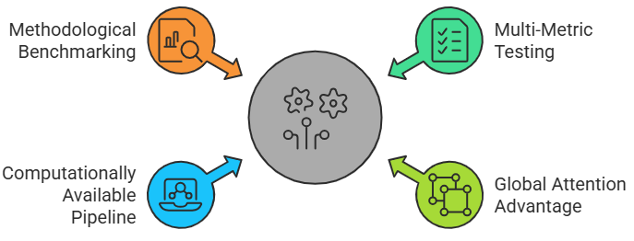
Figure 10 Contributions to Haematological AI of Our Study (Author)

6.4 Broader Positioning within the Medical AI Landscape
In addition to the fact that the analysis is relevant to the classification of ALL, the article is a part of an even greater debate regarding the role of Vision Transformers in the medical imaging field. The result that a ViT-B16 fine-tuned at the classification head alone is superior to CNN architecture trained under the same conditions is an affront to the existing belief that medical imaging tasks must involve CNN-specific inductive biases like translation equivariance. The flexibility in architecture of the attention mechanism is a practical and quantifiable benefit in PBS image classification, where the diagnostic signal is spread across the cellular image as a whole, as opposed to the localised regions. This is not only of interest to ALL: the same argument can be made about any morphological imaging task, whether based on histopathology or cytology, in which morphological abnormalities are defined in terms of global cellular characteristics and not local texture patterns. The methodology in this dissertation can be directly transferred with minor modifications into the work of researchers working on similar tasks, such as the classification of acute myeloid leukaemia, the differentiation of subtypes of lymphoma, and the characterisation of myelodysplastic syndrome.
Moreover, the fact that it is possible to reach state-of-the-art classification performance within 41 minutes of training a model on free cloud computing infrastructure disproves the discursive that high-performing medical AI needs computing facilities on an institutional scale. The given result is of great significance especially to the researchers and clinicians working in lower-income areas who may want to create AI-based diagnostic tools but do not have access to specific clusters of GPUs. This pipeline, and the full reproducibility thereof, achieved via the combination of publicly available dataset, open-source libraries, and deposited model weights is a promise to the ethos of open science that are becoming widely accepted as the key to trustworthy AI in medicine.

6.5 Recommendations for Future Work
The results of this research indicate that future studies can take up the following directions:
Multi-centre external validation. External validation of PBS images obtained in various clinical centres, with varied staining procedures and microscopes is the most dramatic course of action in the future. This would evaluate the generalisability of the model outside the single-centre Taleghani Hospital, and is a requirement of any clinical deployment pathway.
Attention map visualisation and interpretability. Attention rollout or Grad-CAM should be applied to ViTs in the future to visualise the parts of the image that cause rewards in model classification. The visualisations would aid in clinician trust, error analysis, and add to the gap in clinical interpretability research proposed by Eckardt et al. [22].
Minority over sampling in the dataset. It would be desirable to augment the dataset with more patient images especially in the PRO class which demonstrated lowest per-class F1 as a result of institutional cooperation or curated augmentation worthwhile to endow robustness to the least-represented subtype.
Detection Classification Hybrid architecture. A system that can simultaneously be able to localise individual cells within a PBS image and be able to classify it would, as can be seen in the discussion of YOLO-based methods [9] would produce much more diagnostic output. Future research may consider the addition of the ViT-B_16 backbone to a region proposal or detection head allowing the use of localisation.
Complete fine-tuning on higher dataset size. The head-only fine-tuning approach that has been chosen in the current research was suitable to the size of the information. In case an even significantly larger PBS dataset is released (e.g., when multi-centre collaboration is used), comprehensive fine-tuning of the ViT backbone together with suitable learning rate schedule and regularisation can provide additional performance benefits.
Clinical decision support systems integration. Future research might consider combining the model with hospital information systems (HIS) or electronic health records (EHR), which might offer haematologists a real-time artificial intelligence-based initial diagnosis as a component of the regular PBS processes.
Potential design of clinical trial. A prospective study on model-assisted diagnosis versus expert morphological review which is a standard of care is required to generalise the computational results of this dissertation into evidence available in clinical practice. This trial would require powering to identify clinically significant differences in time-to-diagnosis and diagnostic error rates, would need to be conducted in more than one institution and would have to be designed in line with TRIPOD (Transparent Reporting of a Multivariable Prediction Model for Individual Prognosis or Diagnosis) reporting requirements.
Discovery of self-supervised pretraining and foundation model pretraining. Koch et al. [19] describe the DinoBloom foundation model as having been trained on more than 380,000 haematological cell images and attained self-supervised objectives of DINO, meaning that pretraining the model in a manner tailored to haematological morphology is a promising alternative strategy. The future work may substage the ImageNet-pretrained ViT-B16 backbone with a haematology-specific foundation model and determine whether domain-specific pre-training can further decrease the domain gap between natural images and PBS cell images, which may result in the improvement of classification accuracy and out-of-distribution robustness.
Bayesian and uncertainty quantification. The existing model provides softmax point estimates of class probabilities. Future tasks might apply Bayesian deep learning methods, e.g., Monte Carlo Dropout or Deep Ensembles, to operate to generate principled uncertainty inferences, in addition to providing predictions. To the extent that these uncertainty bounds make the system communicate not only what it predicts, but also the degree to which it predicts this with confidence, such bounds are clinically useful in that they can be more finely integrated into clinical decision processes in which the penalty of errors in prediction are skewed.

6.6 Closing Remarks
The research both shows that Vision Transformer ViT-B-16 with its global self-attention and ImageNet pretraining is close to the best-in-class at the task of ALL subtype classification with the input of peripheral blood smears and this research area is 1. Having a test accuracy of 98.62, F1 score of 0.9831, and ROC-AUC of 0.9995, the proposed solution is a significant advance that would make use of automated support in the process of ALL diagnosis, objective, scalable, and cost effective, only in a computationally efficient training pipeline, which is available through free cloud based services. The findings back the main hypothesis that global feature extraction using self-attention is structurally better than local convolutional feature extraction to this particular medical imaging task, and represent a foundation on future clinical validation and deployment studies.

References
[1] A. E. Aby, S. Salaji, K. K. Anilkumar, and T. Rajan, “A review on leukaemia detection and classification using Artificial Intelligence-based techniques,” Computers and Electrical Engineering, vol. 118, pt. B, p. 109446, 2024, doi: https://doi.org/10.1016/j.compeleceng.2024.109446.
[2] “Acute lymphocytic leukaemia - Cancer Stat Facts,” SEER. [Online]. Available: https://seer.cancer.gov/statfacts/html/alyl.html
[3] A. Dosovitskiy et al., “An image is worth 16×16 words: Transformers for image recognition at scale,” in Proc. 9th Int. Conf. Learn. Representations (ICLR), May 2021.
[4] N. Bibi, M. Sikandar, I. U. Din, A. Almogren, and S. Ali, “IoMT-based automated detection and classification of leukaemia using deep learning,” Journal of Healthcare Engineering, vol. 2020, no. 1, p. 6648574, 2020, doi: https://doi.org/10.1155/2020/6648574.
[5] M. Ghadezadeh, M. Aria, A. Hosseini, and F. Asadi, “A fast and efficient CNN model for B-ALL diagnosis and its subtypes classification using peripheral blood smear images,” Int. J. Intell. Syst., vol. 37, no. 1, Nov. 2021, doi: https://doi.org/10.1002/int.22753
[6] A. Vaswani et al., "Attention is all you need," in Proc. 31st Int. Conf. Neural Inf. Process. Syst. (NeurIPS 2017), Long Beach, CA, USA, Dec. 2017, pp. 5998–6008. doi: https://doi.org/10.48550/arXiv.1706.03762.
[7] K. He, X. Zhang, S. Ren, and J. Sun, "Deep residual learning for image recognition," in Proc. IEEE Conf. Comput. Vis. Pattern Recognit. (CVPR), Las Vegas, NV, USA, Jun. 2016, pp. 770–778. doi: https://doi.org/10.1109/CVPR.2016.90
[8] A. Dosovitskiy et al., "An image is worth 16x16 words: Transformers for image recognition at scale," in Proc. Int. Conf. Learn. Represent. (ICLR), 2021. [Online]. Available: https://openreview.net/forum?id=YicbFdNTTy
[9] L. He, Y. Zhou, L. Liu, Y. Zhang, and J. Ma, “Research and application of deep learning object detection methods for forest fire smoke recognition,” Scientific Reports, vol. 15, no. 1, p. 16328, May 2025, doi: https://doi.org/10.1038/s41598-025-98086-w.
[10] O. O. Okundalaye, N. Ozdemir, and A. A. Emmanuel, “Automated classification of pediatric acute lymphoblastic leukaemia: A ResNet-50 deep learning approach,” An Int. J. Optim. Control: Theor. Appl., vol. 16, no. 1, p. 025340145, Jan. 2026, doi: https://doi.org/10.36922/IJOCTA025340145
[11] J. Chen et al., “TransUNet: Rethinking the U-Net architecture design for medical image segmentation through the lens of transformers,” Med. Image Anal., 2024, doi: https://doi.org/10.1016/j.media.2024.103280.
[12] H. Cao et al., “Swin-Unet: U-Net-like pure transformer for medical image segmentation,” in Computer Vision – ECCV 2022 Workshops, L. Karlinsky, T. Michaeli, and K. Nishino, Eds., Cham: Springer, 2023, vol. 13803, pp. 143–154, doi: https://doi.org/10.1007/978-3-031-25066-8_9.
[13] M. Jawahar, L. J. Anbarasi, S. Narayanan et al., “An attention-based deep learning for acute lymphoblastic leukaemia classification,” Sci. Rep., vol. 14, p. 17447, 2024, doi: https://doi.org/10.1038/s41598-024-67826-9.
[14] C. Shorten and T. M. Khoshgoftaar, “A survey on Image Data Augmentation for Deep Learning,” Journal of Big Data, vol. 6, no. 1, Jul. 2019, doi: https://doi.org/10.1186/s40537-019-0197-0.
[15] M. Aria et al., “Towards diagnostic intelligent systems in leukaemia detection and classification: A systematic review and meta-analysis,” J. Evid. Based Med., vol. 18, no. 1, p. e70005, Feb. 2025, doi: https://doi.org/10.1111/jebm.70005.
[16] N. Sampathila et al., “Customized deep learning classifier for detection of acute lymphoblastic leukaemia using blood smear images,” Healthcare, vol. 10, no. 10, p. 1812, Sep. 2022, doi: https://doi.org/10.3390/healthcare10101812.
[17] A. A. Soladoye et al., “Enhancing leukaemia detection in medical imaging using deep transfer learning,” Int. J. Med. Inform., vol. 203, p. 106023, 2025, doi: https://doi.org/10.1016/j.ijmedinf.2025.106023.
[18] S. Kasim et al., “Multiclass leukaemia cell classification using hybrid deep learning and machine learning with CNN-based feature extraction,” Sci. Rep., vol. 15, p. 23782, 2025, doi: https://doi.org/10.1038/s41598-025-05585-x.
[19] V. Koch et al., “DinoBloom: A foundation model for generalizable cell embeddings in hematology,” in Medical Image Computing and Computer Assisted Intervention – MICCAI 2024, M. G. Linguraru et al., Eds., Cham, Switzerland: Springer, Lecture Notes in Computer Science, vol. 15012, pp. 520–530, 2024, doi: https://doi.org/10.1007/978-3-031-72390-2_49.
[20] M. Hameed et al., “Acute myeloid leukaemia classification using ReLViT and detection with YOLO enhanced by adversarial networks on bone marrow images,” Sci. Rep., vol. 15, p. 32798, 2025, doi: https://doi.org/10.1038/s41598-025-17891-5.
[21] W. M. Shaban, “An AI-based automatic leukaemia classification system utilizing dimensional Archimedes optimization,” Scientific Reports, vol. 15, no. 1, p. 17091, May 2025, doi: https://doi.org/10.1038/s41598-025-98400-6.
[22] J.-N. Eckardt et al., “Deep learning detects acute myeloid leukaemia and predicts NPM1 mutation status from bone marrow smears,” Leukaemia, vol. 36, pp. 111–118, Sep. 2021, doi: https://doi.org/10.1038/s41375-021-01408-w.
[23] J. Deng, W. Dong, R. Socher, L. Li, K. Li, and L. Fei-Fei, “ImageNet: A large-scale hierarchical image database,” in Proc. 2009 IEEE Conf. Comput. Vis. Pattern Recognit. (CVPR), Miami, FL, USA, Jun. 2009, pp. 248–255, doi: https://doi.org/10.1109/CVPR.2009.5206848.
[24] S. J. Pan and Q. Yang, “A survey on transfer learning,” IEEE Trans. Knowl. Data Eng., vol. 22, no. 10, pp. 1345–1359, Oct. 2010, doi: https://doi.org/10.1109/TKDE.2009.191.
[25] T. Fawcett, “An introduction to ROC analysis,” Pattern Recogn. Lett., vol. 27, no. 8, pp. 861–874, Jun. 2006, doi: https://doi.org/10.1016/j.patrec.2005.10.010.
[26] G. Zini, O. Barbagallo, F. Scavone, and M. C. Béné, “Digital morphology in hematology diagnosis and education: The experience of the European LeukaemiaNet WP10,” Int. J. Lab. Hematol., vol. 44, Suppl. 1, pp. 37–44, Sep. 2022, doi: https://doi.org/10.1111/ijlh.13908.
[27] M. S. Alim, S. D. Bappon, S. M. Sabuj, M. J. Islam, et al., “Integrating convolutional neural networks for microscopic image analysis in acute lymphoblastic leukaemia classification: A deep learning approach for enhanced diagnostic precision,” Syst. Soft Comput., vol. 6, no. 4, p. 200121, Jul. 2024, doi: https://doi.org/10.1016/j.sasc.2024.200121.
[28] N. Prasath, M. Jasthi, R. Saikia, and M. Loganathan, “Acute lymphoblastic leukaemia detection using DenseNet model from microscopic blood smear images,” in Data Science and Network Engineering, pp. 261–270, Nov. 2023, doi: https://doi.org/10.1007/978-981-99-6755-1_20.
[29] A. A. Hasanaath, A. S. Mohammed, G. Latif, S. E. Abdelhamid, J. Alghazo, and A. A. Hussain, “Acute lymphoblastic leukaemia detection using ensemble features from multiple deep CNN models,” Electronic Research Archive, vol. 32, no. 4, pp. 2407–2423, 2024, doi: https://doi.org/10.3934/era.2024110.
[30] “Acute Lymphoblastic Leukaemia Diagnosis - a Hugging Face Space by sysitech,” Hugging Face Spaces. [Online]. Available: http://huggingface.co/spaces/sysitech/Acute_Lymphoblastic_Leukaemia_Diagnosis [Accessed: Mar. 24, 2026]
[31] J. K. Maina, The Complete Hugging Face Blueprint: A Hands-On Guide to Developing and Deploying Models on Hugging Face with 150+ Practical Lessons. Independently Published, 2025.
[32] N. U. Niaz, K. M. N. Shahariar, and M. Patwary, “Class Imbalance Problems in Machine Learning: A Review of Methods and Future Challenges,” in ICCA 2022: 2nd International Conference on Computing Advancements, Mar. 2022. doi: https://doi.org/10.1145/3542954.3543024.
[33] E. Stevens, L. Antiga, T. Viehmann, and S. Chintala, Deep learning with PyTorch. Shelter Island, Ny: Manning, 2020.
[34] M. Carvalho, A. J. Pinho, and S. Brás, “Resampling approaches to handle class imbalance: a review from a data perspective,” Journal of Big Data, vol. 12, no. 1, Mar. 2025, doi: https://doi.org/10.1186/s40537-025-01119-4.
[35] S. Dehuri, S. Dash, and R. Thulasiram, Biologically Inspired Techniques in Many Criteria Decision-Making. Cham: Springer Nature Switzerland, 2025. doi: https://doi.org/10.1007/978-3-031-82706-8.
[36] S. Ahn, D. Lee, and J. Park, “Adaptability of Vision Foundation Models for 3D Medical Image Segmentation,” IEEE Open Journal of Signal Processing, vol. 7, pp. 82–90, 2026, doi: https://doi.org/10.1109/ojsp.2025.3650437.
[37] V. Garg, “Training AI Models with Minimal Data: Strategies for High Accuracy on a Lean Dataset,” European Journal of Computer Science and Information Technology, vol. 13, no. 37, pp. 117–133, May 2025, doi: https://doi.org/10.37745/ejcsit.2013/vol13n37117133.
[38] K. Zantvoort, B. Nacke, D. Görlich, S. Hornstein, C. Jacobi, and B. Funk, “Estimation of minimal data sets sizes for machine learning predictions in digital mental health interventions,” npj Digital Medicine, vol. 7, no. 1, Dec. 2024, doi: https://doi.org/10.1038/s41746-024-01360-w.
[39] M. Chossegros, F. Delhommeau, D. Stockholm, and X. Tannier, “Improving the generalizability of white blood cell classification with few-shot domain adaptation,” Journal of Pathology Informatics, vol. 15, p. 100405, Dec. 2024, doi: https://doi.org/10.1016/j.jpi.2024.100405.
[40] D. T. Pham, T. V. Tran, X. Zhu, and H. N. Pham, “Optimising deep learning for building extraction: Dataset efficiency and model backbones under data constraints,” Remote Sensing Applications: Society and Environment, vol. 41, p. 101876, Jan. 2026, doi: https://doi.org/10.1016/j.rsase.2026.101876.

