

Creativity, Value Creation and Innovation in Health and Social Care Portfolio of Evidence

Name: Diana Mihaela Briceag
Student Number: 2408209
Module: Changemakers: Creativity & Value Creation
Module Code: BMHP5014
Lecturer: Danielle Dunne

Task 1 – Concept Map Creativity, Value Creation and Health and Social Care Improvement
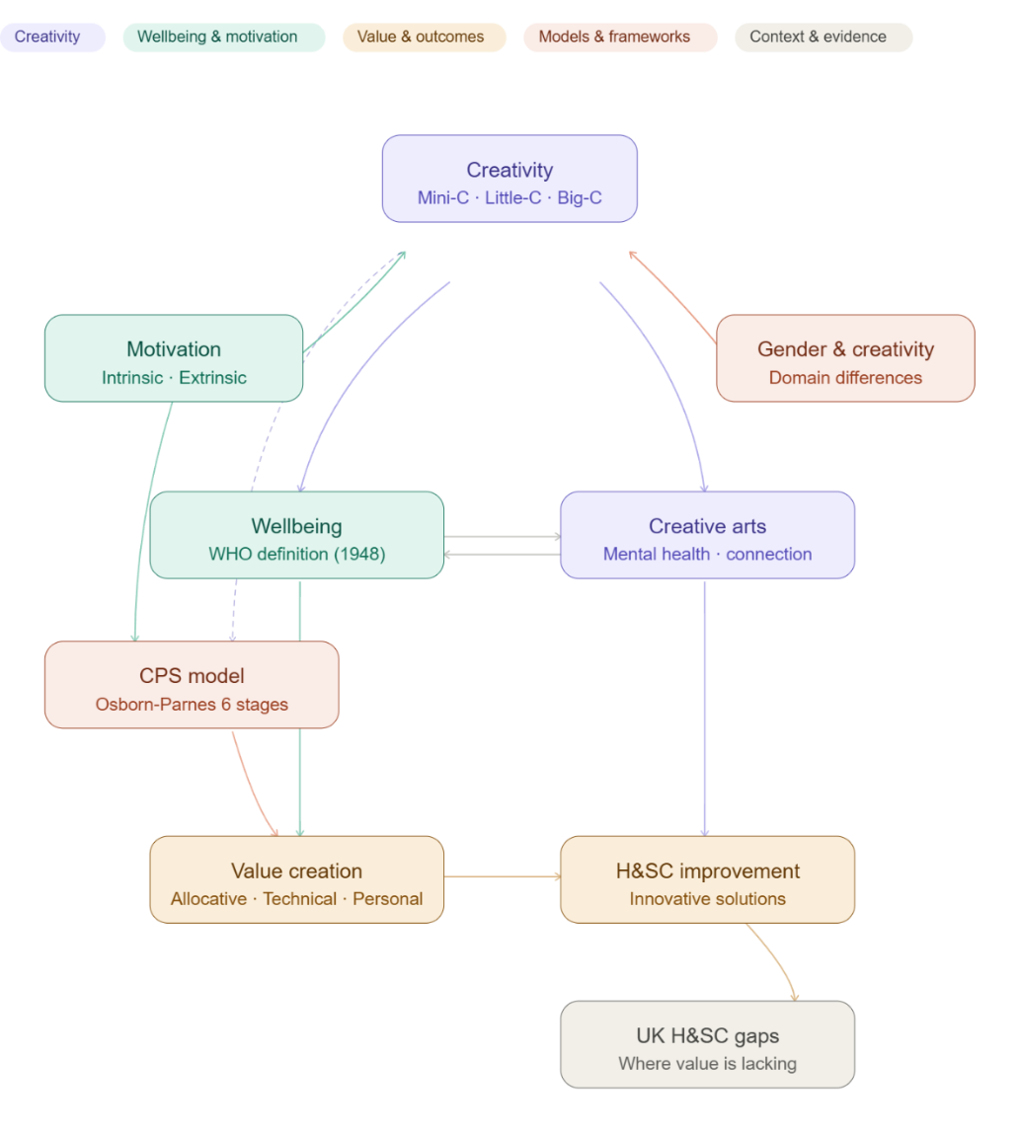

Figure 1: Concept map illustrating the relationship between creativity, value creation and health and social care improvement.

Creativity, value creation and health and social care (H&SC) improvement are fundamentally interconnected concepts that together form the foundation of progressive, person-centred care. Creativity manifests across three distinct levels: Mini-C, which refers to domain-specific and task-oriented thinking within a particular area of practice; Little-C, which encompasses everyday creative problem-solving applied to common challenges; and Big-C, which represents transformative thinking capable of reshaping entire systems and sectors.
Underpinning creative engagement is motivation, which can be understood as either intrinsic, driven by internal satisfaction, personal values and a sense of autonomy, or extrinsic, driven by external rewards or the avoidance of punishment. Practitioners who are intrinsically motivated are significantly more likely to engage creatively and sustainably within care environments.
Creativity and wellbeing share a powerful bidirectional relationship. Positive wellbeing nurtures creative thinking, whilst creative engagement, particularly through the arts, promotes mental health recovery, reduces social isolation and strengthens community connection, which is especially significant within H&SC where holistic wellbeing remains central to quality care.
The Osborn-Parnes Creative Problem-Solving model offers a structured six-stage framework bridging creative thinking and practical application, guiding practitioners from identifying objectives through to implementing actionable solutions within care settings.
Ultimately, creativity generates measurable value. Value in H&SC is understood as achieving the best possible outcomes at the lowest cost, encompassing allocative, technical and personalised dimensions. The UK H&SC system currently faces gaps across all three, making creativity and structured problem-solving frameworks essential to sustainable improvement.

Task 2 – Self-Reflection of Group Activity
Description
During a class session, my group had ten minutes to generate as many alternative uses for a paperclip as possible. We approached the task conversationally, building on each other's contributions openly and enthusiastically. Ideas included using a paperclip to open an envelope, remove hair from a hairbrush and clean underneath fingernails.
Feelings
Initially I found the task more challenging than anticipated. Thinking beyond the obvious function of such a familiar object felt unnatural at first. However as the group conversation developed, my thinking became freer and a genuine sense of creative energy began to emerge amongst us.
Evaluation
The group dynamic was the most valuable aspect of the activity. One person's suggestion would consistently spark a new idea in someone else, generating a creative momentum that would not have been achievable working independently.
Analysis
The activity demonstrated divergent thinking, which Guilford (1967) defines as generating multiple creative responses from a single starting point, contrasting with convergent thinking, which narrows possibilities to one correct solution. Both modes are fundamental to creativity. Applying Gibbs (1988) reflective cycle has enabled me to extract genuine meaning from the experience rather than simply recounting events.
Conclusion
This activity reinforced that creativity thrives in collaborative environments, which is particularly relevant within health and social care where effective teamwork underpins quality care delivery.
Action plan
Going forward I intend to contribute ideas earlier in group tasks, having recognised that my confidence and creativity grew considerably once I engaged fully with the discussion.

Task 3 – Case Study of a UK Innovation
Introduction
The NHS and UK social care system is operating under considerable and escalating pressure. Rising patient demand, persistent workforce shortages, and severe financial constraints have rendered traditional models of care increasingly unsustainable (NHS England, 2023). In response, the sector has begun to embrace innovative, prevention-focused approaches that place the individual at the centre of their care journey. Social prescribing represents one of the most compelling examples of this shift, offering a genuinely creative alternative to purely clinical intervention by addressing the wider social, emotional and environmental factors that shape a person's health and wellbeing.
Creativity and Innovation in Practice
Social prescribing connects individuals to a diverse range of community-based activities and support networks, including arts programmes, gardening groups, physical exercise classes and volunteering opportunities, moving decisively away from the assumption that every health need requires a medical solution. At the heart of the model are link workers, embedded within primary care networks, who work alongside patients to understand their lives holistically and connect them to resources that a standard GP appointment could never provide.
This initiative reflects creativity operating at multiple levels simultaneously. At the everyday level it embodies Little-C creativity, with link workers finding personalised, practical solutions to individual needs. At a systemic level it represents Big-C creativity, fundamentally reimagining how care is conceived, delivered and measured across the health and social care landscape. It aligns directly with the UK's strategic ambition to shift care into the community, prioritise prevention over crisis response, and achieve genuine integration between NHS and social care services.
Value Creation and Impact
The value generated through social prescribing is substantial and multidimensional. Porter (2010) defines value in healthcare as achieving the best possible outcomes at the lowest cost. Social prescribing delivers allocative value by channelling resources toward early intervention, technical value by measurably reducing unnecessary GP consultations and hospital admissions, and personalised value by tailoring support to the unique circumstances of each individual.
NHS England (2023) reports that social prescribing has demonstrated meaningful improvements across key impact measures, including patient satisfaction, mental health outcomes, reduction in social isolation, and overall service efficiency within participating primary care networks.
Conclusion
Social prescribing stands as a powerful illustration of how creative, person-centred thinking can generate genuine and lasting value within the NHS. By reframing care around prevention, community connection and individual need, it offers a sustainable and humane response to one of the most pressing challenges facing the UK health and social care system today.

Task 4 – Research Task
Lower life expectancy in Birmingham is a major and deeply concerning health and social care issue, reflecting wider inequalities in health outcomes, poverty, and access to preventative care across the city and beyond.
One important study found that men in Birmingham lived approximately two years less than men in the rest of England, with diseases of the circulatory system accounting for a significant proportion of this gap. The authors explained that this was not solely caused by illness itself, but also by the delayed identification of cardiovascular risk, meaning many men were not reaching preventative support early enough to benefit from intervention. They highlighted the value of targeted cardiovascular screening for men over 40, alongside more systematic use of GP registers to strengthen early detection, improve treatment uptake and support long-term disease management (Grayland, 2009).
A second study examined how life expectancy inequalities across England have shifted over time, revealing that the gap between deprived and affluent communities has widened considerably. People in the most deprived areas experienced significantly higher death rates than those in more affluent areas. The research identified several key contributing conditions, particularly circulatory disease, respiratory disease, various cancers, dementia, and avoidable deaths in early childhood. The authors concluded that lower life expectancy in disadvantaged communities is driven by a combination of long-term social deprivation and preventable illness rather than any single isolated cause (Bennett et al., 2018).
Together these studies demonstrate that lower life expectancy in Birmingham is deeply rooted in structural inequality and preventable disease. Improving outcomes requires earlier screening, stronger prevention strategies, and sustained action on the wider social determinants of health, including housing, employment, diet and equitable access to services (Grayland, 2009; Bennett, 2018).

Task 5 – Podcast: Creative Innovation Campaign

Task 6 – NHS Leadership Framework Analysis
Summary of the NHS Leadership Framework
The NHS Leadership Framework provides a consistent approach to leadership across health and social care in England, recognising that effective leadership should be demonstrated at every level of an organisation, not solely in senior roles (NHS Institute for Innovation and Improvement, 2011).
The framework comprises nine domains: demonstrating personal qualities, working with others, managing services, improving services, setting direction, creating the vision, delivering the strategy, leading change through people, and developing capability. Together these reflect a holistic model integrating self-awareness, collaboration, strategic thinking and continuous improvement. As Fullan (2016) notes, effective leadership uplifts others and makes change meaningful.
Improving Services: Encouraging Creativity and Better Care
Improving services empowers leaders to drive innovation across care delivery (NHS Institute for Innovation and Improvement, 2011). A leader applying this domain would encourage staff to challenge existing practices and generate creative solutions that improve patient outcomes.
This reflects transformational leadership, specifically intellectual stimulation, which Bass, Avolio and Atwater (1996) describe as encouraging critical thinking and problem solving. In practice this might involve championing social prescribing or redesigning patient pathways, fostering a culture where creativity generates lasting value for patients and communities.
Task 7 – Self-Reflection Journal Entry
Prior to this module, my understanding of creativity was largely confined to its artistic expression. I had not considered how deeply it underpins service improvement, value generation, and the wellbeing of both patients and practitioners. This module has fundamentally shifted my perspective.
Exploring divergent and convergent thinking introduced me to an entirely new way of approaching problems. Rather than instinctively seeking one definitive answer, I now consciously consider a broader range of possibilities before reaching a conclusion. The paperclip activity was a deceptively simple yet genuinely illuminating exercise that brought this shift to life in a practical and memorable way.
Engaging with Porter's (2010) definition of value has also transformed how I understand care delivery. I now recognise that creativity is not peripheral to good care but central to it, directly contributing to improved outcomes, greater efficiency and more personalised support for service users.
Most significantly, this module has cultivated a more open and flexible mindset within me. In a sector facing mounting workforce pressures and increasing demand, the ability to think creatively and reflectively feels not merely beneficial but absolutely essential to delivering genuinely high quality care.

References
Bass, B., Avolio, B. and Atwater, L. (1996) The transformational and transactional leadership of men and women. Applied Psychology: An International Review, 45(1), pp.5–34. Available at: https://iaap-journals.onlinelibrary.wiley.com/doi/10.1111/j.1464-0597.1996.tb00847.x
Bennett, J., Pearson-Stuttard, J., Kontis, V. et al. (2018) Contributions of diseases and injuries to widening life expectancy inequalities in England from 2001 to 2016: a population-based analysis of vital registration data. The Lancet Public Health, 3, pp.e586–e597.
Fullan, M. (2016) The new meaning of educational change. 5th edn. New York: Teachers College Press. Available at: https://www.taylorfrancis.com/books/mono/10.4324/9781315188225/new-meaning-educational-change-michael-fullan
Gibbs, G. (1988) Learning by doing: A guide to teaching and learning methods. Oxford: Further Education Unit, Oxford Polytechnic.
Grayland, J. and Wilson, R. (2009) Improving male life expectancy in Birmingham. Public Health, 123(1), pp.e50–e56. Available at: https://doi.org/10.1016/j.puhe.2008.10.029
NHS England (2023) Social prescribing. Available at: https://www.england.nhs.uk/personalisedcare/social-prescribing/
NHS Institute for Innovation and Improvement (2011) The NHS Leadership Framework. Coventry: NHS Institute for Innovation and Improvement. Available at: https://www.leadershipacademy.nhs.uk/wp-content/uploads/2012/11/NHSLeadership-Leadership-Framework-CLF.pdf
Porter, M.E. (2010) What is value in health care? New England Journal of Medicine, 363(26), pp.2477–2481. Available at: https://www.nejm.org/doi/full/10.1056/NEJMp1011024

Task 2 - Self-Reflection of Group Activity
Complete a self-Reflection on the Convergent/Divergent paperclip thinking class activity using a reflective model (250 words, 1 source)
Please refer to Week 2 content.

Task 3 - Case Study of a UK innovation
Write a concise case study analysis of an innovative project or initiative within the NHS or UK social care. Focus on how creativity was used to drive change and the value it created for patients or service users (400 words, 2 sources).
Please refer to Week 3 content

Task 4 - Research Task
Identify a current issue in health and social care (e.g. e.g., mental health stigma, access to care for vulnerable populations). Find two pieces of academic research (journal articles) that explain the reason for this problem. Paraphrase the findings of each article (300 words, 2 sources).
Please refer to week 4 content.

Task 5 - Podcast
Record a two-minute Podcast introducing your idea for component 2 using https://www.rev.com/onlinevoicerecorder The MP3 audio must be downloaded and embedded as a file (see guidance video on how to do this here: https://www.youtube.com/watch?v=D21isId0agw) or an accessible OneDrive link if using a chromebook (make accessibility – anybody) before inserting into your portfolio. Check the accessibility of the link before submitting.
Please refer to week 4 & 6 content.

[please insert file or link here]

Task 6 - NHS Leadership Framework Analysis
Write a short summary (200 words) explaining the key components of the NHS Leadership Framework. Then, choose one component and describe (150 words) how a leader might use it to encourage creativity and improve care in the NHS (2 sources).
Please refer to week 7 content.

Task 7 - Self-Reflection Journal Entry
Write a short journal entry about what you learned in this module. Focus on how your understanding of creativity and value creation withing H&SC has changed and how it has informed your professional practice (200 words).
Please refer to week 9 content.

Reference List

