In line with the Education and Inspections Act 2006 (p.7, c.1), the Department for Education provides legislative guidance for schools on behaviour management (DfE, 2012). It reinforces the demand for an obligatory behaviour policy that governing bodies and head teachers must implement and maintain accountability for. It is their responsibility to develop a culture that meets the requirements for the whole school (Bennett, 2017). This essay identifies two approaches to behaviour management that can be applied to primary school settings, namely Nurture Groups and Assertive Discipline.
With twenty percent of UK children and adolescents being recognised as having some form of social, emotional, or behavioural difficulty (SEBD), and ten percent going on to experience lifetime mental illnesses, substantial social and psychological interventions as early as possible would appear an obligatory requirement (Costello et al. 2005).
Nurture Groups (NGs) were first established in 1969, by an educational psychologist named Boxall, however these numbers have grown considerably over the last decade. They are recognised as short-term reactive intervention strategies to support children with extreme SEBD (nurtureuk, 2020) within the school environment.
Attachment research has evolved from Freud’s theories on love, but it was Bowlby’s 1958 psychoanalytical view of Attachment Theory that recognised the importance of an early emotional bond between a child and its mother. He saw this relationship as fundamental for conventional social and emotional development to materialise. His theory has since been tested, verified, and expanded by Ainsworth (Bretherton, 1992). NGs embrace Bowlby’s and Ainsworth’s Theories on attachment, by providing social and emotional security in an area of proximity (Cherry, 2019). As a rule, pupils who attend, normally have attachment issues or disorders relating to considerable trauma, deprivation, or bereavement that has occurred within their short lives. Pupils who benefit most significantly from this type of intervention are looked-after children (LAC) as they are likely to have lower developmental issues. Unconditional positive regard (UPR) is fundamental in identifying and supporting which nurturing experiences are absent or have been misplaced, as failure to recognise these missing qualities can impede a child’s social, emotional, and cognitive development.
The Boxall Profile assessment tool is used to provide a comprehensive understanding of a child’s cognitive and behavioural difficulties and the effectual interventions required (WAG 2010). It identifies the child’s strengths and sets realistic targets for the areas where additional support is required.
NGs generally consist of two teaching staff, experienced in nurture intervention programmes, with a maximum of twelve pupils, supported by all staff and parents. Support is flexible, but a typical school day begins and ends in normal classrooms, so pupils can continue as active members of the mainstream environment, with NG sessions attended in between (WAG 2010). Each school uses their own approach to staffing, times, and locations, based on individual pupils needs. NGs allow children to re-visit and re-create their early learning experiences in order to improve their social skills in a safe and caring environment. With teachers acting as role models, children learn to observe and copy their behaviours through role play, emotional literacy sessions, meal times, and curriculum-based activities (WAG, 2010). Hughes & Schlosser (2014) identify the use of positive verbal and nonverbal communications as having an efficacious outcome on the children’s emotional wellbeing. Here, everything is carried out at a much slower pace and children receive praise and recognition for even the smallest of achievements, allowing them to feel valued, which increases their self-esteem and wellbeing. Studies show that pre-empting these physical and mental wellbeing issues early can prevent a cycle of dysfunctional behaviour in the future (nurtureuk, 2020).
Evidence from one local authority in 2012, shows NGs to be instrumental in increasing attendance and reducing exclusions, with a thirty three percent decrease in pupils being referred to primary pupil referral units (PRU) (Children, Young People and Education Cabinet Board, 2012 p.57).
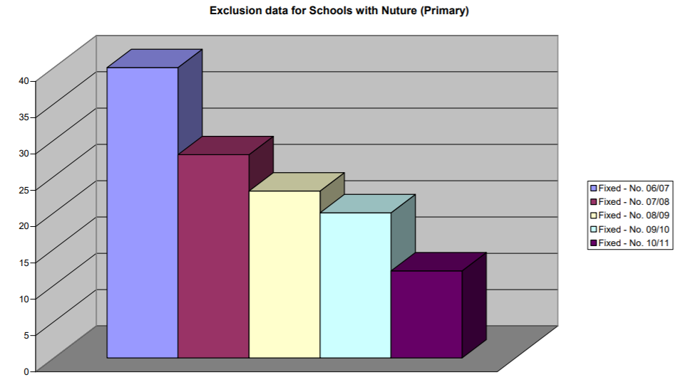
Exclusion data for Schools with Nurture (Primary)
They also witnessed an increase in self-confidence and esteem and an improvement in home, school relationships. By reducing the number of poor behavioural incidents, they have established a higher level of engagement and academic achievements (Children, Young People and Education Cabinet Board, 2012). Whilst another confirms that children identified with abnormal development profiles before attending the group have either changed to making good progress or are now exhibiting ‘normal’ development and meeting or exceeding their expected targets in some areas such as spelling and reading, thus reducing the gap between their reading and chronological age (Estyn 2015). Some schools already have excellent tracking systems in operation to monitor progress, while others are still at the development stage.
Estyn (2015) also reports how one pilot school is offering numerous parenting workshops and programmes. Based on the NG concept, they recreate the NG atmosphere for them to simulate at home whilst supporting their child’s learning. Pupil’s progress is tracked, and questionnaires are completed by teachers and parents to analyse the evidence provided. Based on these proven and positive results, NGs have since been implemented in numerous other schools throughout Wales.
One concern about NGs is that they are only short-term interventions with children usually returning to their normal classrooms after two to four terms. With most studies on NG provision having evolved from the importance of Bowlby’s Attachment Theory, to where a child can encounter multiple attachments and relationships; if positive attachments are the answer to improving behaviour and academic achievements, then additional investigation and more longitudinal studies are still required; with specific attention placed on long term effects and the relationships and understanding of multi-agency professionals and carers responsible for (LAC) (Sloan, 2019). Another is that they are not suitable for children with additional learning needs (ALN) (nurtureuk, 2020). There is also no definitive number for how many NGs are in existence, as some authorities use different names and they may not have registered with the nurtureuk charity network . This makes it difficult to get a complete and accurate evaluation of its worth.
Assessments from Local Authorities (LAs) recognise NGs as being the most justifiable, cost effective intervention for SEBD Children. Despite the National Assembly for Wales (2019) recognising their benefit, issues still remain around the availability of funding for education, which is continuously under review, in line with School Funding (Wales) Regulations (2010) and LAs. Some LAs partially or fully fund NGs, while other schools who had previously accessed grants such as Better Schools Fund (BSF) and Raising Attainment and Individual Standards in Education (RAISE), that are no longer available are now having to allocate funding from their already inadequate individual school budgets (ISBs).
In contrast, Assertive Discipline (AD) is a training program developed by Canter in 1976 to support classroom management and children with emotional and behavioural difficulties (EBD) (Swinson & Cording 2002). Its purpose is to advise and support teachers on how to remain in control of the classroom, by using proactive and positive collaboration as opposed to reactive and authoritarian techniques (Obey-Jordan, 2007). Appropriate and inappropriate AD behaviours are the same for all pupils and should be agreed and shared between governing bodies, headteachers, staff, children and parents and carers (Garner 2011). Teachers should not be expected to manage everything alone and be able to seek help from head teachers and parents when necessary (Borrego-Gonzales, 2020).
AD places its emphasis on Watson’s Theory on Behaviourism, where he believed that behaviour is based on the influences of the environment rather than inborn or genetic elements. And Skinner’s Theory, which suggests that positive reinforcement strengthens or increases the likelihood of positive behaviour being repeated (Ayers et al. 2000).
Teachers should never be prevented from teaching because of poor behaviour, so it is up to them to decide on a consistent approach to accommodate all pupils. AD highlights the importance of the relationship between the pupil and the teacher’s expectations, with the teacher as the authority on discipline. It is up to the teacher to select age appropriate measures they are comfortable with implementing, that are not time consuming and limit disruption (Super Teachers Unite, 2017). By remaining assertive and using positive reinforcement, pupils understand what level of behaviour is expected from them and that there will be consequences if rules are not followed (Obey-Jordan, 2007). Issues should only arise if the teacher has difficulty in remaining assertive and becomes passive or aggressive instead. AD should be systematically organised, opposed to any form of negative behaviour and take into consideration pupil’s personalities, temperaments, and friendships. Principle approaches to AD must include transparent rules; recognition and rewards for appropriate and exceptional behaviour, and consequences for when standards are not met. Children love praise for even the smallest achievement. Verbal recognition, reward or positive communication with a parent or carer not only raises the child’s self-esteem, but also improves home, school partnerships. For children who are easily distracted, ADs repetitive warnings allow them the time to recover their behaviour with punishment or exclusion only used in profound circumstances and with extreme caution (Borrego-Gonzales, 2020). AD strategies should refrain from using intimidating, sarcastic and hostile ultimations to eliminate negative and disruptive behaviour.
While this strategy works for many, some critics suggests that by identifying positive and negative actions for themselves, allows children to observe, discover and develop their own preferred standards (Borrego-Gonzales, 2020).
One case study observing a consistent rule breaker in a UK primary school explains why this type of behaviour management can have mixed results. They identified three key issues: resistance to the approach because it evoked negative emotions and angry responses; perceptions of trust and fairness where teachers appeared biased or based their opinions on past reputations; and peers where conflicting morals and values resulted in embarrassment, respect or retribution (Woods, 2008). The following conversation highlights the type of resentment and anger that can lead to resistance and trigger even more disruptive behaviour.
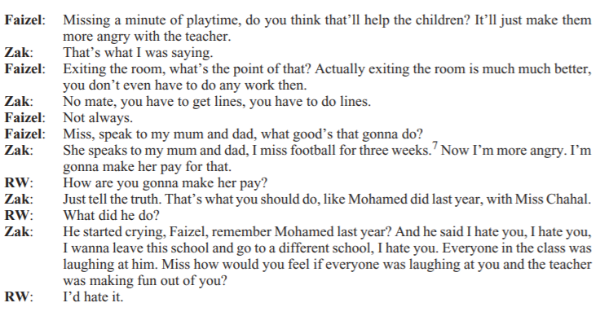
Extract of 2 pupil’s perceptions of the consequences:
AD can also impact on the communication between a teacher and their pupils as they are always seen to be in complete control. Some still believe AD to be an authoritarian system where pupils are forced into accepting rules and parents must be compliant for children to master self-discipline (Obey-Jordan, 2007). It is essential that teachers ascertain through observation and experience, whether AD is having the positive effect on classroom behaviour they anticipate.
Without disregarding this evidence, what can be acknowledged is the increased level of performance, resulting in higher academic achievements that AD produces in a calm and peaceful atmosphere, which brings back the joy of teaching. It is also easy to implement and cost effective as it does not involve any additional resources. The only funding required is the initial outlay for videos, text books, workbooks and the online training sessions. Once completed these can be accessed and replicated by all members of staff.
To conclude, there is a strong correlation between good behaviour and social, emotional, and academic achievement, yet behaviour is still recognised as one of school’s biggest challenges (Bennett, 2017). The earlier behaviour management can be addressed the better the outcome. Both behaviour strategies can be introduced at any age, but as a child gets older, they become less accepting and it is more challenging to tap into their emotional intelligence. By implementing these methods at primary school level, it allows the child time to examine and redefine their behaviour before bad habits are learnt and it is too late to correct them.
Early attachment has a significant influence on a child’s behaviour, but unfortunately not all children are privileged enough to experience a nurturing childhood. Many miss out on the opportunity to develop the social and emotional skills required to succeed. Boxall concludes that NGs provide vulnerable children with an additional opportunity to internalise successful relationships and attachments thanks to the sensitive and caring nature of their teachers. It is therefore understandable that NGs need to be made available as early as possible, to reduce the risk of personal and academic failure for children and young people both now and in later life (nurtureuk, 2020).
AD is a behavioural approach that requires positive reinforcement. Teachers strive to remain in control of the classroom by giving clear and succinct instructions to raise self-esteem. However, some see this as a reactive approach, centred around consequences for undesirable behaviour when rules are not followed.
NGs are recognised as short-term, reactive interventions that support children with extreme SEBD (nurtureuk, 2020), whereas AD is a long-term, proactive strategy, which if implemented early enough can determine a child’s behaviour for the duration of their schooling (Universal Class 2020). Teachers normally pick strategies that match their beliefs and what they feel they can optimise in the best interest of their pupils. Irrespective of how long these practices have been around, they are still relevant and very much in existence in contemporary classrooms.
What is visible from this analysis is that as a result of these behaviour management approaches, whole schools have witnessed behavioural improvements, with a reduction in classroom and playground incidents and permanent exclusions and referrals. However, research still recognises the need for more extensive, high calibre investigation (Hughes & Schlosser, 2014).
References:

Ayers, H. et al (2000) Perspectives on Behaviour A Practical Guide to Effective Interventions for Teachers. 2nd Ed. Oxon: David Fulton Publishers.

Bennett, T. (2017) Creating a Culture: How school leaders can optimise behaviour. Available at: https://assets.publishing.service.gov.uk/government/uploads/system/uploads/attachment_data/file/602487/Tom_Bennett_Independent_Review_of_Behaviour_in_Schools.pdf (Accessed: 17 April 2020).
Borrego-Gonzales, M. (2020) Assertive Discipline. Available at: https://miriahborrego-gonzales.weebly.com/why.html (Accessed: 20 April 2020).
Bretherton, I. (1992) The Origins of Attachment Theory: John Bowlby and Mary Ainsworth. Available at: http://www.psychology.sunysb.edu/attachment/online/inge_origins.pdf (Accessed: 17 April 2020).
Children, Young People and Education Cabinet Board (2012) An Evaluation of Nurture Groups in Neath Port Talbot (p.54). Available at: https://democracy.npt.gov.uk/Data/Children,%20Young%20People%20and%20Education%20Cabinet%20Board/20120618/Agenda/$CYPEB-180612-REP-EL-AE.doc.pdf (Accessed: 19 April 2020).
Cherry, K. (2019) Bowlby & Ainsworth: What is Attachment Theory? Available at: https://www.verywellmind.com/what-is-attachment-theory-2795337 (Accessed: 17 April 2020).

Costello, E. J. et al (2011) Trends in psychopathology across the adolescent years: what changes when children become adolescents, and when adolescents become adults? J Child Psychol Psychiatry. Available at: https://www.ncbi.nlm.nih.gov/pmc/articles/PMC3204367/ (Accessed: 22 April 2020).

Department for Education (2012) Behaviour and discipline in schools Guidance for governing bodies. Available at: https://assets.publishing.service.gov.uk/government/uploads/system/uploads/attachment_data/file/463484/Behaviour_and_discipline_in_schools_guidance_for_governing_bodies.pdf (Accessed: 17 April 2020).

Education and Inspections Act 2006 p. 7. c.1. Available at: http://www.legislation.gov.uk/ukpga/2006/40/part/7 (Accessed: 17 April 2020).
Estyn (2015) Setting up nurture groups for children and parents. Available at: https://www.estyn.gov.wales/effective-practice/setting-nurture-groups-children-and-parents (Accessed: 17 April 2020).
Garner, P. (2011) Promoting the conditions for positive behaviour, to help every child succeed: review of the landscape. Available at: https://dera.ioe.ac.uk/12538/1/download%3Fid%3D158591%26filename%3Dpromoting-the-conditions-for-positive-behaviour-to-help-every-child-succeed.pdf (Accessed: 17 April 2020).
Hughes, N.K. and Schlosser, A (2014) The effectiveness of nurture groups: a systematic review. Available at: https://www.tandfonline.com/doi/abs/10.1080/13632752.2014.883729?src=recsys&journalCode=rebd20 (Accessed: 17 April 2020).
National Assembly for Wales (2019) School Funding in Wales. Available at: https://www.assembly.wales/laid%20documents/cr-ld12643/cr-ld12643-e.pdf (Accessed: 20 April 2020).
Nurtureuk (2020) What is nurture? Available at: https://www.nurtureuk.org/nurture/what-nurture (Accessed: 16 April 2020).

Nurtureuk (2020) Nurture Group Research FAQ. Available at: https://www.nurtureuk.org/research-evidence/impact-and-evidence/nurture-group-research-faq (Accessed: 20 April 2020).

Obey-Jordan, K. (2007) The Impact of Assertive Classroom Discipline on Social Skills. Available at: https://digitalcommons.brockport.edu/cgi/viewcontent.cgi?article=1427&context=ehd_theses (Accessed: 20 April 2020).
Sloan, S. et al. (2019) The effectiveness of Nurture Groups in improving outcomes for young children with social, emotional and behavioural difficulties in primary schools: An evaluation of Nurture Group provision in Northern Ireland. Available at: https://reader.elsevier.com/reader/sd/pii/S0190740919309697?token=46445EA35F48D2BD57F824F2A6E75D5EB018123F8AD62697821A48DF43B4775C14E280A98196C55B32907F4C25CE97DA (Accessed: 22 April 2020).
Super Teachers Unite (2017) Assertive Discipline: A Positive Approach to Classroom Management! Available at: https://www.youtube.com/watch?v=yZH-zLaakjw (Accessed: 17 April 2020).

Swinson, J and Cording, M. (2002) ‘Assertive Discipline in a school for pupils with emotional and behavioural difficulties’, British Journal of Special Education 29(2), pp.72-75. Available at https://web-b-ebscohost-com.ezproxy.uwtsd.ac.uk/ehost/pdfviewer/pdfviewer?vid=2&sid=e112fb62-5b12-4393-93c2-e31b2f20a8b3%40pdc-v-sessmgr05 (Accessed: 20 April 2020).
Universal Class (2020) Types of Classroom Management: Assertive Discipline. Available at: https://www.universalclass.com/articles/self-help/types-of-classroom-management-assertive-discipline.htm (Accessed: 16 April 2020).
WAG (2010) Nurture groups: A handbook for schools. Available at: https://gov.wales/sites/default/files/publications/2018-12/nurture-groups-a-handbook-for-schools.pdf (Accessed: 16 April 2020).
Woods, R. (2008) When rewards and sanctions fail: A case study of a primary school rule-breaker. Available at: file:///C:/Users/Student/Downloads/When_rewards_and_sanctions_fail_A_case_study_of_a_.pdf (Accessed: 16 April 2020).

