University of Wales Trinity Saint David

Networks and Cyber Security Essentials
ACCA4024
Synthesize a solution to a potential real-life scenario.

Olivia Collins
2403891
13/05/25

Introduction 2
Identification of Threats 2
Security Policies 3
Mitigation Measures 4
Monitoring and Response 5
Training and Awareness Program 6
Conclusion 7
Appendix 7

Introduction
Over the past decade, cybersecurity has become one of the most difficult challenges that companies are struggling with across the globe. The rapid evolution of technology has brought many benefits, with efficient communication and global connectivity. However, it has also introduced companies with more exposure to security threats. Not only have cybersecurity threats become increasingly prominent and damaging but trying to protect systems from them have become harder as well. With multiple types of risks that need to be covered, companies are finding keeping their sensitive information more strenuous. Especially, with the uprise of more companies turning to remote work, causing a growing range of vulnerabilities.
Not only is cybersecurity super important for every industry, but it is critically important in the financial sector due to the high value of data and transactions it handles. Financial institutions like FinSecure Ltd manage sensitive client information, process high volume monetary transactions and maintains their reputation and trust through their clients. Due to this, FSL must be vigilant and fast with its cybersecurity measures and protocols. [1]
This report will highlight and identify the threats towards companies and individuals, how we can face these threats and how to effectively avoid and manage security.

Identification of Threats
FinSecure Ltd (FSL), has recently experienced several cybersecurity incidents that have highlighted multiple weaknesses within its current security infrastructure. While incidents did not result in a data breach, it is still essential that if it continued to be unaddressed, it could lead to severe financial and reputational consequences. [2]
One of the most concerning and continuous threats is phishing attacks that are targeting employees through convincing emails. These attacks involve deceptive messages that appear to be from legitimate and trusted departments or companies. These messages target and trick recipients into revealing sensitive information and data, like log in information or financial data or trick them into clicking malicious links that install malware on company devices without the recipient knowing. Several employees have reported these emails, and in one instance, credentials were unknowingly shared which led to an immediate system monitoring and password reset.
Due to the phishing incident, FSL also faced multiple unauthorised access attempts on its internal network. This happened before the system was monitored, due to the firewall detecting unusual login activities originating from an external network. Although, these attempts were completely blocked before any damage and harm was caused. This directly shows that FSL is being directed by threats actors, particularly probing for potential weaknesses to exploit in future attacks.
Another massive threats that many people under mind are human errors. According to study performed by IBM, “Human error causes 95% of cybersecurity breaches” [3]. This could range from accidental data breaches to poor password hygiene or even using unsecured personal devices. Accidental data breaches can happen by human error; many ways could include talking to unauthorised people about sensitive information or accidentally putting files in wrong directories and folders. Another error can be bad password hygiene, this includes making password easy and guessable, reusing the same passwords across accounts and even leaving passwords out in the open (on paper or on hand). This can be stopped by doing cybersecurity training for employees. [4]
These incidents emphasize the importance of more comprehensive and structured approaches to cybersecurity. Strengthening measures and policies to avoid as many threats as possible will be the best way to continue alongside fostering a security aware culture across the organisation.

Security Policies
To protect and secure FSL’s digital assets, security policies are recommended. Security policies are used within cybersecurity, to place rules and practices on an organisation’s network, ensuring that sensitive information is managed and secured. These policies are essential for defining permissions hierarchy and ensuring compliance with laws and regulations. Given the recent security events that have happened, FinSecure Ltd needs consider and implement a policy framework that addresses both human and technical vulnerabilities. Here are some security policies that will be effective with FSL’s systems. [5]
  - Access Control Policy
Access Control Policies outlines who access what, under what conditions and using what methods. For example, if there was a Chief Banking Officer they would have more access than a Bank Teller. This ensures that the correct personnel access the right information.
  - Password Policy
Passwords are the first line of defence when it comes to protecting FSL’s systems and data. Poor password hygiene is quite common among employees and having a strong password policy will help with minimising any risk of unauthorised access, especially with phishing attacks. An average password policy includes, howling a password must be, a combination of different letters, number and special characters and nothing guessable like 123, password, a birthday, name or often used words. [6]
  - Device Usage Policy
As remote working have become increasingly prominent, policies must be put into place. Within FSL the use of personal and company issued devices to access corporate resource has increased. To ensure that this flexibility is smooth and safe, a Device Usage Policy must be put into place which includes the following rules.
Only authorised devices that have been registered and approved by the IT department may be used to access the company systems. For example, phones, laptops or tablets must be registered and approved before the employee is able to use the device for work purposes.
  - Data Protection Policy
Data is one of the most important and valuable assets that FinSecure Ltd has, so protecting this data is vital for maintaining client trust, compliance with legal obligations and safeguarding business operations.
Within this Data Protection Policy, all data must be classified and filed according to its sensitivity level, such as public information, private or highly confidential. The access Control Policy plays a part within this policy, the higher the access level means the more sensitive information that can be accessed. For example, a Chief Banking officer will have access to all of the information, whether that is finance information or personal information. Whereas, a Bank Teller would only have access to customer information. All sensitive data must be encrypted in both transit and at rest. This will stop any unauthorised users to access this data.
Using these security policies establishes a clear framework for protecting FinSecure Ltd’s systems, data and users. These policies not only promote consistency with security practices across the whole company. But also reduces the risk of internal and external threats.

Mitigation Measures
Mitigation measures are steps that an organisation must take to reduce the likelihood and impact of cybersecurity threats. For FSL, these measures are essential for addressing internal and external threats that were recently identified through incidents that have occurred, such as phishing and unauthorised access attempts. There are few measures that will help with mitigation strategies. [7]
Phishing Mitigation involves implementing strategies and techniques to reduce risk of phishing attacks. The strategy used will be an advanced email filtering system. This system, which is also known as a secure email gateway, will be able to block any suspicious spam emails, malicious links, and even suspicious attachments.
For Unauthorised access issues, there will be a Multi-Factor Authentication protocol put into place. MFA will be required for all employees' logins, especially when accessing sensitive data and documents. This will force employees to enter a code from their phones to get access into the system, meaning that any outsiders without the authenticator app will not have access.
Together, these mitigation measures ensure a multi-layered defence strategy that addresses FinSecure Ltd’s most pressing cybersecurity issues. From safeguards like MFA and endpoint protection to secure device usage. Each measure plays a role in reducing the risk and enhancing overall security.

Monitoring and Response
Continuous monitoring and an effective response plan are essential to identify potential threats early, minimising any damage and recovering quickly from security incidents. FinSecure Ltd will be adopting a proactive approach to monitoring its IT environment and responding to cybersecurity threats in a fast and professional manner.
  - Monitoring
A Security Information and Event Management system is used to aggregate and analyse logs from various sources including firewalls, servers, and endpoint to provide real-time threat detections and anomaly spotting. This system will automatically update and alert if any suspicious such as unapproved file access, repeated log in failures and strange network traffic. [8]
  - Response
To respond to these alerts, we must have an Incident Response Plan in place [9]. This plan must be clear and tested, which will guide the organisation in managing these security incidents, the common phases of an IRP includes:
Preparation – Ensuring that the staff members are prepared and ready with the right steps and tools to use during a security incident
Detection and Analysis – Identifying and assessing the nature of the incident
Containment – Isolating any affected devices, files, or systems to prevent the spread of any viruses or threats.
Eradication – Removing the threat from all systems by deleting malware and revoking any data that was affected.
Recovery – Restoring systems and data from secure backups.
Learning Lessons - Conducting a post-incident assessment to improve any future efforts. [10]
This plan will follow through from the detection stage, so one a threat is detected the plan will start. Here is a flowchart describing how the plan will carry out.
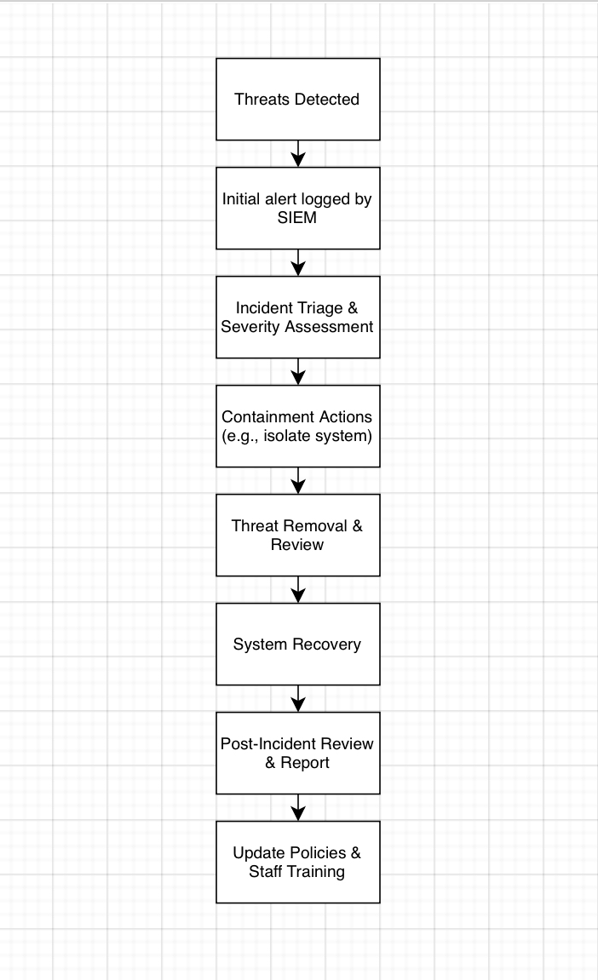
[11]
Each stage has been considered thoroughly out to be as simple as possible, so even someone with the least amount of cybersecurity experience is able to understand this flowchart and plan.

An effective monitoring and response strategy ensure that FSL can detect and contain threats before they escalate into major incidents. By integrating real-time monitoring, stricter incident response procedures and clear stages, the company and its employees can act fast when it comes to protecting critical data and information.

Training and Awareness Program
Technology has changed multiple lifestyles, but those who use it need to know who to be careful and weary on how to use technology to stay safe and take action against cybersecurity threats. Human error is one of the most common causes of cybersecurity incidents, often exploited through phishing, poor password hygiene and carelessness. This has also been a common cause of incidents within FinSecure Ltd, therefore a training program has been created for the employees to follow.
The main goals of the training program are to: increase staff understanding of cybersecurity risks and responsibilities, promote safe online behaviour, equip employees to recognise, and respond appropriately to threats, and ensure that employees are actively following company policies and regulations. [12]
Training components
New employees will undertake a cybersecurity meeting, covering policies, safe practices, and incident reporting procedures. Current employees will complete quarterly training sessions that will be held online to reduce interruptions with their current workloads. These sessions will cover phishing identification, secure remote work and how to report suspicious activity.
Due to the past incidents of phishing, there will be an internal phasing test to see if employees are vigilant and capable enough to prevent phishing attacks.
Posters and videos are posted and sent to all employees monthly to remind them to be safe and secure from any cybersecurity threats, this will also help promote the internal reporting process.
Each of these training components will help with the proactive mindset within employees to start looking out and reporting for these cyber security vulnerabilities and risks.
By educating the employees and encouraging the mindset of keeping the company safe, FinSecure Ltd can become a computer smart company. With the reduction of human error incidents, this training can also reduce the risk of successful cybersecurity attacks.

Conclusion
In today’s rapidly changing digital landscape, cybersecurity threats are not only more frequent but are becoming increasingly more sophisticated. FinSecure Ltd has faces some of these challenges, such as phishing attacks and unauthorised access attempts, highlighting the urgent need for a robust security strategy. This report has identified key internal and external threats, proposed a set of new policies, and outlined mitigation measures, monitoring procedures and staff training initiatives.
By implementing the recommendations in this report, FinSecure Ltd will be well positioned to safeguard its systems, data and reputation, providing a safe and secure environment for its clients.

Appendix
References
[1] "The Global Cyber Threat to Financial Systems IMF F&D." https://www.imf.org/external/pubs/ft/fandd/2021/03/global-cyber-threat-to-financial-systems-maurer.htm
[2] "Types of Cyberattacks." https://www.crowdstrike.com/en-us/cybersecurity-101/cyberattacks/common-cyberattacks/
[3] T. H. News. "Why Human Error is #1 Cyber Security Threat to Businesses in 2021." https://thehackernews.com/2021/02/why-human-error-is-1-cyber-security.html
[4] "The Role of Human Error in Successful Cyber Security Breaches." https://blog.usecure.io/the-role-of-human-error-in-successful-cyber-security-breaches
[5] "What are cyber security policies?", https://mitigogroup.com/, https://mitigogroup.com/cyber-security-wiki/what-are-cyber-security-policies/
[6] "Top 10 password policy recommendations for SysAdmins in 2025." https://www.securden.com/blog/top-10-password-policies.html
[7] "Cyber risk mitigation strategies: How to strengthen your efforts." https://www.dataguard.com/blog/cyber-risk-mitigation-strategies/
[8] "What Is SIEM? | Microsoft Security." https://www.microsoft.com/en-gb/security/business/security-101/what-is-siem
[9] "What Is an Incident Response Plan (IRP)?" https://www.paloaltonetworks.co.uk/cyberpedia/incident-response-plan
[10] "6 Phases in the Incident Response Plan." https://www.securitymetrics.com/blog/6-phases-incident-response-plan

[11] "Flowchart drawn with Draw.io" http://draw.io
[12] "What Is Security Awareness Training?" https://www.mimecast.com/content/what-is-security-awareness-training/
  - PowerPoint


