FALLING WATER

THE MAN WHO BUILT AMERICA
Frank Lloyd Wright was one of history’s greatest architects who designed over 1,000 buildings throughout his life. In 1935 he designed Falling water: voted the best all-time work of American architecture by the American Institute of Architects (AIA) which revamped his architectural career (The art pilgrim, 2017).
“One should conceive the building in the imagination first not on paper but in the mind, thoroughly”, which explains why after 9 months, there was no physical evidence of any progress towards Edgar Kaufmanns weekend home and yet, Wright was able to draft up Fallingwater within 2 hours (Rawson, 1989). Impressively, the initial drawings of the house aren’t too dissimilar to the finished building and Kaufmann was impressed with the design, but also surprised that it was sited above the waterfall rather than beside it, as any other architect would have done (Fallingwater, 2017).
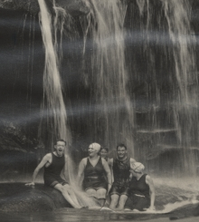

Figure 1, the Kaufmanns under the falls (Fallingwater, 2017)

Wrights prime motive to place it here was the family’s love for the sound of the water as it crashed over the fall. Although it would have been picturesque to frame the waterfall from inside, to live amongst the sound was more intimate; as said by American Philosopher John Dewey, “the eye is the sense of distance, while sound itself is near” (McCarter, 2002, p. 17). Another reason for its position, was that there was an inappropriate sun orientation below the fall, whereas in wrights proposed location the building would receive a wholesome amount of sunlight throughout the entire day that would create playful shadows off the forms of the structure and give a softened, diffused lighting inside (McCarter, 2002, p. 4).
It was finished in 1937 utilising four main materials: rock, reinforced concrete, steel, and glass. The walls were constructed by hand using Pottsville sandstone that had been quarried from the site and placed in irregular patterns to echo the natural formations around it and concrete was used to create cantilevers that appear to float over the stream (Fallingwater, 2017).

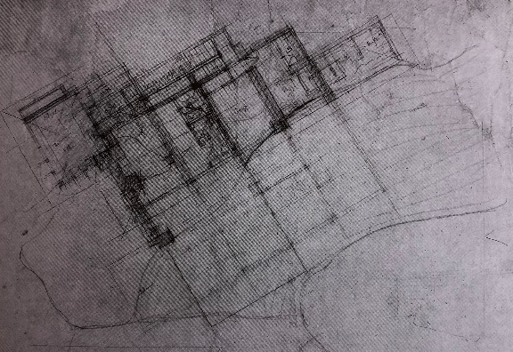

Figure 2, first sketch plan of Fallingwater (1935) (McCarter, The construction of Fallingwater, 2002)

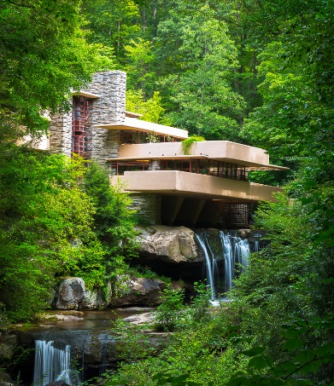
The rendered finish was not white, such as that in European Modernism. Instead, it was a melon-like mauve, not too dissimilar to the colour on the underside of the leaves in the area as seen in figure 3 (Britton, 2014). “Thus if the house was photogenic, it was not by accident”, meaning even the iconic image that we receive of Fallingwater, as seen in figure 4, was intentionally thought out by Wright by setting the plan of the house at a 60° angle to the road and falls (McCarter, 2002, p. 4).
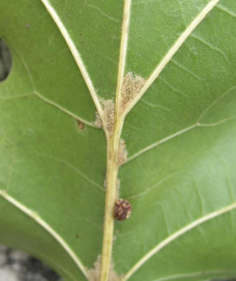

Figure 3, underside of Oak leaf (Missouri State University, 2017)
Figure 4, iconic image of Fallingwater (Borden, 2008)

THE DETAILS
Wright became very sensitive to the site, saving trees wherever he could and left rock cropping’s in their original form, to such an extent that concrete trellises curve around the tree trunks (figure 5) (Wiebe, 2015). A boulder was even left to penetrate through the building fabric and now forms part of the living room floor which is laid with waxed flagstones to cleverly resemble the stream when the sun shimmers across them (figure 6).(McCarter, 2005, p. 196).
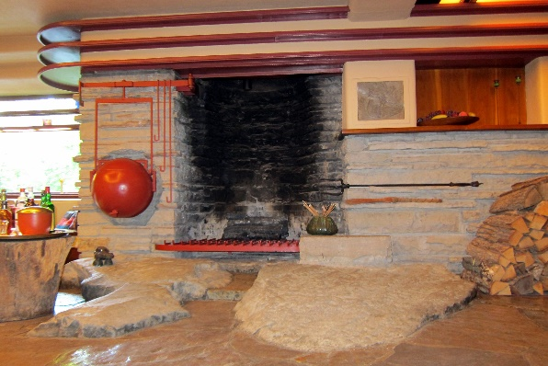
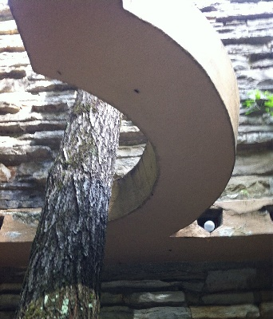

Figure 5, Fallingwater trellis curving around a tree (The art of construction, 2012)
Figure 6, inside Fallingwater living room (Gobetz, 2011)

Wright had glass go directly into a channel in the rock, which is then filled with caulk to reinforce the idea of the building growing out from the landscape, creating an interesting contrast between the fragile glass and the rough, heavy rock (figure 7). In and around these windows are horizontal steel mullions which have a Cherokee red finish (Britton, 2014). Red is the complimentary colour for green which is why it is used by the Japanese for the ironwork in their gardens, showing one of the many ways that Wright was influenced by Japanese architecture (Britton, 2014). Likewise, the red could also have been used to match the Maple trees that are native to the site (Litchman, 2017).
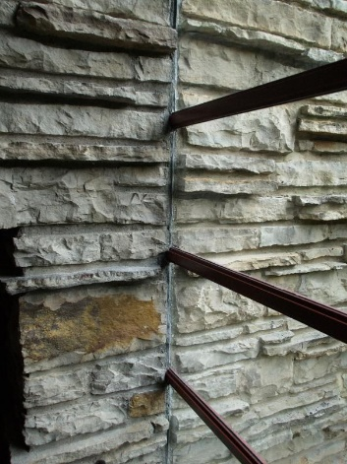

Figure 7, glass to rock detail (Wright-house, n.d)

The ceiling heights in Fallingwater are playful to create drama, ranging from 6ft 4 up to 9ft where Wright had based the proportions off his own height and the bedrooms, as well as the kitchen, are both small in comparison to the living room, showing how they were designed only for their primary purpose (Glancey, 2001).
Even the furnishings had been careful considered and echo the architecture of the house: they were made using walnut by the Gillen Woodworks Company of Milwaukee and incorporated overhangs to resemble the cantilevers (Hanks, 1979, p. 147). Wright requested that the grain be used horizontally, as opposed to the typical vertical, in order for it to be more moisture resistant and prevent warping (Hanks, 1979, p. 147).

INFLUENCES AND IDEAS
Fallingwater comes with a romanticised story of Wright drawing up this stunning home with its creative, new ideas in the space of 2 hours but the house is actually, for the most part, a collaboration of his most successful ideas that he had been experimenting with and refining for decades. The most obvious precedents being Taliesin (1911) and the Samuel Freeman house (1923) where he similarly used native rock for the walls in his own home (figure 8) (Wiebe, 2015). Also, Fallingwater and the Freeman house both share the corner window with horizontal mullions rising through all floors of the building (figure 9), which was also used in the Richard Lloyd Jones house (1929) (figure 10) (McCarter, 2002, p. 5).
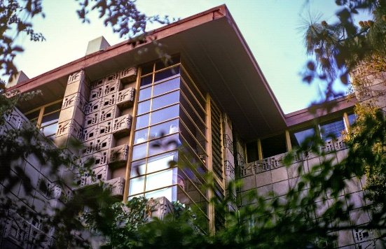
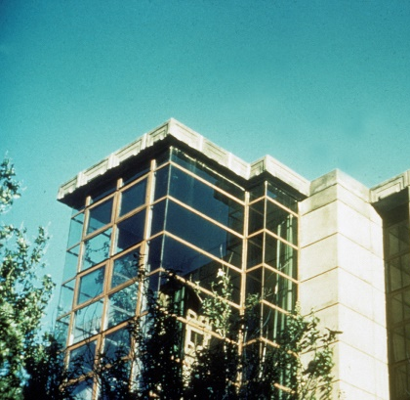
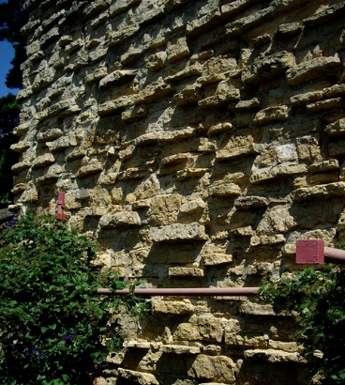
Figure 10, Richard Lloyd Jones house corner window (Speck, n.d) REF
Figure 8, external wall at Taliesin East (Shane, 2006)
Figure 9, Freeman house corner window (Frank Lloyd Wright Foundation, 2021)

Additionally, architectural historians have suggested similarities between the Mrs Thomas Gale house (1907) (figure 11) and Fallingwater for its form, and potential influence from the Robie house (1909) (figure 12) towards the primary cantilever that runs over the stream (McCarter, 2005, p. 208). It has also been referenced that the orthogonal projections of the house resemble Theo Van Doesburg’s famous painting, “Rhythm of a Russian Dance” (1918) (figure 13), and that Wright was playing European modernists at their own game by using elements from their style of architecture (Wiebe, 2015).
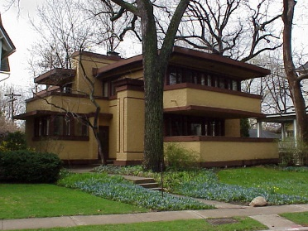
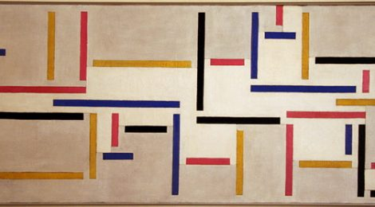
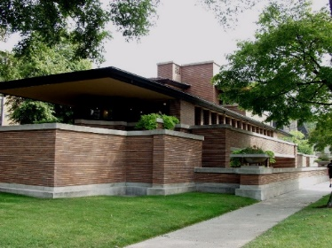

Figure 12, Robie house (Frank Lloyd Wright Foundation, 2019)
Figure 13, Rhythm of a Russian Dance painting by Theo Van Doesburg (Barrera, 2018)
Figure 11, Mrs Thomas Gale house (Thompson, 2012)

The house is beautifully organic, creating the perfect conjunction between the manmade and the natural which exemplifies Wright’s philosophies. Traditionally, country houses dominate the site, instead, Fallingwater compliments it. At this stage in his life, Wright had come away from the limitations of the Prairie house to express the spiritual value of nature: his early designs were based around his Welsh heritage of having the fireplace as the central core of the house but as his ideologies developed, rather than focusing inward his buildings began to look out, usually at water (Standen, 2022).

In an interview, Frank Lloyd Wright stated, “there was a fascist symbol that the architecture of freedom and democracy needed something besides the box, so I started out to destroy the box as a building” he wanted to alleviate the feeling of standing closure and instead shape a space that would appeal to all senses (NBC, 1953). It is almost metaphorical that Wright’s architectural career started not long after the traumatic Great fire of Chicago, and finished with involving water in his architecture, the defeater of fire.
The house itself has a very subtle diagonality to it, which strays from the major and minor axis of classical architecture in order to make it more visually open (McCarter, 2005, p. 263). The plan was designed so that your journey through the house offers you glimpses of your destination without giving you a direct route to it, incorporating different architectural experiences in between (McCarter, 2002, pp. 14,17). In comparing Wright with other architects of his time you can see how different he was to the other modernists. French architect Le Corbusier perceived buildings as machines that had to be pure and functional for mankind, where Wrights’ buildings saw the power of nature, the beauty in the imperfectly perfect, and utilised it to create profound architecture. Both are extreme influences of today’s world, yet Fallingwater offers a sense of natural harmony and a feeling of wholesomeness to its visitors, something that the machine aesthetic of Savoye (figure 14) arguably couldn’t.
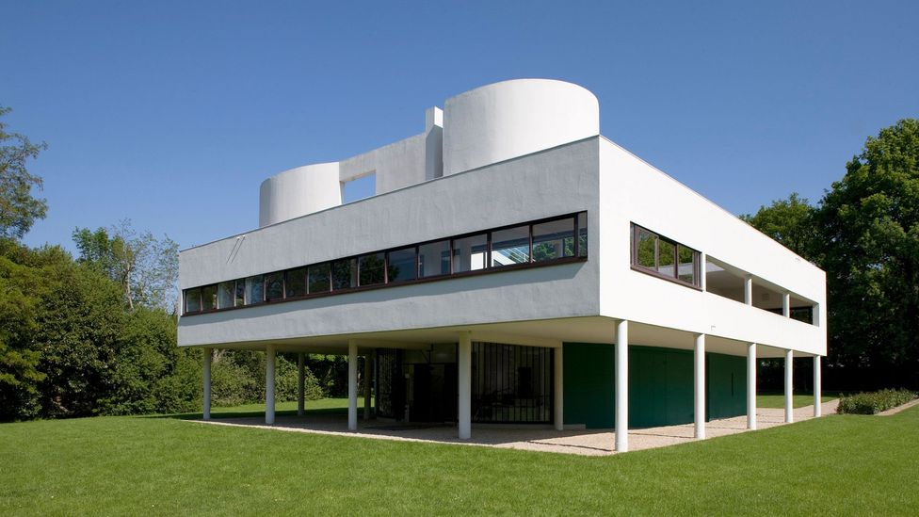

Figure 14, Villa Savoye (Glancey, 2016)

THE ISSUES
Despite being one of the best examples of organic architecture, Fallingwater isn’t the most sustainable. It is the most expansive use of concrete on any of Wights domestic projects and details, such as that of the glass-to-rock connection, are highly inefficient, using only caulk to act as a seal (Alter, 2020). Wrights’ buildings have been criticised for their poor performance and functionality, but it is often overlooked due to the beauty and experimental nature of his work. The Kaufmanns had noted that Fallingwater wasn’t the most comfortable which was developed on in the 1939 extension and Mrs Kaufmann would often stay the night in there instead (Alter, 2020).

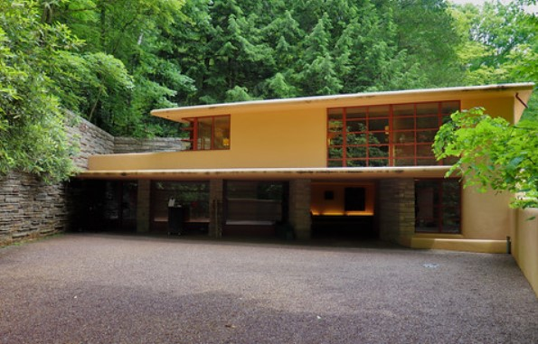

Figure 15, Fallingwater guesthouse (Neat, 2019)

CONCLUSION
The house with the waterfall is a genius piece of architecture and Wright demonstrated competence and brilliance all throughout the project despite constant doubts from all angles. It is a remarkable design with collaborations from all of Wrights best work, set in a gorgeous landscape to form the most beautiful home in the world. “A work of art beyond any excellence. Itself an ever-flowing sense of exhilaration. House and site together form the very image of a man’s desire to be at one with nature, equal and wedded to it” – Edgar Kaufmann Jr. (Alter, 2020).

References
Alchetron. (2014). Edgar J Kaufmann. Retrieved from Alchetron: https://alchetron.com/Edgar-J-Kaufmann Accessed: 19 April 2022
Alter, L. (2020). Fallingwater: A contradiction in sustainable design. Retrieved April 2022, from Treehugger: https://www.treehugger.com/fallingwater-contradiction-sustainable-design-4859188
Barrera, R. (2018). Rhythm of a russian dance, Theo Van Doesburg. Retrieved from University of Oregon: https://blogs.uoregon.edu/284s18/2018/04/17/rhythm-of-a-russian-dance-theo-van-doesburg/
Borden, D. (2008). Architecture: A world history. (E. Corso, Ed.) New York: Abrams. Retrieved April 18, 2022
Britton. (2014). Frank Lloyd Wrights organic architecture: Green design before its time. Retrieved April 18, 2022, from Britton: htps://www.brittonmdg.com/blog/frank-lloyd-wrights0organic-architecture-green-design-before-its-time/
Fallingwater. (2017). Designing Fallingwater. Retrieved from Fallingwater: https://fallingwater.org/history/about-fallingwater/designing-fallingwater/. Accessed on: 19 April 2022
Fallingwater. (2017). Preservation history. Retrieved from Fallingwater: https://fallingwater.org/history/preservationcollections/preservation-history/. Accessed on: 19 April 2022
Fallingwater. (2017). Stone walls. Retrieved April 18, 2022, from Fallingwater: https://fallingwater.org/worldheritagepreserved/. Accessed on: 19 April 2022
Fallingwater. (2017). The house over the waterfall. Retrieved from Fallingwater: https://fallingwater.org/history/about-fallingwater/designing-fallingwater/. Accessed on: 19 April 2022
Fallingwater. (2017). The Kaufmanns. Retrieved from Fallingwater: https://fallingwater.org/history/about-fallingwater/the-kaufmann-family/. Accessed on: 19 April 2022
Fallingwater. (2017). Concrete. Retrieved April 18, 2022, from Fallingwater: https://fallingwater.org/worldheritagepreserved/
Frank Lloyd Wright Foundation. (2019). Robie House Reopens After Interior Restoration. Retrieved from Frank Lloyd Wright Foundation: https://franklloydwright.org/robie-house-reopens-after-interior-restoration/. Accessed on: 19 April 2022
Frank Lloyd Wright Foundation. (2021). Frank Lloyd Wright’s Samuel & Harriet Freeman House For Sale. Retrieved April 18, 2022, from Frank Lloyd Wright Foundation: https://franklloydwright.org/frank-lloyd-wrights-samuel-harriet-freeman-house-for-sale/
Glancey, J. (2001). The folly of Fallingwater. Retrieved April 18, 2022, from The Guardian: https://www.theguardian.com/culture/2001/sep/10/artsfeatures
Glancey, J. (2016). The man who changed the way we live. Retrieved April 18, 2022, from BBC: https://www.bbc.com/culture/article/20160901-the-man-who-changed-the-way-we-live
Gobetz, W. (2011). Fallingwater - Living room fireplace and kettle. Retrieved April 18, 2022, from Flickr: https://www.flickr.com/photos/wallyg/6013523418/
Hanks, D. (1979). Renaissance:1930-1959. In D. Hanks, The decoractive designs of Frank Lloyd Wright (p. 147). London: Cassell Ltd. Retrieved April 18, 2022
Litchman, L. (2017). Maple Trees in Pennsylvania. Retrieved from Garden Guides: https://www.gardenguides.com/99883-maple-trees-pennsylvania.html. Accessed on: 19 April 2022
McCarter, R. (2002). The construction of Fallingwater. In R. McCarter, Falingwater (p. 8). London: Phaidon Press Limited. Accessed on: 19 April 2022
McCarter, R. (2002). The design of Fallingwater. In R. McCarter, Fallingwater (p. 4). London: Phaidon Press Limited. Accessed on: 19 April 2022
McCarter, R. (2005). From the Praire house to Fallingwater. In R. McCarter, A primer of architectural principles (2 ed., p. 208). London: Phaidon Press ltd. Retrieved April 18, 2022
McCarter, R. (2005). From the Praire house to Fallingwater. In R. McCarter, & R. McCarter (Ed.), A primer of architectural principles (2 ed., p. 204). London: Phaidon Press Ltd. Retrieved April 18, 2022
McCarter, R. (2005). Later developments. In R. McCarter, & R. McCarter (Ed.), A primer of architectural principles (2 ed., p. 196). London: Phaidon Press Limited. Retrieved April 18, 2022
McCarter, R. (2005). The later work. In R. McCarter, A primer of architectural principles (2 ed., p. 263). London: Phaidon Press Ltd. Retrieved April 18, 2022
Missouri State University. (2017). Quercus shumardii. Missouri: Missouri State University.
NBC (Director). (1953). A conversation with Frank Lloyd Wright [Youtube] Avaialble at: https://www.youtube.com/watch?v=W8EABJrMplY&list=WL&index=1&t=25s Accessed on: 18 April 2022
Neat, G. (2019). Fallingwater guest house. Retrieved April 18, 2022, from Flickr: https://www.flickr.com/photos/115582557@N03/48091277466
Rawson, M. (Director). (1989). The house on the waterfall [Motion Picture]. Available at: https://www.imdb.com/title/tt0325583/. Accessed on: 18 April 2022
Standen, I (2022) History of arch week 12_FLW [lecture] UWTSD January 24th 2022
The art of construction. (2012). Fallingwater. Retrieved April 18, 2022, from The art of construction: https://riles-files.blogspot.com/2012/07/fallingwater.html
The art pilgrim. (2017). Fallingwater. Retrieved April 18, 2022, from The art pilgrim: https://www.theartpilgrim.org/pilgrimages-2/fallingwater
Wiebe, C. (2015). Frank Lloyd Wright, Fallingwater, Available at: https://www.khanacademy.org/humanities/ap-art-history/later-europe-and-americas/modernity-ap/a/frank-lloyd-wright-fallingwater. Retrieved April 18, 2022
Wright-house (n.d) [pintrest] 19 April 2022. Available at: https://www.pinterest.co.uk/pin/470978073500864700/ C. (2015). Frank Lloyd Wright, Fallingwater.

