Name – Shivcharan Mistry
Student ID – 2244603
Module – Marketing Management
Module Code – LCMB7001
Lecturer – Efua Adams
Title – Marriott International - Marriott’s Response to the COVID Crisis
Word Counts – 3500

TABLE OF CONTENTS

1. INTRODUCTION 1
1.2 MARRIOTT RESPONSE TO COVID 1
1.3 MARKETING STRATEGIES DURING THE COVID CRISIS 1
1.4 STRATEGIES USED BY MARIOTT INTERNATIONAL DURING COVID 1
2. SWOT ANALYSIS OF MARRIOTT INTERNATIONAL DURING COVID 3
2.1 STRENGHT 3
2.2 WEEKNESS 3
2.3 OPPORTUNITIES 3
2.4 THREAT 3
3. THE IMPACT OF COVID-19 ON MARRIOTT INTERNATIONAL'S MARKETING STRATEGIES 4
3.1 PRODUCT STRATEGY 4
3.2 EFFECT ON STAKEHOLDERS 4
3.3 PRICING STRATEGY 4
3.4 EFFECT ON STAKEHOLDERS 4
3.5 PROMOTION STRATEGY 4
3.6 EFFECT ON STAKEHOLDERS 5
3.7 PLACE STRATEGY 5
3.8 EFFECT ON STAKEHOLDERS 5
3.9 PEOPLE STRATEGY 5
3.10 EFFECT ON STAKEHOLDERS 5
4. COMPETITIVE ANALYSIS OF MARRIOTT INTERNATIONAL'S STRATEGIES DURING THE COVID CRISIS 6
5. IMPACT OF TECHNOLOGY IN MARRIOTT INTERNATIONAL'S STRATEGIES DURING THE COVID CRISIS 6
6. PROVIDE A MANAGERIAL IMPLICATION ON MARKETING STRATEGIES IMPLEMENTED BY MARRIOTT INTERNATIONAL DURING THE COVID CRISIS 7
7. RECOMMENDATIONS ON HOW MARRIOTT INTERNATIONAL CAN IMPROVE THEIR MARKETING STRATEGIES IN THE POST PANDEMIC ERA 8
LIST OF REFRENCES 10

LEFT BLANK PAGE

1. INTRODUCTION
When COVID first began to affect the areas in which the Marriott International has operations, the company was forced to take decisive action. It, like a great number of other hotels, has been forced to take extreme measures in order to save costs, including temporarily closing businesses. It is hoped that taking these precautions will be sufficient to get the chain through the first wave of the outbreak.
In the early stages of the pandemic, travel restrictions and mandatory quarantine led to a precipitous drop in the number of hotel reservations made. As the pandemic has continued for an extended period of time, a great number of hotels have been compelled to permanently close their doors.

1.2 MARRIOTT RESPONSE TO COVID
- Marriott International announced a 50% salary cut for his senior team and the furloughing of many personnel, including from their Maryland headquarters. Two thirds of its headquarters personnel will take unpaid leave for 90 days, which will be evaluated during the pandemic. During low occupancy, cutting administrative expenditures, including personnel costs, decreasing work weeks, and cancelling non-essential travel and spending is crucial to its survival. Marriott will invest $140 million USD from these cost reductions in COVID-19-affected departments MarketLine (2020)
- Marriott closed food and beverage outlets to reduce COVID-19 transmission and social isolation. Marriott hotels offer high-quality food and beverages across all brands. Hotel food and beverage outlets are pricey and reduce contact with others, delaying the transmission of the illness MarketLine (2020)

1.3 MARKETING STRATEGIES DURING THE COVID CRISIS
The COVID-19 epidemic is forcing businesses in the tourism and hospitality industries to innovate and adapt to changes in the business environment that have never been seen before. Innovation is essential for hospitality and tourism firms to remain competitive during and after the epidemic (Gössling et al., 2020).
Product, process, marketing, and organizational innovation were the Oslo Manual's most comprehensive typologies (Oslo Manual, 2005). An "innovation in marketing" is defined as "a new method or practice for marketing that involves significant changes in product, placement, promotion, or pricing."

1.4 STRATEGIES USED BY MARIOTT INTERNATIONAL DURING COVID
- PRODUCT INNOVATION - In order to facilitate social distancing, hotels have embraced new technology systems for the safe and hygienic delivery of services in an incremental manner. These new technology systems include completely automated hotel check-in systems (for example, mobile keys) and self-service kiosk check-in devices (Shin & Kang, 2020). Our upgrading their existing products or technology.
- DIGITAL MARKETING - We will travel again." As someone who adores traveling and works in the travel sector, I find that these four simple phrases convey a sense of optimism. This message was distributed through a variety of social networking sites. The following notice was displayed on various other platforms: "Soon, we will emerge from behind our screens, instead of looking at the camera, we are going to look each other in the eye. We are going to clink our glasses. We are going to give each other hugs. We shall go on another trip. Maintain your health and a pleasant attitude till then. We'll keep an eye out for you. This is because travel is still seen to be risky. This message, in general, struck a chord with me on a deep level.
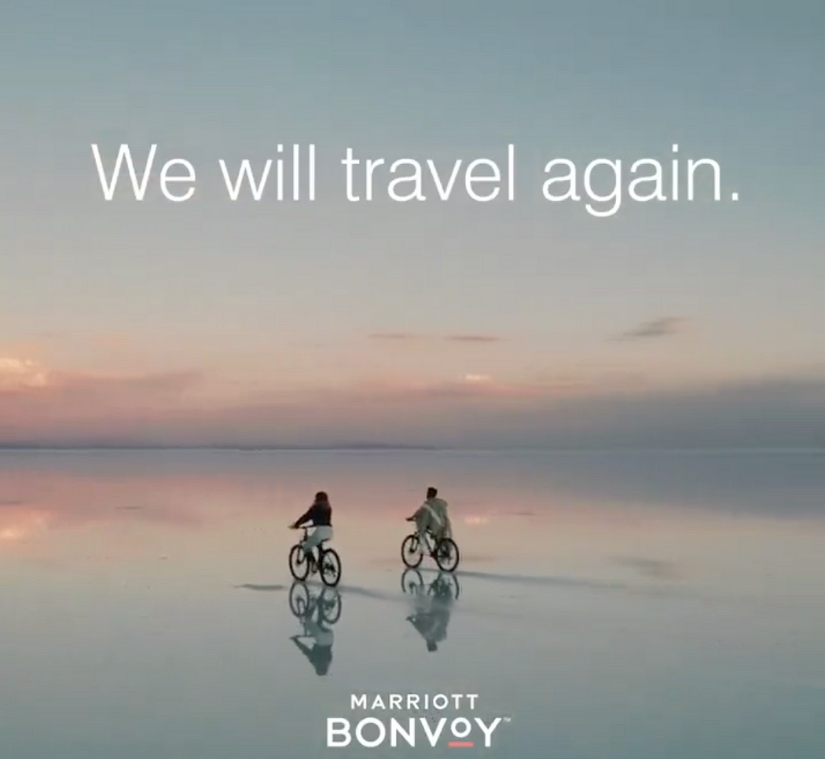
Source - https://www.linkedin.com/posts/marriott-international_we-will-travel-again-soon-we-will-step-activity-6649314784367919105-bH-M/
- LOYALTY MARKETING - The Marriott Bonvoy reward program has gained significant popularity around the world as a result of the company's status as the biggest hotel group in the world, which provides customers with an extensive range of available lodging options. In addition to pausing the expiration of points until 2020, Marriott has stated that its loyalty programs would have their statuses extended until the year 2021.

2. SWOT ANALYSIS OF MARRIOTT INTERNATIONAL DURING COVID
A comprehensive and well-informed evaluation of the company's strengths, weaknesses, opportunities, and threats is contained inside the Marriott International. The research was based on an in-depth understanding of the hospitality sector as well as the existing competitive environment.

2.1 STRENGHT
Marriott International's strengths include its great brand awareness, global reach, experienced management team, and good financial position. Other strengths include the company's global presence. Due to the company's many qualities, it was able to survive the COVID-19 epidemic and emerge in a good position as a result.
In order to lessen the effects of COVID-19, Marriott possesses considerable cash reserves in addition to several funding lines. Strong Operational Network – This will enable the organization to disperse risk and limit its effects wherever it is practicable to do so MarketLine (2020).

2.2 WEEKNESS
The company's high fixed expenses, its reliance on business travel, and its vulnerability to economic downturns are the three factors that contribute to Marriott International's shortcomings. The corporation may have difficulties in the future as a result of these flaws, in especially if the COVID-19 pandemic persists or if there is a worldwide economic slump.

2.3 OPPORTUNITIES
The opportunities for Marriott International include growth in domestic travel, expansion into new markets, and development of new brands. The company is well-positioned to capitalize on these opportunities, given its strong brand recognition and global reach.

2.4 THREAT
There is a pandemic of COVID-19, there is a recession, and there is greater competition. These are the risks that Marriott International faces. These dangers might present the organization with substantial obstacles at some point in the future.

3. THE IMPACT OF COVID-19 ON MARRIOTT INTERNATIONAL'S MARKETING STRATEGIES
During the Covid-19 crisis, Marriott International, along with numerous other hospitality businesses, faced significant obstacles. Marriott employed a variety of marketing strategies from the marketing mix in order to navigate these challenging times and mitigate the impact on its stakeholders. Let's examine the effects of these strategies on both internal and external stakeholders.
3.1 PRODUCT STRATEGY
- During the pandemic, Marriott adapted its product offerings to meet a mix requirement of its consumers. As an example, they created "Work From Hotel" packages to attract remote employees and "Staycation" deals to attract local leisure travellers.
- The implementation of enhanced health and safety protocols, such as contactless check-ins, increased cleansing measures, and social distancing practices, aided in assuring consumers of their safety and well-being (Marriott, 2023).

3.2 EFFECT ON STAKEHOLDERS
- External Customers - The modified product offerings and safety measures instilled confidence in customers, encouraging them to continue staying at Marriott properties.
- Employees - Internal stakeholders valued the implementation of safety measures because it protected their health while at work and ensured their employment security as the business persisted.

3.3 PRICING STRATEGY
- During the recession, Marriott adjusted its pricing strategy to remain competitive. To encourage reservations, they provided attractive discounts, flexible cancellation policies, and loyalty program benefits (Marriott, 2023).
- As travel restrictions and closure measures varied, dynamic pricing was utilized to respond to fluctuations in demand and supply.

3.4 EFFECT ON STAKEHOLDERS
- External Customers - Customers confronting uncertainty appreciated lower prices and flexible cancellation policies, which led to an increase in bookings and customer loyalty.
- Franchisees - Reduced room rates may have posed revenue challenges for Marriott licensees, but the brand's support for flexible pricing likely alleviated the burden.

3.5 PROMOTION STRATEGY
- Through digital and social media channels, Marriott prioritized assuring consumers of safety and sanitation in its marketing communications.
- They utilized email marketing to communicate with members of their loyalty program, offering them exclusive discounts and perks to encourage repeat business.

3.6 EFFECT ON STAKEHOLDERS
- External Customers - Customers' confidence in scheduling with Marriott increased as a result of transparent and reassuring communication, resulting to an increase in bookings.
- Shareholders - During turbulent times, effective promotion and communication strategies may have helped maintain investor confidence.

3.7 PLACE STRATEGY
- Marriott utilized online reserving platforms and its website to reach consumers directly, particularly during the pandemic when digital engagement increased.
- In order to maximize operations, they implemented temporary closures and shifted resources to areas with greater demand (Marriott, 2023).

3.8 EFFECT ON STAKEHOLDERS
- External Customers - The ease of booking through online platforms and direct communication with hotels made the process more convenient for customers.
- Local Communities - Local communities dependent on the hotel's business may have suffered from temporary closures, including employment losses and diminished economic activity.

3.9 PEOPLE STRATEGY
- During the pandemic, Marriott most likely implemented training programs to familiarize employees with new safety protocols and customer service techniques.
- With a focus on rehiring when business improved, efforts were made to support employees during reductions and absences.

3.10 EFFECT ON STAKEHOLDERS
- Employees - Training and support initiatives assisted employees in adapting to a changing work environment and ensured their well-being during challenging times.
- Shareholders - The people strategy intended to maintain a competent and motivated workforce, which could boost investor confidence.
In conclusion, Marriott International responded to the Covid-19 crisis with an all-encompassing marketing strategy based on the marketing mix. By modifying its product, pricing, promotion, location, and people strategies, Marriott sought to mitigate the negative impact on both internal and external stakeholders. The measures made to improve safety and communication played a crucial role in preserving customer confidence, while employee support helped to mitigate the challenges encountered by the workforce. Due to the unprecedented nature of the crisis, it is essential to observe that some stakeholders, such as local communities and franchisees, may have encountered negative effects.

4. COMPETITIVE ANALYSIS OF MARRIOTT INTERNATIONAL'S STRATEGIES DURING THE COVID CRISIS
- Marriott's ability to rapidly innovate and customize its product offerings provided them wit competitive advantage over other hotel chains that may have been sluggish to respond to changing consumer demands.
- By providing lower prices and flexible policies, Marriott positioned itself favorably in comparison to rivals, as customers were more likely to choose their properties over those with less alluring pricing and cancellation terms.
- By emphasizing safety in their advertisements, Marriott demonstrated a higher level of concern for their visitors than competitors who may not have placed as much emphasis on health and safety.
- Strong online presence and direct customer engagement gave Marriott an advantage over rivals who extensively relied on third-party booking platforms and lacked direct customer interaction.
- Marriott sought to maintain a competent and motivated workforce by investing in employee training and support. This emphasis on employees could set them apart from competitors who place less importance on employee welfare.
Marriott International's Covid crisis response was agile, customer-focused, and health and safety-focused. Their ability to create goods, offer competitive pricing, stress safety in promotions, use direct booking channels, and educate and support employees gave them a competitive edge. Marriott's proactive measures helped them stay competitive and increase client loyalty during the epidemic. However, the competitive environment was always changing, and other industry participants may have used their own techniques to react to the crisis.

5. IMPACT OF TECHNOLOGY IN MARRIOTT INTERNATIONAL'S STRATEGIES DURING THE COVID CRISIS

Technology enabled seamless communication between Marriott and its stakeholders, ensuring that crucial information was disseminated effectively and in real time.
- Contactless Communication - Marriott has implemented contactless check-in and check-out procedures, allowing visitors to use their mobile devices for a variety of services with minimal physical contact.
- Mobile Apps and Chatbots - Guests were able to access information and support services via mobile applications and chatbots powered by artificial intelligence without engaging in face-to-face interactions.
- Real-Time Market Insights - Marriott was able to monitor travel restrictions, infection rates, and demand trends in various countries by using technology, enabling them to make informed decisions regarding international operations.
During the Covid crisis, technology was a crucial enabler for Marriott International. It revolutionized their marketing, communication, and internationalization strategies. By adopting digital marketing, Marriott was able to maintain consumer engagement, personalize its marketing efforts, and improve bookings. During the pandemic, effective communication technologies enabled seamless interactions with customers and stakeholders while ensuring the safety and well-being of visitors.

6. PROVIDE A MANAGERIAL IMPLICATION ON MARKETING STRATEGIES IMPLEMENTED BY MARRIOTT INTERNATIONAL DURING THE COVID CRISIS

- Focus on cleanliness and safety - The importance that Marriott International placed on maintaining a clean and secure environment was a significant contributor to the company's success throughout the COVID outbreak. The management carried out a variety of reforms in order to boost the level of tidiness and security of its hotels. These reforms included the implementation of enhanced cleaning methods, recommendations for social distancing, and the utilization of contactless technology. (Suzanne Markham Bagnera, 2020) The investigation into the effects that COVID-19 had on hotel operations resulted in the formulation of a number of recommendations for hotel owners and managers, including the utilization of fewer hotel rooms, putting an emphasis on take-out or delivery options to reduce public dining; implementing intensified cleaning and sanitizing protocols; committing to the use of personal protective equipment (PPE) for workers; paying increased attention to personal hygiene; communicating new COVID-19 policies to guests and employees; putting into practice physical distancing practices in public areas; and putting into practice protocols for guests who have been exposed to or infected by COVID-19.
- Use of technology - Marriott International also used technology to improve the customer experience and make it easier for guests to book and stay at its hotels. The management has given the proper training to their employees about the technology used in mobile application. If customers don’t understand make sure to guide them and provide knowledge. For instance, the company launched a mobile app that allowed guests to check in, order room service, and pay for their stay without having to interact with anyone in person. This helped to reduce the risk of transmission of the virus and made it easier for guests to stay at Marriott hotels during the pandemic (Marriott, 2023).
- Loyalty programs - Customers were more likely to continue doing business with Marriott International and book more stays at the company's properties thanks to the Marriott Bonvoy reward program. Members of the program are eligible for a range of privileges, including free stays, room upgrades, and other awards, which may be obtained by redeeming points earned via the program. Even throughout the epidemic, this helped to maintain consumer loyalty to Marriott hotels.
- Targeted marketing - Marriott International made use of data analytics in order to direct their marketing efforts on particular demographics of consumers. Because of this, the organization was better able to target the appropriate audience with the appropriate message, which led to a rise in the number of reservations. People who were interested in traveling to locations that were less severely impacted by the epidemic were one of the primary audiences that the corporation targeted in its marketing activities.
- Partnerships - In order to communicate with a larger customer base, Marriott International formed strategic alliances with other companies, including traditional and internet travel agencies. These agreements contributed to increasing the company's brand recognition as well as the number of reservations. For instance, the firm collaborated with Expedia to provide customers with discounts on their hotel stays at Marriott (Marriott, 2023)

7. RECOMMENDATIONS ON HOW MARRIOTT INTERNATIONAL CAN IMPROVE THEIR MARKETING STRATEGIES IN THE POST PANDEMIC ERA

- Continue to focus on cleanliness and safety - Because of the COVID situation, maintaining a clean and safe environment for hotel guests is more critical than it has ever been. Customers should feel reassured, and the company's image should improve as a result of Marriott International's continued attention to these elements. This may be accomplished by the firm maintaining its implementation of improved cleaning methods, standards for social distance, and the use of technology that does not require physical interaction.
- Embrace technology - It is important for Marriott International to maintain its commitment to technology in order to continue enhancing the quality of the customer experience and simplifying the booking and check-in processes for guests of its properties. This may be accomplished by the corporation through further development of its mobile app as well as investment in various other digital technologies.
- Strengthen its loyalty program - For the purpose of retaining customers and encouraging them to book more stays at the company's hotels, Marriott International has to improve its customer loyalty program, which is known as Marriott Bonvoy. This can be accomplished by the corporation by including new advantages, such as special discounts and upgrades, in the membership program.
- Target specific audiences - Marriott International should keep directing its marketing efforts on certain demographics in order to be successful. This will assist the organization in reaching the appropriate audience with the appropriate message, which will ultimately lead to an increase in the number of reservations. The organization is able to accomplish this goal through the utilization of data analytics to segment its client base and through the targeting of its marketing efforts toward those who have an interest in visiting to particular locations or who are searching for particular categories of hotels.
- Partner with other businesses - It is important for Marriott International to maintain its collaborations with other companies so that it may reach a larger customer base. These collaborations have the potential to assist in increasing the company's brand recognition as well as the number of bookings received. The corporation may get into business partnerships with airlines, travel agencies, internet travel agencies, and any other companies that are involved in the travel sector.
These are just a few recommendations from my side on how Marriott International can improve its marketing strategies in the POST PANDEMIC era. By following these recommendations, the company can continue to attract customers and grow its business in the years to come.
- The changing needs of customer - The ever-evolving requirements of customers: Because of the COVID situation, the requirements that consumers have become more specific. Customers today are more worried about the cleanliness and safety of their surroundings, and they are also more inclined to reserve their accommodations at hotels that provide flexible cancellation policies. When establishing its marketing tactics, Marriott International should make sure to take into account the aforementioned criteria.
- The competitive landscape - Because of the COVID crisis, the hospitality industry's competitive environment has seen significant shifts. While some hotels have been forced to close their doors, others have been able to successfully transform their operations to accommodate the new environment. It is important for Marriott International to be current on the most recent developments in the hospitality sector as well as to ensure that its marketing methods are competitive.
- The economic environment - The conditions of the economic environment are also shifting. Due to the fact that the world economy is still in the process of recovery from the COVID crisis, there may be a decrease in the demand for hotel stays. Marriott International needs to keep a close eye on the economy and make sure that its marketing efforts are in step with the state of the market at all times.
By taking these factors into account, Marriott International can develop marketing strategies that are effective in the POST PANDEMIC era.

LIST OF REFRENCES
- Gössling, S., Scott, D., & Hall, C. M. (2020). Pandemics, tourism and global change: A rapid assessment of COVID-19. Journal of Sustainable Tourism, 1–20

- Marketline (2020) Marriott International: Marriott's response to the COVID crisis as the travel and tourism industry struggles. Place of publication: www.marketline.com Available at: https://moodle.uwtsd.ac.uk/course/view.php?id=10168 (Accessed: 10 July 2023).

- Marriott (2023) Travel with confidence during COVID -19. Available at: https://clean.marriott.com/ (Accessed: 10 July 2023).

- Shin, H., & Kang, J. (2020). Reducing perceived health risk to attract hotel customers in the COVID-19 pandemic era: Focused on technology innovation for social distancing and cleanliness. International Journal of Hospitality Management, 91, 102- 120.

- Suzanne Markham Bagnera, E.S. (2020) Navigating Hotel Operations in Times of Covid-19 | Boston Hospitality Review, Navigating Hotel Operations in Times of Covid-19 | Boston Hospitality Review. Available at: https://www.bu.edu/bhr/2020/03/25/navigating-hotel-operations-in-times-of-covid-19/ (Accessed: 10 July 2023)

