Name:___________Kyle Hall______________________

Student Number: 2533563________________________
__________________________________________________________

WORKSHEET 1 – TESTING (Using Variables)

- Original code:
Surname = str(input("Hi, please input your surname. "))
CarReg = str(input("Please enter your car registration."))
Age = int(input("Please enter your Age."))
Lectures = float(input("Please enter how many hours of lectures you have a week. "))

print (f"Your surname is:{Surname}")
print(f"Your vehicle registration is: {CarReg}")
print(f"Your Age is: {Age}")
print(f"and you have {Lectures} hours of lectures a week.")

- Code Testing

For each test below, run your code and enter the values provided. Provide a screenshot of the programme running. Did the programme behave correctly or did it do something unexpected? Fill in a box for each test below. You should present 14 separate boxes, 1 for each test. (Note: the first box is provided as a template)

Surname:
- Enter JONES
- Leave blank
- Enter 123

Car registration:
- Enter BG56UDU
- Leave blank
- Enter BG56345DFE (ie too long for a UK car registration number)

Age
- Enter 34
- Enter 150
- Enter -4
- Enter a letter

Hours per week of lectures
- Enter 12
- Enter 15.5
- Enter -4
- Enter 150 (ie longer than the maximum possible hours that the University is open in a week)

Test:
Surname i. Enter JONES

Screenshot(s) of output:
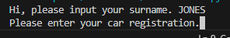
Result: Did the program behave as expected ie syntactically and logically correct?
YES
If NO, what problems were encountered and why? Suggest how things could be improved.

Test:
Surname ii. Leave blank

Screenshot(s) of output:
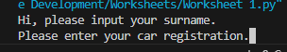
Result: Did the program behave as expected ie syntactically and logically correct?
NO
If NO, what problems were encountered and why? Suggest how things could be improved.
Logically there shouldn’t be a case where someone doesn’t have a surname, an if statement to attempt to prevent a blank input could be implemented.

Test:
Car Registration i. Enter BG56UDU

Screenshot(s) of output:
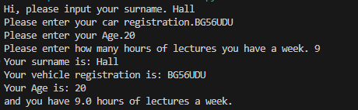
Result: Did the program behave as expected ie syntactically and logically correct?
YES
If NO, what problems were encountered and why? Suggest how things could be improved.

Test:
Car Registration ii. Leave Blank

Screenshot(s) of output:
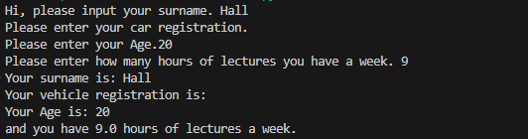
Result: Did the program behave as expected ie syntactically and logically correct?
NO
If NO, what problems were encountered and why? Suggest how things could be improved.
An if statement can be implemented to ensure there is a minimum character amount so it cannot be left blank, private plates can be shorter than standard plates, so I cannot just set it to 7 characters as it can be shorter than that.

Test:
Car Registration iii. Enter BG56345DFE

Screenshot(s) of output:
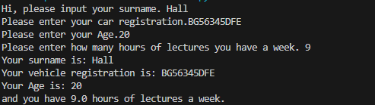
Result: Did the program behave as expected ie syntactically and logically correct?
NO
If NO, what problems were encountered and why? Suggest how things could be improved.
It allows digits past the UK limit, an IF statement can be implemented to fail if this is the case.

Test:
Age i. Enter 34

Screenshot(s) of output:
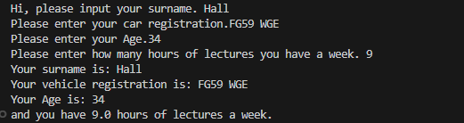
Result: Did the program behave as expected ie syntactically and logically correct?
YES
If NO, what problems were encountered and why? Suggest how things could be improved.

Test:
Age iii. Enter -4

Screenshot(s) of output:
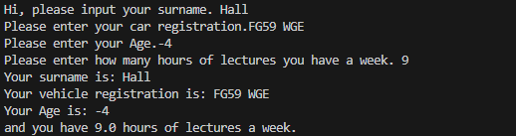
Result: Did the program behave as expected ie syntactically and logically correct?
NO
If NO, what problems were encountered and why? Suggest how things could be improved.
I could set up an IF statement to detect numbers below a certain age, such as 3, as it is highly unlikely a student will be of age 3

Test:
Age iv. Enter a letter

Screenshot(s) of output:
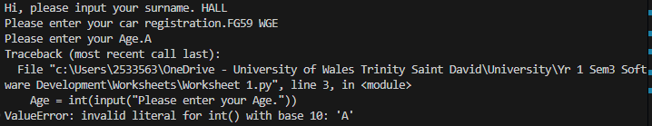
Result: Did the program behave as expected ie syntactically and logically correct?
YES
If NO, what problems were encountered and why? Suggest how things could be improved.

Test:
Hours per week of lectures i. Enter 12

Screenshot(s) of output:
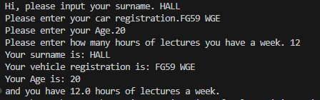
Result: Did the program behave as expected ie syntactically and logically correct?
YES
If NO, what problems were encountered and why? Suggest how things could be improved.

Test:
Hours per week of lectures ii. Enter 15.5

Screenshot(s) of output:
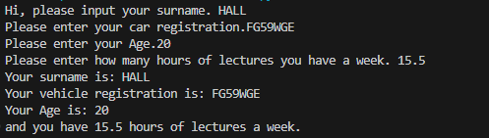
Result: Did the program behave as expected ie syntactically and logically correct?
YES
If NO, what problems were encountered and why? Suggest how things could be improved.

Test:
Hours per week of lectures iii. Enter -4

Screenshot(s) of output:
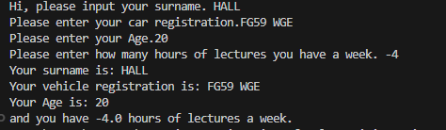
Result: Did the program behave as expected ie syntactically and logically correct?
NO
If NO, what problems were encountered and why? Suggest how things could be improved.
I could implement an IF statement to fail upon a number entered below 0 as this would not be possible.

Test:
Hours per week of lectures iv. Enter 150

Screenshot(s) of output:
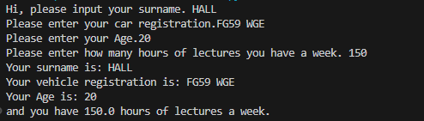
Result: Did the program behave as expected ie syntactically and logically correct?
NO
If NO, what problems were encountered and why? Suggest how things could be improved.
I could set up an if statement to not allow numbers beyond the limit the university could be open in a week.

- Consider the results of the above tests and revisit your original code in order to address the tests that failed. (Note: you may not be able to solve all of the problems that were originally encountered, but solve as many as you can.)

Paste your full revised code here :

Surname = str(input("Hi, please input your surname. "))
CarReg = str(input("Please enter your car registration."))
Age = int(input("Please enter your Age."))
Lectures = float(input("Please enter how many hours of lectures you have a week. "))

print (f"Your surname is: {Surname}")
print(f"Your vehicle registration is: {CarReg}")
print(f"Your Age is: {Age}")
print(f"and you have {Lectures} hours of lectures a week.")

