EFFECTIVE TEAMWORK AND COMMUNICATION

Executive summary
In this report, the effective communication along with its advantage in the organization performance is discussed. The nonverbal and verbal communication is important in an organization is also discussed. Along with the other discussion, the discussion is also focused on different theories and models of communication and the benefits that the organization gets from effective communication. In addition to it, the company McDonald UK is taken to improve the functionality and productivity of the organization.

Table of content
Introduction 4
Definition of effective communication 4
Verbal and non-verbal communication 5
Theories and model related to workplace communication 5
Role of effective communication to maximise and improve the workplace productivity: 9
Benefits of effective communication in the workplace 10
Conclusion 10
Reference list 11
Appendix 14

Introduction
In the workplace, it is important to conduct effective message among the employees to bring flexibility, smoothness and enhance the productivity. In addition to it, for the effective distribution of the responsibility and establishing the group accomplishment in an organization the team plays the pivotal role. The effective teamwork and communication bring the positive and build the healthy environment in the workplace. In this report, the effective theory and model of communication will be discussed along with its importance in the organization functionality. Along with it, the discussion will also be made upon the verbal and nonverbal communication and it is important in the organization practice. The technique and benefit of the effective teamwork and communication will also be discussed along with the relevant outcome. Furthermore, to add the value to the discussion the McDonald's, UK is taking to discuss the importance of effective teamwork and communication in the workplace (Acai et al. 2017)

Definition of effective communication
Effective communication is the way to convey the message that is understood by both ends in a relevant way as intended. It is said that communication is the two-way process, the sender and the receiver conveying the message to each other. The effective communication provides the ample amount of opportunity and benefits to the team and organization as well. The clear and brief communication help the employees to understand the requirement and acceptance and thus according to that the task is performed by implemented the identical efforts. On the other hand, the effective teamwork and communication among the employees help to initiate the innovative and authentic way to work in the dynamic competitive market (Weller and Civil, 2017).
Hence, being the fast food company it is important for McDonald to conduct the effective communication with the employee to bring improvement in the performance. If the effective communication is not present, the employee might not get the relevant information about the responsibility and thus it hampers the overall performance of the company and will also involve customer’s dissatisfaction. Work collaboration plays the significant role in an organization as it provides with the ample amount of ways to work and to deal with the confidential issues among the employees related to share of responsibility and reduce the workforce (Gardner et al.2017).

Verbal and non-verbal communication
Verbal communication is the process to convey the message to the employee by using oral speech for an example interview, meeting. Verbal communication is less time consuming and reduces the cause of misunderstanding among the employees. The team negotiation is important in order to develop the ample amount of information required for the significant performance; hence, in this case, the verbal communication among the employees is vital (Liberman et al. 2017).
Non-verbal communication is the way to communicate without using words of speech; basically it is gestural, shaking hand and so on. The nonverbal communication plays the relevant role where there is mandatory to maintain silence, it is brief and clear (Nakatsukasa and Loewen, 2017).
Hence, it can be said that is important for the McDonald’s to adopt both the verbal and nonverbal communication ways to maximise the product and improve the performance of the employees. Furthermore, it is a responsibility of the team member to initiate the training session for the employees to bring innovation to the performance (Zdenek and Walsh, 2017).

Theories and model related to workplace communication
Group dynamic theories: in the workplace, it is important to adopt the effective and right approach to communicate with the people to avoid the risk of confusion and misinterpretation. The ethical message is required to be conveying to receive hence in this case the theory plays the significant role. The group dynamic theory is implemented by many of the organization to initiate different ethical norms and right communication approach. Hence, the McDonalds can also emphasize the theory to meet the ethical communication norms to improve the performance (Hovland and Lumsdaine, 2017).
Berlo’s model of communication: The Berlo's model of communication is divided into four categories Source(S), Message (M), Channel(C) and Receiver(R). Under each subheading the factor affects the communication process; the model is an effective example of the linear model of communication.
Factors that affect the source are communication skill, the ability that the speaker enhances in terms to communicate the message. In short, it can be said that the ability speaker enhances to listen, writing, speaking, debating, and many more. Along with it the Attitude of the speaker towards the listener and to the subject matter. The knowledge is another factor and it is important for the speaker to have the effective skill to handle the subject matter. A message is affected by content, element, treatment and structure; it is basically the way by which the speaker conveys opinion, emotion, idea and information (Nikolaidis et al. 2017). The channels are the tool that is used by the sender to deliver the message to the receiver and it is affected by hearing, seeing and smelling. Furthermore, a receiver is the person who understands, interpret and analyse the message received. Hence the factors that affect the receiver are communication skill, attitude, knowledge, social system and culture (Illingworth, 2017).
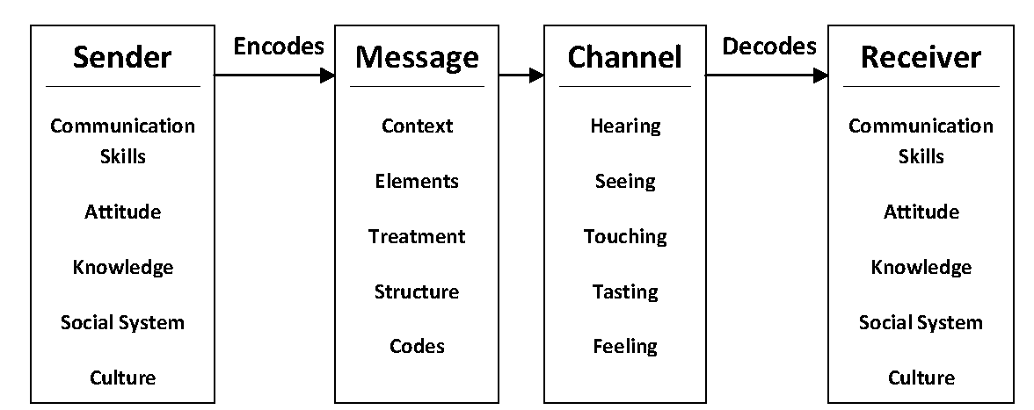
Figure 1: Berlo’s model of communication
(Source: Nikolaidis et al. 2017)
Schramm’s Model of Communication, 1954: according to the model the encoding and decoding is one of the most important parts of the communication process. It is important for the organization to focus on the two elements effectively to bring the sign to the communication process. Encoding is the critical part and it is important for the sender to use the appropriate procedure to convey the information into data. Hence, the model helps to understand how meaningful message is transferred from one person to another. According to the model, the communication process is never ending with the consort of message and feedback. The data interpreted is known as information and it is important for both the sender and receiver to interpret the message at each turn. Hence, it can be said that if the McDonald implemented the model during planning the communication strategy plays the relevant role to bring alignment in the communication process without confusion and thus maximize the performance (Kawai et al. 2017)
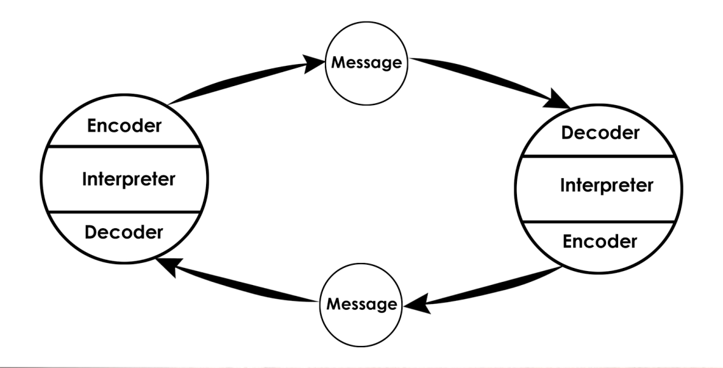
Figure 2: Schramm’s Model of Communication, 1954
(Source: Kawai et al. 2017)

Shannon and Weaver model of communication:
The Shannon and Weaver model has been used by any organization for communicating with their all kinds of stakeholders. Many elements have incorporated with this model of communication; those elements are information sources, transmitter, receiver, destination, noise source and feedback. In the traditional communication model of Shannon and weaver's, did not incorporate the feedback elements in the model of communication but the mathematical model of communication emphasized over the feedback system of audience.
In any workplace, a person can easily get the feedback from their target audience by communication through this model. In order to do communication with their stakeholders a company can implement the effective communication process. One of the leading brands of the United Kingdom that is Mcdonalds has used this mathematical model of communication. They operate their functional process by implementing the effective communication tools. One of the crucial factors of this model is the noise injunction; noise can change the meaning of communication. A communicator needs to understand that noise injunction may changes the meaning of the messages; therefore, it is a prime duty for any person to understand about the negative impact of noise induction and designed their messages as per the intended messages purposes. The information source is the first element of this model that is referred as the message encoding in any communication process. For example the McDonald associate who are aiming to deliver a message to their service users. Here this personel referred as the information source for the specific company. As per this communication model the feedback of this model will works as an effective tools of communication for any workplace.
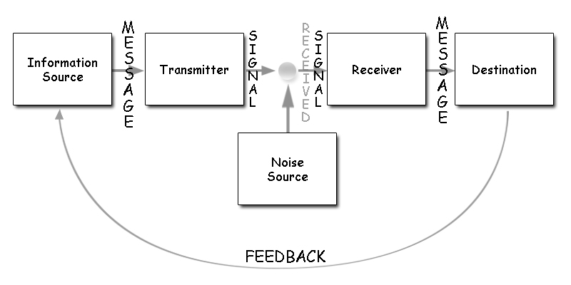

Figure 3: Communication model by Shannon and weaver
(Source: Sutanto, 2017)

Role of effective communication to maximise and improve the workplace productivity:
Sustainability of an organization is depends over the level of its productivity, scale of revenue earning, and over the mode of communication, how they are sending their messages to their service users. The effective communication brings many types of positive outcome with the organization. An organization can maximize their production level by practicing strong communication process among their all departments (Brown et al. 2017). Perfect approach of communication can abide the miscommunication factors from the entire organizational functions.
Role of an effective communication strategy needs to exercise by the associates for informing about the duties and responsibilities of the worker, this process operated by the expert communicator of any organization. Production level of a company can be improved by maintaining different kinds of agendas, like doing the market research, gathering relevant information, maintain collaboration among the departments and finally produce the product for service users. Effective communication in workplace depends over the psychological perspectives of the employee (Xu et al. 2017). All these matters can be controlled by any organization if they are implementing the perfect process of communication. Effective communication strategies are beneficial to maximize and improves the production level of an organization. Workplace production is depends over the collaborative work of the employees, if they can able to work by transforming information among each departments then it will provides benefits to the organizations and the employees. As an example, a group or team of any organization may perform their tasks by exchanging different kinds of information, which will actually brings the best results. The McDonalds Company used the effective communication strategies to operate their basic functions to maximize their profit merging in each year.

Benefits of effective communication in the workplace
Different kind of communication approaches have been practiced by the employees of many companies. In any workplace effective communication necessary to carry out the various kinds of tasks. In any organization, various kinds of information are required to operate the department functions (Nikolaidis et al. 2017). Any department cannot be success until they get support from the other department. They are a large company in the restaurant sector, so they needs to performs various kinds of task starting from the administrative department to sales departments. Lacking of communication generates various kinds of issues within the workplace. The associates of the McDonalds have practiced various communication approaches in order to convey their messages to the target audience. In this context, it must have to be well known by the staffs of McDonalds about their responsibility with accurate information, and then only they became able to perform in best way.The benefit of effective communication helps an organization to earn a good amount of revenue in each financial year (Patton et al. 2017). In a workplace team, management is another important area, In that context the communicator take the initiative to manage also kinds of negative influence from the team members. In a team, there are various kinds of employee coming from different geographical and demographic areas (Hannon et al. 2017). Therefore, it is a prime duty for any team leader to maintain a smooth communication process with the team by how every employee will be able to communicate with each other. This practice helps any organization to earn huge revenue and to enhance the production level.

Conclusion
As a conclusion it can be a stated that this assignment is very much helpful for the researchers who are aiming to gather knowledge regarding this particular topic that is the communication strategy to operates the team agendas. Concisely it can be stated that an effective communication can be considered as an appropriate tool for the communicator to convey their messages to their target audience. The aim of this study is to learnt about the effectiveness of the communication for getting the good results from the organizational functions. In this report, some modern relevant theories have been discussed in appropriate manner to present and the concept of an effective communication tools. All the mentioned theories of communication is helpful to gain the positive roles and helps them to increase their productivity; level. Art the bend of each financial year company will be able to earn a good amount of revenue that helps them to sustain the competence market.

Reference list
Acai, A., McQueen, S.A., McKinnon, V. and Sonnadara, R.R., 2017. Using art for the development of teamwork and communication skills among health professionals: a literature review. Arts & Health, 9(1), pp.60-72.
Weller, J. and Civil, I., 2017. Teamwork and healthcare simulation. Healthcare Simulation Education: Evidence, Theory and Practice, pp.127-134.
Gardner, A.K., Kosemund, M., Hogg, D., Heymann, A. and Martinez, J., 2017. Setting goals, not just roles: Improving teamwork through goal-focused debriefing. The American Journal of Surgery, 213(2), pp.249-252.
Liberman, Z., Woodward, A.L., Keysar, B. and Kinzler, K.D., 2017. Exposure to multiple languages enhances communication skills in infancy. Developmental science, 20(1).
Zdenek, R.O. and Walsh, D., 2017. Advancing Community Development Through Competencies and Comparative Advantages. In Navigating Community Development (pp. 103-113). Palgrave Macmillan, New York.
Hovland, C.I. and Lumsdaine, A.A., 2017. Experiments on mass communication. Princeton University Press.
Illingworth, S., 2017, April. Delivering Effective Science Communication: Advice from a Professional Science Communicator. In Seminars in Cell & Developmental Biology. Academic Press.
Kawai, E., Takagai, S., Takei, N., Itoh, H., Kanayama, N., Tsuchiya, K.J. and HBC Study Team, 2017. Maternal postpartum depressive symptoms predict delay in non-verbal communication in 14-month-old infants. Infant Behavior and Development, 46, pp.33-45.
Nakatsukasa, K. and Loewen, S., 2017. NON-VERBAL FEEDBACK. Corrective Feedback in Second Language Teaching and Learning: Research, Theory, Applications, Implications, 66, p.158.
Nikolaidis, S., Kwon, M., Forlizzi, J. and Srinivasa, S., 2017. Planning with Verbal Communication for Human-Robot Collaboration. arXiv preprint arXiv:1706.04694.
Brown, D., Miller, S. and Oetzel, J., 2017. Communication Network Structures and Content of Men with Prostate Cancer: Models for Explaining Health-Related Quality of Life. Health Communication, pp.1-10.
Xu, X., Maki, A., Chen, C.F., Dong, B. and Day, J.K., 2017. Investigating willingness to save energy and communication about energy use in the American workplace with the attitude-behavior-context model. Energy Research & Social Science.
Hannon, P.A., Helfrich, C.D., Chan, K.G., Allen, C.L., Hammerback, K., Kohn, M.J., Parrish, A.T., Weiner, B.J. and Harris, J.R., 2017. Development and Pilot Test of the Workplace Readiness Questionnaire, a Theory-Based Instrument to Measure Small Workplaces’ Readiness to Implement Wellness Programs. American Journal of Health Promotion, 31(1), pp.67-75.
Patton, L.J., Tidwell, J.D., Falder-Saeed, K.L., Young, V.B., Lewis, B.D. and Binder, J.F., 2017. Ensuring safe transfer of pediatric patients: A quality improvement project to standardize handoff communication. Journal of Pediatric Nursing, 34, pp.44-52.
Sutanto, S.M., 2017. The Use of Facebook Fanpage as Promotional Media for the Novel Book fans by using the Model of SMCR Berlo. Jurnal VCD, 1(1), pp.01-10.
Mishra, K., Ramanujam, P.R., Panda, S.K., Pradhan, B. and Koul, B.N., 2017. Unit-2 Theories of Communication.
Ting, S.H., Marzuki, E., Chuah, K.M., Misieng, J. and Jerome, C., 2017. EMPLOYERS’VIEWS ON IMPORTANCE OF ENGLISH PROFICIENCY AND COMMUNICATION SKILL FOR EMPLOYABILITY IN MALAYSIA. Indonesian Journal of Applied Linguistics, 7(2), pp.315-327.
Alper, M. and Haller, B., 2017. Social media use and mediated sociality among individuals with communication disabilities in the digital age. Disability and Social Media: Global Perspectives.
Leydesdorff, L., Petersen, A.M. and Ivanova, I., 2017. Self-organization of meaning and the reflexive communication of information. Social Science Information, 56(1), pp.4-27.
Yadava, U., Eswara, H.E. and Rahim, A., 2017. Unit-2 Models of Communication.

Appendix



