

Data Handling and Business Intelligence

Assignment 1
Submission deadline
21/11/2025

Name: Badru Keanene
Student ID: 2416450
Module code: LCBB5014_LON
Lecturer: Dr Said Usman

Table of Contents

1.Introduction 3
2.Trends 3
2.1 Business Intelligence 3
2.2 Data warehouse 4
2.3 Data Mining 4
2.4 Current trends 5
2.5 CRISP-DM Model 6
3.Data Warehousing in the Organisation 7
3.1 Data Integration 7
3.2 Data Analysis 7
3.3 Sales Reporting 7
3.4 Supply Chain Data Consolidation 7
3.5 Strategic Decision Making 8
4.Data Mining Techniques 8
4.1 Clustering 8
4.2 Classification 9
5.Predictive-analysis 10
5.1 Power BI 10
5.2 IBM SPSS 10
6.Ethical and Data Security Considerations 11
7.Reporting and Dashboard Solutions 11
8.Conclusion 12
9.References 13

- Introduction
JD Sports
JD Sports started way back in 1981 with just one shop over in the North West of England. Now, they are a big global retailer, selling sports fashion and outdoor gear. As of February 1, 2025, they have got around 4,850 stores in 49 countries around the world, including places where they have franchises and joint ventures. They are all over the UK, Europe, North America, and Asia Pacific (JD Group, 2025).
The purpose of this report is to explain how Business intelligence (BI), Data Warehousing (DW), and Data Mining (DM) could be utilised to support JD Sports strategic decision-making. Also to evaluate relevant ethical and security issues and propose a practical plan for implementing predictive analytics and visual reporting tools.
- Trends

2.1 Business Intelligence

Business Intelligence (BI) refers to a set of technologies and processes used to collect, manage, and analyse organisational data. Its purpose is to generate insights that support strategic planning and operational efficiency. Business Intelligence analysts play a crucial role by transforming raw data into actionable intelligence that informs decision-making across the organisation.

Modern BI tools provide access to a wide range of data sources, including both internal and external datasets, historical and real-time information, as well as structured, semi-structured, and unstructured formats such as social media content. These tools empower users to evaluate business performance comprehensively and identify data-driven opportunities for future action. (IBM, 2021).

2.2 Data warehouse
A data warehouse consolidates information from multiple sources into a centralized repository designed for efficient querying and analysis. It commonly employs Extract, Transform, and Load (ETL) or Extract, Load, and Transform (ELT) methodologies to cleanse, structure, and prepare data for use in Business Intelligence (BI) and other analytical applications (Holdsworth and Kosinski, 2024; Lamer et al., 2024).
Data Warehouse Architecture
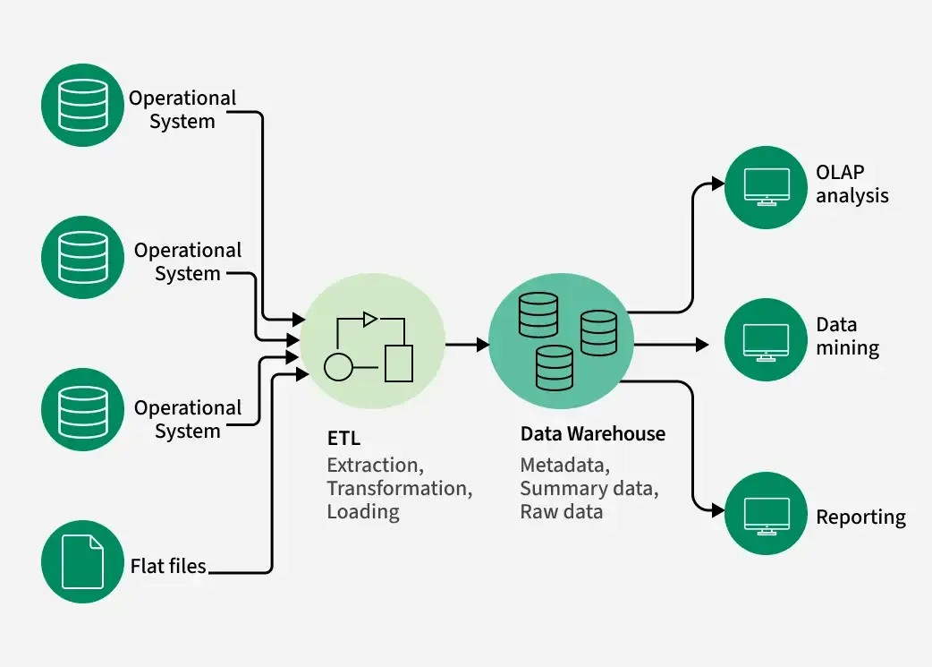
(GeeksforGeeks, 2017b)
  - Data Mining

Data mining involves applying machine learning techniques and statistical methods to identify patterns and extract meaningful insights from extensive datasets. As machine learning, data warehousing, and big data technologies have advanced, the use of data mining also referred to as Knowledge Discovery in Databases (KDD) has grown significantly in recent decades. Despite ongoing improvements in handling large-scale data, organisational leaders may still encounter obstacles related to scalability and automation (Holdsworth, 2024).

  - Current trends

Real-time business intelligence
Real time business intelligence is defined as the capability to analyse and act upon data as it is generated, allowing decision makers to access the freshest information almost instantly within milliseconds after events occur (Natalie, 2025).
Real-time business intelligence (BI) systems provide JD Sports with the ability to make data-driven decisions quickly and efficiently. By leveraging AI-powered platforms like o9 Solutions (Jangoulun Singsit, 2025) and Algolia, (Businesswire.com, 2024) platforms has help JD Sports optimise assortment planning, enhance customer experiences, and improve supply chain efficiency. By analysing sales data, market trends, and factors like weather, JD Sports can forecast demand, adjust inventory, and reduce stock issues. This proactive, AI-powered approach helps the company anticipate customer needs and stay competitive in the fast-paced retail industry.
Cloud warehousing
A cloud-based data warehouse is an internet-hosted centralised platform that allows users with online access to retrieve and manage data remotely. It supports both structured and unstructured data formats and is designed to help organisations consolidate, query, analyse, and prepare data for various analytical and business intelligence purposes (Luzmo.com, 2025).
Cloud warehousing helps JD Sport by providing a scalable and flexible storage solution that can accommodate the company's growth and changing needs. It allows for efficient data management, better visibility, and faster access to information, which are crucial for a multichannel retail environment (Chin, 2023).
  - CRISP-DM Model

The Cross Industry Standard Process for Data Mining (CRISP-DM) is a structured framework comprising of six key stages Business Understanding, Data Understanding, Data Preparation, Modelling, Evaluation, and Deployment that effectively outlines the typical data science life cycle (Saltz, 2020).
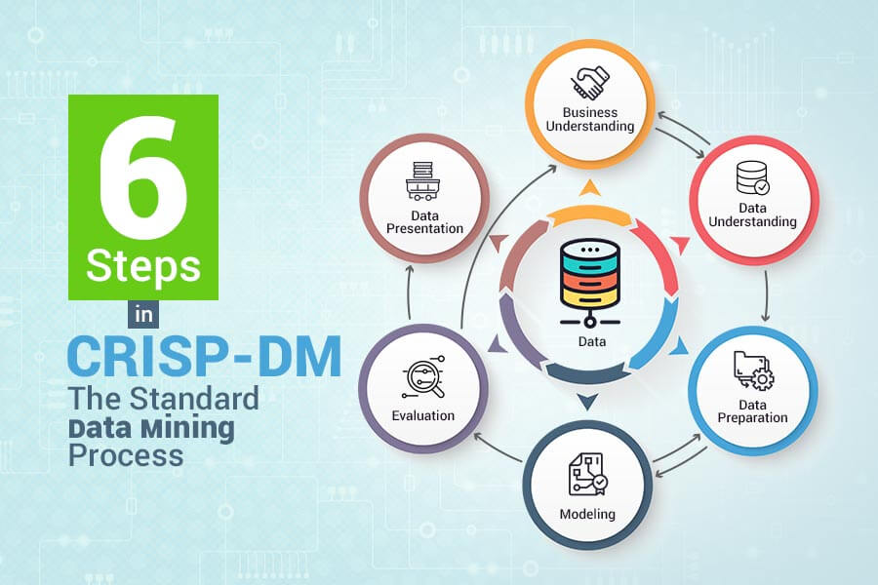
(PGBS, 2020)

JD Sports applies the CRISP-DM framework to drive data-driven retail operations. It defines business goals like inventory optimisation (Business Understanding), integrates multi-source data (Data Preparation), and employs AI tools from o9 Solutions and Algolia for modelling and forecasting (Modelling) (Businesswire, 2024).
- Data Warehousing in the Organisation
JD Sports utilises data warehousing to enhance data access, efficiency, sales reporting, supply chain data consolidation, and strategic decision-making through the following methods:

3.1 Data Integration

JD Sports integrates data from various sources, including customer data, sales data, and supply chain data, to create a comprehensive view of the business. This integration allows for faster reporting, tighter supply chain control better decision-making and strategic planning. By centralising point of sale, e-commerce, supplier and logistics feeds, the warehouse creates a single source of information that reduces data friction between stores and head office and enables consistent sales and inventory metrics across the chain.

3.2 Data Analysis

Data warehousing enables JD Sports to perform complex data analysis, which helps in identifying trends, patterns, and insights that can inform business strategies. This analysis can be used to optimise sales processes, improve customer service, and enhance supply chain efficiency.
  - Sales Reporting

JD Sports uses data warehousing to generate detailed sales reports that provide insights into sales performance, customer behaviours, and market trends. The warehouse also supports integrated, cross-channel reporting that combines e-commerce, store tills and promotional data to produce accurate like-for-like and Stock Keeping Unit (SKU) level performance metrics. These reports are crucial for making informed decisions regarding pricing, promotions, and product offerings.
  - Supply Chain Data Consolidation

Data warehousing allows JD Sports to consolidate and manage supply chain data from multiple sources, ensuring that all relevant information is accessible and up-to-date. JD leverages the data warehouse to integrate supplier lead times, inventory at distribution centres and store stock levels so that demand signals are visible end-to-end. This visibility supports more accurate demand forecasting, more efficient distribution centre allocations and faster response when supply constraints emerges, an approach JD has been scaling alongside new distribution centres and partnerships to regionalise fulfilment (Sensi, 2023). This consolidation is essential for maintaining a robust supply chain and ensuring timely and accurate inventory management. JD Sports has partnered with Avery Dennison to digitise its supply chain (Averydennison.com, 2025), and o9 Solution to transform its assortment planning capabilities (McMillan, 2025), boosting visibility, agility, and efficiency and responsiveness.
  - Strategic Decision Making

JD Sports utilises data warehousing to enhance strategic decision-making by maintaining a centralised data repository. This system enables the organisation to harness data-driven insights that support business growth and innovation, particularly in areas such as product development, marketing initiatives, and operational performance. By utilising data warehousing, JD Sports aims to improve its operational efficiency, drive sales growth, and make informed strategic decisions that align with its business goals.
- Data Mining Techniques

4.1 Clustering

Clustering is an unsupervised approach that groups similar records without predefined labels. It discovers natural segments in customer, product or operational data, enabling targeted marketing, inventory grouping and anomaly detection (Wani, 2024). For a business holding transactional and behavioural data, clustering supports segmentation for personalised offers and early detection of unusual activity. JD Sports uses clustering data mining techniques to analyse products sales and customers buying trends. This helps understanding how these clustering algorithms perform on distinct types of product-related data sets, providing insights into their applicability and effectiveness (Sheridan, 2024).

4.2 Classification

Classification is a technique used to develop models that categorise data into predefined groups. These models are trained using datasets with known outcomes (labels) and are then applied to predict the categories of new, unlabelled data. A common example of a classification model is the Decision Tree.

(GeeksforGeeks, 2017a)

Decision Tree assists in decision-making by visually mapping out various possible outcomes and their relationships. It resembles a tree structure, beginning with a Root Node, which represents the entire dataset and poses the initial question. From there, the structure extends through Branches, which illustrate the pathways between decisions. Internal Nodes represent decision points based on specific data attributes, while Leaf Nodes mark the final outcomes or predictions derived from the data's characteristics (GeeksforGeeks, 2021).
The two techniques complement one another, clustering can create features or segments that improve classifier performance, while classification models can validate and monitor cluster stability over time. Scikit-learn is ideal for rapid experiments with classical clustering and classification (Scikit-learn, 2019). TensorFlow (Algo, 2025) and PyTorch (GeeksforGeeks, 2021b) support complex neural classifiers. Properly applied, clustering and classification translate raw organisational data into actionable segments and reliable predictions that support revenue growth, risk mitigation and operational efficiency.

- Predictive-analysis

5.1 Power BI

Power BI, developed by Microsoft, is a business analytics solution designed to transform data into meaningful insights. It provides a unified set of tools and services that enable business users, analysts, and developers to connect to data sources, create visualisations, and share insights seamlessly across the organisation.
Retailers such as JD Sports need tools that balance usability, integration and forecasting automation. Microsoft Power BI excels for operational reporting and dashboarding, with built-in data connectors, scheduling, and model-driven visuals that integrate tightly with Microsoft ecosystems (Microsoft, 2024).
Power BI serves as a fundamental element within Microsoft Fabric, offering robust analytics and data visualisation functionalities. Within the Fabric ecosystem, it shares capabilities such as data integration, dataflows, and security with other components. Nonetheless, certain features including Power BI reports, dashboards, and the dedicated Power BI service remain exclusive to Power BI.

5.2 IBM SPSS

IBM SPSS (Statistics/Modeler) is designed to support advanced time-series forecasting and automated modelling workflows, making it accessible to both novice and experienced users (Ibm.com, 2025). The platform allows less experienced users to generate complex forecasts involving multiple variables, while seasoned analysts can leverage its capabilities to test and refine predictive models.
At JD Sports, time-series forecasting is applied to anticipate product demand during specific time periods.
- Ethical and Data Security Considerations
The General Data Protection Regulation (GDPR) is widely regarded as one of the most stringent privacy and data protection laws globally. Although established by the European Union (EU), its requirements extend to any organisation that processes or collects data concerning individuals within the EU, regardless of the organisation's geographic location (Wolford, 2025).
Retailers processing personal data must prioritise legal compliance, ethical use and robust security. Under the GDPR organisations are accountable for lawful processing, data minimisation and data subject rights (Legislation.gov.uk, 2025, Ico.org.uk, 2025). Data ownership and controller/processor relationships must be contractually defined and reviewed before sharing datasets with vendors.
Technical safeguards should encompass measures such as role-based access controls, enforcement of least privilege principles, multi-factor authentication, robust encryption for data both at rest and in transit, secure key management, and consistent system patching to mitigate external cybersecurity risks (Legislation.gov.uk, 2025).
Operational controls include activity logging, Security Information and Event Management (SIEM) monitoring, Data Loss Prevention (DLP) mechanisms, staff training programs, and insider threat detection strategies to prevent internal misuse (Europa.eu, 2024).
- Reporting and Dashboard Solutions
Retailers like JD Sports can derive substantial value from modern business intelligence (BI) dashboard solutions such as Tableau, which facilitate real-time performance monitoring and data-informed decision-making. Tableau is a prominent BI and data visualisation platform that empowers users to explore, interpret, and communicate data insights through dynamic dashboards and visual interfaces. By converting raw data into interactive visualisations, Tableau ensures accessibility for both technical and non-technical stakeholders.
Widely adopted across various industries, Tableau supports data-driven strategies through features like drag-and-drop components, filters, drill-down capabilities, and live database connections that ensure access to current information (Gittleson, 2023). Its advanced functionalities including parameter controls, set actions, and integrated forecasting models such as Autoregressive Integrated Moving Average (ARIMA) (Noble, 2024) and Exponential Smoothing (ES) enable intuitive scenario modelling. This includes evaluating the effects of pricing strategies on SKU-level sales or conducting regional cohort analyses (Cătălina Mărcuță, 2025).
For JD Sports, key performance indicators (KPIs) may include same-store sales, conversion rates, average basket value, inventory turnover, stock-out frequency, and regional foot traffic. Real-time BI dashboards empower both operational teams and senior leadership to detect emerging patterns, receive alerts when KPIs exceed defined thresholds, and make timely decisions based on live data rather than outdated reports.
- Conclusion
This report demonstrates that Business Intelligence, Data Warehousing, and Data Mining play a very important strategic role in strengthening JD Sports’ operational performance and long-term competitiveness. By putting all their data into a centralised warehouse, JD Sports can achieve faster reporting, enhanced supply chain visibility, and more accurate forecasting. Data mining techniques such as clustering and classification further support customer segmentation, product optimisation, and proactive decision-making. Predictive analytics tools including Power BI and IBM SPSS give them real-time information and insights, allowing leaders to monitor key KPIs, anticipate demand fluctuations, and improve promotional and marketing strategies. Ethical and security considerations, especially GDPR compliance, remain essential to ensure responsible data use. To maximise BI value, JD Sports should continue investing in AI-driven forecasting, cloud warehousing scalability, and advanced visual dashboards. Collectively, these capabilities will help JD Sports sales growth, improve efficiency, and maintain its position as a global leader in sports fashion retail business.
- References
Algo (2025). What is TensorFlow? [online] Algorithm Man. Available at: https://algorithmman.com/what-is-tensorflow/ [Accessed 17 Nov. 2025].
Averydennison.com. (2025). Case Study | JD Sports - Enabling a connected journey | Avery Dennison. [online] Available at: https://apparelsolutions.averydennison.com/en/perspectives/case-study-jd-sports-connected-product-journey [Accessed 11 Nov. 2025].
Businesswire, 2024. JD Sports Selects o9 Solutions to Enhance Assortment Planning. [online] Available at: https://www.businesswire.com [Accessed 4 Nov 2025].
Businesswire.com. (2024). Algolia’s AI Search Enables JD Sports to Elevate E-commerce Experience. [online] Available at: https://www.businesswire.com/news/home/20240531018420/en/Algolias-AI-Search-Enables-JD-Sports-to-Elevate-E-commerce-Experience [Accessed 31 Oct. 2025].
Cătălina Mărcuță (2025). The Impact of Tableau on Retail Decision-Making - A Developer’s Perspective. [online] Moldstud.com. Available at: https://moldstud.com/articles/p-the-impact-of-tableau-on-retail-decision-making-a-developers-perspective?utm_source [Accessed 18 Nov. 2025].
Chin, C. (2023). JD Sports Launches Its Digital Transformation with Jesta I.S. [online] ERP and Omnichannel Software for the Modern Retailer. Available at: https://www.jestais.com/jd-sports-launches-its-digital-transformation-with-retail-technology-by-jesta-i-s/ [Accessed 31 Oct. 2025].

Europa.eu. (2024). Implementing regulation - EU - 2024/2690 - EN - EUR-Lex. [online] Available at: https://eur-lex.europa.eu/eli/reg_impl/2024/2690/oj/eng [Accessed 17 Nov. 2025].
GeeksforGeeks (2017b). Data Warehousing. [online] GeeksforGeeks. Available at: https://www.geeksforgeeks.org/big-data/data-warehousing/ [Accessed 19 Nov. 2025].
GeeksforGeeks (2017a). Decision Tree. [online] GeeksforGeeks. Available at: https://www.geeksforgeeks.org/machine-learning/decision-tree/ [Accessed 19 Nov. 2025].
GeeksforGeeks (2021). Data Mining Techniques. [online] GeeksforGeeks. Available at: https://www.geeksforgeeks.org/data-analysis/data-mining-techniques/ [Accessed 14 Nov. 2025].

GeeksforGeeks (2021b). What is PyTorch ? [online] GeeksforGeeks. Available at: https://www.geeksforgeeks.org/deep-learning/getting-started-with-pytorch/ [Accessed 17 Nov. 2025].
Gittleson, W. (2023). What is Tableau - The Complete Guide to Tableau. [online] www.datacamp.com. Available at: https://www.datacamp.com/blog/all-about-tableau [Accessed 18 Nov. 2025].
Holdsworth, J. (2024). What is data mining? [online] Ibm.com. Available at: https://www.ibm.com/think/topics/data-mining [Accessed 21 Oct. 2025].

Holdsworth, J. and Kosinski, M. (2024). Data Warehouse. [online] Ibm.com. Available at: https://www.ibm.com/think/topics/data-warehouse [Accessed 21 Oct. 2025].

IBM (2021). Business intelligence. [online] Ibm.com. Available at: https://www.ibm.com/think/topics/business-intelligence [Accessed 21 Oct. 2025].
Ibm.com. (2025). Forecasting - IBM SPSS Statistics. [online] Available at: https://www.ibm.com/products/spss-statistics/forecasting?utm_source [Accessed 17 Nov. 2025].
Ico.org.uk. (2025). UK GDPR guidance and resources. [online] Available at: https://ico.org.uk/for-organisations/uk-gdpr-guidance-and-resources/?utm [Accessed 17 Nov. 2025].
Jangoulun Singsit (2025). JD Sports picks o9 AI-powered platform for assortment planning. [online] Retail Insight Network. Available at: https://www.retail-insight-network.com/news/jd-sports-o9-ai/ [Accessed 31 Oct. 2025].
JD Group (2025). JD Sports Fashion - Investor Relations. [online] Jdplc.com. Available at: https://www.jdplc.com/overview/default.aspx [Accessed 21 Oct. 2025].

Lamer, A., Saint-Dizier, C., Paris, N., & Chazard, E. (2024). Data Lake, Data Warehouse, Datamart, and Feature Store: Their Contributions to the Complete Data Reuse Pipeline. JMIR Medical Informatics, 12, e54590. https://doi.org/10.2196/54590

Legislation.gov.uk. (2025). Data (Use and Access) Act 2025. [online] Available at: https://www.legislation.gov.uk/ukpga/2025/18/contents [Accessed 17 Nov. 2025].
Luzmo.com. (2025). What is a Cloud Data Warehouse? (+ 6 Top Choices for 2025) | Luzmo. [online] Available at: https://www.luzmo.com/blog/cloud-data-warehouse [Accessed 3 Nov. 2025].

McMillan, A. (2025). How o9 Will Unlock Efficiencies for JD Sports. [online] Supplychaindigital.com. Available at: https://supplychaindigital.com/operations/o9-unlock-efficiencies-jd-sports?utm [Accessed 11 Nov. 2025].
Microsoft (2024). What Is Power BI? [online] learn.microsoft.com. Available at: https://learn.microsoft.com/en-us/power-bi/fundamentals/power-bi-overview [Accessed 17 Nov. 2025].
Natalie (2025). What is Real-Time Business Intelligence? - IDA. [online] IDA -. Available at: https://www.intuitivedataanalytics.com/what-is-real-time-business-intelligence/ [Accessed 3 Nov. 2025].

Noble, J. (2024). ARIMA models. [online] Ibm.com. Available at: https://www.ibm.com/think/topics/arima-model [Accessed 18 Nov. 2025].
PGBS (2020). Six steps in CRISP-DM – the standard data mining process | PGBS. [online] Proglobalbusinesssolutions. Available at: https://www.proglobalbusinesssolutions.com/six-steps-in-crisp-dm-the-standard-data-mining-process/ [Accessed 19 Nov. 2025].
Saltz, J. (2020). CRISP-DM is Still the Most Popular Framework for Executing Data Science Projects. [online] Data Science Project Management. Available at: https://www.datascience-pm.com/crisp-dm-still-most-popular/ [Accessed 4 Nov. 2025].
Scikit-learn (2019). scikit-learn: machine learning in Python — scikit-learn 0.20.3 documentation. [online] Scikit-learn.org. Available at: https://scikit-learn.org/stable/index.html [Accessed 17 Nov. 2025].
Sensi, J. (2023). JD Sports unveils supply chain transformation - InternetRetailing. [online] InternetRetailing. Available at: https://internetretailing.net/jd-sports-supply/?utm [Accessed 11 Nov. 2025].
Sheridan, N. (2024). JD Sports Marketing Strategy 2024: A Case Study – Latterly.org. [online] Latterly.org. Available at: https://www.latterly.org/jd-sports-marketing-strategy/ [Accessed 17 Nov. 2025].
Wani, A.A. (2024). Comprehensive analysis of clustering algorithms: exploring limitations and innovative solutions. PeerJ Computer Science, [online] 10, pp.e2286–e2286. https://doi.org/10.7717/peerj-cs.2286
Wolford, B. (2025). What is GDPR, the eu’s new data protection law? [online] GDPR.EU. Available at: https://gdpr.eu/what-is-gdpr/ [Accessed 17 Nov. 2025].

