Name: Misbah shams.
Id:2325771:
Module: Changemakers: Building your personal building for sustainable Employment.
Module code: BMHP5015.
Lecturer: Raheela Shail

Becoming a Mental Health Support Worker in the UK: Development Plan, Self-Evaluation, and Employability Skills.

- Introduction:
In the UK health and social care system, Mental Health Support Workers (MHSWs) play a crucial role in helping individuals with mental health concerns. Under the guidance of certified experts, support workers assist service users with daily activities, emotional well-being, and recovery planning. I am enthusiastic about mental health, appreciate empathetic treatment, and want to make a significant contribution to people's recovery journeys, which is why I have selected this position as my future profession.
This study assesses my present competences, examines the employability skills necessary for the MHSW position, and suggests a thorough action plan for both professional and personal growth. It also looks at how I'll create a professional identity, a personal brand, and a network inside the mental health industry. The goal is to pinpoint the gaps that need to be filled in order for me to land a job as a Mental Health Support Worker and to lay out specific, doable measures to close those gaps over the course of the next five years.

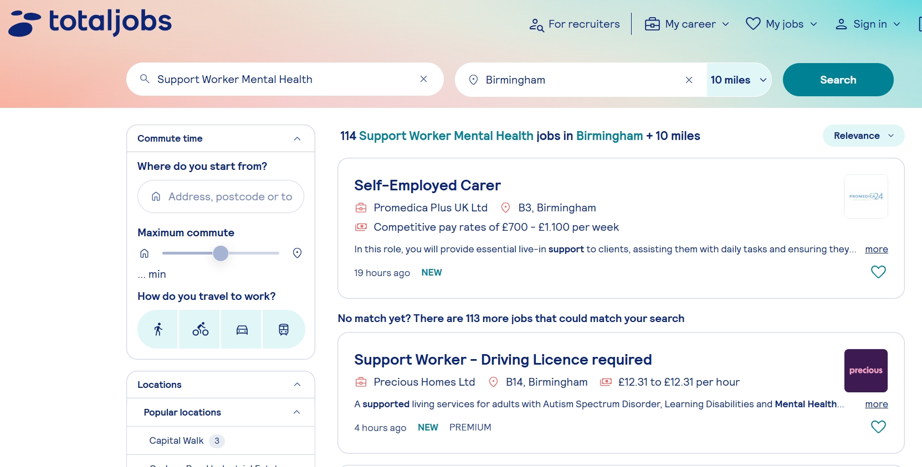

Person Specification and Job Description:
Supporting daily living, encouraging independence, keeping an eye on mental health, and participating in care planning are just a few of the duties listed in a typical job posting for a mental health support worker (NHS Jobs, 2023). Additionally, support staff aid those in emotional distress, provide therapeutic activities, and keep correct records (Newham Council, 2023). Because mental health settings can entail complicated needs and problematic behaviours, many occupations require a grasp of risk assessment, confidentiality, and safeguarding (HSE, 2023). Employers frequently look for traits like empathy, effective communication, fortitude, and the capacity to maintain composure under pressure (NHS Employers, 2024). Although many businesses teach new employees, it is desirable to have knowledge about mental health disorders and recovery approaches. The Care Certificate, which covers requirements including duty of care, communication, infection control, and safeguarding, is frequently required for new support workers (Skills for Care, 2023).
Job advertisements place a strong focus on values-based hiring, which means that companies give preference to those who have empathy, respect, and a sincere desire to help others (Mind, 2024). Additionally appreciated is experience gained via community service or voluntary labour (Rethink Mental Illness, 2024). I determined the qualifications and standards that direct my growth strategy after looking through a number of job advertising.

3. Employability Skills Analysis
The following employable skills are necessary for a Mental Health Support Worker, according to the job criteria.
Communication
A fundamental prerequisite is the ability to communicate effectively both orally and in writing. Support workers must correctly record observations in care records and communicate with service users, families, and healthcare personnel in a clear and concise manner. (Mind, 2024) Employees must "communicate effectively and informatively" while sustaining therapeutic interactions, according to the NHS job. (2023)
Emotional intelligence and empathy
In the field of mental health, empathy is essential. The person criteria states that having empathy for those who have struggled with mental health issues is crucial. (Rethink Mental Illness, 2024
NHS Jobs Employees with emotional intelligence are better able to control their own emotions, comprehend those of others, and react to suffering in a compassionate manner.
Resilience and Stress Management:
Staff members must maintain composure and professionalism in times of crisis since mental health environments can be unexpected. According to the Health and Safety Executive, mental fortitude and sound judgement are necessary for handling occupational hazards and handling hostility (HSE, 2023). For this reason, de-escalation techniques are crucial.
Cooperation and Teamwork:
A multidisciplinary team of social workers, psychologists, psychiatrists, and nurses may include Mental Health Support Workers. Consistent care and safety are ensured by effective cooperation (NHS England, 2024).
Critical Thinking and Problem-Solving:
When monitoring behavioural changes or helping someone who is in distress, support workers frequently make snap choices. Safe practice requires situational awareness and risk assessment (NHS Employers, 2024).
Professionalism and Moral Behaviour
Core expectations include respecting professional boundaries, equality, confidentiality, and safety (Skills for Care, 2023). Adhering to ethical standards guarantees high-quality treatment and protects service consumers.

Clinical and Technical Skills:
Support workers must possess a basic level of clinical competence even if they are not registered practitioners. They may monitor physical health (blood pressure, etc.), follow risk assessments, or help with personal care. Post-holders may conduct observations, according to the NHS job description.
Professionalism and Ethical Behaviour:
Respecting dignity, protecting others, and maintaining confidentiality are non-negotiable. Support staff are expected to act professionally and uphold trust principles. The NHS specification places a strong emphasis on respect, trust, and nonjudgmental attitudes.
Flexibility:
Flexibility, adaptation, and shift work are frequently necessary for mental health care. Candidates must be ready to perform 24-hour shifts and in a variety of clinical settings, according to the person specification.
When combined, this employability skills allow Mental Health promote Workers to manage risk, promote recovery, and deliver high-quality, person-centred care while preserving their personal wellness.

4. Self-Appraisal
I used components of the SWOT framework and informal reflection to evaluate my own skills. I evaluated my abilities against those specified in job descriptions from NHS Jobs and other companies (Totaljobs, 2024; NHS Jobs, 2023).

Capabilities for Self-Evaluation Table of Self-Evaluation

Skill / Competency | Required for MHSW | My Current Level | Strategy for Development | Timeline
Communication | High | Good – academic and volunteer experience | Practice clinical documentation; seek feedback from supervisors | Year 1–2
Empathy & Emotional Intelligence | High | Good – through volunteering | Continue volunteering, reflect in journal, attend empathy workshops | Year 1–3
Resilience / Stress Management | High | Medium – limited crisis exposure | De-escalation training, shadow experienced workers, reflective practice | Year 2–3
Teamwork | High | Good | Take leadership roles, continue collaborative projects | Year 1–3
Problem-Solving / Critical Thinking | High | Medium | Observe decision-making in practice, complete risk-assessment training | Year 2–4
Organisational Skills | Medium | Good | Manage and prioritise volunteer tasks, maintain a professional portfolio | Year 1–2
Technical / Clinical Skills | Medium-High | Low | Complete Care Certificate, first aid training, NVQ Level 3/4 | Year 1–3
Professionalism & Ethical Practice | High | Medium-High | Join professional associations, attend ethics/safeguarding workshops | Year 1–3
Adaptability | Medium | Medium | Rotate through different volunteering roles, flexible working | Year 1–3

Reflection on My Current Skills:
I have discovered both my strengths and my areas for development via this assessment. I have strong communication skills since I've worked on academic projects and volunteered, which has taught me patience, clear writing, and active listening. I intend to practise writing clinical notes and ask for frequent comments because I have little expertise with clinical documentation, which is highly specialist and important in a support worker capacity.
Due in large part to my voluntary work with those dealing with mental health issues, I have developed strong emotional intelligence and empathy. However, I wish to strengthen this via consistent introspection and by going to programs on empathy or peaceful communication.
I haven't worked in really troubled mental health settings, but I have been exposed to some stressful situations. I will get de-escalation training, observe seasoned mental health practitioners, and keep a reflective notebook to analyse challenging situations in order to strengthen my resilience.
My ability to work well with others is one of my strong points; I like working in groups and have led modest initiatives before. I'll take advantage of volunteer opportunities to conduct group activities and get feedback to grow.
I think I'm somewhat capable of fixing problems. Rapid decision-making and risk assessment, however, are not yet second nature. I will attend risk-assessment training and watch how seasoned employees evaluate and escalate risk in order to develop this.
I am confident in my organisational skills since balancing voluntary work and school has made it easier for me to focus and manage my time. I will maintain a portfolio of my accomplishments, reflections, and training to formalise this.

In a technical sense, I am less mature. My first-aid training and Care Certificate are still pending. I intend to finish them within three years, along with an NVQ Level 3 or 4 in Health & Social Care, because they are necessary for integrated care employment.
I think professionalism is key. I want to attend safeguarding and ethical training, become a member of pertinent professional bodies (like Mind or other mental health charities), and put what I've learnt into practice. Lastly, I think of myself as rather flexible, but I still need additional exposure to various care settings. My ability to adapt will be enhanced by volunteering in various contexts.
5. Developing a Professional and Personal Brand:
I can better showcase my beliefs, abilities, and dedication to mental health work when I have a strong personal brand. The significance of compassion, respect, and recovery-focused practices is emphasised by mental health charities (Rethink Mental Illness, 2024). My empathy, communication abilities, and commitment to helping others will all be reflected in my personal brand.
I want to make a professional LinkedIn profile and CV that highlights my accomplishments, training, credentials, and volunteer work. I can keep up with changes in mental health practice by following organisations like Mind, NHS England, and Skills for Care (Mind, 2024; NHS England, 2024). My professional identity will be enhanced by sharing thoughtful posts on my classes and volunteer work.
My capacity to establish constructive relationships with service consumers while maintaining composure and support is my unique selling proposition (USP). In the field of mental health care, these interpersonal abilities are highly valued by employers (NHS Jobs, 2023).
6. Strategy for Networking:
Finding opportunities and picking the brains of seasoned professionals depend on networking. I want to grow my network in three different ways:
Volunteering: I may meet mental health specialists by being involved with charities like Samaritans or Mind (Mind, 2024).
Events and training: NHS trusts, Skills for Care, and mental health organisations host workshops that provide chances to meet employees and discover services (Skills for Care, 2023).
LinkedIn: Making connections with recruiters, support worker groups, and mental health teams will help me develop business connections (Rethink Mental Illness, 2024).
In addition to making me more visible, networking gives me important insights regarding expectations and current practices.

7. Action Plan and Timeline:
Year | Goal | Key Actions | Anticipated Outcomes
Year 1 | Build foundation | Complete Care Certificate; start volunteering; self-audit of skills | Acquire basic care knowledge, experience, and identify gaps
Year 2 | Gain practical experience | Volunteer in more challenging settings; training in first aid, de-escalation | Develop resilience and crisis-management capability
Year 3 | Professional development | Register for NVQ Level 3/4; join professional bodies; attend conferences | Gain formal qualifications and deepen professional identity
Year 4 | Secure employment | Apply for Mental Health Support Worker roles; leverage network; gain recommendation | Obtain a paid or permanent MHSW position
Year 5 | Specialist progression | Advanced mental health training (e.g. diplomas); lead peer-support activities; publish reflections | Enhanced expertise and clearer career pathway (e.g. to nursing or social work

5-Year Action Plan Table
The skills and credentials that NHS Employers (2024), Skills for Care (2023), and mental health charities (Rethink Mental Illness, 2024) suggest are in line with this action plan.
Narrative Plan:
In Year 1, I will complete the Care Certificate, which is essential for many MHSW roles, including the NHS job spec I reviewed. Concurrently, I will begin volunteering at a mental health charity to develop empathy, communication, and teamworking. I will also perform a skills self-audit to assess my strengths and gaps.
In Year 2, I plan to deepen my practical experience by volunteering in higher-intensity settings (e.g., inpatient services) and completing training in de-escalation, first aid, and risk assessment. This will build my resilience and capacity to manage emotionally challenging situations.
By Year 3, I aim to enrol in NVQ Level 3 or 4 in Health & Social Care, a qualification often required or highly regarded in MHSW job specifications. I will also join professional organisations, attend conferences, and engage in networking to strengthen my professional credibility.
In Year 4, I will start applying for Mental Health Support Worker roles, using my network and portfolio to support applications. Having built practical experience, qualifications, and a strong professional identity, I should be competitive for Band 3 or equivalent roles.
Finally, in Year 5, I aim to specialise: I will pursue advanced training or diplomas in mental health, possibly take on peer-support or facilitative responsibilities, and contribute to professional discussion via blogs or forums. This will support long-term career progression, potentially into nursing, social work, or peer leadership.

8. Resources Needed:
I will require access to the Care Certificate training, NVQ certifications, safeguarding courses, and crisis intervention training in order to accomplish my professional objective (Skills for Care, 2023). I will get practical experience by volunteering with Mind or nearby NHS Trusts (Mind, 2024). My skill development will be aided by online resources including the NHS Learning Hub and CPD websites (NHS England, 2024)

9. Communicating Skills to Employers:
I'll convey my abilities using a variety of techniques:
A professional resume designed for positions providing mental health support
LinkedIn profile featuring credentials, accomplishments, and relationships
Reflective logs, supervisor comments, and training documentation are all included in the digital portfolio.
Interview techniques, using the STAR system to provide actual volunteer instances (Totaljobs, 2024)
These tactics will demonstrate to potential employers my dedication, competence, and readiness for the MHSW position.
10. Conclusion:
Becoming a Mental Health Support Worker is both aspirational and feasible if supported by deliberate planning, self-awareness, and commitment to professional growth. This report has analysed the core employability skills for the role—such as communication, empathy, resilience—and evaluated my current strengths and areas for development. My five-year action plan outlines clear, achievable steps to build relevant experience, formal qualifications, and a robust professional identity. Through volunteering, training, networking, and personal reflection, I am confident I can meet the standards required by NHS and other mental health employers. I will continue to build my brand and share my journey, demonstrating both competence and values. By following this structured plan, I intend not only to secure a Mental Health Support Worker role but to thrive in it, contributing positively to the lives of others while growing as a compassionate, resilient professional.
References list:
NHS Jobs (2023) Mental Health Support Worker: Job Advert and Person Specification. NHS. Available at: https://www.jobs.nhs.uk (Accessed: 23 November 2025).
Totaljobs (2024) Mental Health Support Worker – NHS Role Description. Totaljobs. Available at: https://www.totaljobs.com (Accessed: 23 November 2025).
Newham Council (2023) Mental Health Support Worker: Job Description and Person Specification. Newham Council. Available at: https://www.newham.gov.uk (Accessed: 23 November 2025).
Manchester Mind (2022) Community Engagement Worker / Support Worker: Job Description & Person Specification. Manchester Mind. Available at: https://www.manchestermind.org (Accessed: 23 November 2025).
NHS Employers (2024) Job Evaluation Handbook. NHS Employers. Available at: https://www.nhsemployers.org (Accessed: 23 November 2025).
Skills for Care (2023) The Care Certificate Standards. Skills for Care. Available at: https://www.skillsforcare.org.uk (Accessed: 23 November 2025).
Mind (2024) Understanding Mental Health Problems. Mind UK. Available at: https://www.mind.org.uk (Accessed: 23 November 2025).
Rethink Mental Illness (2024) Working in Mental Health Services: A Guide. Rethink. Available at: https://www.rethink.org (Accessed: 23 November 2025).
Health and Safety Executive (HSE) (2023) Violence at Work: Managing Workplace Risks. HSE. Available at: https://www.hse.gov.uk (Accessed: 23 November 2025).
NHS England (2024) Guidance on Supporting People with Mental Health Needs. NHS England. Available at: https://www.england.nhs.uk (Accessed: 23 November 2025).

