University of Wales Trinity St David
School of Engineering
Combustion Emissions, Calculations and Mapping for Efficiency
Haydn Jones
P140231
BEng Advanced Engine Design
11/01/18
Powertrain & Sustainability
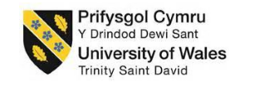
M3X8824

Contents

1.0 Introduction 1

2.0 NOx formation 2

3.0 Assumptions 3

4.0 NASA Tables 4

5.0 Enthalpy Tables 5

6.0 Temperature 6
6.1 Analysis 8

7.0 Zeldovich Model 9

8.0 NOx Parts Per Million 12
8.1 Analysis 12

9.0 Exhaust Gas Recirculation (EGR) 13
9.1 Analysis 15

10.0 Conclusion 16

11.0 References 17

12.0 Appendices 18
12.1 Polynomials 18
12.2 Excel 19

1.0 Introduction
This report will discuss Nitrous Oxide formation from first principles focusing more so on the lean side of stochiometric air/fuel ratio, calculating things such as the average temperature of the flame and then using this to calculate the temperature of the burned zone which is required to calculate NOx formation. In this report, a simple NOx model using the Zeldovich model will be used and discussed, whilst not a perfect representation of what is occurring inside the cylinder it does give us an understanding of how the A/F ratio affects the model and then further on how the inclusion of exhaust gas recirculation (EGR) affects NOx formation.

2.0 NOx formation
NOx incorporates the formation of nitric oxide $NO$ and nitrogen dioxide $NO_{2}$ although $NO$ is the primary oxide emitted during combustion. (Glassman & Yetter, 2008) At high temperatures such as >2000 K which is frequently seen inside and engine, dissociation occurs which is the breaking up of a compound into simpler constituents that can recombine with other constituents. (The Editors of Encyclopædia Britannica, 2011) Because of this dissociation affect $CO_{2}$ and $H_{2}O$ both give off free oxygen radicals that ‘attack’ the nitrogen molecules to form $NO$. (Lee, et al., 2014)
$$O+N_{2}=NO+N$$
$$N+O_{2}=NO+O$$
Equation 2.1 Dissociation to Form NO (Heywood, 1988)
$NO$ formation is highest post flame rather than at the flame front and this is called thermal NOx production. As the burned gases are still undergoing compression from the pressure increase and as such temperature increases beyond the combustion temperature. (Heywood, 1988)
There are two other forms of NO formation, fuel NOx formation in which nitrogen in the fuel oxidizes with the air (Schwerdt, 2006) however as isooctane contains no nitrogen, this is not applicable. The other form is prompt NOx where nitrogen in the air combines with radical hydrocarbons produced during combustion. This only occurs in rich conditions (Borman, 1998) and again will not be applicable in this report.

3.0 Assumptions
- The engine is 1.6L naturally aspirated.
- It will stay at a constant 1800 RPM
- Pressure rise is linear and begins at 10 bar at start of combustion and will rise by a constant 2 bar up to 50 bar representing the new European drive cycle test loads.
- Volumetric efficiency stays at 40%.
- Therefore volume sucked in is 400cc x 40%=160cc.
- Equivalence ratio starts at stoichiometric then leanness increase by 0.1 up to 0.95 then it increases by 0.5 up to 0.6.
- Universal gas constant stays at 8316 ${Kmol}^{-1} K^{-1}$ .
- Polytropic index n is kept at 1.2.
- Volume of the cylinder at TDC is 40cc.
- Atmospheric pressure is 1 bar @ 293K.
- $N_{2} \& O_{2}$ concentrations are consistent throughout combustion.
- The process is adiabatic.
- Flame speed remains the same.
- The mixture is homogeneous.
- The temperature remains constant throughout combustion.
A note about the last two bullet points, a lot of mixtures in an engine are not completely homogeneous, meaning that there will be lean and rich patches in the mixture, this will have an effect on the temperature throughout combustion as these different patches will burn at different temperatures meaning that NOx production will be different throughout the mixture.

4.0 NASA Tables
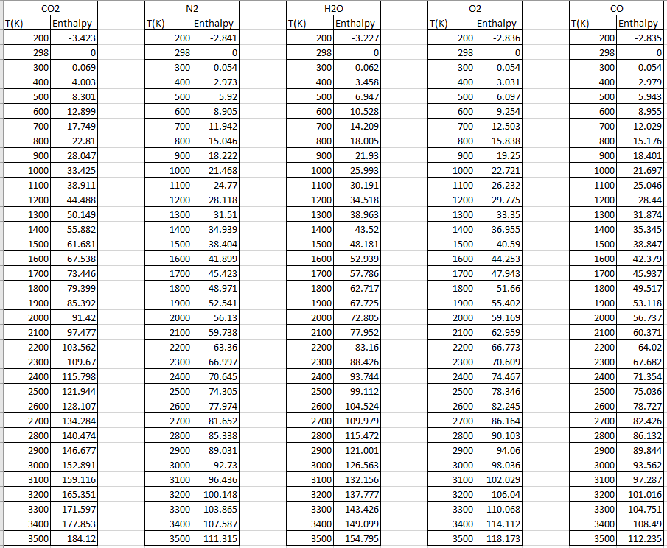
Figure 4.1 NASA Tables (Turns, 2006)
Using these NASA tables we can obtain polynomials as seen in fig 2 which allows us to calculate the enthalpy per degree Kelvin instead of every 100 degrees. This allows the temperature calculated to be more accurate. The enthalpy value is the amount of enthalpy required to go from 298 K to the desired temperature so for nitrogen to get to a temperature of 2200 K, 63.36 MJ/Kmol is needed.
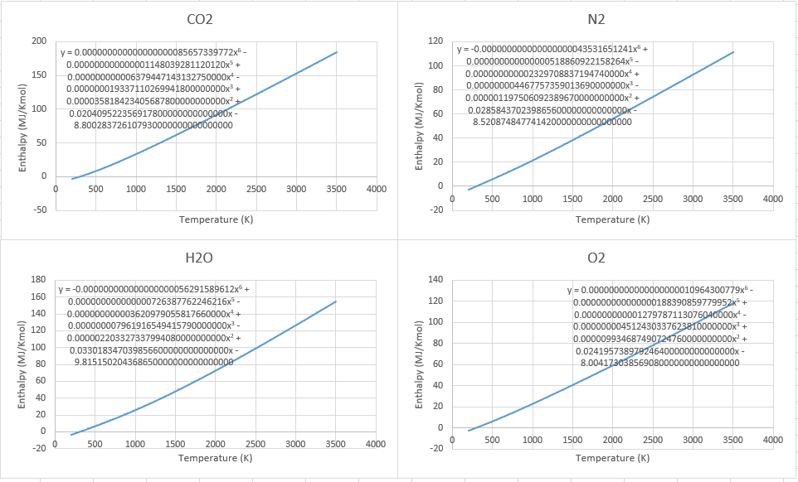
Figure 4.2 Enthalpy over Temperature Polynomials

5.0 Enthalpy Tables
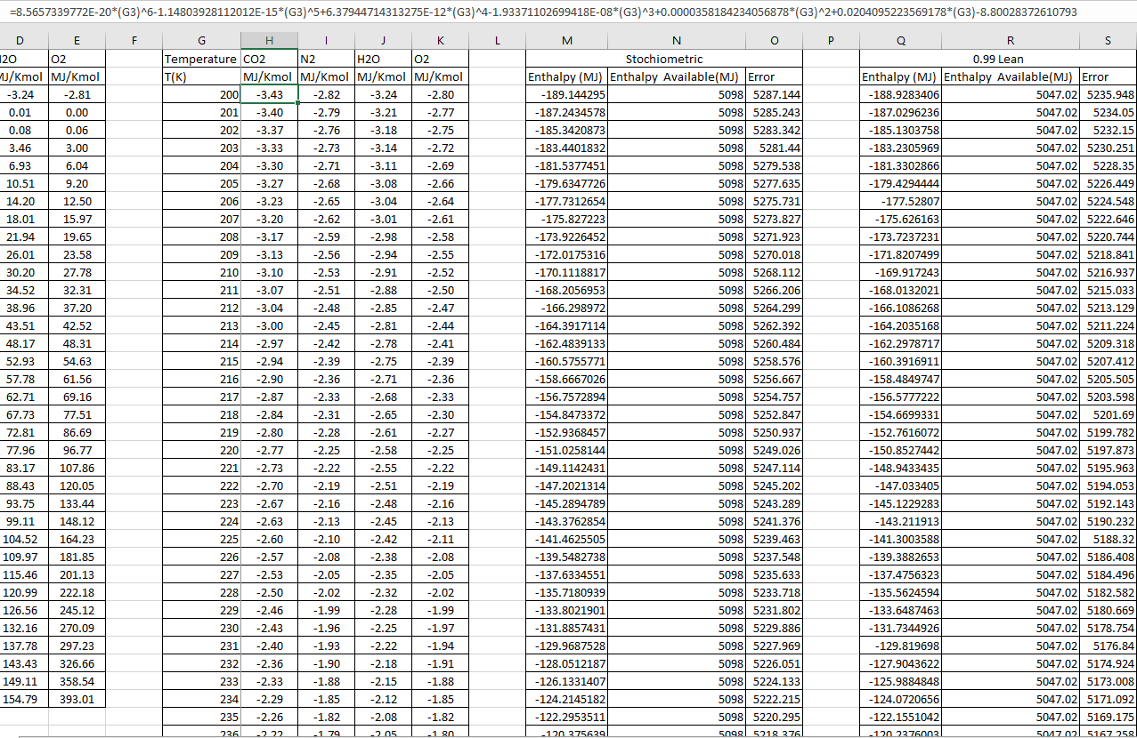
Figure 5.1 Using the Polynomials
Using the polynomial equation generated by the graphs on fig 4.2 enthalpy values for each degree K can be calculated. To obtain these, enthalpy available can first be calculated, at stoichiometric:
$$C_{8}H_{18}+12.5\left(O_{2}+3.76N_{2}\right)→8{CO}_{2}+9H_{2}O+47N_{2}$$
$$224+12.5\left(0+\left(3.76×0\right)\right)→\left(8×393\right)+\left(9×242\right)+0$$
$$224→5322$$
Equation 5.1 Enthalpy of the mixture
Net enthalpy released:
$$5322-224=5098 MJ$$
As this equation stays balanced for each fuel equivalence ratio (FER, ф), to work out later available enthalpy it is:
$$Enthalpy available \left(MJ\right)=ф×Stoichiometric enthalpy$$
Equation 5.2 Enthalpy available
Actual enthalpy at each temperature:
$$Enthalpy needed \left(MJ\right)=ф\left(\left(8×CO_{2}\frac{MJ}{Kmol}\right)+\left(9×H_{2}O\frac{MJ}{Kmol}\right)\right)+\left(47×N_{2}\frac{MJ}{Kmol}\right)+(Free O_{2}×O_{2}\frac{MJ}{Kmol})$$
$$Free O_{2}@ ф\sim 0.9=0.9 C_{8}H_{18}+12.5\left(O_{2}+3.76N_{2}\right)→7.2CO_{2}+8.1H_{2}O+47N_{2}+dO_{2}$$
$$25 O atoms→14.4+8.1 O atoms$$
$$25=22.5+2d$$
$$2.5=2d$$
$$d=1.25$$
Equation 5.3 Free Oxygen
For every 10% leanness 1.25 free $O_{2}$ is created therefore for every 1% leanness 0.125 free $O_{2}$ is created.
Now the error can be calculated:
$$Error=Enthalpy available-Enthalpy needed$$
Equation 5.4 Enthalpy error

6.0 Temperature
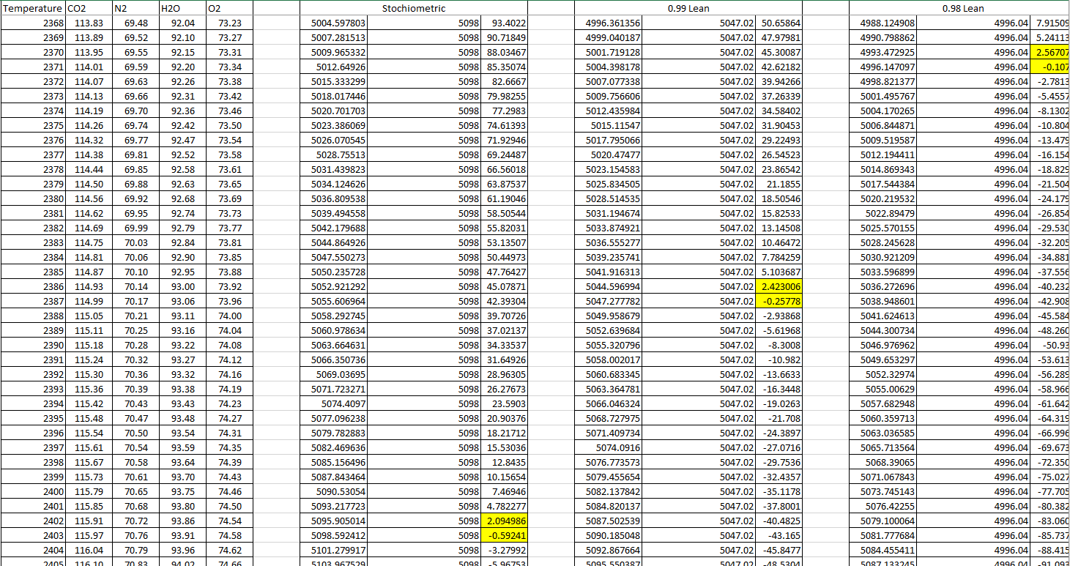
Figure 6.1 Zero error point
With the values calculated, the zero-error point can be located which informs us of the temperature needed to heat the products to the available enthalpy as it is assumed that all heat is going towards heating of the products as the process is assumed to be adiabatic. To get the exact adiabatic temperature value the two values chosen must be interpolated using stoichiometric as an example:
$$\frac{T-2402}{2403-2402}=\frac{5098-5095.9}{5098.59-5095.9}$$
$$\frac{T-2402}{1}=\frac{2.1}{2.69}$$
$$T-2402=0.78$$
$$T=2402+0.78$$
$$T=2402.78 K$$
Equation 6.1 Adiabatic Flame Temperature
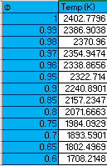
Figure 6.2 Adiabatic Temperature

Figure 6.3 Adiabatic Temperature
The adiabatic flame temperature assuming all heat released goes to warming up the products, gives a starting point to work out the temperature before including pressure rise which leads to calculating the temperature of the burned zone to account for this rise in pressure:
$$T_{B}=T1({\frac{P2}{P1})}^{\frac{n-1}{n}}$$
Equation 6.2 Temperature of the Burned Zone
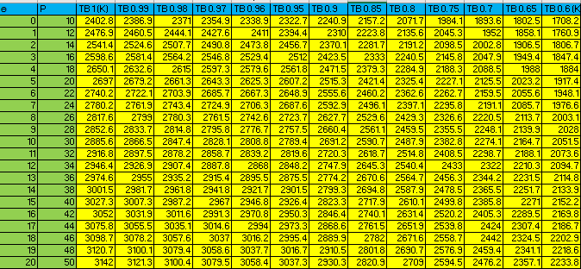
Figure 6.4 Temperature of the Burned Zone

Figure 6.5 Burned Temperature over Crank Angle

6.1 Analysis
It can be seen that temperature decreases as FER becomes leaner, this is because there is less fuel to burn meaning less molecules to vibrate and collide causing a lower temperature, the quantity of air also stays the same which means there is less enthalpy available overall. Pressure increases from 0° crank angle at 10 bar to 50 bar at 20°. This is because even though the piston is travelling down causing the volume to increase which would reduce the pressure, the flame front is still travelling down the cylinder meaning the pressure rises and therefore so too does the temperature.
Peak temperatures are predicted to be quite high because starting temperatures are adiabatic meaning that no heat loss is occurring, this would not be the case in reality.

7.0 Zeldovich Model
The Zeldovich model is used to calculate using chemical kinematics the [NO] concentration over time (kmols/M³/sec) in the burned zone and is given by:
$$\frac{d\left[NO\right]}{dt}=4.17×{10}^{3}\left[N_{2}\right]{\left[O_{2}\right]}^{\frac{1}{2}}\exp\left(\frac{-67837}{T_{B}}\right)$$
Equation 7.1 Zeldovich Equation (McDonald, 2017)
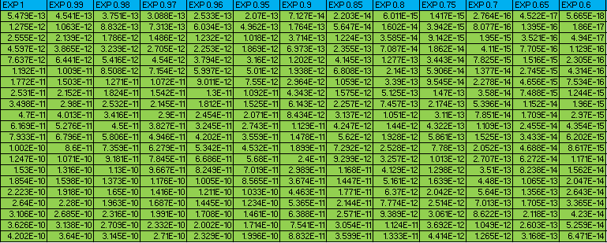
Figure 7.1 Zeldovich Exponential
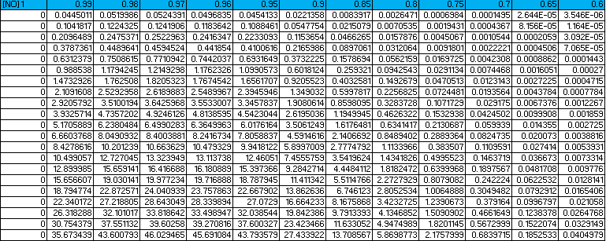
Figure 7.2 Zeldovich model

Figure 7.3 [NO] over Crank Angle
Where concentrations of$\left[N_{2}\right]/[O_{2}]$ :
$$Kmols/m^{3}=\frac{Kmols \left[N_{2}\right]/[O_{2}]}{Burned volume}=\frac{α\left[N_{2}\right]/[O_{2}]}{V_{cyl}}$$
Equation 7.2 Molecule Concentrations
Multiplying constant:
$$α=\frac{Kmols in cylinder}{Kmols in equation}$$
Equation 7.3 Multiplying Constant Alpha
From the ideal gas law:
$$PV=n.RU.Tair$$
Equation 7.4 Ideal Gas Law
Kmols in cylinder:
$$n=\frac{P.V}{T_{air}.Ru}$$
$$∴n=\frac{({1×10}^{5}×160×{10}^{-6})}{(8314×293)}=6.57×{10}^{-6}$$
Equation7. 5 Kmols in Cylinder
Kmols in equation:
$$Kmols in equation=ф+\left(12.5×\left(1+3.76\right)\right)$$
Equation 7.6 Kmols in Equation
Now that [NO] has been calculated as a function of time it can now by calculated as a function of crank angle for every degree to calculate the total Kmols made during the combustion process:
$$Kmols \left[NO\right] /m^{3}/°=\frac{d[NO]}{dt}×\frac{1}{6×RPM}$$
Equation 7.7 Kmols [NO] per Degree
Then the amount of Kmols produced for the effective cylinder volume (40cc):
$$Kmols \left[NO\right] produced=Kmols\left[NO\right] /m^{3}/°×40×10^{-6}$$
Equation 7.8 Kmols [NO] per Degree for Cylinder
The total number of Kmols produced for each FER is then summed up and will be the values used for the NOx PPM equation.
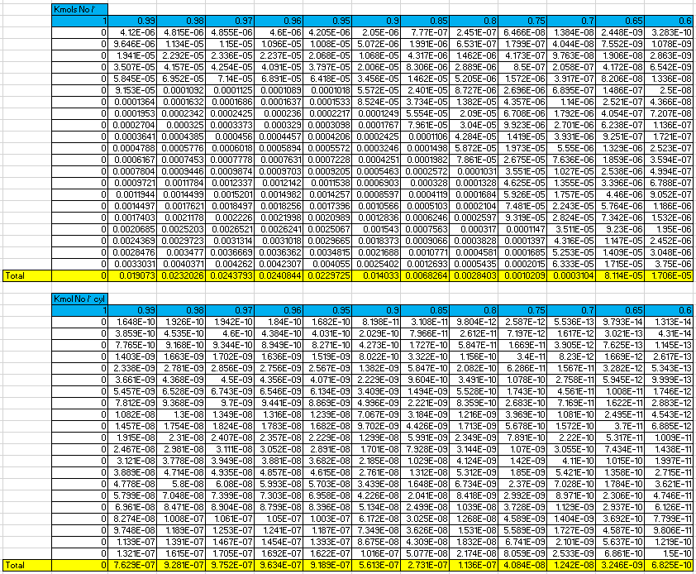
Figure 7.4 Kmols [NO] Per Degree & Kmols [NO] Produced in Cylinder

8.0 NOx Parts Per Million
To find the number of kmols in exhaust it is a total of all the reactants that will be found in the exhaust such as $8 CO_{2}$ and$9 H_{2}O$:
$$Kmols in exhaust=ф×\left(8+9\right)+47+x$$
Equation 8.1 Kmols in Exhaust
NOx parts per million:
$$NOx PPM=\frac{Kmols \left[NO\right] produced}{Kmols in exhaust×α}$$
Equation 8.2 NOx PPM
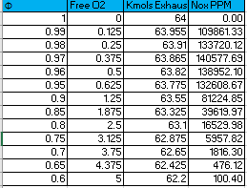
Figure 8.1 NOx PPM

8.1 Analysis
It can be seen that Stoichiometric produces 0 NOx, this is due to the limitations of the model in that it is assumed that there are no free oxygen molecules available. What can be seen is that NOx production increases up to 0.97Φ and then decreases. This is because at 0.97Φ there is enough free oxygen to become NO and the temperature is still high enough for disassociation to occur, as the FER becomes leaner more free oxygen is created which implies that NOx should increase but as seen in fig 6.3 the temperature decreases meaning that the chance of disassociation occurring decreases.
The predicted NOx PPM is high as the predicted flame temperature is also too high as mentioned in section 6.

Figure 8.2 NOx PPM to Fuel Equivalence Ratio

9.0 Exhaust Gas Recirculation (EGR)
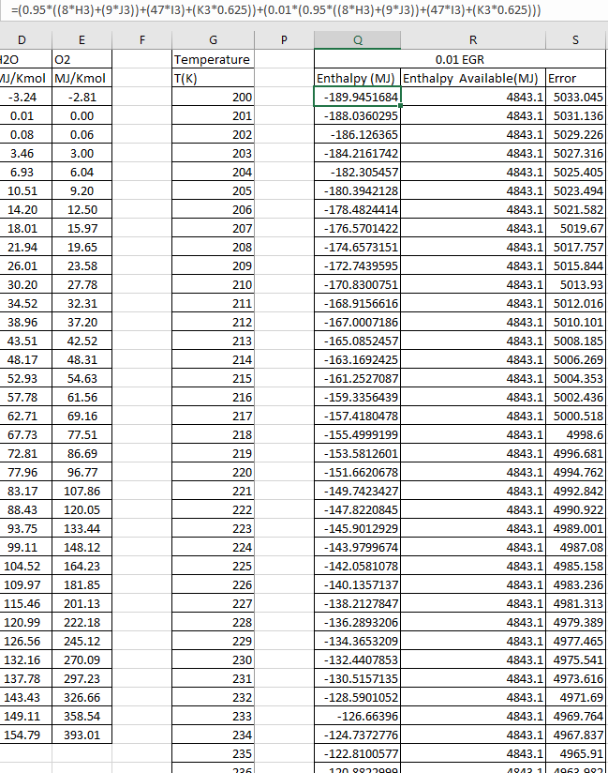
Figure 9.1 EGR enthalpy tables
To calculate the enthalpy needed to reach the available enthalpy with the EGR included the percentage of EGR is added onto the original 0.95 enthalpy and can been seen in fig 9.1. From there it is the same interpolation technique as used before to find out the adiabatic flame temperatures.
$$EGR enthalpy required:EGR needed+EGR \%(EGR needed)$$
Equation 9.1 EGR Enthalpy
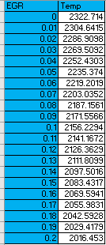
Figure 9.2 EGR Adiabatic Flame Temperature
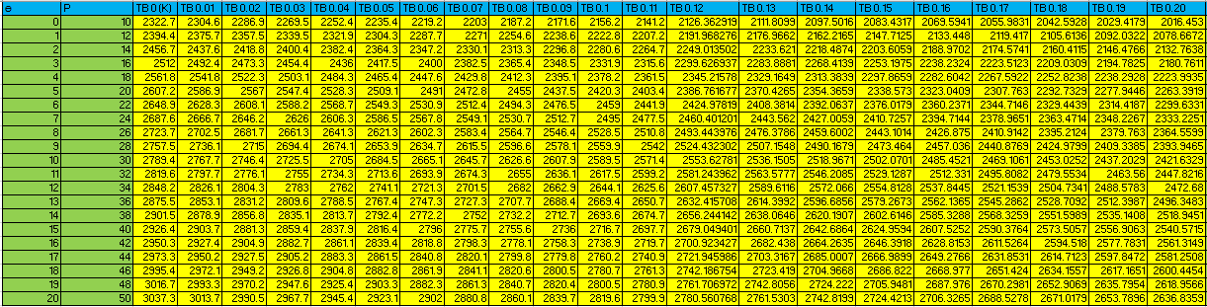
Figure 9.3 EGR Burned Temperature
As exhaust gases are now being recirculated back into the cylinder we must now reconsider the concentration of nitrogen and oxygen in the cylinder. As nitrogen and oxygen are being recirculated back, to calculate the new values it is simply the original value so for example 47 for nitrogen plus the EGR percentage of that value.
$$N_{2}@1\% EGR=47+(0.01×47)$$
Equation 9.2 Molecules of Nitrogen
Number of kmols in equation also changes now, taking the original value of 60.45 and adding the EGR percentage of exhaust gas kmols, for example at 1% EGR:
$$=60.45+(0.01(ф\left(8+9\right)+47+0.63125)$$
$$=61.088$$
Equation 9.3 Number of Kmols in Equation
Now that the kmols in the equation has changed it can be seen in fig 9.4 that alpha changes and as such the concentrations of both nitrogen and oxygen change.

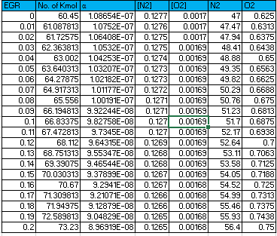
Figure 9.4 EGR [N2][O2] Concentrations

9.1 Analysis
As it can be seen in fig 9.2 as the EGR % increases, temperature decreases, this is because the EGR dilutes the mixture, reducing the oxygen concentration (Dec, et al., 2009) and increasing the specific heat capacity as there is now a greater number of Kmols being burned thus increasing the heat capacity of the charge which in turn lowers peak temperatures. (Dimitriou, et al., 2015)

Figure 9.5 EGR [NO] Concentration

Figure 9.5 follows the same pattern as fig 7.3 but this time EGR is reducing the NO concentration, this is because as the temperature decreases, dissociation is less likely to occur as it relies heavily on temperature for the molecular compounds to break up to create free oxygen radicals but also on a high temperature for the oxygen to combine with the nitrogen, as equation 2.1 implies NO can convert back to its original compounds if the temperature is low enough however the Zeldovich model does not take this into account.
Kmols in the exhaust has been rectified to account for the EGR in the same manner as kmols in the equation because as more kmols were introduced into the cylinder due to EGR meaning that there will be more kmols on the reactant side:
$$CO_{2}+\left(CO_{2}×0.01\right)=7.676 \\ H_{2}O+\left(H_{2}O×0.01\right)=8.6355 \\ O_{2}+\left(O_{2}×0.01\right)=0.63125 \\ N_{2}+\left(N_{2}×0.01\right)=47.47$$
Compared to the original values with no EGR included:
$$CO_{2}$$ | 7.6
$$H_{2}O$$ | 8.55
$$O_{2}$$ | 0.625
$$N_{2}$$ | 47
Table 9.1 0.95ф Original Compound
NOx PPM has drastically reduced with the inclusion of EGR due to the temperature reduction caused by its inclusion.
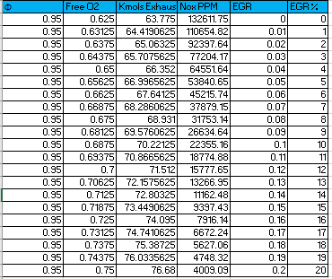
Figure 9.6 EGR NOx PPM

Figure 9.7 EGR NOx PPM

10.0 Conclusion
This report has shown that whilst running lean but close to stoichiometric can be disastrous in terms of NOx emissions, becoming leaner can have the opposite effect in that NOx emissions are drastically reduced due to decline in temperature. It can be seen then that running lean can be a solution to emissions whilst also having the effect of increasing thermal efficiency as heat loss would be reduced due to a reduced temperature difference between the engine and its environment. (Lee, et al., 2014)
However due to the issues brought with a lean mixture it is advantageous to consider other methods of NOx emissions, one of which has been the introduction of EGR which has been shown in this report to drastically reduce NOx emissions even at an FER of 0.95 which had one of the highest NOx emissions.
It is important to note however that like increasing the leanness, increasing EGR comes with its own issues such as poor combustion quality, partial burning and misfire. (Heywood, 1988) Because of the issues involved for future improvements it is important to note other methods of reducing NOx emissions such as cooling the charge with methods such as water injection or by removing the NOx after the engine using catalysts or special chemical treatment using urea.

11.0 References
Borman, G., 1998. Combustion Engine. Singapore: McGraw-Hill.
Dec, J., Sjöberg, M. & Hwang, W., 2009. Isolating the Effects of EGR on HCCI Heat-Release Rates and NOX Emissions, s.l.: SAE.
Dimitriou, P., Burke, R., Copeland, C. & Akehurst, S., 2015. Study on the Effects of EGR Supply Configuration on Cylinder-to-Cylinder Dispersion and Engine Performance Using 1D-3D Co-Simulation, Bath: SAE.
Glassman, I. & Yetter, R. A., 2008. Combustion. 4th ed. London: Academic.
Heywood, J., 1988. Internal Combustion Engine Fundamentals. New York: McGraw-Hill.
Lee, S., Ozaki, K. & Lida, N., 2014. A Potentiality of Dedicated EGR in SI Engines Fueled by Natural Gas for, s.l.: SAE.
McDonald, M., 2017. Zeldovich Model Notes. Swansea: University of Wales Trinity St David.
Schwerdt, C., 2006. Modelling NOx-Formation in Combustion Processes, s.l.: Lund University.
The Editors of Encyclopædia Britannica, 2011. Encyclopædia Britannica-Dissociation. [Online]
Available at: https://www.britannica.com/science/dissociation
[Accessed 10 01 2018].
Turns, S. R., 2006. Thermodynamics Concepts and Applications. Cambridge: Cambridge University Press.

12.0 Appendices

12.1 Polynomials
Polynomials were set to the 6th order with 30 decimal places, this is the maximum Excel can achieve and was carried out to obtain the greatest accuracy to get the most accurate temperature. The x found in the equation is the temperature at each degree Kelvin.
CO2:
y = 0.000000000000000000085657339772x⁶ - 0.000000000000001148039281120120x⁵ + 0.000000000006379447143132750000x⁴ - 0.000000019337110269941800000000x³ + 0.000035818423405687800000000000x² + 0.020409522356917800000000000000x - 8.800283726107930000000000000000
N2:
y = -0.000000000000000000043531651241x⁶ + 0.000000000000000518860922158264x⁵ - 0.000000000002329708837194740000x⁴ + 0.000000004467757359013690000000x³ - 0.000001197506092389670000000000x² + 0.028584370239865600000000000000x - 8.520874847741420000000000000000
H2O:
y = -0.000000000000000000056291589612x⁶ + 0.000000000000000726387762246216x⁵ - 0.000000000003620979055817660000x⁴ + 0.000000007961916549415790000000x³ - 0.000002203327337994080000000000x² + 0.033018347039856600000000000000x - 9.815150204368650000000000000000
O2:
y = 0.000000000000000000010964300779x⁶ - 0.000000000000000188390859779952x⁵ + 0.000000000001279787113076040000x⁴ - 0.000000004512430337623810000000x³ + 0.000009934687490724760000000000x² + 0.024195738979246400000000000000x - 8.004173038569080000000000000000

12.2 Excel


