This document should be used to demonstrate the authors understanding of PHP and to support the website that was created to view temperatures, collected from sensors.
Smart and Connected Devices
The document to support the website created by student 1704746.
Andrew Cooper
1704746
BSc Software Engineering
Smart and Connected Devices
Lecturer: Gaynor Thomas
Contents
1. Introduction 2
2. Implementation 2
2.1 Security Measures 3
2.1.1 SQL Injection 3
2.1.2 Cross-Site Scripting (XSS) 3
2.1.3 Main Page Session 4
2.2 Other Points of Interest 5
2.2.1 Filtering Data 6
3. Conclusion and Future Improvements 7

Introduction
The author was required to make a website that could be used in a real-life scenario to send and retrieve data from a local database and display it in a user friendly format with the use of graphs. Insertion of data must be from a text file and information on the file should be removed after the task completed to reduce the risk of entering the same data into the database more than once. To ensure data is being protected, the author has implemented basic security measures such as user logins to ensure only authorized users can access the website.

Implementation
A variety of tools and techniques was used to successfully create the web pages for the temperature search website these include: HTML, PHP and Bootstrap. These were used to allow the author to create the web pages, send and retrieve data from a database and design and style the web pages efficiently, making them responsive and adopting the mobile-first development approach.
Starting from the log in page, the developer has ensured that only people with correct usernames and passwords are able to access the application seen in figure 1.
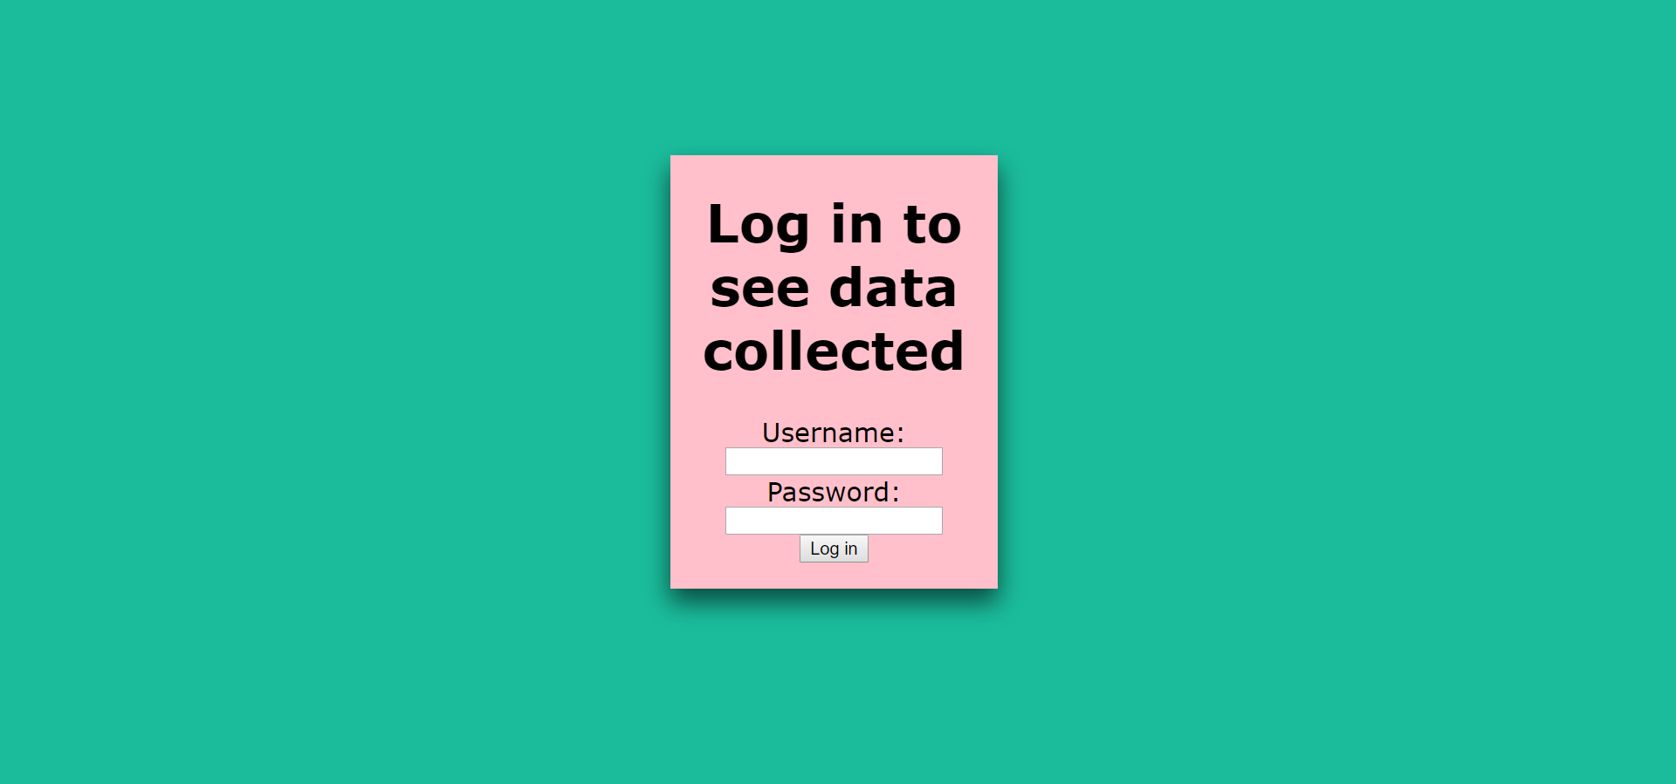
Figure 1: An image of the log in page
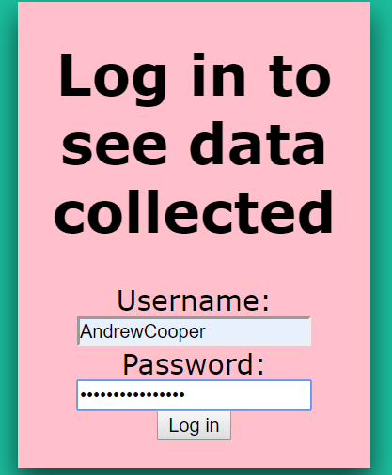
Figure 2: A user typing in their details
Seen in figure 2, the password field has been created so others cannot see the password as this is important secret information.
Furthermore, the user name and password fields have been marked with required to ensure that users are entering data before attempting to move on through the website.
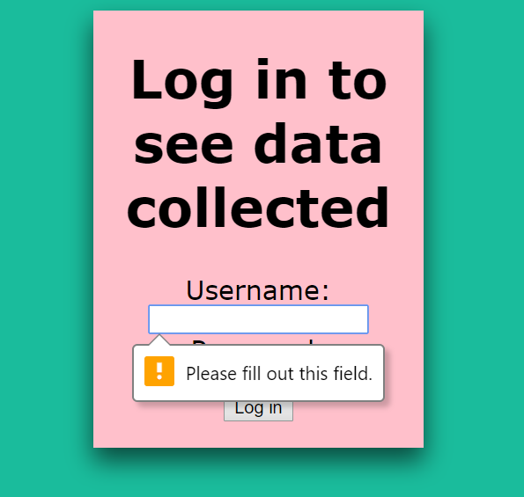
Figure 3: Required Fields

Security Measures
To ensure that people who want to gain access without the correct information cannot easily enter with the use of SQL injections, the author has also ensured that the username and password inputs have been sanitized, as demonstrated in figure 4.
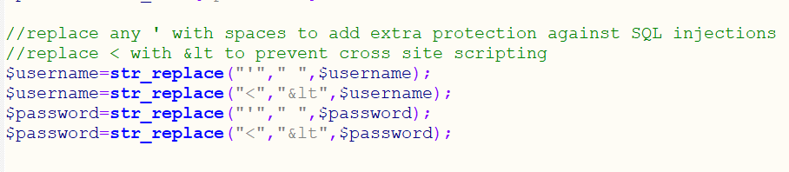
Figure 4: Entry Sanitization
As seen in figure 4 measure have been implemented to help reduce the risk of both SQL injections and cross-site scripting.

SQL Injection
An SQL injection takes advantage of the data definition language (DLL) that allows website to send, retrieve and modify data in the database. People usually use this attack to gain important delicate information but can also be used to cause havoc, an example of this is if a hacker was to ‘DROP’ tables. To reduce the chance of this happening within the program, the author has ensured that all commas are replaced with spaces. It is important to note that not everyone who enters a comma on a website have malicious intent, for example people with commas in their name, such as “O’Brian”.

Cross-Site Scripting (XSS)
Cross-site scripting is where a hacker will write code for the website to do something other than what was initially intended, examples of this range from changing the colour of a page through to retrieving genuine users personal data.
This attack could happen if text boxes aren’t sanitized as hackers can use basic JavaScript to perform tasks they wish to complete. Please see figure 5.
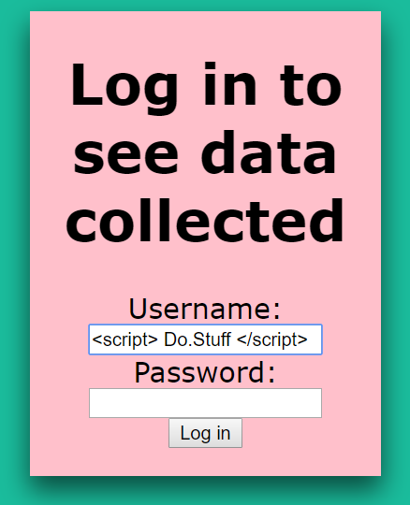
Figure 5: Cross-Site Scripting
To reduce the risk of this happening, the less than symbol “<” will be replaced with “&lt”.

Main Page Session
Sessions are used to store and pass information between pages. To ensure that users don’t just bypass the login page by typing in the main pages’ URL, the author has implemented a session that require the username to be entered on the log in page and this is shared with the main page. Figure 5 is the display that shows if a username has not been provided.
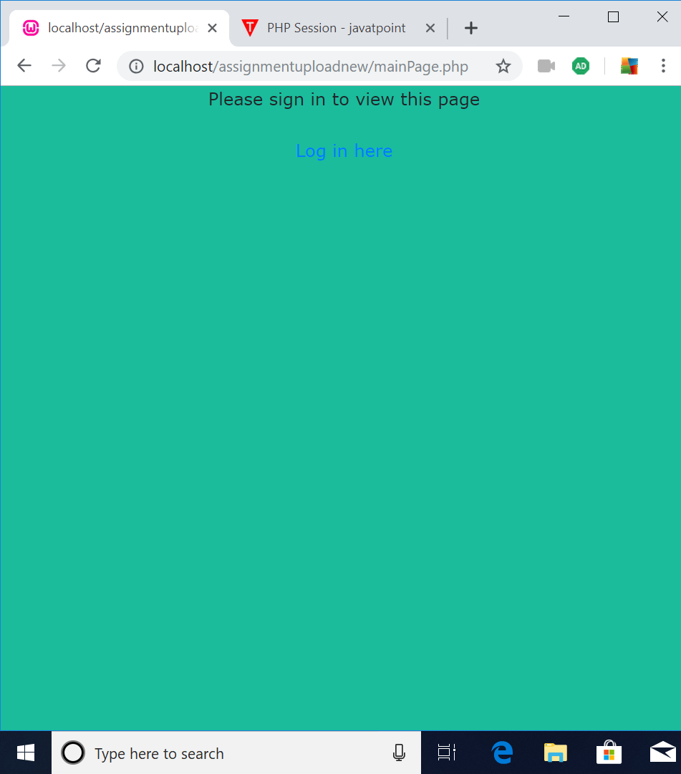
Figure 6: No username provided
Figure 6 is a screenshot taken from the authors assignment and shows the main page without the username being provided from the login page. Users who try using this to access the page will be directed back to the log in page.
Figure 7 and figure 8, seen below, shows that the user has inserted the required information and therefore are able to enter the website successfully.
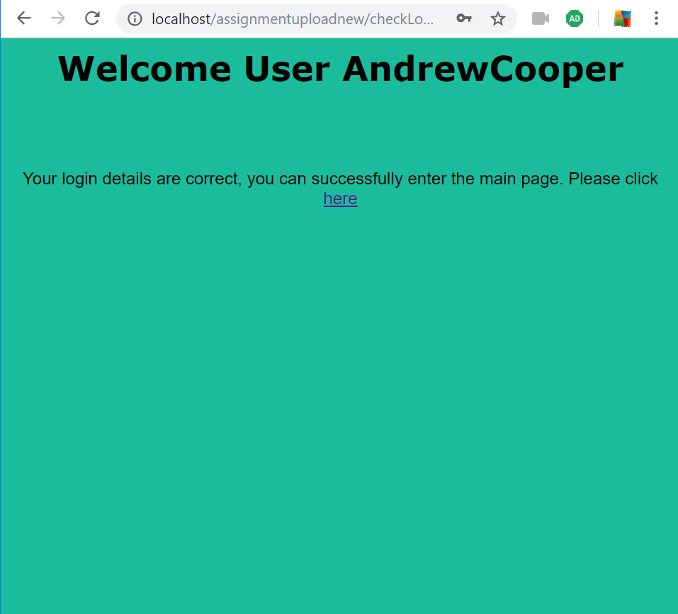
Figure 7: Successful Login
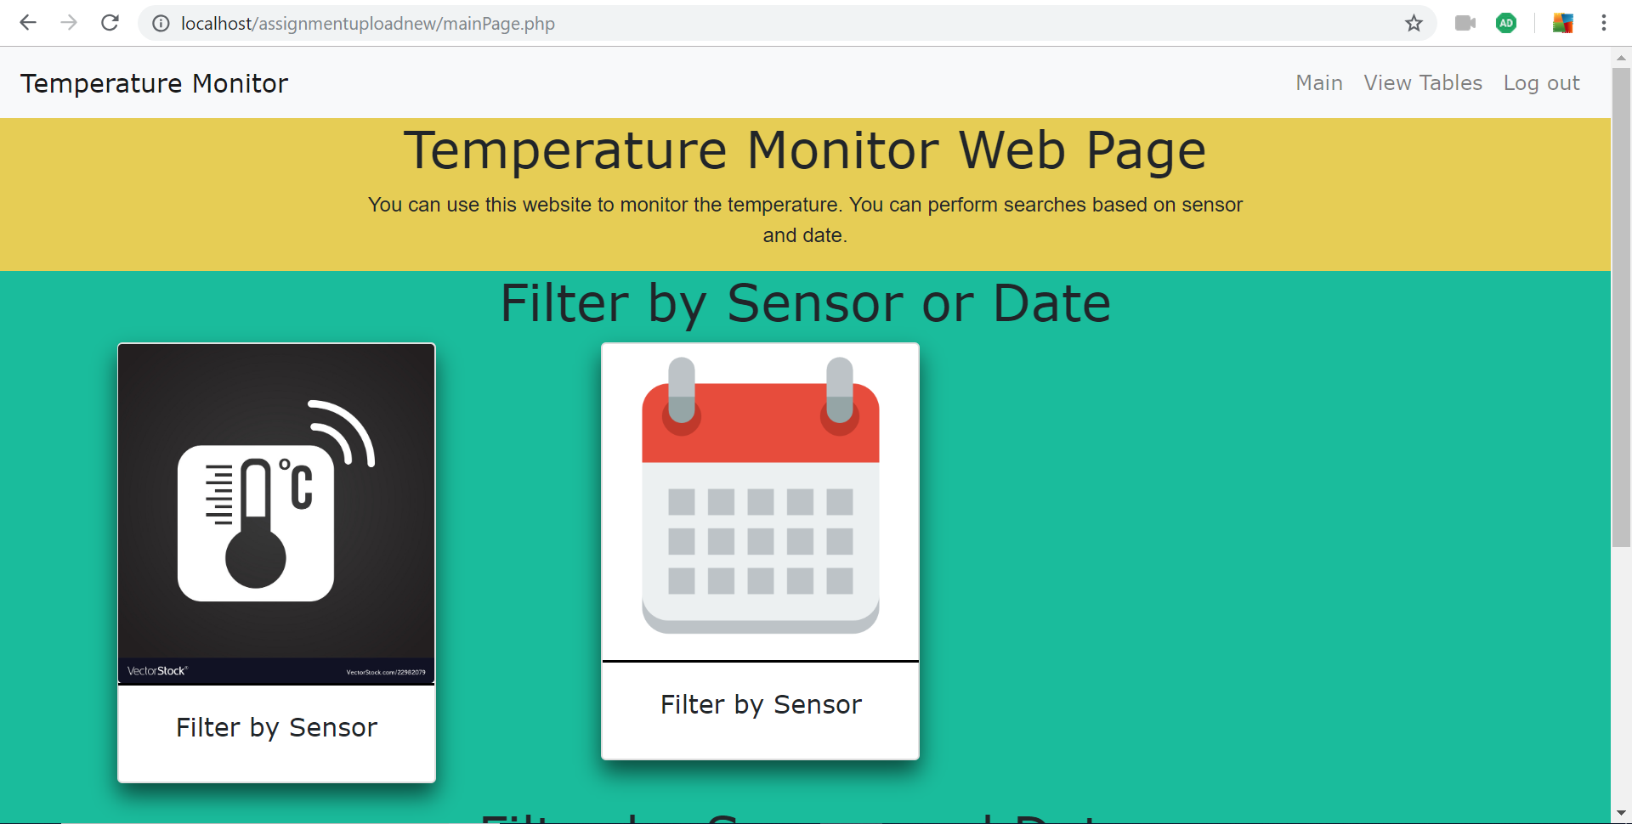
Figure 8: Main page after successful log in

Other Points of Interest
Besides the security measures that have been taken to assist keep data secure as possible, there are other elements of the website that should be acknowledged, such as the website adopting the mobile-first development technique. As the use of mobile phones for web surfing becomes increasingly popular, many companies are developing websites for smallest devices first then expanding. An example of how the website has been made with mobile users in mind can be seen in figure 9.
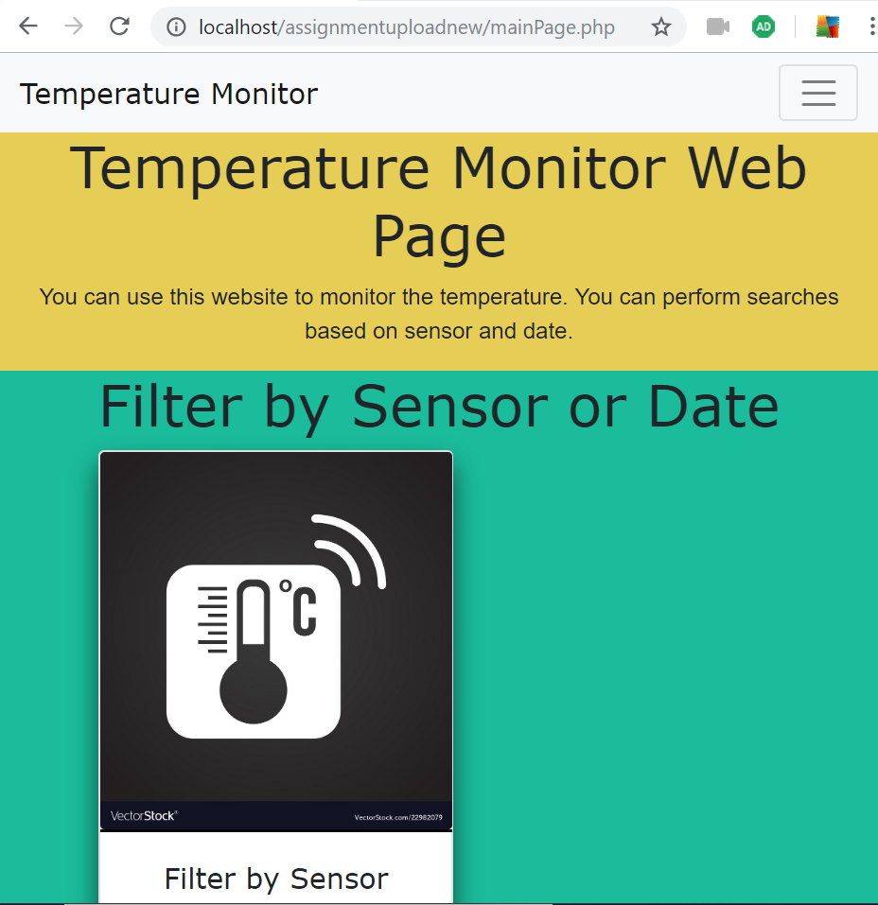
Figure 9: Responsive navigation bar
Figure 9 shows that when the screen width becomes smaller the navigation bar will be contained in the hamburger icon, which will drop down when clicked.

Filtering Data
Users of the website have different options for filtering to only retrieve data they wish to view, an example of this is by date and sensor or just by sensor.
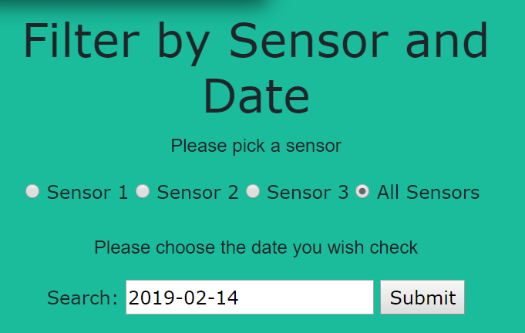
Figure 10: Filter Options
When the request has been entered by the user, the website will store the information gathered from this page to produce a query to run on the local database as seen in figure 11.
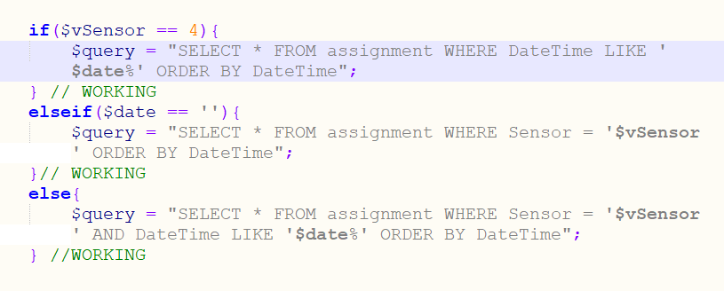
Figure 11: Query building based on user entry
The if statement, seen in figure 11 determines what data should be retrieved based on user entry. Using figure 10 and figure 11, a graph can be displayed using phpmygraphs. Please see figure 12 for the graph produced from the query.
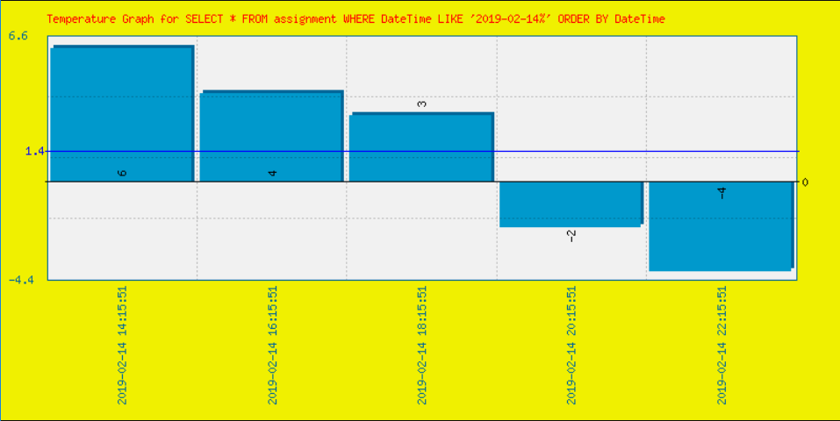
Figure 12: Graph based on user entry

Conclusion and Future Improvements
To conclude, the author has created a website using PHP, HTML and Bootstrap that allows users to search the temperatures received by IoT sensors. The information gathered is stored on a database and queries can be run to fetch the data for user viewing. Participants of the website must have a verified user account and password to be able to gain access into the website and safety precautions have been implemented to reduce the possible exploits within the website, such as SQL injections and cross-site scripting. Furthermore, users are able to set values to perform queries to gain relevant information in graph format.
In future iterations of the website the author could make a few changes which could enhance peoples experience. One change that would be made would be to add a drop down list of all possible graph types available to the user instead of having a standard graph type. Also, the website could have a button to allow users to add new sensors, although this can be done by running an unseen page on the website, it would be better for users to have this on the user interface.

