Assignment 1 – Reflective Review of Learning Journey
Professional Career Development
BMSK4005
Mohammed Nazmul Ahmed (1805954)

Table of Contents
Introduction 2
SWOT Analysis 3
Personal Analysis 3
Honey and Mumford 4
VARK Learning Style 5
GO MAD 6
SMART Analysis 7
Personal Ananlysis 7
References 8
Appendicies 9

Introduction

I decided to attend this course to enhance and develop my skills, in order for me to have a better chance at future employment and also take my developed skills into the workplace. Throughout the module we were taught different learning styles and different techniques to boost our skills further. For example, Marton and Ramsden say, “learning aims to deliver qualitive and relatively permanent change in how an individual see, experiences or understands something in the real world.” (Marton and Ramsden, 1988). We conducted a SWOT analysis (Strengths, Weaknesses, Opportunities, Threats) and SMART (Specific, Measurable, Achievable, Realistic, Time Bond) analysis on ourselves. We also completed different types of learning and profiling tests. These include Honey and Mumford, VARK, The Big 5 Personality Test and Myers Briggs. A SMART analysis is setting yourself a personal goal or objectives. SMART stands for Specific, Measurable, Achievable Realistic and Time bound. When conducting a SMART analysis, you need to start by detailing clear goal/objective explaining what you are going to do. When measuring your goal, you will determine how successful you were with your goal. To make your goal achievable you should not make it impossible to succeed otherwise it will only demotivate you. If your goal is not realistic then it may be a waste of time. Lastly you need to set yourself a specific time frame of when you start and end your SMART analysis. This is because you can monitor your progress and if you are on track to meet your goal.

SWOT Analysis

SWOT stands for Strengths, Weakness, Opportunities and Threats. I have identified my strengths and weaknesses and assessed how I can turn my weaknesses into strengths in order to provide better opportunities. I have identified and evaluated whether there are any threats to the opportunities I have recognised. Appendix 1

Personal Analysis

The process has taught me to understand, learn new skills and prepare me for better employment possibilities. Also, the course helped develop concepts of my self-awareness through extensive team building exercises and assessments. Everyone has weaknesses, my main weakness is confidence. I resist putting myself forward especially for presentations. This course is helping me overcome my fear of presenting by giving me opportunities during lectures to take part in group presentations. I believe that confidence plays a key role in employment as Taylor explains “This will help you advance in your job and career”. (Taylor, 2012). By gaining confidence, it is easier to complete tasks and jobs successfully without coming across any obstacles. Also, with increased confidence there are further benefits such as the ability to communicate with colleagues in an effective and efficient manner. I strongly feel that if I improve my confidence, I will be able to become very successful in future employments. I will be able to demonstrate good leadership skills by confidently sharing ideas and opinions with my colleagues, also this new-found confidence can help me enable others to develop their confidence. Additionally, I have assessed whether there are any threats to my future employment. I have come to the conclusion that a lack of confidence is a threat to my future employment potential, if I do not possess enough confidence, I am at risk of losing the employment opportunity to someone else who has greater confidence. Therefore, I think confidence plays a major role in getting into employment.

Honey and Mumford

During a lecture, I completed a Honey and Mumford questionnaire which resulted in me being a reflector. This shows that I stand back from events and activities, however, the Honey and Mumford learning style shows that I learn best from listening to others and taking information in carefully but thoroughly. As well as taking information in carefully and thoroughly, being a reflector, I can learn from activities that allow me to think before acting and reach decisions in my own time without any pressure. I believe being a reflector is a valuable attribute to acquire, the reason behind this is quality pieces of work can be produced by analysing and taking extra care.
According to the Honey and Mumford questionnaire, I have many weaknesses such as having the tendency to hold back from direct participation, being too cautious and not taking enough risks as well as taking time to reach a decision. In order to overcome these weaknesses, I need become more involved in lecture discussions and also be more active within group tasks.
There is also a lot of support available from the university to help overcome my weaknesses. Study support are provided by the university, access to online resources such as the library as well as one on one interviews with the lecturers.
In addition, I have a lot of friends and family that can help me overcome my weaknesses. The Honey and Mumford questionnaire has identified three other learning styles. These are Activists, Theorist and Pragmatist. From the questionnaire Theorist and Pragmatist were both my second learning style, activist came bottom. With this information, I have discovered that I am an individual that does not like being in the limelight and prefers working alone. There are many attributes which Activists possess which could benefit and advance my skills. For instance, they have the confidence to give presentations, lead discussions, also they are not afraid to take risks. On the other hand, Activists have difficulties learning from listening to lectures or difficulties when they are asked to complete solitary work. They also have the tendency to do too much themselves and have difficulty delegating wanting the limelight. I believe that I could benefit a lot by working with Activists. Activists would be able to help me overcome my confidence issue and give me the ability to be flexible/open minded with the tasks ahead.

Together with the Honey and Mumford learning style, we learned three other learning styles. These are VARK, The Big Five Personality test and Myers Briggs. From the other three learning styles there was a correlation between them. They all had concluded that I am a student that prefers working independently and is quiet but reflective.

VARK Learning Style

After completing the VARK learning style questionnaire I observed that I learn from Aural study strategies. “The VARK inventory was developed in an effort to improve faculty development and to help students become better learners” (Khanal, L, Shah, S, Koirala, S,.2014). I feel that the VARK learning style best describes me, this is because VARK shows that I learn best from listening. I take in the information via attending lectures/tutorials, discussing topics with other students and lecturers. The questionnaire also explains that I’d prefer to listen to the lecturer rather than taking notes which means that my notes will not be helpful in the future when looking back at the topic. Having the ability to learn from listening is a major attribute to have, this is because you can absorb more information quickly and effectively. Although I have qualities in listening, according to VARK I struggle to learn visually such as analysing diagrams, power points and graphs. I need to enhance my visual skills. As well as spending more time, I could use my own techniques, for example converting words in to symbols so that I understand the diagram/picture better. I could draw pictures, diagrams to help me grasp visual learning. Figure 1

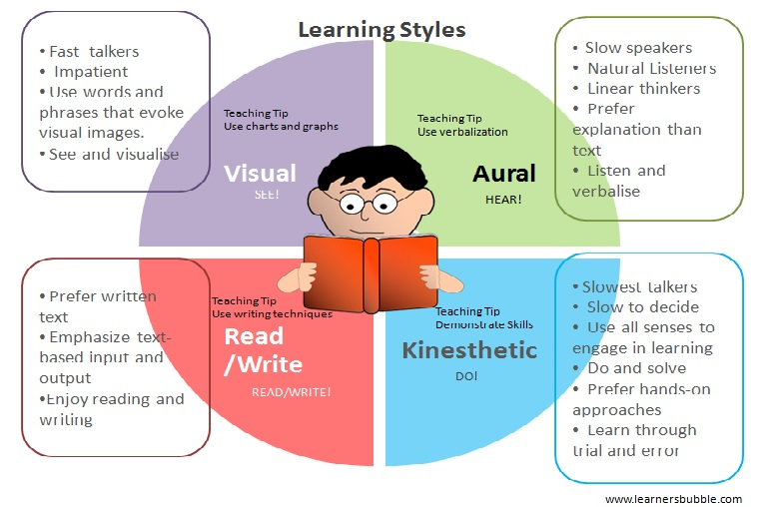
Figure 1

GO MAD

We also learnt about the GO MAD model and Kolb’s learning style. The GO MAD model allows you to have a clear vision on what you intend to do, exploring goals you may have, setting up a plan of priorities, getting people involved around you, take responsibility and action (Gilbert, A and Chackrovaity, T. 2001). See appendix 2.

This model taught me a lot about my self-awareness and that I would be looking for in the future. I identified a reason why I want to make the difference. The key objective for me was gaining the qualification in order to have better opportunities. To gain the qualification I need to possess many strengths to achieve my goal. I believe that I have various set of strengths, this includes patience, independence, teamwork, adaptability and communication. According to website youthcentral.vic.gov.au “There are eight skills that employers want employees to have, no matter what industry you’re working in”. The first skill listed is communication which is an area of strength. Good communication skill enables you to be able to speak clearly with people and write well in order to be understood in emails, memos and letters. During lectures, working in groups will enhance my level of communication by discussing the topics with my fellow peers in addition to completing group tasks. In order to advance my communication skills further, I recently have volunteered to become a member of the local mosque. The role I have been assigned to is a “Treasurer”, which involves me looking after the mosque’s finances. This role demands excellent communication skills and trust. The GO MAD model allowed me to define my goals. My main goal was to complete the course successfully. To accomplish this goal, I have carried out a SMART analysis. To measure my goal, I have set myself an extra five hours a week to prepare for assignments and in class assessments. To achieve my goal, I have taken advantage of all the online resources as well as the tutor support available from the university. I believe my goal is obtainable, this is because I have many skills to successfully complete the course. My skills include good communication, organisation and determination to succeed. I will review my progress with my lecturer at the end of each semester. I also need to consider finance, personal commitments and my time management. The reason behind finance is, if I can afford time to continue my studies due to having personal commitments such as family expense which also leads into time management. I will have prioritised time for family, work as well as studying. Although I have a lot of commitments, I believe that I possess enough organisational skills to overcome the challenge of making time. To manage my time more effectively, I would consider allowing plenty of time to complete assignments. I would dedicate two to three hours on the weekend to complete the tasks ahead. After defining my goal, I identified which plans and priorities I need to execute my goals. I plan to study further to be able to advance my knowledge and skills further. In order to study further I will use all the resources available to me such as the study support provided by the university and modern-day technology. The GO MAD model allowed me to consider which tasks may affect or help to reach my goals. I have determined I will need access to good transport links, for example, drive a car, in order to arrive for work or interviews on time as well as being able to travel greater distances for better opportunities. I have set myself a goal of attending presentations to build up my presentation skills. I will look into involving others who could help me to achieve my goals. I will look firstly at family. Secondly, I would seek help from lecturers (Laura, Mel, Beth). Lastly, I would consider any influential people that would be able to provide experience and support.

Personal Development Plan (PDP)

This module taught me to create a PDP (Personal Development Plan) on myself. See appendix 3. A PDP allows you to create a plan of objectives/goals, what priorities you have such as which sills you possess to enable you to reach your goals, how much time you set yourself set deadlines, if there are any threats or obstacles to achieving your goals, what skills you possess to meet your goals, what support is available to help achieve your goal and how exactly you will monitor your progression and success. The recruitment agency “Reed” believes that a personal development plan benefits you by defining a particular career path and a way of succeeding your objectives.

Conclusion

To conclude, on this module I analysed my strengths, weaknesses, my learning styles and learnt different ways I could improve them. I identified confidence as one of my weaknesses and I used conversion strategies to show how I could improve my weakness. I used a SWOT analysis to show my attributes and also, I used the SMART analysis to set out specific goal I want to achieve in the future. The different questionnaires revealed which way I learn best. They identified how I prefer to learn and also taught me ways how I could improve learning using the other methods. I also designed a personal development plan on myself. This enabled me to shape out what my future plans are. This course has already enhanced my learning skills and it will enhance it even further.

References

- Briggs, I and Myers, P, B. (1995) “Gifts Differing: Understanding personality types.” California: Davies-Black Publisher
- Cottrell, S. (2010) “Skills for Success: The Personal Development Planning Handbook”, Basingstoke: Palgrave Macmillan.
- Gilbert, A and Chackrovaity, T. (2001) “GO MAD: About coaching.” Bath: Bath Press.
- Honey, P. and Mumford, A. (1982) “Manual of learning Styles.” London: Peter Honey
- Khanal, L, Shah, S, Koirala, S. (2014), “Exploration of preferred learning styles in medical education using VARK modal”, (Volume 3, Issue3), Russian open medical journal.
- Marton, F. and Ramsden, P. (1988) “What does it take to improve learning?” P. Ramsden. (Ed.), New York: Teachers College Press.
- Nainikac, (2014), “The V.A.R.K Learning Styles,” (ONLINE). Available at: www.learnersbubble.com/the-v-a-r-k-learning-styles/ (Accessed 6 November 2018.
- Rolfe, A. (2018), (ONLINE), Available at: https://www.reed.co.uk/career-advice/personal-development-planning-what-you-need-to-know/. (accessed 6 November 2018).
- Symonds, M. (2011), “SWOT analysis in project management,” (ONLINE). Available at: https//www.projectsmart.co.uk/swot-analysis-in-project-management.php (accessed 6 November 2018).
- Taylor, L. (2012), “Tame your Terrible Office Tyrant,” (Online), Available: www.forbes. com, (5th October 2018).

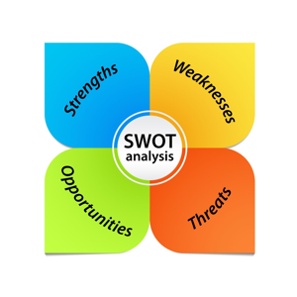
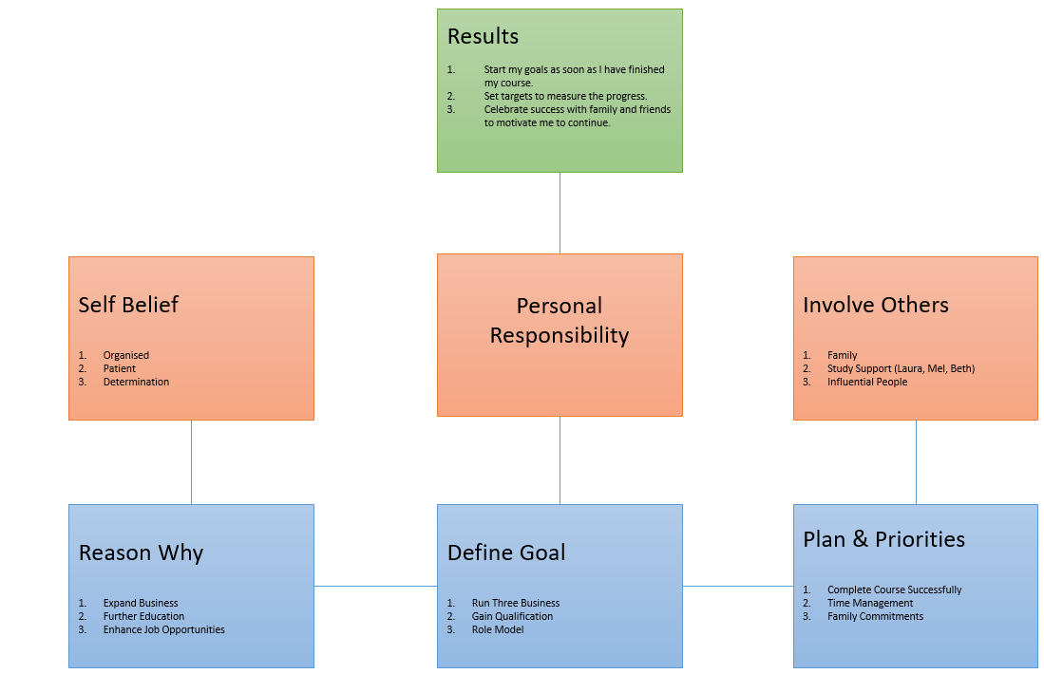
Appendices
Appendix 1 - GO MAD Model
Appendix 2 - SWOT analysis

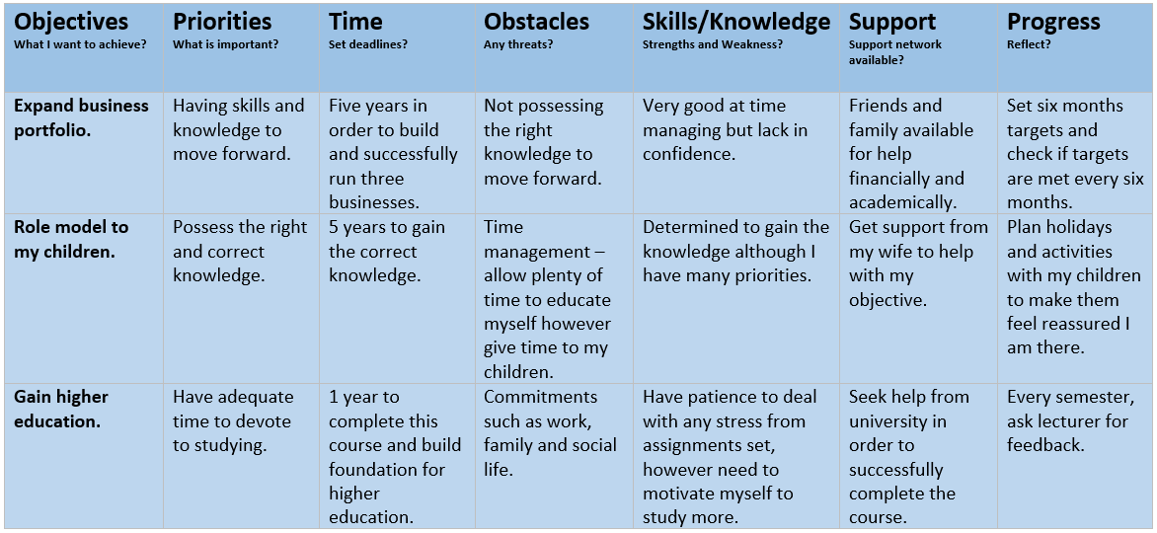
Appendix 3 - PDP (Personal Development Plan)

