Report
ACCC5004_WED Assessment 2, FEB 2021 – RESIT, Part 1

Name: Ion Gabriel Matei
Student Number: 1816251
Module Title: Web Development (ACCC5004_LON)
Assignment Title: ACCC5004_WED Assessment 2 - FEB 2021 - RESIT - Part 1
Lecturer: Suneth Fernando

Pages Contents
1 Case Study Research
6 Research and development
10 Implementation
11 Websites and Bibliography

Pages Figures
1 Fig1. HTML Script
1 Fig2.SQL Server
2 Fig3.Database Diagram
2 Fig4.LUHR Database
3 Fig5.Student Data
3 Fig6.AdminValidation
4 Fig7.Course Details
4 Fig8.Course Page
4 Fig9.Create Account
5 Fig10.Admin Account
5 Fig11.Insert Student Data
6 Fig12. Student Account
9 Fig13. Implementation

Introduction
The Report proposes to present a work related with development of a website for student registration at University.
In this scenario students are able to explore University website and to find information about study, learning programs, courses, registration and updates for their accounts [9].
In order to accommodate the students, University website offer facilities under next conditions:
- Courses for “Level 4 CertHE Skills for the Workplace and Level 4 CertHE Health and Social Care” [9].
- Every course contains 8 modules [9].
- Course registration is available for only one course at the time [9].
- Course administrator will validate submitted applications [9].
- Module progression is related with successfully passing the assessments [9].

Case Study Research
“London University of Human Resources” is the website of our project, where attendant students can register accounts and find all necessary information about programs, courses and modules.
Personal data and general information about courses are stored into “normalised database” build up with Microsoft SQL Server Management Studio.
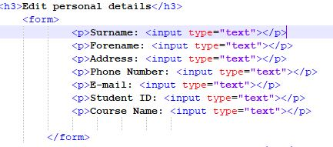Fig1.HTML Script [5]
Database “normalisation” refers to the process of setting up data in a database organised environment [1].
An organised database establishes relationship between different entities contained and structures tables according with well evaluated rules. A database is a designed data structure where data is protected and singular represented while easily can be accessed and modified [1].
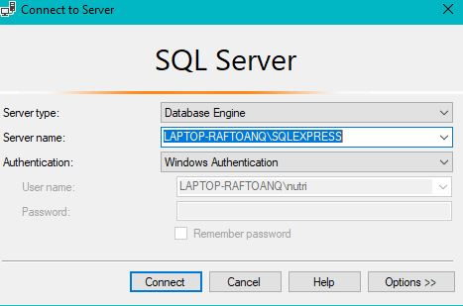Fig2.SQL Server
SQL Server Management Studio (SSMS) was used as solution because of it integrated environment for managing any SQL infrastructure [1].
SSMS provides also a set of tools to help the database admin to “configure, monitor, and administer instances of SQL Server and databases” [1].

The website collects data from registered students and saves via SSMS where the administrator can “monitor, and upgrade the data-tier components used by application, and build queries and scripts” [1].
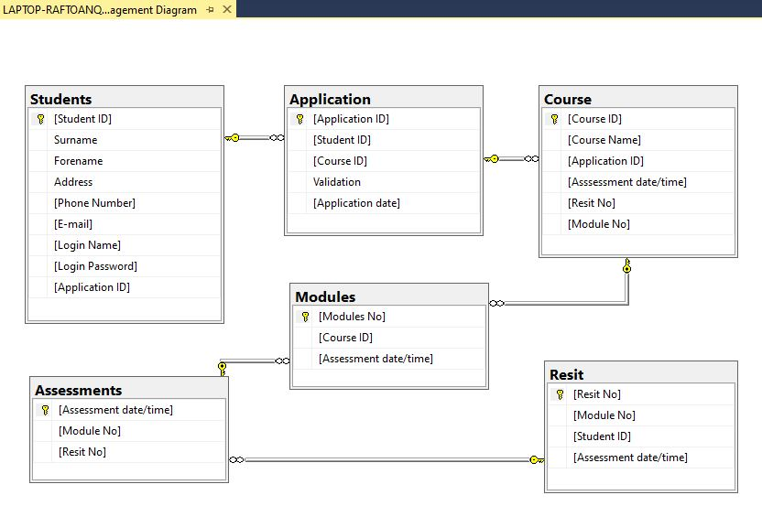
Fig3.Database Diagram
The relationship established inside database are destined to keep unique records and to facilitate fast operations such as delete, insert, reports from any secured internet connection at anytime [1].
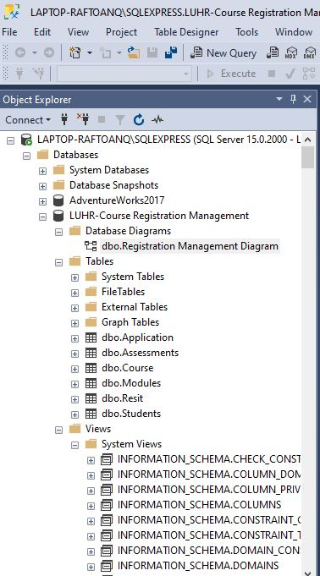Fig4.LUHR Database
LUHR-Course Registration Management is storing data such as student names and address, phone number and email, is securing account login credentials and its associated student id and application id after admin validation process.
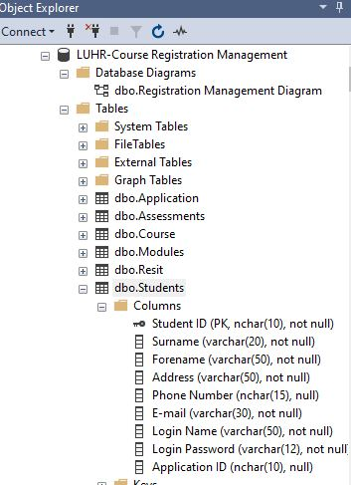Fig5.Student Data
For registration, future students are necessary to fallow a set of rules and to agree with University conditions. Students are able to search and select 4 different levelled certified courses for “Skills at Workplace or Health and Social Care”.
In order to secure registration activity and to avoid duplicated accounts every student will be able to select and register only one course at the time.
A designated admin from University will be able to view applications and to validate all data.
Once validated the application, the student have to login and will find at student page information about selected course, progression and updates, assessments and will be there again able to amend his personal data.
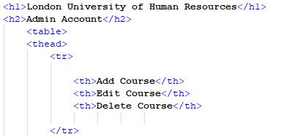Fig6.AdminValidation
Each course is structured on 8 modules and can be visualised with or without logging in personal accounts.
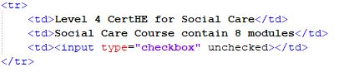Fig7.Course Details
Course page display available options for any attendant just before account registration and facilitate a search method for different modules.
Fig8.Course Page
In order to setup the personal account, the website provides a designated page for login and for data registration.
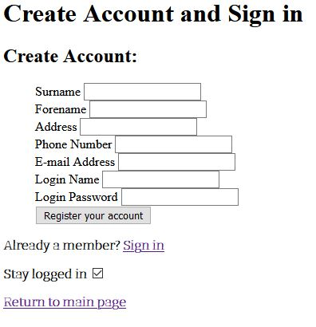 Fig9.Create Account
Using a management studio for database facilitates access roll creation and restrictive mode administration.
Database administrator can request reports and other queries for better management and for efficient control of resources [4].
LUHR-Course Registration Management database is created for delivering necessary scalability in such demanding working environment.
As database administrator there are facilities to securely edit course details, to check and validate applications, to list available courses and to add more details related with studying modules.
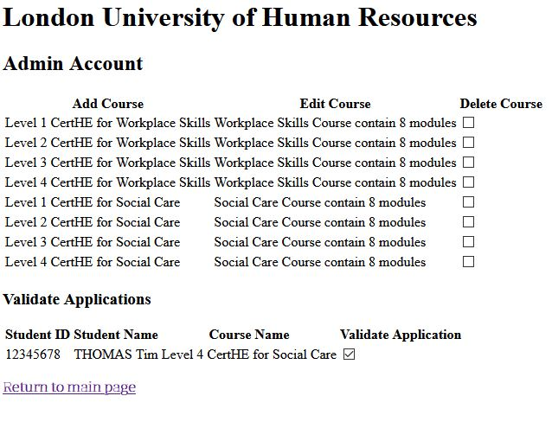Fig10.Admin Account
Additionally the student provides options to amend already registered data. Students are able to see and manage their accounts in a friendly, personalised page and also are able to see and receive information about course modification or other university requests.
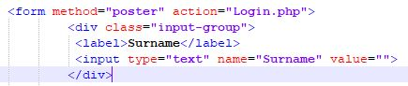Fig11.Insert Student Data
Student page is simply registration form for university admission and then by it importance for student data integrity it needs to be securely managed using a adequate database management system with restricted access. 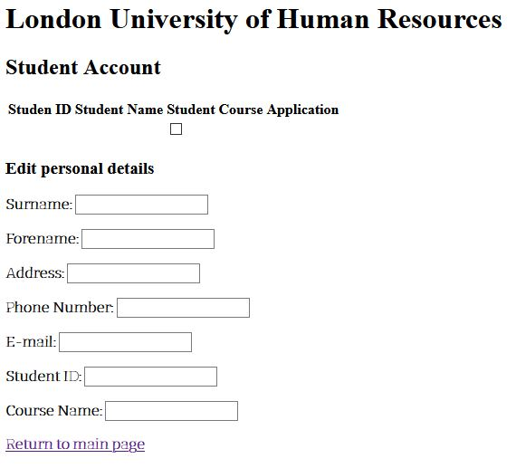Fig12. Student Account
Research and development
Defined by Oxford Languages as “HTML” or “Hypertext Markup Language” we are using this programming solution for website development this “standardized system” in order to relate text files and its associated and necessary fonts, colours, and other graphic effects with the ultimate purpose to be exposed on internet world [5].
Websites are stored on web servers and so related server technology facilitates web page deployment via a numerous programming models and frameworks [1].
PHP is such called “server scripting language”, very popular and well designed to be considered today “a powerful tool for making dynamic and interactive Web pages” [3].
PHP-users finds often very similar available frameworks offered by the software developers at the moment but when we discuss about overall performance and with attention to features and maintenance support is definitely appear several differences [2].
Laravel, Symfony and Phalcon are 3 of the most disputed names online and are necessary to see why this are so popular and controversy at the same time [2].

If we judge by the number of users, installations or downloads or even more from media popularity, Laravel is the most wanted PHP solution.
Taylor Otwell is the owner of 2011 released product and their communication announced proudly millions of download since. [7].
A technical approach will describe Laravel as user friendly HTML creative environment based on self language named”Blade” [7].
As an interactive database “object-relational mapper”, or ORM, Laravel is used to easily define models and to establish relationships using PHP that after will be executed in SQL [7].
This translation makes everything to look easy, comprehensible and friendly to use. Code is less abstract and gives a chance to adjust for different database systems and that is their key to successfully address to for a market with plenty database systems and demanding growth.
Laravel package contains live streaming windows, ideal for broadcasting events or community meetings, podcasts and video recording facilities and that answer to very necessary moments worldwide [7]. To be able all of that massive flux of data within the application is possible running multiple services at same time conferring real time experience for users with no worries for delay or straining.
These great features recommend Laravel for small and big businesses at the same time and make it, according with Jetbrains.com the most utilised solution [2].
Laravel comes also with a consistent community where new starters find support and examples of successful coding.
Benefits for a great documentation reflect on an intuitive and simplified syntax, easy to learn and understand with no prior experience. Server experience is easy when using Laravel Forge and Laravel Envoyer, two solutions dedicated for cloud infrastructure such as Amazon [2]. Other dedicated solution is Laravel Cashier who facilitates billing service.
Self developed structure and features are making Laravel a secure solution and flexible enough to accommodate with any advanced application.
There is little inconvenience to remember while using Laravel but not for general public I may say and mostly for advanced users who could find over structured.
Some users find it “heavy framework” and that can be translated as “slower” comparing with other frameworks do to its features variety.

A great reputation has also Symfony a serious competitor for Laravel, a inovative PHP framework, facilitated by SensioLabs.
The most innovative part comes from facility to utilise “reusable components” that can be integrated in future PHP programs, components available for free in open source tools. Growing user community find Symfony as a top solution, secure and well featured for completing projects.
Model-view-controller pattern was used to facilitate user interface and to structure the framework logical tree [4].
Object-relational mapping using “Doctrine ORM” and “Twig Template Engine” facilitate views, reconfigure database, migration, validating objects and HTML experience [6].
Symfony is a secured solution, long time and advanced option for developing complex projects or business database optimisation with:
- Strong documentation and open community support.
- Over 60 individual components make it a highly customizable solution [6].
- Built-in testing facilities [6].
- Low costs for maintenance and deployment [2].
Are there few negative points to mention and mostly are related with complexity of its components that may require additional knowledge for using or understanding it and that may be a hard try for beginners [6].
Challenging may be also the eventual insertion needs that may be found complex or too specific to implement.

Another very particular option for PHP developers is Phalcon.
Phalcon may discourage at first time because is not a PHP specific language framework but actually is written and precompiled in C.
This characteristic makes it super fast for machine and very competitive on the market for others frameworks available.
Framework structure offer similar capabilities to what we researched before including object-relational mapping, insertions and caching, divisional architecture, and lots of security features [2]. Because it’s accurate performance and scalability Phalcon is now most utilised by big enterprises companies.
Other features:
- Low overhead or low memory consumption because the code is compiled to a specific processor [8].
- PHQL – utilises internal SQL for relational database creating and adapted for multiple use [8].
- Provides advances routing capabilities [8].
- Template Engine (Volt) and forms builder [8].
In conclusion Phalcon is innovative, robust and maybe the “fastest PHP framework ever buld”, like the owners love to advertise their product [8].
Despite this high speed runner product are also few inconvenience to remember when talking about using Phalcon and that start with syntax complexity and continue with implementing difficulty because its double nature, see here PHP extension of a C based language solution. Other aspects of inconvenience are related with: MySQL, PostgreSQL and SQLite as only accepted database [8].
Our database-web solution utilises Microsoft drivers for PHP application to enable integration with SQL server.
Microsoft drivers are actually PHP extensions that allow the reading and writing of SQL data collected by PHP scripts [1].
There is a warning related to Visual Studio 2019 and PHP 7.4 editions that may result in incompatibility issue while running on windows machine [1].
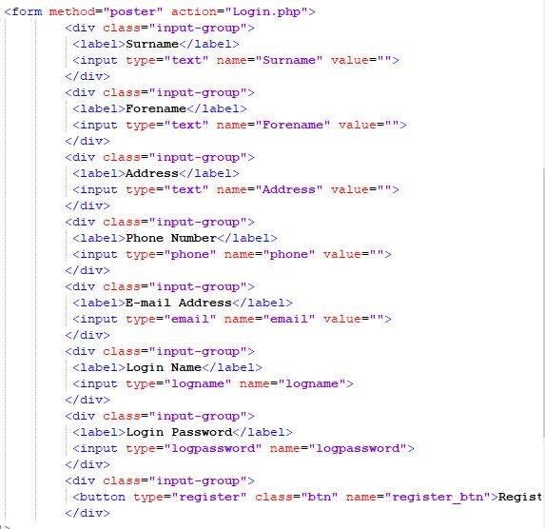 Fig13. Implementation 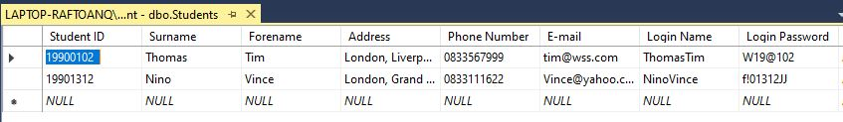
Implementation

LUHR-Course Registration Management is an interactive software solution for building up university database, while offering website content experience for the users.

Regularly database information can be accessed via user or admin page, after securely login session is confirmed.

Actually are reflecting two systems interconnected by server technology via web application and database management system. HTML documents with CSS customisation facilitate user interface and SQL commands execute database specific operations while are requested.

Standard URL is used to translate user requests directly from web browser. Connected web server utilise its server software to identify PHP scripts and to interpret in execution containing code of PHP file [10].
PHP queries request from database specific content and get displayed back to the web page.

Requested database content will be delivered as response to the PHP script [11].
The script is stored in PHP variables and then under different statements web page displays the content.

PHP interpreter create the final delivered HTML content and post to the server its copy.
This became actually output of the web server as response at browser request [10].

For a good experience and secure sessions the PHP version and database system must adhere to a good compatibility as a server-software solution [12].

PHP frameworks makes all this work easy and send the user experience to unlimited possibilities by adding innovative experience of the great features[2].

Websites and Bibliography

[1]Microsoft, Docs, [Online], 2020, Available: https://docs.microsoft.com/en-us/office/troubleshoot/access/database-normalization-description 21 May 2020
[2]Athemes, Publication, [Online], 2021, Available: https://athemes.com/collections/best-php-frameworks/
[3]W3Schools, [Online], 2021, Available: https://www.w3schools.com/php/DEFAULT.asp
[4]Flavio Copes, Handbook, [Online], 2019, Available: https://www.freecodecamp.org/news/the-html-handbook/ Flavio Copes, July 23, 2019
[5]Oxford Dictionaries, [Online], 2021, Available: https://en.oxforddictionaries.com/definition
[6]Symfony, [Online], 2021, Available: https://symfony.com/doc/current/doctrine.html
[7] Laravel, [Online], 2021, Available: https://laravel.com
[8] Phalcon,[Online], 2021, Available: https://phalcon.io/en-us
[9] UWTSD, Moodle, [Online], 2020/2021, Available: https://moodle.uwtsd.ac.uk/pluginfile.php/245756/mod_resource/content/5/ACCC5004-Web-Development-Oct-2020%20coursework%20v2.pdf
[10] J.Foster , HTML 101, The Essential Beginner's Guide to Learning , US, Online-HTML Coding,, 2018, pp. 21-38.
[11] J. Maivald, Adobe Dreamweaver Classroom in a Book, US, Adobe Press, 2021
[12] A. Forbes, The Joy of PHP, US , BeakCheck LLC, 6th edition, 2012

