RESTful Web Service Exercise

POST
We are going to use a basic test webservice called {JSON} Placeholder:
https://jsonplaceholder.typicode.com/
NOTE: resources are not really updated on the server but the service fakes a successful operation for testing i.e. adding, editing and deleting actually has no effect. We will play around with the “posts” which look like this:
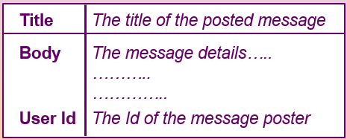

To add a new post you use this web service like this:
https://jsonplaceholder.typicode.com/posts
Content-Type: application/json; charset=UTF-8
Method: POST
Body: ‘{
“title”: “…..”,
“body”: ”…..”,
“userId”: 2 }’

This sends a POST request to the webservice:

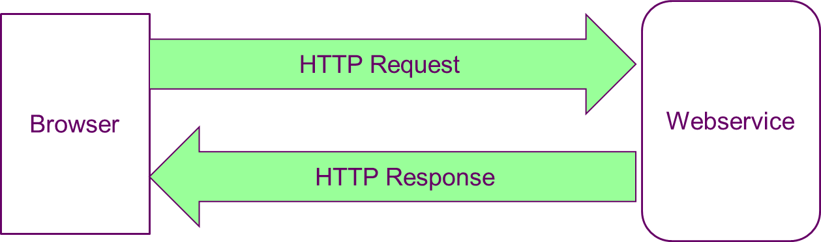

The response is returned like so:
Status: 201 (Created)
Body: ‘{
“title”: “…..”,
“body”: ”…..”,
“userId”: 2,
“id”: 101
}’

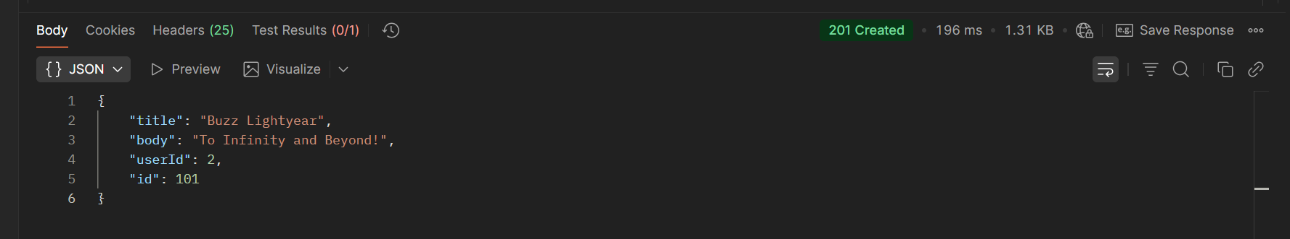
Check this using postman – Postman API Platform
Add a html file to the nodejs folder you created (or create a new file for this exercise and add the html file). Call the file ajax-websrv.html
<!DOCTYPE html>
<html>
<head>
<meta charset="utf-8" />
<title>Web Service Demo</title>
/head>
<body>
<form id="postdata-form">
<h2>Add new post</h2>
<label for="title-text">Title:</label>
<input id="title-text" type="text" /><br/>
<label for="body-text">Body:</label>
<input id="body-text" type="text" /><br/>
<label for="user-id-text">UserId:</label>
<input id="user-id-text" type="text" /><br/>
<input id="ajaxpost-button" type="button" value="Add Post" />
<div id="postresults">Waiting...</div>
</form>
<script src="https://code.jquery.com/jquery-3.7.1.min.js"
integrity="sha256-/JqT3SQfawRcv/BIHPThkBvs0OEvtFFmqPF/lYI/Cxo="
crossorigin="anonymous"></script>
<script src="ajax-websrv.js"></script>
</body>
</html>

Now create a new file called ajax-websrv.js
Write a function like so:
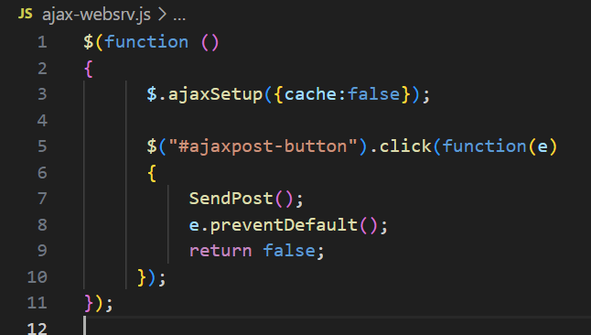
Create the SendPost() function inside ajax-websrv.js under the anonymous function you have crerated and include the ajax HTTP request.
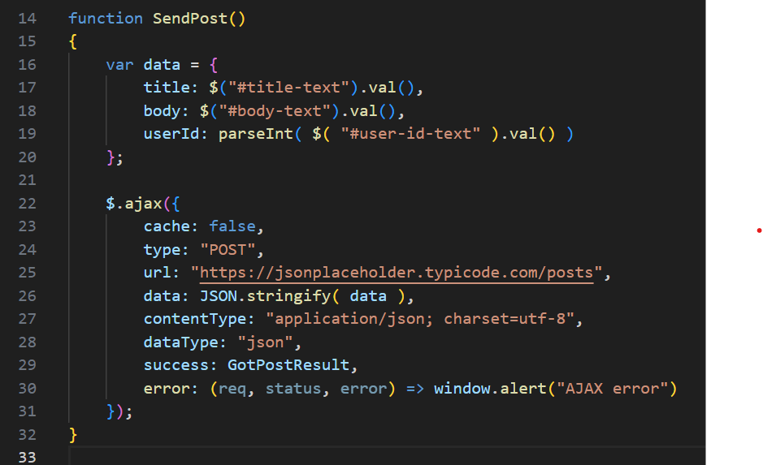
HTTP Request

Create a further function, GotPostResult() in the same file under the sendpost() function.
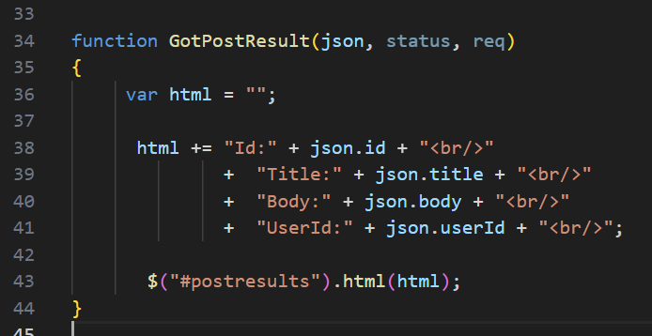
HTTP Response
Open the html page and see the results returned on success (201, created).
DELETE

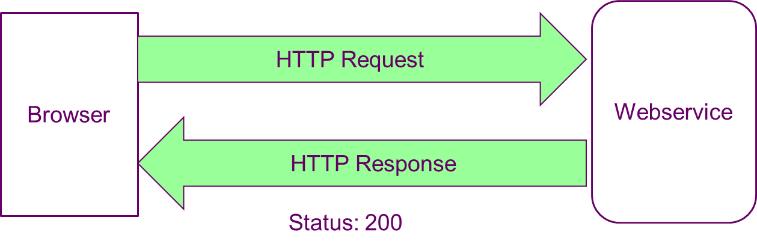

To delete a post you use this webservice something like this:
https://jsonplaceholder.typicode.com/posts/2
Content-Type: application/json; charset=UTF-8
Method: DELETE
Body: ‘’

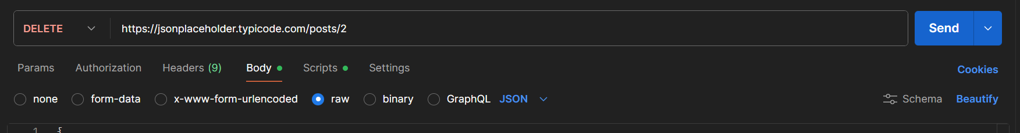

Repeat the same procedure as above but for DELETE,
BUT just add the highlighted parts to the existing files:

<!DOCTYPE html>
<html>
<head>
<meta charset="utf-8" />
<title>Web Service Demo</title>
/head>
<body>
<form id="postdata-form">
…
</form>
<form id="deletedata-form">
<h2>Delete existing post</h2>
<label for="id-text">Post Id:</label>
<input id="id-text" type="text" /><br/>
<input id="ajaxdelete-button" type="button" value="Delete Post" />
<div id="deleteresults">Waiting...</div>
</form>
<script src="https://code.jquery.com/jquery-3.7.1.min.js"
integrity="sha256-/JqT3SQfawRcv/BIHPThkBvs0OEvtFFmqPF/lYI/Cxo="
crossorigin="anonymous"></script>
<script src="ajax-websrv.js"></script>
</body>
</html>

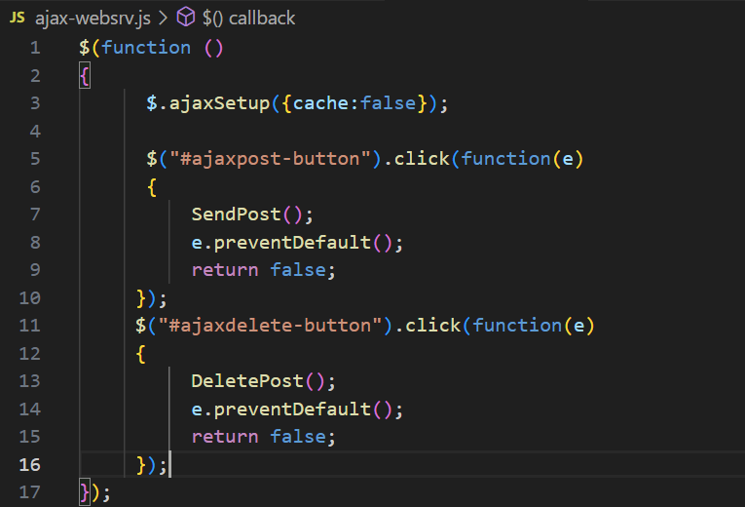
Add the HTTP DELETE Request at the end of ajax-websrv.js
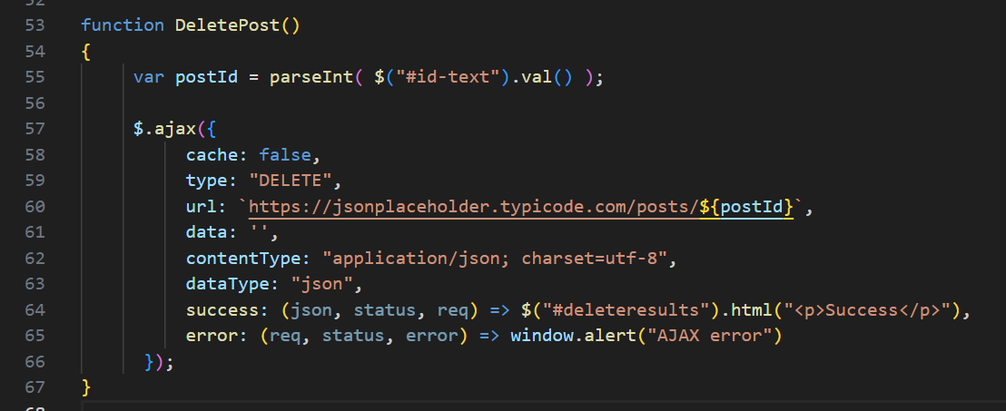
Alternative to JS Template:
“https://jsonplaceholder.typicode.com/posts/” + postId,

GET By ID
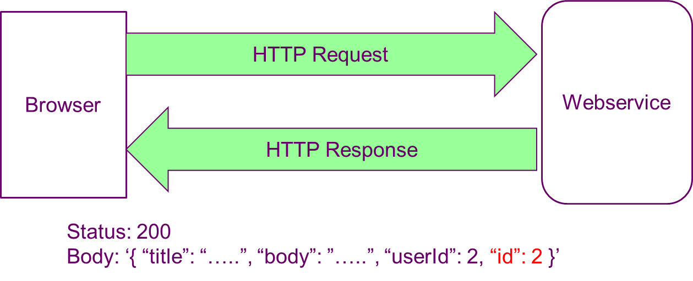

To get a specific post by its “id” you use this webservice something like this:
https://jsonplaceholder.typicode.com/posts/2
Content-Type: application/json; charset=UTF-8
Method: GET
Body: ‘’

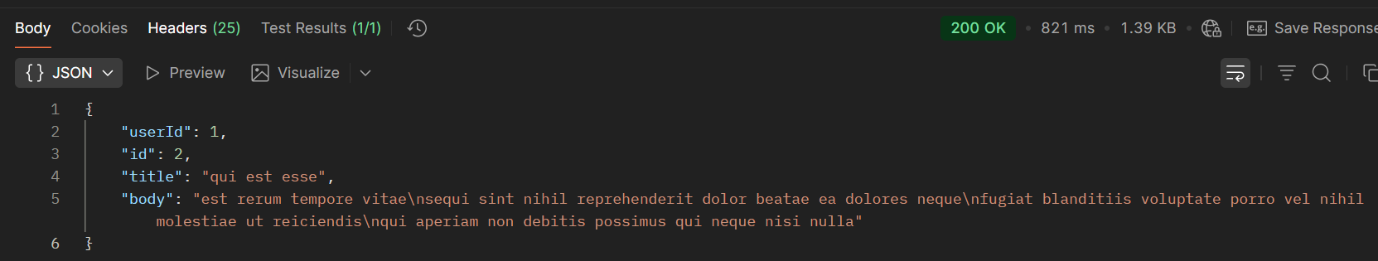

Add this to your html file:
<form id="readdata-form">
<h2>Read a post</h2>
<label for="getid-text">Post Id:</label>
<input id="getid-text" type="text" /><br/>
<input id="ajaxgetbyid-button" type="button" value="Get Post" />
<div id="getbyidresults">Waiting...</div>
</form>

Add this to the initial anonymous function:
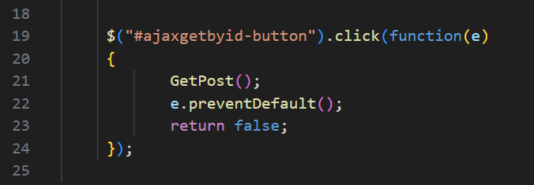

Add the HTTP request to the end of the ajax-websrv.js file:
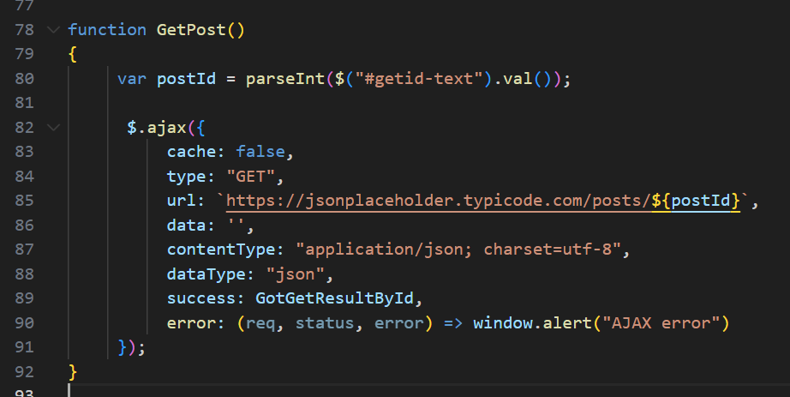

Now add the HTTP response after that:
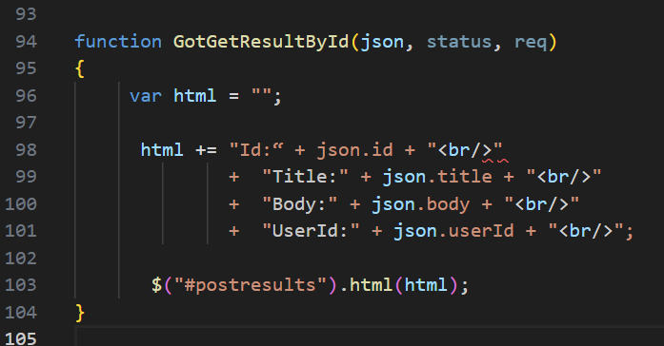

Run the HTML file and try them all. Read the JSON data returned on success.

