Written Report
The future of hospitality and is it profitable to be green?

Student name: Cristina - Florentina Patanghel
Student ID number :2118920
Module name: Sustainable Hospitality & Tourism Management
Module number : BMIH5006
Module Lecturer : Kathryn Roberts

Table of Contents
Cover page ………………………………………………………………………….pg.1-2
Executive Summary………………………………………………………………..pg.3
Introduction…………………………………………………………………………..…….pg.4
Subsection - Sustainability meaning and importance…………………………........pg.4
Main Findings ……………………………………………………………………………..pg.4-17
Subsection – Impact of Hospitality and Tourism over sustainability……………..pg.4-5
1.Doxey’s Irridex Model……………………………………………………………………pg.5
2.Butler’s Life Cycle Model……………………………………………………….pg.6
3.Doxey and Butler correlated…………………………………………………...pg.6-7
Subsection – Example of negative impacts of overturism………………………….pg.7-8
4.Sustainable Tourism and The Triple Bottom Line………………………….pg.8
Subsections -Perspectives on Sustainability…………………………………………pg.9
-Future of Hospitality and Tourism Industry………………………………………pg.10
- Customers position and profitability towards sustainability practices……..pg.10-12
-Responsible Tourism and Examples……………………………………………….pg.12
5.Milton Friedman Theory…………………………………………………………pg.16
Subsection – Financial concerns regarding sustainability………………………pg. 16-17
Future recommendations……………………………………………………….pg.17-18
Conclusion…………………………………………………………………………pg.18
References…………………………………………………………………………pg.19-22

Executive summary

At present, sustainability is vital. Taking into account the problems with the environment, overtourism, the depletion of resources, and climate change, implementing sustainable practises is essential to the health of the world and the generations to come .Policies, corporate practises, and personal decisions are being influenced by sustainability initiatives, which range from eco-friendly lifestyles to renewable energy.
As the present times encourage corporations to actively be involved and make their CSR a crucial part of their business core strategy , makes Milton Friedman’s Theory to be outdated and irrelevant.
Considering sustainability issues will play a bigger role in shaping the hospitality sector in the future, Doxey’s and Butler’s Model alongside with TBL are useful tools for the hospitality sector.
Although implementing sustainable practises may have initial expenses, businesses in the hospitality sector will find that it is a wise and profitable move in the long run due to the advantages and beneficial effects on profitability. Businesses that prioritise green projects are likely to prosper in the future of hospitality as customer preferences change and the significance of sustainability increases.
The ability of the hotel and tourist sector to strike a balance between economic viability and social and environmental responsibility will become more and more important as time goes on. Sustainable practises are becoming essential for firms seeking long-term sustainability in a shifting global landscape, as well as a competitive edge.

Introduction
There is a sustainability dilemma threatening humanity. Decades of meticulous research have provided unquestionable proof that human activities are triggering the natural systems that support life and well-being to become unstable and eventually collapse.
In addition to addressing environmental and social issues, the hospitality and tourism sectors depend on sustainability to maintain their competitive edge, adhere to legal obligations, and support the long-term welfare of their destinations and local communities (TWI,2018).

Sustainability- meaning and importance
The concept of sustainability refers to supplying current demands without endangering the capacity of future generations to provide for their own needs. It includes an all-encompassing strategy for progress that accounts for social, economic, and environmental factors. To protect the earth and its people in the long run, sustainability aims to strike the right balance among each of these three elements (Mollenkamp,2023).
Main findings
Impact of Hospitality and Tourism over sustainability
The travel and tourism industry's is very important for the global economy as a result of 7.6% GDP contribution in 2022 was up by 22% from 2021 , creating 22 million new employment opportunities in 2022 (Statista,2023).
The tourism and hospitality sectors may have a variety of positive and negative effects on the environmental, social and economic aspects such as :

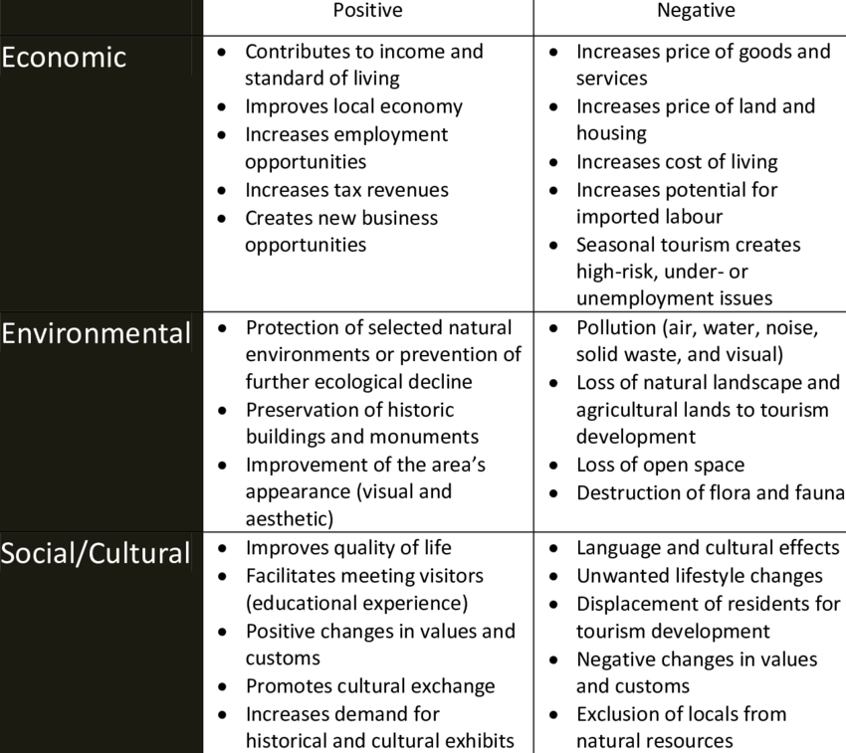

Diagram (Kreag,2001)
Adopting sustainable tourism and hospitality practises entails reducing the detrimental effects of tourism and encouraging beneficial contributions to the community, the environment, and local economies. The goal of these procedures is to develop a more moral and accountable approach to managing tourism and hospitality (EcoBnB,2023)
Doxey’s Irridex Model
The Irridex Model, which is used to assess the impacts of tourism development on sites, is a crucial tool in the tourist management business for addressing the environmental sustainability issue (Taiminen,2018).
The way that hosts treat visitors is essential to the tourism sector's long-term growth.
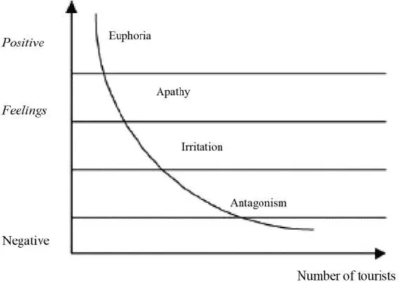
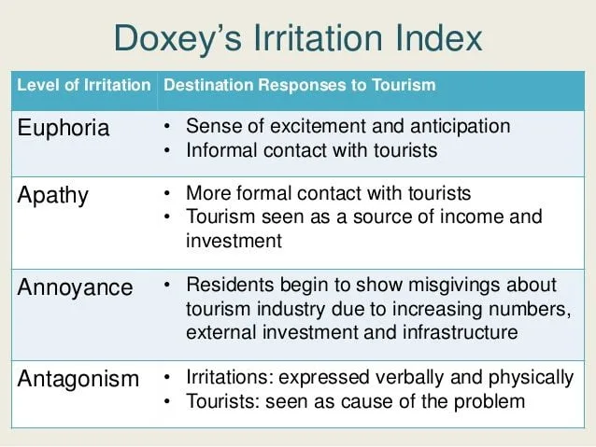

Butler’s life cycle model
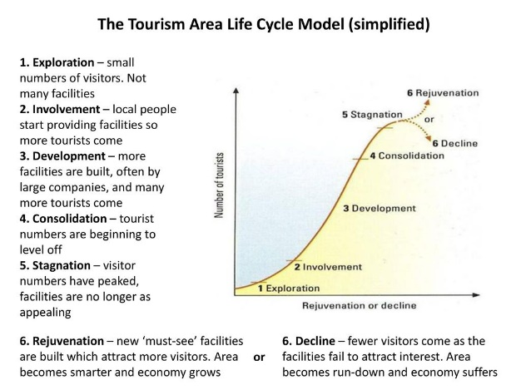
The Tourism Area Life Cycle (TALC) model developed by Richard W. Butler is a conceptual framework that explains the phases of a tourist destination's development throughout time. The 1980-introduced concept posits that places experience multiple stages, each distinguished by varying degrees of tourism development. The TALC model aids in comprehending a destination's development as well as any prospective obstacles or chances (Rahman,2023).

Diagram(SlidePlayer,2019)

Butler and Doxey correlated
According to scientific studies on the impact of tourism traffic in tourist areas, an excessive concentration of visitors causes overcrowding in prime locations, obsessive marketing and insistent commercialization all lower the aesthetic standard of visitors' experiences and harm the area's heritage and cultural assets. Overcoming the social carrying capacity restrictions, or the capacity to absorb changes as they occur, is what leads to the formation of a negative attitude among locals towards tourists (Cheung and Hin-Li,2019).

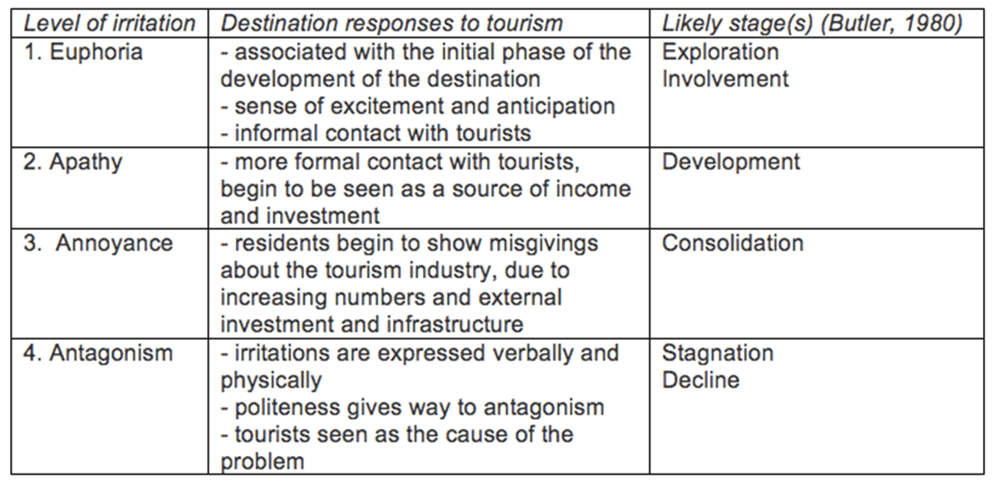

Diagram(Ballister,2015)
Example of negative impacts of overturism
Venice
One of the best examples of a place suffering from the effects of excessive tourism is Venice. The city, renowned for its distinctive historical and cultural legacy, has had numerous difficulties as a result of the large number of visitors ,including :
- Congestion and Overcrowding
- Infrastructure Strain
- Environmental Impact
- Housing and Cost of Living
- Cultural Erosion
- Protests and Local Resentment
- Economic Dependency and Vulnerability (SusieHeng,2021)
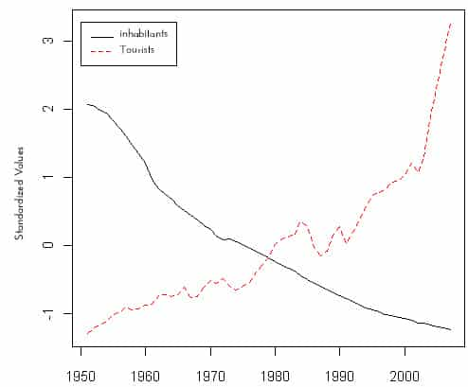
There are almost 20 million tourists that visit Venice per year, and on the peak days, about 120,000 people come to the city of only 55,000 permanent residents (Responsible Tourism,2021).

As a result 2,000 residents protested against the growth of tourism in 2017 by marching through the streets, demanding for improved housing and community services for the city's residents as well as a request for to action against the pollution that large cruise ships generate (Blair,2018).
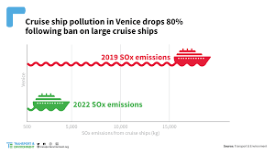

Luigi Brugnaro, the mayor of Venice, has recently disclose controversial proposal of limiting the number of tourists. In April 2018, he released a segregation system that would restrict access to well-known locations like St. Mark's Square and the Rialto in the event of excessive crowding. Visitors would be routed via alternate routes, and only locals and businesspeople would be permitted to use the busiest thoroughfares (Responsible Tourism,2021).

Sustainable Tourism and the Triple bottom Line
Sustainable tourism integrates economic, social, and environmental factors to build a more responsible and balanced tourism sector, which is consistent with the Triple Bottom Line principles. A thorough framework for assessing the sustainability of companies, particularly those in the tourism industry, is offered by the Triple Bottom Line created by J. Elkington (Utheim,2020).
- Economic Dimension (Profit)
- Social Dimension (People
- Environmental component (Planet)
- Community Involvement and Stakeholder Engagement
- Long-Term Sustainability
- Education and Awareness of Tourists
- Corporate Social Responsibility (CSR)
- Standards and Certifications (Utheim,2020)

Perspectives on Sustainability
For companies hoping to prosper in an ever-changing business and environmental world, adopting sustainable practises is an investment well worth making, even though there may be some obstacles along the way. Making the switch to a greener lifestyle can benefit the environment, society, and financial results (Chron,2020).

Going GREEN
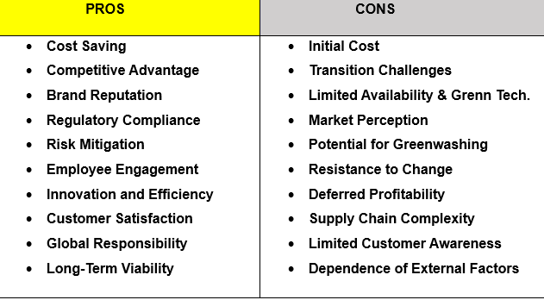
(Doerr,2023)

Future of Hospitality and Tourism Industry
Sustainable practises will undoubtedly play a major role in the hospitality industry future and companies who proactively adopt & incorporate these practises stand to gain significantly from them.
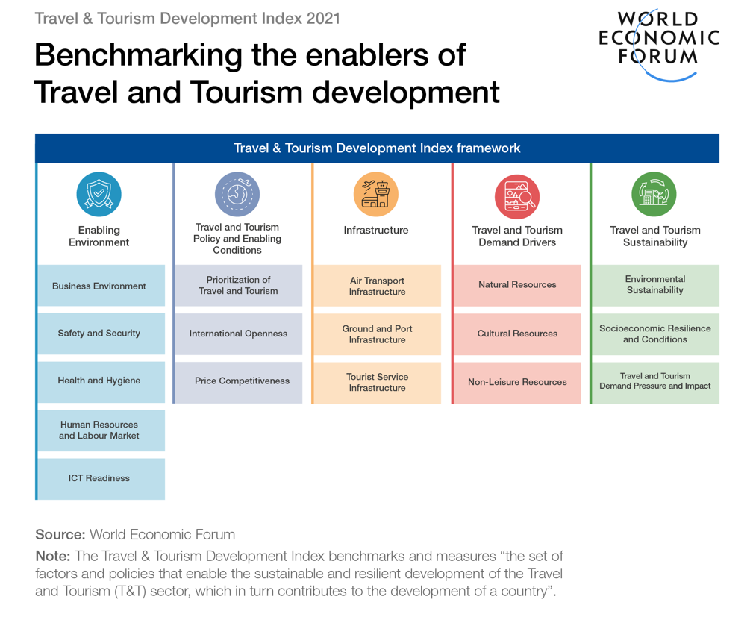

Customers position and profitability towards sustainability practices
In order to satisfy the increasing demand from environmentally concerned customers and ethical reasons, many firms nowadays understand how important it is to implement environmentally sound practises. Customers are looking for goods and services from businesses that show a commitment to sustainability as they grow more conscious of the environment (Mintel,2023).

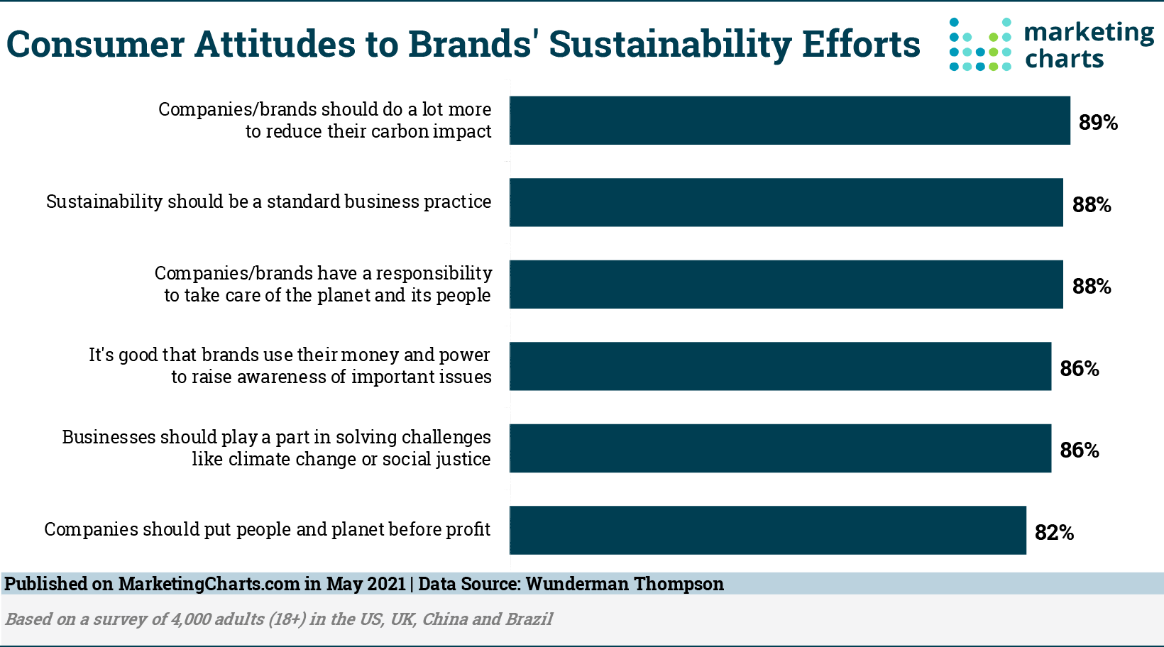

Diagram (Marketing Charts,2021)
Sustainable practises are vital, according to 90% of executives. As just 60% of organisations have sustainability strategy in place, the problem is a lack of execution Businesses may make long-term investments by implementing a sustainability strategy (World Economic Forum,2022).

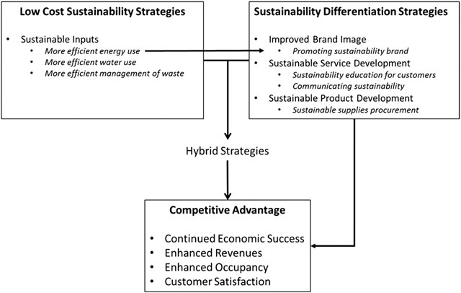

Diagram (Walsh and Dodds,2017)
Businesses may be encouraged by customer demand to implement eco-friendly practises and policies in order to stay competitive in the market.
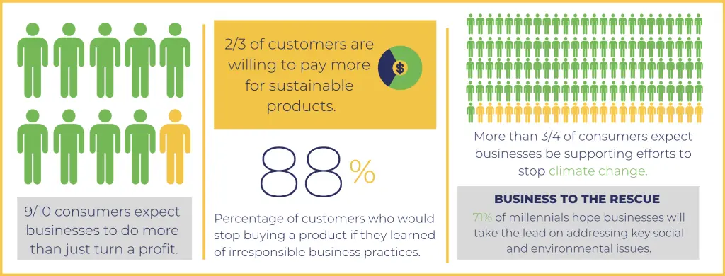

Responsible Tourism
Travel that is considerate of the local environment, people, and customs is known as responsible tourism. Its goal is to mitigate the negative consequences brought about by careless mass travel (Amenitiz,2022).

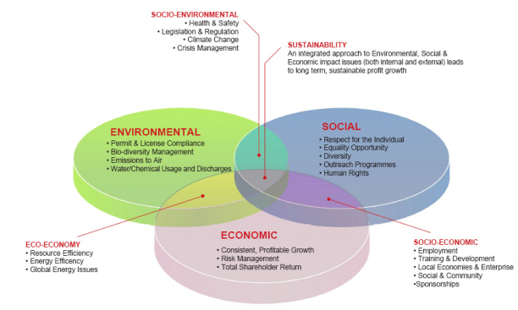

- Positive Tourism destination example
Palau
The Pacific island nation of Palau is dedicated to environmentally friendly travel and preservation of the marine environment. The nation has put policies in place to safeguard its coral reefs, lessen the negative effects of tourism on the ecosystem, and encourage ethical diving (Galloway,2022).
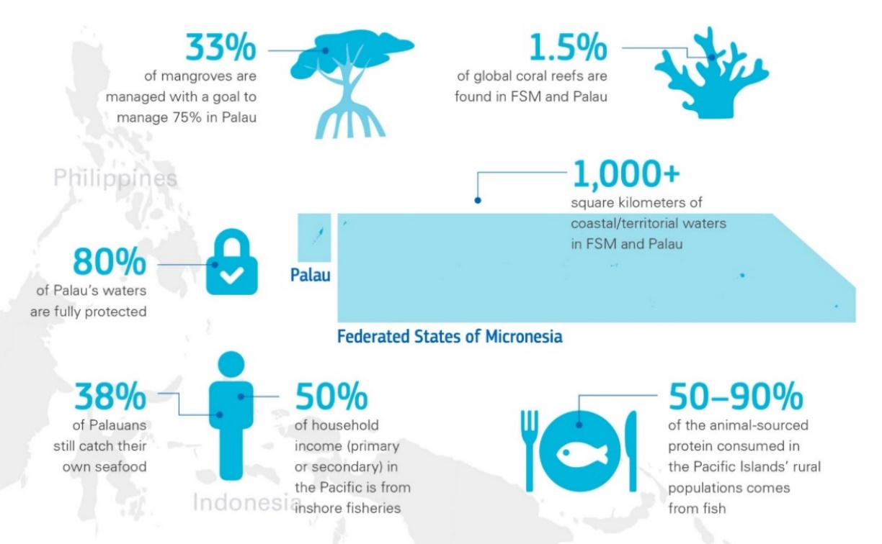

Palau Pledge: The first country on Earth to alter its immigration regulations in favour of environmental preservation is Palau. In order to gain access, guests must sign a passport committing to behave responsibly in both ecological and cultural aspects while on the island, for the benefit of the children and future generations of Palauans (Lin,2017).

- Sustainable hotel example
Soneva Fushi, Maldives
Soneva is a luxury resort in the Maldives that operates with sustainability at its core since it was founded on the idea that a company should exist for a reason greater than merely shareholder returns.
Approximately 5% of Soneva's annual revenue, or $250,000, is allocated to social and environmental programmes via their non-profit organisation, The Soneva Foundation, which was founded in 2010.
Soneva Fushi actively participates with the community, lending support to initiatives related to infrastructure, healthcare, and education. The resort aspires to have a beneficial social and economic influence on the communities that surround it (Soneva,2023).
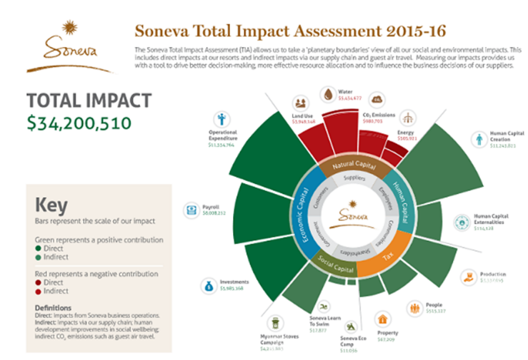

Diagram(Soneva, 2023)
Key sustainable practices
Waste-to-Wealth Program: With an emphasis on recycling and waste reduction, the resort has put in place a "Waste-to-Wealth" programme. Non-organic garbage is recycled, and organic waste is turned into compost. Initiatives for upcycling are also included in the programme at each Soneva resort's Eco Centro Waste-To-Wealth facility.
Carbon-Neutral Operations: Achieving carbon-neutral operations is a priority for Soneva Fushi. To reduce its carbon footprint, the resort makes investments in energy-efficient technologies, renewable energy sources, and carbon offset schemes.
To offset their travel emissions, Soneva introduced a required 2% carbon charge to visitors' bills in 2008. It has funded reforestation projects in Thailand that have prevented the release of around 400,000 tonnes of CO2 into the atmosphere, wind turbines in South India, and low-carbon cooking stoves in Myanmar that have reduced CO2 emissions by 60% and saved firewood and lung disease deaths (Soneva,2023).
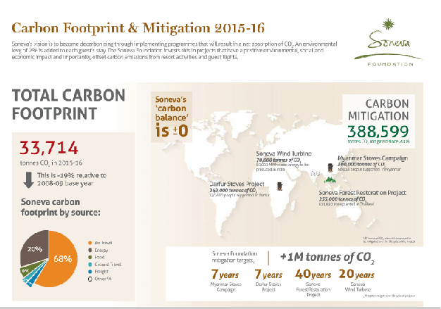

Diagram (Soneva,2023)
Water Stewardship: Soneva Fushi has put in place water-saving techniques, such as water treatment procedures, effective irrigation systems, and rainwater collection. It is recommended of guests to engage in water-saving measures.
Locally Sourced and Organic Food: To help regional farmers and lessen the environmental effect of food transportation, the resort places a high priority on locally sourced and organic food options. They cultivate fresh fruit in their on-site gardens.
Initiatives for Marine Conservation: The resort actively participates in projects aimed at protecting and restoring coral reefs. Their goal is to reduce the negative effects that human activity has on marine environments.
Educational Activities: Soneva Fushi provides its visitors with educational activities, such as sustainability workshops, guided eco-tours, and chances to discover the local way of life and environmental protection initiatives.
Green Building Design: By employing natural ventilation, energy-efficient design, and sustainable materials, the resort embraces green building concepts (Soneva,2023).

Milton Friedman Theory on Corporate Social Responsibility
The 1950 theory claims that maximising revenue and increasing returns to shareholders is a company's primary duty. According to Friedman, a company's social responsibility policies do not need to be approved by its shareholders. Another name for it is shareholder theory.
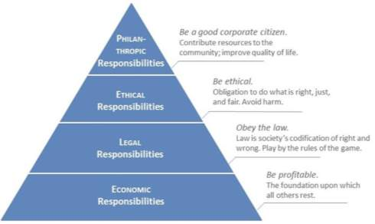

Since it overlooks a company's obligations to its workers, the communities in which it works, and the environment, this philosophy has come under criticism as being out dated (The Beautifull Truth,2017) .
Financial Concerns regarding sustainability
When deciding how a corporation will approach sustainability, finance resilience is frequently a major factor. Although companies are increasingly seeing the long-term advantages of sustainable practises, they frequently have to think about the costs involved in putting such policies in place. Even while cash flow may come first, incorporating sustainability into operations is becoming crucial for long-term performance and adaptability to a shifting environmental and economic context (McKinsey & Co,2022).
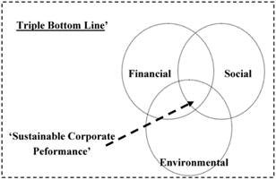

Future recommendations
Although reaching total "greenness" is a difficult and continuous task, the hotel sector can undoubtedly make major progress in being more ecologically sustainable. Diverse operations, including lodging, food services, transportation, and events, are what define the industry. Since a lot of hospitality establishments are adopting environmentally friendly procedures.
Total sustainability necessitates taking care of a number of issues as e:
1.Energy Efficiency : encouraging renewable energy sources and energy-efficient technologies.
2.Waste and Water Reduction : recycling initiatives and water-saving measures should be implemented and promoted .
3.Local Sourcing : embrace local and sustainable sourcing methods for resources, products, and food.
4.Community Engagement: involving in the community in sustainability practices for reciprocal benefit.
5.Reduce Carbon Footprint : minimising guest travel is possible for hospitality firms by promoting sustainable mobility solutions.
6.Education and Awareness : educating guests and staff on sustainable implementations and encouraging engagement.
7. Technology Integration : implementing technology to provide eco-friendly visitor experiences and smart energy.
8.Green Certifications : promoting business commitment to sustainability by highlighting awards and certifications within CSR declaration.

Conclusion
Even if the hotel and tourism sector may have difficulties becoming completely green, ongoing development and a dedication to sustainability can have a significant positive influence. A growing number of companies are making major changes, and the sector as a whole is realising how important sustainability is. Making significant strides towards a greener hotel sector requires embracing innovation, implementing best practises, and aiming for quantifiable, attainable targets.

Reference List

Amenitiz (2022) Importance of responsible and sustainable tourism, Available at : https://amenitiz.com/en/blog/importance-of-responsible-and-sustainable-tourism/ , (Accessed 11/11/2023)
Blair(2018) 8 holiday destinations at risk of being ruined by tourism, Available at : https://www.countryliving.com/uk/wildlife/countryside/g22127274/holiday-destinations-ruined-by-tourism/ (Accessed 11/11/2023)
Ballister (2015) The Unfortunate Progression of Tourism, Pt. II , Butler’s Life Cycle Model linked to Doxey’s Irridex Model Diagram, Available at : https://ethicaltraveler.org/2015/12/tourisms-unfortunate-progression-pt-ii/ (Accessed 11/11/2023)
Cheung and Hin-Li (2019) Understanding visitor–resident relations in overtourism: Developing resilience for sustainable tourism, Journal of Sustainable Tourism, Vol 27, No 8, pg.1197-1216
Chron(2020) Advantages & Disadvantages of Corporations Going Green, Available at : https://smallbusiness.chron.com/advantages-amp-disadvantages-corporations-going-green-39944.html , (Accessed 11/11/2023)
Doerr (2023) 37 Principal Pros & Cons Of Going Green , Available at : https://environmental-conscience.com/going-green-pros-cons/ ,(Accessed 11/11/2023)
EcoBnB (2023) Green Hospitality: Sustainable Practices for Hotels and Resorts , Available at : https://ecobnb.com/blog/2023/05/green-hospitality-sustainable-practices-hotels-resorts/ , (Accessed 11/11/2023)
Galloway (2022) In a world-first initiative, visitors to Palau will be offered exclusive experiences based on how they treat the environment and culture, not by how much they spend , Available at : https://www.bbc.com/travel/article/20220517-palaus-world-first-good-traveller-incentive , (Accessed 11/11/2023)
Kreag (2001) Positive and Negative Impacts of Tourism Development , Available at : https://www.researchgate.net/figure/Positive-and-Negative-Impacts-of-Tourism-Development-Kreag-2001_tbl1_321012857 (Accessed 11/11/2023)
Lin (2017) Palau Becomes First Country to Require 'Eco-Pledge' Upon Arrival ,Available at : https://www.nationalgeographic.com/travel/article/passport-stamp-ecotourism-pledge , (Accessed 11/11/2023)
Mollenkamp (2023) What is Sustainability? How Sustainabilities Work, Benefits, and Example , Available at : https://www.investopedia.com/terms/s/sustainability.asp#:~:text=In%20the%20broadest%20sense%2C%20sustainability,available%20for%20the%20long%20term. (Accessed 10/11/2023)
Mintel (2023) Sustainability & Consumer Behaviours , Available at : https://www.mintel.com/consumer-market-news/consumer-attitudes-towards-sustainability/ , (Accessed 11/11/2023)
Marketing Charts (2021) Consumers Want A Lot from Brands on the Sustainability Front , Available at : https://www.marketingcharts.com/brand-related/csr-117184 , (Accessed 11/11/2023)
McKinsey & Co (2022) Resilience for sustainable, inclusive growth , Available at : https://www.mckinsey.com/capabilities/risk-and-resilience/our-insights/resilience-for-sustainable-inclusive-growth , (Accessed 11/11/2023)
Rahman (2023) Butler’s Tourism Area Life Cycle Model (TALC) , Available at : https://www.howandwhat.net/butler-tourism-area-life-cycle-model-talc/ (Accessed 11/11/2023)
Responsible Tourism(2021) Overtourism in Venice , Available at : https://www.responsibletravel.com/copy/overtourism-in-venice (Accessed 11/11/2023)
Statista (2023) Share of travel and tourism's total contribution to GDP worldwide in 2019 and 2022, with a forecast for 2023 and 2033 , Available at : https://www.statista.com/statistics/1099933/travel-and-tourism-share-of-gdp/#:~:text=Overall%2C%20these%20industries%20represented%207.6,to%207.7%20trillion%20U.S.%20dollars. (Accessed 10/11/2023)
SusieHeng (2021) Positive / Negative Impacts of Venice Tourism , Available at : https://susieheng.trubox.ca/positive-negative-impacts-of-tourism/ (Accessed 11/11/2023)
SlidePlayer (2019) Intro in the Tourism Area Life Cycle Model /Diagram , Available at : https://slideplayer.com/slide/13677361/ , (Accessed 11/11/2023)
Soneva (2023) Soneva Sustainability Report 2013-2014, Available at : https://soneva.com/wp-content/uploads/2021/04/Soneva-Sustainability-Report-2013-14.pdf , (Accessed 11/11/2023)
Soneva (2023) Soneva Sustainability Report 2015-2016) , Available at : https://soneva.com/wp-content/uploads/2021/04/Soneva-Sustainability-Report-2015-16_compressed.pdf , (Accessed 11/11/2023)
TWI (2018) What is Sustainability and Why is it so Important? , Available at : https://www.twi-global.com/technical-knowledge/faqs/faq-what-is-sustainability (Accessed 10/11/2023)
Taiminen (2018) The negative impacts of overtourism on tourism destination from environmental and socio-cultural perspectives /Doxey’s Irridex Diagrams , Available at : https://www.semanticscholar.org/paper/The-negative-impacts-of-overtourism-on-tourism-from-Taiminen/ea1479c4a54346787876b7043792e7b50be88310 (Accessed 11/11/2023)
The Beautifull Truth (2017) What is the Friedman Doctrine? , Available at : https://thebeautifultruth.org/the-basics/what-is-the-friedman-doctrine/ , (Accessed 11/11/2023)
Utheim(2020) What is the definition of sustainable tourism. What impact do we have? , Available at : https://travelopment.com/what-is-the-definition-of-sustainable-tourism-what-impact-do-we-have/ (Accessed 11/11/2023)
Walsh and Dodds (2017) Sustainability strategies that contribute to competitive advantage , Available at : https://www.researchgate.net/figure/Sustainability-strategies-that-contribute-to-competitive-advantage-in-the-North-American_fig3_316176162 , (Accessed 11/11/2023)
World Economic Forum (2022) Why sustainability is crucial for corporate strategy ?, Available at : https://www.weforum.org/agenda/2022/06/why-sustainability-is-crucial-for-corporate-strategy/ , (Accessed 11/11/2023)

