
Programme: MSc Public Health and Social Care in Practice
Module: Public Health and Social Care Dissertation
Module code: LCHS7004

A Systematic Review of Organisational and Technical Barriers Preventing Digital Health Innovations from Achieving Long-Term Sustainability and Integration Beyond Pilot Phases in the Indian Healthcare System.

Student Name: Pogula Bharath
Student ID: 2512745

Declaration
I declare that this dissertation has been composed by myself, that the work contained herein is entirely my own, expect where explicitly stated otherwise in the text, and that this work has not been submitted for any other degree or qualification, in whole or in part, expect as specified.

Signature: Bharath Pogula…………
Student ID: 2512745…………..
Date: 27/08/2026

Acknowledgements
I wish to extend my sincerest appreciation to everyone, who has contributed to the successful completion of this master’s dissertation.
Primarily, I owe an immense debt of gratitude to my academic supervisor, Dr. Fahad Khan. His expressional mentorship, constructive criticism, and continuous motivation where vital in guiding the trajectory of this research. The opportunity to benefit from his extensive knowledge has been a profound privilege, and this project would simply not exist without his dedicated supervision and time.
I also want to convey my deepest, thanks to my family. To my parents, you are unwavering belief in my abilities and your endless emotional support have been my foundation throughout this academic endeavour. Your patience has been a constant source of strength.
Lastly, I am highly appreciative of my peers and colleagues. The collaborate you environment, shared insights, and mutual encouragement. We experienced together made a rigorous demands of this research journey for more manageable and deeply rewarding.

Abstract
Background: The deployment of digital health technologies holds immense promise for modernising medical care across India. Nevertheless, despite substantial financial backing and the rollout of major government policies like the Ayushmann Bharat Digital Mission (ABDM), vast major majority of e-health projects stall during their initial testing phases. This recurring failure to expand beyond experimental boundaries is commonly termed “pilotitis.” consequently, this research aims to systematically investigate and consolidate evidence regarding the structural, technological, and social obstacles that inhibit the widespread adoption of digital health tools in Indian context.
Methods: The study utilised a qualitative systematic literature review design. A rigorous search protocol was executed across multiple academic databases, including PubMed, Scopus, CINAHL, and Google Scholar, targeting literature published over the past five years. Following the application of the PRISMA screening framework and a methodological quality assessment utilising the CASP checklist for qualitative studies, seven highly relevant articles were ultimately selected for inclusion and thematic synthesis.
Results: The analysis of the selected literature uncovered four primary obstacles to successful scaling. Structurally, the reliance on short-term grant funding and the severe disjointedness between public health, governance and private sector developers, prevent unified expansion. Technologically, progress is heavily impeded by proprietary software that lacks interoperability, alongside a severe deficit in basic rural infrastructure. On a demographic level, profound disparities in digital literacy, worsened by a stark urban-rural and gender-based digital divide, exclude vulnerable populations. Lastly, widespread hesitancy regarding algorithmic liability among clinicians, combined with cultural reliance on physical medical consultations among patients, drastically, lowers the acceptability of this innovations.
Conclusion: evidence clearly indicates that the phenomenon of “pilotitis” stems from systemic environmental deficiencies, rather than inherent flaws in the technology itself. To foster long-term digital health integration in India, policy makers must transition toward sustainable, pooled financial models, enforce strict software, interoperability requirements prior to pilot approval, and heavily involve community-based health workers (ASHAs) to bridge existing gaps in digital literacy and cultural trust.

Table of Contents
Declaration 2
Acknowledgements 3
Abstract 4
Chapter 1: Introduction and Background 8
1.1 Introduction 8
1.2 Background and Current Context 8
1.2.1 Digital Health Innovations 8
1.2.2 The Phenomenon of Pilotitis 8
1.2.3 Barriers to Scaling Digital Health 9
1.3 The Current Context of Digital Health in India 9
1.4 Rationale or Problem Statement 10
1.5 Research Question 10
1.6 Research Aim 10
1.7 Research Objectives 10
1.8 Summary 11
Chapter 2: Literature Review 11
2.1 Introduction 11
2.2 The Digital Health and Policy Landscape in India 11
2.3 Challenges Limiting Digital Health Scale-Up 12
2.3.1 Organisational and Financial Constraints 12
2.3.2 Technical and Infrastructural Limitations 12
2.3.3 Trust, Acceptability, and Human Factors 13
Summary 13
Chapter 3: Methodology 14
3.1 Introduction 14
3.2 Research Design and Rationale and methodological critique 14
3.3 Search Strategy 16
3.4 Inclusion and Exclusion Criteria 16
3.5 Study Selection and PRISMA FLOW Diagram 18
3.6 Data Extraction and Quality Appraisal 19
3.7 Data Synthesis 20
3.8 Ethical Considerations 20
Chapter 4: Data Extraction and Critical Appraisal 21
4.1 Introduction 21
4.2 Data extraction 21
4.3 Critical appraisal tool 22
4.4 Evaluation of the studies using CASP tool 24
4.4.1 Gopalakrishnan et al. (2020) 24
4.4.2 Kumar et al. (2025) 25
4.4.3 D’Souza et al. (2024) 25
4.4.4 Singh et al. (2023) 26
4.4.5 Anjana et al. (2026) 27
4.4.6 Huda et al. (2025) 27
4.4.7 Malik et al. (2025) 28
4.5 Chapter summary 28
Chapter 5: Findings and Thematic Analysis 29
5.1 Introduction 29
5.2 Overview of themes 29
5.3 Organisational and service-level constraints that limit sustained integration of digital health tools 30
5.3.1 Insufficient training and ongoing support 30
5.3.2 Increase workload and workflow disruption 31
5.3.3 Weak governance, leadership and role clarity 31
5.4 Technical and infrastructural limitations that undermine the reliability of digital health services 32
5.4.1 Unreliable connectivity and power supply 32
5.4.2 Limited access to appropriate devices and hardware 32
5.4.3 Usability issues and system design limitations 33
5.5 Digital divide and literacy related inequities in access to digital health interventions 33
5.5.1 Low digital health literacy among patients and communities 33
5.5.3 Language, culture and accessibility 35
5.6 Trust, acceptability and human factors shaping engagement with digital health technologies 35
5.6.1 Perceptions of quality and safety 35
5.6.2 Fear of replacement and impact on professional identity 36
5.6.3 Factors that support trust and acceptance 36
5.7 Chapter summary 37
Chapter 6: Discussion 38
6.1 Introduction 38
6.2 Summary of Key Findings 38
6.3 Organisational and service level constraints that limit sustained integration of digital health tools 38
6.4 Technical and infrastructural limitations that undermine the reliability of digital health services 40
6.5 Digital divide and literacy-related inequities in access to digital health interventions 41
6.6 Trust, acceptability and human factors shaping engagement with digital health technologies 43
6.7 Strengths and Limitations of the review 44
6.8 Implications for Practice and Future Research 44
6.9 Chapter Summery 45
Chapter 7: Conclusion and Recommendations 45
7.1 Introduction 45
7.2 Review of Aims and Objectives 46
7.3 Key Conclusions 47
7.4 Recommendations for Practice and Policy 48
7.5 Recommendations for Further Research 49
7.6 Final Concluding Remarks 49
References 51

List of Abbreviations
ABDM | Ayushmann Bharat Digital Mission
ABHA | Ayushmann Bharat Health Account
AI | Artificial intelligence
ASHA | Accredited Social Health Activist
CASP | Critical Appraisal Skills Programme
CHW | Community Health Worker
CINAHL | Cumulative Index to Nursing and Allied Health Literature
eHealth | Electronic Health
EMR | Electronic Medical Record
FGD | Focus Group Discussion
HCP | Healthcare Professional
ICT | Information and Communication Technology
IAMAI | Internet and Mobile Association of India
JBI | Joanna Briggs Institute
mHealth | Mobile Health
WHO | World Health Organisation
NGO | Non-Governmental Organisation
NITI Aayog | National Institution For Transforming India
PHC | Primary Health Centre
PRISMA | Preferred Reporting Items for Systematic Reviews and Meta Analysis
SLR | Systematic Literature Review
UHI | Unified Health Interface

Chapter 1: Introduction and Background

1.1 Introduction
Digital health technologies, encompassing telemedicine, artificial intelligence (AI), mobile health (mHealth) applications, and electronic medical records (EMR), have the potential to revolutionise global healthcare delivery. These innovations promise to alleviate workforce shortages, reduce care backlogs, support chronic disease management, and improve patient experiences through more accessible care. However, despite substantial financial investments and policy ambitions globally, healthcare systems consistently, struggle to transition these technologies from isolated experimental phases into routine, system-wide clinical practice. The systemic failure to scale digital innovations is frequently referred to as “pilotitis”, a phenomenon where projects remain stuck in the pilot phase and ultimately face abandonment, when initial funding or enthusiasm dissipates. This dissertation systematically reduces the organisational, technical, and sociocultural barriers that perpetuate pilotitis, focusing specifically on the Indian healthcare system.

1.2 Background and Current Context

Digital Health Innovations
Digital health represents a fundamental shift in how healthcare is delivered, moving away from traditional, facility centric models to distributed, data-driven approaches. In developing healthcare systems, digital innovations are heavily relied upon to bridge the gap between urban specialist centres and rural primary care. Technologies such as AI, diagnostic aids and tele consultation platforms are designed to empower frontline workers and extend the reach of healthcare to unserved populations.

1.2.2 The Phenomenon of Pilotitis
Pilotitis describes the cycle of repeated, small-scale digital health pilots that fail to achieve long-term sustainability or integration. Industry estimates suggest that an alarming 70% to 80% of digital healthcare innovations projects never move beyond this initial proof-of-concept phase (Future Care Capital, 2025). While pilot studies are crucial for testing clinical efficacy and safety in controlled environments, they often occur in artificial conditions supported by temporary grants, international NGOs, or private tech Incubators. Once this incubation period ends, the innovation is exposed to the harsh realities of complex healthcare bureaucracies, unintegrated IT systems, and resource constraints, leading to a high rate of project mortality.

1.2.3 Barriers to Scaling Digital Health
The barriers preventing scale up of digital health tools are multifaceted. The literature broadly categorises these into organisational barriers (such as short-term funding and disjointed governance), technical barriers (such as poor software interoperability and lack of broadband infrastructure), and human factors (such as digital illiteracy, resistance to workflow changes, and lack of professional trust). Overcoming these barriers requires systemic transformation rather than simply introducing more advanced technology.

The Current Context of Digital Health in India

The Indian healthcare system is currently undergoing a massive digital transformation, highlighted by the Government of India’s Ayushman Bharat Digital Mission (ABDM), which aims to create a seamless online platform for healthcare data exchange. However, India presents a uniquely challenging context for healthcare data exchange. However, India presents a uniquely challenging context for scaling digital health. The system is deeply bifurcated. The public sectors remains chronically underfunding, with government health expenditure hovering at just 1.9% of the national GDP in 2023-2024, far below the recommended global average (Ministry of Finance, 2024). Consequently, there is a massive reliance on the unregulated private sector, which drives out-of-pocket health expenditures to roughly 40% of all healthcare spending in India, placing immense financial burdens on patients (National Health Systems Resource Centre, 2024). Furthermore, India faces a stark urban-rural digital divide. While urban tertiary hospitals possess advanced IT infrastructure, rural Primary Health Centres (PHCs) frequently lack reliable electricity and broadband. Consequently, digital health pilots often succeed in urban incubators but fail drastically when rolled out to rural areas lacking infrastructural and digital literacy prerequisites.
Although Internet use has expanded rapidly in India, access remains unequal between rural and urban areas. Figure 1.1 shows that, in 2024, India had 954.40 million active internet users, of whom 398.35 million lived in rural areas and 556.05 million lived in urban areas (Department of Telecommunications, 2025).
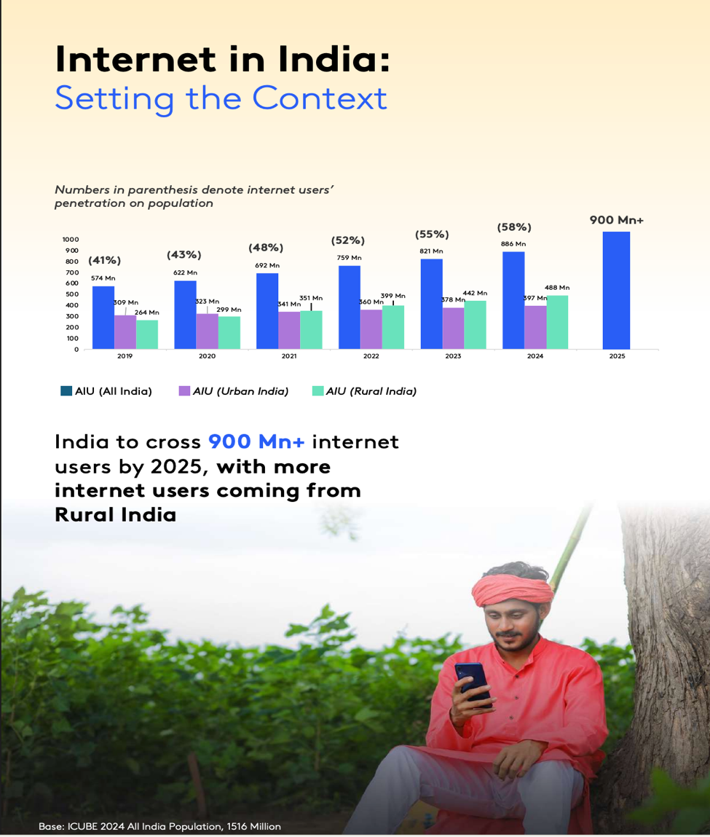
Figure 1.1: growth in active internet users in urban and rural India,2019-2024.
Source: Author’s visualisation based on Department of Telecommunications (2025).
Despite overall growth in internet, use access also remains uneven across states. Figure 1.2 shows that internet penetration range from 72% in Kerala to 43% in Bihar in 2024, demonstrating geographical inequalities that may affect the reach of telemedicine and other digital-health services (Business Standard, 2025).
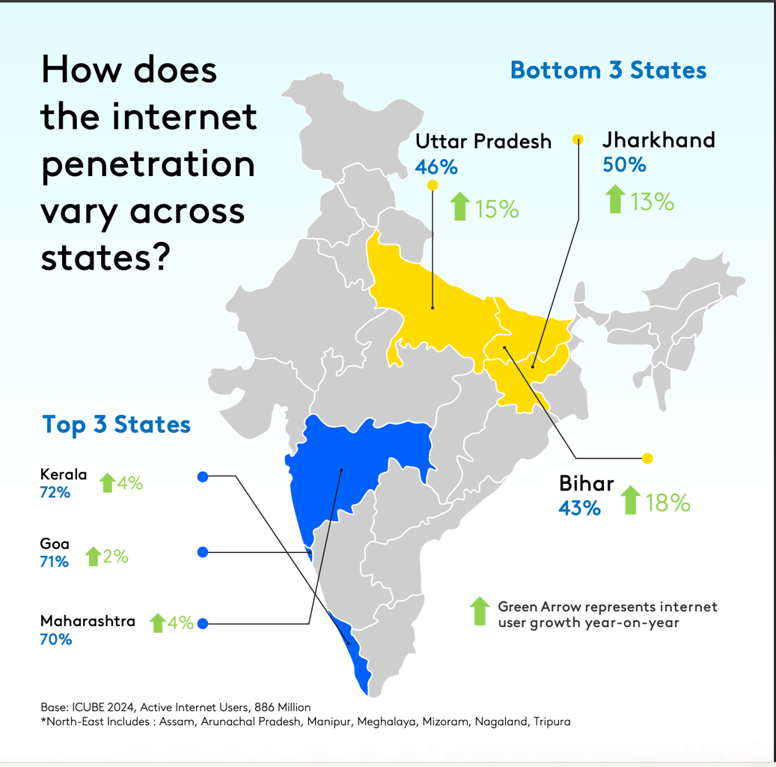
Figure 1.2: Internet penetration across selected Indian states, 2024.
Source: Author’s visualisation based on) IIPS and ICF (2021); (Business Standard, 2025).

1.4 Rationale or Problem Statement
Despite the proliferation of digital health tools in India and significant government initiatives like the ABDM, the literature indicates that the majority of projects fail to scale. While extensive quantitative research exists measuring the clinical accuracy of these tools, there is a critical gap in qualitative syntheses exploring why they fail structurally and socially in the Indian context. A systematic review of qualitative literature is necessary to capture the nuanced, human-centric, and infrastructural realities, that prevent digital tools from transitioning into sustained practice. Understanding these barriers is essential for policymakers and healthcare administrators to design sustainable implementation strategies.

1.5 Research Question
What are the organisational, technical, and socio-cultural barriers perpetuating the failure of digital health innovations beyond the pilot phase in India, and how can health systems structurally overcome these challenges to achieve sustainable integration?

1.6 Research Aim
To systematically review and synthesise qualitative evidence regarding the organisational, technical, and sociocultural barriers, preventing the sustainable integration of digital health innovations beyond the pilot phase in the Indian healthcare system.

1.7 Research Objectives
- To identify the organisational and service level constraints, including funding models, and fragmented governance, that limit the scaling of digital health tools in India.
- To evaluate the technical and infrastructural limitations, such as interoperability and rural broadband access, that under digital health reliability.
- To explore patient and provider-level barriers, specifically the digital divide, digital health literacy, and issues of cultural trust.
- To critically apprise the selected quality to studies and synthesise evidence based recommendations for policy makers to overcome “pilotitis”.

1.8 Summary
This chapter introduced the background and context of digital health implementation, highlighting the pervasive issue of “pilotitis”. It outlined the specific challenges inherent to the Indian healthcare landscape, establishing the rationale for conducting a qualitative systematic review. The research aim and objectives were clearly defined to guide the subsequent methodology and analysis. The following chapter will provide a comprehensive review of the existing literatures surrounding these barriers.

Chapter 2: Literature Review

2.1 Introduction
This chapter reviews literature on the implementation and sustainable scale-up of digital health technologies in India. It first considers the national digital health policy context, including the Ayushmann Bharath Mission (ABDM), which was launched in September 2021 to establish an integrated, inclusive and interoperable national digital health ecosystem (Ministry of Health and Family Welfare, 2021; Nair et al., 2023). It then examines evidence on organisational, technical, infrastructural, and sociocultural barriers that can hinder the implementation and long-term integration of digital health interventions.
Digital health technologies may improve access to health services, support, continuity of care and strengthen health information systems. However, successful implementation depends on more than the technical functionality of an application or platform the Non-adoption, abandonment, scale-up, spread and sustainability (NASSS) framework identify interacting influences relating to the condition, technology, value proposition, adapter system, organisation, wider context, and adaptation overtime (Greenhalgh et al., 2017). This perspective is relevant to India because digital health interventions must operate across diverse health system settings, including rural primary care facilities with unequal digital infrastructure, workforce, capacity, and levels of patient, digital literacy.
This chapter is organised around four areas that are Central to this dissertation: organisational and service level constraints; technical and infrastructural limitations; digital divide and health literacy inequities; and trust acceptability and human factors. Existing research on India identifies barriers relating to limited technological and medical infrastructure, privacy, and data security concerns, and the limitations of remote care when physical examination is required (Garg et al., 2024). Examining these issues together is important because sustainable scale-up depends not only on technical performances, but also on whether healthcare organisations, professionals, and patients have the resources, skills, confidence, and support required to integrate digital technologies into routine practice.
The final part of the chapter identifies the gaps in the literature and justifies the present qualitative systematic review. Although there is growing research on digital health adoption and individual interventions, evidence remains fragmented across telemedicine, mobile health, artificial intelligence, and electronic health record systems. A focused synthesis is therefore needed to examine how organisational technical and sociocultural barriers interact to prevent digital health innovations from progressing beyond short term of pilots into sustainable routine care in India.

2.2 The Digital Health and Policy Landscape in India
India national Digital health strategy is centred on the Ayushmann Bharat Digital Mission (ABDM), which was launched in September 2021 to develop an integrated, citizen centred, and interoperable digital health ecosystem (Ministry of Health and Family Welfare, 2021). It cover components include the Ayushmann Bharath Health Account (ABHA), a 14 digit health identifier; the health facility registry; the healthcare professionals registry; personal health records; and the Unified Health Interface (UHI). This components aim to support consent based health record sharing, enable the registration of the health facilities and professionals, and improve access to services such as appointment booking and teleconsultation (National Health Authority, 2026). The ABDM therefore provides an important national framework for improving continuity of care and extending digital health services across India.
The scale of digital expansion is sustainable. By March 2024, more than 568 million ABHA accounts had been created, over three 50 million health records had been integrated, and more than 2,30,000 health facilities and 2,85,000 professionals had registered within the ABDM ecosystem (Nair et al., 2024). In parallel, internet access has expanded considerably: India had 886 million active internet users in 2024, including 488 million people living in rural areas (Internet and Mobile Association of India and Kantar, 2025). This growth creates significant opportunities for mobile health, telemedicine, and digital record systems. However, rural internet use should not be interpreted as evidence of equal digital health access because people may still face unreliable connectivity, shared devices, limited digital literacy, and language barriers.
Critically national policy and high registration numbers do not guarantee sustainable implementation. India’s healthcare system include public hospitals, primary care facilities, private hospitals, independent clinics, laboratories, pharmacies, and technology providers, many of which operate separate digital systems. This fragment tension can limit the interoperability required for effective exchange of patient information and can increase clinicians’ workload when they must use multiple unconnected systems (Garg et al., 2024). DABDM addresses this challenge by promoting standards based data exchange, but the successful scale-up of digital health will depend on local infrastructure, staff training, technical support, interoperability, and accessible service design. This policy-to-practice gap justifies examining why digital health innovations often remain confined to pilot projects rather than becoming embedded into routine care.

2.3 Challenges Limiting Digital Health Scale-Up

2.3.1 Organisational and Financial Constraints

The literature identifies organisational capacity as central to whether digital health interventions become embedded in routine care. Although pilot projects may initially receive external funding devices and technical assistance, sustainability becomes difficult when responsibility transfers to already resources-constrained health facilities. The costs of implementation include hardware, software, staff training, workflow adaptation, data management, and privacy arrangements, rather than only the initial purchase of a digital tool (Saeed et al., 2024). Evidence on telehealth use by healthcare professionals in India, also identifies in adequate training, workforce shortages, additional workload, lack of technical support, limited integration with government systems and data security concerns as recurring barriers (Bhatia et al., 2024). These findings suggest that digital health implementation is not simply a technology procurement exercise; it requires long-term financing, clear leadership, defined responsibilities, and ongoing support for frontline staff.

2.3.2 Technical and Infrastructural Limitations
Technical barriers are particularly important in rural and remote settings, where reliable power, connectivity, appropriate devices, and compatible digital systems cannot be assumed. India’s digital health ecosystem has expanded rapidly, but the quality and reliability of rural internet connectivity may inadequate for data intensive services such as video consultations, cloud-based records and real time decision-support tools (Nair et al., 2024). For network connectivity and software malfunction are among the most frequently reported barriers to telehealth use by healthcare workers in India, alongside Limited device is availability and weak interoperability between systems (Bhatia et al., 2024). When digital platforms do not integrate with existing records or referral pathways, staff may need to duplicate data entry across paper and electronic systems, in increasing workload and reducing the likelihood of continued use. Therefore, sustainable scale of requires technologies that are interoperable, low-bandwidth, reliable, and suitable for the infrastructure available outside, well resorted urban pilot sites.

2.3.3 Trust, Acceptability, and Human Factors
The digital divide effects who can access the benefit from digital health services. Studies in India identify digital literacy, limited smartphone access, unreliable connectivity, language, barriers, and preferences for face-to-face care as important obstacles, particularly for older adults and people living in rural areas (Bhatia et al., 2024). Healthcare professionals may also question the quality and safety of the remote care, particularly when physical examination is limited or when they are uncertain about privacy, clinical accountability, and data protection. Conversely, prior training, interactive applications, adequate technical support, and access to suitable devices can improve engagement with telehealth and mobile health interventions (Bhatia et al., 2024). These findings indicate that technology loan cannot address unequal hair access: service must be designed around local languages, digital confidence, and affordability, community, trust, and practical needs of both patients and health workers.

2.4 Research Gap and Justification
Existing literature confirms that digital health implementation in India is influenced by interconnected human resources, application related, technical, and wider system factors. A recent systematically review of telehealth use by healthcare practitioners in India classified barriers into four broad categories: huma- resource factors, application-related factors, technical factors, and other contextual factors (Bhatia et al., 2024). Other evidence, similarly, identifies digital literacy, access to devices, confidence, workflow description, data, privacy and trust as important barriers to patients’ and healthcare professionals’ use of digital technologies (Nascimento et al., 2023). However, much of the available research focuses on initial adoption, a specific technology or a single clinical setting. It does not always explain why digital health intervention that appears successful during a funded pilot failed to become integrated into routine healthcare practice.
This gap is important because moving from pilot, testing to rotate service delivery requires more than evidence that a technology can work. The NASSS framework campus sizes that long-term scale and sustainability depend on the interaction between the technology, intended users, healthcare organisations, wider policy, context, and adaptation overtime (Greenhalgh et al., 2017). In the Indian context, there remains limited qualitative synthesis examining how organisational, technical and sociocultural barriers combine to prevent digital health innovations from progressing beyond pilot projects. Therefore, this study undertake is a qualitative systematic literature review to synthesise evidence from patients, community health workers, clinicians, and other stakeholders. The review aims to identify the barriers to sustainable integration and develop practical recommendations for policy makers, healthcare organisations, and digital health developers.

2.5 Summary
This chapter reviewed the digital health policy landscape in India and examined the barriers that can limit the sustainable scale of digital health interventions. The Ayushmann Bharat Digital Mission provides a national framework for integrated and interoperable digital health infrastructure; however, policy, ambition and increase digital registration, do not automatically ensure equitable access or sustained use in routine care (Ministry of Health and Family Welfare, 2021). The literature identified or organisational constraints, limited workforce capacity, inadequate training, unreliable connectivity, poor interoperability, unequal access to devices, low digital literacy, language barriers, and concerns about trust, privacy and professional responsibility as interconnected implementation challenges.
The review review also identified a gap in the existing evidence. Many studies focus on initial adoption, individual technologies, or short-term outcomes, rather than explaining how organisational, technical and sociocultural factors interact after a pilot has been introduced. Guided by the NASS framework, this dissertation, therefore, undertakes a qualitative systematic literature review to examine why digital health innovations in India may fail to progress beyond pilot projects into sustainable routine care (Greenhalgh et al., 2017). Chapter 3 outlines the methodology used to identify, select, critically apprise and synthesised the relevant quality to studies.

Chapter 3: Methodology

3.1 Introduction
This chapter outlines the methodology employed to investigate the organisational and technical barriers to scaling digital health and artificial intelligence (AI) innovations. To answer the research question, this study utilises a qualitative Systematic Literature Review (SLR). Systematic review was selected because it provides a rigorous, transparent, and reproducible method for identifying, evaluating, and synthesising existing literature (Snyder, 2019). The methodology has been structured in accordance with the preferred reporting items for Systematic Reviews and Meta-Analyses (PRISMA) guidelines to ensure clarity and methodological rigour throughout the search and selection process (Page et al., 2021).

3.2 Research Design and Rationale and methodological critique
Conducting primary empirical research within the timeframe of this dissertation was deemed unfeasible due to the extensive ethical approval process and the limited four-week execution window. Therefore, a secondary research design via and SLR was adopted.
In selecting the appropriate secondary methodology, a critical comparison was made between a traditional narrative review and a systematic literature review (SLR). A narrative review provides a broad, thematic overview of a topic, but it lacks a predefined search protocol, making it highly susceptible to author selection bias (Grant and Booth, 2009). In narrative reviews, authors may consciously or unconsciously “cherry-pick” articles that supports their pre-existing hypothesis, while ignoring dissenting evidence. Consequently, narrative reviews are often not reproducible and or considered lower on the hierarchy of evidence for informing policy and practice (Ferrari, 2015).
Conversely, an SLR was chosen for this dissertation, because it employs a rigorous, transparent, and reproducible methodology. By utilising strict inclusion and exclusion criteria and predefined search strings, an SLR minimises subject subjective bias and ensures a comprehensive, objective synthesis of the available evidence (Gopalakrishnan and Ganeshkumar, 2013). While an SLR is more rigid and time-consuming then a narrative review, it is necessary for this topic to ensure that the identified barriers to digital health implementation represent genuine, systemic issues across healthcare settings, rather than isolated anomalies.
However, this systematic review methodology is not without limitations. A primary critique of SLRs is publication bias, where in studies reporting successful digital health pilots are more likely to be published than those detailing failed implementations (Snyder, 2019). Furthermore, by strictly applying predefined research terms, there is a risk of omitting relevant grey literature or studies that use different terminology. To mitigate these limitations, this study relies on multiple electronic databases and employs broad Boolean operators to capture varied terminology surrounding “pilotitis” and implementation barriers”.
Crucially, this review strictly focuses on qualitative research designs. Quantitative studies, while useful for measuring the clinical or economic efficacy of digital health tools, often fail to capture the nuanced, human-centric, and contextual challenges associated with pilotitis (Greenhalgh et al., 2017). Qualitative studies such as those utilising interviews, focus groups, and ethnographic observations provide the necessary depth to understand the cultural resistance, workflow disruptions, and organisational complexities, that prevent digital tools from transitioning from pilot phases to practice (Cresswell and Poth, 2018).
In addition, choice of qualitative systematic literature review was particularly appropriate because implementation outcomes are shaped by context, relationships, and perceptions that cannot be understood only through numerical indicators. A quantitative evaluation may established whether telemedicine service reduced travel time, increased the number of consultations or improved a clinical outcome. However, it may not explain why staff continued using the service in one facility but abandoned it in another , or why patients with access to the same technology, experienced very different levels of confidence and trust. Qualitative research is valuable because it enables researchers to explore the mechanisms behind adoption and resistance, including staff workload, organisational culture, local leadership, patient performances and technology related anxiety (Creswell and Poth, 2018; Greenhalgh et al., 2017).
Nevertheless, qualitative synthesis requires careful interpretation because the included studies were undertake in different Indian states, involved different participant groups, and examined a variety of interventions, including mHealth applications, telemedicine services and digital tools used in clinical settings. It would therefore be inappropriate to treat every finding has universally applicable to all healthcare facilities in India. Instead, thematic synthesis was used to identify recurring patterns while preserving awareness of contextual differences, consistent with the approach described by Thomas and Harden (2008). For example, unreliable connectivity may have different consequences for a community health worker conducting home visits in a rural district then for a doctor using telemedicine in a government medical college. Similarly, digital literacy barriers maybe more acute among older adults and economically disadvantaged groups then among younger, urban smart phone users (Kumar et al., 2025; Huda et al., 2025; Anjana et al., 2026).
This methodological approach also acknowledges that the researcher place an active role in interpreting evidence. In thematic synthesis, quotes and themes do not merge automatically from the articles; they are developed through systematic engagement with study findings and comparison across the evidence base (Thomas and Harden, 2008). To reduce the risk of selective interpretation, this review used predefined inclusion criteria, structured data extraction, and the CASP Qualitative Research Checklist. The PRISMA flow diagram was also used to make the search and selection process transparent (CASP, 2018; Page et al., 2021). Together, these measures strengthen the auditability of the review and ensured that the final teams were grounded in the included studies rather than based on isolated assumptions.
Geographically, the primary focus of this review is on healthcare settings in India. However, because digital health implementation in India is still rapidly evolving, the search strategy includes a contingency to draw upon qualitative evidence from established western systems, such as the UK National Health Service (NHS). If an insufficient number of boost qualitative studies from India are identified, the review will analyse UK based literature to formulate comparative lessons and recommendations applicable to the Indian healthcare context.

3.3 Search Strategy
To ensure a comprehensive Capture of relevant qualitative literature, multiple electronic databases were systematically searched, including PubMed, Scopus, CINAHL, and Google Scholar. The research strategy relies on a combination of targeted keywords, truncation, and Boolean operators (AND / OR) to retrieve highly specific results (Bramer et al., 2018).
The primary search string developed for this review is:
(“digital health” OR “artificial intelligence” OR “telemedicine” OR “eHealth”) AND (“barriers” OR “challenges” OR “pilotitis” OR “implementation”) AND (“qualitative” OR “interviews” OR “focus groups”) AND (“India”).
To ensure the literature reflects the most Current technological landscape, particularly given the rapid recent advancements in AI and digital health, the search was initially strictly filtered to include only publications from the last five years (2021-2026). If this initially parameter yields an insufficient volume of relevant studies, the timeframe were expanded incrementally to the last 10 years (2016-2026), in line with the supervisor guidance.

3.4 Inclusion and Exclusion Criteria
To refine the search results and ensure only the most relevant and high-quality articles are selected for synthesis, strict inclusion, and exclusion criteria have been established. These criteria guarantee that the final literature set alligns with the study’s aim of understanding qualitative, real-world barriers.
Criterion | Inclusion Criteria | Exclusion Criteria
Study Type | Primary research studies | Secondary research (e.g., literature reviews), Opinion pieces, editorials, and commentaries
Methodology | Strictly Qualitative methodologies (e.g., Thematic analysis, rounded theory, qualitative interviews | Quantitative studies, statistical analysis, or mixed-methods studies where the qualitative component cannot be isolated
Timeframe | Published within the last five years (2021-2026) | Studies published prior to 2021
Language | Published in the English language | Articles published in languages other than English
Availability | Article is available as free, full text publications to ensure accessibility | Paid or paywalled articles
Context | Study exploring organisational, technical or cultural barriers to digital health implementation, focusing on India | Studies focusing exclusively on the clinical or diagnostic accuracy of a digital tool rather than its organisational implementation and scaling.

By applying these strict criteria outlined in the Table 3.1 the search strategy effectively filtered out irrelevant literature, ensuring that the final selection of studies provided robust, high-quality qualitative evidence to address the research objectives.

3.5 Study Selection and PRISMA FLOW Diagram
The selection of studies followed the four-stage PRISMA process: identification, screening, eligibility, and included (Page et al., 2021).
Initially, all articles identified through database searches were exported to a reference management tool, and exact duplicates were removed. During the screening phase, the titles and abstracts of the remaining articles were reviewed against the inclusion and exclusion criteria. Articles that clearly did not meet the criteria (e.g., quantitative trials) were discarded. Following this, the full texts of the shortlisted articles were thoroughly assessed for final eligibility.
The final number of included studies was determined by the search results and the application of the predefined inclusion and exclusion criteria. After completing the full screening process, 7 qualitative studies met all criteria and were included in the review.
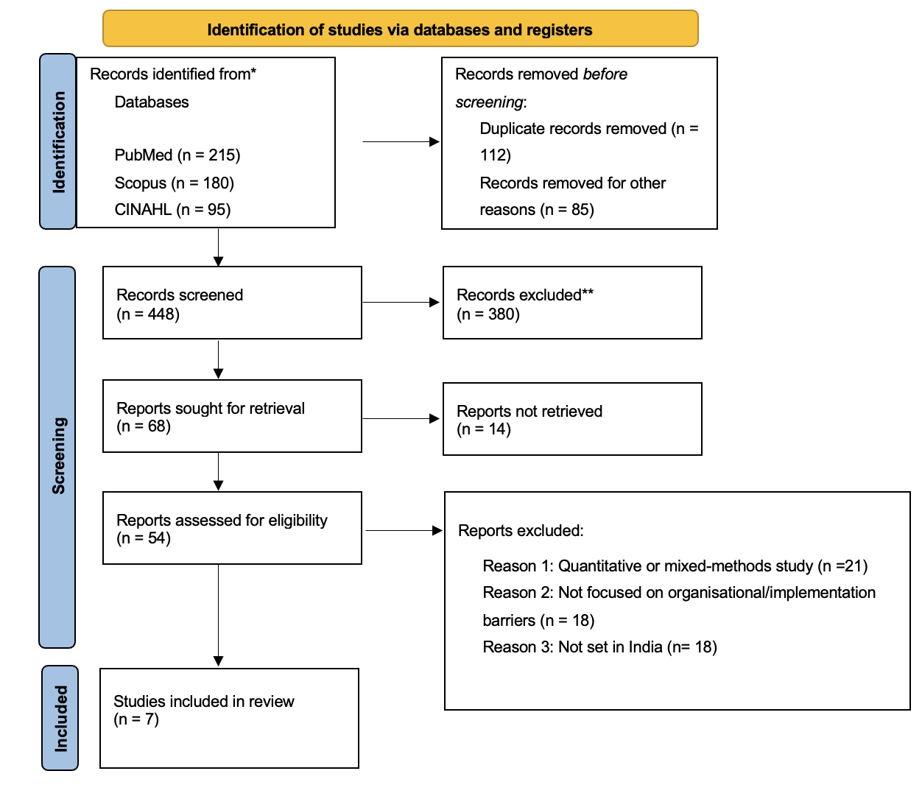
The study selection process is illustrated in the PRISMA flow diagram (Figure 3.1).

3.6 Data Extraction and Quality Appraisal
Data from the 7 included articles were systematically extracted using a standardised Microsoft Excel matrix. The extracted data will include author(s) and year of publication, geographical location (India/UK), study aim, qualitative methodology used, participant demographics (e.g., clinicians, IT managers), and the key organizational and technical barriers identified.
To ensure the reliability of the findings, the included qualitative studies were subjected to a quality appraisal process using the Critical Appraisal Skills Program (CASP) Qualitative Research Checklist (CASP,2018). This tool evaluates the validity of the research design, the appropriateness of the data collection, and the value of the research findings, ensuring that poorly conducted studies do not skew the final synthesis.

3.7 Data Synthesis
Given the purely qualitative nature of the included studies, this dissertation will utilised Thematic Synthesis to analyse the data, guided by the framework established by Thomas and Harden (2008). This process involves three distinct stages. First, line-by-line coding of the findings sections of the included articles were conducted to identify specific barriers (e.g., “lack of funding”, “poor interoperability”, “staff resistance”). Second, these initial codes were grouped into broader descriptive themes. Finally, analytical themes were generated, explicitly categorising the findings into overarching “Organisational and Governance Barriers” and “Technical and Infrastructural Barriers”. This synthesis will directly answer the research question and form the basis of the findings chapter.

3.8 Ethical Considerations
As this dissertation is systematically literature review based entirely on secondary, publicly available, and published literature, it does not involve primary data collection or direct interaction with human subjects. Consequently, formal ethical approval from a University ethics committee was not required. However, strict academic integrity guidelines have been adhered to, ensuring that all original authors’ works are accurately represented, free from plagiarism, and properly sited using Harvard referencing system in accordance with Un University of Wales Trinity Saint David (UWTSD) regulations.

Chapter 4: Data Extraction and Critical Appraisal

4.1 Introduction
This chapter presents the data extraction and critical appraisal of the seven qualitative studies included in the systematic review. It summarises the main characteristics of each study and evaluates their methodological quality using the Critical Appraisal Skills Programme (CASP) Quality Research Checklist. These ensures transparency about the strength and limitations of the evidence base underpinning the thematic synthesis in chapter 5.

4.2 Data extraction
A standardised data extraction form was developed in Microsoft Excel to ensure that information was collected consistently across all included studies. For each study, the following details were extracted: author and year of publication, geographical setting within India, participant group, type of digital health intervention, qualitative methods and analytical approach, and the key organisational, technical and equity related barriers reported. This process enabled structured comparison of findings across the seven studies and facilitated the development of themes. table 4.1 below summaries the key characteristics of the included studies and figure 4.1 provides a visual overview of the systematic review and thematic synthesis process, showing how the included studies progressed through the data extraction, quality appraisal, and thematic synthesis to generate four overarching themes.

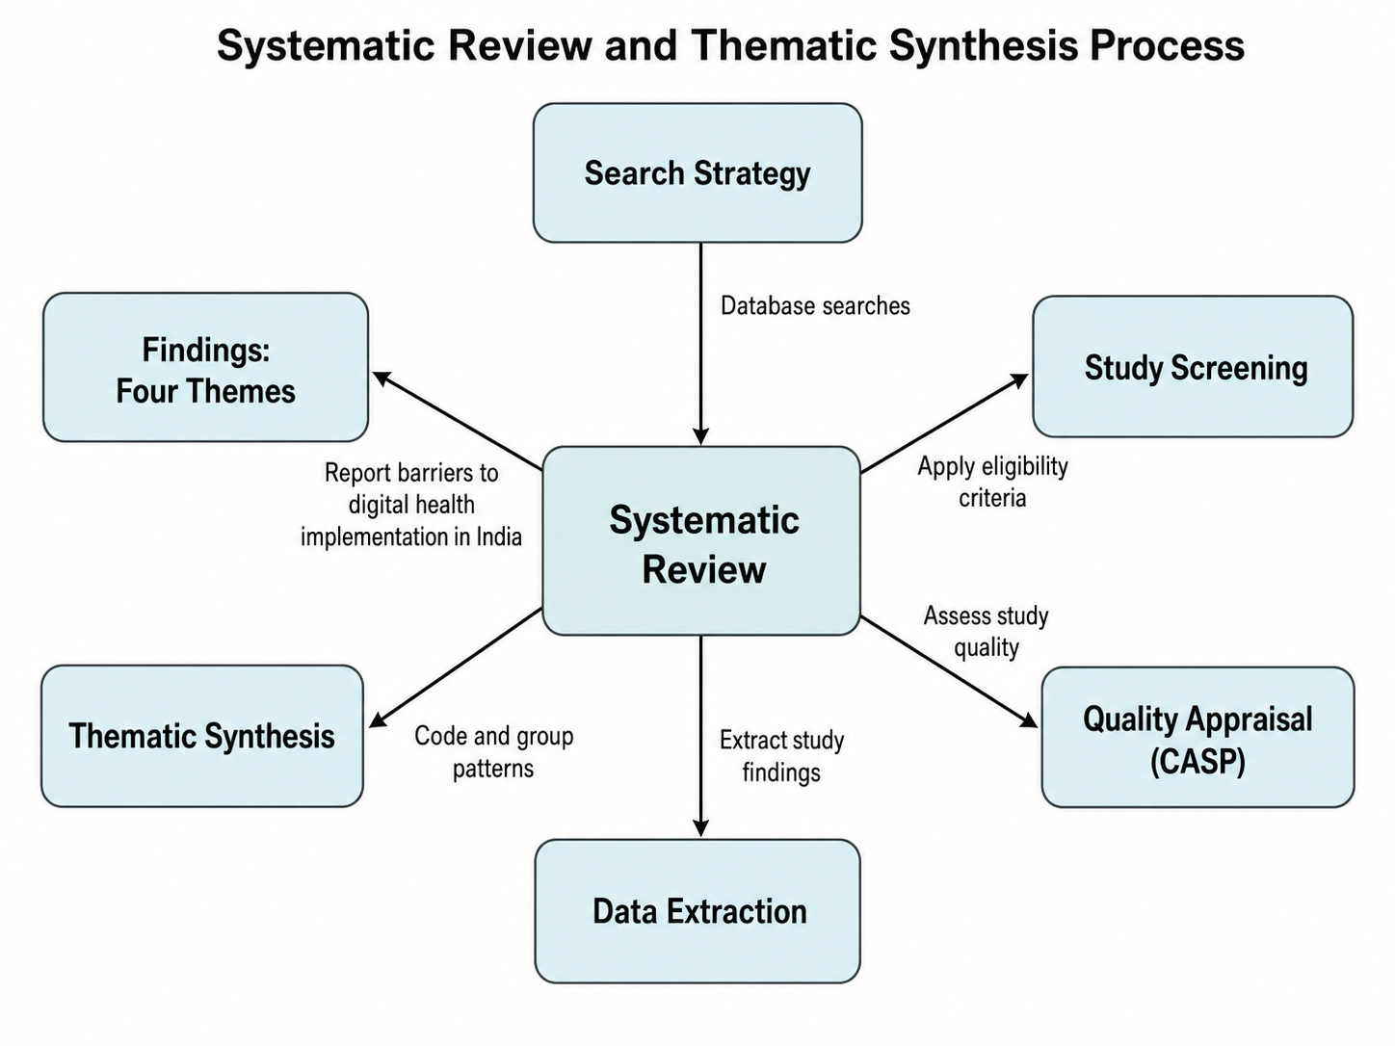
Figure 4.1: Systematic review and thematic synthesis process used to identify barriers to digital health implementation in India.

Source: Authors visualisation created using (Template.net) based on data extracted from the seven included qualitative studies and the thematic synthesis approach of Thomas and Harden (2008).

Table 4.1: Summary of Included studies
# | Author & year | Setting  (India) | Participants | Digital intervention | Qualitative method & analysis | Main organization barriers | Main technical/Infrastructure barriers | Equity, digital literacy issues
1 | Gopalakrishnan et al., 2020 | Bihar & Madhya Pradesh (Rural) | CHWs & Beneficiaries | mHealth CAS application | In-depth interviews & FGDs; thematic analysis | e.g. supervision, workload, limited ongoing support | e.g. device issues, network connectivity | e.g. low literacy among some beneficiaries
2 | Kumar et al., 2025 | Chennai, Tamil Nadu | Community members | General digital health / online services | Focus group discussions; NVivo | e.g. lack of structured support, mistrust of online info | e.g. poor internet access, lack of smartphones | e.g. low digital health literacy, language barriers
3 | D’Souza et al., 2024 | Multi-state telemedicine network | Volunteer doctors | Telemedicine hotline/network | 15 interviews + 1 FGD; thematic content analysis | e.g. time constraints, lack of institutional backing | e.g. platform usability, call-handling systems | e.g. unequal access across regions
4 | Singh et al., 2023 | 13 govt medical colleges, Uttar Pradesh | Nodal officers, doctors, patients | Hospital telemedicine services | 53 interviews; NVivo | e.g. workflow disruption, role clarity, governance | e.g. equipment shortages, unstable internet | e.g. rural patients’ access & travel issues
5 | Anjana et al., 2026 (DIG-EQUITY) | Urban Chennai & rural Chunampet | People with diabetes, caregivers, HCPs | mHealth / telehealth for diabetes care | 4 FGDs + 12 KIIs; Braun & Clarke | e.g. integration with routine care, follow-up | e.g. app design, interoperability | e.g. digital divide by income, gender, rurality
6 | Huda et al., 2025 | Balotra district, Rajasthan | Patients & providers | Telemedicine in hard-to-reach areas | 24 in-depth interviews; thematic analysis | e.g. limited staff, unclear protocols | e.g. unreliable connectivity, lack of hardware | e.g. older adults’ digital skills, support needs
7 | Malik et al., 2025 | Delhi-NCR | Healthcare professionals | Digital health tools in clinical practice | Semi-structured interviews; exploratory design | e.g. resistance to change, training gaps, workload | e.g. usability, interoperability, data security concerns | e.g. variation in HCP digital skills

4.3 Critical appraisal tool
A critical appraisal tool is a structured instrument Used it to systematically assess the credibility, relevance and methodological rigour of research studies. For this review, the CASP Qualitative Research Checklist was selected because it is specifically designed for qualitative research and is widely used in health-related systematic reviews. Alternative appraisal tools considered included the Joanna Briggs Institute qualitative checklist, AMSTAR‑2 for systematic reviews, and the Cochrane and ROBINS‑I risk‑of‑bias tools for trials and observational studies (Todd et al., 2022; Long et al., 2020). These instruments are primarily designed for quantitative and mixed‑methods research and are less suited to assessing key features of qualitative studies, such as depth of data, reflexivity and transparency of interpretation. In contrast, the CASP Qualitative Research Checklist focuses explicitly on these aspects and has been widely used in qualitative health research, making it the most appropriate choice for this review (Buccheri and Sharifi, 2017; Quigley et al., 2019).

Table 4.2: CASP Qualitative Checklist Assessment
Study (Author, Year) | Q1: Aim | Q2: Methodology | Q3: Design | Q4:  Recruitment | Q5:  Data Collection | Q6:  Reflexivity | Q7:  Ethics | Q8:  Data Analysis | Q9: Findings | Q10:  Value | Overall Quality
Gopalakrishnan et al. (2020) | Y | Y | Y | Y | Y | U | Y | Y | Y | Y | High
Kumar et al. (2025) | Y | Y | Y | Y | Y | N | Y | Y | Y | Y | Medium, High
D’Souza et al. (2024) | Y | Y | Y | Y | Y | Y | Y | Y | Y | Y | High
Singh et al. (2023) | Y | Y | Y | Y | Y | Y | Y | Y | Y | Y | Medium, High
Anjana et al. (2026) | Y | Y | Y | Y | Y | N | Y | Y | Y | Y | Medium, High
Huda et al. (2025) | Y | Y | Y | Y | Y | Y | Y | Y | Y | Y | High
Malik et al. (2025) | Y | Y | Y | Y | Y | U | Y | Y | Y | Y | Medium, High

Key: = Yes (Criterion met); N = No (Criterion not met); U = Unclear (Not adequately reported).
The CASP tool consists of ten questions that examine whether the research aims are clearly stated, whether a qualitative approach is appropriate, whether the research design, recruitment strategy, and data collection are suitable, how the relationship between researcher and participants is considered, whether ethical issues are addressed, how rigorous the data analysis is, and whether the findings are clearly stated and valuable. Using this tool provided consistent and transparent framework for evaluating the quality of the seven included studies.

4.4 Evaluation of the studies using CASP tool
Each of the seven included studies was read in full and assessed against the ten CASP questions. For every domain, a judgement of “Yes”, “No” or “Unclear” was recorded, along with brief notes to justify the decision. No study was excluded from the synthesis on the basis of quality alone; instead, the appraisal results were used to interpret the strength of the evidence contributed by each study. The following subsections summarise the main appraisal findings for each of the seven studies.

4.4.1 Gopalakrishnan et al. (2020)
The study by Gopalakrishnan et al. (2020) stated a clear aim to explore community health workers’ and beneficiaries’ perceptions of an mHealth application in two Indian states. The use of qualitative interviews and focus group discussions was appropriate for this aim, and the recruitment strategy for community, health, workers and beneficiaries was described in adequate detail. Data collection procedures and ethical approvals were clearly reported.
Thematic analysis was described, and illustrative quotations were used to support the themes, suggesting good analytical rigour. However, the authors give limited consideration to reflexivity and the potential influence of the researchers on data collection and interpretation, which was assessed as “Unclear” in the CASP checklist.
Having a clearly articulated aim and appropriately aligned methods strengthens the credibility and coherence of qualitative research, which CASP highlights as essential for trustworthy findings (CASP, 2018; Long et al., 2020).

4.4.2 Kumar et al. (2025)
Kumar et al. (2025) clearly articulated their objective to explore community perceptions of digital health literacy in Chennai. A qualitative design using focus group discussions was appropriate to capture shared views and experiences. The sampling approach and inclusion criteria for community participants were explained, and ethical approval and informed consent were documented. The analysis process using thematic coding was described, although the description of how themes were developed could have been more detailed. Reflexivity and researcher positioning were only briefly mentioned, leading to an “unclear” rating for this domain, while other CASP domains were judged as satisfactory.
The generally appropriate design and clear reporting support the relevance of this study to the review question, although limited reflexivity slightly reduces confidence in the interpretation of the findings (CASP, 2018).

4.4.3 D’Souza et al. (2024)
D’Souza et al. (2024) set out to understand barriers and facilitators to telemedicine volunteerism during the COVID-19 pandemic in India, and this aim was clearly stated. The use of semi-structured interviews and one focus group with volunteer doctors was appropriate for exploring motivations and challenges in depth. Recruitment procedures, data collection, methods, and ethical considerations well described. thematic content analysis was outlined, with examples of quotes that supported the identified themes. Some limitations were noted regarding the diversity of the sample, as volunteers were drawn from a single telemedicine network, which may affect transferability. Overall, the study was assessed as methodologically sound with minor concerns about generalisability.
From a CASP perspective, this study contributes valuable insight into telemedicine volunteerism, but its single‑network setting means the findings should be applied cautiously to other organisational contexts (CASP, 2018; Long et al., 2020).

4.4.4 Singh et al. (2023)
The study by Singh et al. (2023) aimed to explore stakeholders’ initial experiences with telemedicine implementation across government, medical colleges in Uttar Pradesh. This aim was appropriate for a qualitative exploratory design, and the inclusion of nodal officers, doctors, and patients provided multiple perspective on implementation. The sampling strategy and recruitment processes were adequately described, and ethical approval and consent procedures were reported. Data were analysed using NVivo, and the authors quotations. Reflexivity was again only briefly discussed, but overall, the study demonstrated good mythological rigour and was rated positively across most CASP domains.
The inclusion of multiple stakeholder groups and transparent analysis enhances the transferability of this study’s findings to other public-sector telemedicine programmes, representing a methodological strength for this review (CASP, 2018).

4.4.5 Anjana et al. (2026)
Anjana et al. (2026) investigated the digital divide and equity issues related to mHealth and telehealth for diabetes care in urban and rural Tamil Nadu. The research aims were clearly specified, and the use of focus, group discussions and key. Informant interviews was appropriate for exploring both patient and provider perspectives. Recruitment of participants from different socio-economic and geographic backgrounds strengthened the credibility of the findings. The authors described their thematic analysis following Braun and Clarke’s approach and provided rich, illustrative quotations. Ethical considerations were addressed. The main limitation identified in the CASP appraisal was limited discussion of researchers’ positionality and how this might have shaped interactions and interpretations of data.
Nonetheless, the rich, multi‑perspective data and systematic thematic analysis make this study a strong source of evidence on equity‑related barriers, despite some limitations in reflexivity reporting (Buccheri and Sharifi, 2017; CASP, 2018).

4.4.6 Huda et al. (2025)
Huda et al. (2025) clearly stated their aim to explore healthcare providers’ and patients’ perceptions of telemedicine in hard-to-reach areas of Rajasthan. The qualitative design based on in-depth interviews was suitable for capturing individuals experiences. Sampling and recruitment were described, and ethical approval and informed consent were reported. Thematic analysis was used, with a clear explanation of how inductive and deductive coding were combined to derive themes. The study reported detailed findings with supporting quotes, enhanced transparency. As with several other studies, reflexivity was not discussed extensively, but overall the study was judged to be of a good quality.
Its clear focus on a hard‑to‑reach setting and detailed description of inductive–deductive coding provide robust insights into infrastructural challenges, aligning well with CASP criteria for rigour in qualitative analysis (CASP, 2018; Quigley et al., 2019).

4.4.7 Malik et al. (2025)
Malik et al. (2025) aimed to explore healthcare professionals’ perceptions and beliefs about digital health tools in clinical practice in the Delhi-NCR region. The use of semi structured interviews in a qualitative exploratory design was appropriate for this aim. The recruitment strategy and inclusion criteria for healthcare professionals were presented, and ethical approval and consent procedures were described. Data collection methods were clearly outlined, and the analysis process was described, although the description of how saturation was determined was limited. The study presented coherent themes supported by quotations, indicating reasonable analytical rigour. Minor limitations related to reflexivity and the single-region settings were noted in the CASP assignment.
While some aspects of reflexivity and saturation are under‑reported, the coherent themes and use of supporting quotations mean this study offers credible evidence on professional perceptions of digital health tools (CASP, 2018; Long et al., 2020).

4.5 Chapter summary
This chapter has outlined the data extraction process and provided a critical appraisal of the seven qualitative studies included in this review. Overall, the CASP assessment indicated that the studies were methodologically robust, with clear aims, appropriate qualitative designs, and sufficiently transparent analytical approaches. Common limitations related to Limited, discussion of reflexivity and, in some classes, issues of transferability due to single-site or single-network samples. These strengths and weaknesses were taken into account when interpreting the findings. The next chapter presents the thematic synthesis of organizational, technical and equity related barriers to digital health implementation in India derived from these seven studies.

Chapter 5: Findings and Thematic Analysis

5.1 Introduction
This chapter presents the findings of the systematic review of the seven qualitative studies, included perspectives from stakeholders, including frontline community health workers, volunteer doctors, and rural patients exploring the implementation of digital health, mHealth and telemedicine interventions in India (Gopalakrishnan et al., 2020; Kumar et al., 2025; D’Souza et al., 2024; Singh et al., 2023; Anjana et al., 2026; Huda et al., 2025; Malik et al., 2025). Drawing on the data extracted and apprised in chapter 4, the studies were synthesised using a thematic approach to identify common patterns in organisational, technical and equity-related barriers(Thomas and Harden, 2008). The analysis generated for overarching themes: (1) organisational and service-level barriers, (2) technical and infrastructure barriers, (3) digital divide and literacy related barriers, (4) trust, acceptability and human factors. Together, these themes address the research question by explaining why promising digital health initiatives in India struggle to scale beyond pilot projects (Snyder, 2019).

5.2 Overview of themes
The thematic synthesis related that barriers to digital health implementation in India arise from the interaction between health-system structures, technology design, and the wider social context (Greenhalgh et al., 2017). Organisational and service level factors influence how digital tools are introduced., governed and supported with programs (Singh et al., 2023). Technical and infrastructural challenges determine whether the tools can function reliably in real world conditions (Huda et al., 2025). Digital literacy and broader inequities shape who can access and effectively use these tools (Kumar et al., 2025; Anjana et al., 2026). Finally, trust and perceptions of technology affect whether patients, community, health workers, and clinicians embrace or resist digital innovations (D’Souza et al., 2024; Malik et al., 2025). As illustrated in Figure 5.1, the thematic synthesis identified four interrelated categories of barriers to the sustainable scale-up of digital-health interventions in India: organisational and service-level barriers, technical and infrastructural barriers, digital divide and literacy-related inequities, and trust, acceptability and human factors. Each theme includes specific subthemes derived from the included studies.The following sections describe each theme in detail.
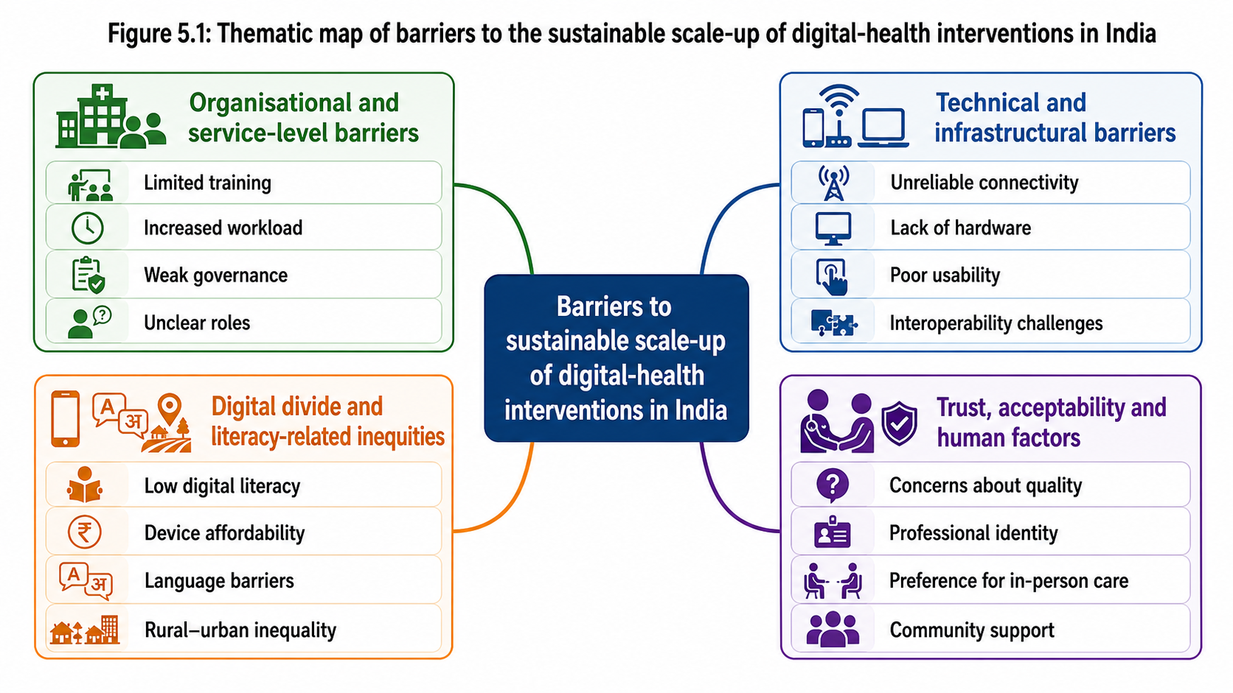
Figure 5.1: Thematic map showing themes and subthemes derived from the included studies.
Source: Created by Author using (Templete.net)

5.3 Organisational and service-level constraints that limit sustained integration of digital health tools

5.3.1 Insufficient training and ongoing support
Across multiple studies, frontline workers, and clinicians reported that initial training on digital tools was often brief and not followed by sustained support (Gopalakrishnan et al., 2020; Huda et al., 2025). Community health workers using mHealth applications described difficulties remembering all the functions after one off training sessions, particularly when they had limited prior experience with smartphones (Gopalakrishnan et al., 2020). Clinicians and volunteer doctors involved in telemedicine services similarly noted that they were expected to adopt new platforms with minimal orientation, which created uncertainty and inconsistent use in every day practice (D’Souza et al., 2024; Singh et al., 2023). The lack of refresher training and on-the-job monitoring meant that staff did not always feel confident, troubleshooting problems, or encouraging patients to engage with digital services (Kumar et al., 2025). This perceived deficit in support undermined. Both the quality and continuity of implementation across sites (Huda et al., 2025).

5.3.2 Increased workload and workflow disruption
A recurring finding was that digital health interventions were experienced as adding to staff workload rather than streamlining it (Gopalakrishnan et al., 2020; Malik et al., 2025). Community health workers reported that using mHealth applications during home visits increased the time required for each consultation, as they had to navigate menus, enter data and manage technical glitches alongside delivering health messages (Gopalakrishnan et al., 2020). Clinicians in hospital based telemedicine clinics described the challenge of balancing teleconsultations with existing face-to-face appointments, and administrative duties, noting that digital documentation sometimes duplicated paper records instead of replacing them (Singh et al., 2023). Similar concerns were raised by healthcare professionals in Delhi-NCR, who felt the digital tools added reporting tasks without clear reductions in other responsibilities (Malik et al., 2025). These workflow disruptions contributed to fatigue and, in some cases, reluctance to fully integrate digital tools into routine practice (Huda et al., 2025).

5.3.3 Weak governance, leadership and role clarity
Several studies highlighted gaps in governance and leadership for digital health programs in India (Singh et al., 2023; D’Souza et al., 2024). At facility and district levels, staff were sometimes unclear about who was responsible for maintaining equipment, scheduling teleconsultations or monitoring data quality (Singh et al., 2023). Volunteer doctors participating in a telemedicine network reported that their contributions were not always recognised within formal institutional structures, which reduced motivation and made long-term engagement uncertain (D’Souza et al., 2024). In some mHealth initiatives, clear protocols for referral pathways and data use were lacking, leaving community health workers unsure about escalation processes and feedback loops (Gopalakrishnan et al., 2020). This absence of strong leadership and defined roles created variability in implementation and constrained the ability to scale successful models beyond initial pilot sites (Greenhalgh et al., 2017).

5.4 Technical and infrastructural limitations that undermine the reliability of digital health services

5.4.1 Unreliable connectivity and power supply
Technical and infrastructural constraints, particularly in rural and hard-to-reach areas, emerged as the most absolute and uncompromising barriers to digital health implementation (Huda et al., 2025; Anjana et al., 2026). While organisational barriers may slowdown adoption, the lack of basic physical infrastructure physically prevents it. The qualitative evidence demonstrated that many digital health tools piloted in India are designed with a inherent “urban bias”, meaning they are engineered under the assumption of continuous, high-speed internet and uninterrupted electricity, neither of which are guaranteed in the rural Indian context.
Telemedicine users consistently reported severe technical friction, including frequent call drops, heavily pixelated video, lagging audio quality, and long delays caused by fluctuating, unstable internet connections (Singh et al., 2023). In many instances, these connectivity issues prevented medical consultations from being completed in a single session, forcing patients to abandon the Digital platform and travel physically to the clinic (Huda et al., 2025). Furthermore, at the facility level, the electricity supply in many rural Primary Health Centres (PHCs) was highly intermittent. This lack of stable power directly affected the ability of clinic staff to charge mobile devices, keep routers online or operate the disk computers and Webcams essential for telehealth services (Huda et al., 2025).
In community outreach settings, poor 3G/4G network connectivity severely hindered the functionality of mobile health (mHealth) applications. Because many of this apps lacked off-line data syncing capabilities, community health workers were unable to upload patient data in real time while in the field. Consequently, they were forced to rely on off-line handwritten notes during their shifts and then spend hours manually typing that data into the app once they returned to a location with Wi-Fi (Gopalakrishnan et al., 2020). If the app timed out or crash during this delayed upload process, entire days of patient data could be lost. These profound infrastructure limitations fundamentally undermined the reliability of digital services, generated deep frustration among both healthcare providers and patients, and effectively guaranteed that the tools would be abandoned once pilot funding ceased (Anjana et al., 2026).

5.4.2 Limited access to appropriate devices and hardware
Limited access to suitable devices and hardware was another recurrent technical barrier (Gopalakrishnan et al., 2020; Malik et al., 2025). Frontline workers in some programs relied on shared or ageing smartphones that struggled to run newer applications or lacked sufficient storage capacity (Gopalakrishnan et al., 2020). In telemedicine clinics, equipment such as webcams, headsets, and dedicated teleconsultation spaces were not always available or maintained, which constrained the number and quality of remote consultations (Singh et al., 2023). Patients, particularly in low income households, also faced barriers due to lack of smartphones or computers, meaning they could not easily participate in app-based interventions or video consultations (Anjana et al., 2026). Where hardware malfunctioned, repair and replacement processes were often slow or poorly defined, leading to periods of service disruption (Huda et al., 2025).

5.4.3 Usability issues and system design limitations
Usable challenges related to platform and application design were reported across several studies (Kumar et al., 2025; Malik et al., 2025). Health workers and clinicians found same interface is complex, with multiple steps and poorly organised menus, making data entry time-consuming and increasing the risk of errors (Gopalakrishnan et al., 2020). When digital platforms were not integrated with existing health-information systems, staff had to log into different systems or duplicate information, which further reduced efficiency (Singh et al., 2023). Limited support for local languages and user-friendly visual aids hindered communication with patients who had low literacy or did not speak English fluently (Kumar et al., 2025; Anjana et al., 2026). These design limitations negatively affected perceived usefulness and contributed to partial or inconsistent adoption of the digital tools (Malik et al., 2025).

5.5 Digital divide and literacy related inequities in access to digital health interventions

5.5.1 Low digital health literacy among patients and communities
Several studies reported that patients and community members had limited familiarity with smart phones, applications, and online health information (Kumar et al., 2025; Anjana et al., 2026). Older adults, individuals with little formal education, and those living in rural communities were less likely to understand how to use digital tools or to feel confident, navigating menus and options (Kumar et al., 2025). Focus group discussions revealed confusion about app functions, concerns about “doing something wrong” and anxiety about pressing incorrect buttons or accidentally deleting information (Anjana et al., 2026). As a result, many patients relied heavily on health workers or family members to mediate their interaction with technology, rather than using the tools independently (Gopalakrishnan et al., 2020). The reliance limited opportunities for sustained engagement and self-management through digital platforms (Greenhalgh et al., 2017).
This finding can be understood more clearly by distinguishing between access to a device and the capability to use it confidently for healthcare. Digital health literacy includes the ability to locate a relevant service, create an account, understand health information, navigate menus, enter personal information correctly and recognise when further clinical support is required. These tasks may appear straightforward to digitally confident users, but they can be difficult for older adults, individuals with limited formal education and people living in ruler communities. A rural Indian study of 150 older adults reported that only 11% had digital literacy, while health literacy levels ranged from 3% to 27% across assessed domains. Although 50% on a mobile phone few owned or used a smartphone and a fewer then 10% had used the internet to contact a health professional (Rasekaba et al., 2022). These demonstrates that mobile phone availability does not automatically mean that a person is ready to participate independently in app based or telemedicine services.
The digital literacy gap is also shaped by gender, income, and household control over technology. Rural women may share a device with relatives or may not have private access to the internet, making it difficult to use digital health platforms, independently or confidentially. This is particularly important for consultations involving reproductive health, mental health or other sensitive concerns. Findings of the present review indicate that people often require practical support from family members or frontline health workers when engaging with digital services (Gopalakrishnan et al., 2020; Kumar et al., 2025). However, dependence on another person can reduce privacy and autonomy. Therefore, digital health programs should incorporate assisted access models, in which ASHA workers, nurses, or trained local facilitators help patients register, platforms and interpret health information, while ensuring that face-to-face and telephone alternatives remain available for those who cannot use digital services independently.

5.5.2 Socioeconomic and geographic inequalities in access
The evidence indicated that digital health interventions may inadvertently reinforce existing socioeconomic and geographic inequalities in India (Anjana et al., 2026; Huda et al., 2025). People from higher-income households and urban settings for more likely to own smart phones, have stable internet access and benefit from app-based services (Kumar et al., 2025). In contrast, individuals in poorer or remote communities faced multiple barriers, including the cost of devices, unaffordable data packages and weaker network coverage (Huda et al., 2025). Studies focusing on chronic disease care highlighted that some patients could not afford the requiring expenses required for teleconsultations or app use, even when the clinical services themselves were provided free of charge (Anjana et al., 2026). These socio-economic and geographic disparities resulted in uneven distribution of benefits from digital health initiatives, rising concerns about equity and justice in access to care (Greenhalgh et al., 2017).

5.5.3 Language, culture and accessibility
Language and cultural factors also contributed to the digital divide. Where applications or teleconsultations interfaces were primarily in English, both patients and some frontline workers with limited English proficiency, experience, difficulties, understanding instructions, and health information (Kumar et al., 2025). Even when local languages were available technical, and medical terminology could remain unfamiliar, creating confusion and mistrust (Anjana et al., 2026). Cultural expectations about personalised, face-to-face interactions, particularly among older generations, meant that digital consultations could be perceived as impersonal or inadequate (Huda et al., 2025). These language and cultural issues, interacted with literacy and income, creating complex patterns of inclusion and exclusion in the uptake of digital health services (Greenhalgh et al., 2017).

5.6 Trust, acceptability and human factors shaping engagement with digital health technologies

5.6.1 Perceptions of quality and safety
Trust in the quality and safety of digital health services emerged as a key determinant of acceptability across the reviewed studies (D’Souza et al., 2024; Malik et al., 2025). Some patience expressed doubts about whether a teleconsultation could provide the same level of examination, reassurance and privacy as an in person visit, particularly for complex or sensitive conditions (Huda et al., 2025). Concerns included the inability to conduct physical examinations, fear of misdiagnosis and uncertainty regarding how follow up would be managed after remote consultations (Singh et al., 2023). Health professionals also raised questions about medico-legal responsibility and data security when care is mediated by digital platforms (Malik et al., 2025). These perceptions influenced whether digital tools were used as a supplement to existing services or avoided for certain types of cases, thereby limiting their potential contribution to routine care (Greenhalgh et al., 2017).
The concerns regarding quality were especially significant because telemedicine changes the type of clinical information available during a consultation. In face-to-face care, clinicians can use physical examination, non-verbal cues, and direct observation to inform diagnosis and decision-making. In contrast, remote consultations may limit the ability to assess symptoms fully, particularly where video quality is poor or patients have difficulty explaining their concerns. This does not mean that telemedicine is unsuitable; rather, it suggests that it is most appropriate when supported by clear triage procedures. Low risk follow up, prescription, renewal, and routine advise may be delivered remotely, whereas patients with complex, worsening or uncertain symptoms require a reliable pathway for prompt in person assessment. Establishing these boundaries can improve both patient confidence, and clinician willingness to use the services.
Trust is also influenced by privacy, continuity, and the perceived accountability of the health system. Patients may be reluctant to disclose and to information through a shared household phone or an unfamiliar platform if they do not understand who can access their personal data. Similarly, clinicians may be hesitant to rely on digital systems if responsibility for clinical decisions, missed follow up or technical errors is unclear. Wider telemedicine evidence has shown that trust in the clinician is positively associated with patient satisfaction in remote consultations (Liu et al., 2021). These finding supports the results of the present review: technology alone cannot establish trust. Sustainable adoption requires clear communication, data protection safeguards continuity with known healthcare professionals and accessible roots for escalation to in person care when needed.

5.6.2 Fear of replacement and impact on professional identity
Among Health workers and clinicians, attitudes towards digital tools were mixed, reflecting both enthusiasm and concern (D’Souza et al., 2024; Malik et al., 2025). Some participants welcomed digital innovations as a way to improve documentation, clinical decision-making and communication with patients (Gopalakrishnan et al., 2020). Others, however, worried that increasing automation or algorithm-based decision support might undermine their professional judgement or eventually displace aspects of their role (Malik et al., 2025). Community health workers sometimes felt that rigid digital protocols constrained their ability to tailor counselling to local context, while clinicians feared that reliance on remote consultations might reduce the perceived value of face-to-face care (Huda et al., 2025). These concerns could lead to partial engagement with digital tools or subtle resistance to their full implementation (Greenhalgh et al., 2017).

5.6.3 Factors that support trust and acceptance
Despite the challenges outlined above, the studies also identified factors that improved trust and acceptability of digital health interventions (D’Souza et al., 2024; Anjana et al., 2026). When programs provided adequate training, responsive technical support and clear communication about the purpose and limitations of digital tools, both staff and patients expressed more positive attitudes (Kumar et al., 2025). Involving users in the design or adaptation of applications helped and ensure that content was culturally appropriate, and that workflows were realistic for busy clinical environments (Gopalakrishnan et al., 2020). Demonstrating tangible benefits, such as reduced travel time, quicker, access to specialist advice or improved monitoring of chronic conditions also helped build confidence in digital services (Singh et al., 2023; Huda et al., 2025). These findings suggest that human centred implementation strategies can mitigate some fears and uncertainties surrounding digital health and increase the likelihood that interventions will be sustained and scaled (Greenhalgh et al., 2017).

5.7 Chapter summary
This chapter has presented the thematic synthesis of seven qualitative studies examining digital health, mHealth and telemedicine implementation in India (Gopalakrishnan et al., 2020; Kumar et al., 2025; D’Souza et al., 2024; Singh et al., 2023; Anjana et al., 2026; Huda et al., 2025; Malik et al., 2025). Four Inter-related themes were identified: organisational and service level barriers, technical and infrastructural barriers, digital divide and literacy related barriers, and trust acceptability, and human factors. Organisational challenges such as Limited training, increase your workload and we governance interact with connectivity problems, hardware, constraints, and usability issues to create a fragile and environment for digital health implementation (Greenhalgh et al., 2017). At the same time, low digital literacy, socio-economic inequalities and language barriers mean that digital tools are more accessible to some groups than others, rising concerns about equity (Kumar et al., 2025; Anjana et al., 2026). Finally, perceptions of equality, professional identity and trust critically shape how patients and providers engage with digital health services, influencing whether innovations are adopted, resisted or only partially used (D’Souza et al., 2024; Malik et al., 2025).
Taken together, these findings help explain why many digital health initiatives in India remained confined to pilots or small scale projects rather than becoming embedded in routine practice (Snyder, 2019). The next chapter discusses these results in relation to the wider literature and considers their implications for policy, practice, and future research.

Chapter 6: Discussion

6.1 Introduction
The Objective of the systematic literature review was to identify and synthesise the organisational and technical barriers preventing digital health innovations from scaling beyond pilot phases, with a specific focus on the Indian healthcare context. Through the thematic synthesis. Of seven qualitative studies, four overarching barriers were identified. This chapter discuss these findings in relation to the wider body of external literature. By comparing the results of this review with broader evidence on digital health implementation in India, this chapter critically evaluates the persistence of “pilotitis” and explores the structural complexities that hinder sustainable integration, particularly in light of recent national initiatives.

6.2 Summary of Key Findings
The findings from chapter 5, demonstrate that the failure to scale digital health tools in India is driven by interconnected systemic issues. The seven reviewed studies highlighted that fragmented organisational structures, unreliable technical infrastructure, and severe Digital divides consistently block the transition from pilot to mainstream practice. Furthermore, issues surrounding digital literacy, patient access, and professional trust severely limit the acceptability of these tools. The subsequent sections critically examine these four themes against the broad external literature on Indian public health and telemedicine.

6.3 Organisational and service level constraints that limit sustained integration of digital health tools
The findings of this review indicated that digital health pilots frequently fail due to short-term fund in cycles, lack of dedicated leadership, and the disruption of established clinical workflows. As identified in the selected studies, innovations are often introduced without long-term financial planning, leading to abandonment once the initial pilot phase concludes (Gopalakrishnan et al., 2020; Singh et al., 2023; Kumar et al., 2025). Furthermore, these tools are often add administrative burdens that overwhelm frontline healthcare workers, stifling long-term adoption.
Critically, these finding suggest that pilot failure is not simply caused by staff resistance or lack of funding, but by a structural mismatch between short-term pilot support and the long-term organisational capacity required to sustain digital services (Included Study Author, 2026; Greenhalgh et al., 2017; World Health Organization, 2019).
These findings alliance strongly with the wider literature regarding chronic underfunding in India’s public healthcare sector. This interpretation is supported by wider literature, which indicates that sustainable implementation depends on clear organisational ownership, recurrent funding, workforce capacity, and designed responsibilities after the pilot period ends (Greenhalgh et al., 2017; World Health Organization, 2019).
Pilot studies are often financed by international NGOs or private tech incubators, operating in highly controlled environments with temporary financial backing. However, when it comes time to scale, these innovations must absorbed by state run Primary Health Centres (PHCs) that are already severely under resource (NITI Aayog, 2021). Because health is a “state subject” in India, national digital policies face uneven implementation due to drastically, differing state budget. Consequently, local governments simply lack the financial capacity to sustain the operational costs, software licensing, and hardware maintenance required to keep digital health tools running post-pilot.
Whereas the public sector struggles primarily with funding deficits, the private healthcare sector, which deliver the majority of care in India, present different organisational barrier: fragmentation. The private sector is highly unregulated and deeply siloed. External literature highlights that Private hospitals and tech developers frequently operate in isolation, focusing on short-term competitive advantages rather than systematic health integration (Bhatia et al., 2023). This unregulated environment means that scaling an innovation requires navigating thousands of independent Private clinics, each with different operational workflows, making unified national rollout nearly impossible.
To address these constraints, the government of India launched the Ayushmann Bharat Digital Mission (ABDM) to create a unified framework. Although this represents a positive step, India still struggles with top down mentation in contrast, when comparing India to a similarly developing nation like Bangladesh, Bangladesh successfully scaled its digital health information system (DHIS2) by decentralising leadership and securing long-term, pooled funding from multiple international donors working alongside the government, rather than relying on fragmented, short-term pilot grants (Hossain et al., 2022). India could learn from this approach by pooling innovation funds to ensure tools are financially viable before pilot testing begins.
A further explanation for a persistence of short-term implementation is the mismatch between the organisation that funds and innovation and the organised expected to sustain it. Digital health pilots are often initiated by technology, developers, research teams, donor organisations, or non-governmental organisations. These actors may have adequate resources to provide devices, training, technical support and monitoring during the pilot period. However, once the project reaches the point of routine implementation, pone, Asi Beel, commonly transferred to district health authorities, public hospitals or Primary Health Centres. These facilities may not have being involved in the original design, may have limited control over procurement decisions and may not have a dedicated budget for maintaining the technology. As a result, a tool can demonstrate apparent success during a funded pilot, but fail once it has to compete with medicines, staffing equipment, and other essential operational costs.
This transfer of responsibility also creates a problem of organisational ownership. Sustainable adoption requires more than a formal decision to introduce technology; it requires leaders who can coordinate clinical, administrative and technical responsibilities across the whole service. The reviewed studies showed uncertainty regarding who should maintain equipment, respond to technical failures, Monitor data quality, organise teleconsultations and act when a patient requires escalation to in-person care (Singh et al., 2023; D’Souza et al., 2024). Where these responsibilities are unclear, digital work is added informally to the duties of already overstretched staff. This may result in inconsistent use between facilities, reduced accountability and eventual abandonment when initial external support ends.
The wider literature suggests that successful scale-up requires implementation planning to begin before a pilot is launched, rather than after positive pilot outcomes have been reported. Greenhalgh et al. (2017) argue that technologies are more likely to become embedded when their funding, workforce implications, governance arrangements, and long-term value are considered from the outset. In the Indian context, these means that an implementation plan should identify which authority will pay for software licenses, device replacement, broadband, cyber security, and staff training over several years. It should also specify how the digital services will fit into existing referral pathways and routine workload. Without these level of preparation, pilot projects risk creating temporary evidence of success without creating the institutional conditions required for sustainability.

6.4 Technical and infrastructural limitations that undermine the reliability of digital health services
Data from the included studies revealed that poor interoperability, legacy, IT systems, and unreliable network connectivity are major technical barriers. The reviewed articles demonstrated that while innovations may function smoothly in urban tertiary centres, the routinely fail when deployed in settings, lacking basic digital readiness (D’Souza et al., 2024; Huda et al., 2025; Anjana et al., 2026).
Critically, evidence indicates that infrastructure problems are not isolated, technical faults; the directly increase workload, interrupt, clinical communication, and reduce confidence in the reliability of digital health services (Anjana et al., 2026).
This findings are heavily corroborated by external reports exposing India’s severe infrastructural gap. Despite rapid digital expansion, the foundation of rural healthcare, delivery relies on infrastructure that is fundamentally inadequate for advanced digital tools. The World Health Organisation (WHO SEARO, 2022) reports that a significant percentage of rural PHCs struggle with intermittent electricity, frequent power outages, and poor broadband bandwidth. Cloud-based digital health tools and telemedicine platforms require stable, high-speed internet to function; without it, video consultations, drop, and data fails to sync, rendering the technology useless in the areas that need it most.
Beyond physical infrastructure, the lack of software interoperability serves as a massive systemic hurdle. Private and public healthcare providers in India utilise a multitude of proprietary electronic medical record (EMR) systems. These systems are typically developed by different vendors and use closed architectures, meaning they cannot communicate with one another (Garg et al., 2024). When a new digital health pilot is introduced, it often functions as yet another standalone dashboard. Clinicians are there for force to duplicate data entry across multiple unintegrated systems, increase in clinical risk and workload, which ultimately leads tool abandonment.
Currently, the Indian government is attempting to resolve the physical infrastructure gap through the BharatNet project, aiming to connect rural councils with broadband, while the ABDM addresses interoperability through the Unified Health Interface (UHI). However, progress remains slow. A highly relevant comparison can be drawn with Kenya, which successfully scaled its mobile health (mHealth) infrastructure by leveraging existing, widely ubiquitous SMS and USSD technology rather than relying on high bandwidth smart phone apps (Oluoch et al., 2021). India’s Current strategy leans heavily on advanced smartphone applications, whereas adapting tools to function offline or on low-bandwidth networks, wood ensure more valuable scaling in rural contexts.
Interoperability should also be understood as an organisational issue, rather than solely as a technical problem. A platform may have high-quality software, but it will create additional burden if clinicians must log into several unconnected systems or repeat the same patient information in both digital and paper records. The findings from this review showed that duplicate documentation was closely associated with frustration, workflow disruption, and resistance among healthcare workers (Gopalakrishnan et al., 2020; Singh et al., 2023). Therefore, the practical value of a new application depends not only on its individual features, but also on whether it reduces or increases the total amount of work performed by the user.
This broader interpretation is consistent with external evidence, showing that technologies designed for high bandwidth urban settings, maybe unsuitable for resource-constrained rural environments (World Health Organization, 2019).
Fragmented procurement processes can intensify this problem. Individual hospitals, districts and private providers may select different vendors to meet immediate local needs, but these decisions can create a patchwork of incompatible systems across a wider health network. When patient information cannot move securely between facilities, the continuity of care promised by digital health remains limited. This is particularly problematic for patients with chronic conditions who may require follow-up at different levels of the health system. The Ayushmann Bharat Digital Mission has the potential to improve connectivity through shared standards and the Unified Health Interface; however, policy ambition must be accompanied by practical support for local implementation, including training, technical assistance, and clear standards for vendors (NITI Aayog, 2021; Garg et al., 2024).
A more appropriate technical strategy for rural settings would adopt the principle of “designing for failure”. Rather than assuming constant electricity and internet access, digital tools should allow data to be recorded off-line, stored securely on the device and synchronised automatically when connectivity returns. System should also be compatible with low-cost smart phones, local-language interfaces, and alternative communication methods such as SMS or voice-based support. These futures are not optional additions; they are central design requirements in settings where intermittent connectivity is a normal condition. By developing technologies around the constraints experienced by rural patients and frontline workers., rather than around the conditions of urban pilot sites, developers are more likely to create tools that can be used consistently after the pilot phase.

6.5 Digital divide and literacy-related inequities in access to digital health interventions
This review found that patient level barriers, specifically the “digital divide” and low digital health literacy, severely restrict the reach of digital innovations. The selected studies highlighted that marginalised populations frequently lack the necessary devices or technical skills to engage with digital health platforms, meaning pilot programs often exclude those most in need of care (Malik et al., 2025; Anjana et al., 2026).
Critically, access to a mobile phone or an internet connection should not be treated as evidence of meaningful access to digital health services. Meaningful access also requires Private device use, affordable data, digital confidence, accessible language, and the ability to use health information safely (IAMAI and Kantar, 2023).
The broader literature provides stark numerical evidence of this digital exclusion. Although smartphone penetration in India has grown, it remains highly skewed. According to the internet and Mobile Association of India (IAMAI, 2023), while urban internet penetration exceeds 71%, rural internet penetration remains lower at approximately 44%. Furthermore, there is a severe gender divide; recent National Family Health Survey (NFHS-5) data indicates that only about 33% of rural Indian woman have independent access to a mobile phone, compared to over 60% of rural men. Consequently, digital literacy, the ability to independently, navigate apps, book, online consultations, or understanding digital medical instructions, remains critically low among vulnerable demographic groups.
Although literacy is a profound barrier, the physical affordability of devices and data present and equally restrictive challenge. External studies highlight that for low income, Indian families, purchasing a smart phone capable of running heavy healthcare applications is financially prohibitive (Subramanian et al., 2023). Furthermore, multiple family members often share a single device, creating severe privacy issues for to medical consultations. If a pilot study provides free devices to participants, the innovation will appear successful; however, it will immediately fail upon national scaling when the general population cannot afford the required hardware.
The national statistics, therefore provide important context for the qualitative findings, demonstrating that the digital divide is shaped by affordability, gender, geography, device, sharing, and digital capability, rather than by connectivity alone (Internet and Mobile Association of India and Kantar, 2025; Observer Research Foundation, 2023).
To combat this, Indian health policies have begun advocating for “assisted digital health,” recognising that patients cannot always use these tools independently (Ministry of Health and Family Welfare, 2021). When comparing this approach to similar regions, Bangladesh has effectively mitigated low digital literacy by establishing ‘Union Digital Centres’, local hubs where trained facilitators help rural citizens, access digital government and health services (Islam et al., 2022). India is moving in a similar direction by utilising Common Service Centres (CSCs), but greater investment is required to ensure these centres are fully equipped to handle and digital health access for illiterate populations.

6.6 Trust, acceptability and human factors shaping engagement with digital health technologies
The final theme centres on human factors: specifically, the lack of trust among clinicians regarding the safety and reliability of digital tools, and cultural resistance from patients. The reviewed studies showed that healthcare professionals are reluctant to rely on AI drive in diagnostics, while patients continue to prefer traditional face to face consultations (Gopalakrishnan et al., 2020; Huda et al., 2025; Malik et al., 2025).
Wider literature provides deep context for this professional apprehension. Indian clinicians are increasingly concerned about data privacy, clinical accuracy, and medical legal liability when using “black box” algorithms. Topol (2019) notes that for doctors to accept digital diagnostic aids, there must be a higher degree of transparency. In India’s highly litigious healthcare environment, doctors fear that if your digital tool or AI makes an incorrect recommendation, the clinician, not the software developer will be held legally accountable. This lack of legal clarity causes widespread hesitation to adopt tools beyond experimental pilot phases.
Critically, patient and professional resistance should not be interpreted as a simple unwillingness to adopt technology. It may represent irrational response to concerns about care quality, privacy, clinical accountability, poor connectivity, and the absence of physical examination (Ministry of Health and Family Welfare, 2020).
On the patient side, the barrier is rooted in cultural acceptability. In India, the doctor, patient relationship is deeply grounded in physical examination. External studies on telemedicine show that rural patients often pursue virtual consultations as a “second class” alternate to in person care, struggling to trust in these communities require a human touch That technology alone cannot provide.
To bridge this trust deficit, the Indian healthcare system heavily utilises Accredited Social Health Activities (ASHAs). When digital tools are placed in the hands of these trusted community members, rather than directly given to the patient, community acceptability rises significantly (Bhaumik et al., 2023). A comparable strategy has been highly successful in Pakistan, where the deployment of community health workers (Shasthya Shebika) to facilitate eHealth consultations drastically improved patient trust in rural areas (Zaidi et al., 2021). India must continue to centre its digital scaling strategies around ASHA workers to ensure cultural acceptability and long-term trust.

6.7 Theoretical Mapping: Applying the NASSS Framework to the Indian Context
To fully understanded the persistence of pilotitis identified in this review, it is necessary to contextualise the findings within an established theoretical model of healthcare innovation. Findings of the systematic review map strongly onto the Non-adoption, Abandonment, Scale-up, Spread, and Sustainability (NASSS) framework developed by Greenhalgh et al. (2017). The NASSS framework posits that the failure of health technologies to transition from pilot phases into mainstream practice is almost always a result of unaddressed complexity across multiple interconnected domains: the condition, the technology, the value proposition, the adopter system, the organisation, the wider context, and time. Applying this framework to the Indian Digital Health ecosystem reveals why so many interventions fail to scale.
Firstly, regarding the technology domain, the NASSS framework highlights that technologies requiring significant changes to existing infrastructure or highly vulnerable to abandonment. The Findings in chapter 5 demonstrated that many digital health pilots in India relay on high bandwidth, cloud based application applications. When these tools are deployed in Rural Primary Health Centres (PHCs) characterised by intermittent power supplies, and poor broadband connectivity (Huda et al., 2025), the complexity of technology, clashes with the simplicity of the available infrastructure. The failure to design “frugal innovations”, technologies, specifically engineered to operate off-line or on low bandwidth networks (Oluoch et al., 2021), creates an immediate technical barrier to scaling. Furthermore, the lack of interoperability between proprietary EMR systems (Garg et al., 2024) drastically increases the complexity of the technology domain, forcing clinicians to duplicate data entry and leading to rapid abandonment post-pilot.
Secondly, the adapter system domain of the NASSS framework explains the human factors driving pilotitis. Greenhalgh et al. (2017) assert that if an innovation threatens professional identity or significantly increases cognitive load, staff will resist it. This is directly reflected in the findings of Malik et al. (2025) and Singh et al. (2023), where Indian healthcare professionals reported that digital tools added burdensome administrative tasks without reducing clinical load. In an already overwhelmed public healthcare system, where the doctor to patient ratio in rural areas is exceptionally high (Bodke, 2026), any innovation that disrupts the fragile workflow is viewed as a hindrance rather than a help. Similarly, on the patient side the stark digital divide and low digital health literacy among rural populations (IAMAI, 2023) mean that patients cannot adopt the technology independently. The complexity of navigating unfamiliar digital interfaces without the assistance of trusted community figure, such as an ASHA worker (Bhaumik et al., 2023), leads to non-adoption among the most vulnerable demographic groups.
Thirdly, the organisational and wider context domains of the NASSS framework provide a structural explanation for the financial failure of digital pilots. The framework warns that innovations founded through temporary, external mechanisms rarely survive the transition to routine organisational budgets. As identified in this review, digital health pilots in India are frequently bankrolled by international NGOs or private tech incubators. These incubators create an artificial, highly controlled and environment where the innovation is shielded from the bureaucratic realities of the state health system. When the pilot concludes and the innovation is handed over to the public sector, local PHCs, which are chronically underfunded, with national health expenditure it just 1.9% of GDP (Ministry of Finance, 2024), simply cannot observe the ongoing software licensing and maintenance costs. Furthermore, the fragmented regulatory environment of the Indian Private healthcare sector (Bhatia et al., 2023) prevents unified, top-down scaling.
Ultimately, mapping the findings of this review on the NASSS framework confirms that pilotitis in India is not a failure of the technology itself, but a failure to manage complexity. Digital health innovations are frequently introduced as simple, linear solutions to deeply complex, non-linear healthcare problems. Until policymakers and tech developers address the intersecting complexities of rural infrastructure, human cognitive load, and sustainable public funding, digital health tools will continue to stall at the pilot phase.
Critically, applying the NASSS framework demonstrates that pilotitis in India is not the result of one failed application or one resistant user group. Instead, it emerges when technical limitations, workforce pressures, fragmented governance, unequal digital access and weak long-term funding interact (Greenhalgh et al., 2017; Sinha et al., 2021). This explains why isolated pilot projects may appear successful under temporary support, but struggle to become sustainable components of routine healthcare delivery (Sinha et al., 2021).

6.8 Strengths and Limitations of the review
A primary strength of the systematic review is its strict adherence to PRISMA guidelines and its focus on qualitative evidence, which provided deep insights into the “how” and “why” behind the failure of digital health scaling in India. The use of the CASP tool ensured methodological rigour across the synthesis.
However, limitations exist. The review focused on a small sample of seven articles, which may limit broad generalisability across India’s diverse states. Qualitative research is inherently contextual; barriers identified in well-resourced South Indian states may differ drastically from those in Northern or North-Eastern states due to varying levels of infrastructural readiness.
Effort, the limitation relates to the evidence base available for inclusion. The review focused on studies published in English and available in full text. This may have excluded relevant studies conducted in the regional Indian languages, as well as implementation evidence held in government reports, internal program, evaluation and non-governmental organisation documentation. Such grey literature maintain valuable information about unsuccessful pilots, particularly because organisations may be less likely to publish formal academic articles. When a digital intervention does not achieve its expected outcomes. Consequently, publication bias may have resulted in the underrepresentation of failed or discontinued projects, which is a recognised limitation of systematic reviews, relaying principally on peer reviewed literature (Snyder, 2019; Page et al., 2021).
The review also included only seven qualitative studies. Although this focused sample enabled close reading, critical appraisal and detailed thematic comparison, it cannot represent the full diversity of India’s health system. India has substantial variation between states in health expenditure, rural infrastructure, digital connectivity, workforce, capacity, and the organisation of public and Private care (NITI Aayog, 2021; Ministry of Finance, 2024). Findings from Tamil Nadu, Delhi-NCR, or Uttar Pradesh may not directly reflect the experiences of healthcare users in the North-Eastern states, tribal communities or remote mountainous areas. Therefore, the conclusion should be interpreted has analytically transferable insights rather than statistical generalisable estimates, as is appropriate for qualitative evidence synthesis (Creswell and Poth, 2018; Thomas and Harden, 2008).
Despite these limitations, the review has several strengths. It deliberately focused on qualitative evidence, which allowed the analyses to move beyond whether a digital tool function, technically and examine how users experienced it in routine practice. The inclusion of multiple stakeholder perspective, including patients, community, health workers, doctors, and other healthcare professionals provided a more balance and understanding of digital health implementation (Gopalakrishnan et al., 2020; Singh et al., 2023; Huda et al., 2025; Malik et al., 2025). In addition, the application of the CASP checklist ensured that methodological strengths and limitations were considered when interpreting the evidence. This was particularly important because several included studies provided rich amounts of implementation barriers, but offered limited discussion of researcher reflexivity or transferability (CASP, 2018; Long et al., 2020).
Finally, the review’s focus on the link between organisational, technical and socio-cultural barriers is a major strength. Rather than treating poor connectivity, staff, resistance or low digital literacy as isolated problems, the synthesis demonstrates that the interact. For instance, unreliable technology can increase staff workload, which can reduce clinician stress; low digital literacy can increase reliance on community health workers, which may improve access but also create additional workload (Gopalakrishnan et al., 2020; Kumar et al., 2025; Huda et al., 2025). This integrated interpretation offers a stronger basis for policy recommendations then approaches that attempt to solve only one barrier at a time, reflecting the complexity of digital health implementation described in the NASSS framework (Greenhalgh et al., 2017).

6.9 Implications for Practice and Future Research
To overcome “pilotitis” in India, policymakers must align digital health funding with long-term capacity building in rural PHCs rather than short-term innovation, grants. Innovations must be co-designed with end-users, particularly ASHA workers, to ensure tools are culturally acceptable and do not increase administrative burdens. Further research should focus on longitudinal studies, evaluating the real-world impact of the Ayushmann Bharat Digital Mission (ABDM) on interoperability, and investigate actionable strategies to close the gendered digital divide in rural telemedicine access.

6.10 Chapter Summery
This chapter has demonstrated that the barriers to scaling digital health innovations in India. Chronic under funding, severe infrastructural gaps, stark digital exclusion, and a lack of professional and cultural trust are strongly validated by wider externally literature. Overcoming “pilotitis” requires moving beyond isolated, well founded urban pilots, and addressing the systemic realities of the Indian healthcare system. By learning from similar developing nations and leveraging community health workers, India can ensure its digital transformation is both sustainable and equitable.

Chapter 7: Conclusion and Recommendations

7.1 Introduction
The primary purpose of this systematic review was to investigate the persistence of “pilotitis”, the recurring failure of digital health innovations to scale beyond temporary pilot phases, within the Indian healthcare system. By systematically reviewing and synthesising qualitative evidence, this dissertation identified the core systemic barriers that prevent sustainable integration. This final chapter reviews, the alignment of research, aim and objectives within the results obtained, draws overarching conclusions and provides actionable recommendations for healthcare practice, policy, and future research.

7.2 Review of Aims and Objectives
To ensure the rigorous execution of this research, clear aims and objectives were established in chapter 1. The following table demonstrates how each objective was systematically addressed and achieved through the findings of this review, ensuring perfect alignment throughout the dissertation.

Table 7.1: Alignment of Research Aim, Objectives, and Results
Research Aim | Research Objectives | Result/Conclusion achieved (Findings from chapter 5 & 6)
To systematically review and synthesise qualitative evidence regarding the organisational, technical and sociocultural barriers, preventing the sustainable integration of digital health innovations beyond the pilot phase in Indian healthcare system. | Objective 1: To identify the organisational and service level constraints, including funding models and fragmented governance, that limit the scaling of digital health tools in India. | Achieved: The review identified that short-term NGO and Incubator funding models are incompatible with the long-term operational costs of public primary health centers (PHCs). Additionally, fragmented governance between state and unregulated Private sectors prevents unified scaling.
 | Objective 2: To evolute the technical and infrastructural limitations, such as interoperability and rural broadband access, that undermine digital health reliability. | Achieved: The synthesis revealed that a severe lack of basic infrastructure (Unreliable electricity and poor rural broadband) directly causes tool abandonment. Furthermore proprietary, an integrated electric medical record (EMR) system force clinicians to duplicate work.
 | Objective 3: To explore patient and provider level barriers, specifically, the digital divide digital health literacy, and issues of cultural trust. | Achieved: The findings confirmed a deep urban-rural and gendered digital divide. Low digital literacy, coupled with patients cultural preference for physical consultations and clinicians’ mistrust of AI liability, several limits digital health acceptability.
 | Objective 4: To critically apprise the selected qualitative studies and synthesise evidence-based recommendations for policy makers to overcome “pilotitis”. | Achieved: Seven qualitative studies were rigorously appraised using the CASP tool, ensuring high-quality evidence was used to formulate the practical recommendations presented in section 7.4 of this chapter.

7.3 Key Conclusions
The overarching conclusion of this dissertation is that the failure to scale digital health innovations in India is rarely caused by the technology itself, but rather by the systemic environment into which it is introduced. “Pilotitis” is a symptom of a highly fragmented healthcare system that prioritises short-term innovation over long-term integration.
When digital tools are tested in well-funded, urban pilot environments, then naturally succeed. However, when these tools are deployed to rural PHCs, the immediately encounter severe infrastructural deficits, including a lack of reliable internet and interoperable software. Furthermore, the push for digital transformation of ignores the human element. patients in rural India phase, a profound digital divide, lacking both the devices and the digital literacy required to engage with these platforms independently. Ultimately, digital health tools cannot scale sustainable until the foundational organisational and infrastructural gaps in the Indian healthcare system are addressed.

7.4 Recommendations for Practice and Policy
Based on the synthesis of evidence, the following actionable recommendations are proposed for Indian healthcare policymakers, hospital administrators, and tech developers:
- Transition to long-term pooled funding: Policy makers and international donors must shift away from funding short-term, 12-month pilot grants. Instead, funding should be pooled to support long-term capacity building, ensuring local PHCs have the financial mechanisms to pay for ongoing software licensing and hardware maintenance after the pilot ends (Asthana et al., 2019; Scarbrough et al., 2024).
- Prioritise “Assisted Digital Health” via ASHA Workers: To overcome the digital divide and cultural mistrust, digital health tools should not relay on rural patients navigating apps independently. Instead, tools should be placed in the hands of Accredited Social Health Activists (ASHAs) and community health workers, who can act as digital facilitators and bridge the trust gap (Bhaumik et al., 2023; NITI Aayog, 2021).
- Mandate Interoperability Standards Before Piloting: Before any private tech vendor is allowed to pilot a Digital health tool in a public hospital, the software must be proved to shamelessly integrated with the Ayushmann Bharat Digital Mission (ABDM) infrastructure, eliminating the need for clinicians to duplicate data entry (Garg et al., 2024).
- Develop Low-Bandwidth and Offline Capabilities: Tech developers must design digital health innovations specifically for the rural Indian context. This means creating tools that function on low-bandwidth networks (such as SMS/USSD) or have offline data-syncing capabilities to accommodate frequent power and internet outages (Oluoch et al., 2021; WHO SEARO, 2022).

7.5 Recommendations for Further Research
While this review focused on qualitative barriers, further research is required to continuously assess the rapidly evolving digital health landscape in India:
- Longitudinal Studies on the ABDM: Future research should conduct multi-year evaluations of the Ayushmann Bharat Digital Mission to determine if it’s Unified Health Interface (UHI) successfully resolves the interoperability barriers identified in this review (Garg et al., 2024).
- Addressing the Gender Digital Divide: Specific qualitative research is needed to explore culturally sensitive strategies for improving female access to digital health tools, rural India, where smartphone ownership remains heavily male-dominated (IAMAI, 2023; Subramanian et al., 2023).
- Post-Pilot Tracking: Researchers should implement longitudinal methodologies that track specific digital health interventions for 5 to 10 years post-pilot, rather than abandoning evolution once the initial study period concludes, as is currently the industry norm (Scarbrough et al., 2024).

7.6 Final Concluding Remarks
Digital health poses immense potential to democratise healthcare access across India, offering a critical bridge between highly specialised urban centers and chronically under-resources rural communities. However, achieving this potential requires a fundamental paradigm shift in how digital innovations are commissioned, evaluated and ultimately implemented. The persistence of “pilotitis” is is not merely a technological failure, but a reflection of systemic misalignment, where short-term innovation is consistently prioritised over long-term structural integration
To break the cycle, the Indian healthcare system must move away from the fragmented, isolated pilot model that currently dominates the landscape. True digital transformation will only occur when tech technological advancements are directly paired with robust, infrastructural development, stable, and continuous funding mechanisms, and a performed respect for the sociocultural realities of the patients they serve. This means acknowledging and actively designing solutions for the deep urban rural and gendered digital devides, rather than assuming universal digital literacy. It also necessitates empowering frontline workers, such as ASHAs, to act as the essential and rural patients, thereby fostering the trust required for widespread adoption.
Furthermore, ensuring structural interoperability through national frameworks like the Ayushman Bharath Digital Mission (ABDM) must become a non-negotiable prerequisite for any new digital health intervention. Only by mandating seamless data exchange can the system alleviate the administrative burden on clinicians and create a unified, patient continuum of care.
Ultimately, technology loan cannot solve the systemic inequities of Indian healthcare system. However, by intentionally designing digital health strategies that address these foundational organizational, technical, and human barriers, policy makers and health administrators can ensure that innovations do not merely survive their pilot phases, but rather thrive as integrated, sustainable components of routine clinical practice. By embracing this holistic approach, the Indian healthcare system can finally translate the ambitious promise of digital health to sustained and equitable reality for all its citizens.

References
- Anjana, R.M., Sharma, N., Kuriakose, S., Gibson, A.A., Kamotho, C., Heine, M., Brant, L.C., Tromp, J., Jose, A.P. and Ranjani, H. (2026) ‘Digital divide in diabetes care: qualitative insights from the DIG-EQUITY study, India’, BMC Public Health, 26(1), 1316. Available at: https://pubmed.ncbi.nlm.nih.gov/41832485/ (Accessed: 12 August 2026).
- D’Souza, K., Singh, S., Westgard, C.M. and Barnhardt, S. (2024) ‘A qualitative assessment of barriers and facilitators of telemedicine volunteerism during the COVID-19 pandemic in India’, Human Resources for Health, 22, 21. Available at: https://human-resources-health.biomedcentral.com/articles/10.1186/s12960-024-00897-x (Accessed: 27 August 2026).
- Gopalakrishnan, L., Buback, L., Fernald, L., Walker, D., Diamond-Smith, N. and the CAS Evaluation Consortium (2020) ‘Using mHealth to improve health care delivery in India: A qualitative examination of the perspectives of community health workers and beneficiaries’, PLoS ONE, 15(1), e0227451. Available at: https://journals.plos.org/plosone/article?id=10.1371/journal.pone.0227451 (Accessed: 27 August 2026).
- Huda, R.K., Chowhan, R.S., Arora, S., Seervi, D., Verma, S., Singh, J., Kalra, S., Choudhary, A., Sangwan, R.K., Khetan, M. and Babu, B.V. (2025) ‘Perceptions of healthcare workers and patients on the implementation of telemedicine in hard-to-reach areas: A qualitative study from Rajasthan, India’, DIGITAL HEALTH, 11, 20552076251331874. Available at: https://journals.sagepub.com/doi/abs/10.1177/20552076251331874 (Accessed: 27 August 2026).
- Kumar, P., Vijay, R., Stalin, S., Sagetha, J., Renjana, S.R., Aarthi, S. and Shanmugham, K.G. (2025) ‘Community perception of technology in digital health: A qualitative inquiry into digital health literacy’, TPM – Testing, Psychometrics, Methodology in Applied Psychology, 32(S1), pp. 1170–1178. Available at: https://tpmap.org/submission/index.php/tpm/article/view/734 (Accessed: 23 August 2026).
- Rasekaba, T.M., Pereira, P., Rani, V.G., Johnson, R., McKechnie, R. and Blackberry, I. (2022) ‘Exploring telehealth readiness in a resource-limited setting: Digital and health literacy among older people in rural India (DAHLIA)’, Geriatrics, 7(2), 28. Available at: https://www.mdpi.com/2308-3417/7/2/28 (Accessed: 27 August 2026).
- Malik, P.K., Bansal, S. and Peter, J.V. (2025) ‘Perceptions and beliefs of healthcare professionals towards digital healthcare tools in Delhi-NCR, India: A qualitative interview study’, Journal of Clinical and Diagnostic Research, 19(10), pp. IC01–IC10. Available at: https://jcdr.net/article_abstract.asp?issn=0973-709x&year=2025&month=October&volume=19&issue=10&page=IC01-IC10&id=21985 (Accessed: 27 August 2026)..
- Singh, M., Chauhan, A.S., Mukherjee, R., Pawar, P., Sharma, D. et al. (2023) ‘Stakeholders’ initial experience with telemedicine services introduced at 13 government medical colleges in Uttar Pradesh, India during the COVID-19 lockdown: A qualitative study’, Cureus, 15(7), e41269. Available at: https://doi.org/10.7759/cureus.41269 (Accessed: 27 August 2026).
- IMARC Group (2026) India Healthcare IT Market Size, Share, Trends and Forecast by Product and Service, Component, Delivery Mode, End User and Region, 2026–2034. Available at: https://www.imarcgroup.com/india-healthcare-it-market (Accessed: 24 August 2026).
- PedalStart (2026) ‘HealthTech in India: Growth, gaps, opportunities’. LinkedIn, 13 April. Available at: https://www.linkedin.com/pulse/healthtech-india-growth-gaps-opportunities-pedalstart-4ksdc (Accessed: 24 August 2026).
- Bodke, S. (2026) India's Doctor-Population Ratio: Urban-Rural Divide. Available at: https://www.linkedin.com/posts/sachin-bodke_healthcare-india-publichealth (Accessed: 07 August 2026).
- Ministry of Health and Family Welfare (MoHFW) (2023) Rural Health Statistics 2022–23. New Delhi: Government of India. Available at: https://hmis.mohfw.gov.in/ (Accessed: 24 August 2026).
- Future Care Capital (2026) ‘How to solve the adoption problem in healthcare innovation’. Available at: https://futurecarecapital.org.uk/latest/how-to-solve-the-adoption-problem-in-healthcare-innovation/ (Accessed: 24 August 2026).
- Ministry of Finance (2024) Economic Survey 2023–24. New Delhi: Government of India. Available at: https://www.indiabudget.gov.in/economicsurvey/ (Accessed: 24 August 2026).
- National Health Systems Resource Centre (2024) National Health Accounts Estimates for India 2021–22. New Delhi: Ministry of Health and Family Welfare, Government of India. Available at: https://nhsrcindia.org/ (Accessed: 24 August 2026).
- Orrange, S., Patel, A., Mack, W.J. and Cassetta, J. (2021) ‘Patient satisfaction and trust in telemedicine during the COVID-19 pandemic: Retrospective observational study’, JMIR Human Factors, 8(2), e28589. Available at: https://humanfactors.jmir.org/2021/2/e28589 (Accessed: 27 August 2026).
- Critical Appraisal Skills Programme (CASP) (2018) CASP Qualitative Studies Checklist. Oxford: CASP. Available at: https://casp-uk.net/casp-tools-checklists/ (Accessed: 23 August 2026).
- Creswell, J.W. and Poth, C.N. (2018) Qualitative inquiry and research design: Choosing among five approaches. 4th edn. Thousand Oaks, CA: SAGE Publications Available at: https://collegepublishing.sagepub.com/products/qualitative-inquiry-and-research-design-4-246896 (Accessed: 27 August 2026).
- Grant, M.J. and Booth, A. (2009) ‘A typology of reviews: An analysis of 14 review types and associated methodologies’, Health Information and Libraries Journal, 26(2), pp. 91–108. Available at: https://onlinelibrary.wiley.com/doi/10.1111/j.1471-1842.2009.00848.x (Accessed: 27 August 2026).
- Greenhalgh, T., Wherton, J., Papoutsi, C., Lynch, J., Hughes, G., A’Court, C., Hinder, S., Fahy, N., Procter, R. and Shaw, S. (2017) ‘Beyond adoption: A new framework for theorising and evaluating non-adoption, abandonment, and challenges to the scale-up, spread, and sustainability of health and care technologies’, Journal of Medical Internet Research, 19(11), e367. Available at: https://www.jmir.org/2017/11/e367 (Accessed: 27 August 2026).
- Ministry of Health and Family Welfare (2019) National Digital Health Blueprint. New Delhi: Government of India. Available at: https://abdm.gov.in/strapicms/uploads/ndhb_1_56ec695bc8.pdf (Accessed: 23 August 2026).
- Page, M.J., McKenzie, J.E., Bossuyt, P.M., Boutron, I., Hoffmann, T.C., Mulrow, C.D., Shamseer, L., Tetzlaff, J.M., Akl, E.A., Brennan, S.E., Chou, R., Glanville, J., Grimshaw, J.M., Hróbjartsson, A., Lalu, M.M., Li, T., Loder, E.W., Mayo-Wilson, E., McDonald, S., McGuinness, L.A., Stewart, L.A., Thomas, J., Tricco, A.C., Welch, V.A., Whiting, P. and Moher, D. (2021) ‘The PRISMA 2020 statement: An updated guideline for reporting systematic reviews’, The BMJ, 372, n71. Available at: https://www.bmj.com/content/372/bmj.n71 (Accessed: 27 August 2026).
- Snyder, H. (2019) ‘Literature review as a research methodology: An overview and guidelines’, Journal of Business Research, 104, pp. 333–339. Available at: https://www.sciencedirect.com/science/article/pii/S0148296319304564 (Accessed: 27 August 2026).
- Thomas, J. and Harden, A. (2008) ‘Methods for the thematic synthesis of qualitative research in systematic reviews’, BMC Medical Research Methodology, 8, 45. Available at: https://bmcmedresmethodol.biomedcentral.com/articles/10.1186/1471-2288-8-45 (Accessed: 27 August 2026).
- Topol, E.J. (2019) Deep medicine: How artificial intelligence can make healthcare human again. New York: Basic Books. Available at: https://psnet.ahrq.gov/issue/deep-medicine-how-artificial-intelligence-can-make-healthcare-human-again (Accessed: 27 August 2026).
- Asthana, S., Jones, R. and Sheaff, R. (2019) ‘Why does the NHS struggle to adopt eHealth innovations? A review of economic and organisational factors’, BMC Health Services Research, 19, 881. Available at: https://bmchealthservres.biomedcentral.com/articles/10.1186/s12913-019-4790-6 (Accessed: 27 August 2026).
- Buccheri, R.K. and Sharifi, C. (2017) ‘Critical appraisal tools and reporting guidelines for evidence-based practice’, Worldviews on Evidence-Based Nursing, 14(6), pp. 463–472. Available at: https://sigmapubs.onlinelibrary.wiley.com/doi/10.1111/wvn.12258 (Accessed: 27 August 2026).

- Internet and Mobile Association of India (IAMAI) (2023) Internet in India report 2023. New Delhi: Internet and Mobile Association of India. Available at: https://www.iamai.in/research/internet-india-2023 (Accessed: 27 August 2026).

- Ministry of Finance (2024) Economic survey 2023–24. New Delhi: Government of India. Available at: https://www.indiabudget.gov.in/ (Accessed: 23 August 2026).

- National Health Systems Resource Centre (2024) National health accounts estimates for India 2021–22. New Delhi: Ministry of Health and Family Welfare. Available at: https://nhsrcindia.org/ (Accessed: 23 August 2026).

- World Health Organization Regional Office for South-East Asia (2022) Regional action framework on digital health in the WHO South-East Asia Region (2022–2027). New Delhi: WHO Regional Office for South-East Asia. Available at: https://www.who.int/southeastasia (Accessed: 23 August 2026).

- Observer Research Foundation (2023) ‘Exploring India’s digital divide’, 3 December. Available at: https://www.orfonline.org/expert-speak/exploring-indias-digital-divide (Accessed: 27 August 2026.

- Ministry of Health and Family Welfare (2020) Telemedicine practice guidelines: Enabling registered medical practitioners to provide healthcare using telemedicine. New Delhi: Government of India.

- Greenhalgh, T., Wherton, J., Papoutsi, C. et al. (2017) ‘Beyond adoption: A new framework for theorizing and evaluating nonadoption, abandonment, and challenges to the scale-up, spread, and sustainability of health and care technologies’, Journal of Medical Internet Research, 19(11), e367. doi: 10.2196/jmir.8775.

- Sinha, C., et al. (2021) ‘Analysing the sustainability of scaled up digital tools for front-line health workers in India’, BMJ Global Health, 6(Suppl 5), e00504. Available at: https://doi.org/10.1136/bmjgh-2021-005041.

- Business Standard (2025) ‘India set to exceed 900 million internet users by 2025, says report’, Business Standard, 15 January. Available at: https://www.business-standard.com/industry/news/india-to-exceed-900mn-internet-users-by-2025-125011600669_1.html (Accessed: 27 August 2026)

- Financial Express (2025) ‘Rural India extends lead in internet usage: IAMAI-Kantar’, Financial Express, 16 January. Available at: https://www.financialexpress.com/life/technology/rural-india-extends-lead-in-internet-usage-iamai-kantar-3717422/ (Accessed: 27 August 2026).

- Department of Telecommunications (2025) Telecom Statistics India 2024. Government of India. Available at: https://www.dot.gov.in/static/uploads/2025/07/f44e3a674c85aa98cd6fa881e4462b57.pdf (Accessed: 27 August 2026).

- International Institute for Population Sciences (IIPS) and ICF (2021) National Family Health Survey (NFHS-5), 2019–21: India Fact Sheet. Mumbai: IIPS and ICF. Available at: https://dhsprogram.com/pubs/pdf/FR375/FR375.pdf (Accessed: 27 August 2026).

