Assignment Title:

Developing Workplace Critical Thinking

Student name- Ehsan Meerza
Student No- 1604560
Module Code- BMSK5001

Executive Summary
Development of workplace critical thinking is one of the major challenges that are faced by the business organisations in the modern world. The decision making process helped to develop the critical thinking skills in the workplace. But, the beliefs, values, and attitudes shape the behaviour of the employees in the workplace. So, organisation will have to develop the beliefs, values, and attitudes in a way which will ultimately help to develop workplace critical thinking. For that reason, there should be clear idea about the concepts of beliefs, values, and attitudes and how these concepts are related to each other. There are many management theories which can be helpful for influencing the beliefs, values, and attitudes which will help to develop the workplace critical thinking for the organisation.
Table of Contents
Executive Summary 2
Introduction 4
Identify a management theory relevant to your role and critically assess its impact on your own beliefs, attitudes and values. 5
Critically assess their own beliefs, attitudes and value systems and their impact on workplace behaviour; 10
Conclusion 17
References and Bibliographies 18

Introduction
Critical approach is must for any person or organisation to be successful because it helps to think perfectively in the workplace which will ultimately lead to effective decision making. The process of developing the critical approach in workplace thinking will include discussion of various theoretical models (Kumar, 2018). The nature of the thinking depends on the beliefs, values, and attitudes of the workplace. For that reason, the researcher will define beliefs, values, and attitudes and shown the differences and relationships between those factors. In addition, the report will include the critical assessment of the beliefs, values, and attitudes of the researcher in past job role and the impact of those issues on the behaviour of the workplace. Finally, the impact of different beliefs, values, and attitudes on different management theories will be shown in the report.

Identify a management theory relevant to your role and critically assess its impact on your own beliefs, attitudes and values.
Beliefs
Belief can be described as the inner feelings of a person about something and the feelings can be both true and false and may also be irrational in nature (Kumar, 2018). For example: I believe that starting business in July bring success for me.
Values
Values in the combination of the ways of living the life for a person. It can include the measure of worth and indicate the importance of the things which are attached to the person (Caroselli, 2011). For example: I believe in freedom of opinion in the workplace. The values are formed on the basis of the beliefs of the person because values indicates those things which are given importance by a person.
Attitudes
The process of expressing the values and beliefs through words and behaviour is known as the attitudes of a person (Aveyard, Sharp and Wooliams, 2011). For example: I become angry when there are not healthy and safe workplace for the employees. Attitude is the combination of the beliefs and values because people behave according to the beliefs and values.
Differences between Beliefs, Attitudes, and Values in Workplace
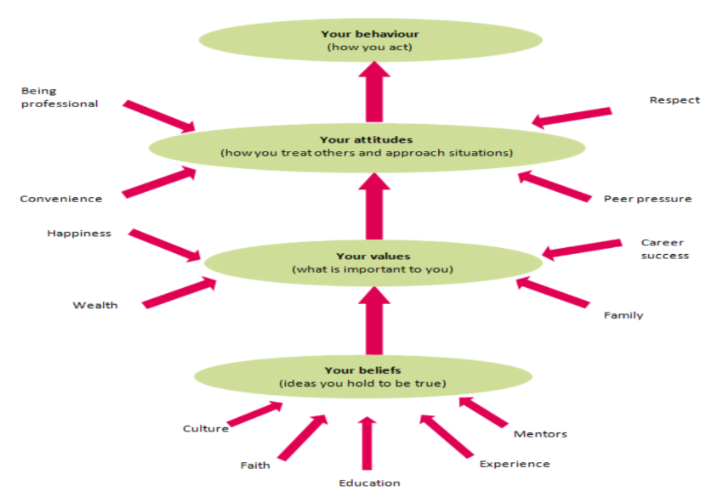
Figure 1: Difference and relationship between Beliefs, values, and attitudes in the workplace.
Source: Lecturesheet
Belief is the basic thing which form other things. The belief can be described as the ideas which are thought as the truth by any particular people. Generally, the belief of an employee of the workplace include the culture, faith, education, experiences, and so on. Beliefs of a person shapes the values of the person (Jones-Devitt and Smith, 2007). The values include the things which are important to the person who has certain beliefs. The values can include the happiness of the person through wealth, families, career success, and so on. The values form your attitude because attitude means dealing or treating others in different approach. The persons set the attitudes by considering the values of them. One can be professional in the workplace, can show respect to others, and so on by considering the values which has formed the attitudes. Finally, the behaviour of person is formed by the attitude of the person.
The beliefs, values, and attitudes are related to each other to form the behaviour of the employees in the workplace (Randolph, 2013). The beliefs of the employees about the workplace will form the values of the employees which will shape the attitudes and will be the behaviour of the employees in the workplace. So, there are differences between beliefs, values, and attitudes but they are related to each other.
Role of Me in Past Workplace
I worked in the Sainsbury for 2 years as the customer service officer and my responsibility was to deal with the experiences of the customers. In the process of working as the customer service manager, I tried to understand about the opinion about the products and services which are offered by the Sainsbury. At the same time, I had to develop strategies to ensure the customers are getting the services smoothly and are satisfied with the services of Sainsbury. In addition, I had to maintain the complaints of customers and had to deal the unsatisfied customers.
My Beliefs, Attitudes, and Values in Sainsbury
Sainsbury has forced to develop the beliefs that it is my own organisation and the success of the organisation is the success of mine. Sainsbury has given me the belief that I can progress toward better career. In addition, the HR department has succeeded to build the belief that I am working for one of the leading supermarkets of the world. But I had some wrong values like focusing on the performance more than capability.
The performance was the main focus of the organisation so the values of the Sainsbury were developed on the performance. After performing any job or activities, I had to evaluate the performances. The concept of professional development has become the value of me in the Sainsbury and it helped me to improve my financial condition in the Sainsbury.
The attitude has developed in a way which ensured that I will focus on the improvement of the performance. As attitude is the expression of the values and beliefs so I have positive attitudes toward performing my activities. In addition, my attitude was toward to the achievement of my personal and overall goals in the Sainsbury. At the same time, my behaviour was toward providing better services towards the customers of Sainsbury.
Particular Management Theory that Support My Role in Sainsbury
Human Relations Theory best suits with the role of customer service manager in Sainsbury because it deals with the relationship with the customers. The basic objective of the human relations theory is to manage the activities of the group dynamic, teamwork, and the social system within the organisation (Harvey, 2018). This theory deals with the process of identifying the influence of changes in the work place to increase the productivity of the organisation. It is believed that the behaviour of the employees will be changed if they are given special attention. In addition, this theory believes that the influence of social factors increase the productivity. Sainsbury has provided special attention on me so that I can develop my beliefs, values, and attitudes which support the objectives of the organisation. In addition, I focused on the performance so it has helped me to provide attention to the customers of the Sainsbury. I have identified the changes in the process and relationship in my working environment so that I can help to use the changes in positive ways to improve the productivity of the services.
According to Rusconi (2018) the human relation approach deals with the need for attention because it is believed and found that the productivity of the employees increases with the attention of the management. In addition, the social interaction is must for the employees of the organisation because it will shape the behaviour of the employees in the workplace. This theory focused on the individual achievement of the employees because the organisation will be able to influence the employees to achieve more through ensuring the individual achievement. Sainsbury has attached me with the process of operations of the organisation so I had developed the value that I will serve with better performances. The interaction with the customers has helped me to develop social interactions which ensured my behaviour in the workplace.
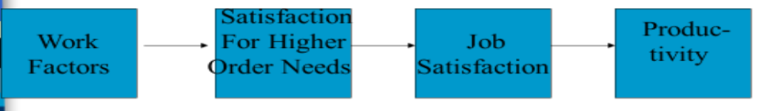
Figure 2: Human Relation Management Theory
Source: Lecture Sheet
But, van Zyl and Bays and Gilchrist (2013) claimed that the theory will not be successful if there are no perfect research and data about the relationship between the needs and satisfaction of the employees within the workplace. In addition, the success of the workplace will not come if the organisation misuse or manipulate the activities of the managers. Attention and job satisfaction are two key issues in this theory and absence of these will create for the success of the organisation. I had to collect data from the customers of Sainsbury through conducting the research. At the same time, I have ensured that I will get the attention of the management of the Sainsbury. The beliefs, values, and attitudes have provided me the job satisfaction which is one of the requirements of applying this theory in the workplace. For that reason, it can be called that the human relation management theory is the best theory which suits with the role of customer service manager in Sainsbury.

Critically assess their own beliefs, attitudes and value systems and their impact on workplace behaviour;
Before understanding the nature of impact of beliefs, attitudes, and value systems on the workplace behaviour, it is important to understand the nature of own beliefs, attitudes, and value systems.
Impact of Beliefs, Attitudes, and Values on Workplace Behaviour
Sustainability of the workplace is influenced by the beliefs, attitudes, and values of the employees of the organisation. The sustainable development is the process of use, development, and protection of the resources so that they can be used for the welfare of the society (Wright, 2016). The sustainable development depends on the values, attitudes, and behaviours of the people because they will take the decisions for the betterment of the society which will provide the life support to the planet. The values, beliefs, and attitudes of employees of Sainsbury has forced to focus on the environmental, economic, social, and political factors which are the components of sustainability. Due to influence of the values and culture, the Sainsbury performs the corporate social responsibility toward the society. My beliefs and values include that I will have to ensure sustainable environment in the workplace. For that reason, I have introduced the customer service in the way which will ensure that the customers will get solutions of all their problems. At the same time, I will use the positive and calm attitudes at the time of providing services to the customers.
Saifulina and Carballo-Penela (2016) described that future proofing is another concept of business which directly related with the values, beliefs, and attitudes which are hold by the business organisation. The sustainability values and culture of Sainsbury has influenced to prepare a product or system which will prevent decay, will have flexibility and adaptability, will improve redundancy, will local and healthy, and so on. Through this process, the future proofing is influenced by the beliefs, values, and attitudes of the employees which will ultimately influence the workplace. Sainsbury has provided the attitude that we will look for the performances which will ensure the future for the organisation and the customers.
The learning about creativity and critical thinking is necessary for decision making in the changing business environment. So, beliefs, attitudes, and values should be form in a way which will help employees to take better decisions in the workplace. The beliefs, attitudes, and value system should be developed in the ways which will help the behaviour of decision making in the workplace with critical thinking.
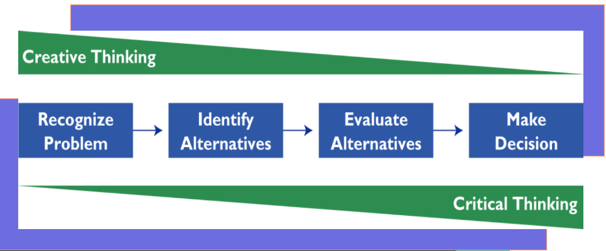
Figure 4: Critical Thinking as the Values or Beliefs in the decision making process in the workplace
Source: Lecture Sheet
So, the beliefs, values, and attitudes influence the problem solving in the workplace of the Sainsbury. Pigza (2015) claimed that the problem solving will look for the information which will form behaviour of the employees to think creatively and critically. In the process of managing the complaints of the customers, I had to develop the skills of decision making because I had to take different types of decisions to solve the problems of the customers. At the same time, my beliefs and values has developed the critical thinking ability which has ultimately helped to focus on quick and effective decision making.
The influence of the beliefs, attitudes, and values on the behaviour of workplace can be explained through De Bono’s 6 hats methods because the behaviour changes in different situation in the workplace. In white hat situation, the behaviour will influence with the available data. The employees will analyse the past data and will try to find out the trends of future. I had to focus on the previous data about the requirements of the customer services by the customers of Sainsbury to take decisions. The Red hats work using intuition, emotions, and reactions which directly influence the nature of working in the Sainsbury. The attitudes of me has helped to manage the situation of red hats. So, the red hat situation of workplace is directly influence by values, beliefs, and attitudes. Through Black hat, the focus is given on the weaker points of the workplace and decisions are taken defensively and cautiously. The employees will focus on the positive issues in the workplace and there will be optimistic attitude within the employees in the workplace in the Yellow Hats. The Green hat situation focus on the creativity in the workplace. So, the beliefs of freedom will affect the situation and the problem solving will be done through freewheel thinking process by the employees. Blue hat focuses on the control of the process in the workplace.
There are employees of different beliefs, values, and attitudes in the workplace so Hat theory will be appropriate for the workplace. The behaviour of the workplace will be determined by considering the influence of the different beliefs, values, and attitudes.
Decision making is another behaviour in the workplace which is directly influenced by the beliefs, values, and attitudes of the employees. The decision making can be called the process of bringing changes to avoid problems in the workplace (Tsalikis and Peralta, 2019). The values and culture of the leaders and employees of the organisation shapes the behaviour of the decision making in the workplace. The beliefs and values of the employees influence the decision making because they decide whether the decision will be centralized or consensus based. The values and attitudes of the employees of Sainsbury has influenced that whether the decisions will be taken by considering the positive or negative issues of the workplace. My role in Sainsbury has forced me to develop the attitudes which helped me to take quick and effective decision to serve the customers in better ways.
Different Management Theories Related to Workplace
Business organisations want to implement the management theories to improve the productivity and quality of the services of the organisations. In modern business world, the business manager do not use single theory to get success rather they use the combination of some management theories depending on the nature and purpose of the workplace. Pugliese and Senna (2018) informed that the basic objective of the management theories is to ensure the effective use of the employees. In the process of performing the role of customer service manager, I had to understand about the management theories. In addition, I had the idea about how these theories help me in performing the role in Sainsbury.
Different Beliefs, Attitudes, and Values to Interpret Management Theories
Scientific Management Theory
The scientific process is followed rather than depending on the brilliance of any particular employees for managing the activities of business. The process of using scientific manner to approach different aspects of the business is called the scientific management theory. There are some scientific tools like research, management, and analysis which are used in the workplace to manage the workplace of the organisation (Wang and Pizam, 2011). In Sainsbury, the time motion studies were influence by the values of the employees in the workplace. The job analysis of scientific management theory has been influenced by the beliefs of the employees about the workplace. The scientific theory believes in written prescribed tasks and ways in the workplace. At the same time, individualization in the workplace is done and the motivation is provided through high wages for the employees. As the Sainsbury mainly focus on the performance and evaluate that the performance is up to the mark or not, so it can be called the use of the scientific management theories. Through using different scientific research technique, I had performed the activities of collecting and analyzing data related to the customer service. So, it indicates the use of scientific management theory in my role in Sainsbury.
It is believed that scientific theory has defined the administrative roles of the employees in the workplace. In addition, it focuses on the supervision of the performance in the workplace rather than focusing on the employees. The specialization of the employees ensure the span of control in the workplace which increase the productivity of the organisation. Again, this theory has developed the engineering for efficiency which influence the production and focus on the quality of the products and services for the organisation. By applying the theory, the management of Sainsbury ensured that whether the employees perform their defined activities or not. In case of customer service, specialization of the employees are done to get idea about that whether span of control has improved the productivity or not.
The criticism related to the scientific management theory is that it is prepared by centering the employees where the employees do not get main focus. In addition, Frynas and Stephens (2014) argued that the human community in the workplace is denied and the employees are aliened from the society. To avoid the criticism in Sainsbury, the organisation has provided some importance on the human because the culture has been developed through positive values and attitudes.
Contingency Theories
This management theory is used to focus on the current aspects which are continued in the workplace of the organisation. The business environment of the workplace play vital part in the application of the theory. The structures and control system is set on the basis of the factors which affect the business activities of workplace. Contingency theory ensures that how the external environmental factors influence the ability of obtaining resources by the organisation. In addition, various department should have the specific implementation of this theory to ensure the access to scare resources (Peretomode, 2012). Furthermore, the changes in the influencing factors, new competitors, economic conditions, and so on are considered by this theory to understand the situation of the workplace.
The influence of the beliefs and values ensure that which will be the best fit management approach to deal with the influence of external environment. On the basis of beliefs and values, the employees will select whether the mechanistic or organic structure according to the theory because the mechanistic structure is for stable environment and organic structure is for changing environment of the workplace. This theory was applied to understand the nature of impact of the changes in the business environment on the activities. For that reason, my role of customer service manager has to use the contingency theory because the nature of demand of customer is ever changing. Sainsbury has developed this attitudes by considering the values and beliefs of the employees so that employees can use the theory if necessary.
Systems Theory
Jones (2008) stated that this management theory works by considering the impact of different systems on the behaviour of the workers in the organisation. System can be defined as the elements which are formed to achieve any particular objectives. The systems theory is used to find out the dynamics of the systems along with the constraints and condition of the system which can be applied for the achieving of the specific goals by the organisation. Through this theory, people will get idea about the ways to analyse, think, and understand about the condition of workplace. In addition, the subsystems of the workplace should work together to be successful. According to the theory the closed systems do not have interaction with the environment and has fixed relationship with the elements of the system. In contrast, the open systems has self-regulation process and can interact with the environment.
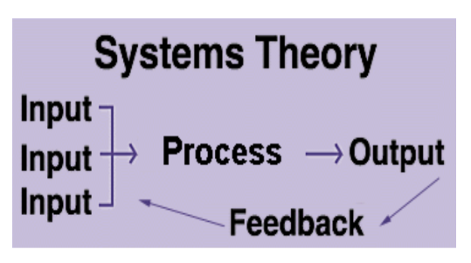
Figure 5: Elements of System Theories
Source: Lecture sheet
The criticism about the system theory is that the theory is more popular in the theoretical way but is difficult to implement in the workplace. At the same time, Wilkinson (2013) argued that there are no specific tools or techniques which can be sued for analyzing the situation of the workplace.
This theory is related with the role of providing customer service in Sainsbury because there are different subsystems which are directly related with this role. The input of the theory is the opinion of the customers of the Sainsbury which are collected and maintained by the customer service manager. At the same time, I need to process the complaints and feedbacks of the customers which works as the process. Finally, I had to solve the problems and need to maintain good relationship with the customers which include the output and feedback system. So, It can be called that the system theories can be applied my role in Sainsbury.
Bureaucratic Management Theory
Some principles are set as the ideal bureaucracy and these principles are followed to manage the business activities of the organisation. Rule based power and hierarchy are the two principles which have formed the bureaucracy theory of management. Through this theory, organisation goes to rigorous division of Labour in the workplace. In addition, Vaidya (2012) indicated that the authority of the workplace is defined to specific persons who are related with the management. The functional authority is provided if the employees have enough knowledge and competencies. The power is distributed in hierarchical ways in the workplace and the processes are defined by the authority. Rather than providing independent beliefs, values, and attitudes, the theory focus on documents and written communication in the workplace. The impersonal communication is promoted in the workplace and the compensation is provided based on the position of the employees in the workplace. The main focus of bureaucracy theory is to minimize the inputs but to maximize the output for the organisation.
There are opportunity to link this theory with my role in the customer service position because I need to follow the principles which are set by the Sainsbury. I have the opportunity to think and decide some issues related to the customer service but I need to follow the principles which are set by the Sainsbury. I don’t have the opportunity to shift in the other section within the organisation because the division of the labour has been done by the Sainsbury. But, there are the opportunity of functional authority, if the person has proper capabilities to manage and perform the functions.

Conclusion
Developing workplace critical thinking will help the organisation to ensure effective and quick decision making which will help the organisation to achieve the goals in effective manner. In the process of developing critical thinking in the workplace, the organisation need to form perfect workplace behaviour. The workplace behaviour of the employees depends on the beliefs, values, and attitudes of the employees. For that reason, the report has focused on different aspects of beliefs, values, and attitudes and their impact on the job roles. At the same time, it has described how different management theories will affect the beliefs, values, and attitudes of the employees.

References and Bibliographies
Aveyard, H., Sharp, P. and Wooliams, M. (2011). A beginner's guide to critical thinking and writing in health and social care. Maidenhead, Berks.: Open University Press.
Caroselli, M. (2011). The critical thinking tool kit. New York: AMACOM Books.
Frynas, J. and Stephens, S. (2014). Political Corporate Social Responsibility: Reviewing Theories and Setting New Agendas. International Journal of Management Reviews, 17(4), pp.483-509.
Harvey, F. (2018). Critical GIS: Distinguishing critical theory from critical thinking. The Canadian Geographer / Le Géographe canadien, 62(1), pp.35-39.
Jones, R. (2008). Nursing leadership and management. New Delhi: Jaypee.
Jones-Devitt, S. and Smith, L. (2007). Critical Thinking in Health and Social Care. London: Sage Publications.
Kumar, M. (2018). The Relationship Between Beliefs, Values, Attitudes and Behaviours. [online] Owlcation. Available at: https://owlcation.com/social-sciences/Teaching-and-Assessing-Attitudes [Accessed 6 Jan. 2019].
Peretomode, D. (2012). Situational And Contingency Theories Of Leadership: Are They The Same?. IOSR Journal of Business and Management, 4(3), pp.13-17.
Pigza, J. (2015). Navigating Leadership Complexity Through Critical, Creative, and Practical Thinking. New Directions for Student Leadership, 2015(145), pp.35-48.
Pugliese, D. and Senna, H. (2018). Business Decision Making: Studying the Competence of Leaders. Revista de Gestão e Projetos, 09(02), pp.01-19.
Randolph, S. (2013). Strategic Thinking. Workplace Health & Safety, 61(1), pp.52-52.
Randolph, S. (2013). Strategic Thinking. Workplace Health & Safety, 61(1), pp.52-52.
Rusconi, G. (2018). Ethical Firm System and Stakeholder Management Theories: A Possible Convergence. European Management Review.
Saifulina, N. and Carballo-Penela, A. (2016). Promoting Sustainable Development at an Organizational Level: An Analysis of the Drivers of Workplace Environmentally Friendly Behaviour of Employees. Sustainable Development, 25(4), pp.299-310.
Tsalikis, J. and Peralta, A. (2019). Priming effects on business ethical decision making. Priming effects on business ethical decision making, 01(01).
Vaidya, K. (2012). Inter-organizational information systems and business management. Hershey, Pa.: Information Science Reference.
van Zyl, M., Bays, C. and Gilchrist, C. (2013). Assessing Teaching Critical Thinking with Validated Critical Thinking Inventories: The Learning Critical Thinking Inventory (LCTI) and the Teaching Critical Thinking Inventory (TCTI). Inquiry: Critical Thinking Across the Disciplines, 28(3), pp.40-50.
Wang, Y. and Pizam, A. (2011). Destination marketing and management. Wallingford, Oxfordshire: CABI.
Wilkinson, T. (2013). Theories of strategic management. Santa Barbara, Calif: Praeger.
Wright, P. (2016). Making Great Theories. Journal of Management Studies, 54(3), pp.384-390.

