
Master of Business Administration
Student Name: Shaikhul Alam Shanto
Student Number: 2504527

Module Code: LCMB7026
Assessment: Individual Report
Course Name: International Marketing: Principles and Practices
Assignment Title: “Comparative Analysis of the International Marketing Mix of KFC in the United Kingdom and India”
Lecturer: Tushara Balendran

Submission Deadline: 24th April 2026

Table of Contents
Introduction 1
Brand Overview: KFC in United Kingdom and the India 2
PESTLE Analysis of KFC in United Kingdom and India. 3
Hofstede’s Cultural Model: UK vs India 6
Comparison of KFC STP Strategies (Segmentation, Targeting, Positioning) United Kingdom and India. 7
Comparison of KFC Marketing Mix Strategies (7Ps): United Kingdom and India. 10
Analysis of the Brand’s Directional Development Strategy in India 14
Evaluation of Ethical Issues Related to the Marketing Mix of KFC in the United Kingdom and India. 15
Recommendations for KFC’s International Marketing Strategies 16
Reflective Account Using Gibbs’ Reflective Cycle of KFC in UK and India 17
Conclusion 20
References 21
Appendix 23

Introduction
International marketing is important at ensuring that multinational firms increase their activities and are able to adapt in various international markets. Firms should be able to adapt their marketing mix to various economic environments, cultural norms and behaviours of the consumers. KFC is a major global brand of the quick-service restaurant and operates in many other markets around the world. This report gives a comparative analysis of international marketing of KFC in United Kingdom and India. The paper assesses the macro-environments through PESTLE model, Hofstede’s Cultural Model, analyses of segmentation, targeting, positioning, marketing mix approaches and Directional Development Strategy to the company to determine how KFC localises its global brand strategy to suit various market environments.

Brand Overview: KFC in United Kingdom and the India
KFC is a fast-food restaurant among the largest brands of the quick-service restaurant (QSR). Colonel Harland Sanders is the founder of the company which was established in 1952 and today owned by Yum! Brands. KFC focuses on buying fried chicken products that have been made using its popular eleven herbs and spices recipe. The company has grown to have a global presence and has franchise operations in over 150 countries and territories across the globe over the decades using a franchising form of business (Yum!). Brands, 2023).
The Mission of KFC is “to serve high-quality, great-tasting food quickly and consistently, while creating a satisfying customer experience and maintaining strong brand values worldwide.”
KFC has had a good market standing in the United Kingdom since it opened its first restaurant in 1965. UK is one of the most mature and lucrative foreign markets of the brand, having over 1,000 stores in the country. Increasing demand of the convenience of dining food, as a result of the popularity of fast food has aided the expansion of the fried-chicken restaurant sector in the UK. KFC has further engaged a lot in modernisation of the restaurants, online ordering, and drive-through services to improve the convenience of the customers and sustain itself in the competitive market of quick-service restaurants (Reuters, 2025).
The India, on the contrary, is a fast-emerging market of KFC. The brand first started in India in 1995 but initially experienced a problem with the existing culture, regulation and fear of western influence in fast-food. In order to overcome these hurdles, KFC implemented the localisation strategy whereby it has introduced a menu that is owed to the taste of Indian consumers such as vegetarian products and local flavours. These corruptions helped the company to be compatible with the cultural food practises and food habits practised in India (Knowledge at Wharton, 2010).
Conclusion: During the last few years, KFC has grown tremendously in India by having franchise associates like Devyani International and Sapphire Foods. The growing demand of international fast-food brands in the country has been facilitated by the rapid urbanisation, the growing disposable incomes, and the growth in the number of middle-class people (Mint, 2024).

PESTLE Analysis of KFC in United Kingdom and India.
“The macro environment consists of larger societal forces that affect the microenvironment, including demographic, economic, natural, technological, political, and cultural forces.” (Kotler and Keller, 2016)
United Kingdom
The United Kingdom macro-environment offers a stable and mature market to the multinational quick-service restaurant brands like KFC.
1. Political
Politically, the UK has a sound political system that is democratic and has established regulatory institutions. The policies of the government focus on food safety, labour protection, and regulating business, which have a direct impact on fast-food companies that are active in the market (UK Government, 2024).
2. Economic
Economically, UK is a developed economy that is high-income with high consumer purchasing power. The fast-food industry in the country is big and well established due to the hectic lifestyle and the requirement to have quick foods. Market reports indicate that the market of quick-service restaurants in the UK is on an expansion path thanks to the rising urbanisation and growth of online food delivery services (Statista, 2025). 3. Social
Fast-food industry is highly encouraged by the social environment. The preference of convenient foods among British consumers is growing because of the busy schedules and work time in busy jobs and businesses. Dining out is typical especially among young customers and those in urban professions. The fact that the culture is open to international cuisine has also helped in the success of American style fast-food eateries like KFC. Nonetheless, the increase in health awareness has also resulted in the rising demand of healthier menu choice and food ingredient transparency (Public Health England, 2023).
4. Psychographic
The psychographic variables in UK are indicative of fast-paced, convenience-driven lifestyle where consumers are concerned with fast food and digital services. Consumers appreciate independence and efficiency which is close to high individualism. Based on the VALS segmentation, KFC is focused on Experiencers that enjoy variety, fun and socialised meals (Solomon et al., 2019; Hofstede Insights, 2025).
5. Technological
The UK has advanced internet penetration and the digital infrastructure in the UK is high in terms of technological factors. Uber Eats and Deliveroo are food delivery apps that have dramatically changed consumer buying behaviour, making fast food more affordable than ever with mobile ordering and delivery, as well as delivery to the home (Statista, 2025).
6. Legal
In terms of legal aspects, the fast-food industry is controlled by the Food Standards Agency, which is very strict in matters of food safety, nutrition labelling, and hygiene practises.
7. Environmental
Furthermore, the environmental issues are also playing an important role in business operations, as there is a growing demand on businesses to lower plastic packaging and minimise carbon emissions in line with national sustainability goals (UK Government, 2024).
India
India is a fast-emerging market with dynamic macro-environment that greatly affects the operations of the multinational restaurant chains like KFC.
1. Political
In terms of politics, India has enacted a number of economic reforms along with foreign direct investment (FDI), policies to promote business growth on the international front. Retail and service industries have also been supported by government policies that have been used to bring and expand international fast-food chains (Government of India, 2024).
2. Economic
India has on the economic front achieved a great growth in the last twenty years with increased urbanisation and growth of the middle-class citizens. Even though the income rates are still mixed, the growing disposable incomes among the city consumers have led to high demands of low-cost quick-service restaurants. The Indian fast-food industry is still growing at a significant pace, especially the metropolis and the growing urban centres (Statista, 2025).
3. Social
India has its own set of challenges and opportunities in terms of the social environment of the international fast-food brands. Cultural practises and religious beliefs greatly affect the consumer behaviour of Indians coupled with their dietary patterns. International restaurant chains also owe their popularity to the fact that family-based culture of dining and the growing exposure to Western ways of life among youthful consumers (Knowledge at Wharton, 2010).
4. Psychographic
Psychographic behaviour in India is informed by good cultural practises, familyistic orientation and the increase in modernity desires. There is a tendency to balance the traditional and global influences among consumers. KFC focuses on the status-conscious, international brands-oriented segment of the market (Strivers) of the VALS segmentation and promotes the development of fast-food consumption (Solomon et al., 2019; Hofstede Insights, 2025).
5. Technological
India has witnessed a strong digital connectivity and mobile internet adoption. Food delivery websites like Zomato and Swiggy have revolutionised the restaurant sector by increasing the availability of fast-foods and promoting e-commerce to order food (Statista, 2025).
6. Legal
Legally, food companies are expected to adhere to the regulations set by the Food Safety and Standards Authority of India that provides standards of food quality, hygiene, and labelling.
7. Environmental
Environmental as well as sustainable packaging and other environmental concerns are also gaining momentum since India is becoming increasingly challenged with the problem of urban pollution and plastic waste (Government of India, 2024).
Comparison
An analysis of the macro-environmental factors of the United Kingdom and India indicates that there are major differences in the macro-environmental factors that affect the international marketing strategies of KFC. The United Kingdom is a mature and economically controlled market with high consumer buying power, well-developed technological infrastructure, and need to eat out on a convenient basis.
In both countries technological use is also increasing at a high rate especially the use of digital food delivery sites. But at the same time when the UK market is devoted to the enhancement of convenience and efficiency in services, the Indian market can be devoted to the affordability and the localisation of the products to suit the varied cultural tastes.

Hofstede’s Cultural Model: UK vs India
Geert Hofstede has come up with a system of cultures that explains how values in society affect behaviour and business practices. When this model is used to apply to KFC in United Kingdom and India, cultural differences are significant in influencing marketing strategies.
UK is a high score on individualism, thereby consuming individuals focus on their tastes and comfort, which justifies the consumption of fast food and fast-food restaurants. It also possesses relatively low power distance which means that the society prefers equality and informal interactions during service provision. India, on the other end, has more power distance and a more collectivist culture, where family and social groups have a significant impact on consumption behaviour. Moreover, the long-term orientation is stronger in India and thus; consumers attach importance to tradition and cultural continuity and this influences the food preferences and acceptance of international brands (Hofstede Insights, 2025).
It is these cultural differences that make KFC modify its menu and marketing tactics to fit local tastes, especially in India by using product localisation (Knowledge at Wharton, 2010).
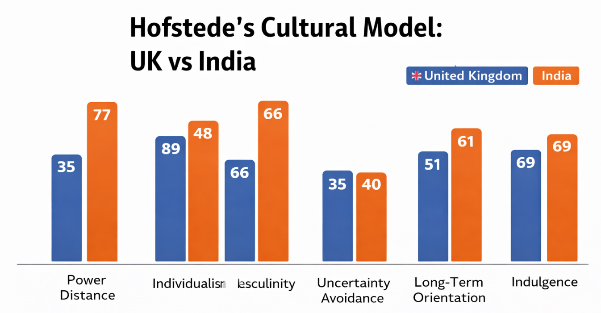
Conclusion: To sum up, the Hofstede model proves that cultural values play a major role in the customer behaviour. The capability of KFC in adapting to these differences increases its performance in the two markets.
Source: Hofstede Insights. (2025).

Comparison of KFC STP Strategies (Segmentation, Targeting, Positioning) United Kingdom and India.
Segmentation, Targeting and Positioning (STP) model is a popular tool in the context of international marketing to identify customer segments and create effective marketing programmes in the various market segments. Multinational brands like KFC have been using STP model to suit their products to the behaviour of consumers, cultural values and economic status in a given nation. The analysis of the United Kingdom and India shows that KFC modifies its marketing strategy to align to different market conditions.
Segmentation
The term market segmentation can be described as a process of segmenting a large consumer market into smaller segments according to demographic, geographic, psychographic and behavioural attributes (Kotler and Keller, 2016). KFC in the United Kingdom has taken demographic and lifestyle as the basic factors that define the market segmentation. The target audience of the brand consists of young people, students, and working adults who like convenient and affordable foods. Busy urban consumers are also one of the key market segments since they tend to use the services of quick-service restaurants either during lunch or dinner. Besides, the UK market can also be observed as undergoing behavioural segmentation, as the frequency of fast-foods consumption, as well as the need to order something to-go or have it delivered, has a certain effect on the buying trend (Statista, 2025).
Segmentation in India, on the contrary, is more complicated because of the diversity of the country culture and income distribution. KFC divides the Indian market according to the demographic and cultural and income. Urban middle-income consumers, students, and young professionals are the main categories of customers as they are more sensitive to the international food trends and Western cuisines. In India, cultural segmentation will be of great significance since religion and tradition play a major role in determining what people eat. The percentage of the population who are vegetarians is high, and this has prompted KFC to launch vegetarian dishes which include paneer food-based dishes and rice meals to attract the local market (Knowledge at Wharton, 2010).
Targeting
Targeting entails choosing certain groups of customers that a firm intends to serve. KFC in the United Kingdom has been focusing on the young adult and middle-income consumers that are seeking affordable and convenient food services in the form of fast-food. A significant target market is the students and the urban workers as they often buy fast foods as a result of their busy schedules and lack of time to prepare meals. KFC also focuses on families with value meal deals and promotion packages to be used by a group (Statista, 2025).
In India, KFC is focusing mainly on the fast-rising population of middle-income and the younger generation who are in the urban population. International fast-food brands are particularly popular among young consumers as they feel that they are associated with the modern lifestyle and world civilization. Furthermore, KFC is also inclined to families that attend fast-food restaurants to enjoy social meals. The brand sells smaller portion sizes and value meals to attract the price-sensitive consumers and this makes the products more affordable to a larger portion of the population (Euromonitor, 2024).

Positioning
Positioning is the way in which a brand is held in the mind of the consumers as compared to the competitors. KFC positions itself as a convenient and affordable brand of fast-food in the United Kingdom that has a unique taste of fried chicken. The marketing campaigns use speed of service, digital convenience and flavourful products as the focus of the company. The focus on humour, brand history and the exclusive secret of the recipe, which Colonel Harland Sanders created, is common in advertising, as well. Brands, 2023).
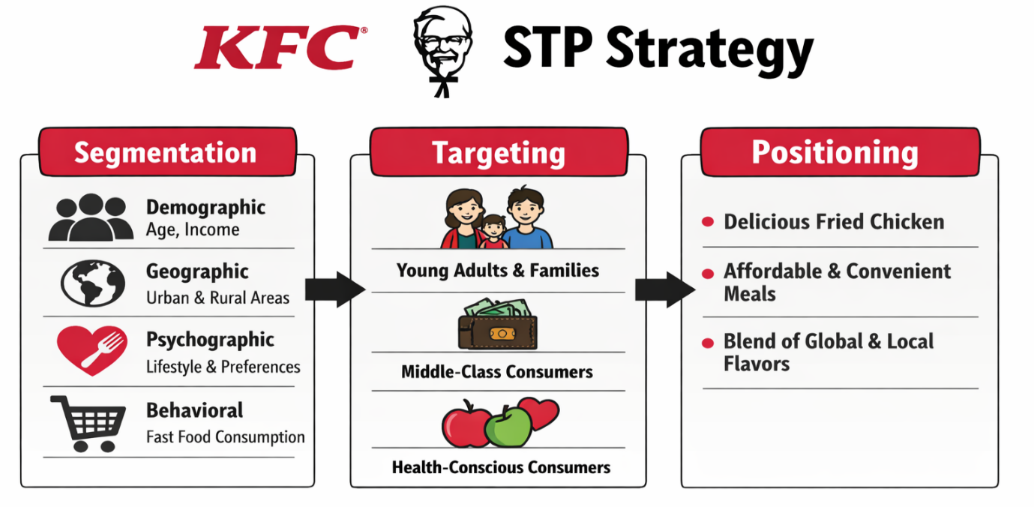
Positioning strategy used by KFC in India focuses on offering modern global experience of dining along with localised menu choices. The brand markets itself as a stylish and aspirational fast-food restaurant, as well as exhibiting cultural sensitivity in terms of localisation of the menu. As an illustration, the global and local brands can be promoted by vegetarian menu items and spicy flavour profiles. Such a positioning strategy can enable KFC to be out of line with the traditional Indian restaurants and yet attractive to the local tastes and cultural expectations (Knowledge at Wharton, 2010).
Source: KFC, 2026
Conclusion: In general, the comparison reveals that, although KFC has a similar global business strategy in the form of the fried chicken products and convenience, its segmentation, targeting and positioning policies differ much between the United Kingdom and India. The adaptations enable the brand to adapt well to the various consumer behaviours, cultural norms and economic conditions in every market.

Comparison of KFC Marketing Mix Strategies (7Ps): United Kingdom and India.
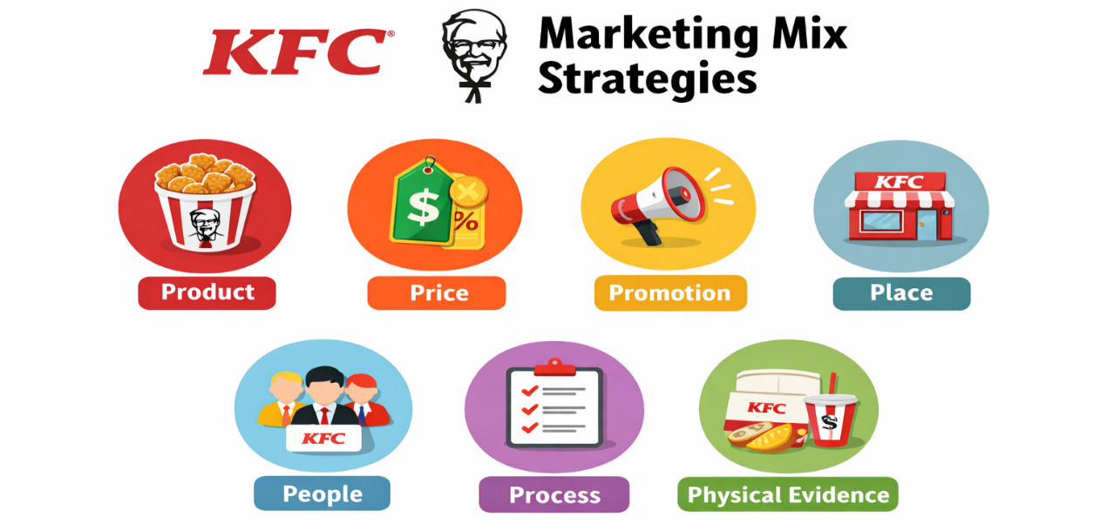
International marketing mix is the strategic application of product, price, place, promotion, people, process and physical evidence at meeting customer demands at various markets across the globe. These components are usually modified in response to cultural, economic and competitive variations in different nations by multinational companies. KFC uses the flexible international marketing mix strategy to retain the global brand identity and react to the local market conditions. The comparison of the United Kingdom and India shows how KFC modifies its aspects of the marketing mix to the specific demands of the consumers in developed and emerging markets.

Source: KFC, 2026
1. Product
Among the most important differences between the operation of KFC in the United Kingdom and India, product adaptation can be identified. The menu in the UK market has been mostly dedicated to the conventional fried chicken foods including chicken buckets, burgers, wraps and fries. These products indicate the western consumerism tendencies towards fast food containing meat and ready-to-eat meal portions. KFC, periodically, can also give menu innovation in the form of limited-time offers, including spicy chicken, or new burger flavours, to ensure its customers remain interested and in competition with other quick-service restaurant brands (Statista, 2025).
Product adaptation, on the other hand, is far greater in India because of the cultural and religious restrictions to food. A huge percentage of the Indian consumers are vegetarian and consumption of beef is ethnically sensitive in most areas. This has led KFC to offer localised products like paneer burgers, rice bowls and vegetarian wraps which are vegetarian products. Also, the company has added stronger spices and flavours in its menu in order to adapt to the Indian culinary preferences. This localisation approach enables KFC to retain its main product image, and make its products culturally relevant, as well as attractive to the Indian consumers (Knowledge at Wharton, 2010).
2. Price
The purchasing power and economic conditions also differ significantly in the two markets, which explains the differences in the pricing strategies. KFC pricing strategy in the United Kingdom is competitive and is in line with other quick service restaurants chains. The pricing is expected to be more expensive than in emerging markets, but the consumers in the UK tend to have larger disposable incomes, and this gives the company the luxury of charging relatively high prices to some of its menu items. Promotional discounts are often combined with group purchases and using combo meals to encourage higher values of transactions (Euromonitor, 2024).
The consumers sensitivity to prices in India is significantly more as the average income level is less and there is intense competition of local fast-food stores. As a result, KFC uses the value-based pricing model, as it provides low-priced meals and reduced portions. Cheap and value meals would be used to attract students and middle-income consumers. This pricing flexibility will help the company to tap more customers and stay profitable in a highly competitive market (Statista, 2025).
3. Place (Distribution)
The various market structures are also translated in the distribution strategies of the United Kingdom and India. The KFC restaurants are well distributed in busy places like city centres, shopping malls or transport centres in the UK. The convenience that the brand focuses on is also provided with the drive-through restaurants and the solid relationships with online food delivery services. E-commerce platforms to order food like Uber Eats and Deliveroo are very important in enhancing accessibility and maximising sales using the home delivery system (Statista, 2025).
In India, KFC distribution strategy would target major urban centres and urban centres that are developing at a high pace. The restaurants are usually found in the shopping malls, high-street retail areas and commercial districts of middle-class consumers. Smaller cities are also becoming more popular expansion strategies as the development of new opportunities of the fast-food brands under the influence of urbanisation and income growth. The food delivery services like Zomato and Swiggy have also greatly helped KFC increase its market coverage in India (Euromonitor, 2024).
4. Promotion
The two markets also have differences in promotional strategies because of cultural differences and consumer behaviour differences. KFC advertisements in the United Kingdom frequently employ humour, brand history and nostalgia based on the heritage of the brand, and its founder, Colonel Harland Sanders. Influencer marketing and social media campaigns and digital advertising are significant to attract younger consumers. The promotional services like the limited time menu and discount deals are commonly utilised to keep the repeat customer coming back (Yum!). Brands, 2023).
Promotional campaigns are also commonly focused on the aspirational lifestyles in India, youth culture and social experiences in relation to being served in international restaurant brands. The local languages, Bollywood style narration, and themes, which are local and culturally relevant, are often used in advertising so as to reach the minds of the Indian audiences. Another marketing tool is celebrity endorsement and promotions done related to the festivals. These marketing variations would enable KFC to enjoy emotional attachment with the local consumers and brand awareness in an already highly competitive fast-food industry (Knowledge at Wharton, 2010).
5. People
People factor in the marketing mix is the employees and customer service relations. In the UK, KFC focuses on the effective service provision and online ordering platforms that save time and make it convenient to customers. The employee training is aimed at ensuring the continuation of service quality and the hygiene level, which matter to the customers of the developed markets (Euromonitor, 2024).
In India, customers receive a warm feeling provided by employees. As eating out is a communal practise in India, customer service and hospitality is also of great significance. KFC thus invests in employee training so that they can be able to interact with their customers and offer them culturally acceptable service experiences (Statista, 2025).
6. Process
The two countries also differ in terms of operational processes. The use of technology in service delivery via self-service kiosks, mobile ordering and digital payments services have greatly enhanced efficiency in service delivery in the United Kingdom. These innovations comply with the demand of consumers to receive a quick and convenient service (Statista, 2025).
Digital ordering in India is also increasing at a very high rate, but the use of the traditional counter service is still prevalent. Nevertheless, a rising number of mobile payment systems and food-delivery solutions have increased the rate of digital transformation of the Indian quick-service restaurant market (Euromonitor, 2024).
7. Physical Evidence
Physical evidence is the material aspects that create the perception of the brand to the customers. The KFC restaurants in the United Kingdom are also organised in a modern fashion so as to create a modern dining atmosphere with comfortable seating and digital ordering kiosks. The company has a global brand identity which is maintained by cleanliness, brand colours and standard restaurant layouts. Brands, 2023).
The restaurant settings in India usually blend the global aesthetics of international brands with the local design motifs to attract local consumers. Well, its interiors, family seating and picture menu display will be used to establish a hospitable environment that will lengthen the duration of dining and visiting the restaurant as a team.
Conclusion: Conclusively, a comparison between the international marketing mix strategies used by KFC in the United Kingdom and India reveals the need to adjust the marketing strategies to fit the local market conditions. Though the brand has a stable global image based on its fried chicken products and heritage, there is a large difference in product offerings, pricing strategy, promotional strategy, and distribution channel. Such adaptations are to a big extent determined by the cultural values, the consumer behaviour and the economic conditions in a given country.

Analysis of the Brand’s Directional Development Strategy in India
Directional development strategies describe the process of increasing the market share and attaining long-term growth of the companies in a specific market. In the case of multinational customers of fast foods like KFC, penetration and development of a market, and product adjustment to the environment are strategies that can tend to expand into emerging economies.
Market penetration is one of the most crucial strategies that KFC employs in India in an attempt to enhance the brand in the pre-existing markets. Since its entry in India in 1995, the firm has slowly increased its stores in major metropolitan cities in India like Delhi, Mumbai and Bangalore. The expansion strategy will be based on opening restaurants in shopping malls and commercial centres, as well as high-traffic urban areas where middle-class customers make regular visits. In this way, KFC will be able to raise brand awareness and attract a greater portion of the fast-growing market of quick-service restaurants (Euromonitor, 2024).
Product development and localisation is another important aspect of the directional development strategy of KFC in India. The need to food consumption in India is highly dependent on the cultural and religious inclination with a significant percentage of the population adhering to the vegetarian diet. In order to accommodate these local cultural tastes KFC has produced some locally prepared menu foods like vegetarian burgers, rice bowls and spicy chicken dishes that cater to the Indian taste. The product adaptation approach will allow the company to be culturally relevant without losing its global brand (Knowledge at Wharton, 2010).
Another strategy KFC has embraced has been strategic partnership in the form of franchise operators which include Devyani international and sapphire foods Also, online delivery intermediaries like Zomato and Swiggy have facilitated the expansion of the company by enhancing the availability of urban customers (Statista, 2025).
Conclusion: Lastly, KFC directional development strategy in India is conducted on a market penetration strategy, product localisation and strategic franchising. These measures allow the company to grow very fast and adjusting to local cultural tastes and economic environment.

Evaluation of Ethical Issues Related to the Marketing Mix of KFC in the United Kingdom and India.
Ethics is a growing significant factor in the international marketing strategy, especially among multinational food industries doing business in different markets. There have been a number of ethical issues surrounding KFC marketing mix in the United Kingdom and India. Such issues are largely related to the health concerns, animal welfare and the sustainability of the environment.
Among the major ethical concerns is the question of public health that is related to the intake of fast-food. KFC products usually contain a high level of calories, salt and fat that might cause health complications like obesity and heart diseases. The consumption of fast food by the young consumers has been an issue of concern by the public health organisations in the United Kingdom. Consequently, the government has established tougher measures on nutritional labelling and advertising behaviours to promote a healthy eating habit (Public Health England, 2023).
The other ethical concern is in regard to the animal welfare practises in the poultry supply chain. The fast-food companies have been condemned by animal rights organisations due to sourcing of chicken to suppliers who may not be having the required standards of welfare. Such organisations like People for the Ethical Treatment of Animals have launched campaigns that have motivated fast-food brands to use more humane sourcing policies. In its turn, KFC has committed itself to the enhancement of the welfare of animals, as well as to the growth of supply chain transparency (PETA, 2024).
Another ethical challenge is in terms of environmental sustainability. The fast-food sector has come under attack due to a high production of packaging waste, especially the single-use plastics that are being used to package take-aways. To deal with these issues, KFC has already initiated programmes like recycling and waste cutting in the form of packaging and programmes (Yum!). Brands, 2023).
Conclusion: To sum up, although KFC has enjoyed immense success in most parts of the world, the marketing mix has indicated its ethical issues concerning the health of the populace, animal welfare, and environmental sustainability. These problems should be solved by responsible sourcing, healthier products and sustainable packaging to ensure that the consumers remain loyal to the company and contribute to the long-term image of the brand in the two markets.

Recommendations for KFC’s International Marketing Strategies
In order to sustain its growth and competitiveness within the fast-foods sector in the global arena, KFC ought to continue enhancing its international marketing plans in both the United Kingdom and India. In the strategic plans that the company can take, the following are the recommendations:
- Expand healthier menu options
- Add more grilled chicken, low-calorie dishes and plant-based options to react to growing levels of health consciousness among the customers, especially in the UK market.
- Be more transparent in nutritional information both on menus and online to help consumers make healthy decisions.
- Strengthen localisation strategies in emerging markets
- Keep localising menu products in response to local preferences and eating habits in India.
- More veggies and local-style dishes should be added to the menu to meet the needs of different cultures.
- Enhance digital marketing and online engagement
- Invest more in online ordering systems, mobile applications and online delivery relationships.
- Move younger consumers in both markets to use social media marketing, influencer partnership and personalised promotions.
- Improve sustainability and environmental practices
- Less single-use plastic packaging and more recyclable / biodegradable materials.
- Adopt greener supply chain activities to enhance corporate social responsibility and brand image.

- Expand into emerging urban markets
- In India, it should put emphasis on developing restaurant outlets in the fast-developing tier-2 and tier-3 cities where the demand towards international fast-food brands is growing.
Conclusion: Finally, the need to empower healthy product innovation, localisation policies, digital exchange and sustainability campaigns will empower KFC to improve its global marketing activities. The company can preserve the competitive advantage in developed and emerging markets by balancing global brand consistency and adopting local consumer needs.

Reflective Account Using Gibbs’ Reflective Cycle of KFC in UK and India
Reflective practise is a significant learning process that enables one to reflect on the experiences and enhance their knowledge and skills. The reflective cycle of Graham Gibbs offers a systematic approach to the analysis of learning experience in six stages description, feelings, evaluation, analysis, conclusion and action plan (Gibbs, 1988). This reflective report is a discussion of the procedure taken in conducting research, analysing and putting together the report on the international marketing strategies of KFC in the United Kingdom and India.
Description
This assessment was aimed at analysing and comparing the KFC international marketing mix strategies in two countries. To accomplish the assignment, I chose KFC as the target brand as it is a global corporation that shows sound and effective localisation strategies in various markets. I then selected the two countries as the United Kingdom and India to compare them as they have different economic conditions, cultural attributes and consumer behaviours.
The process used to conduct the research was secondary data collected using academic books, journals, industry reports and reliable online sources. The analysis was organised using frameworks of PESTLE analysis, STP and international marketing mix (7ps). I looked at how KFC will modify the product, pricing, promotion and distribution strategies to suit the cultural variations and economic factors of the two markets. I have completed the analysis and compiled the findings in various parts after the analysis, and they consist of market analysis, marketing mix comparison, ethical considerations and strategic recommendations.
Feelings
I was a little bit confused as to how to structure a thorough international marketing analysis at the onset of the assignment. The work demanded the usage of a number of theoretical models and incorporation of scholarly materials, which seemed to be difficult at first. But as I developed the research process, I gained more confidence in the fact that I was able to find the relevant information and put the marketing theories into practise.
The topic was also of special interest to me since it emphasised that global brands need to change their approach to local consumer tastes. The comparison of the UK and Indian markets has enabled me to build a more comprehensive perception of the cultural and economic factors that have an impact on the international marketing decision making.
Evaluation
All in all, the process of conducting research and preparation was a good learning experience. Among the strengths of the assignment, the chance to implement theoretical marketing concepts to a real-life company could be identified. Applying models like the PESTLE and STP allowed me to organise the analysis in a logical way and get to know the influence of the macro-environmental factors on business strategies.
Analysis
Considering the experience in general, the assignment made me realise how vital the change of marketing strategies in various international markets could be. The juxtaposition of the United Kingdom and India clearly indicates that the cultural and economic disparities actually determine the consumer behaviour and marketing choices.
To take an illustration, PESTLE analysis indicated that the UK is a highly developed and regulated market whereas India is a very fast emerging market and has a wide range of cultural backgrounds. It is due to these differences in the environment that KFC uses varying methods of marketing across countries. In India, the company presents vegetarian menu and sharper flavours to local tastes, but in the UK the company is more convenience-oriented, digitally ordering products, and innovating product development.
Conclusion: To sum up, this assignment helped me to gain a better insight into the field of international marketing strategies and the real-life usage of marketing frameworks. The analysis process enabled me to gain analytical and understand the ways of how international firms evolve their functions to fit various cultural and economic backgrounds.
Action Plan
To enhance my research and analytical abilities in future academic projects, I will also aim to begin research process with more time and visit a larger variety of academic journals and industry reports. This will enable me to get more evidence which are more detailed and come up with better arguments.
I will also concentrate on my critical analysis improvements, which involve comparing various points of view with each other and estimating the strengths and weaknesses of various approaches to marketing.
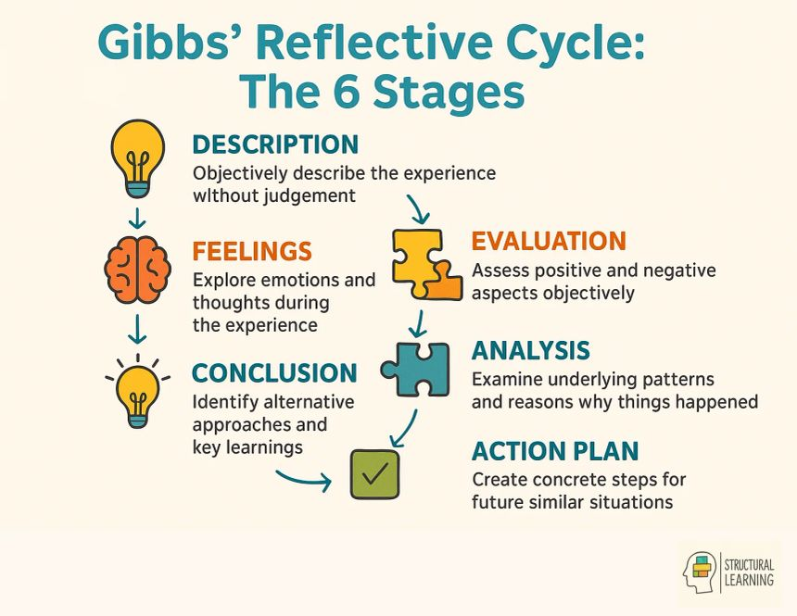
In general, the use of the reflective cycle of Gibbs has enabled me to critically analyse my learning process, and what areas are worth improving on. The reflective practise will help me to further my growth as a marketing student as well as improve my capacity to interpret complex business environment in future academic and professional contexts.

Conclusion
Conclusively, the comparative analysis shows that KFC successfully adjusts its international marketing strategies to the various market settings. The discussion of the United Kingdom and India reveals how the value of cultures, the situation of the economy and consumer behaviour impacts on marketing judgments. Although the brand has a consistent global identity, the elements of marketing mix are changed to fit the local preferences. This kind of strategic adaptation helps KFC to be competitive and continue with long term growth in both developed and emerging markets.

References
Euromonitor. (2024) Consumer foodservice market analysis. Available at: https://www.euromonitor.com (Accessed: 11 March 2026).
Knowledge at Wharton. (2010) Changing habits: Finding a new recipe for success in India’s food markets. Available at: https://knowledge.wharton.upenn.edu/article/changing-habits-finding-a-new-recipe-for-success-in-indias-food-markets/ (Accessed: 11 March 2026).
Statista. (2025) Quick service restaurant market statistics. Available at: https://www.statista.com (Accessed: 11 March 2026).
UK Government. (2024) Food safety and environmental sustainability policies. Available at: https://www.gov.uk (Accessed: 11 March 2026).
Public Health England. (2023) Healthy eating and nutrition guidelines. Available at: https://www.gov.uk/government/organisations/public-health-england (Accessed: 11 March 2026).
Food Safety and Standards Authority of India. (2024) Food safety regulations and standards. Available at: https://www.fssai.gov.in (Accessed: 11 March 2026).
Yum! Brands. (2023) KFC global brand information. Available at: https://global.kfc.com (Accessed: 11 March 2026).
PETA. (2024) KFC animal welfare campaigns and corporate responsibility. Available at: https://www.peta.org (Accessed: 11 March 2026).
Government of India. (2024) Foreign direct investment policy and retail sector development. Available at: https://dpiit.gov.in/foreign-direct-investment (Accessed: 11 March 2026).
Kotler, P. and Keller, K. (2016) Marketing Management. 15th edn. Harlow: Pearson Education.
Gibbs, G. (1988) Learning by Doing: A Guide to Teaching and Learning Methods. Oxford: Oxford Polytechnic.
Devyani International. (2023) Franchise overview: KFC operations in India. Available at: https://www.devyani.in (Accessed: 11 March 2026).
Sapphire Foods. (2023) KFC India franchise information. Available at: https://www.sapphirefoods.com (Accessed: 11 March 2026).
Uber Eats. (2025) Food delivery market insights. Available at: https://www.ubereats.com (Accessed: 11 March 2026).
Deliveroo. (2025) Quick-service restaurant delivery trends in the UK. Available at: https://www.deliveroo.co.uk (Accessed: 11 March 2026).
Zomato. (2025) Indian online food delivery platform statistics. Available at: https://www.zomato.com (Accessed: 11 March 2026).
Swiggy. (2025) Food delivery market data and trends in India. Available at: https://www.swiggy.com (Accessed: 11 March 2026).
People for the Ethical Treatment of Animals (PETA). (2024) Global fast-food ethical campaigns. Available at: https://www.peta.org (Accessed: 11 March 2026).
Knowledge at Wharton. (2010) KFC’s local adaptation strategy in India. Available at: https://knowledge.wharton.upenn.edu/article/kfcs-local-adaptation-strategy-in-india/ (Accessed: 11 March 2026).
Solomon, M., Bamossy, G., Askegaard, S. and Hogg, M. (2019) Consumer Behaviour: A European Perspective. 7th edn. Harlow: Pearson Education.
Hofstede Insights. (2025) Country comparison tool. Available at: https://www.hofstede-insights.com/country-comparison/ (Accessed: 12 March 2026).
Knowledge at Wharton. (2010) Changing habits: Finding a new recipe for success in India’s food markets. Available at: https://knowledge.wharton.upenn.edu/article/changing-habits-finding-a-new-recipe-for-success-in-indias-food-markets/ (Accessed: 12 March 2026).

Appendix
Supporting Data for Comparative Analysis of KFC in the UK and India
Appendix A: PESTLE Comparison Summary
Factor | United Kingdom | India
Political | Stable political environment and strict food safety regulations | Government support for FDI but complex regulatory environment
Economic | High-income economy with strong purchasing power | Emerging economy with rising middle-class consumption
Social | High demand for convenience food and delivery services | Preference for spicy flavours and vegetarian options
Technological | Advanced digital ordering and delivery infrastructure | Rapid growth of food delivery apps such as Zomato and Swiggy
Legal | Strict labour and food safety regulations | Food Safety and Standards Authority of India regulations
Environmental | Strong focus on sustainability and waste reduction | Growing environmental awareness and plastic reduction policies

Appendix B: Growth of KFC Outlets in the UK and India
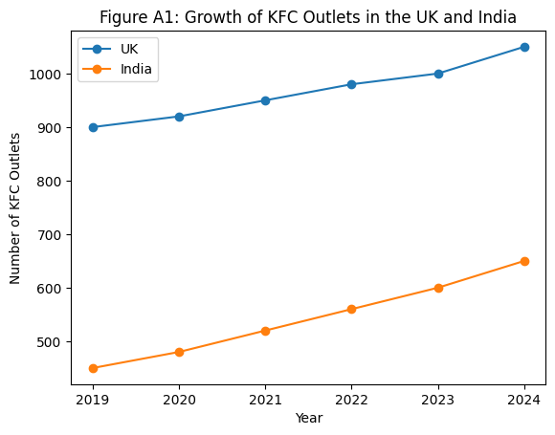
Source: Adapted from industry reports and company information (Statista, 2025; Yum! Brands, 2023).
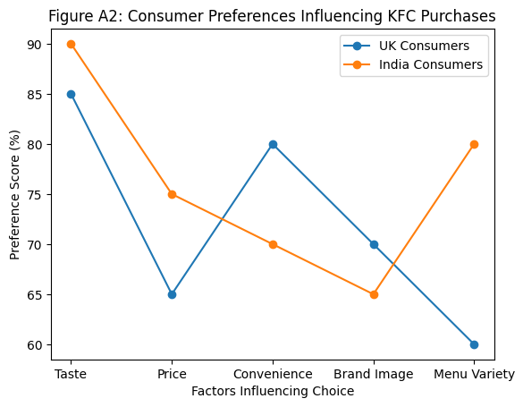
Appendix C: Consumer Preferences Influencing KFC Purchases
Source: Illustrative survey results compiled for academic analysis of consumer behaviour in the UK and India.

Appendix D: Marketing Mix Highlights (7Ps)
Marketing Mix Element | United Kingdom | India
Product | Original chicken, burgers, wraps, plant-based options | Chicken buckets, rice bowls, spicy flavours, vegetarian options
Price | Premium fast-food pricing | More affordable pricing to attract middle-class consumers
Place | High street outlets, drive-through, delivery platforms | Shopping malls, urban centres, delivery apps
Promotion | Digital campaigns and influencer marketing | Celebrity endorsements and festival promotions
People | Customer service training and brand experience | Local staff with cultural understanding
Process | Digital ordering kiosks and mobile apps | Mobile ordering and fast takeaway services
Physical Evidence | Modern restaurant design and branding | Localised store design and family-friendly environment

