B
Developing Innovation and creativity for business advantage
BA Leadership and Management Skills for the Workplace BMSW6102

July 10, 2023
sABRINa REID - 1920873
Lecturer: Dr Abdullah Ijaz

Table of Contents
Bee Ables Innovative Service Proposition 2
Introduction 2
Innovative Product to Sell and How the Product Is Innovative 2
Where/ How Sales of Product and Service 3
Unique Selling Point 3
Product and services 4
Competitors in this field, what are they doing and how they sell their service. 5
Emerging Customer Needs and Wants Service Attends to 6
How Bee Ables Services Attends to the Emerging Customer Needs and Wants Service 9
Bee Ables Competitive Advantage 10
How Bee Ables value proposition is different from the competitions?**** how Bee Able is Providing some value to customers that other competitors are not. 10
Conclusion 13


Image 1, Source: Author

Bee Ables Innovative Service Proposition

Introduction
Studies frequently demonstrate the significant value of organizations innovative strategic concepts. With the aim to identify and meet new consumer requirements, for business innovation and performance, 'Bee Able', a fresh contemporary wheelchair designing company, has developed a commercially viable, contemporary-designed kneel chair that addresses the diverse needs and interests of those who use this product as an innovative service proposition.
Innovation refers to adjustments and enhancements made to technology, goods, operations, and services that are beneficial for customers and other stakeholders in a commercial organisation Rainey, (2005).

Innovative Product and services

The Kneel Chair
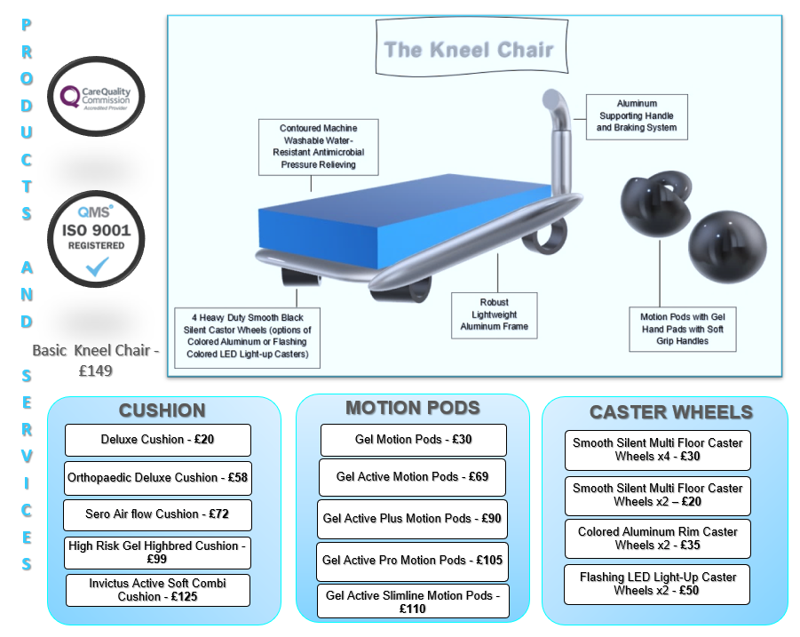
Image 2, Source: Author
The Bee Ables Kneel Chair is a brand-new, state-of-the-art device designed specifically to assist people who have temporary disabilities or limited to moderate mobilities who experience access-related restrictions in areas such as the office, landings, bedrooms, narrow hallways, kitchens, or even bathrooms. By assisting them to live a higher quality of lifestyle within their homes, places of employment, places of learning, and perhaps more importantly when they are visiting relatives and close friends. Through fulfilling the needs recognized by individuals with disabilities while providing more significant mobile accessibility, the Kneel Chair can give individuals an entirely fresh perspective on daily life. The Kneel Chair additionally boosts equality, integration, socialization, independence, dignity, mobility, and a sense of security, with the amenities aimed at improving the overall quality of their daily lives. According to (Haag, 2013), "the aim of the product service & description is of providing a description of the product or service provided. emphasized distinctive features consist of those which stand out and present an advantage over the competition.

Where/ How Sales of Product and Service
Bee Ables products and services are offered through the e-commerce marketplace, utilising stores such as, Bee Ables, Sunrise Medical, Amazon, and eBay where customers can browse through the online catalogue, and select the items they desire, enabling them to use their creativity when designing their Kneel Chairs specifications during their ordering. With a pop-up text support engine to assist the customers, in conjunction with access to online customer services. In addition to in person, using a physical store to cater to clients who require personal appointments regarding weighing, measuring, and testing for tailored specifications.
Bee Ables Market Sales Strategies
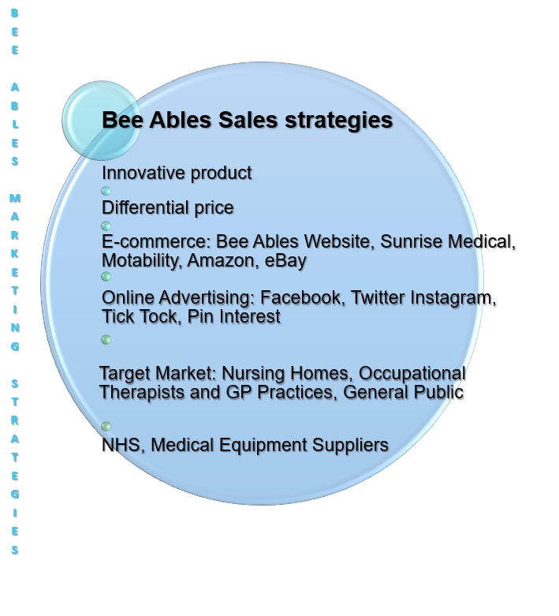
Image 3, Source: Author

Unique Selling Point
For those with low to moderate mobility, there are currently no other competing items on the market that offer this special product or service, instead, my closest competitors include manual wheelchairs, walking sticks, wheeled walking frames, and powered wheelchairs. The Kneel Chair is a brand-new, original, and distinctive product that is a customised wheelchair that is not only light and portable with swivel wheels but also comfy and environmentally friendly, that has yet to become available on the market.
While maintaining a sturdy aluminium frame, it provides those with limited mobility or moderate abilities with increased independence, for instance when they need to use the restroom at a friend's or relative's house. The user slides onto the pressure-relieving cushion that is located on top of the Kneel Chair frame and can access the seating area by using the grabrails on either side of the chair and a sliding board. The Kneel Chair is lightweight and can be easily carried upstairs.
The user may then fold down the grabrails, which also releases the brake mechanism, once they are comfortable sitting with their legs crossed or kneeling down. The user may then put their hands in the motion pods and start to sketch while rolling on any landing or corridor, gaining access as they turn into a small bathroom, where they can replace the brake system to easily use the lavatory. Any other area of the property where a wheelchair would be too big, bulky, or heavy to enter could easily be accessed using the same procedure.

Emerging Customer Needs and Wants Service Attends to
Wheelchair users often find difficulties utilising the bathroom amenities within other people’s homes, whilst visiting, as some houses retain long narrow corridors, small narrow bathrooms, or upstairs lavatories at the end of a long landing. Bee Ables Kneel Chair is a brand-new, innovative device designed specifically to assist people who have temporary disabilities or live with limited to moderate mobilities who experience access-related restrictions within these areas, maybe to gain access from one room to another or within a room in any property that may not be wheelchair accessible or adapted to meet the need of a wheelchair user.

Bee Ables Competitive Advantage
The clear advantage over competitors is the assistance provided to wheelchair users and individuals with limited to moderate abilities to live a higher quality of life inside their homes, the workplace, and schools, and perhaps more importantly, the freedom and peace of mind to visit relatives and friends whose homes are not particularly wheelchair friendly. A few of the leading UK e-commerce firms for mobility and handicap aids and equipment. However, none of these devices can provide the user with the additional independence that the Kneel Chair can.
The Kneel Chair has the power to give people a completely new perspective on daily life by enabling and meeting the needs acknowledged by people with disabilities while providing more significant mobile accessibility. This will improve equality, integration, socialisation, independence, dignity, mobility, a sense of security, and a sense of self-confidence with the amenities aimed at improving the overall quality of their everyday experiences. The following conclusions were reached after doing competitive research and gathering information from potential rivals to examine the market:
Bee Ables Market Audit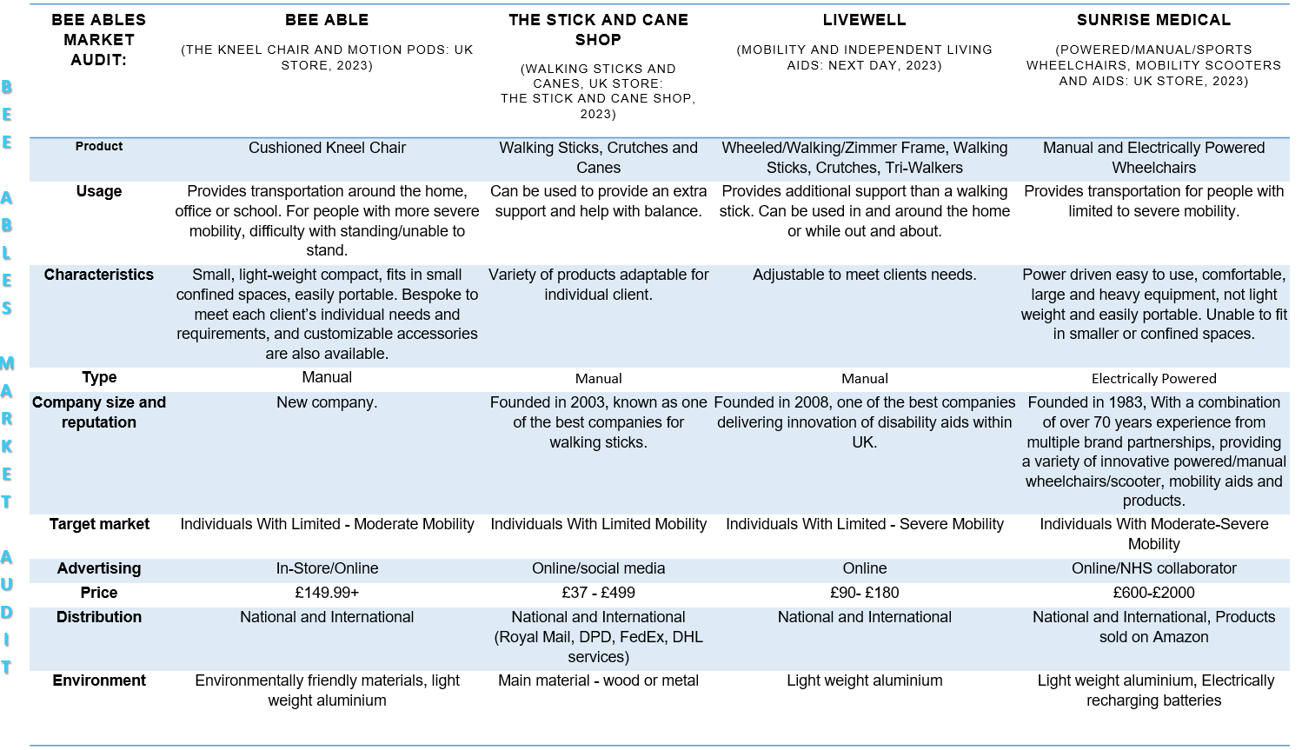
Image 4, Source: Author

Competitors in this field, what are they doing and how they sell their service.
Sunrise Medical, a leading e-commerce company that provides innovative disability aids and equipment in the UK, as well as maintaining distribution and sales offices in 8 countries, 10 countries with manufacturing sites, and distribution across 130 countries, employs over 2000 associates globally and is a significant rival of Bee Able. Sunrise Medical was founded in 1983. For customers with limited to severe mobility, Sunrise Medical offers a wide selection of manual and electrically powered wheelchairs, as well as a variety of mobility aids and accessories.
However, powered wheelchairs are neither lightweight nor compact, and more crucially, they cannot be folded and put in a car's trunk, instead, they must be physically pushed into accessible cars and to accessible locations. The manual and sporting wheelchairs are collapsible, portable, and made of lightweight aluminium. However, neither of these wheelchairs is as portable or adept at navigating confined spaces as the Kneel Chair. Sunrise offers wheelchairs starting at £600 through their web store. Able. For customers with limited to severe mobility, Sunrise Medical offers a wide variety of manual and electrically driven wheelchairs, as well as a variety of mobility aids and accessories.
The Stick and Cane Shop, a fiercely competitive business in the market founded in 2003, offers a wide selection of walking sticks, crutches, and canes that assist those with temporary or limited mobility. Crutches and walking sticks give people the additional support and assistance they need to maintain their balance while walking. Additionally, they provide walking sticks that may be adjusted to the user's height needs. Walking sticks, crutches, and canes may assist a person navigate into tight areas while being lightweight, portable, and simple to store. Nevertheless, in order to use this assistance, the user must be able to bear their own weight and walk to some extent.
Originated in 2008 Livewell one of the top online retailers of devices for independent living and mobility is Livewell in the UK. Livewell evolved from its initial days as an online marketplace to supply used-for-demonstration and reconditioned products to include new completed products across a variety of categories such as wheeled walking frames, and walking sticks. Currently fully established as one of the top e-commerce companies in the UK for disability and mobility aids and devices. However, none of these devices can provide the user with the additional independence that the Kneel Chair can.


How Bee Ables value proposition is providing some value to customers that other competitors are not.
Through carrying out target market research and collected data from potential consumers, to analyse the demographic behaviour of the market demand the findings are as follows:
Target Market Questionnaire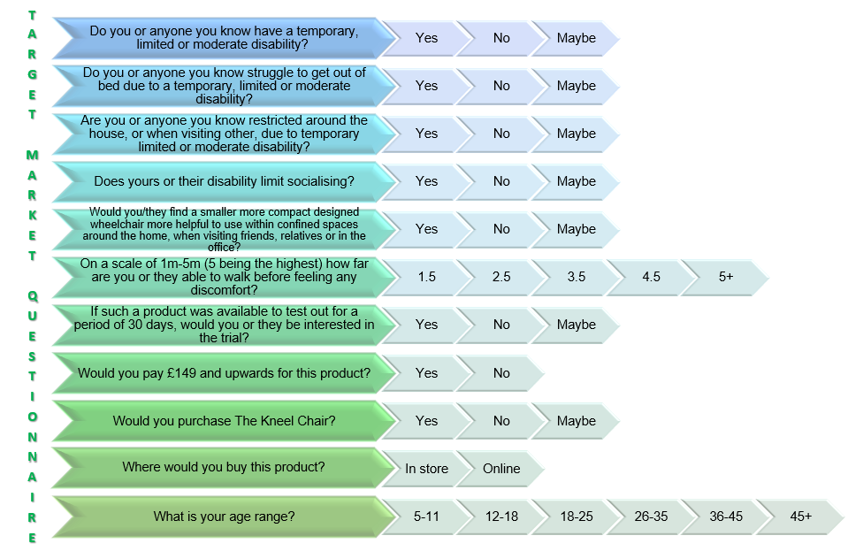
Image 5, Source: Author
Target Market and Demographic Behaviour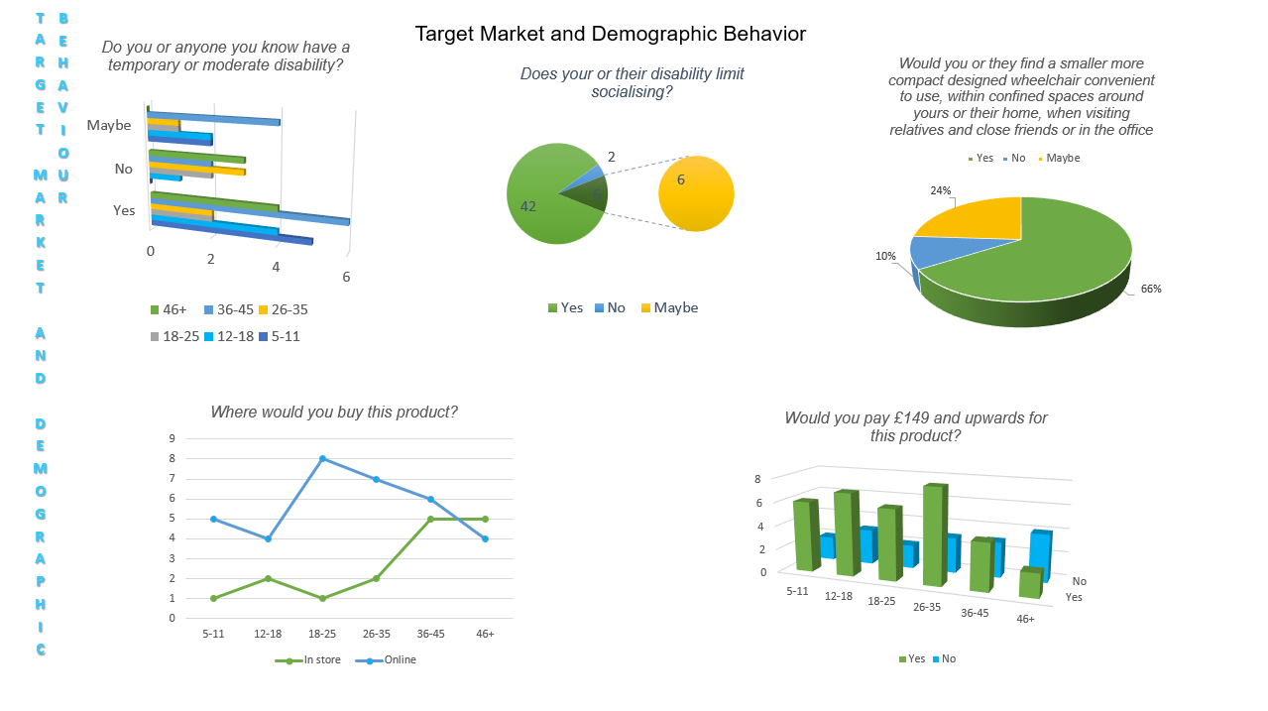
Image 6, Source: Author



Market Analysis
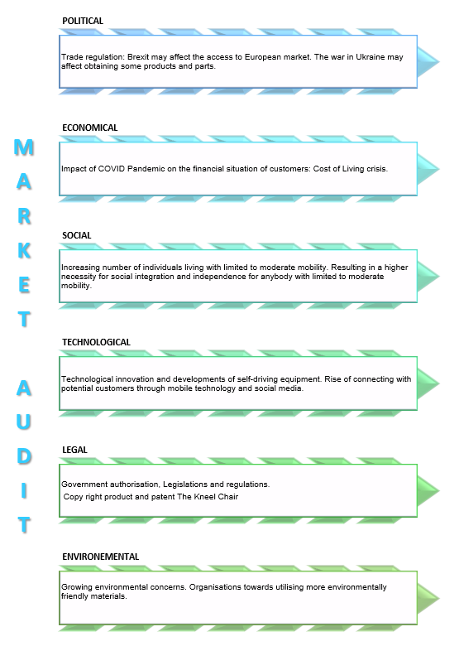
Image 7, Source: Author

  - E-commerce: Propose to setup an online website or application and consider the following: 800 words -Explain where and how I will sell the kneel chair, if on a platform like amazon or eBay, or open my own online store.
Think about – my unique selling point described in a good way – advertise on Instagram, Facebook, radio, ticktock -videos of the kneel chair visually showing how the Kneel Chair is improving lives. How I’m providing value to customers.
E-commerce:
    - WordPress/PHP/Python/Java •Using SaaS, e.g., Shopify • Using a marketplace, e.g., Amazon or eBay • Creating content(Facebook), including copyright and photograph • Financing(done) • Equipment and supplies(look@ price list chart all things needed for business, (health and safety check licenses) - • Staff • Using Payment Services -how am I going to accommodate customers in payments, e.g., card, PayPal Clear pay, Klarna • If accepting card payments, be aware of PCI-DSS compliance issues.
(GDPR- provides EU consumers with protection and control over how their personal data is collected, used or sold. (In ecommerce, personal data is collected for everything from website visitor analytics to purchase transactions and shipping. THIS IS IMPORTANT)

The Kneel Chair will be publicly available to purchase through the Kneel Chair website. Customers can browse the catalogue online and choose the items they are interested in, enabling them to use their creativity when designing their Kneel Chairs specifications during the ordering process. Customers will additionally have access to online customer services as well as an interactive text assistance engine. Using an actual retail space to serve customers that are interested in personal appointments for weighing, measuring, and testing for the purpose of meeting customised requirements in person. In addition to utilising stores such as, Bee Ables, Sunrise Medical, Amazon, and eBay.
Java will be utilized throughout Bee Ables' website for developing and operating all mobile applications, creating, and scaling cloud applications, developing chatbots and other tools for advertising, powering all enterprise-level web-based applications, and providing assistance to the company's artificial intelligence (AI) and internet of things (IoT) mobile devices. Bee Able will employ Microsoft 365 for complex business applications which include customer relationship management (CRM), and enterprise resource planning (ERP), together with document management, in addition to corporate productivity apps including email, collaboration, and calendaring.
The main benefit of Bee Able selling on Amazon is the breadth of its online presence, which may increase sales from the highly visited marketing channel. With almost 2.4 billion interactions monthly via desktop and mobile devices, Amazon has an extensive customer base that may increase Bee Ables company sales through new customers who prefer to shop online.
Social media platforms particularly Facebook, Instagram, Twitter, and Tick Tock will be utilized to promote merchandise posted by Bee Ables customers as evidence of Bee Ables brand's consistency and to assist in capturing new customers. Additionally, hashtags are utilised to improve company conversions, enhance sales, and drive visitors to the Bee Able brand. Making it simpler to purchase company items on Instagram via the brand page along with coming up with deals and discounts that attract new consumers and excite loyal ones. In addition to employing buyable pins, Pinterest attracts high-value clients and increases exposure for websites with high conversion rates.
Making pages may be used to promote the Kneel Chair if Bee Able has amassed a sizable audience. Joining groups can help the company remain current, appealing, relevant, and up to date of present trends within the business world as well as attract prospective clients. In addition to analytics, which is essential, to assist with analysing the effectiveness of Bee Ables' marketing initiatives and subsequently plan for the future of the company along with utilizing social media analytics to determine the effectiveness of business tactics and what further needs to be done to increase e-commerce conversion rates.


  - Marketing: 800 words

4Ps of marketing:
The 4Ps, which are Product, Price, Place, and Promotion, provide a comprehensive framework for developing a marketing strategy. Here's how each "P" can be incorporated:

Product:

Product and services

The Kneel Chair
Image 8, Source: Author

The unique design, usability, and primary function of the Kneel Chairs are all that distinguish and set apart this wheelchair from others. It comes with an effective pressure-relieving cushion and quiet, lockable swivel wheels which are offered in a selection of striking colour combinations. Soft gel handle spherical motion pods are also incorporated for the user's hands' comfort and support during movement. These attributes provide the user with padding, comfort, stability, plus the agility to retain movement in confined locations that traditional wheelchairs would typically find challenging to reach, such as upstairs on the landing or even when using a relative's lavatory. The Kneel chair is significantly more economical and cost-effective than its closest rivals, with costs starting at £149.99 as opposed to other wheelchairs, which start at £600.00.
Price: -You should justify the chosen price point in terms of profitability and market competitiveness. – with the price of the kneel chair profit should be shown to be made within the 1st 3years

Budgeting is an economic strategy that manages all of a company's resources. distributing all of these resources to an identifiable goal is the purpose of establishing a budget (Martin, 2022).
With prices starting at £149.99 compared to comparable wheelchairs' £600.00 starting price, the Kneel chair is substantially more affordable and cost-effective than its closest competitors. With a variety of options available, The Kneel Chair gives customers the flexibility to custom design their Kneel Chair to meet their exact requirements. A Kneel Chair that is one size fits all is unsuitable since Bee Able recognises that each of our customer's conditions is complex and individual. Customers of Bee Able have the choice to personalise their Kneel Chairs with unique components, which include motion pods and contoured pressure-relieving cushions, in addition to selecting customised caster wheels. Bee Able offers a range of pressure-relieving cushions, including High-Risk Gel Hybrids, Active Soft cushions, and luxury soft gel memory foam cushions.
PRODUCT | PRICE
Deluxe Cushion | £20.00
Orthopedic Deluxe Cushion | £58.00
Sero Air Flow Cushion | £72.00
High Risk Gel Hybrid Cushion | £99.00
Invictus Active soft Combi Cushion | £125.00

Image 9, Source: Author

In addition, Bee Able provides a variety of custom-crafted, active motion pods, from the conventional design to the active design collection, that not only look great yet additionally provide the user with more comfort and agility.
PRODUCT | PRICE
Gel Motion Pods | £30
Gel Active Plus Motion Pods | £90
Gel Active Pro Motion Pods | £105
Gel Active Slim line | £110
Image 10, Source: Author

Bee Able offers a selection of caster wheels, including colour coated aluminium rim wheels, flashing coloured LED light-up designs, and smooth, silent all-floor caster wheels.
PRODUCT | PRICE
Smooth Silent Multi Floor Caster Wheels x4 | £30
Smooth Silent Multi Floor Caster Wheels x 2 | £20
Colored Aluminum Rim Caster Wheels x2 | £35
Flashing Colored LED Light-up Caster Wheels x2 | £50
Image 11, Source: Author

The Kneel Chair & Motion Pods will be manufactured and assembled through Sunrise, an innovative manufacturing designer of medical equipment. A deal has been concluded with Sunrise, Bee Able is paying Sunrise £10,000.00 for every 100 units, where 1 unit is equal to 1 kneel chair and a single pair of motion pods. Sunrise will receive £2,000 from Bee Able for the first 20 devices it produces. In order to guarantee certainty that the Kneel Chair complies with all the European Medical Device Directive 93/42/EEC (MDD) EN 12183 norm testing for manual wheelchairs requirements, and in protecting the health & safety of Bee Ables customers, a prototype will also be created (Iso,2014).
Sunrise will manufacture and provide all the necessary environmentally friendly components, including the silicone exterior shell motion pods with silicone gel padding, along with the aluminium frame and braking systems. The LED castor wheels are available from Wheelchair Parts Dot Net for a starting price of £22.00. The coloured aluminium caster wheels are purchased from ECP Wheelchairs for £15.00, and the pressure-relieving cushion is purchased from Medical Care Suppliers for £15.00.
Sunrise has been hired to fully manufacture, assemble, and package each Kneel Chair for £85.00 and each pair of Motion Pods for £15.00, for a total manufacturing cost of £100.00. Be Able will sell the Kneel Chair starting at £149.00, making a profit of £85.00.
The Kneel Chair can be produced custom-made, with the buyer having the option to purchase a conventional all-in-one package for £229.00. The Kneel Chair may be individually customized by customers with their personal preferences for cushions, caster wheels, and motion pods. With the premium customized package, priced at £484.00, Be Able will generate a profit of £359.00. The price of a kneel chair differs depending on the individual specifications required by each customer.
with the price of the kneel chair profit should be shown to be made within the 1st 3years


Bee Ables Sales Forecast 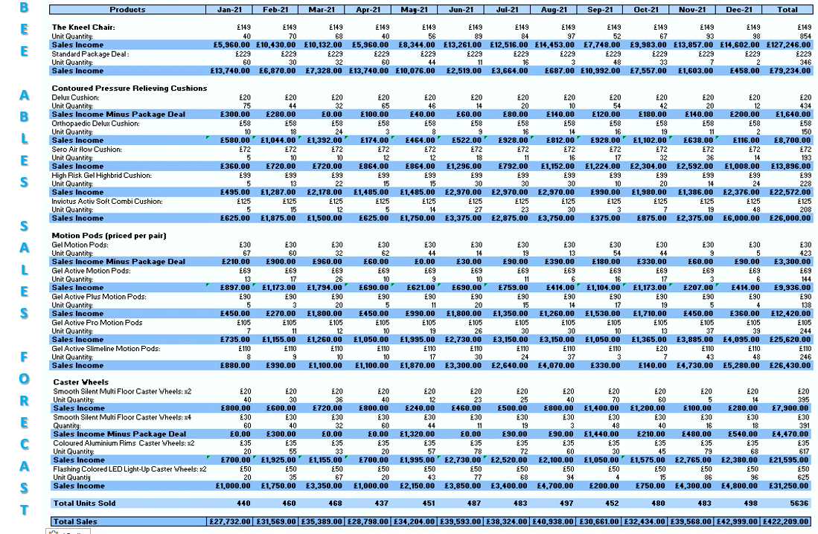
Image 12, Source: Author

Bee Ables Cash Flow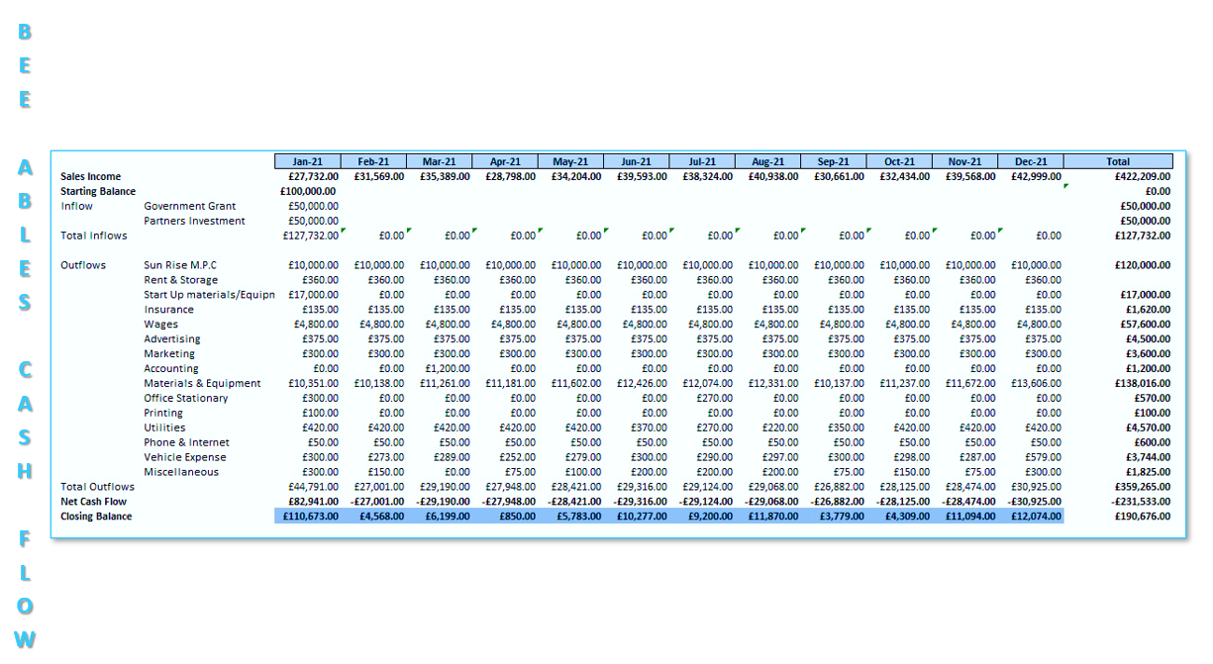
Image 13, Source: Author



Bee Able Budget Forecast
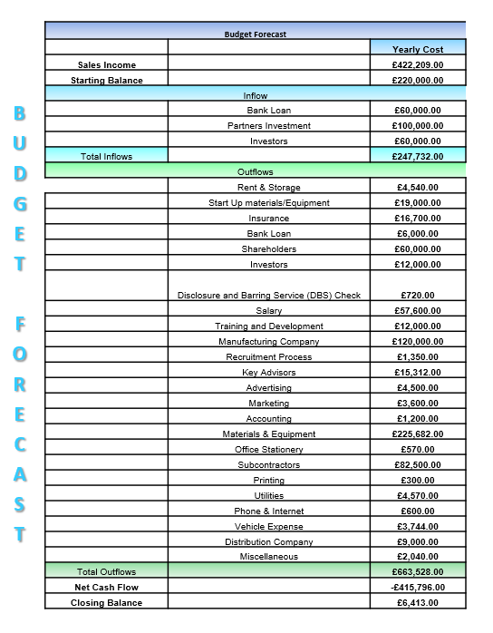
Image 14, Source: Author
Place: This relates to distribution—how and where the product or service will be sold. You should detail distribution strategy, whether it's selling online, in a physical store, or through third-party retailers. -Depending on the service, a physical store will be needed,
Bee Ables products and services are offered remotely through the e-commerce market, utilising stores such as, Bee Ables, Sunrise Medical, Amazon, and eBay where customers can browse through the online catalogue, and select the items they desire, enabling them to use their creativity when designing their Kneel Chairs specifications during their ordering. Resulting in specifically tailored designed Kneel Chairs and accessories, with a pop-up text support engine to assist the customers, in conjunction with access to online customer services. In addition to in person, using a physical store to cater to clients who require personal appointments regarding weighing, measuring, and testing for tailored specifications.
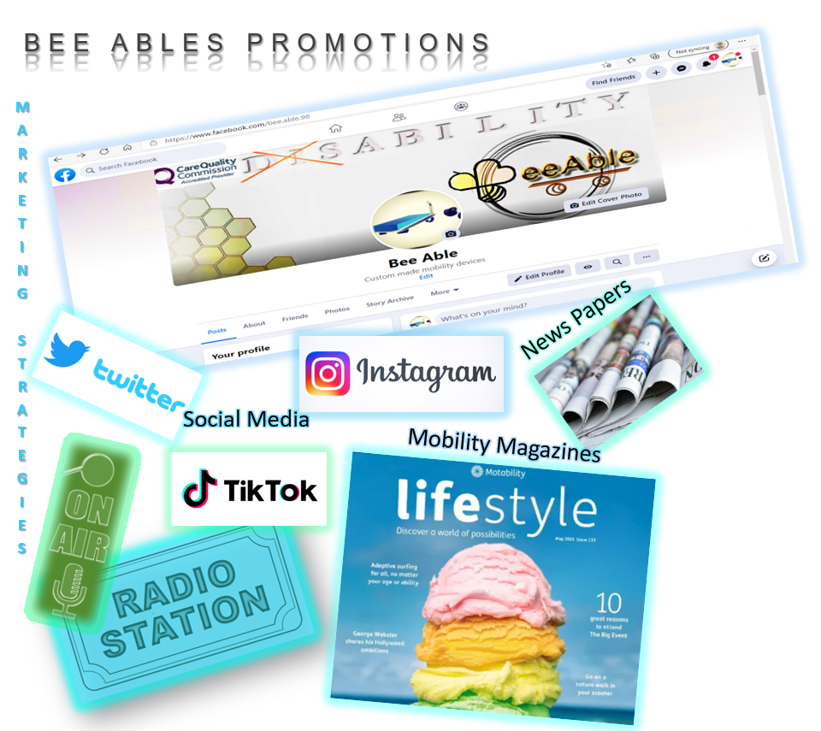
Image 15, Source: Author

Promotion: It could be expanded to consider all aspects of promotion, including advertising, sales promotions- Discount to the first 100 customers – disability grps shop mobility there customers to reach facebook groups to gert access to there customer base do talks show produst test proudt out. Opendays , on social media sites do paid advertising that targets my demagraohic people trying to reach to to invite to open days to promot open days. Advertise in newspapers, shopping centers, like how promot car. ( think about how people con tact me f- emaikls. (How will I get people to know about my brand how to get them to see and come to store to try out. to them offering discounts.(Be Creative ask google), public relations -hire social media influencers. and direct marketing.
    - How will you promote your service? -Advertisement social media marketing through Instagram, Tick Tock, Facebook. Are you considering any innovative marketing strategy?
    - Who are your target customers? How will you reach them?
    - Consider the use of social media, e.g., Facebook, Instagram, etc. • Consider the use of paid search engines, e.g., Google • Understand the role of customer journeys • Consider the use of physical or online marketing techniques, as applicable • Consider the pre-launch promotion.

- Research these words above, to add them when talking about the web site I’m going to create to sell my Keel Chair on. Creating content- using Instagram

Research these words above, to add them when talking about the web site I’m going to create to sell my Keel Chair on. Creating content- using Instagram
-Twitter –(basically saying if you need to talk to us here, we are here) -Instagram -so that it easy for customers to access customer support- web chat -AMAZON 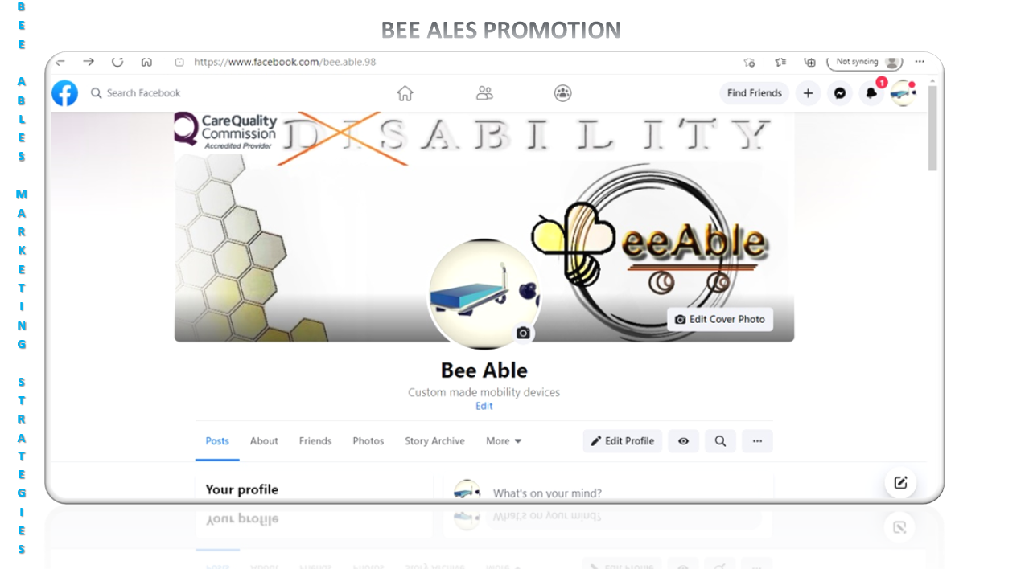
Ensure to use appropriate, recent, and credible references to support your work.

Conclusion


References
Haag, A. (2013). Writing a Successful Business Plan. WORKPLACE HEALTH & SAFETY. [Online]. 61(1), 19-29. [11 July 2023]. Available from: https://journals.sagepub.com/doi/pdf/10.1177/216507991306100104
Iso. (2014). ICS: 1118010 Aids and adaptation for moving. ISO 7176-1:2014(en) Wheelchairs — Part 1: Determination of static stability. [Online]. 1(3), 28. [26 November 2022]. Available from: https://www.iso.org/obp/ui/#iso:std:56817:en
Livewell. (2008). Livewell. [Online]. [23 June 2023]. Available from: https://www.livewelltoday.co.uk/
Martin, H. (2022). Viva Financial Tuition. [Online]. [26 November 2022]. Available from: https://www.vivatuition.com/cima-knowledge-centre/why-is-budgeting-important-to-a-business
Quickie. (2023). Sun Rise Medical LTD. [Online]. [23 June 2023]. Available from: https://www.sunrisemedical.co.uk/wheelchairs/quickie/lightweight-wheelchairs
Rainey, D. (2005). Product innovation : Leading Change Through Integrated Product Development. [Online]. New York: Cambridge University Press. [4 July 2023]. Available from: https://www-vlebooks-com.ezproxy.uwtsd.ac.uk/Product/Index/2004001?page=0&startBookmarkId=-1
Silva, A & Simoes, R. (2011). Handbook of Research on Trends in Product Design and Development: Technological and Organizational Perspectives. [Online]. Hershey, Pennsylvania: IGI Global Publisher of Timely Knowledge. [28 June 2023]. Available from: https://www-igi-global-com.ezproxy.uwtsd.ac.uk/gateway/book/41797
Sunrise. (2023). Sun Rise Medical . [Online]. [29 June 2023]. Available from: https://www.sunrisemedical.co.uk/company-information#

