Student name: Nerea Juaristi
Student ID: 2212615
Module name: Personnel Resourcing and Development
Module code: BMIH5005
Lecturer’s name: Helen Lee

Research Project Proposal – Impact of current challenges on the human resource department relating to recruitment and retention

Table of Contents
Introduction 3
Background 3
A Glimpse of Elegance and Tradition 3
Cultural Significance and Community Engagement 4
Exemplary Service and Culinary Excellence 4
Discussion 5
Impact of Current Affairs on Employee Retention 5
COVID -19 5
Employee Wellbeing 5
Shift in Work Dynamics 5
Uncertain Economic Situation 6
Adapting to Market Changes 6
Job Insecurity 6
Brexit 6
Inflation and Economic Situation 6
Cost-Cutting Measures 6
Compensation Challenges 7
Global Retirement Tide 7
Talent Shortages 7
Knowledge and Skill Drain 7
Potential Solutions and Industry Examples 8
Transparent Communication and Engagement 8
Prioritizing Employee Well-being 8
Adapting to Market Changes and Consumer Preferences 8
Embracing Flexible Work Arrangements 9
Implementing Strategic Workforce Planning 9
Investing in Continuous Training and Development 9
Evaluation and Conclusion 10
References 12
Appendix 14
SWOT Analysis 14
PESTLE Analysis 16

Introduction
This comprehensive investigation will examine the impact of personnel modifications within the hotel business of the United Kingdom, with particular emphasis on The Savoy located in London. The objective of this project, which the student is tasked with completing, is to examine the many challenges and opportunities that arise from the environment. In order to accomplish this objective, it is important to examine the impacts on worker dynamics and devise intelligent strategies to ensure employee satisfaction and productivity.

Background

A Glimpse of Elegance and Tradition
The Savoy has a long-standing history. Situated in the heart of London, in close proximity to the renowned River Thames, this location epitomizes affluence, refinement, and enduring appeal. Since its inauguration in 1889, this esteemed hotel has served as a destination for renowned travelers, affluent individuals, and prominent figures hailing from many corners of the globe. The Savoy has established itself as a prominent tourist attraction in London because to its opulent Art Deco interior design, exceptional service, and unwavering commitment to providing visitors with an authentic British experience.

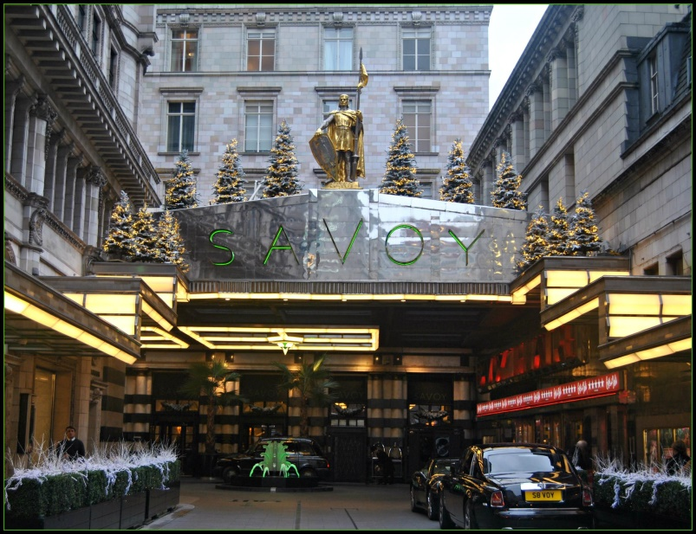
Figure 1: The Savoy Hotel

Cultural Significance and Community Engagement
The Savoy has a broader scope than its designation as a mere hotel. London's rich cultural heritage is significantly shaped by this particular aspect. The hotel contributes to the enrichment of the city's cultural landscape with the provision of the esteemed Savoy Theatre, renowned for its exceptional performances, and the iconic American Bar, a historically significant establishment cherished by aficionados of fine beverages. Both of these locations are situated inside the confines of the hotel (James, 2020).

Exemplary Service and Culinary Excellence
The Savoy has established itself as a standard for exemplary service in the hotel industry since its inception over a century ago. Both the renowned Savoy Grill and Gordon Ramsay at The Savoy play a significant role in enhancing the hotel's esteemed status as a culinary haven (Aron, Botella and Lubart, 2019). The hotel's commitment to exceeding guest expectations is evident via its diverse culinary offerings, exemplified by renowned establishments like the Savoy Grill and Gordon Ramsay at The Savoy.


Figure 2: The Luxurious Savoy Suite in Central London | The Savoy

Discussion

Impact of Current Affairs on Employee Retention COVID -19

Employee Wellbeing
The COVID-19 pandemic has shown the paramount need of prioritizing the well-being and safety of workers. Hotels that demonstrate a significant commitment to health and safety regulations, provision of mental health care, and fostering a positive work culture are more prone to cultivating employees that is dissatisfied but committed (Li, Taeihagh and Tan, 2023).

Shift in Work Dynamics
The hotel business has seen significant changes in work practices as a result of the COVID-19 pandemic. Currently, there is an urgent need to implement measures such as remote work arrangements, job transitions, and enhanced health and safety protocols inside the workplace (Ostrowska-Tryzno and Pawlikowska-Piechotka, 2022). In light of the global pandemic, The Savoy, along with its counterparts in the hospitality industry, may need to modify its staff recruitment and retention strategies to promote flexible work arrangements and effectively respond to the evolving demands of the labor force. In order to address the evolving requirements of the workforce, it would be necessary to do the aforementioned action.

Uncertain Economic Situation

Adapting to Market Changes
The dynamic nature of the United States economy often influences consumer behavior and purchasing patterns. In order to maintain its success and stability, The Savoy must consistently demonstrate its agility and adaptability. According to Köseoglu et al. (2013), One approach to address this problem involves ensuring that the goods and services offered by the organization effectively align with the evolving demands of the market. Conversely, this facilitates the retention of employees.

Job Insecurity
Individuals employed by organizations tend to have heightened concerns over their job security when the overall stability of the company is compromised. The potential course of action for The Savoy may include the use of effective communication strategies aimed at alleviating employee concerns and fostering a sense of employment stability (Ozdemir, Han and Dalbor, 2022).

Brexit
In the United Kingdom, the hospitality industry has been struggling as a result of a shortage of labor brought on by Brexit. Because of these issues, establishments such as The Savoy have undergone various changes. Now that people are restricted in their ability to travel freely and visa requirements have been tightened, there is widespread concern over the availability of clever and diverse individuals. If people want to maintain the foreign workers we presently have and employ new ones after Brexit, we need to put into action strategic planning for our workforce. This is due to the fact that they need all of the already employed foreign workers to remain in their positions (Cameron, Jenkins and Marson, 2018).

Inflation and Economic Situation

Cost-Cutting Measures
Considering the current state of the economy, it is likely that several hotels will need to implement cost-cutting measures in order to maintain their profitability. This phenomenon has the potential to diminish the perceived value of employee benefits and hence reduce employment retention rates (GRIC and Bojnec, 2013). In order to ensure the long-term preservation of its workforce, an organization must strike a delicate equilibrium between maintaining financial stability and addressing the needs and desires of its personnel.

Compensation Challenges
The potential volatility of the economy and the concurrent escalation of prices may provide challenges for enterprises in devising and implementing competitive remuneration schemes (Forbes et al., 2013). Due to recent economic shifts, it is imperative for The Savoy to critically evaluate its remuneration packages and implement necessary modifications to ensure their continued appeal.

Global Retirement Tide

Talent Shortages
The departure of highly skilled professionals from the labor market has the potential to exacerbate existing skills shortages within businesses. In order to address this issue, it is imperative for The Savoy to proactively foster a culture that promotes ongoing learning and development, so ensuring the effective preparation of future cohorts of business executives (Cetron et al., 2020).

Knowledge and Skill Drain
The increasing global retirement rate is a significant challenge for the hotel business, as it results in a diminished pool of experienced and knowledgeable individuals actively engaged in the workforce. Hotels are anticipated to develop and use efficacious strategies to facilitate the transition process when experienced personnel depart. Several of these strategies include initiatives aimed at facilitating information exchange and ensuring smooth transitions in leadership roles.

Potential Solutions and Industry Examples

Transparent Communication and Engagement
Aligned with the core principles upheld by InterContinental Hotels Group (IHG), it is conceivable that The Savoy would prioritize the promotion of transparent and candid dialogue. According to Kim and Kim (2016), implementing feedback mechanisms, incentive schemes, and continuous engagement platforms may contribute to fostering a positive organizational climate inside a corporation.

Prioritizing Employee Well-being
Upon examining the operations of Hilton Worldwide, The Savoy might potentially implement fitness initiatives, enhance workplace aesthetics, and provide mental health assistance. This measure would be implemented with the aim of prioritizing the well-being and satisfaction of its employees (Ahmed et al., 2020).

Adapting to Market Changes and Consumer Preferences
The Savoy might potentially benefit from the insights and innovative initiatives of market leaders such as Radisson Hotel Group. In order to enhance its position as a market leader, The Savoy should adopt a proactive approach towards addressing market dynamics and strive to align its product offerings with evolving consumer preferences (Victorino et al., 2005).


Figure 3: The Royal Suite by Gucci

Embracing Flexible Work Arrangements
The implementation of more flexible working hours at The Savoy, like to the approach used by Marriott International, is a potential avenue for consideration. This approach not only enhances employee satisfaction, but it also facilitates the attainment of favorable work-life equilibrium by adapting to the evolving demands of the workforce (Amirul and Shaari, 2021).

Implementing Strategic Workforce Planning
The Savoy may proactively manage its workforce by formulating focused recruitment strategies, prioritizing critical employment roles and forecasting potential skill shortages. Prominent industry leaders, such as Four Seasons, are renowned for their meticulous approach to staffing requirements, ensuring a consistent presence of highly competent personnel. Due to the implementation of these tactics, they have gained recognition as one of the leading entities in their respective industry.

Investing in Continuous Training and Development
It is suggested that The Savoy may adopt a comparable business strategy to that of AccorHotels, whereby investments are made towards the development of comprehensive training programs. These efforts not only serve to address skill deficiencies, but also demonstrate the company's commitment to fostering the professional development of its personnel.

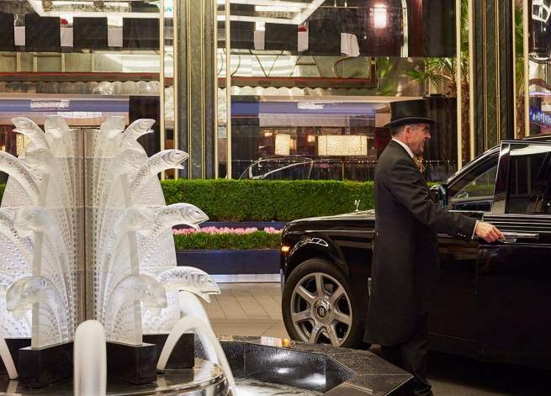
Figure 4: Continuous Training and Development

Evaluation and Conclusion
The objective of this research was to examine the challenges associated with recruitment and retention of personnel within the service hotel industry in the United Kingdom, with specific emphasis on The Savoy located in London. The research started by examining the renowned historical background of the hotel, specifically highlighting its reputation for opulence, exceptional customer service, and unwavering adherence to established customs. The primary objective of this investigation was to analyze the many variables that influence the duration of employment among hotel sector personnel, as well as explore the interconnectedness between these elements.
A research was conducted to examine the impact of recent events, including as Brexit, the COVID-19 epidemic, inflation, economic conditions, and the global trend of employee attrition, on the attrition rate among staff at The Savoy. The concerns included potential labor shortages post-Brexit, the need to adapt work practices due to the COVID-19 pandemic, and the imminent global retirement tsunami leading to knowledge and skill attrition. The resolution of all three of these problems posed significant challenges.
To address these concerns, relevant instances from the appropriate domain have been presented, along by potential solutions. After conducting an analysis of the operational practices employed by prominent companies such as Four Seasons, Marriott International, Hilton Worldwide, AccorHotels, InterContinental Hotels Group (IHG), and Radisson Hotel Group, several recommendations have emerged. These recommendations include prioritizing the well-being and satisfaction of employees, fostering transparent communication, implementing strategic workforce planning, facilitating flexible work arrangements, and allocating resources towards continuous training and professional development.
In conclusion, The Savoy occupies a unique position since it is at the confluence of contemporary concepts and longstanding customs. This pertains to the many problems and opportunities that arise in relation to its environment. The hotel demonstrates a keen focus on effectively managing the intricacies inherent in the United Kingdom's hospitality sector. The clarity of their strategy plans is particularly evident in their intention to mitigate the impact of recent events on worker retention. The objective of these recommendations is to minimize staff attrition at the hotel due to external circumstances.

References
Ahmed, M., Zehou, S., Raza, S.A., Qureshi, M.A. and Yousufi, S.Q., 2020. Impact of CSR and environmental triggers on employee green behavior: The mediating effect of employee well‐being. Corporate Social Responsibility and Environmental Management, 27(5), pp.2225-2239.
Amirul, S.R. and Shaari, S.C., 2021. An overview: Twenty years of flexible working arrangements. Advances in Business Research International Journal, 7(2), pp.27-41.
Aron, L., Botella, M. and Lubart, T., 2019. Culinary arts: Talent and their development.
Cameron, D., Jenkins, A. and Marson, J., 2018. The consequences of the Brexit vote on management attitudes to recruitment in the hospitality industry. Business Law Review, 39(4).
Cetron, M.J., Davies, O., DeMicco, F. and Song, M., 2020. Shaping the future of hospitality and travel: trends in energy, environmental, and labor force and work. International Hospitality Review, 34(2), pp.129-152.
Forbes, K., Sebastian, V., Mapingure, C., Mirimi, K., Chimutingidza, F. and Mataruse, R., 2013. Employee perceptions of dollarisation and the hospitality industry performance. Australian Journal of Business and Management Research, 2(10), pp.31-37.
GRIC, S. and Bojnec, Š., 2013. Inflation and hospitality industry prices. Eastern European Economics, 51(3), pp.91-108.
James, G., 2020. Relationship between intrinsic job satisfaction, extrinsic job satisfaction, and turnover intentions in luxury hotels (Doctoral dissertation, Walden University).
Kim, S.B. and Kim, D.Y., 2016. The impacts of corporate social responsibility, service quality, and transparency on relationship quality and customer loyalty in the hotel industry. Asian Journal of Sustainability and Social Responsibility, 1(1), pp.39-55.
Köseoglu, M.A., Topaloglu, C., Parnell, J.A. and Lester, D.L., 2013. Linkages among business strategy, uncertainty and performance in the hospitality industry: Evidence from an emerging economy. International Journal of Hospitality Management, 34, pp.81-91.
Li, L., Taeihagh, A. and Tan, S.Y., 2023. A scoping review of the impacts of COVID-19 physical distancing measures on vulnerable population groups. Nature communications, 14(1), p.599.
Ostrowska-Tryzno, A. and Pawlikowska-Piechotka, A., 2022. Tourism, the hotel industry at the time of the COVID-19 pandemic. Sport and Tourism Central European Journal, 5(2), pp.139-152.
Ozdemir, O., Han, W. and Dalbor, M., 2022. Economic policy uncertainty and hotel occupancy: the mediating effect of consumer sentiment. Journal of Hospitality and Tourism Insights, 5(2), pp.253-273.
Victorino, L., Verma, R., Plaschka, G. and Dev, C., 2005. Service innovation and customer choices in the hospitality industry. Managing Service Quality: An International Journal, 15(6), pp.555-576.

Appendix

SWOT Analysis
Internal Factors
Strengths | Weaknesses
Culinary Excellence  The Savoy Grill and Gordon Ramsay at The Savoy are two of the hotel's world-renowned restaurants.  Commitment to Cultural Engagement  The Savoy influences London's culture via the American Bar and Savoy Theatre.  Prime Location in London  A convenient location on the River Thames in central London enables the Savoy to quickly reach famous landmarks and economic districts. Due to its central location, the Savoy is popular with vacationers, business travelers, and those seeking a true London experience.  Historic Legacy and Prestige  From its beginning, Savoy has been associated with opulence and prestige. The institution's fame boosts the brand's reputation and attracts high-end clients. | High Operational Costs  The Savoy must raise operational costs to maintain its unsurpassed splendor.  In times of economic difficulty, long-term operational costs may hurt profitability; strong financial management is needed to prevent this.  Labor Market Challenges  Brexit may cause labor shortages, making it harder to hire and keep a talented and diverse staff.  Labor market issues may affect service quality and operational efficiency, necessitating proactive personnel planning.

External Factors
Opportunities | Threats
Innovative Technological Integration  Innovative technologies may improve everyday operations and visitor satisfaction. Digital check-in and smart room amenities may set the Savoy apart as a contemporary business.  Adaptation to Changing Consumer Preferences  The Savoy may leverage on changing client interests, such as a desire for personalized experiences and more ecologically friendly company practices. Tailoring services to consumers' evolving preferences boosts customer satisfaction and the hotel's market leadership. | External Economic Factors  Global events, an unsteady economy, and increasing costs may affect luxury expenditures. If the economy worsens, The Savoy may struggle to sustain sales, which might hurt its financial performance.  Global Retirement Tide  Because experienced people are retiring, the organization may lose information and skills. Effective succession planning and knowledge transfer are crucial to avoiding the detrimental effects of global retirement on operational continuity. This tendency will likely persist.

PESTLE Analysis
 | External factors to considered | Factors affected within my industry | Importance to organisation
Political | - Immigration Policies  - Government Regulations | - Workforce Mobility: Worker mobility and recruitment are directly affected by governmental decisions.  - Regulatory Compliance: Hotels must have compliance processes since government rules affect many aspects of their business. | Labor Market Stability: Immigration laws affect the Savoy's capacity to employ talented international candidates.  Legal Compliance: To prevent legal troubles and maintain one's reputation, one must strictly follow government guidelines.
Economic | - Economic Uncertainties  - Global Events | Consumer Spending: Hospitality clients' purchasing patterns depend on the economy.  Revenue Generation: Hotel profitability is directly related to the economy and international events. | Financial Performance: The Savoy must analyze the economy to ensure financial stability and change prices.  Adaptability: Preventative measures are essential to react to changing economic conditions and maintain revenue.
Sociocultural | - Health and Well-being Trends  - Changing Consumer Preferences | Workplace Culture: Society's values affect workplace culture and worker well-being.  Service Offerings: The surrounding society influences visitors' preferences and desires. | Employee Retention: A company's capacity to promote positive and socially desirable culture affects employee satisfaction and retention.  Guest Satisfaction:  Guest satisfaction increases when services are tailored to their needs.
Technological | - Online Booking Platforms  - Digital Transformation | Guest Interaction: Online platforms greatly impact hotel guests' experiences and engagement.  Operational Efficiency: Technology affects hotel management and service. | Competitiveness: Only technological advancements can keep an industry competitive.  Guest Experience: Technology is essential for improving visitors' experiences.
Legal | - Labor Laws  - Health and Safety Regulations | Operational Practices: Company activities must comply with health and safety laws.  Workforce Management: Workforce management techniques must alter due to employment legislation changes. | Employee Relations: When labor laws are obeyed, employees are treated fairly and legally.  Reputation Management: Compliance with health and safety regulations is crucial to maintaining a good reputation.
Environmental | - Sustainability Trends  - Climate Change Impact | Sustainable Practices: Environmentally conscious hotel measures are becoming mainstream.  Adaptation to Climate Change: Climate change is forcing hotels to adjust to shifting travel trends. | Consumer Appeal:  Environmentally friendly practices and processes match consumers' changing preferences, making the hotel more enticing.  Long-Term Viability: Climate change adaptation helps the hotel survive and recover from bad weather.

