Sam Event Decoration

Business Plan Pitch ( Presentation)

BMIH5012/BMIH5012D HANNA HAILEMARIAM 2316775

29/04/2025
- Company Name: Sam Event Decoration
- Business Type: Event decoration services
- Industry: Event Planning and Management
- Target Market: Weddings, corporate events, private parties
- Location: Swansea, UK


Introduction to the Company

Market Overview
- UK Events Industry: Generates over £61.653 billion annually (UKEVENTS, 2024)
- Growth Areas: Corporate events, weddings, and hybrid events (Market Research Future, 2024)
- Trends: Sustainability, digital tools, and immersive experiences (Eventbrite, 2023)
- UK event industry stats
- Target demographics: Age group, income level, event types
- Trends: Increase in eco-friendly events, growing demand for immersive experiences
- Competitor analysis

Market Research
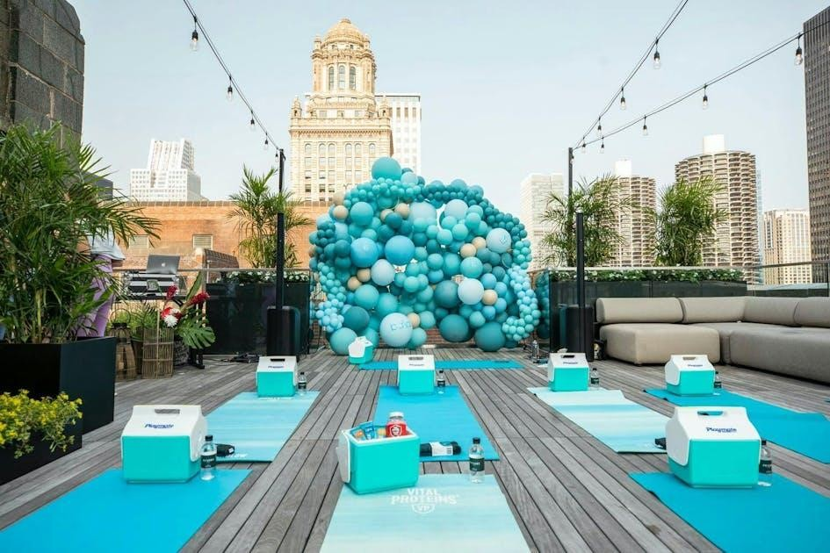
Competitor Profiles
•
Competitors:
Local event suppliers, major event décor brands
•
Unique selling proposition (USP): Custom AR previews, eco
-
friendly materials, full
-
service package
(
VisitBritain
, 2024).
•
Visual comparison chart (Feature vs. Competitor)

Marketing Strategy
 | 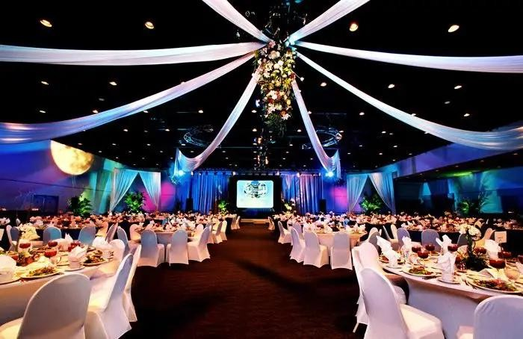
  - Pricing strategy: Competitive with a focus on premium services
  - Marketing channels: Social media, local partnerships, SEO
  - Promotional plan: Discounts for first-time clients, AR demo packages
SWOT Analysis
Strengths
Weaknesses
Innovative use of Augmented Reality (AR) technology enhances customer experience and planning
(
VisitBritain
, 2024).
Limited brand recognition and lack of trust as a new market entrant.
Commitment to sustainable practices aligns with growing consumer demand for eco
-
conscious
services.
Restricted start
-
up capital limits equipment quality and marketing reach.
Partnership with local artisans and suppliers ensures quality, uniqueness, and community
engagement.
Dependence on local suppliers may affect scalability and service consistency.
Opportunities
Threats
The UK events industry generates over £61.653 billion annually, offering growth opportunities
(
UKEVENTS,
2024).
Economic downturns may reduce clients’ spending on event services.
Increasing digital tools and AR adoption in event planning support innovative services (Market
Research Future, 2024).
Established competitors with loyal client bases pose barriers to market entry (Mintel, 2024).
Rising demand for personalised and immersive event experiences creates niche service potential.
Fluctuations in supplier costs or availability may disrupt service delivery and margins.
(
Mintel,
2024).
Team Organisation
Name
Position
Skills & Experience
Roles & Responsibilities
Sarah Thompson
Founder & Creative Director
10+
years in event planning, Event
Management degree.
Oversees all creative aspects, manages
supplier relationships
Michael Edwards
Operations Manager
Level 5 Diploma in Event Management
(
The Event Crowd,
2024)
Coordinates logistics, plans events,
ensures client satisfaction
TBD
Marketing & Social Media Coordinator
Digital content creation, Social media
management
Develops and executes marketing
strategies, manages brand visibility
Financial Plan
- Revenue projections for the first year
- Break-even analysis
- Funding needs for initial setup and marketing
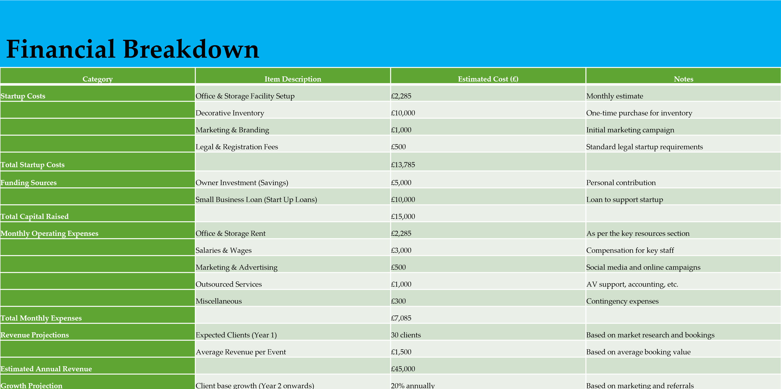
- Recap: Key business highlights, growth potential
- Call to action:
- Funding request, partnership opportunitiesContact information
- Focus on Sustainability and Innovation
- Team's Expertise and Commitment
- Strategic Growth in a Thriving Market

Conclusion
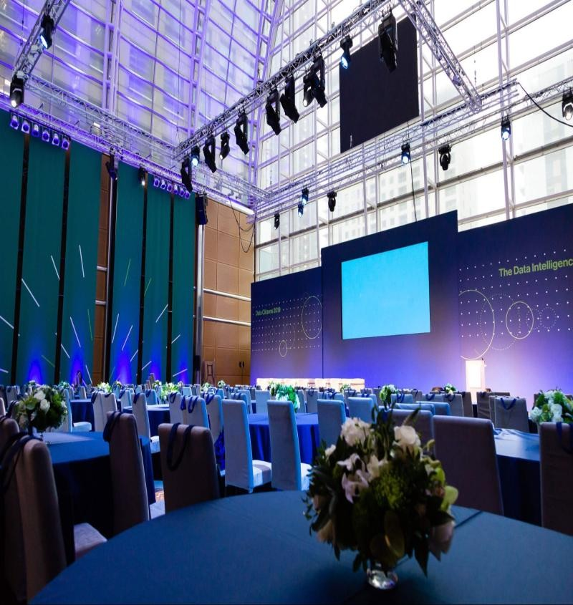

References
- Baker, M. (2021). Marketing Strategy and Management. 7th ed. Palgrave Macmillan.
- Bladen, C., Kennell, J., Abson, E., & Wilde, N. (2022). Events Management: An Introduction. Routledge.
- Chartered Institute of Marketing (CIM), (2024). Event Design and Management Course. Available at: www.cim.co.uk.
- EU Business News, (2024). The Growth of the UK Events Industry. Available at:
www.eubusinessnews.com.

