

The Conservation of Energy and Environmental Protection at Dragon LNG Terminal

Module: Environmental Protection and Sustainable Manufacturing Systems

Lecturer: K.Berry

Author: James Hammond

Contents

Abstract. 3
Introduction. 3
Boil-off gas (BOG). 3
BOG Compressors. 4
BOG Cooler. 4
Heat Exchangers. 5
The Recondenser. 6
Reducing Energy Losses. 7
Pipework Insulation. 7
Caustic usage and wastewater flow. 10
Caustic Area. 11
Conclusion. 12
References. 13
Bibliography. 13

Abstract.
This report will aim to explore the infrastructure of the boil off gas (BOG) cooler its impact on the surrounding plant and processes and the way it reduces energy loss and implements the conservation of energy. It will investigate the insulation process and the benefits, processes and materials used to complete this to eliminate energy loss. It will also offer any potential improvements that could be implemented from the study carried out on the processes surrounding the cooler.
This second part of the report will aim to give an understanding as to the wastewater within Dragon LNG process area, caustic usage, and the monitoring and procedures in place for wastewater surrounding the caustic plant.

Introduction.
The purpose of this report is to look at how the BOG cooler reduces energy loss and assists with energy recovery by looking into the process of heat exchanging through Liquid Nitrogen Gas (LNG) and BOG, then the use of these substances once its passed through the cooler and entered the Submerged Combustion Vaporizers (SCVs). This report will also look at the insulation used on pipes and valves to ensure the energy is kept within these and not lost through heat absorption or evaporation.
The report will also outline how Dragon Liquid Natural Gas Terminal monitors and treats the wastewater and the recovery process involved if any contamination should occur.

Boil-off gas (BOG).
Boil-off gas or BOG is created by the LNG being warmed above its boiling point through heat in leak from the tanks and the pipework. Even though the tanks are insulated to limit the ingress of heat, even a small amount will cause slight evaporation. BOG is utilised within the process in 4 ways.
- Recondensed within the recondenser.
- Consumed as fuel gas in the SCVs.
- Reliquefied in the Reliquefaction plant before being returned to tank storage via recondenser by-pass.
- Returned to the LNG ship as displacement gas during unloading.
There are many pieces of equipment on the Dragon LNG terminal involved in limiting the energy loss that comes from BOG and recover this gas to return it to a liquid state or utilise it elsewhere in its gaseous state.

BOG Compressors.
Two BOG compressors are used to handle all required operating modes within the terminal up to a three LNG tank capacity, with room for a third compressor should the terminal need future expansion.
During normal operation, the BOG is taken from the tanks through the BOG compressors via a BOG compressor suction drum. Upstream of the BOG compressors suction drum is a desuperheater which maintains the compressor suction minimum temperature at -114°C. This is achieved by injecting LNG into the suction line. The compressors can deliver gas up to 9.2 bar g, for consumption as LP fuel gas and reliquefication in the recondenser during send out.
During high send out rates only one intermittent compressor operation is needed to maintain tank pressure as the liquid displacement out of the tanks can be higher than the boil off rate.

BOG Cooler.
The BOG cooler (figure1) is installed downstream from the BOG compressors and is required to desuperheat gaseous nitrogen when processing rich LNG compositions at low send out rates. This operates between 101-418te/h.
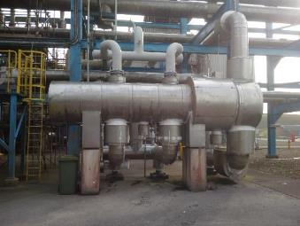
Figure 1. BOG cooler.

The Bog cooler acts as a heat exchanger which is cooled by LNG flowing from the send out pumps through the cooler on route to the SCVs. The other substance is the BOG from the compressors on its way to the recondenser. Figure 2 shows the flow of LNG and BOG through the cooler.

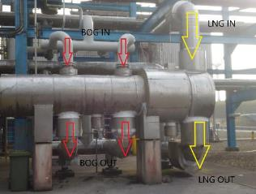
Figure 2. BOG cooler with flow indication.

Heat Exchangers.
The Bog cooler works in the same way as a basic heat exchanger. This allows heat or coldness of a substance to be transferred to a second substance without the two physically mixing through direct contact. Figure 3 shows a section of a heat exchanger, a substance would flow from the shell-side fluid in cooling or heating the substance in the tube-side bundles and leaving slightly warmer or cooler through the shell-side outlet. This setup allows heat transfer without the two substances mixing.

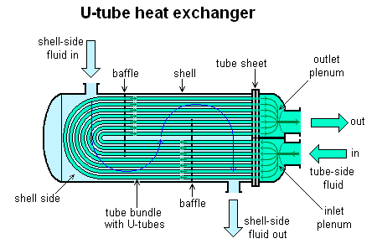
Figure 3. Heat exchanger diagram.

The Recondenser.
The recondenser in figure 4, consists of an inner cylinder containing metal ring packing to allow absorption of the vapour into the liquid, and a larger outer vessel. The larger outer vessel forms an annular space around the inner cylinder. The inner cylinder is welded to the top of the vessel so that the vapour space around the column does not contact the surrounding outer vessel. The boil-off gas enters the top of the recondenser into the inner cylinder along with LNG and encounter each other in the packed cylinder. This is shown in figure 5, the blue inlet is the LNG from the tanks and the yellow the BOG from either the cooler or BOG compressor discharge. These two coming into contact produces a liquid which is collected in the bottom of the recondenser. This provides a surge volume acting to maintain a constant flow to the HP send out pumps should the inlet valve to these shut inadvertently.
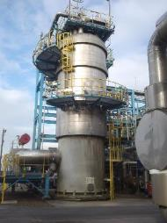
Figure 4. Recondenser.

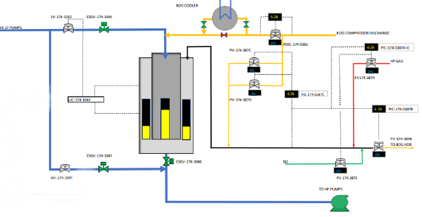
Figure 5. Reconderser flow diagram.

Reducing Energy Losses.
The BOG cooler uses the LNG to cool the BOG on route to the recondenser. As a product of this the LNG warms slightly on route to the SCVs. This heat exchange serves multiple purposes.
LNG to the SCV.
The SCVs are heated using fuel gas, a take-off for this has been taken downstream of the BOG compressor supplying the LP fuel gas system. However, the main source of fuel gas is supplied via a let-down package from the HP gas send out header, with the LP fuel gas supply as a backup source.
The LNG coming from the BOG cooler and going to the SCVs is warmed slightly from this heat exchange resulting in less fuel gas being required to then transform this LNG from -160 °C to +6°C gas to then be sent out to the grid. This warming from the BOG cooler minimises the input of energy in the form of fuel gas therefore reducing energy usage and loss through more fuel gas being required.
BOG to the Recondenser.
The BOG supplied to the recondenser, from the BOG cooler, has already had heat taken from it through indirect contact with LNG. This slight cooling effect will lessen the workload when the LNG is added to the recondenser with BOG returning it to a liquid. As shown in figure 2 the unlagged pipes at the top where the warm BOG enters, and the colder BOG exits through the lagged pipes at the bottom of the cooler. This insulation/lagging limits any energy loss though transfer between the two.

Pipework Insulation.
Insulation or lagging of LNG pipework on the Dragon LNG terminal is important, operating at temperatures of -161°C requires insulating to protect both the pipework and the product within them. Thermal insulation is imperative to avoid energy or heat loss as well as protection from moisture or corrosion, ensuring plants reliability and longevity. The insulation is on pipework that carries LNG as you can see from figure 6. Also shown in figure 6 is frosting that appears on some of the joints or connections.

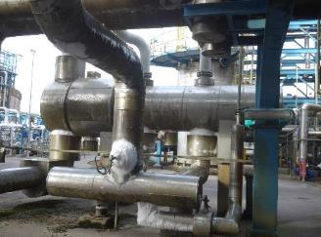
Figure 6. BOG cooler showing frosting on lagging.

The insulation is a multi-stage installation consisting of the duct wrap. This can be 25-50mm thick depending on the size of the valve or pipework. This is then sealed by foil tape (Figure 7).
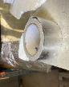
Figure 7. Foil tape for sealing joints.

This is then followed by a layer or Trymer Polyisocyanurate (PIR). PIR is a “closed-cell, foam insulation for industrial pipes, tanks, vessels, and equipment used in cryogenic and LNG applications. Trymer PIR can be used on applications that operate at temperatures ranging from -297°F to 300°F (-183°C to 148°C)”. PIR is very economical both from a cost perspective and with installation costs, it is easy to make and can be fabricated in longer lengths cutting out the potential of energy loss and risk of failure.
There is then a void that is filled with a two-component polyurethane foam system which is environmentally friendly consisting of no HCFC’s or CFC’s and adds structural support. It is designed to insulate valves and flange boxes. The high-density foam is made up of a closed cell structure (approx. 95%) and will withstand temperatures as low as -129°C. To dismantle the product, it must have a release agent applied either a lubricant or grease to the inside to allow the box to be removed. The benefits of this Polyurethane foam are that it is resistant to moisture, it insulates, it acts as a sound suppressant and a continuous air barrier and can be utilised in various size spaces. This is sealed with an adhesive called Foamglas Pittseal 444N.
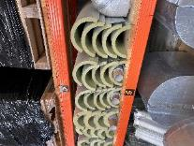
Figure 9. Ready cut out insulation.

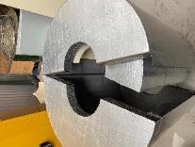
Figure 8. Premade insulation.

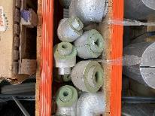
Figure 10. Premade joints.

Figure 8

These can be made to measure or can come in multiple premade shapes and sizes (see figures 8-10).
The final stages are a heavy-duty protective foil called Tembutil-IF which has a self-adhesive layer, is UV resistant, weatherproof and puncture/tear resistant. Another is the stainless-steel box which goes around the outside of the valve or pipework to protect the foam underneath from damage and prevent any further energy loss, (see figures 11 and 12). Like the insulation inside these can come in various premade sizes and can also be made to measure.

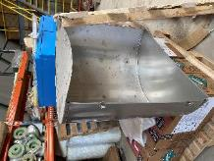
Figure 12. Cross section of casing.

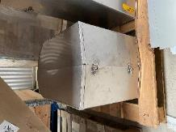
Figure 11. Premade stainless-steel box.

Caustic usage and wastewater flow.
The requirement for caustic comes from the submerged combustion vaporizers (SCVs) (see Figure 13). When the LNG is vaporised in coils submerged in the water bath inside the SCVs, combustion with CO₂ dissolving in the hot water bath causes acidic conditions. This is controlled by introducing a 20%wt caustic solution to maintain a neutral pH. As the water is condensed through combustion products a stream of the neutralised water is taken away from the baths. Figure 14 shows the path in which the neutralised water overflows and is carried to the SCV basin (Figure 15).
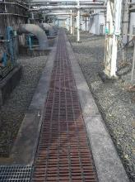
Figure 14. Gullies in which wastewater flows.

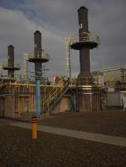
Figure 13. SCVs requiring caustic usage.

Figure 1

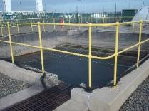
Figure 15. Neutralized water in the SCV overflow basin.

Figure 4

The level in this basin is controlled by two 4” overflow pipes (figure 16). These transfer the water back to the fire water pond, (see figure 17).
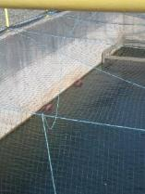
Figure 16. Overflow pipes in basin.

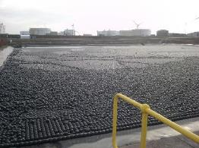
Figure 17. Firewater pond.

The Fire water pond is covered with the black balls to limit the suns rays effecting the pH levels of the water. This water is analysed and monitored to ensure a neutral pH should it overflow into a natural soakaway.

Caustic Area.
The caustic storage area consists of a 64m³ storage tank (figure 18), 2 caustic distribution pumps (figure 19) located just outside of the bunded area around the storage tank.
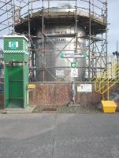
Figure 18. Caustic storage tank.

Figure 6

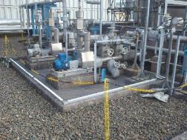
Figure 19. Caustic distribution pumps in bund.

Figure 8

Figure 7

If the sump (figure 20) has water inside, it is tested by operational personnel for pH before it is emptied using the drain inside the bund. The drains are operated from outside the bund. (Figure 21). The testing is to ensure it is rainwater that is being disposed and not contaminated water.
The test is carried out using litmus paper and emptied on completion of a successful neutral test. The difficulty in carrying out this test is that access to the water is over the bund wall which is difficult to access in good weather conditions made even harder in inclement weather. The alternative is to drop the litmus paper into the water and see if the pH indicator is visible which would not be possible in low light or windy conditions, leaving an aspect of human error in the reading.
If the water is contaminated, then it is removed by tanker to avoid any damage to the environment and surrounding areas. Caustic contamination in high concentration would have hazardous effects in the surrounding waterways and environment.

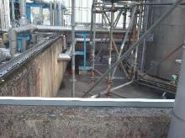
Figure 20. Caustic storage tank bund.

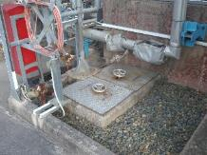
Figure 21. Caustic bund drain controls.

Conclusion.
To conclude, the Dragon LNG terminal has multiple ways in which it conserves energy, through tested methods of heat transfer which see any energy transfer used to benefit other parts of the plant, to a rigorous insulation routine which ensures heat losses are kept to a minimum wherever possible.
One part of the insulation process that could be improved on is where the insulation is penetrated due to instrumentation. This is obvious when looking at certain gauges or sensors as the extreme temperatures show frosting and icing where it is very difficult to insulate, as well as on some bends where the insulation is potentially made up of multiple sections. This could be overcome by using one large accurately cut piece of insulation rather than sectioned into smaller pieces.
The water that could be considered contaminated, and harmful to the environment is treated before becoming wastewater, and where harmful substances could contaminate the surrounding areas, they are tested and deemed safe before being drained into natural soakaways or disposed of safely should they become contaminated.
Another aspect that could be improved is the use of pH monitors, installed into the bunds ensuring any human error is removed when making it easier and quicker for operational personnel to detect the pH levels before discharging or reporting.

References.

- Manual No. DLNG-M-OM-001 – Operations Manual [Accessed 12 February 2021]

- Jm.com. 2021. Insulation for Cryogenic and LNG Systems. [online] Available at: <https://www.jm.com/en/industrial-insulation/insulation-for-cryogenic-and-lng-systems-/> [Accessed 7 April 2021].

Bibliography.

- Roechling.com. 2021. Cryogenic insulation / Cryogenic insulation materials | Röchling EN. [online] Available at: <https://www.roechling.com/uk/industrial/characteristics/cryogenic-insulation-materials> [Accessed 1 April 2021].

- Foamglas.com. 2021. LNG. [online] Available at: <https://www.foamglas.com/en-gb/applications-and-solutions/process-piping-and-equipment/above-ground/cryogenic/lng/lng> [Accessed 1 April 2021].

- Temati.com. 2021. Thermal insulation (protection), CUI, asbestos abatement and more. [online] Available at: <https://www.temati.com/> [Accessed 7 April 2021].

(Insulation for Cryogenic and LNG Systems, 2021)

