HTML & CSS Web Development
Course: BSc/HND Computing (All Streams)

Module: L4 - Introduction to Web and Database Concepts (ACCA4023)
Date: Monday 26th April

Liam Smalldon – 1910726

Table of Contents
Contents
Introduction 3
Requirements 3
Implementation 3
Evaluation 3
Website Usability 3
Website Accessibility 4
Search Engine Optimisation 5
Evaluation of Website 5
References 7
Appendices 8

Introduction
The subject matter of the website is an information point that covers some important and useful aspects of Mountain Biking. There will be screenshots included of the website. This report will cover the purpose of the website, its target audience and how the website is relevant.
The website will also be subjected to validation where an online validation tool will be used to see if there are any errors in the HTML code and in the CSS (Cascading Style Sheets) code.
To further this, the website will be evaluated on its design, particularly its usability and utility which contributes greatly to the users experience on the site. To further this the accessibility will be reviewed which will check things like contrast and if text is easily readable. The search engine optimisation techniques will also be looked at. Furthermore, all of these points will be researched thoroughly.

Requirements
The website’s subject is Mountain Biking, commonly abbreviated to MTB. It is an information point that covers some key areas of the sport and is aimed at people who enjoy the sport of Mountain Biking and would like to learn more about it. It covers the subject of the types of bikes, what makes bikes different, how MTB trails are graded in difficulty and where you can ride in South Wales.

Implementation
Screenshots of each webpage.
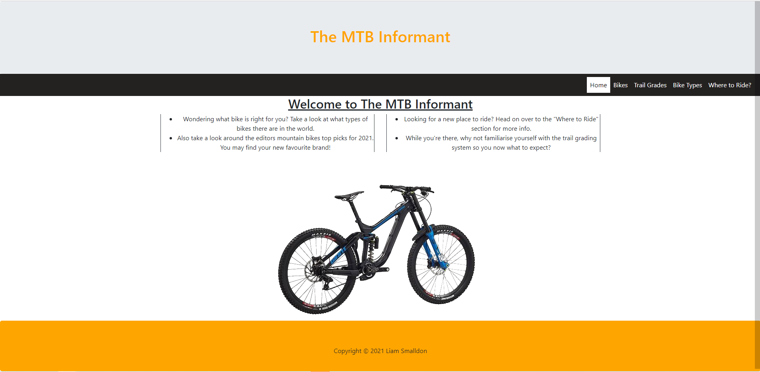
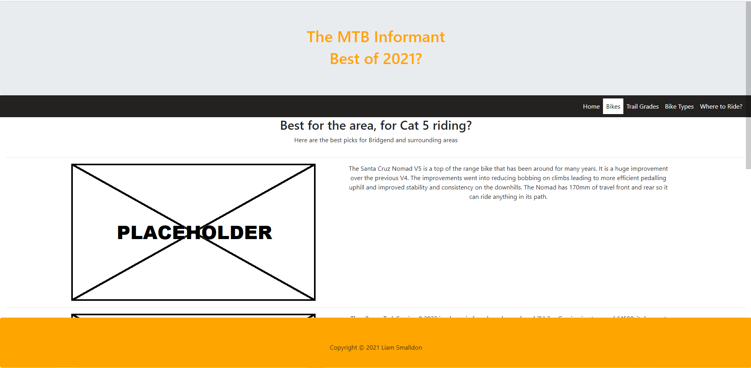
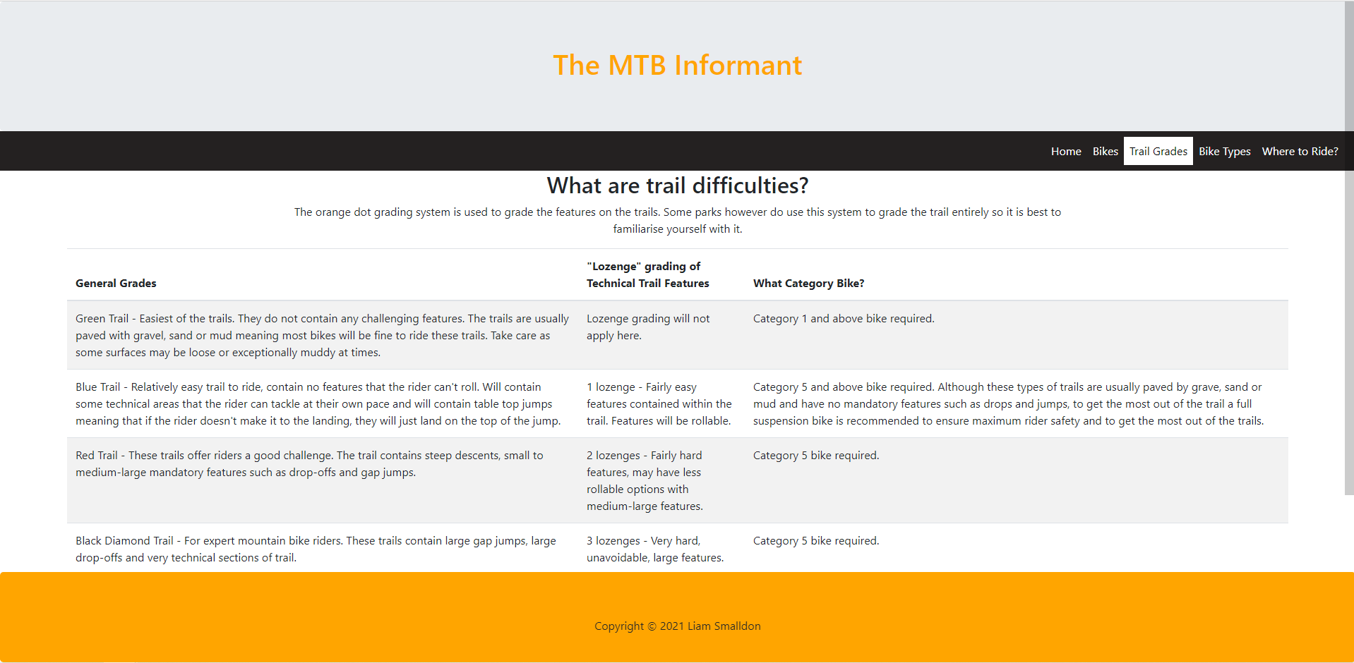
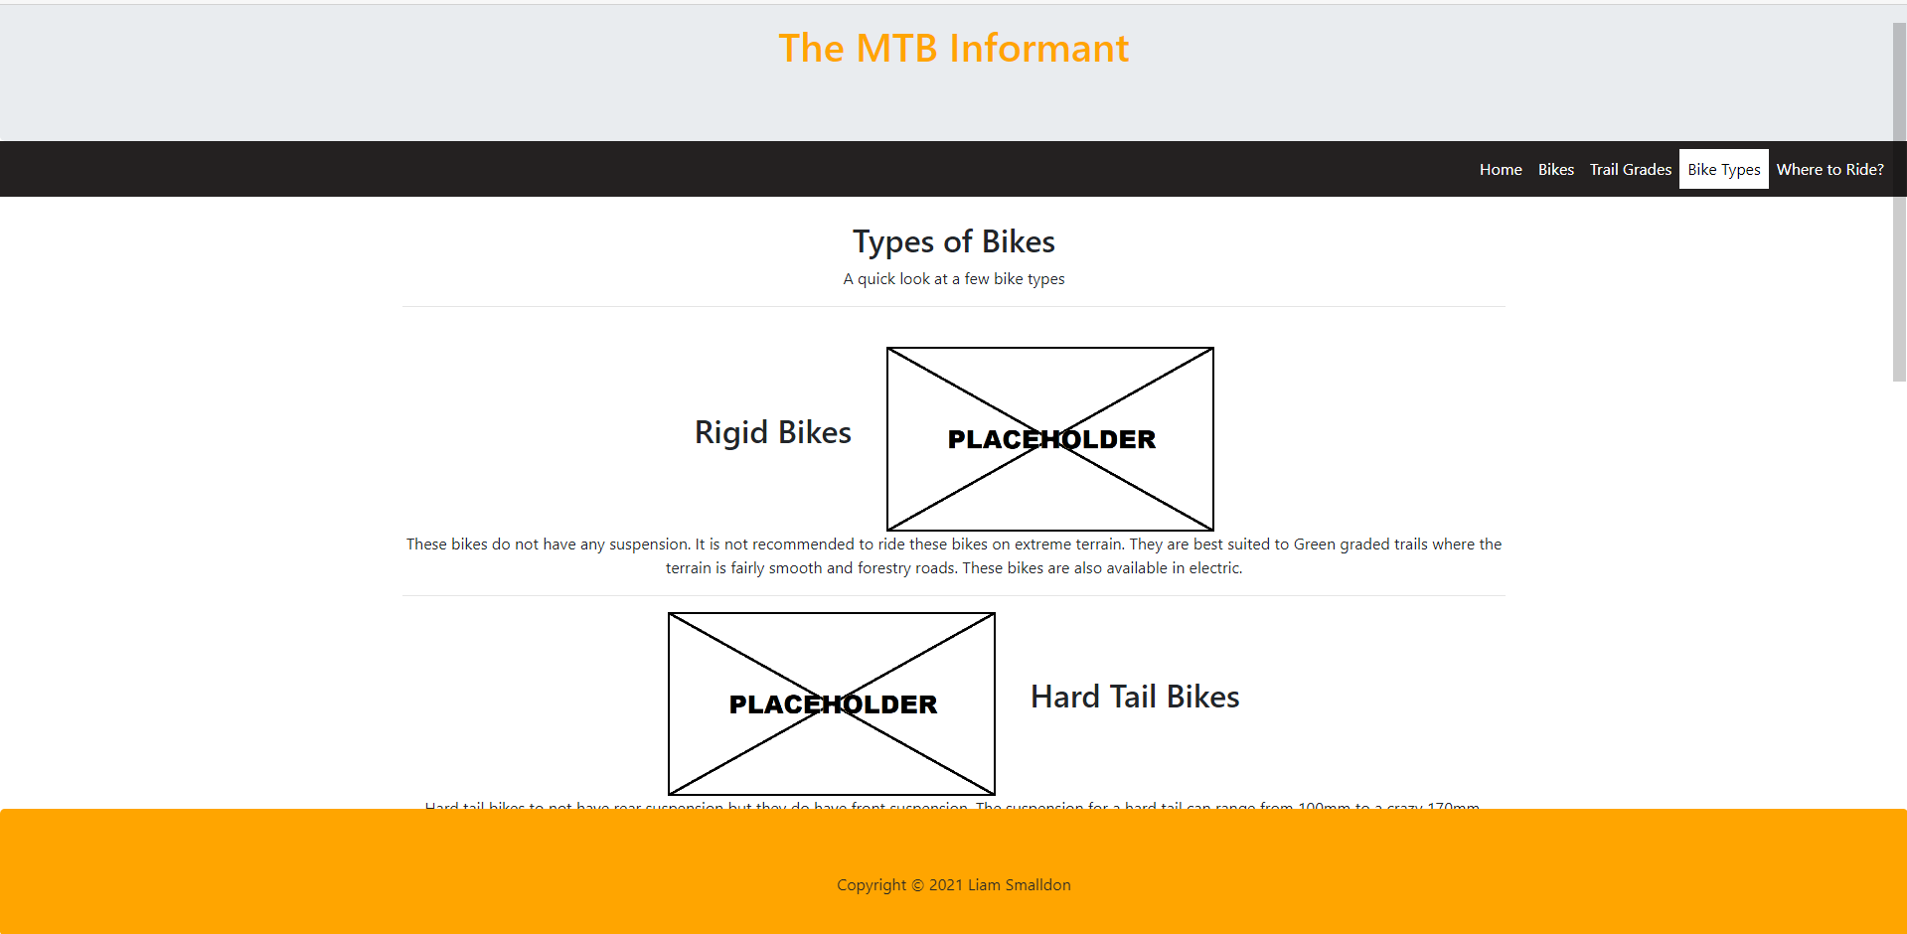
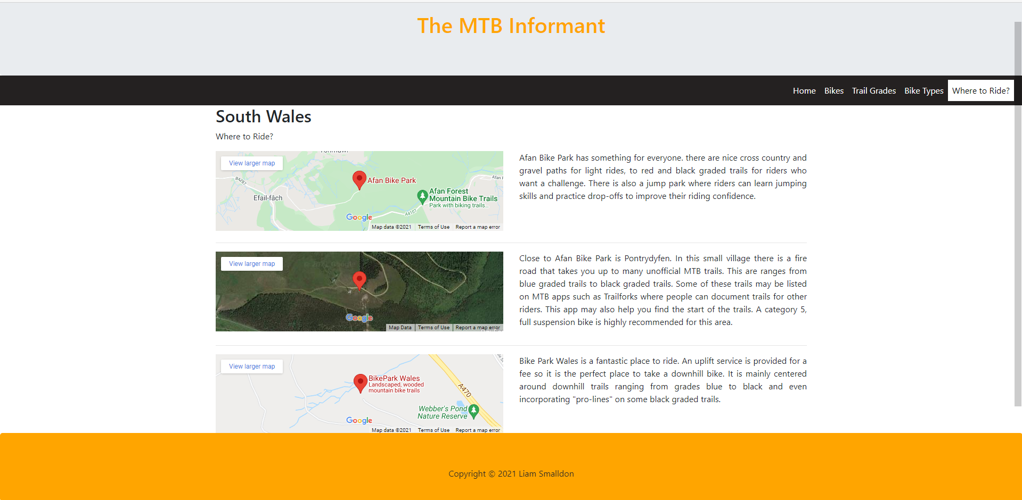

The website was passed through an online HTML validator. Each page had a small error that was correctable. Firstly, on the homepage the author of this document had forgotten to add an “alt” attribute to an image. There is now a description of the image if it fails to load so visitors to the site would know what is there. On the “Bikes” page, there were also missing “alt” attributes on the image tags which were fixed along with some unclosed elements as the closing “</div>” tag had been forgotten. Furthermore, there was a stray tag found on another page, which was removed as it was no longer needed.
Finally, an “AI HTML Inspector” browser add-on was used. The website was loaded into a browser and the add-on ran an evaluation. It found several violations as some content was not placed inside container elements with appropriate ARIA landmark roles. An attempt was made to update the landmark structure of the webpage by placing the violated elements not contained in landmarks, into container elements with proper landmark roles. However, due to a lack of knowledge, fixing some of these violations was not possible. To fix it, the “role” attribute is needed on some HTML elements to create a landmark to fix the elements causing the violations. Adding these would make the website more robust as it would help third party software work on the site, such as text to speech software.
The CSS file was validated and no errors were found. The CSS file was used for certain things on the website, and some styling was also done in the HTML via Bootstrap 4.

Evaluation
There are factors that contribute to the quality of a website. These include website usability, accessibility, and search engine optimisation.
Website Usability
Website usability is how intuitive a website is for visitors. This means that it should have a clear navigation system, so a user is able to navigate the website with ease. The user should feel like they know where they are going even though it may be new to them. The speed in which a user completes these tasks is also important as it shows that the website is designed well and the user is not getting lost and does not have to think about what to do next [1].
In addition to this, it creates a good impression on visitors who could be potential clients if your site is for ecommerce. This impression will keep the attention of the visitor, meaning they are less likely to leave the site and go elsewhere. To further this, the impression may cause the visitor to recommend the website to other people [2].
Before a website is published, a usability test can be performed. This is where someone who has never used the website before is asked to complete an order, navigate to a certain part of the site and just have a general play around. The testers feedback is gathered throughout. This will allow the web designer to assess the websites effectiveness and allow the web designer to redesign some aspects if they are in need of a change.
Website Accessibility
Website accessibility coincides with website usability. There are guidelines online that help web designers to make websites that are accessible for everyone. Accessibility covers things like the contrast of the pages. This mainly focuses on the background and the text on top. It is best practice to keep text black on top of a white background as this provides the best readability to the website’s visitors [3]. Keeping to this practice web designers should also not put text on images but underneath as a caption. Icons and buttons should also be eye-catching and obvious they are buttons so that people can click them, and the text is readable and conveys where the button will take them. This is called the luminosity contrast ratio [4].
There are online tools that can check website contrast and other appropriate colour combinations. The accessibility should ideally be assessed in the design phase of the website; however, things may change once the website comes to life [4].
Text size should also be the appropriate size and in a readable font. This should then be spaced away from the edges of the page to further increase user readability.
The HTML of website should contain landmarks. A landmark is an element such as “main” and “nav”. These are assigned as roles in the HTML elements. These special regions improve navigation for assistive technologies [5].
There are four main principles for web accessibility. They are perceivable, operable, understandable and robust.
Perceivability means that the website must be apprehensible by anyone. This means the website must be laid out appropriately presenting everything clearly to the visitor. Text alternatives must be applied for non-text content such as images. This allows screen readers to describe image to the visually impaired [5].
Next the site must follow some operable guidelines. Keyboard accessibility is a must, the site must be navigable entirely through the keyboard. The design must also not incorporate and content that can cause any seizures of physical reactions. A nice, warm colour Wallette is recommended, nothing bright and flashy [5] [6].
Creating a robust website is a must. The HTML and CSS should be clean and be in a good structure containing landmarks that third party software can locate on the page aiding in screen readers for people who need them. The website should also be compatible with multiple browser and devices so responsiveness is a key part of the website [7].
Search Engine Optimisation
Search Engine Optimisation (SEO) plays a big role in getting users to visit websites. Search engine optimisation is considered when designing and developing websites as it makes them search-engine friendly [5]. Search engines frequently crawl websites. A new website may take some time to be indexed but this can be improved if the website is popular and has a good structure which will increase its crawlability. This means it is also important to have keywords on the pages of the website as web browser then know the topic of the site allowing them to provide the site in the search engines results. Search engines, provide content that will best answer a searchers query, increasing the need of keywords and succinct information displayed on the website [6].

Evaluation of Website
The website was designed prior to being developed through creating wire frames and following a brief. The author of this document believes that this contributed to the website’s usefulness in a number of ways.
Firstly, the websites functionality is very simple, meaning that visitors to the site will have an intuitive experience. All the user needs to do is navigate via buttons on the top right of the webpage and scroll down the page to see its content. The layout of the pages follows a tried and true design which is showing the navigation bar across a header in plane view. In the authors website the navigation bar also highlights the button that the page is currently on. This ensures the visitor does not get confused which contributes to how good the usability of the site is.
Through the use of Bootstrap 4, the author has been able to create a responsive website. This means that no matter what screen resolution a visitors device has, be it a computer or mobile phone, the website will resize itself to fit the devices screen size. This means that the user of the device will not have text running off the page or images that do not fit on the page indicating that they will never have to horizontally scroll to see the content on the website. Everything will resize and move into a vertical format that is readable and easy to navigate.
For the accessibility aspect of the site, the website had its contrast checked via an online contrast checker. Here the text was placed on a background and its luminosity contrast ratio was calculated. All tests carried out had very high ratios meaning that the text is highly readable. The text on the authors website was kept in the colour black on a white background for maximum accessibility and no text overlapped or was overlayed on images.
To further the websites accessibility, an “AI HTML Inspector” was used as a web browser add-on to check the websites code. This found some errors where text alternatives were not available for non-text content such as images. This was rectified and has increased the sites perceivability.
The operability of the website is very good. The whole website is keyboard accessible. The visitor can use the tab button on their keyboard to choose what page they would like to see on the navigation bar. They can use page up and down to then scroll the content on each page.
Due to the simplicity of the website, it is quite robust. Software such as web browsers can display the content correctly and screen readers can be used to help the visually impaired. This could be improved on by following ARIA HTML standards to ensure that all elements have their proper landmark to improve the readability of the site for third party software.
The website was optimised for search engines. The SEO techniques applied to the website are the use of large headers, sub-headers, bullet points, white space, images, easy navigation, easy text to read and bucket brigades.
To start off headers and sub-headers are larger than other text and contain key phrases that will fit people’s search queries. The headers contain abbreviations like “MTB” and words like “informant” meaning that when the site is indexed by a web crawler, it will then be displayed when people search for mountain biking information. To further this, the term mountain biking, along with bike brand names have been used to influence where the website will be indexed.
A bucket brigade, which is a technique to capture and retain a website visitors’ interest, was used within the bullet pointed information, where it asks the visitor an enticing question, hopefully making them stay on the site and find out the answer to that question.
There is plenty of white space on the site indicating that the text on the page is succinct as too much text can overwhelm visitors. Something that is quick to read is more likely to capture and retain a visitor’s attention.
Furthermore, images are used throughout to illustrate the point that is being made by the surrounding text and to give the website a more lively, colourful look making it less daunting to browse.
The site does not use any black hat techniques which are ways of pushing the website to achieve higher rankings by spamming keywords or hiding content and links on the page. Machine learning has helped uncover these techniques so the site does not use them as it may hurt its ranking.
The author of this document thinks that, for future improvements of the website, that the space of the footer could be better utilised. For instance, if the website increases in popularity, social media accounts could be embedded into the footer. Here links to the websites social media could be present which would serve as a news feed for small updates that may not be worth adding to the site.
More content on the site would also be welcome as it fits into the theme. Other pages could be added where subjects like bike maintenance could be covered and what tools will be needed.
Another improvement could be purchasing the rights or creating their own images to use on the website. The images would then be of higher quality and used for a specific purpose without having to make do with copyright free images found online or adding placeholders.

References

[1] | A. D. a. S. Cassar, “An Intelligent Framework for Website Usability,” vol. 2014, p. 1.2. The Importance of Usability on the Web, 14 04 2014.
[2] | DREAMKATCHA, “The importance of website usability,” DREAMKATCHA, [Online]. Available: https://dreamkatcha.com/importance-website-usability/#:~:text=Website%20design%20usability%20is%20the,of%20use%20of%20a%20website.&text=Good%20website%20usability%20creates%20a,what%20they%20are%20searching%20for.. [Accessed 19 04 2021].
[3] | R. R. e. al, Web Accessibility: Web Standards and Regulatory Compliance, C. Mills, Ed., 2006, pp. 155-156.
[4] | w3, “Colors with Good Contrast,” www.w3.org, 23 01 2019. [Online]. Available: https://www.w3.org/WAI/perspective-videos/contrast/. [Accessed 19 04 2021].
[5] | W3C , “Web Content Accessibility Guidelines (WCAG) 2.1,” www.w3.org, 05 06 2018. [Online]. Available: https://www.w3.org/TR/WCAG21/#abstract. [Accessed 22 04 2021].
[6] | Bureau of Internet Accessibility, “What Are the Four Major Categories of Accessibility?,” Bureau of Internet Accessibility, 13 09 2019. [Online]. Available: https://www.boia.org/blog/what-are-the-four-major-categories-of-accessibility#:~:text=The%20Web%20Content%20Accessibility%20Guidelines,Operable%2C%20Understandable%2C%20and%20Robust.. [Accessed 22 04 2021].
[7] | WUHCAG, “What are the Web Content Accessibility Guidelines?,” www.wuhcag.com, [Online]. Available: https://www.wuhcag.com/web-content-accessibility-guidelines/#:~:text=A%20robust%20website%20is%20one,cannot%20correctly%20process%20your%20website.. [Accessed 22 04 2021].
[8] | T. Linchpin, “How to Design an SEO Friendly Website that Ranks Well In Google,” linchpinseo.com, 10 03 2021. [Online]. Available: https://linchpinseo.com/how-to-design-an-seo-friendly-website/#:~:text=SEO%20web%20design%20is%20a,index%20it%20in%20their%20database. [Accessed 19 04 2021].
[9] | B. M. e. al, “How Search Engines Work: Crawling, Indexing, and Ranking,” moz.com, [Online]. Available: https://moz.com/beginners-guide-to-seo/how-search-engines-operate. [Accessed 19 04 2021].

Appendices
Home Page HTML

<!DOCTYPE html>
<html lang="en">

<head>
<title>Liam's MTB Website</title>
<meta charset="utf-8">
<meta name="viewport" content="width=device-width, initial-scale=1">
<link rel="stylesheet" href="styles.css">
<link rel="stylesheet" type="text/css" href="https://maxcdn.bootstrapcdn.com/bootstrap/4.5.2/css/bootstrap.min.css">
<script src="https://ajax.googleapis.com/ajax/libs/jquery/3.5.1/jquery.min.js"></script>
<script src="https://cdnjs.cloudflare.com/ajax/libs/popper.js/1.16.0/umd/popper.min.js"></script>
<script src="https://maxcdn.bootstrapcdn.com/bootstrap/4.5.2/js/bootstrap.min.js"></script>
</head>

<body>

<div class="jumbotron text-center landmark"
style="margin-bottom:0; color:orange">
<h1>The MTB Informant</h1>
</div>

<nav class="navbar navbar-expand navigation">
<div class="collapse navbar-collapse collapse" id="collapsibleNavbar">
<ul class="nav navbar-nav ml-auto">
<li class="nav-item">
<a class="nav-link active" href="home.html">Home</a>
</li>
<li class="nav-item">
<a class="nav-link" href="bike-table.html">Bikes</a>
</li>
<li class="nav-item">
<a class="nav-link" href="trail-grades.html">Trail Grades</a>
</li>
<li class="nav-item">
<a class="nav-link" href="bike-types.html">Bike Types</a>
</li>
<li class="nav-item">
<a class="nav-link" href="where-to-ride.html">Where to Ride?</a>
</li>
</ul>
</div>
</nav>

<div class="container" style="text-align: center;">
<div class="row">
<div class="col-12">
<h2 class="heading">Welcome to The MTB Informant</h2>
<div class="content">
<div class="row">
<div class="col-md-6">
<ul class="desc border-right border-left border-dark">
<li>Wondering what bike is right for you? Take a look at what types of bikes there are
in the world.</li>
<li>Also
take a look around the editors mountain bikes top picks for 2021. You may find your
new favourite brand!</li>
</ul>
</div>
<div class="col-md-6">
<ul class="desc border-right border-left border-dark">
<li>Looking for a new place to ride? Head on over to the "Where to Ride" section for
more info.</li>
<li>While you're there, why not familiarise yourself with the trail grading system so
you now what to expect?</li>
</ul>
</div>
</div>
</div>
</div>
</div>
<div>
<img class="image img-fluid" src="copyright-free-images/Mountain-Downhill-Bike.png" alt="Downhill Bike">
</div>
</div>

<footer>
<div class="jumbotron text-center" style="margin-bottom: 0; background-color: orange; height: 100px;">
<p>Copyright &copy; 2021 Liam Smalldon</p>
</div>
</footer>

</body>

</html>

Bike Table HTML

<!DOCTYPE html>
<html lang="en">

<head>
<title>Liam's MTB Website</title>
<meta charset="utf-8">
<meta name="viewport" content="width=device-width, initial-scale=1">
<link rel="stylesheet" href="styles.css">
<link rel="stylesheet" type="text/css" href="https://maxcdn.bootstrapcdn.com/bootstrap/4.5.2/css/bootstrap.min.css">
<script src="https://ajax.googleapis.com/ajax/libs/jquery/3.5.1/jquery.min.js"></script>
<script src="https://cdnjs.cloudflare.com/ajax/libs/popper.js/1.16.0/umd/popper.min.js"></script>
<script src="https://maxcdn.bootstrapcdn.com/bootstrap/4.5.2/js/bootstrap.min.js"></script>
</head>

<body>

<div class="jumbotron text-center" style="margin-bottom:0; color:orange">
<h1>The MTB Informant</h1>
<h1>Best of 2021?</h1>
</div>

<nav class="navbar navbar-expand navigation">
<div class="collapse navbar-collapse collapse" id="collapsibleNavbar">
<ul class="nav navbar-nav ml-auto">
<li class="nav-item">
<a class="nav-link" href="home.html">Home</a>
</li>
<li class="nav-item">
<a class="nav-link active" href="bike-table.html">Bikes</a>
</li>
<li class="nav-item">
<a class="nav-link" href="trail-grades.html">Trail Grades</a>
</li>
<li class="nav-item">
<a class="nav-link" href="bike-types.html">Bike Types</a>
</li>
<li class="nav-item">
<a class="nav-link" href="where-to-ride.html">Where to Ride?</a>
</li>
</ul>
</div>
</nav>

<div class="container-fluid">
<div class="row">
<div class="overview col-12">
<h2>Best for the area, for Cat 5 riding?</h2>
<p>Here are the best picks for Bridgend and surrounding areas</p>
</div>
</div>
<hr>
<div class="content">
<div class="row" style="padding-right: 10%;">
<div class="col-md-6">
<img class="image img-fluid" style="padding-left: 20%;" src="copyright-free-images/placeholder.png"
alt="Santa Cruz Nomad V5 Enduro Bike">
</div>
<div class="col-md-6">
<p class="description">
The Santa Cruz Nomad V5 is a top of the range bike that has been around for many years. It is a
huge improvement over the previous V4. The improvements went into reducing bobbing on climbs
leading to more efficient pedalling uphill and improved stability and consistency on the
downhills.
The Nomad has 170mm of travel front and rear so it can ride anything in its path.
</p>
</div>
</div>
<hr>
<div class="row" style="padding-right: 10%;">
<div class="col-md-6">
<img class="image img-fluid" style="padding-left: 20%;" src="copyright-free-images/placeholder.png"
alt="Trek Session Downhill Bike">
</div>
<div class="col-md-6">
<p class="description">
The all new Trek Session 9 2022 is a bargain for a brand new downhill bike. Coming in at around
£4500, it does not come in a fancy carbon
frame but a robust aluminium frame. It has an all new high pivot suspension design with an idler
wheel in the drive train to reduce pedal kickback.
This also means the bike doesn't get hung up when riding through rough terrain as the rear
suspension has a more rearward axle path.
</p>
</div>
</div>
<hr>
<div class="row" style="padding-right: 10%;">
<div class="col-md-6">
<img class="image img-fluid" style="padding-left: 20%;" src="copyright-free-images/placeholder.png"
alt="Propain Spindrift Enduro Bike">
</div>
<div class="col-md-6">
<p class="description">
The Propain Spindrift is a free ride bike. It comes in carbon or aluminium and a whopping 180mm
of travel front and rear. Depending on your choice of parts when purchasing you could even get a
190mm travel fork! The bike is for people who can't get enough travel and love riding big
features. Be it at the bike park or your local trails this bike can do both with no problems.
</p>
</div>
</div>
<hr>
<div class="row" style="padding-right: 10%;">
<div class="col-md-6">
<img class="image img-fluid" style="padding-left: 20%;" src="copyright-free-images/placeholder.png"
alt="Forbidden Dreadnought Enduro Bike">
</div>
<div class="col-md-6">
<p class="description">
Forbidden Dreadnought. This is a relatively new bike brand on the market and comes with an
interesting design. It has a longer chain with the slack taken up by an idler wheel that's
attached to the rear triangle. This is in place for the high pivot point suspension design. This
will reduce pedal kick and increase speed through the rough stuff.
</p>
</div>
</div>
</div>
</div>

<footer>
<div class="jumbotron text-center" style="margin-bottom: 0; background-color: orange; height: 100px;">
<p>Copyright &copy; 2021 Liam Smalldon</p>
</div>
</footer>

</body>

</html>

Trail Grades HTML

<!DOCTYPE html>
<html lang="en">

<head>
<title>Liam's MTB Website</title>
<meta charset="utf-8">
<meta name="viewport" content="width=device-width, initial-scale=1">
<link rel="stylesheet" href="styles.css">
<link rel="stylesheet" type="text/css" href="https://maxcdn.bootstrapcdn.com/bootstrap/4.5.2/css/bootstrap.min.css">
<script src="https://ajax.googleapis.com/ajax/libs/jquery/3.5.1/jquery.min.js"></script>
<script src="https://cdnjs.cloudflare.com/ajax/libs/popper.js/1.16.0/umd/popper.min.js"></script>
<script src="https://maxcdn.bootstrapcdn.com/bootstrap/4.5.2/js/bootstrap.min.js"></script>
</head>

<body>

<div class="jumbotron text-center" style="margin-bottom:0; background-image:url(0131_cr.jpg); color:orange">
<h1>The MTB Informant</h1>
</div>

<nav class="navbar navbar-expand navigation">
<div class="collapse navbar-collapse collapse" id="collapsibleNavbar">
<ul class="nav navbar-nav ml-auto">
<li class="nav-item">
<a class="nav-link" href="home.html">Home</a>
</li>
<li class="nav-item">
<a class="nav-link" href="bike-table.html">Bikes</a>
</li>
<li class="nav-item">
<a class="nav-link active" href="trail-grades.html">Trail Grades</a>
</li>
<li class="nav-item">
<a class="nav-link" href="bike-types.html">Bike Types</a>
</li>
<li class="nav-item">
<a class="nav-link" href="where-to-ride.html">Where to Ride?</a>
</li>
</ul>
</div>
</nav>

<div class="container">
<div class="row">
<div class="col-12">
<h2>What are trail difficulties?</h2>
<p>The orange dot grading system is used to grade the features on the trails. Some parks however do use this
system to grade the trail entirely so it is best to familiarise yourself with it.</p>
</div>
</div>
</div>
<div class="container-fluid">
<div class="row justify-content-center">
<div class="col-11">
<table class="table table-striped">
<thead>
<tr>
<th scope="col">General Grades</th>
<th scope="col">"Lozenge" grading of Technical Trail Features</th>
<th scope="col">What Category Bike?</th>
</tr>
</thead>
<tbody>
<tr>
<td>Green Trail - Easiest of the trails. They do not contain any challenging features. The trails are
usually
paved with gravel, sand or mud meaning most bikes will be fine to ride these trails. Take care as some
surfaces may be loose or exceptionally muddy at times.</td>
<td>Lozenge grading will not apply here.</td>
<td>Category 1 and above bike required.</td>
</tr>
<tr>
<td>Blue Trail - Relatively easy trail to ride, contain no features that the rider can't roll. Will
contain
some technical areas that the rider can tackle at their own pace and will contain table top jumps
meaning
that if the rider doesn't make it to the landing, they will just land on the top of the jump.</td>
<td>1 lozenge - Fairly easy features contained within the trail. Features will be rollable.</td>
<td>Category 5 and above bike required. Although these types of trails are usually paved by grave, sand or
mud
and have no mandatory features such as drops and jumps, to get the most out of the trail a full
suspension
bike is recommended to ensure maximum rider safety and to get the most out of the trails.</td>
</tr>
<tr>
<td>Red Trail - These trails offer riders a good challenge. The trail contains steep descents, small to
medium-large mandatory features such as drop-offs and gap jumps.</td>
<td>2 lozenges - Fairly hard features, may have less rollable options with medium-large features.</td>
<td>Category 5 bike required.</td>
</tr>
<tr>
<td>Black Diamond Trail - For expert mountain bike riders. These trails contain large gap jumps, large
drop-offs and very technical sections of trail.</td>
<td>3 lozenges - Very hard, unavoidable, large features.</td>
<td>Category 5 bike required.</td>
</tr>
<tr>
<td>Double Black Diamond Trail/Orange Grade - These are extreme trails and are only suitable for
experienced
riders. They are basically one long pro-line. Risk of injury is high as features will require the rider
to
leave the ground. The whole trail will
require total commitment.</td>
<td>3 on lozenge grading system.</td>
<td>Category 5 bike required.</td>
</tr>
<tr>
<td>"Pro Line" / Orange Grade? - These are little additional lines, most commonly seen at bike parks on
the
black diamond trails.
These are for advanced riders and are extremely hard to ride</td>
<td>Named pro-lines for their extreme difficulty. 3 on lozenge grading system.</td>
<td>Category 5 bike required.</td>
</tr>
</tbody>
</table>
<hr>
</div>
</div>

<div class="container">
<div class="row">
<p class="alert-danger">Many trails aren't official and therefore are illegal according to UK law. This means
they have no official
difficulty rating.<br>
You can gauge your local unoffical trails by walking them and seeing what features they have and compare that
to the grading systems out there or prior riding experience.
It isn't illegal to ride these trails but it is illegal to build them. Therefore the land owner has every
right to destroy the trails.</p>
</div>
</div>
</div>

<footer>
<div class="jumbotron text-center" style="margin-bottom: 0; background-color: orange; height: 100px;">
<p>Copyright &copy; 2021 Liam Smalldon</p>
</div>
</footer>

</body>

</html>

Bike Types HTML

<!DOCTYPE html>
<html lang="en">

<head>
<title>Liam's MTB Website</title>
<meta charset="utf-8" />
<meta name="viewport" content="width=device-width, initial-scale=1" />
<link rel="stylesheet" href="styles.css" />
<link rel="stylesheet" type="text/css"
href="https://maxcdn.bootstrapcdn.com/bootstrap/4.5.2/css/bootstrap.min.css" />
<script src="https://ajax.googleapis.com/ajax/libs/jquery/3.5.1/jquery.min.js"></script>
<script src="https://cdnjs.cloudflare.com/ajax/libs/popper.js/1.16.0/umd/popper.min.js"></script>
<script src="https://maxcdn.bootstrapcdn.com/bootstrap/4.5.2/js/bootstrap.min.js"></script>
</head>

<body>
<div class="jumbotron text-center" style="
margin-bottom: 0;
background-image: url(0131_cr.jpg);
color: orange;
">
<h1>The MTB Informant</h1>
</div>

<nav class="navbar navbar-expand navigation">
<div class="collapse navbar-collapse collapse" id="collapsibleNavbar">
<ul class="nav navbar-nav ml-auto">
<li class="nav-item">
<a class="nav-link" href="home.html">Home</a>
</li>
<li class="nav-item">
<a class="nav-link" href="bike-table.html">Bikes</a>
</li>
<li class="nav-item">
<a class="nav-link" href="trail-grades.html">Trail Grades</a>
</li>
<li class="nav-item">
<a class="nav-link active" href="bike-types.html">Bike Types</a>
</li>
<li class="nav-item">
<a class="nav-link" href="where-to-ride.html">Where to Ride?</a>
</li>
</ul>
</div>
</nav>

<div class="container" style="text-align: center">
<div class="row">
<div class="col-12">
<br>
<h2>Types of Bikes</h2>
<p>A quick look at a few bike types</p>
<hr style="width: 100%;">
<br>
</div>
</div>
<div>
<div class="col-12">
<h2 class="title col-md-4">Rigid Bikes</h2>
<img class="image col-md-4 h-100" src="copyright-free-images/placeholder.png"
alt="Rigid Bike" />
</div>
<p>These bikes do not have any suspension. It is not recommended to ride these bikes on extreme terrain.
They are best suited to Green graded trails where the terrain is fairly smooth and forestry roads.
These bikes are also available in electric.</p>
<hr />

<div class="col-12">
<img class="image col-md-4 h-100" src="copyright-free-images/placeholder.png"
alt="Hard Tail Bike" />
<h2 class="title col-md-4">Hard Tail Bikes</h2>
</div>
<p>
Hard tail bikes to not have rear suspension but they do have front
suspension. The suspension for a hard tail can range from 100mm to a crazy 170mm.
These bikes are made to the category 5 standard so they will be able to handle the toughest trails.
However, they will require expert line choices and perfect technique from the rider in order to make it
down the trails.
These bikes are also available in electric.
</p>
<hr />

<div class="col-12">
<h2 class="title col-md-4">Trail Bikes</h2>
<img class="image col-md-4 h-100" src="copyright-free-images/placeholder.png"
alt="Trail Bike" />
</div>
<p>
Full suspension bikes with travel typically in the range of 120mm to 150mm. These bikes are very
efficient for climbing due to their light-weight amd can manage anything on the decent. Around 150mm is
more than enough to tackle the majority of features on the trails. Extreme features will require expert
line choice.
</p>
<hr />

<div class="col-12">
<img class="image col-md-4 h-100" src="copyright-free-images/norco-enduro-bike.jpg"
alt="Enduro Bike" />
<h2 class="title col-md-4">Enduro Bikes</h2>
</div>
<p>
Enduro bikes have 150mm to 170mm of travel. Because of this, they are slightly heavier than trail bikes
due to the larger suspension and have slightly more aggressive geometry. They are for people who enjoy
climbing to the top to tackling their local trails and enjoy visits
to the bike park. Their longer travel makes them a great all rounder.
</p>
<hr />

<div class="col-12">
<h2 class="title col-md-4">Freeride/Super Enduro</h2>
<img class="image col-md-4 h-100" src="copyright-free-images/pascal-obermeier-YOphb-Xr2sk-unsplash.jpg"
alt="YT Decoy" />
</div>
<br>
<div class="description">
<p>
Full suspension bikes with travel typically in the range of 180mm to
190mm.
</p>
<p>
These bike are a blend of downhill and enduro. They still have a high enough gear range to allow
riders to climb. This is then combined with a monstrous amount of suspension travel. Some can even
be fitted with
a dual crown fork for a more aggressive look. These bikes are made for riders to access trails where
uplifts are not available allowing them to take on any challenge and even make their own way down
the mountain off piste.
</p>
</div>
<hr />

<div class="col-12">
<img class="image col-md-4 h-100" src="copyright-free-images/Mountain-Downhill-Bike.png"
alt="Downhill Bike" />
<h2 class="title col-md-4">Downhill Bikes</h2>
</div>
<br>
<p>
Full suspension bikes with travel typically in the range 190mm+ front
and rear.
</p>
<p>
These bikes are made to do one thing, descend. The aggressive downhill
geometry paired with only 7 speed drive train means they're only
really suitable for bike parks. The downhill bike has a unique look of
a dual crown fork and a low, out of the way seat.
</p>
</div>
</div>

<footer>
<div class="jumbotron text-center" style="margin-bottom: 0; background-color: orange; height: 100px">
<p>Copyright &copy; 2021 Liam Smalldon</p>
</div>
</footer>
</body>

</html>

Where to Ride? HTML

<!DOCTYPE html>
<html lang="en">

<head>
<title>Liam's MTB Website</title>
<meta charset="utf-8">
<meta name="viewport" content="width=device-width, initial-scale=1">
<link rel="stylesheet" href="styles.css">
<link rel="stylesheet" type="text/css" href="https://maxcdn.bootstrapcdn.com/bootstrap/4.5.2/css/bootstrap.min.css">
<script src="https://ajax.googleapis.com/ajax/libs/jquery/3.5.1/jquery.min.js"></script>
<script src="https://cdnjs.cloudflare.com/ajax/libs/popper.js/1.16.0/umd/popper.min.js"></script>
<script src="https://maxcdn.bootstrapcdn.com/bootstrap/4.5.2/js/bootstrap.min.js"></script>
</head>

<body>

<div class="jumbotron text-center" style="margin-bottom:0; color:orange">
<h1>The MTB Informant</h1>
</div>

<nav class="navbar navbar-expand navigation">
<div class="collapse navbar-collapse collapse" id="collapsibleNavbar">
<ul class="nav navbar-nav ml-auto">
<li class="nav-item">
<a class="nav-link" href="home.html">Home</a>
</li>
<li class="nav-item">
<a class="nav-link" href="bike-table.html">Bikes</a>
</li>
<li class="nav-item">
<a class="nav-link" href="trail-grades.html">Trail Grades</a>
</li>
<li class="nav-item">
<a class="nav-link" href="bike-types.html">Bike Types</a>
</li>
<li class="nav-item">
<a class="nav-link active" href="where-to-ride.html">Where to Ride?</a>
</li>
</ul>
</div>
</nav>

<div class="container" style="text-align: justify;">
<div class="row">
<div class="col-12">
<h2>South Wales</h2>
<p>Where to Ride?</p>
</div>
</div>
<div class="row">
<div class="col-md-6">
<iframe class="img-fluid"
src="https://www.google.com/maps/embed?pb=!1m18!1m12!1m3!1d5888.859350466645!2d-3.7248077954379673!3d51.642251055507515!2m3!1f0!2f0!3f0!3m2!1i1024!2i768!4f13.1!3m3!1m2!1s0x486e5d36025d08d7%3A0x1471b2ba7431a25!2sAfan%20Bike%20Park!5e0!3m2!1sen!2suk!4v1618706575295!5m2!1sen!2suk"
width="600" height="450" style="border:0;" loading="lazy"></iframe>
</div>
<div class="col-md-6">
<p class="desc">
Afan Bike Park has something for everyone. there are nice cross country and gravel paths for light
rides, to red and black graded trails for riders who want a challenge. There is also a jump park
where riders can learn jumping skills and practice drop-offs to improve their riding confidence.
</p>
</div>
</div>
<hr>
<div class="row">
<div class="col-md-6">
<iframe class="img-fluid"
src="https://www.google.com/maps/embed?pb=!1m18!1m12!1m3!1d1510.869417237821!2d-3.75950350972151!3d51.62816635382261!2m3!1f0!2f0!3f0!3m2!1i1024!2i768!4f13.1!3m3!1m2!1s0x486e5d7c0352b011%3A0xb77c3ef4741711f!2sFoel%20Fynyddau!5e1!3m2!1sen!2suk!4v1619095356180!5m2!1sen!2suk"
width="600" height="450" style="border:0;" loading="lazy"></iframe>
</div>
<div class="col-md-6">
<p class="desc">
Close to Afan Bike Park is Pontrydyfen. In this small village there is a fire road that takes you up
to
many unofficial MTB trails. This are ranges from blue graded trails to black graded trails. Some of
these trails may be listed on MTB apps such as Trailforks where people can document trails for other
riders. This app may also help you find the start of the trails. A category 5, full suspension bike
is highly recommended for this area.
</p>
</div>
</div>
<hr>
<div class="row">
<div class="col-md-6">
<iframe class="img-fluid"
src="https://www.google.com/maps/embed?pb=!1m18!1m12!1m3!1d2471.62304165642!2d-3.3790910840690445!3d51.721638702836906!2m3!1f0!2f0!3f0!3m2!1i1024!2i768!4f13.1!3m3!1m2!1s0x486e3c82c5f1825b%3A0xdef51d439910375c!2sBikePark%20Wales!5e0!3m2!1sen!2suk!4v1618707732598!5m2!1sen!2suk"
width="600" height="450" style="border:0;" loading="lazy"></iframe>
</div>
<div class="col-md-6">
<p class="desc">
Bike Park Wales is a fantastic place to ride. An uplift service is provided for a fee so it is the
perfect place to take a downhill bike. It is mainly centered around downhill trails ranging from
grades blue to black and even incorporating "pro-lines" on some black graded trails.
</p>
</div>
</div>
<hr>
<div class="row">
<div class="col-md-6">
<iframe class="img-fluid"
src="https://www.google.com/maps/embed?pb=!1m18!1m12!1m3!1d4956.408985507091!2d-3.5997537638451083!3d51.601141595844965!2m3!1f0!2f0!3f0!3m2!1i1024!2i768!4f13.1!3m3!1m2!1s0x0%3A0x0!2zNTHCsDM2JzAzLjUiTiAzwrAzNSc1MS45Ilc!5e0!3m2!1sen!2suk!4v1619095761297!5m2!1sen!2suk"
width="600" height="450" style="border:0;" loading="lazy"></iframe>
</div>
<div class="col-md-6">
<p class="desc">
Blaengarw valley has unofficial trails in the forestry between Blaengarw and Maesteg. Further up the
valley there are official trails but, due to lack of maintenance from the council they are no longer
very fun. Trails here would all get the black trail grade. Trails here include mandatory drops,
jumps and very steep, technical sections of trail.
</p>
</div>
</div>
<hr>
</div>

<footer>
<div class="jumbotron text-center" style="margin-bottom: 0; background-color: orange; height: 100px;">
<p>Copyright &copy; 2021 Liam Smalldon</p>
</div>
</footer>

</body>

</html>

CSS File

.nav.navbar-nav li a {
color: white;
}

.nav.navbar-nav li a.active {
background-color: white;
color: black;
}

.navigation {
background-color: rgb(36, 33, 33);
text-align: right;
}

.container {
text-align: center;
}

.heading {
text-decoration: underline;
}

.title {
display: inline;
}

.overview {
text-align: center;
}

.image-two {
float: left;
margin-right: 1.5em;
}

.description {
text-align: center;
}

footer {
position: sticky;
left: 0;
bottom: 0;
width: 100%;
}

