28 November 2024
Catherine Parnaby
2412703
Biodiversity of the Mumbles Sea Wall
An assessment of biodiversity after disturbance through construction

Contents
1 Introduction 1
2 Methodology 2
3 Results 6
4 Discussion 12
4.1 Biodiversity along Mumbles Sea Wall 12
4.2 Survey Methods 14
4.3 Eco-engineering 14
5 Conclusion 16
6 References 17
7 Bibliography 19

Figure 1 Image of transect along Mumbles Sea Wall 2
Figure 2 Image of Mumbles Coastal Project with actual survey sites marked as a blue x modified from Swansea.gov (2024) 3
Figure 3Collage of surveyed quadrats 4
Figure 4 Sediment sample sieved and weighed 5
Figure 5 Quadrat Samples 9
Figure 6 Shell Abundance across 5 sites 10
Figure 7 Shell abundance across 5 sites. 10
Figure 8 Sites 1,2,3 left to right across top and 4,5,6 left to right along the bottom. 12
Figure 9 Image of textured panel with green algae along the bottom. Also in the image appears to be Channelled Wrack. 13
Figure 10 Image of green algae colonising the wall 15

Introduction

Mumbles sits at the South of Swansea Bay, Wales. It is within the Bristol Channel which has the 2nd highest tidal range in the world (Nuuttila et al., 2018) due to several factors including the North Atlantic swells and its coastal configuration funnelling the ocean through the narrowing Severn Estuary where the tidal range exceeds 14m (Haslett, 2009).
The Mumbles Sea wall was constructed originally in the 19th century (Swansea.gov) and is a hard engineering coastal defence against tidal flooding. In recent years its degradation coupled with the rising sea levels due to climate change has placed the buildings and communities at risk from flooding once again.
The Mumbles Coastal Protection Project sought to develop and improve this defence with a vertical sea wall and sloping revetment for 1.2 kilometres along the Mumbles promenade (Swansea Council, 2024b). Building with Nature was a key aspect to this development and through collaboration with various experts and organisation including Ruth Callaway, Swansea Council and Knights Brown construction company, Mumbles Sea Hive project (Ruth Calloway, 2023) was created to explore the eco-engineering interventions to facilitate the colonisation of fauna on the sea wall.
The aim of this report is to assess the current biodiversity of shoreline species in an area along the Mumbles Sea wall and look at previous studies carried out in the area giving consideration to the influencing coastal processes. It will also discuss the implications of ecoengineering projects such as this and assess its potential success for future projects.

Methodology

To assess the biodiversity of species at the Mumbles Sea Wall, survey methods to measure presence and abundance included a printed map of the Mumbles Sea Wall (see figure 1) with a transect line drawn running adjacent to the seawall from the Northwest point of sea wall to the Southeast. This covered approximately 1 km with 10 stops marked along the line as a potential survey sites.
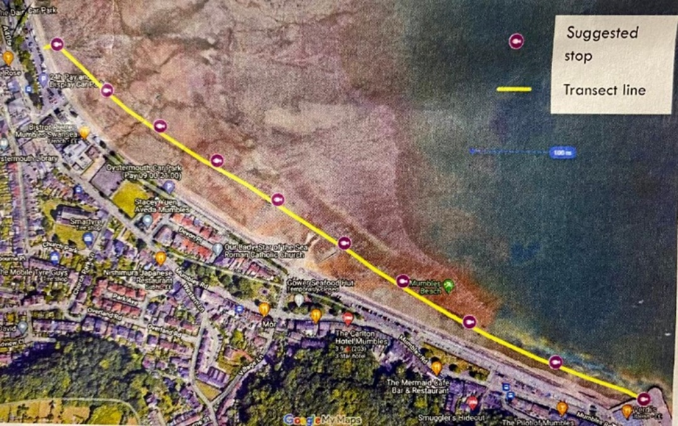
Figure 1 Image of transect along Mumbles Sea Wall
At each site the location was recorded using What3Words and the survey was carried out by six university students who each recorded a different type of species. Each site was estimated to be 100 m² and was surveyed using the DAFOR index, a randomly placed quadrat and sediment samples.
Due to tidal restrictions, the survey was cut short after just 3 sites were surveyed to ensure the safety of all students, however a further three sites were surveyed just over a week later. The initial survey was carried out mid-morning on October 25th during a flood tide with a predicted high tide for 1.15pm at a height of 6.93 m. Further data from three more sites was collected on November 4th around midday. The tide condition for this survey was an ebb tide with a predicted low tide at 1.28pm with a height of 1.71 m.
Figure 2 is a map of the construction area showing the approximate area of the completed survey sites, site 1 being just North of the sea wall as this was where the access via steps was situated.
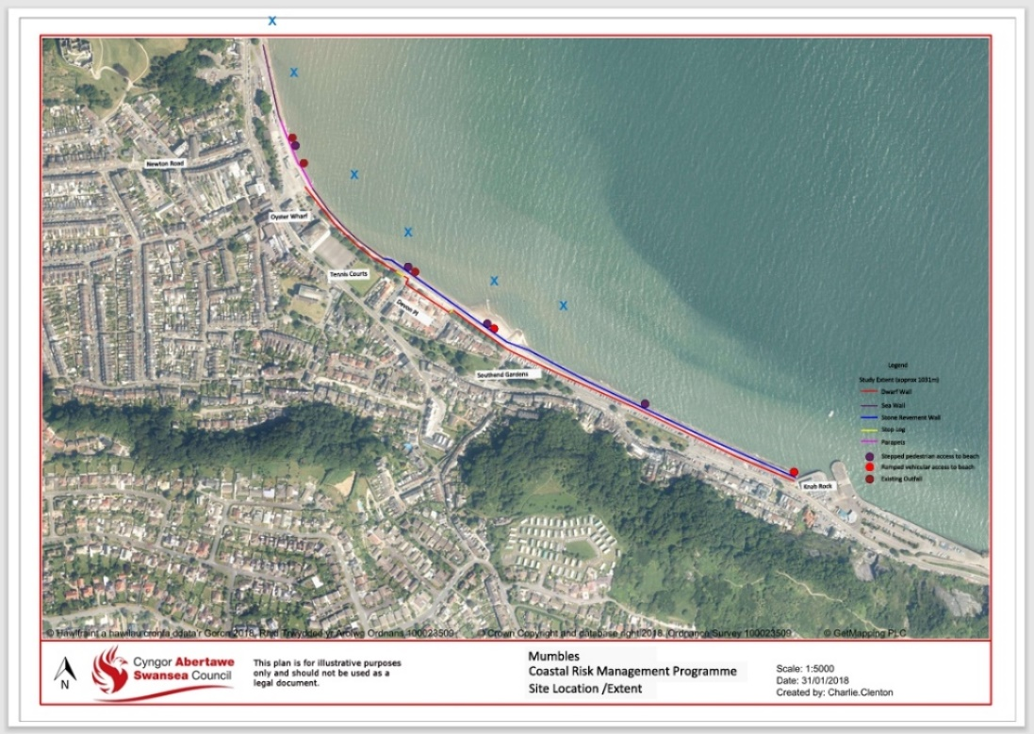
Figure 2 Image of Mumbles Coastal Project with actual survey sites marked as a blue x modified from Swansea.gov (2024)

Seaweeds and rockpool species, worms and shells were recorded using the DAFOR index, a survey method which is generally used for a rapid assessment of relative abundance of species in a large area (The Joy of Botany | Whiteknights biodiversity, no date).
Table 1 Showing DAFOR index as a numeric representation
 | D  Dominant | A  Abundant | F  Frequent | O Occasional | R  Rare
Relative Abundance | >30% | 5-30% | <5% | Scattered Patches | One Patch
Abundance Rank | 5 | 4 | 3 | 2 | 1

The DAFOR scale was converted into a numerical value to offer graphical representation and this value and is named ‘abundance rank’.

Shells were recorded using a 50 cm x 50 cm quadrat that was randomly placed in each site and a photo taken of it for assessment later. This was to used as a proxy to quantify the number of shells to offer a site wide abundance.
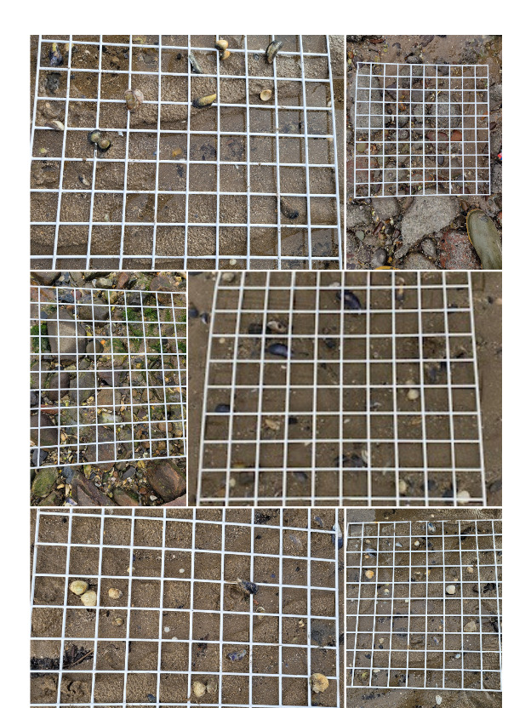
Figure 3Collage of surveyed quadrats
Another analysis from the quadrats was carried out to count all of the species within the quadrat to assess the biodiversity. To compare diversity across three of the survey sites, the compliment to the Simpson’s Diversity Index (1-D) (Kiernan, 2024) was used. A count of each species in a quadrat from sites 1, 3 and 5 was recorded in a table and the Simpson’s Diversity formula incorporated into it.
Table 2 Species count for biodiversity analysis
This offers a representation of species diversity vs uniformity (Royal Geographical Society, 2021) with its value ranging from 0-1 with a greater diversity being represented by a higher value and uniformity representing a value closer to zero.
$D=1-\frac{∑n(n-1)}{N(N-1)}$
Compliment to Simpson's Diversity Index

A water sample was also collected and tested at the site to measure the salinity, dissolved oxygen and pH. Salinity was measured with both a hand-held refractometer and a digital Hannah Salinity Tester. A digital probe measured the dissolved oxygen and a Hannah HI 9812-5 was used to measure the water pH.
A sediment sample was taken from each site and sieved in situ with the aim of analysing any macrofauna that was present. A further sediment sample was collected for sediment analysis, this was not sieved on site. Sediment analysis was conducted at the lab where it was dried in the oven for 48 hours at 40 °C and then sieved using a Cole-Parmer test sieve. The sizes used were No 35 - 500µm, No 60 – 250 µm, No120 - 125 µm and No 230 - 63 µm. Anything finer was collected at the bottom. Each grain size was weighed and the data was entered into an Excel table to create a grain size distribution chart.
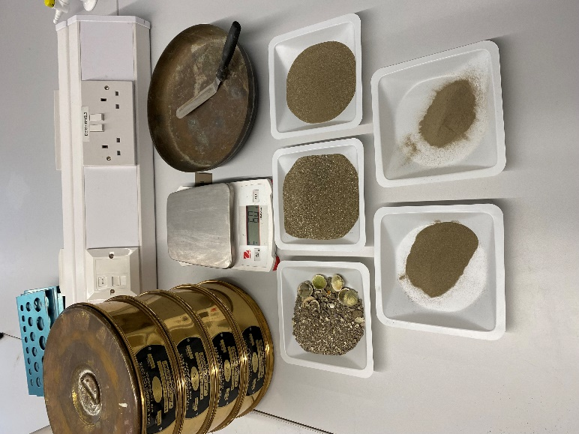
Figure 4 Sediment sample sieved and weighed

Results
Data was collated for observations of seaweeds, species in rockpools, signs of worms such as casts and crustaceans. During the survey at site 3, there was a parcel of Oystercatchers a little closer to the shoreline from us so this was recorded as a ‘noteworthy’ species as it is one of the wading birds that frequent the SSSI at Blackpill, Swansea (Swansea Council, 2024a). Data in red were collected from the quadrats and converted to the DAFOR scale and placed into the table for assessment.
Table 3 Raw Data for species abundance

Graph 1 Showing Species distribution across 6 sites

It can be seen from Graph 1 that there is greater species abundance of a few key species such as cockles and acorn barnacles and while Serrated Wrack is in a relatively small abundance, it is the only one present in all sites.
There were 4 different species of brown seaweed found along the transect. According to (Oakley, 2011) brown seaweeds such as wracks are expected to be prevalent mainly along the middle shore and the results of the DAFOR index survey supported this.
Where the DAFOR scale has been converted to abundance ranking, Graph 2 shows a presence of Serrated Wrack in all sites albeit only in patches except for higher abundance of Frequent (<5%) at Site 6. In the North-westerly sites of 1,2 and 3 a higher abundance of Bladder Wrack was observed. Thong weed was also Abundant at Site 1. Knotted Wrack was a little more sporadic in its placement in that it was found in Abundance in site 1 however just a patch recorded in both sites 4 and 5. Site 1 was a particularly healthy habitat for Brown Seaweeds.

Graph 2 showing abundance of brown seaweed across 6 sites

Evidence of Channelled Wrack (White, 2008) was spotted at the base of the vertical sea wall at the north end (see image 1). This type of brown Seaweed would normally be found high up on the upper shore forming along rocks (Oakley, 2011).
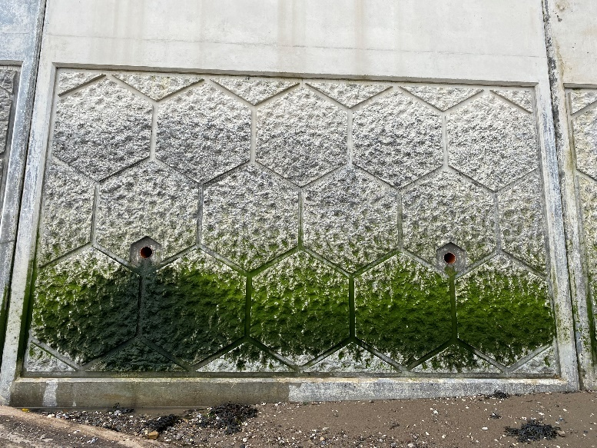
Image 2 Picture of vertical sea wall

There were obvious signs of two different worms across the survey sites, the Lug Worm and the Sand Mason worm. The Lug Worm was recorded on 4 sites out of 6, all of which were near the sea wall construction site. The Sand Mason Worm was seen on the South side of the wall on sites 5 and 6.

Graph 3 showing abundance of worm casts across 5 sites.

Most crustaceans were recorded using a 50 cm x 50 cm quadrat at each site except site 6 where no record was made due to the excitement of digging up a ragworm! On some sites there were multiple quadrat photographs and where this is the case, an average number of species was taken from the photos.
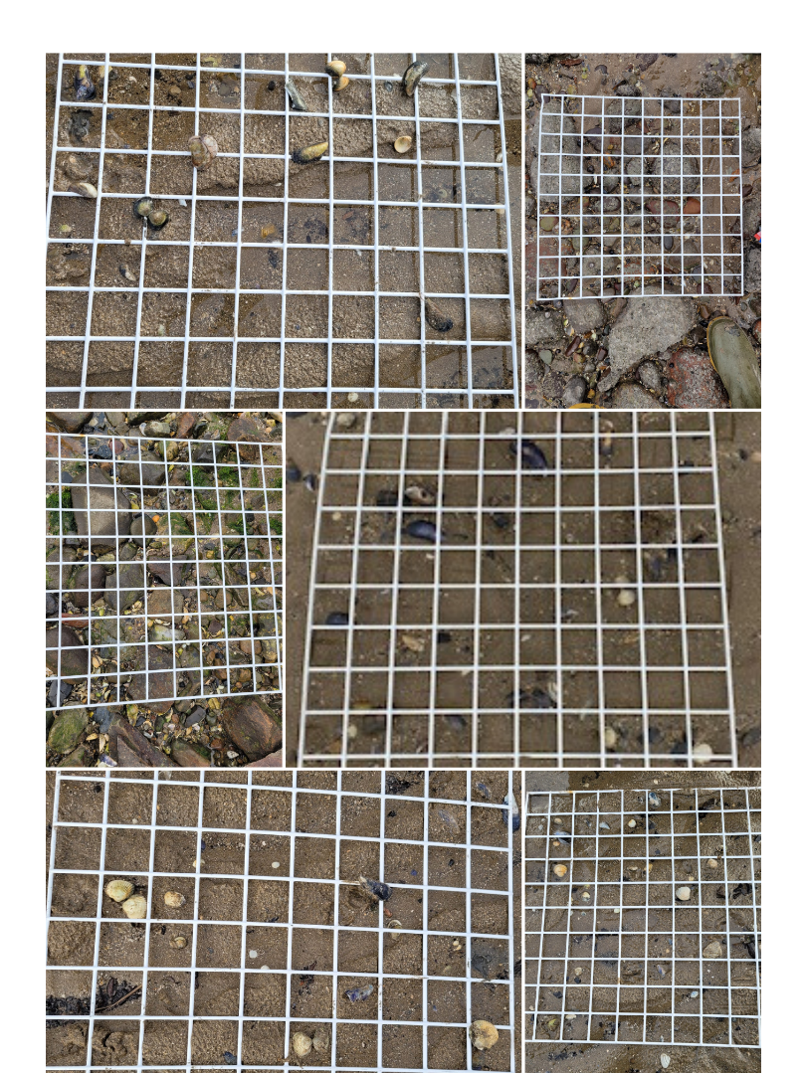
Figure 5 Quadrat Samples

Figure 6 Shell Abundance across 5 sites

The following figure offers a good visual representation of the shell species across 5 sites of quadrat samples.

Figure 7 Shell abundance across 5 sites.
As the graph shows, there is a good mix of cockles and mussels across the beach, which supports the diet of the wading birds that visit.

With regards to biodiversity, the results from the Simpson’s Diversity Index (1-D) was extracted from the following table.
Table 4 Number of Species in 3 quadrats

Table 5 Compliment to Simpson's Diversity Index Calculations
 | Site 1 | Site 2 | Site 3
$$D=1-\frac{∑n(n-1)}{N(N-1)}$$ | $$D=1-\frac{290}{702}$$ | $$D=1-\frac{42}{110}$$ | $$D=1-\frac{999296}{1051650}$$
$$D=1-\frac{∑n(n-1)}{N(N-1)}$$ | $$D=0.59$$ | $$D=0.62$$ | $$D=0.05$$

The analysis of sediment concurs with the literature regarding the bay, as a mix of poorly sorted cobbles and pebbles, sand and mud (Callaway, Fairley and Horrillo-Caraballo, 2020) (Webster and Harrison, 2021), and after putting the sample through the Cole-Parmer sieve, it was evident that over 70% of the grains were greater than 0.25mm or medium to course sand.
Table 6 Grain size distribution table
Sieve No. | Particle Size (mm) | Mass Retained (g) | % Retained | % Finer
35 | 0.5 | 73.9 | 17.17406461 | 82.82593539
60 | 0.25 | 232.4 | 54.00883105 | 28.81710435
120 | 0.125 | 94.3 | 21.91494306 | 6.902161283
230 | 0.063 | 29.7 | 6.902161283 | 0
 | Total | 430.3

Discussion

Biodiversity along Mumbles Sea Wall

There was 25 of species observed across the 6 sites varying from worms to seaweed to crustaceans and even a sighting of some Oyster Catchers. It was evident that each sample site varied slightly in terms of sediment substrate and therefore species.
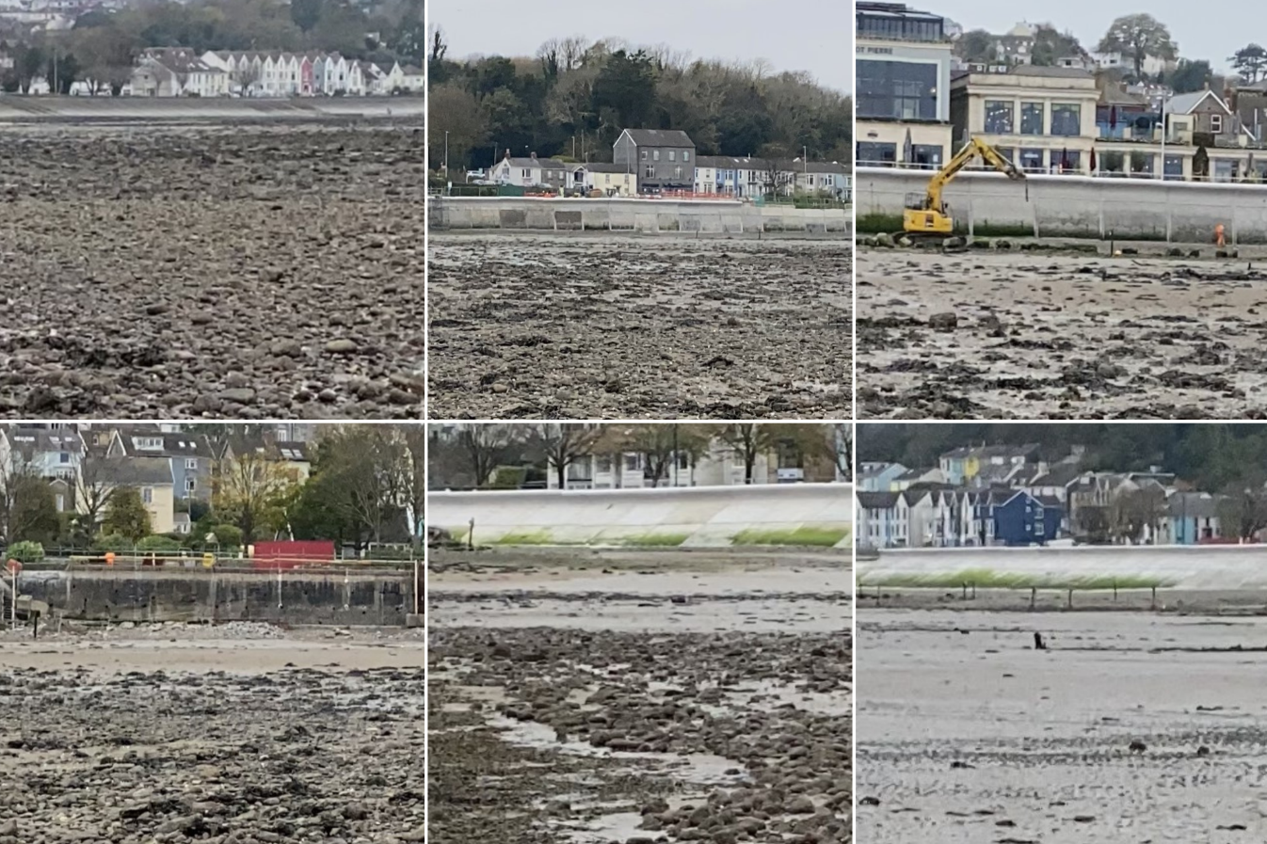
Figure 8 Sites 1,2,3 left to right across top and 4,5,6 left to right along the bottom.

A preliminary ecological report carried out in 2021 for the Mumbles Coastal Project highlights that the project is situated within 5 km of the SSSI at Blackpill (Webster and Harrison, 2021). This offers an indication of the types of benthic organisms we could expect to see in the area. Several types of migratory wading birds over-winter at Blackpill, Swansea such as the Ringed Plover, Sanderling and Oyster Catcher (Swansea Council, 2024a). Ringed Plover and Sanderling feed on marine worms and crustaceans whereas the diet of the Oyster Catcher which were observed at Site 3 is mussels and cockles (RSPB, 2024).

Table 7 Species abundance across all sites

Table 1 shows the presence of benthic organisms across all six sites. Lug Worm castings, Acorn Barnacles, Common Mussels and Common Cockles, while no live mussels were found, their shells were in abundance across the area.
Previous studies of the area include (Callaway, Fairley and Horrillo-Caraballo, 2020) where epifauna was sampled via a beam trawl and infauna via a day grab, indicated that there was much smaller species richness and abundance in the western part of the bay compared to the rest of it. Although the historical comparison of benthic data in Swansea Bay over 30 years showed a “striking similarity” (Callaway, 2016).
Worth noting was the presence of filamentous green algae already growing on the newly constructed sea wall and what appears to be Channeled Wrack along the base.
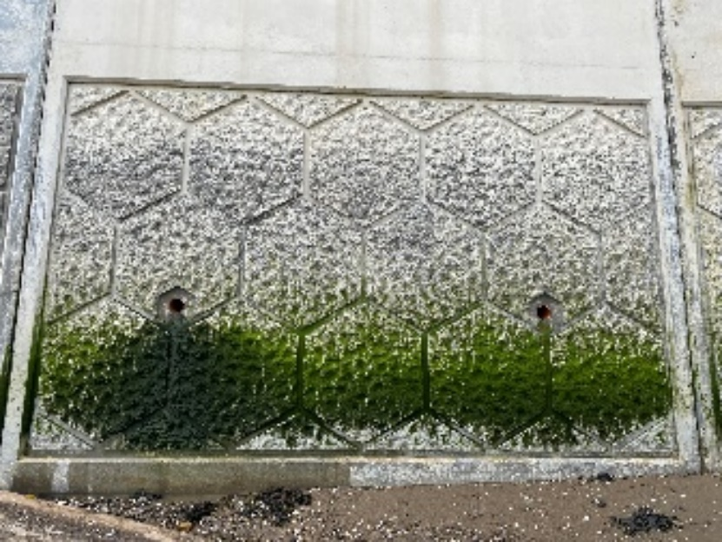
Figure 9 Image of textured panel with green algae along the bottom. Also in the image appears to be Channelled Wrack.
This is of particular interest because the Channelled Wrack will readily assemble to cleared shores after disturbance (White, 2008) and can provide shelter for smaller epifauna. Green algae grow readily in shallow water with plenty of light (Oakley, 2011), and is the base of the food web in the marine environment.

Survey Methods

Using the DAFOR index to assess biodiversity had its strengths as a quick and simple survey method for several people to use in a wide area. It is relatively straight forward and therefore could be a great baseline to develop into a citizen science project to monitor the abundance of shoreline organisms JNCC.gov.uk (n.d.). Citizen Science monitoring projects have been highly successful in data collection and is also great for community engagement (bnhc.org.uk, no date).
The limitations of the DAFOR index is its subjectivity as it involves estimating the percentage cover which can vary between individuals and offer inaccuracies. The parameters of each category within the scale don’t offer a full range of percentage cover, for example; ‘Dominant’ covers 31-100% cover which is a broad spectrum. This was certainly the case at Site 6 where the small ‘Needle Whelk’ like shells covered much more than 30% but there wasn’t a category high enough for a more accurate description.
Using the DAFOR scale to estimate abundance using a quadrat as a proxy is a much more reliable and precise than a visual check over a large area, however it isn’t particularly accurate unless many more quadrats were used (Vaughn, Taylor and Eberhard, 1995) and this is demonstrated with the lack of presence and abundance data from rockpools, as they were only placed over the sand.

Eco-engineering

There are many different processes that shape a coastline and its marine life. Natural processes like wave energy can affect sediment transportation, (Haslett, 2009) wave exposure and submergence can affect the biota that thrive in the different types of zonation. However anthropogenic processes are also making an impact. With over 45% of the world’s population living on the coast (Stone, Callaway and Bull, 2019) and sea levels rising from the anthropogenic contributions to climate change, defences against the sea have been ‘hardening’ the coastline for centuries (Esteves, 2014).
However, hard engineering can be costly, the cost of the Mumbles Coastal Project is estimated at £23 million (knightsbrown.co.uk, 2024) , can be counteractive for biodiversity in comparison to the natural shoreline (Kosová et al., 2023) and can alter the natural processes on sediment transport with scour.
The ‘hold the line approach’ that was adopted for the Mumbles Sea Wall (Webster and Harrison, 2021) means the replacement and modification of an existing defence. (Burgess et al., 2021) However, an exploration of eco-engineering options through collaboration with multiple stakeholders, ‘The Mumbles Sea Hive project’ (Calloway, 2023) was incorporated into the Mumbles Coastal Protection scheme. The concrete panels of hexagonal textured patterns aimed to enhance the biodiversity of shoreline species after the rebuild of the coastal structure. As can be from picture 10, it appears to have been successful.
Figure 10 Image of green algae colonising the wall
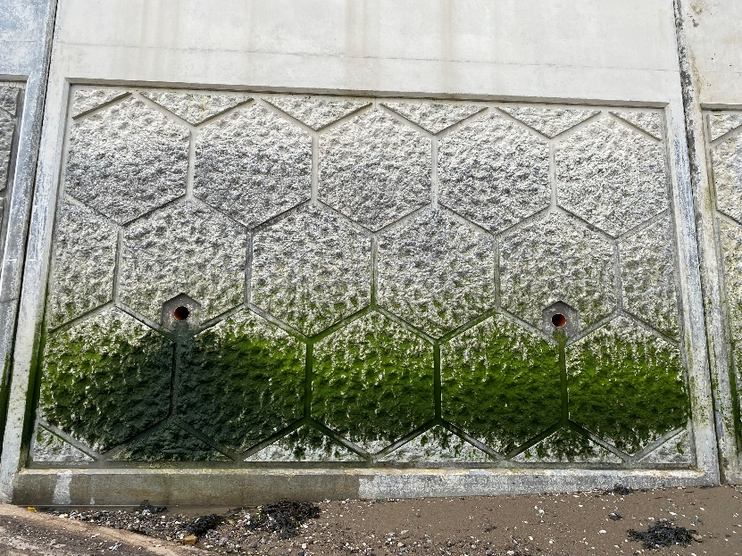
Given that there has been successful colonisation of green algae on the surface of the wall and a clear presence of a variety of marine wildlife on the sand near the wall, it could be suggested that designs such as this could prove beneficial for future coastline projects.

Conclusion
The sea defence in Mumbles was failing and the decision to ‘hold the line’ and rebuild the wall was made. Hard engineering processes have historically been the ‘go-to’ option but in recent years a ‘softer’ approach has been recognised as a necessity to reduce the impact on the diversity of the coastline defence.
Several species inhabit the rocks, sand and mud that is the littoral zone of the coast and its of ecological importance to ensure its diversity. By adding texture to the vertical sea wall, the Mumbles Coastal Project have had positive engagement with the public and have been successful in creating a habit that benthic communities can thrive in and continue playing their role in their ecosystem.
While the survey using the DAFOR index had its limitations, it’s simplicity could certainly provide a baseline for future environmental monitoring.
Every construction site will disturb the environment and its inhabitants during the process, however projects like Mumbles Sea Hive and Mumbles Coast projects can pave the way for future coastline defences.

References
bnhc.org.uk (no date) National BioBlitz Network : Bristol Natural History Consortium. Available at: https://www.bnhc.org.uk/bioblitz/national-bioblitz-network (Accessed: 27 November 2024).
Burgess, K. et al. (2021) Shoreline Management Plans: Supplementary guidance for their ongoing maintenance and delivery – Wales. Cardiff.
Callaway, R. (2016) ‘Historical Data Reveal 30-Year Persistence of Benthic Fauna Associations in Heaviy Modified Waterbody’, Frontiers in Marine Science, 3. Available at: https://doi.org/10.3389/fmars.2016.00141.
Callaway, R., Fairley, I. and Horrillo-Caraballo, J. (2020) ‘Natural dynamics overshadow anthropogenic impact on marine fauna at an urbanised coastal embayment’, Science of The Total Environment, 716, p. 137009. Available at: https://doi.org/10.1016/J.SCITOTENV.2020.137009.
Calloway, R. (2023) Mumbles Sea Hive - Blue Cube. Available at: https://bluecubemarine.co.uk/projects/mumbles-sea-hive/ (Accessed: 24 November 2024).
Esteves, L.S. (2014) Managed Realignment : A Viable Long-Term Coastal Management Strategy? Dordrecht: Springer Netherlands. Available at: https://doi.org/10.1007/978-94-017-9029-1.
Haslett, S.K. (2009) Coastal systems. 2nd ed. London: Routledge (Routledge introductions to environment).
JNCC.gov.uk (2024) Setting up new surveys and contributing data | JNCC - Adviser to Government on Nature Conservation. Available at: https://jncc.gov.uk/our-work/setting-up-new-surveys-and-contributing-data/#survey-design (Accessed: 27 November 2024).
Kiernan, D. (2024) 10.1: Introduction, Simpson’s Index and Shannon-Weiner Index, SUNY College of Environmental Science and Forestry Natural Resources Biometrics.
knightsbrown.co.uk (2024) Mumbles Coastal Protection Scheme - Knights Brown. Available at: https://knightsbrown.co.uk/project/mumbles-coastal-protection-scheme/ (Accessed: 28 November 2024).
Kosová, E. et al. (2023) ‘The BioGeo Ecotile: Improving biodiversity on coastal defences using a multiscale, multispecies eco-engineering design’, Ecological Engineering, 188, p. 106881. Available at: https://doi.org/10.1016/J.ECOLENG.2022.106881.
Nuuttila, H.K. et al. (2018) ‘Seasonal and diel patterns in cetacean use and foraging at a potential marine renewable energy site’, Marine Pollution Bulletin, 129(2), pp. 633–644. Available at: https://doi.org/10.1016/j.marpolbul.2017.10.051.
Oakley, Judith. (2011) Seashore safaris : exploring rocky and sandy seashores with Judith Oakley. Rev. ed. Cardiff: Graffeg.
Royal Geographical Society (2021) A Guide to Simpson’s Diversity Index.
Ruth Calloway (2023) Mumbles Sea Hive, Website. Available at: https://bluecubemarine.co.uk/projects/mumbles-sea-hive/ (Accessed: 21 November 2024).
Stone, R., Callaway, R. and Bull, J.C. (2019) ‘Are biodiversity offsetting targets of ecological equivalence feasible for biogenic reef habitats?’, Ocean & coastal management, 177, pp. 97–111. Available at: https://doi.org/10.1016/j.ocecoaman.2019.04.003.
Swansea Council (2024a) Blackpill SSSI (Site of Special Scientific Interest) and Wildlife Centre. Available at: https://www.swansea.gov.uk/blackpillSSSI (Accessed: 21 November 2024).
Swansea Council (2024b) Mumbles coastal protection project - Swansea. Available at: https://www.swansea.gov.uk/mumblescoastalprotection?lang=en (Accessed: 21 November 2024).
The Joy of Botany | Whiteknights biodiversity (no date). Available at: https://blogs.reading.ac.uk/whiteknightsbiodiversity/2015/03/14/the-joy-of-botany/ (Accessed: 26 November 2024).
Vaughn, C.C., Taylor, C.M. and Eberhard, K.J. (1995) ‘A comparison of the effectiveness of timed searches vs. quadrat sampling in mussel surveys. ’, In Conservation and Management of Freshwater Mussels II: Initiatives for the Future. , pp. 16–18.
Webster, H. and Harrison, J. (2021) Mumbles Coastal Protection Project Preliminary Ecological Appraisal Report. Warrington. Available at: https://property.swansea.gov.uk/online-applications/files/54F5A1C1C38CB2FB4AB29038CD390130/pdf/2021_3149_FUL-PRELIMINARY_ECOLOGICAL_APPRAISAL_REPORT-1314398.pdf (Accessed: 23 November 2024).
White, N. (2008) Channelled wrack (Pelvetia canaliculata) - MarLIN - The Marine Life Information Network. Available at: https://doi.org/10.17031.

Bibliography

A. Hawkes, H. (1998) “Origin and development of the biological monitoring working party score system,” Water Research, 32(3), pp. 964–968. Available at: https://doi.org/10.1016/S0043-1354(97)00275-3.
bnhc.org.uk (no date) National BioBlitz Network : Bristol Natural History Consortium. Available at: https://www.bnhc.org.uk/bioblitz/national-bioblitz-network (Accessed: November 27, 2024).
Bunker, F.StP.D. et al. (2017) Seaweeds of Britain and Ireland. 2nd edn. Plymouth: Wild Nature Press.
Burgess, K. et al. (2021) Shoreline Management Plans: Supplementary guidance for their ongoing maintenance and delivery – Wales. Cardiff.
Callaway, R. (2016) “Historical Data Reveal 30-Year Persistence of Benthic Fauna Associations in Heaviy Modified Waterbody,” Frontiers in Marine Science, 3. Available at: https://doi.org/10.3389/fmars.2016.00141.
Callaway, R., Fairley, I. and Horrillo-Caraballo, J. (2020) “Natural dynamics overshadow anthropogenic impact on marine fauna at an urbanised coastal embayment,” Science of The Total Environment, 716, p. 137009. Available at: https://doi.org/10.1016/J.SCITOTENV.2020.137009.
Calloway, R. (2023) Mumbles Sea Hive - Blue Cube. Available at: https://bluecubemarine.co.uk/projects/mumbles-sea-hive/ (Accessed: November 24, 2024).
Clenton, C. (2018) “Swanseagov Map.” Available at: https://www.swansea.gov.uk/media/2041/Mumbles-coastal-protection-scheme---site-location--extent-map/pdf/t4Mumbles_coastal_protection_scheme_-_site_location__extent_map.pdf?m=1628690311587 (Accessed: November 22, 2024).
Collins, M., Ferentinos, G. and Banner, F.T. (1979) “The hydrodynamics and sedimentology of a high (tidal and wave) energy embayment (Swansea Bay, Northern Bristol Channel),” Estuarine and Coastal Marine Science, 8(1), pp. 49–74. Available at: https://doi.org/10.1016/0302-3524(79)90105-1.
Collins, M.B. and Banner, F.T. (1980) “Chapter 11 Sediment Transport by Waves and Tides: Problems exemplified by a Study of Swansea Bay, Bristol Channel,” Elsevier Oceanography Series, 24, pp. 369–389. Available at: https://doi.org/10.1016/S0422-9894(08)71356-4.
Esteves, Luciana S. (2014) Managed Realignment : A Viable Long-Term Coastal Management Strategy? Dordrecht: Springer Netherlands. Available at: https://doi.org/10.1007/978-94-017-9029-1.
Esteves, Luciana S (2014) Managed realignment : a viable long-term coastal management strategy? Dordrecht: Springer (SpringerBriefs in environmental science).
Everall, N.C. et al. (2017) “Comparability of macroinvertebrate biomonitoring indices of river health derived from semi-quantitative and quantitative methodologies,” Ecological Indicators, 78, pp. 437–448. Available at: https://doi.org/10.1016/j.ecolind.2017.03.040.
Groves, J.A. (2015) The Joy of Botany | Whiteknights biodiversity. Available at: https://blogs.reading.ac.uk/whiteknightsbiodiversity/2015/03/14/the-joy-of-botany/ (Accessed: November 26, 2024).
Gutiérrez, J.L. et al. (2011) “Physical Ecosystem Engineers and the Functioning of Estuaries and Coasts,” Treatise on Estuarine and Coastal Science, 7, pp. 53–81. Available at: https://doi.org/10.1016/B978-0-12-374711-2.00705-1.
Haslett, S.K. (2009) Coastal systems. 2nd ed. London: Routledge (Routledge introductions to environment).
JNCC.gov.uk (2024) Setting up new surveys and contributing data | JNCC - Adviser to Government on Nature Conservation. Available at: https://jncc.gov.uk/our-work/setting-up-new-surveys-and-contributing-data/#survey-design (Accessed: November 27, 2024).
John, S. (Siân), Meakins, N. and Association., C.I.R. and I. (2015) Coastal and marine environmental site guide. Second edition. London: CIRIA (CIRIA ; C744).
Kiernan, D. (2024) 10.1: Introduction, Simpson’s Index and Shannon-Weiner Index, SUNY College of Environmental Science and Forestry Natural Resources Biometrics.
knightsbrown.co.uk (2024) Mumbles Coastal Protection Scheme - Knights Brown. Available at: https://knightsbrown.co.uk/project/mumbles-coastal-protection-scheme/ (Accessed: November 28, 2024).
Kosová, E. et al. (2023) “The BioGeo Ecotile: Improving biodiversity on coastal defences using a multiscale, multispecies eco-engineering design,” Ecological Engineering, 188, p. 106881. Available at: https://doi.org/10.1016/J.ECOLENG.2022.106881.
NRW (2024) Natural Resources Wales / Shoreline Management Plans. Available at: https://naturalresources.wales/flooding/managing-flood-risk/shoreline-management-plans/?lang=en (Accessed: November 28, 2024).
Nuuttila, H.K. et al. (2018) “Seasonal and diel patterns in cetacean use and foraging at a potential marine renewable energy site,” Marine Pollution Bulletin, 129(2), pp. 633–644. Available at: https://doi.org/10.1016/j.marpolbul.2017.10.051.
Oakley, Judith. (2011) Seashore safaris : exploring rocky and sandy seashores with Judith Oakley. Rev. ed. Cardiff: Graffeg.
Probert, P.K. (2017) Marine Conservation. Cambridge University Press. Available at: https://doi.org/10.1017/9781139043588.
Royal Geographical Society (2021) A Guide to Simpson’s Diversity Index.
RSPB (no date a) Oystercatcher Bird Facts | Haematopus Ostralegus. Available at: https://www.rspb.org.uk/birds-and-wildlife/oystercatcher (Accessed: November 21, 2024).
RSPB (no date b) Ringed Plover Facts | Charadrius Hiaticula. Available at: https://www.rspb.org.uk/birds-and-wildlife/ringed-plover (Accessed: November 21, 2024).
RSPB (no date c) Sanderling Bird Facts | Calidris Alba. Available at: https://www.rspb.org.uk/birds-and-wildlife/sanderling (Accessed: November 21, 2024).
Ruth Calloway (2023) Mumbles Sea Hive, Website. Available at: https://bluecubemarine.co.uk/projects/mumbles-sea-hive/ (Accessed: November 21, 2024).
Siegel, F.R. (2020) “Structures That Protect Coastal Populations, Assets, and GDPs: Sea Dikes, Breakwaters, Seawalls,” in, pp. 11–25. Available at: https://doi.org/10.1007/978-3-030-22669-5_3.
Stone, R., Callaway, R. and Bull, J.C. (2019) “Are biodiversity offsetting targets of ecological equivalence feasible for biogenic reef habitats?,” Ocean & coastal management, 177, pp. 97–111. Available at: https://doi.org/10.1016/j.ocecoaman.2019.04.003.
Sullivan, K. (2024) New seawall will be a home for marine life – research at the heart of eco-engineering project - Swansea University. Available at: https://physics.swansea.ac.uk/press-office/news-events/news/2024/05/new-seawall-will-be-a-home-for-marine-life--research-at-the-heart-of-eco-engineering-project.php (Accessed: November 24, 2024).
Swansea Council (2024a) Blackpill SSSI (Site of Special Scientific Interest) and Wildlife Centre. Available at: https://www.swansea.gov.uk/blackpillSSSI (Accessed: November 21, 2024).
Swansea Council (2024b) Mumbles coastal protection project - Swansea. Available at: https://www.swansea.gov.uk/mumblescoastalprotection?lang=en (Accessed: November 21, 2024).
Tyler-Walters, H. (2007) Common cockle (Cerastoderma edule) - MarLIN - The Marine Life Information Network. Available at: https://www.marlin.ac.uk/species/detail/1384 (Accessed: November 27, 2024).
Tyler-Walters, H. (2008a) Blow lug (Arenicola marina) - MarLIN - The Marine Life Information Network. Available at: https://www.marlin.ac.uk/species/detail/1402 (Accessed: November 27, 2024).
Tyler-Walters, H. (2008b) Common mussel (Mytilus edulis) - MarLIN - The Marine Life Information Network. Available at: https://www.marlin.ac.uk/species/detail/1421 (Accessed: November 25, 2024).
Vaughn, C.C., Taylor, C.M. and Eberhard, K.J. (1995) “A comparison of the effectiveness of timed searches vs. quadrat sampling in mussel surveys. ,” In Conservation and Management of Freshwater Mussels II: Initiatives for the Future. , pp. 16–18.
Webster, H. and Harrison, J. (2021) Mumbles Coastal Protection Project Preliminary Ecological Appraisal Report. Warrington. Available at: https://property.swansea.gov.uk/online-applications/files/54F5A1C1C38CB2FB4AB29038CD390130/pdf/2021_3149_FUL-PRELIMINARY_ECOLOGICAL_APPRAISAL_REPORT-1314398.pdf (Accessed: November 23, 2024).
White, N. (2008) Channelled wrack (Pelvetia canaliculata) - MarLIN - The Marine Life Information Network. Available at: https://doi.org/10.17031.

