Mental Health in Young People
Meta Description: ‘YoungMinds is a mental health charity for children and young adults, offering support and advice to help navigate the difficulties most of us experience as we grow up.’
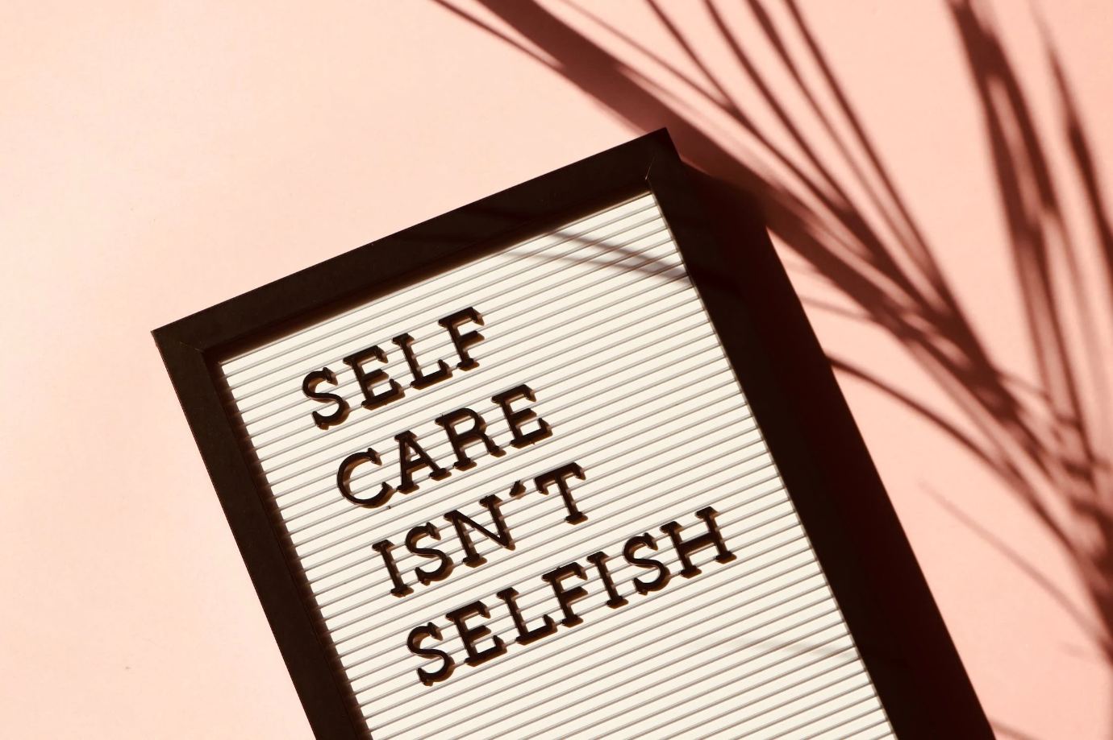
National statistics show a daily rise in the number of young people seeking assistance for mental health difficulties. More youngsters are visiting A&E after experimenting with various "magic stuffs" they were able to purchase on the black market that boosts their self-confidence yet they are unaware of its damaging consequences.
As parents, it is our responsibility to be there for and encourage our kids. How can we accomplish that first-hand? We must be present, pay attention, continue to be involved in their lives, and offer support as they face challenges.

However, things might occasionally get tough and parents might feel like any assistance is insufficient. The role of YoungMinds in this is crucial. It has changed thousands of lives over the years and helped many young people overcome their mental afflictions.

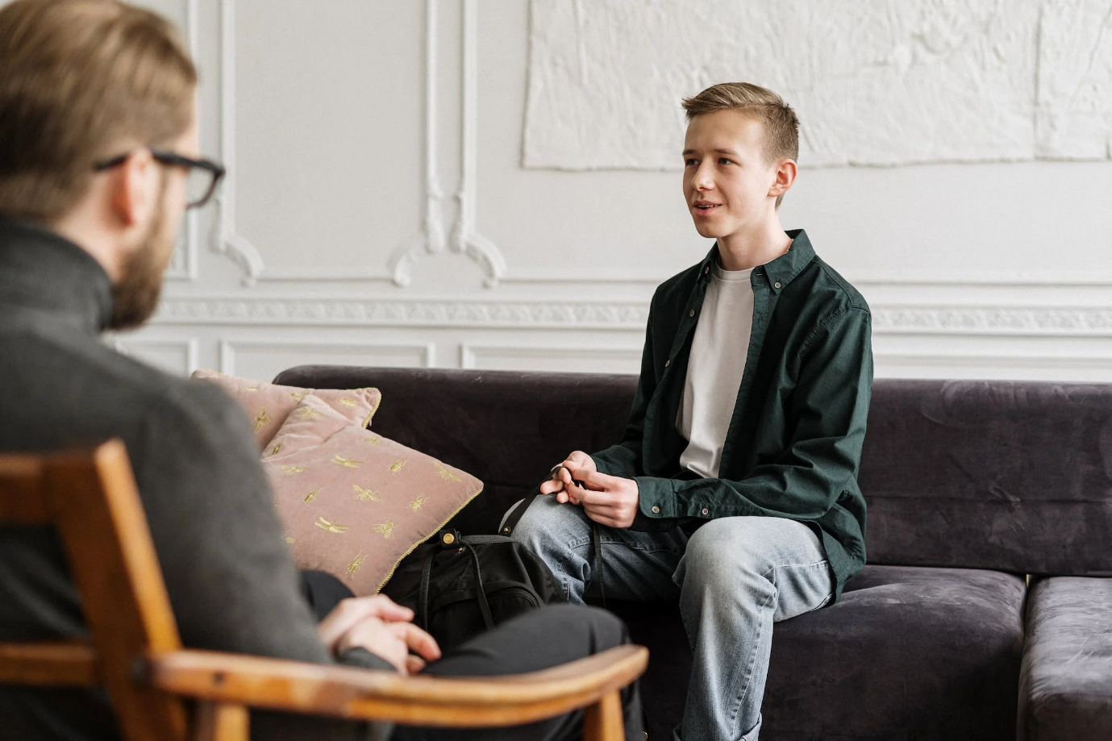
Why YoungMinds?

You feel that you need support to comprehend what is occurring when you have a loved one who is struggling with mental health concerns.
YoungMinds provides assistance to both parents and youngsters.

Helping families deal with mental health problems at home
They will make sure that all young people receive help that meets them where they are at as quickly as possible, whether they require a comforting talk, specialised mental health support, or simply the assurance that they are not alone in how they are feeling.

For further information on how to contact YoungMinds, please see my upcoming blog

Promoting long-term change
Additionally, the charity constantly advocates for change. Fighting for political reform to enhance mental healthcare in our nation, it is at the forefront of the mental health challenge.

The charity is still very young, but it has already made a big difference. 74% of young people reported feeling more optimistic about their mental health after visiting the YoungMinds website, according to its 2021 impact report.

You can read the complete report on their website if you're interested in learning more about the effect YoungMinds has had. It's incredibly informative and goes into great detail on the work of the charity and how it has benefited the younger generation just in the past year.

YoungMinds is paving the way.
At the moment, YoungMinds is the only mental health charity operating in the UK. It's a group that provides daily support and direction to young people who are struggling with mental health issues.
You can visit the website here and click on the Find help and advice button, it will point you in the right direction in just a few steps. Alternatively, check out their contact page for information on the YoungMinds textline and other ways to get in touch.
Please don't hesitate to ask if you have any questions about YoungMinds or mental health.

References:

YoungMinds. (n.d.). Highlight Tour. [online] Available at:
https://www.youngminds.org.uk/about-us/reports-and-impact/impact-report-2021/highlight-tour/.

Blog Submission

Student Name: Madalina Blaglosov
Student ID: 2207678

Name of Students in Group:
Abdou Abouelkheir
Robert Thomas Yeo
Jac Thomas
Khaldoun Nabelsi
Godson Vezhlathumperil Tony

Link to Individual Blog:
https://mentalhealthyoungminds.blogspot.com/2022/11/mental-health-in-young-people-meta.html

https://mentalhealthyoungminds.blogspot.com/2022/11/promoting-long-term-change-additionally.html

Words included in Individual’s Blog (including reference list):

492 words including reference list

