The Global Business Environment A2
(LCBB4005)
Lecture:Rexon Nitng
Student:Nadya Vasileva
Student ID :1908838
Group -1 BAMB

Table of Contents

Introduction 3
Background of the company ‘Tesla’ 3
PESTLE Analysis 4
Porter’s 5 Forces 5
Porter’s Value Chain 7
Application of Porter’s Value Chain to the Company 8
Conclusion and Recommendation 10
Reference List: 11

Introduction
Global business environment aims to influence the decision making process of a firm on using its respective resources and capabilities for operating business in the global competitive market. The study focuses on the external and internal influential factors which are shaping the strategy of an electric car company ‘Tesla’ in an outright way. Apart from that, the study highlights the Porter’s value chain along with five forces that outlines the company’s existing position in the current aggressive market. Further recommendations have been made to demonstrate the potential scopes to utilize by Tesla for grabbing the sustainable position in the context of the global business environment.

Background of the company ‘Tesla’
A group of energies founded Tesla in the year of 2003 who wishes to introduce a new revolution of electric cars in the automobile industry instead of gasoline cars. The automobile brand is infinitely scalable to produce electric vehicles along with storage products and generation of clean energy (tesla.com. 2020). The vision of the brand is to create a ‘Zero-emission’ future instead of relying on fossil fuel which can demolish the eco-balance system. The electrical powertrain and cutting-edge battery technology were unveiled by Tesla in 2008 through designing the first ever electrical sedan Model S which was combined with safety, performance and efficiency.
During the year of 2015. The brand launched the safest, quickest and capable sports utility Model X and in 2016, the brand released “Secret Master Plan” through introducing Model 3. The Tesla car costing £38,900 was announced for its Model 3 in the UK after a £3,500 plug in car grant from the UK Government (autoexpress.co.uk. 2019). In 2019 Tesla Model 3 is leading as the electric car in the UK by taking one third of market share that is giving a nail-biting competition to Australia. Moreover, the Tesla cars are made with highly-effective architecture along with a floor mounted battery pack for allowing incredible protection to the eco-system.

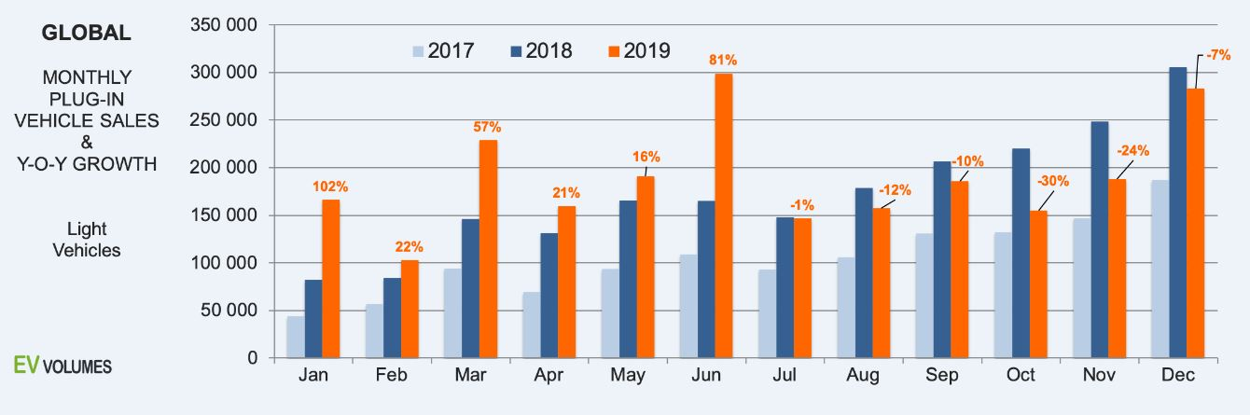
Figure 1. The sales of electric vehicles in the global market
(Source: As influenced by ev-volumes.com. 2019)

PESTLE Analysis
Factors | Analytical Reports
Political | - National and state governments of the UK have taken initiatives in producing and selling electric vehicles by encouraging the car manufacturer.
Economical | - The popularity of electric vehicles is directly connected with the global economy.  - During 2019, the global economic growth was estimated to remain at 3%.  - In 2018, the market of electric vehicles is expected to capitalise $39.8 billion up to $1.5 trillion by 2025.
Social | - Tesla cars are less expensive than gasoline cars.  - The creative concept of electric cars is fascinating the eco-friendly objects through eliminating the usage of fossil fuels.
Technological | - CEO Musk is using advanced technology in Tesla manufacturing to enhance its product portfolio.  - Driverless technology is the updated vision and mission of the brand for managing competitive edge in the marketplace.
Legal | - Due to the investment of National Highway Traffic Safety Administration and Transportation Safety, crashes between Tesla cars occurred in 2019.  - Tesla faced numerous lawsuits and regulatory issues that blocked its direct sale to consumers.
Environmental | - Due to being driven by an electric recharging system, Tesla cars barely have any negative impact on the environment over carbon emissions like gasoline cars.  - Tesla is enjoying a reputed position in the supply chain network by being energy efficient in terms of environmental impact.
Table 1. PESTLE Analysis
(Source: As influenced by autoexpress.co.uk. 2019)
Analysis
The government’ support would encourage the brand to move forwards whereas Tesla would be influenced by its multiple campaigns and advertisements related to environmental sustainability in the UK. On the other note, the global economic rate would push the brand to capitalize its current market share by launching different advanced models in future. The less expensive and zero emission features would increase its acceptability in UK society. Technological and legal scopes may create obstacles in the pathway due to grabbing the enjoyment in driving electric cars.

Porter’s 5 Forces
Industry competition
General Motors has been recognised as the highest selling car manufacturer in 2016 due to its position in the matured automobile industry with multi-billion-dollar oligopoly. Market competitors design new infrastructure of existing car models and approach global customers with attractive initiatives. The external factors and Tesla’s high intensities plays as the strongest forces of industry rivals as follows:
- Firm’s high aggressiveness (strong force)
- Costs of low switching (strong force)
Supplier’s bargaining power
Due to having limited production capacity, Tesla supplier’s bargaining power is moderate compared to other rivals in the same industry. Those moderate force create the bargaining power of such suppliers are as follows:
- Supplier’s moderate size (moderate force)
- Moderate level of supply (moderate force)
Buyer’s bargaining power
Due to having power to choose alternative manufacturers, models, batteries and solar panels the customers are enjoying a strong grip in purchasing decisions that creates a potential bargaining power. These following forces determines the customer’s bargaining power on the respective company:
- Costs of low switching (strong force)
- Availability of moderate alternatives (moderate force)
- Lower volume in purchasing (weak force)
Threat of new competitors
The threat of new competitors in the automobile industry is low because of the high obstacle for entry and the large size of potential competitors along with high cost of production (Hayes, 2017). These following forces have been considered as low to affect the current market position of Tesla such as:
- Higher cost in branding (weak force)
- Higher cost in business consistency (weak force)
- Higher scalability (weak force)
Substitute threats
Competitors offer alternatives along with public transportation that enables threats of alternatives services to Tesla in the automotive industry. Apart from that, hybrid models and updated price ranges are often offered by the competitors which also perform well that can be considered as threats to the company.

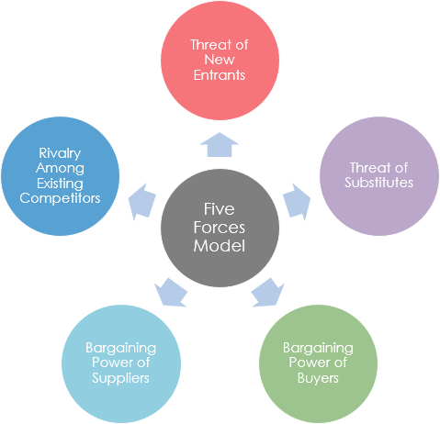
Figure 2. Porter’s Five Forces
(Source: As influenced by Chesula and Kiriiny, 2018)

Porter’s Value Chain
Value chain denotes the integral system of an organisation to make money or increase profit through creating multiple products or services. As stated by Kano (2018), Global Value Chain (GVC) has been considered as the distinctive form of asymmetrical networks that enhance organisational efficiency through creating economization and capitalisation. Michael Porter introduced his value chain model through the aid of the concept of making the company competitive in order to support and provide more knowledge regarding sustainable advantages. Porter divided the marketing and supportive activities into two different segments such as primary and secondary. The primary activities are included with inbound logistics, organisational operation, outbound logistics, marketing, sales and service whereas secondary activities denote procurement, HR management, infrastructure and technological enhancement. Eling and Lehmann (2018) noted it would be easiest to maximise customer experience and improve business process by offering new products and preparation for industrial competition through understanding of porter's value chain.
The inbound logistics are related with racing, warehousing and inventory control of raw materials of a company whereas operations are underlined with transformation of raw materials into finished goods. The outbound logistics are associated with distribution of such goods or services to the consumers whereas marketing and sales aim to socialise the service features through advertisements, promotion and pricing (Martín-Herrán and Sigué, 2017). Services are included with the maximisation activities of consumer experiences through customer service, maintenance, fund, repairs, warranty and exchange. Procurements are associated with negotiation or bargaining processes with suppliers and vendors whereas human resource management seeks to implement numerous strategies to enhance productivity and employee’s performance level. Infrastructure covers the organisational support systems such as accounting, legal and administrative functions whereas technology enhancement intends to channelize the operational outcome in the global context.

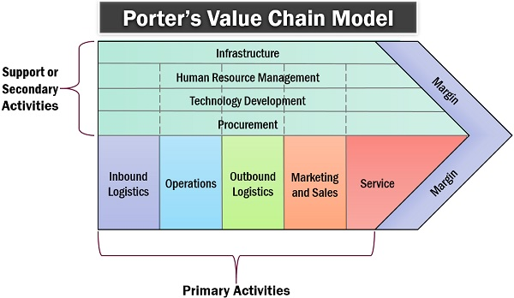
Figure 3. Porter’s Value Chain Model
(Source: As influenced by Kano, 2018)

Application of Porter’s Value Chain to the Company
Primary Activities
Inbound logistics
The United States is the centralised place of Tesla warehouses and one in Taiwan that are leased facilities whereas the brand’s own principle manufacturing facility company is located in Fremont and California. The facility size is approximately 5.5 million square feet and other warehouses are used for storage systems, solar panels and delivery purposes. It has been considered by Tesla to build a new gigafactory in Somerset in the UK for research, development and manufacturing plant (autocar.co.uk. 2020). On the other hand, the warehouse in Taiwan is mostly used for storage, service and administrative activities where the company works preliminary on a basis of build-to-order scheme.
Organisational operation
Despite having the headquarters in Palo Alto in California, Tesla has extended its manufacturing business, selling and supply chain network in the overseas market as well. The automotive segment of Tesla involves designing, improving, manufacturing and selling whereas the energy generation and storage part are included with design, manufacturing, installation and solar energy selling. Tesla sources its value through implementing its manufacturing process with a high level of integrated robots that works in a choreographed routine are included with riveting, welding, gripping, bending, moving and installing.
Outbound logistics
Tesla’s outbound logistics involves electric car distribution, systems of energy storage and the solar panels production. The company makes direct delivery of finished goods to its own stores and galleries in the US along with other countries. The brand allows its buyers for customisation according to their expectation and desire through ordering online whereas a small inventory is maintained by Tesla in the showroom for immediate sales.
Marketing and Selling
The unconventional marketing and selling practices of Tesla are like other business practices of electric automakers. CEO Elon Musk believes in his own word of mouth in case of socialisation of brand's content instead of virtual promotion through advertising or market campaigns. Generally, Tesla sells its electric vehicles to the general public via auto auctions conducted by third parties.
Service
Roadster is the first product launched by the brand in 2008 followed by Model S whereas Model X and Model 3 were introduced subsequently back to back in 2015 and 2016. Apart from that, Model Y and Cyber trucks have been recognised as the energy products that are effective, powerful, safe for the environment and driving.

Secondary Activities
Infrastructure
Despite having two segments such as automotive and energy products, Tesla’s administrative structure is also quite efficient and concrete which is different. On the other note, Elon Musk is the ultimate decision maker whereas Zachary J Kirkhorn takes care of accounting and finance due to be chief financial officer of Tesla. In fact, the infrastructure network of Tesla is included with supercharger stations, vehicles of mobile services and service locations.
HRM
It has been noted that more than 48,000 people were recruited in Tesla during 2018 due to relying upon thousands of efficient and talented employees who run the company effectively. The HR managers of Tesla are credible activists who concrete the workforce planning, compensation, performance management, employee retention and provide coaching for personal development by being innovative, trustworthy, driven and collaborative (tesla.com. 2020). Tesla has been putting its best efforts in embedding HRM systems in its daily activities in order to provide the brand a competitive edge for making it more sustainable.
Technological enhancement
Technology is influencing the global automobile industry through channelizing autonomous driving technology and electric mobility that create hottest technological areas. BMW has also launched electric and hybrid vehicles in order to extend its global business whereas Tesla is still in the lead in improving its products consistently in the global market.
Procurement
The parts and components in making electric vehicles are mostly shipped from thousands of suppliers and vendors worldwide. Panasonic has been considered as the leading suppliers of battery cells of the brand whereas Tesla releases on single sourcing.

Conclusion and Recommendation
The study concluded with the Tesla external and internal forces that drive its operational activities and administrative functions. Tesla has been considered as the leader in manufacturing electric cars in the global market though it seems that the brand needs further improvement in marketing for attracting multiple potential customers. The brand is quite efficient and effective in customisation whereas driverless technology can make numerous obstacles in the brand's sustainability. The internal factors are making Tesla more meaningful to its respective customers whereas it can be difficult to maintain its ethics while facing the external forces for stability in the existing market.
It would be beneficial for the brand to concrete its marketing campaigns and initiatives in promotional activities for increasing more awareness in the current society instead of only speeches. The brand can embed its manufacturing plants in the rural areas in order to use their vast lands and creative talents of respective immigrants instead of only selecting metropolitan cities. Apart from that, Tesla can use solar energy for charging its battery and not relying upon the electric recharging system in the specific plants which can increase its maintenance costs. Such recommendations would assist Tesla to gain more competitive advantages and sustainable position with rapid growth in the global business environment.

Reference List:
autocar.co.uk. (2020). Tesla linked to new UK gigafactory in Somerset. Available at: https://www.autocar.co.uk/car-news/industry/tesla-linked-new-uk-gigafactory-somerset#:~:text=The%20635%2Dacre%20site%20is,have%20visited%20the%20Bridgwater%20site. [Accessed on: 27th June, 2020]
autoexpress.co.uk. (2019). First Tesla Model 3 UK deliveries take place. Available at: https://www.autoexpress.co.uk/tesla/model-3/87867/new-tesla-model-3-prices-specs-news [Accessed on: 25th June, 2020]
Chesula, O.W. and Kiriiny, S.N., (2018). Competitiveness In The Telecommunication Sector In Kenya Using Porters Five Forces Model. International Journal of Research in Finance and Marketing (IJRFM), 8(7), pp.1-10.
Eling, M. and Lehmann, M., (2018). The impact of digitalization on the insurance value chain and the insurability of risks. The Geneva papers on risk and insurance-issues and practice, 43(3), pp.359-396.
ev-volumes.com. (2019). Global BEV & PHEV Sales for 2019. Available at: https://www.ev-volumes.com/ [Accessed on: 26th June, 2020]
Hayes, A.S., (2017). Cryptocurrency value formation: An empirical study leading to a cost of production model for valuing bitcoin. Telematics and Informatics, 34(7), pp.1308-1321.
Kano, L., (2018). Global value chain governance: A relational perspective. Journal of International Business Studies, 49(6), pp.684-705.
Martín-Herrán, G. and Sigué, S.P., (2017). Retailer and manufacturer advertising scheduling in a marketing channel. Journal of Business Research, 78(5), pp.93-100.
tesla.com. (2020). Human Resources Business Partner. Available at: https://www.tesla.com/en_GB/careers/job/human-resourcesbusinesspartner-46909?redirect=no [Accessed on: 28th June, 2020]
tesla.com. (2020). Tesla’s mission is to accelerate the world’s transition to sustainable energy. Available at: https://www.tesla.com/en_GB/about?redirect=no [Accessed on: 25th June, 2020]

