
August 11, 2026
University of Wales Trinity Saint David
London campus

University of Wales Trinity Saint David

SSB Assignment
Portfolio

SSB Assignment
Portfolio

SSB Assignment
Portfolio

SSB Assignment
Portfolio

SSB Assignment
Portfolio

SSB Assignment
Portfolio

SSB Assignment
Portfolio

SSB Assignment
Portfolio

SSB Assignment
Portfolio

SSB Assignment
Portfolio

Module Name: Software Solutions for Business

Module Code: ACCA 4026

Student Name: Ali Helvdjioglu

Student ID: 2544173

Group: 1

Lecturer’s Name: Kwame Assa-Agyei

Module Name: Software Solutions for Business

Module Code: ACCA 4026

Student Name: Ali Helvdjioglu Student ID: 2544173

Group: 1

Lecturer’s Name: Kwame Assa-Agyei

Module Name: Software Solutions for Business

Module Code: ACCA 4026

Student Name: Ali Helvdjioglu Student ID: 2544173

Group: 1

Lecturer’s Name: Kwame Assa-Agyei

Module Name: Software Solutions for Business

Module Code: ACCA 4026

Student Name: Ali Helvdjioglu Student ID: 2544173

Group: 1

Lecturer’s Name: Kwame Assa-Agyei

Module Name: Software Solutions for Business

Module Code: ACCA 4026

Student Name: Ali Helvdjioglu Student ID: 2544173

Group: 1

Lecturer’s Name: Kwame Assa-Agyei

Module Name: Software Solutions for Business

Module Code: ACCA 4026

Student Name: Ali Helvdjioglu Student ID: 2544173

Group: 1

Lecturer’s Name: Kwame Assa-Agyei

Module Name: Software Solutions for Business

Module Code: ACCA 4026

Student Name: Ali Helvdjioglu Student ID: 2544173

Group: 1

Lecturer’s Name: Kwame Assa-Agyei

Module Name: Software Solutions for Business

Module Code: ACCA 4026

Student Name: Ali Helvdjioglu Student ID: 2544173

Group: 1

Lecturer’s Name: Kwame Assa-Agyei

Module Name: Software Solutions for Business

Module Code: ACCA 4026

Student Name: Ali Helvdjioglu Student ID: 2544173

Group: 1

Lecturer’s Name: Kwame Assa-Agyei

Module Name: Software Solutions for Business

Module Code: ACCA 4026

Student Name: Ali Helvdjioglu Student ID: 2544173

Group: 1

Lecturer’s Name: Kwame Assa-Agyei

Module Name: Software Solutions for Business

Module Code: ACCA 4026

Student Name: Ali Helvdjioglu Student ID: 2544173

Group: 1

Lecturer’s Name: Kwame Assa-Agyei

Module Name: Software Solutions for Business

Module Code: ACCA 4026

Student Name: Ali Helvdjioglu Student ID: 2544173

Group: 1

Lecturer’s Name: Kwame Assa-Agyei

Module Name: Software Solutions for Business

Module Code: ACCA 4026

Student Name: Ali Helvdjioglu Student ID: 2544173

Group: 1

Lecturer’s Name: Kwame Assa-Agyei

Module Name: Software Solutions for Business

Module Code: ACCA 4026

Student Name: Ali Helvdjioglu Student ID: 2544173

Group: 1

Lecturer’s Name: Kwame Assa-Agyei

Module Name: Software Solutions for Business

Module Code: ACCA 4026

Student Name: Ali Helvdjioglu Student ID: 2544173

Group: 1

Lecturer’s Name: Kwame Assa-Agyei

Module Name: Software Solutions for Business

Module Code: ACCA 4026

Student Name: Ali Helvdjioglu Student ID: 2544173

Group: 1

Lecturer’s Name: Kwame Assa-Agyei

Module Name: Software Solutions for Business

Module Code: ACCA 4026

Student Name: Ali Helvdjioglu

Student ID: 2544173

Group: 1

Lecturer’s Name: Kwame Assa-Agyei

Module Name: Software Solutions for Business

Module Code: ACCA 4026

Student Name: Ali Helvdjioglu Student ID: 2544173

Group: 1

Lecturer’s Name: Kwame Assa-Agyei

Module Name: Software Solutions for Business

Module Code: ACCA 4026

Student Name: Ali Helvdjioglu Student ID: 2544173

Group: 1

Lecturer’s Name: Kwame Assa-Agyei

Module Name: Software Solutions for Business

Module Code: ACCA 4026

Student Name: Ali Helvdjioglu Student ID: 2544173

Group: 1

Lecturer’s Name: Kwame Assa-Agyei

Module Name: Software Solutions for Business

Module Code: ACCA 4026

Student Name: Ali Helvdjioglu Student ID: 2544173

Group: 1

Lecturer’s Name: Kwame Assa-Agyei

Module Name: Software Solutions for Business

Module Code: ACCA 4026

Student Name: Ali Helvdjioglu Student ID: 2544173

Group: 1

Lecturer’s Name: Kwame Assa-Agyei

Module Name: Software Solutions for Business

Module Code: ACCA 4026

Student Name: Ali Helvdjioglu Student ID: 2544173

Group: 1

Lecturer’s Name: Kwame Assa-Agyei

Module Name: Software Solutions for Business

Module Code: ACCA 4026

Student Name: Ali Helvdjioglu Student ID: 2544173

Group: 1

Lecturer’s Name: Kwame Assa-Agyei

Module Name: Software Solutions for Business

Module Code: ACCA 4026

Student Name: Ali Helvdjioglu Student ID: 2544173

Group: 1

Lecturer’s Name: Kwame Assa-Agyei

Module Name: Software Solutions for Business

Module Code: ACCA 4026

Student Name: Ali Helvdjioglu Student ID: 2544173

Group: 1

Lecturer’s Name: Kwame Assa-Agyei

Module Name: Software Solutions for Business

Module Code: ACCA 4026

Student Name: Ali Helvdjioglu Student ID: 2544173

Group: 1

Lecturer’s Name: Kwame Assa-Agyei

Module Name: Software Solutions for Business

Module Code: ACCA 4026

Student Name: Ali Helvdjioglu Student ID: 2544173

Group: 1

Lecturer’s Name: Kwame Assa-Agyei

Module Name: Software Solutions for Business

Module Code: ACCA 4026

Student Name: Ali Helvdjioglu Student ID: 2544173

Group: 1

Lecturer’s Name: Kwame Assa-Agyei

Module Name: Software Solutions for Business

Module Code: ACCA 4026

Student Name: Ali Helvdjioglu Student ID: 2544173

Group: 1

Lecturer’s Name: Kwame Assa-Agyei

Module Name: Software Solutions for Business

Module Code: ACCA 4026

Student Name: Ali Helvdjioglu Student ID: 2544173

Group: 1

Lecturer’s Name: Kwame Assa-Agyei

Module Name: Software Solutions for Business

Module Code: ACCA 4026

Student Name: Ali Helvdjioglu Student ID: 2544173

Group: 1

Lecturer’s Name: Kwame Assa-Agyei

Contents
Introduction 1
Task 1. e-Commerce Website builders/software solutions 1
1.1 Wix 1
1.2 Shopify 3
Task 2. Mind-map of contemporary software applications 5
2.1 Mind-Mapping Definition and Benefits 5
2.2 Create a mind map of contemporary Business software applications 5
Task 3. Office Applications in E-Commerce and Cybersecurity 5
3.1 Four office software solutions for business operations 7
Ms Word 7
Ms Excel 10
Ms PowerPoint 12
Ms Access 13
3.2 Test any two features 15
Mail Merge 15
PivotTable 16
Task 4. Communication and Collaboration applications 18
4.1 One contemporary Communication and one Online Collaboration 18
Microsoft Teams 18
Google Workspace 19
4.2 Test one feature of a freely available Communication (1) and one feature of a Collaboration (1) application 19
Microsoft Teams 19
Google Docs 21
Conclusion 23
References 23

Introduction
Digital transformation has changed how companies make, give, and handle value in the market. E-commerce website builders and low-code software platforms allow entrepreneurs and small businesses to set up online stores and operations without needing a lot of programming knowledge or a big team of technical experts. These platforms offer adjustable interfaces, payment features, marketing tools, data management options, and links to other apps, which helps lower starting costs and speeds up the process of bringing new products and services to the market.[1], [2] Their availability can also help include more entrepreneurs by making it easier for people and groups that haven't had much access to digital tools before.
However, the ease of doing business through online platforms comes with some problems in how things are run and managed. Using specialized platforms and outside partners can make it harder to change things, make it more expensive to switch to something else, and lead to problems with who controls the data, how the platform is managed, and how value is shared among everyone in the system.[3], [4] So, digital businesses need more than just working online stores; they also need good security measures to keep customer data, payment methods, business files, and internal messages safe. A safe online shopping system needs several types of software working together, like cloud storage, tools to manage who can access what, ways to analyse data, office programs, tools for teamwork, and systems that watch for security threats. Artificial intelligence and analytical tools can help improve the ability to detect threats, but it's still important to consider privacy, transparency, and the need for human supervision.[5]
Office and collaboration tools help with creating documents, analysing data, reporting incidents, and working together as a team. However, these tools can lose their value if people share files with wrong permissions, there are mistakes in spreadsheets, there are harmful files, or if access is not properly controlled. More and more digital companies are relying on connected digital systems and shared information. This literature looks at e-commerce platforms, business software, office tools, and communication apps, and checks how useful they are, what advantages they offer, their limits, and how safe they are for companies that use digital technologies.

Task 1. e-Commerce Website builders/software solutions

1.1 Wix
Wix is a well-known cloud-based website builder that makes it easy for people and companies to create websites. It offers a user-friendly drag-and-drop tool that lets you build your site without needing to know how to code. By using low-code methods, the platform helps create applications quickly, connecting the technical side of systems with business ideas. This lets users focus on what their business needs to do, instead of worrying about the technical details behind it.[1] This accessibility is especially helpful for small-to-medium businesses and individual business owners, as they can use the platform’s flexible design to grow their online stores with much less time and money upfront.[6] In addition, the platform includes built-in payment systems and full digital marketing features, which are important for companies wanting to grow their customer base and improve the overall experience for customers.[7] Wix uses a pricing system with different levels, starting from a free basic plan up to paid premium options. This allows users to add more features like custom.[8] Even though the platform has some good operational features, it still has some downsides. These include difficulty in moving data around and not being able to customize it as much as open-source content management systems. Therefore, companies need to decide if the easy setup and built-in management features of the platform are more important than the possible long-term inflexibility that comes with using a private cloud system.[9], [10] Using these digital tools in line with long-term business goals is very important for startup entrepreneurs. It helps them use their money more wisely and make their operations more flexible.[11] By using these low-code digital tools, companies can act like successful tech startups, which are known for being quick to adapt and innovate. This allows them to create and test new ideas fast, and keep improving them, which is key for entering today's competitive markets.[12] These tools let businesses test ideas with customers in a low-cost way, giving quick feedback to check if their plans work.[13] As a result, using these platforms helps organizations become more resilient by reducing costs and making it easier to move ideas from the planning stage to being sold in the market.[14] By using these low-code platforms, new businesses can keep their operations running smoothly even when there are big changes in the market. This approach works similarly to lean methods, which focus on reducing waste and making the best use of available resources. [15], [16] In addition, the smooth connection of digital tools allows companies to focus their people on planning for the market and interacting with customers instead of handling technical issues.[17] In this situation, the platform works like a tool for starting businesses online, allowing companies to copy their business ideas on a large scale while still being able to adjust as the market changes.[18], [19] These modular platforms make it easier for digital startups to get started, helping turn digital tools into key parts that allow companies to quickly test new ideas and grow in the market.[20] Moreover, having these on-demand resources available fits with bigger changes happening in the software industry, where shorter development times and easier access to infrastructure help companies create value more quickly.[21] In the end, using this kind of combined infrastructure lets startups see their online presence as something that keeps growing and changing. Instead of following old, strict ways of doing projects, they can use ongoing, flexible steps to keep improving and updating their digital work.[22], [23] This change shows how important it is to use digital features like generativity, which let companies keep improving their products and services using up-to-date customer information.[24] By removing complicated technical steps, these environments let entrepreneurs concentrate on the signals from institutions and the approval from the market that are needed to make a business idea work.[25]


Figure1: Wix –
https://manage.wix.com/dashboard/a84c0c26-a38f-4327-9919-df65ef6bdfbc/google-my-business/

1.2 Shopify
Platform Overview and Accessibility
Shopify is a well-known platform that allows people to create complete online stores without needing to know how to code. The ecosystem helps entrepreneurs start businesses with much less money and fewer people needed.[26] It helps a wide range of users, including small shops and big companies like Amazon.[27] The platform's easy access has created a more welcoming environment for starting businesses by making it easier for groups that have been left out before to get involved in technology.[28]
Core Features and Infrastructure
The main features are a customizable store front, built-in payment handling, and a large app marketplace where third-party developers can add new features using separate modules. [29] The platform uses a multi-tiered subscription pricing system, letting businesses adjust their infrastructure costs as their company grows.[4], [12] Shopify helps different people and businesses handle their online stores and transactions smoothly by offering the tools they need.[30]
Ecosystem and Third-Party Innovation
Shopify gives tools that let independent partners create solutions, which helps the ecosystem grow and adds more features. Good digital platforms rely on outside developers to keep coming up with new ideas and improvements. Standardized interfaces make it easier for people and companies to join, which helps grow the network and makes working together cheaper.[31], [32]
Global Expansion and Value Creation
Shopify helps small and medium businesses grow around the world by making complicated tasks easier to handle.[33] The flexible design of Shopify lowers costs for businesses and encourages sharing of knowledge within the community.[34] This setup lets companies concentrate on what they do best instead of dealing with technical issues, which helps them grow steadily over time.[35],[36]
Limitations and Operational Constraints
Meeting a wide range of customer needs quickly can be hard to scale. Depending on outside partners can cause problems with how value is shared.[37] When merchants invest in specific tools or resources, they may end up in a situation where their offerings become less unique, which can be unfair.[3] The platforms' control over key resources can make it harder for other businesses working with them to be flexible or come up with new ideas.[38] Research shows that weak rules and oversight make merchants more at risk from competition within the whole system..[35]
Business Application Example
Startups use Shopify's easy-to-use platform to keep their costs and team sizes low, while still getting results that can compete with bigger companies. This efficiency allows resources to be used for getting into the market and building the brand, rather than dealing with complicated technical systems.[6]

Figure2: Shopify –
https://www.shopify.com/uk/ppc/business/online-store?term=shopify&adid=783996060711&campaignid=15439902872&branded_enterprise=1&BOID=brand&utm_medium=cpc&utm_source=google&matchtype=e&network=g&gad_source=1&gad_campaignid=15439902872&gbraid=0AAAAAC3Mv894IIooTUyVUXArjL_BBtVjC&gclid=Cj0KCQjw7eXTBhDBARIsAKF-w44QPY6OqEInWp_csGfNvpa29D40xo_yxBdZ3Ue-UCh5Qn8fj21FQP0aAhe5EALw_wcB

Task 2. Mind-map of contemporary software applications

2.1 Mind-Mapping Definition and Benefits
Mind mapping is a way to visually organize information around a main idea, using branches that show different levels of detail. Unlike straight notes, mind maps show how ideas are linked together, which makes them helpful for grasping complicated business systems. Research shows that using mind maps helps people organize their thoughts better, understand information more clearly, find things quickly, remember stuff longer, work together more effectively, and solve problems more easily.[39], [40]
For e-commerce and cybersecurity, mind mapping is especially helpful because online businesses use many connected systems like websites, payment systems, customer databases, inventory tracking, cloud services, analytics tools, and communication platforms. Every system needs security steps like controlling who can access it, protecting data with encryption, using safe encryption rules, spotting unusual activity, handling security weaknesses, and having plans to deal with security problems. Mind maps allow managers to see how different parts of a system are connected and spot areas where cybersecurity might be missing. The main benefits are better planning, quicker understanding of how different parts of the system work together, improved teamwork, more assured decisions, and a better way to identify and handle risks. Mind maps can connect threats with the assets they affect, explain possible effects, offer ways to reduce risks, detail how to spot the threats, and explain steps to fix any damage.[39]

2.2 Create a mind map of contemporary Business software applications
Central topic: Business Software Applications and Digital Infrastructure
E-commerce platforms like Shopify, WooCommerce, Wix, and BigCommerce help set up and run online stores. They take care of things like adding products, handling payments, and keeping track of inventory. Security focuses on keeping APIs safe, using strong login methods, protecting payments, and making regular updates.
Cybersecurity tools include firewalls like Palo Alto Networks and Fortinet, endpoint protection software such as CrowdStrike and Microsoft Defender, security information and event management systems like Splunk and IBM QRadar, and vulnerability management tools including Qualys and Nessus. These enable prevention, detection, investigation, and response.
Productivity and office software like Microsoft 365, Google Workspace, and LibreOffice help with managing budgets, reports, policies, customer information, and documents. Security depends on who can access things, needing more than one form of login, keeping shared data safe, and stopping information from being lost or stolen.
Communication tools like Microsoft Teams, Slack, Zoom, and Cisco Webex help people work together but can also create dangers such as phishing attempts, hacked accounts, shared files being seen by the wrong people, and unwanted recordings without permission.
Project management tools like Asana, Monday.com, Trello, and Jira are used to oversee software development, keep track of security problems, make sure everything follows the rules, and handle responses to incidents.
Cloud storage and file sharing services like OneDrive, Google Drive, Dropbox, and Box need encryption, backup plans, access restrictions, tracking of user activities, and secure setup.
Business intelligence and analytics tools like Tableau, Power BI, Google Analytics, and Splunk are used to look at sales data, how customers behave, transaction details, and security events.
Machine learning increasingly detects fraud and anomalies. Identity and access management tools like Okta, Microsoft Entra ID, Auth0, and Duo Security handle access to systems across all areas. This part is very important because if someone gets hold of login details, they could gain access to many different systems.[5]
Interconnections and Strategic Integration
Today's cybersecurity needs include finding key information, grouping related topics, using smart tools, and looking at data to better understand serious threats. E-commerce and cybersecurity work together as one system: e-commerce sites rely on secure cloud storage, user identification, data analysis, communication tools, and protection against threats. Mind maps assist companies in choosing suitable software, giving tasks to the right people, finding weaknesses, and making their digital systems stronger.[41]

Mind map of contemporary software applications
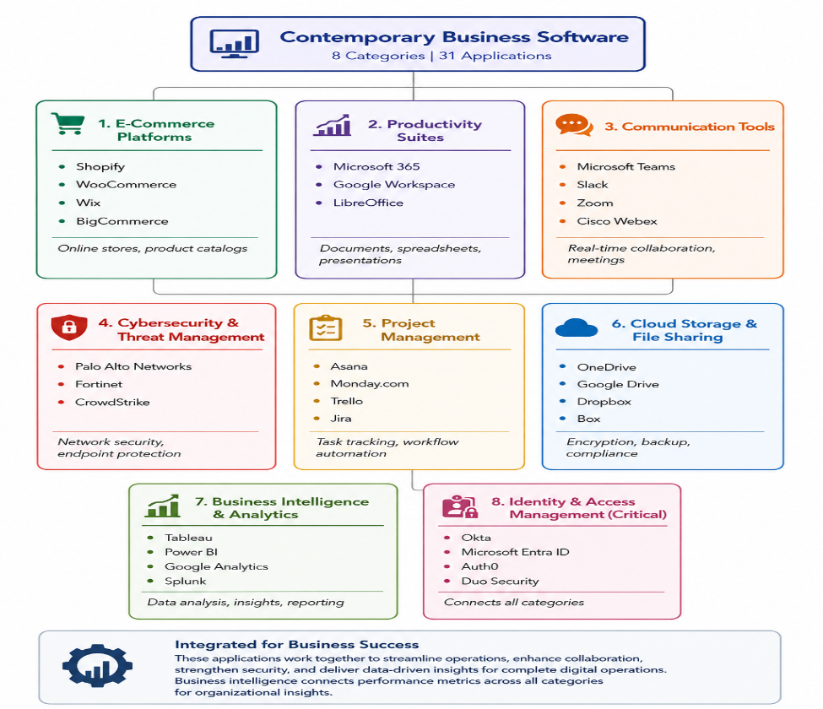
Figure 3: Business Software Mind map

Task 3. Office Applications in E-Commerce and Cybersecurity

3.1 Four office software solutions for business operations

Ms Word

Part A: Microsoft Word

Microsoft Word is a program that helps you make, change, arrange, check, and share documents made of text. It allows for headings, tables, references, page numbers, templates, hyperlinks, comments, and working together on the document. In e-commerce and cybersecurity settings, Word can be used to create customer messages, policies, contracts, product guides, incident response plans, and compliance reports.

Although Word isn't an e-commerce platform, it helps with writing and sharing information related to online business. This is important because new studies show that having good e-commerce systems can help companies work more efficiently by using better technology and making better use of their employees' skills. Word can help companies write down these digital processes in a clear and easy-to-use way.[42]

Key features

Important Word features include styles, templates, Track Changes, comments, document protection, hyperlinks, tables and Mail Merge. Styles allow users to apply consistent formatting to headings and paragraphs, while templates standardize recurring documents such as invoices, order confirmations, refund policies and privacy notices.

Mail Merge connects a Word document to an external data source, usually an Excel worksheet or database. It can insert fields such as a customer name, order number, product and delivery status into a standard letter. Word also provides accessibility tools, including alternative text, heading structures and accessibility checking.
Figure 4: Microsoft Word

Limitations

Word is not a relational database or a secure transaction-processing system. Storing large customer lists in Word can cause duplication, weak searching and version-control problems. Documents may also be copied, forwarded or shared with incorrect permission.

A further limitation is that Office files can be used to distribute malware.[43] Malicious Microsoft Office documents examination shows how attackers use document features and embedded components to deliver malicious payloads.[44] Analysis of 9,086 malicious Office samples identified changing tactics in document-based attacks. Organizations should therefore disable unnecessary macros, verify file sources, apply access controls and avoid placing passwords, payment-card details or unnecessary personal data in Word documents.[43], [44]

E-commerce use case

An online retailer could create a standard order-confirmation letter containing the customer’s name, order ID, product and estimated delivery date. Mail Merge would retrieve these fields from an approved customer-order table and produce individual messages. The process would reduce manual work while maintaining a consistent format.

The source file should be protected, and the output should be checked before distribution. Payment-card numbers, authentication tokens and passwords should not be included.

Cybersecurity use case

A company could use Word to prepare an incident-response manual. The manual might explain how employees report phishing, how administrators isolate an affected account and how managers notify customers after a data breach. Version control would be necessary because outdated procedures could delay response.
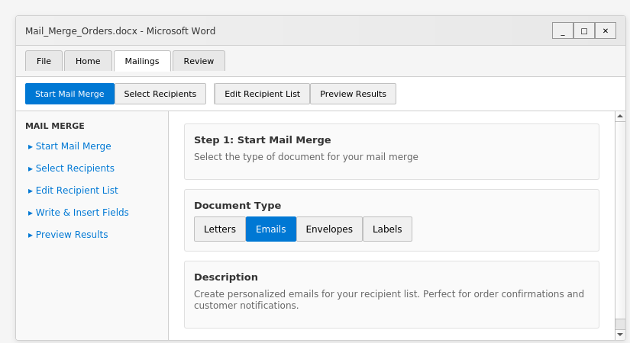
Figure 5: Mail Merge setup in Microsoft Word - Mailings tab showing Start Mail Merge option

Ms Excel

Part B: Microsoft Excel

Definition and purpose

Microsoft Excel is a spreadsheet application used to store, calculate, analyze and visualize structured data. It provides formulas, functions, charts, filters, conditional formatting, PivotTables, data validation and Goal Seek. These features make Excel useful for e-commerce sales analysis, inventory control, budgeting, fraud review and cybersecurity risk tracking.

Excel is valuable because it allows employees to transform raw records into operational information. For example, e-commerce infrastructure has been associated with improved firm productivity, partly through innovation and better allocation of organizational resources. Excel can support this process by helping managers examine sales, costs, stock and performance indicators.[42]

Key features

The IF function can classify data according to a condition.

For example:

IF(E2>500,"High-value order","Standard order")

Lookup functions such as VLOOKUP can connect a product code to a price, category or supplier. PivotTables summarize large datasets by region, product, date or risk category. Goal Seek works backwards from a target value; for example, it can calculate the sales volume required to achieve a target profit.

Excel also provides charts, sorting, filtering and conditional formatting. These tools support rapid analysis of order volumes, conversion rates, refund rates and suspicious transactions.

Cybersecurity Applications

Excel can be used to keep track of vulnerability registers. It allows you to record details like the name of the asset, how severe the vulnerability is, when the patch needs to be applied, who is responsible for handling it, and the current status of fixing the issue. Conditional formatting shows overdue critical issues; PivotTables group open issues by department.

Scenario Analysis

Goal Seek helps retailers figure out how many units they need to sell to reach their profit goals, and it also lets cybersecurity managers calculate how much return their security investments are giving.
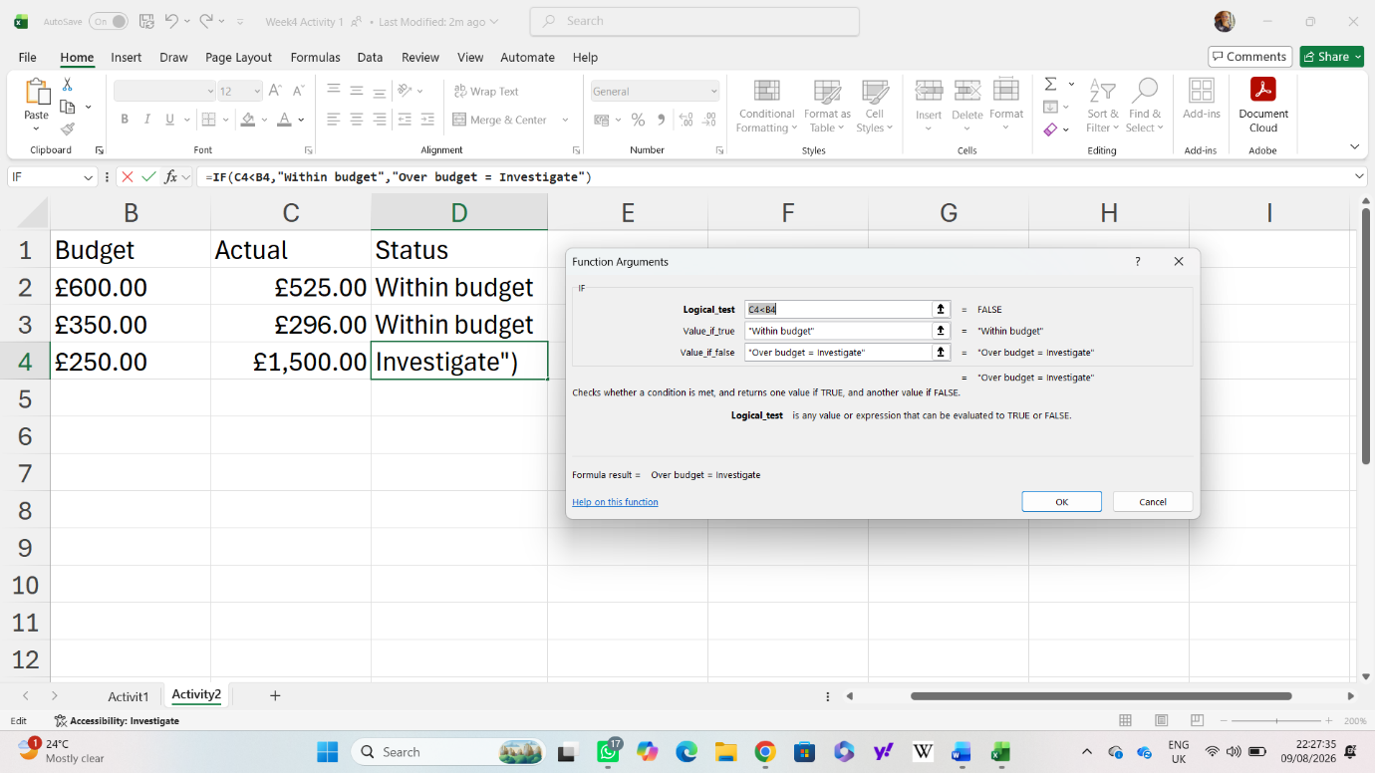
Figure 6: Microsoft Excel

Limitations

Spreadsheet mistakes caused by wrong cell references, mixed-up data, and secret formulas can lead to wrong answers. Automated checks should help, but they shouldn't take the place of people checking things manually. Excel doesn't have strong security features to stop multiple people from editing the same file at the same time or copying data without permission. Because of this, it's not a good choice to use instead of central databases that allow many users to access and work on data at the same time. Sensitive data must be handled by systems that are approved and have controls to limit access, along with records that track who accessed the data and when.

E-commerce use case

Retailers use IF formulas to look at orders and figure out how risky they are, then they make PivotTables to show the total money made. Product code lookups get prices and stock information from special tables that are checked and matched with the inventory system on a regular basis.

Cybersecurity use case

A security team could use Excel to maintain a vulnerability register. An IF formula could mark a vulnerability as “Overdue” when the patch deadline has passed. A PivotTable could show unresolved critical vulnerabilities by department.

The workbook should not contain passwords, encryption keys or complete payment information. Analysts should preserve the original data and record the date on which the analysis was performed.

Ms PowerPoint

Part C: Microsoft PowerPoint

Microsoft PowerPoint is a presentation application used to communicate information through slides containing text, charts, diagrams, images, audio and video. Unlike Word, which is designed for detailed documents, PowerPoint is designed to support spoken explanation and visual storytelling.

PowerPoint is useful in e-commerce because managers often need concise explanations of sales performance, customer behavior and business opportunities. It is also important in cybersecurity because technical information must frequently be communicated to non-technical decision-makers.

Key features

PowerPoint includes templates, themes, slide masters, charts, SmartArt, speaker notes, animations, hyperlinks, presenter view and media embedding. Excel charts can be inserted into slides to show revenue, conversion rates, stock levels or fraud alerts. Slide masters help organizations maintain a consistent visual identity.[44], [45]

Limitations

Charts can make things look simpler than they are by not showing all the important information or by leaving out data that goes against what they're trying to prove. Presentations need to explain where the data comes from, when the reports are made, and what the data might not cover. PowerPoint files can include hidden commands or connections to other websites that might be unsafe. Users should not open files from sources they don't know or turn on macros without checking first.[46]

E-commerce use case

A manager creates presentations each quarter that include information about sales growth, how well customers stay with the company, the average amount spent per order, and how profitable each product is. Presentations need to clearly show real outcomes versus predictions and explain the basic ideas that are assumed to be true.

Cybersecurity use case

Experts talk about the dangers of online shopping, like someone taking over your account, stealing your payment information, and weaknesses in other websites you use. Dashboards show how many incidents there are, how long it takes to respond, and any high-risk problems that haven't been fixed yet. Executive summaries should not include technical details.

Figure 7: Microsoft PowerPoint

Ms Access

Part D: Microsoft Access

Microsoft Access is a software tool used to store, organize, and create reports based on structured data. Unlike spreadsheets, Access keeps connected information in different linked tables.

Key features

Access uses tables, primary keys, foreign keys, relationships, queries, forms, and reports. Primary keys are used to uniquely identify each record in a table. Foreign keys are used to connect records in one table to records in another table. Forms make it easier to enter data; queries search for records that meet certain conditions; reports give clear, organized summaries.
Limitations
This access is not good for big online stores, large company systems, or keeping track of security events. Performance declines with more users and records. Badly made databases can lead to repeated entries or wrong information. Files that need access should be stored securely and backed up. Personal information or security details should not be copied without permission.

E-commerce use case

Small stores connect customers, orders, products, and shipments. Queries help find paid orders that haven't been shipped yet or track the demand for products each month. Payment card information should stay with approved processors.

Cybersecurity use case

Teams record incidents and link them to the affected assets, the analysts in charge, and the steps needed to fix the issues. Reports show that some issues or problems in the system are still not fixed and keep coming back. Access alone should not be the only place where forensic evidence is kept; evidence must be gathered properly and there should be a clear record of who had it and when.

Figure 8: Microsoft Access

3.2 Feature Testing with Screenshots

Mail Merge

Feature Test 1: Mail Merge

Setup and preparation

The test uses a Word letter template linked to an Excel table that has the recipient details. The table includes FirstName, Email, OrderID, Product, and Status. Before beginning the merge, the user needs to delete any duplicate entries, look for empty email addresses, and remove any personal details that aren't needed.

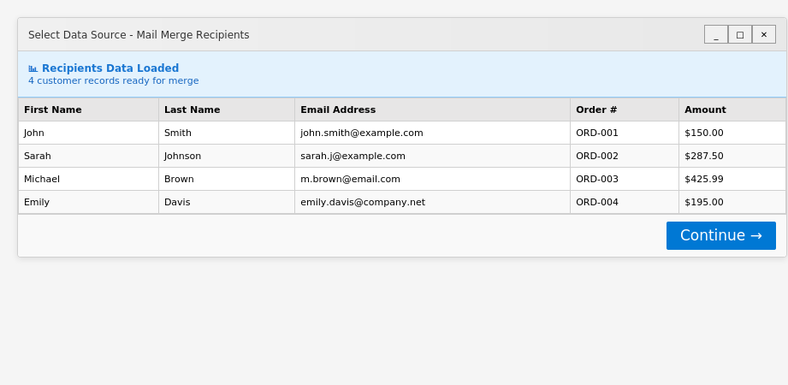
Figure 9: Selecting recipients’ data source - Mail Merge recipients dialog displaying customer data

Feature in action

The Mailings tab is for choosing letters, linking to an Excel file, and adding merge fields. The template includes «FirstName», «OrderID» and «Product». Preview Results is then used to look at each record one by one.

Results/output
The preview shows a custom message sent to Bilal that includes order EC1043 for a keyboard. The test shows that a single Word template can automatically create different messages for customers.
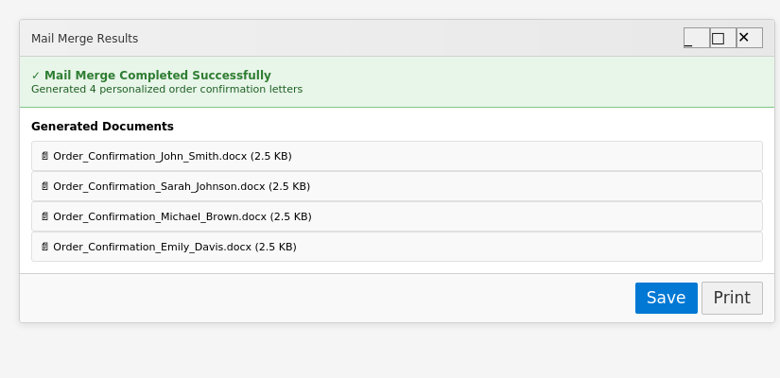
Figure 10: Mail Merge output - Personalized order confirmation letters generated from template

Mail merge is helpful in e-commerce for sending order confirmations, delivery updates, and warranty information. However, using the wrong list of people can lead to problems with keeping data safe. The original file needs to be kept secure, and the person in charge should check some example results before sending them out. Personalization should stick to the rule of only using the least amount of data needed; things like passwords, credit card numbers, and login tokens should never be combined or mixed together. Because office files can be used for harmful purposes, the created documents should also be kept and shared using approved systems.[43], [44]

PivotTable

Feature Test 2: PivotTable

Setup and preparation
The Excel file has columns for OrderID, Region, Product, Units, Revenue, and Risk Flag. Each row shows a single transaction, and each column shows a different piece of information. The data needs to be checked first before starting the analysis because a wrong risk marker or a repeated order might change the outcome.
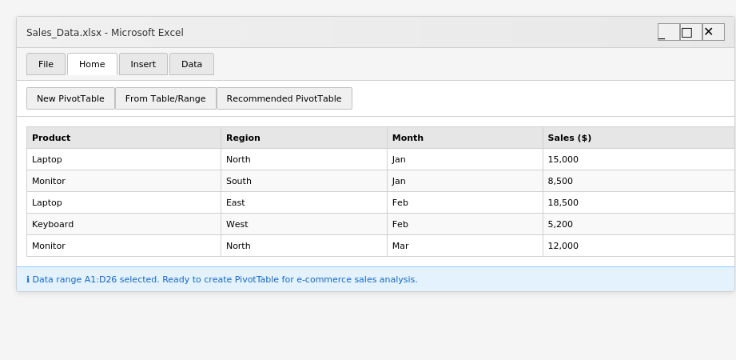
Figure 11: PivotTable setup - Source data selected showing sales information for e-commerce analysis

Feature in action
The PivotTable is set up with Region in the Rows, Risk Flag in the Columns, and Revenue in the Values. Excel then adds up the revenue from both the transactions that are marked and those that are not marked.

Figure 12: PivotTable configuration - Fields organized to analyse sales by product and region

Pivot Table Output
The results show that the North region made 95 in revenue and the South region made 180 in revenue. Total revenue is 275, and 55 of that is from records that have the risk flag marked as “Yes.” The North region needs more attention in this example dataset.
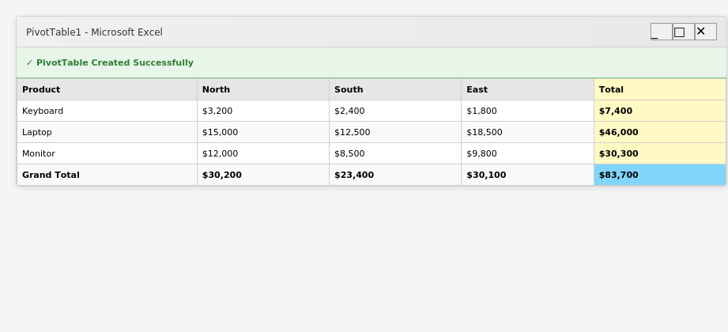
Figure 13: PivotTable output - Completed summary showing sales by product and region
The test shows how a PivotTable turns detailed transaction records into a summary that managers can use. In e-commerce, this can help with looking at sales in different regions, deciding which fraud cases to check first, and examining strange patterns in transactions. In cybersecurity, it can group alerts by region, department, asset, or how severe they are.
The output does not show that a transaction is bad. It just gives a summary of the values that were given to the worksheet. Analysts need to check the original records, update the PivotTable when there are changes, and look into any flagged transactions following the right steps. Spreadsheet results should also be checked by someone else because depending too much on spreadsheet tools can make it harder to catch mistakes.[47]

Task 4. Communication and Collaboration applications

4.1 One contemporary Communication and one Online Collaboration

Microsoft Teams
Part A: Communication App—Microsoft Teams
Microsoft Teams is a tool that helps people communicate by allowing them to chat, make voice and video calls, share their screens, and have discussions in channels grouped by projects or departments. The main features are sending messages, replying in threads, recording conversations, attaching files, and connecting with Microsoft 365. Files can be viewed right inside the channels, which helps to keep messages from getting mixed up.[48]
In e-commerce, different channels work together to handle marketing, managing inventory, providing customer service, and taking care of orders. This setup helps keep track of stock levels in real time and quickly fix any problems that come up. Teams helps with cybersecurity by offering a central place where security teams can report alerts, give tasks, and keep track of investigations. Data is protected by encryption when it is being sent and when it is stored.
Too much information from many sources can make it hard to notice important warnings. External users, harmful links, hacked accounts, and secret recordings can all be dangerous. Companies need to use multi-factor authentication, give users only the access they need, set up solid security options, and provide security training.

Google Workspace
Google Workspace is a group of tools—like Drive, Docs, Sheets, Slides, Meet, and Gmail—that help people work together on creating and editing files. Many people can work on the same document at the same time. They can add notes and see any changes others make right away. The features include working together with others, saving files online, controlling who can see or edit them, and keeping track of all the changes made.
In e-commerce, Sheets handle pricing and inventory, while Docs are used to write product descriptions. All users use the same version, which stops duplicates and mistakes from happening. For cybersecurity, Sheets keep track of incidents; Docs put together reports. Version history and activity logs help track any unwanted changes that happen without permission.
Limitations involve sharing information incorrectly, which can lead to sensitive data being exposed, and accounts being hacked, allowing too much access. Both platforms need multi-factor authentication, data loss prevention, access audits, and training to reduce risks properly.[49]

4.2 Test one feature of a freely available Communication (1) and one feature of a Collaboration (1) application

Microsoft Teams
Communication Feature Test: Microsoft Teams Channel File Sharing
Setup. Make a Microsoft Teams team called E-Commerce Security Project and set up a private channel named Incident Response. Add two test users and open the channel’s Posts and Files sections.
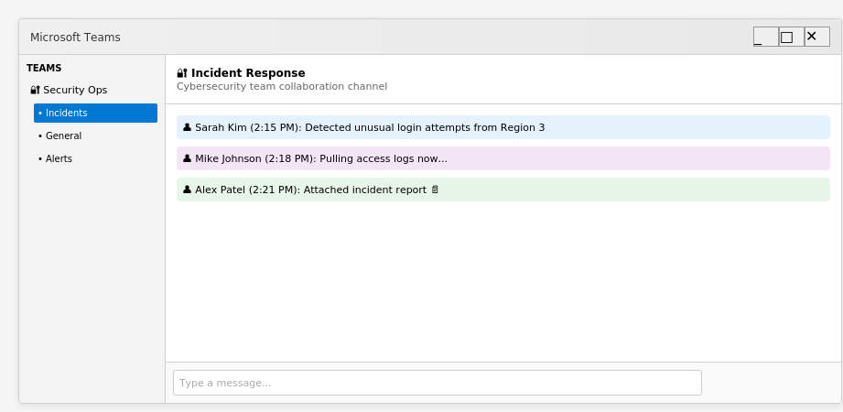
Figure 14: Microsoft Teams channel setup - Incident Response channel ready for team collaboration
Feature in action. After sending the fake alert message: “Unusual login activity detected on the customer-ordering account,” add a made-up file called incident_log.txt and mention the security lead. The screenshot needs to include the channel name, the message, any attachment, and the user who was tagged.
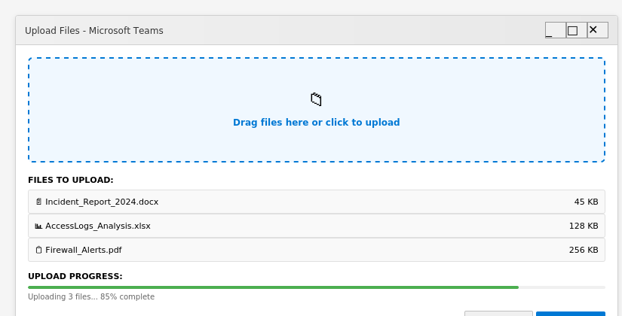
Figure 15: File upload in Teams - Uploading incident response documentation to shared channel
Results. Show the recipient's response that confirms they have seen and reviewed the alert. The screenshot needs to show that the post and the attached file are still visible in the channel.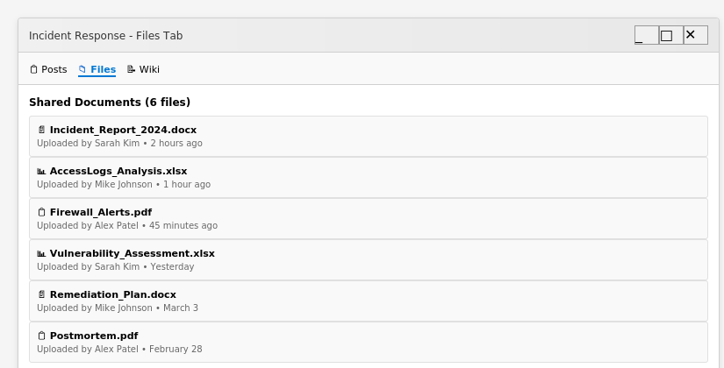
Figure 16: Teams Files tab - Shared incident response documents accessible to all team members
Tests Teams can share information and keep evidence safely. Expected results include successfully sending messages, including any attached files, notifying users, and making incident records easily accessible. Critical for quick alerts on e-commerce fraud and account takeovers.

Google Docs
Collaboration Feature Test: Google Docs Co-authoring
Setup. Make a document called Online Store Incident-Response Procedure and send it to two test users with Editor and Commenter permission.
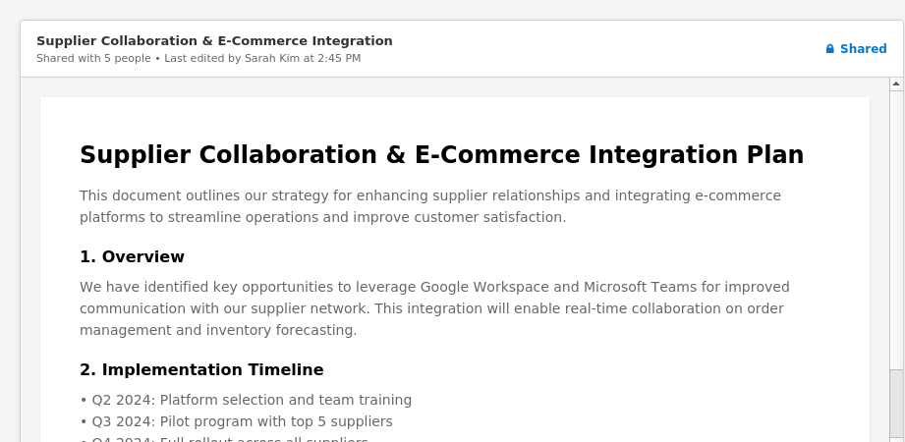
Figure 17: Google Docs shared document - Open collaborative document for e-commerce supplier coordination
Feature in action. Have both users edit separate parts at the same time. One user should add a response step, while the other adds a comment asking for clarification.
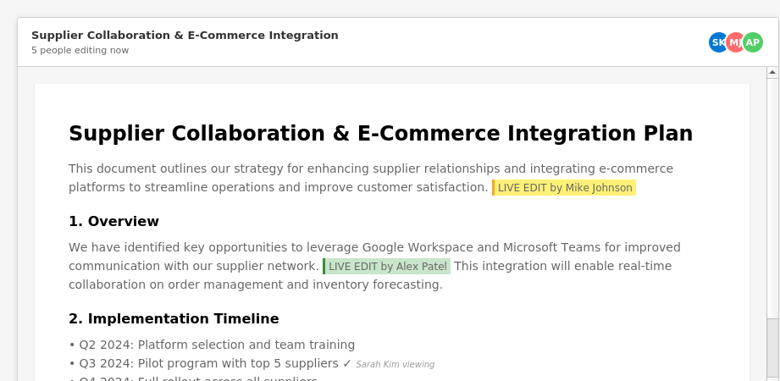
Figure 18: Google Docs co-authoring - Multiple users editing simultaneously with visible cursor positions
Results. Open the file, go to version history, view the version history to see who contributed, when each change was made, what was edited, and the option to restore previous versions.
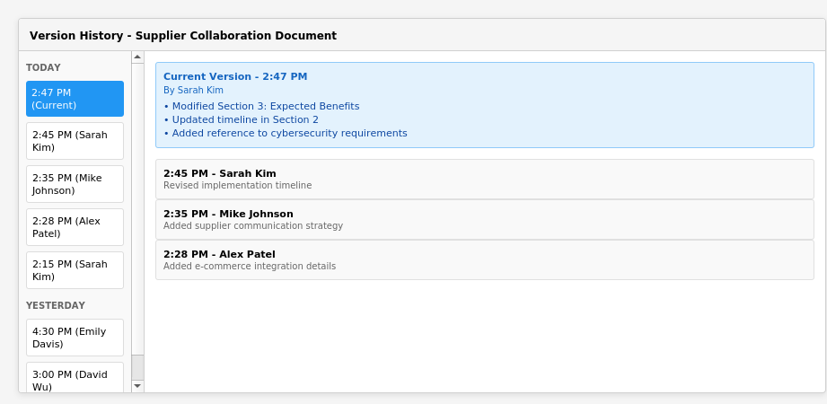
Figure 19: Google Docs version history - Complete revision tracking showing all edits and contributors

Conclusion
Efficient and driving growth in the market for e-commerce platforms like Wix and Shopify with low-code tools and payment functions. Yet, balancing convenience with long-term strategy is important when considering platform dependence, limited customization and governance concerns.
Business infrastructure is interconnected. You rely on office apps, cloud storage, identity management, analytics tools, communication and collaboration tools. Cybersecurity based e-commerce. Microsoft Word, Excel, PowerPoint and Access support documentation and analysis but they need access controls, validation and reviews by human. For example, Microsoft Teams and Google Workspace complement collaboration by navigating the increased risk of improper permissions, malicious files, compromised accounts, or exposure of sensitive data.
Organizations must identify software best suited for their functional requirements, capacity of growth, security demands and resources. Core protections include Cybersecurity policies, staff training, multi-factor authentication, data-protection procedures, monitoring Feature tests using dummy data (without exposing any real sensitive information) Strengths the capacity for e-commerce with a more efficient and safer way to operate.

References
[1] Z. Shi, J. Dong, and Y. Gan, “Democratizing Digital Transformation: A Multisector Study of Low-Code Adoption Patterns, Limitations, and Emerging Paradigms,” Applied Sciences, vol. 15, no. 12, p. 6481, Jun. 2025, doi: 10.3390/app15126481.
[2] G. Dushnitsky and B. K. Stroube, “Low-code entrepreneurship: Shopify and the alternative path to growth,” Journal of Business Venturing Insights, vol. 16, p. e00251, Nov. 2021, doi: 10.1016/j.jbvi.2021.e00251.
[3] M. G. Jacobides, C. Cennamo, and A. Gawer, “Externalities and complementarities in platforms and ecosystems: From structural solutions to endogenous failures,” Res. Policy, vol. 53, no. 1, p. 104906, Jan. 2024, doi: 10.1016/j.respol.2023.104906.
[4] T. Wulfert, “Boundary resource management in innovation ecosystems: The case of e-commerce,” Electronic Markets, vol. 33, no. 1, p. 27, Dec. 2023, doi: 10.1007/s12525-023-00651-6.
[5] R. Kaur, D. Gabrijelčič, and T. Klobučar, “Artificial intelligence for cybersecurity: Literature review and future research directions,” Information Fusion, vol. 97, p. 101804, Sep. 2023, doi: 10.1016/j.inffus.2023.101804.
[6] G. Dushnitsky and B. K. Stroube, “Low-code entrepreneurship: Shopify and the alternative path to growth,” Journal of Business Venturing Insights, vol. 16, p. e00251, Nov. 2021, doi: 10.1016/j.jbvi.2021.e00251.
[7] Mustafa Ayobami Raji, Hameedat Bukola Olodo, Timothy Tolulope Oke, Wilhelmina Afua Addy, Onyeka Chrisanctus Ofodile, and Adedoyin Tolulope Oyewole, “THE DIGITAL TRANSFORMATION OF SMES: A COMPARATIVE REVIEW BETWEEN THE USA AND AFRICA,” International Journal of Management & Entrepreneurship Research, vol. 6, no. 3, pp. 737–751, Mar. 2024, doi: 10.51594/ijmer.v6i3.884.
[8] Sarah Kuzankah Ewuga, Zainab Efe Egieya, Adedolapo Omotosho, and Abimbola Oluwatoyin Adegbite, “COMPARATIVE REVIEW OF TECHNOLOGY INTEGRATION IN SMES: A TALE OF TWO ECONOMIES - THE UNITED STATES AND NIGERIA,” Engineering Science & Technology Journal, vol. 4, no. 6, pp. 555–570, Dec. 2023, doi: 10.51594/estj.v4i6.680.
[9] R. Tarmizi, N. Septiani, P. A. Sunarya, and Y. P. Ayu Sanjaya, “Harnessing Digital Platforms for Entrepreneurial Success: A Study of Technopreneurship Trends and Practices,” Aptisi Transactions on Technopreneurship (ATT), vol. 5, no. 3, pp. 278–290, Nov. 2023, doi: 10.34306/att.v5i3.360.
[10] A. Viljoen, A. Hein, and H. Krcmar, “Low-code development platform ecosystems,” Electronic Markets, vol. 36, no. 1, p. 12, Dec. 2026, doi: 10.1007/s12525-025-00848-x.
[11] A. Delhi and A. Sijabat, “The Role of Technology Adoption in Scaling Startupreneur Business Models in the Digital Economy,” Startupreneur Business Digital (SABDA Journal), vol. 3, no. 2, pp. 141–147, Oct. 2024, doi: 10.33050/sabda.v3i2.631.
[12] A. M. Felicetti, V. Corvello, and S. Ammirato, “Digital innovation in entrepreneurial firms: a systematic literature review,” Review of Managerial Science, vol. 18, no. 2, pp. 315–362, Feb. 2024, doi: 10.1007/s11846-023-00638-9.
[13] A. Agrawal, J. S. Gans, and S. Stern, “Enabling Entrepreneurial Choice,” Manage. Sci., vol. 67, no. 9, pp. 5510–5524, Sep. 2021, doi: 10.1287/mnsc.2020.3920.
[14] C. Kreiterling, “Digital innovation and entrepreneurship: a review of challenges in competitive markets,” J. Innov. Entrep., vol. 12, no. 1, p. 49, Aug. 2023, doi: 10.1186/s13731-023-00320-0.
[15] A. Shore, M. Tiwari, P. Tandon, and C. Foropon, “Building entrepreneurial resilience during crisis using generative AI: An empirical study on SMEs,” Technovation, vol. 135, p. 103063, Jul. 2024, doi: 10.1016/j.technovation.2024.103063.
[16] Olorunyomi Stephen Joel, Adedoyin Tolulope Oyewole, Olusegun Gbenga Odunaiya, and Oluwatobi Timothy Soyombo, “NAVIGATING THE DIGITAL TRANSFORMATION JOURNEY: STRATEGIES FOR STARTUP GROWTH AND INNOVATION IN THE DIGITAL ERA,” International Journal of Management & Entrepreneurship Research, vol. 6, no. 3, pp. 697–706, Mar. 2024, doi: 10.51594/ijmer.v6i3.881.
[17] M. Belitski, J. Korosteleva, and L. Piscitello, “Digital affordances and entrepreneurial dynamics: New evidence from European regions,” Technovation, vol. 119, p. 102442, Jan. 2023, doi: 10.1016/j.technovation.2021.102442.
[18] T. Berman, D. Schallmo, and S. Kraus, “Strategies for digital entrepreneurship success: the role of digital implementation and dynamic capabilities,” European Journal of Innovation Management, vol. 27, no. 9, pp. 198–222, Dec. 2024, doi: 10.1108/EJIM-01-2024-0081.
[19] N. Nagy, R. Bläse, M. Filser, J. Appenzeller, and K. Puumalainen, “Platform dynamics and rapid scaling: an empirical examination of growth drivers in platform-based start-ups,” Review of Managerial Science, vol. 20, no. 5, pp. 1645–1686, May 2026, doi: 10.1007/s11846-025-00918-6.
[20] S. Sanasi, A. Ghezzi, and A. Cavallo, “What happens after market validation? Experimentation for scaling in technology-based startups,” Technol. Forecast. Soc. Change, vol. 196, p. 122839, Nov. 2023, doi: 10.1016/j.techfore.2023.122839.
[21] R. Subramaniam and M. Sambasivan, “Analyzing the role of digital/non-digital technology entrepreneur typology in external factors’ influence on venture launch decisions,” J. Innov. Entrep., vol. 14, no. 1, p. 93, Aug. 2025, doi: 10.1186/s13731-025-00569-7.
[22] P. Centobelli, R. Cerchione, E. Esposito, R. Passaro, and I. Quinto, “The undigital behavior of innovative startups: empirical evidence and taxonomy of digital innovation strategies,” International Journal of Entrepreneurial Behavior & Research, vol. 28, no. 9, pp. 219–241, Dec. 2022, doi: 10.1108/IJEBR-08-2021-0626.
[23] J. Huang, O. Henfridsson, and M. J. Liu, “Extending Digital Ventures Through Templating,” Information Systems Research, vol. 33, no. 1, pp. 285–310, Mar. 2022, doi: 10.1287/isre.2021.1057.
[24] G. Zhang and M. N. Ravishankar, “The role of capabilities in digital service development and delivery: the case of start-up organisations,” Information Technology & People, vol. 37, no. 3, pp. 1156–1184, Apr. 2024, doi: 10.1108/ITP-05-2021-0404.
[25] K. F. Nzembayie and D. Urbano, “Generative AI platforms as institutional catalysts of digital entrepreneurship: Enablement, dependence &amp; power dynamics,” Technol. Soc., vol. 84, p. 103074, Mar. 2026, doi: 10.1016/j.techsoc.2025.103074.
[26] G. Dushnitsky and B. K. Stroube, “Low-code entrepreneurship: Shopify and the alternative path to growth,” Journal of Business Venturing Insights, vol. 16, p. e00251, Nov. 2021, doi: 10.1016/j.jbvi.2021.e00251.
[27] L. Markfort et al., “Patterns of business model innovation for advancing IoT platforms,” Journal of Service Management, vol. 33, no. 1, pp. 70–96, Jan. 2022, doi: 10.1108/JOSM-11-2020-0429.
[28] B. K. Stroube and G. Dushnitsky, “Mapping entrepreneurial inclusion across <scp>US</scp> neighborhoods: The case of low‐code e‐commerce entrepreneurship,” Strategic Management Journal, vol. 46, no. 7, pp. 1762–1789, Jul. 2025, doi: 10.1002/smj.3706.
[29] A. Viljoen, A. Hein, and H. Krcmar, “Low-code development platform ecosystems,” Electronic Markets, vol. 36, no. 1, p. 12, Dec. 2026, doi: 10.1007/s12525-025-00848-x.
[30] T. Wulfert, G. Strobel, and H. Hoang, “Let’s join forces: boundary resources as enablers of value co-creation in e-commerce ecosystems,” Electronic Commerce Research, vol. 25, no. 6, pp. 4433–4470, Dec. 2025, doi: 10.1007/s10660-024-09848-z.
[31] T. Wulfert, R. Woroch, G. Strobel, S. Seufert, and F. Möller, “Developing design principles to standardize e-commerce ecosystems,” Electronic Markets, vol. 32, no. 4, pp. 1813–1842, Dec. 2022, doi: 10.1007/s12525-022-00558-8.
[32] C. Leong, S. Lin, F. Tan, and J. Yu, “Coordination in a Digital Platform Organization,” Information Systems Research, vol. 35, no. 1, pp. 363–393, Mar. 2024, doi: 10.1287/isre.2023.1226.
[33] A. Da Rocha, L. Neves da Fonseca, and C. S. Kogut, “Small firm internationalization using digital platforms: an assessment and future research directions,” International Marketing Review, vol. 41, no. 5, pp. 981–1015, Oct. 2024, doi: 10.1108/IMR-10-2023-0280.
[34] Y. Song, O. Escobar, U. Arzubiaga, and A. De Massis, “The digital transformation of a traditional market into an entrepreneurial ecosystem,” Review of Managerial Science, vol. 16, no. 1, pp. 65–88, Jan. 2022, doi: 10.1007/s11846-020-00438-5.
[35] K. Kapoor, A. Ziaee Bigdeli, Y. K. Dwivedi, A. Schroeder, A. Beltagui, and T. Baines, “A socio-technical view of platform ecosystems: Systematic review and research agenda,” J. Bus. Res., vol. 128, pp. 94–108, May 2021, doi: 10.1016/j.jbusres.2021.01.060.
[36] H. Cha, M. Kotabe, and J. Wu, “Reshaping Internationalization Strategy and Control for Global E-Commerce and Digital Transactions: A Hayekian Perspective,” Management International Review, vol. 63, no. 1, pp. 161–192, Feb. 2023, doi: 10.1007/s11575-022-00494-x.
[37] L. Markfort et al., “Patterns of business model innovation for advancing IoT platforms,” Journal of Service Management, vol. 33, no. 1, pp. 70–96, Jan. 2022, doi: 10.1108/JOSM-11-2020-0429.
[38] M. Engert, J. Evers, A. Hein, and H. Krcmar, “The Engagement of Complementors and the Role of Platform Boundary Resources in e-Commerce Platform Ecosystems,” Information Systems Frontiers, vol. 24, no. 6, pp. 2007–2025, Dec. 2022, doi: 10.1007/s10796-021-10236-3.
[39] A. B. A. Ali, R. K. Ayyasamy, R. Akbar, A. K. Jebna, and K. Adnan, “Cybersecurity Infrastructure Compliance Key Factors to Detect and Mitigate Malware Attacks in SMEs: A Systematic Literature Review,” Sage Open, vol. 15, no. 1, Jan. 2025, doi: 10.1177/21582440251314671.
[40] R. Lakshman Naik and S. Jain, “Recent Advancements in Cybersecurity: A Literature Review,” 2025, pp. 257–269. doi: 10.1007/978-981-96-0924-6_21.
[41] K. Owoigbe, “ARTIFICIAL INTELLIGENCE FOR CYBERSECURITY IN E-COMMERCE: A LITERATURE REVIEW AND FUTURE RESEARCH DIRECTIONS,” International Journal Of Progressive Research In Engineering Management And Science, 2025.
[42] X. Zhou and P. Jiang, “Does e‐commerce infrastructure increase enterprise productivity? Evidence from China’s e‐commerce demonstration city,” International Journal of Finance & Economics, vol. 30, no. 2, pp. 1758–1784, Apr. 2025, doi: 10.1002/ijfe.2994.
[43] V. Koutsokostas et al., “Invoice #31415 attached: Automated analysis of malicious Microsoft Office documents,” Comput. Secur., vol. 114, p. 102582, Mar. 2022, doi: 10.1016/j.cose.2021.102582.
[44] A. Saha, J. Blasco, and M. Lindorfer, “Exploring the Malicious Document Threat Landscape: Towards a Systematic Approach to Detection and Analysis,” in 2024 IEEE European Symposium on Security and Privacy Workshops (EuroS&amp;PW), IEEE, Jul. 2024, pp. 533–544. doi: 10.1109/EuroSPW61312.2024.00065.
[45] V. Koutsokostas et al., “Invoice #31415 attached: Automated analysis of malicious Microsoft Office documents,” Comput. Secur., vol. 114, p. 102582, Mar. 2022, doi: 10.1016/j.cose.2021.102582.
[46] W. Wang, P. Yi, T. Kou, W. Han, and C. Wang, “GLDOC: detection of implicitly malicious MS-Office documents using graph convolutional networks,” Cybersecurity, vol. 7, no. 1, p. 48, Jul. 2024, doi: 10.1186/s42400-024-00243-7.
[47] A. Mukhtar, B. Hofer, D. Jannach, and F. Wotawa, “Spreadsheet debugging: The perils of tool over-reliance,” Journal of Systems and Software, vol. 184, p. 111119, Feb. 2022, doi: 10.1016/j.jss.2021.111119.
[48] D. Wegner, A. B. da Silveira, D. Marconatto, and M. Mitrega, “A systematic review of collaborative digital platforms: structuring the domain and research agenda,” Review of Managerial Science, vol. 18, no. 9, pp. 2663–2695, Sep. 2024, doi: 10.1007/s11846-023-00695-0.
[49] S. Alahmari, K. Renaud, and I. Omoronyia, “Moving beyond cyber security awareness and training to engendering security knowledge sharing,” Information Systems and e-Business Management, vol. 21, no. 1, pp. 123–158, Mar. 2023, doi: 10.1007/s10257-022-00575-2.

